MindSpore报错解决地图

目 录
1 MindSpore常见报错问题和解决方案 1
2 数据处理报错案例 15
2.1 数据集加载-调试小工具 py-spy 17
2.2 如何将自有数据高效的生成MindRecord格式数据集，并且防止爆内存 20
2.3 在使用Dataset处理数据过程中内存占用高，怎么优化 21
2.4 如何处理数据集加载多进程(multiprocessing)错误 26
2.5 MindRecord-Windows下中文路径问题Unexpected error. Failed to open file 30
2.6 MindRecord数据集格式-Windows下数据集报错Invalid file, DB file can not match 31
2.7 数据集加载-GeneratorDataset卡住、卡死 32
2.8 GeneratorDataset报错误Unexpected error. Invalid data type 34
2.9 数据集加载-GeneratorDataset数据处理报错：The pointer[cnode] is null 36
2.10 数据集报错【The data pipeline is not a tree】 39
2.11 数据增强报错：Use Decode() for encoded data or ToPIL() 40
2.12 自定义数据增强报错args should be Numpy narray.Got<class tuple&gt 42
2.13 数据集加载-GeneratorDataset功能及常见问题 43
2.14 数据加载-【too many open files】错误 48
2.15 数据增强-【TypeError: Invalid with type】错误 49
2.16 数据集格式-【MindRecord File could not open successfully】错误 52
2.17 数据集加载-has no attribute child_sampler 54
2.18 数据集加载报错DictIterator has no attribute get_next 57
2.19 数据集加载报错-IndexError: list index out of range 60
2.20 数据增强后，内存不足，自动退出 63
2.21 报错RuntimeError: Invalid data, Page size 64
2.22 报错TypeError: parse() missing 1 required positional. 66
2.23 MindSpore报错RuntimeError: Exception thrown from PyFunc. 69
2.24 报错GeneratorDataset num_workers=8, this value is ... 73
2.25 报错RuntimeError: Exception thrown from PyFunc. 75
2.26 报错RuntimeError: Unexpected error. Invalid data. 78
2.27 图像类型错误导致执行报错：TypeError: img should be PIL image or NumPy array. Got <class 'list'>. 81
2.28 通道顺序错误引起matplotlib.image.imsave执行报错:raise ValueError("Third dimension must be 3 or 4") 83
2.29 cv2.imwrite保存Tensor引起类型报错:cv2.error: OpenCV(4.6.0) :-1: error: (-5:Bad argument) in function 'imwrite' 84
2.30 cv2保存图片类型错误执行报错cv2. error: OpenCV(4.6.0) :-1: error: (-5:Bad argument) in function 'imwrite' - img is not a numpy array 85
2.31 MindSpore报错RuntimeError: Invalid data, the number of schema should be positive but got: 0. Please checkthe input schema. 86
2.32 MindSpore报错MRMOpenError: MindRecord File could not open successfully. 89
2.33 MindSpore报错RuntimeError: Invalid python function, the 'source' of 'GeneratorDataset' should return same number ... 90
2.34 MindSpore报错ValueError: when loss_fn is not None, train_dataset should return two elements, but got 3 93
2.35 MindSpore数据类型转换结果不符合预期 96
2.36 MindSpore报错TypeError:parse() missing 1 required positional argument: ‘self’ 98
2.37 使用mindspore.ops.interpolate报错ValueError:For "scale_factor" option cannot currentiy be set with the mode = bilinear = 4D 100
2.38 新节点3mindspore.dataset.Dataset.split切分数据集时randomize=True时分割出的数据不够随机问题 101
2.39 MindSpore拆分dataset输入给多输入模型 102
2.40 使用ImageFolderDataset读取图片在进行PIL转化的时候出现报错 103
2.41 MindSpore如何对使用了自定义采样器的数据集进行分布式采样 106
2.42 ImageFolderDataset读取图片在进行PIL转化的时候出现报错 108
2.43 使用MindSpore读取数据报错RuntimeError:Exception thrown from dataset pipeline. Refer to 'Dataset Pipline Error Message'. 111
2.44 使用MindSpore对vision.SlicePatches的数据集切分和合并 112
2.45 MindSpore调用Dataset.batch()中per_batch_map函数出错 114
2.46 使用MindSpore对vision.SlicePatches的数据集切分和合并 116
2.47 报错：mindspore._c_expression.typing.TensorType object is not callable 117
2.48 Ascend print数据落盘使用 120
2.49 MindSpore在construct中进行标量计算 121
2.50 MindSpore报错：module 'mindspore.dataset.vision' has no attribute 'Normalize' 122
2.51 使用Dataset处理数据过程中如何优化内存占用高的问题 122
3 模型构建与训练报错案例 129
3.1 报错RuntimeError:Exceed function call depth limit 1000 136
3.2 报错:AttributeError: Tensor has no attribute 139
3.3 报错AttributeError:NoneType has no attribute... 141
3.4 报错:the dimension of logits must be equal to 2 143
3.5 报错ValueError:For 'Pad', all elements of paddings must be >= 0. 145
3.6 报错ValueError:For xx,the x shape:xx must be equal to xxx 147
3.7 报类型错误TypeError: For 'Tensor', the type of `input_data` should be one of ... 150
3.8 报错 ScatterNdUpdate这个算子在Ascend硬件上不支持input0是int32的数据类型 151
3.9 报错TypeError: ScalarAdd不支持bool类型，官网缺少说明 153
3.10 报RuntimeError:ReduceSum算子不支持8维及以上的输入而报错 155
3.11 报类型错误:Unsupported parameter type for python primitive... 157
3.12 报错RuntimeError: Primitive ScatterAdd's bprop not defined. 159
3.13 报运行时错误: For Conv2d,x shape的C_in除以group应等于weight的C_in 161
3.14 报错：alueError: For 'Reshape', the shape of 'input_x' is [65209], the value of 'input_shape' value is [16302, 4]. 164
3.15 报错ValueError: For xxx,x和y的shape不支持 broadcast 165
3.16 报错“ValueError: For MatMul, the input dimensions必须相等 168
3.17 报错：Can not select a valid kernel info for [Default/Pow-op0] in AI CORE or AI CPU kernel info candidates list 170
3.18 报错：ValueError: `x rank` in `NLLLoss` should be int and must in [1, 2], but got `4` with type `int 172
3.19 报错：Select GPU kernel op[BatchNorm] fail! Incompatible data type! 174
3.20 报错：ValueError: For 'MirrorPad', paddings must be a Tensor with type of int64, but got None. 177
3.21 报错：For primitive[TensorSummary], the v rank 必须大于等于0 179
3.22 报错：TypeError: For 'CellList', each cell should be subclass of Cell, but got NoneType. 181
3.23 报错：task_fail_info or current_graph_ is nullptr 183
3.24 报错ValueError：`padding_idx` in `Embedding超出范围 186
3.25 报错ValueError: `seed2` in `StandardNormal` should be int and must >= 0 188
3.26 报错 Ascend 环境下ReduceMean不支持8维及其以上的输入 191
3.27 报错： Conv2D第三维输出数据类型必须是正整数或者SHP_ANY 193
3.28 报错：For 'TopK', the type of 'x' should be one of Tensor[Int32] 196
3.29 报错Minimum inputs size 0 does not match the requires signature size 2 198
3.30 报错ValueError: Currently `half_pixel_centers`=True only support in Ascend device_target, but got CPU 200
3.31 报错ValueError: For AvgPool输出形状的每一维都要大于零 201
3.32 报错TypeError: The function construct needs 0 positional argument and 0 default argument, but provided 1 204
3.33 报错Operator[ ] input( ) output( ) is not support 206
3.34 报错 sth should be initialized as a Parameter type in ... 208
3.35 报错：The 'add' operation does not support the type [kMetaTypeNone, Int64]. 210
3.36 报错：When eval 'Tensor(self.data, mindspore.float32)' by using Fallback feature, an error occurred: data. 212
3.37 报错RuntimeError: Net parameters weight shape ((751, 512)) is different from parameter_dict's ((31789, 512)) 215
3.38 GPU设备提示:The device with Cuda compute capability 5.2 is lower than the minimum required capability 5.3 216
3.39 GPU环境运行MindSpore报错：设卡失败 SetDevice failed 216
3.40 Ascend环境使用MindSpore报出如下错误: Total stream number xxx exceeds the limit of 1024, secrch details information in mindspore's FAQ. 217
3.41 LoadTask Distribute Task Failed 报错解决 218
3.42 GPU训练提示分配流失败[cudaStreamCreate failed] 223
3.43 GPU训练过程中报错：The memory alloc size is 0 224
3.44 报错：ValueError: For 'load_checkpoint', the checkpoint 224
3.45 加载checkpoint的时候报warning日志xxx parameters in the 'net' are not loaded, because they are not in the 'parameter_dict' 225
3.46 报错：ValueError: For 'context.set_context', package type xxx support 'device_target' type xxx, but got xxx. 226
3.47 PyNative模式下The pointer[top_cell_] is null错误 227
3.48 报错RuntimeError:alloc device memory failed, free memory size is less than half of total memory size. 228
3.49 报错ValueError: Please input the correct checkpoint 229
3.50 求导传入sens值时infer报错ValueError: For 'MatMul', the input dimensions must be equal 230
3.51 没有ckpt文件导致模型加载执行报错：please check whether the 'ckpt_file_name' is correct 233
3.52 Tensor张量shape不匹配导致执行报错：ValueError: For 'Sub', x.shape and y.shape are supposed to broadcast 236
3.53 自定义loss没有继承nn.Cell导致执行报错：ParseStatement] Unsupported statement 'Try'. 239
3.54 参数类型错误导致优化器执行报错：TypeError: For 'Optimizer', the argument parameters must be Iterable type 243
3.55 形参与实参的不对应导致ops.GradOperation执行报错：The parameters number of the function is 2, but the number of provided arguments is 1. 246
3.56 return回来的参数承接问题导致执行报错：AttributeError: 'tuple' object has no attribute 'asnumpy' 248
3.57 维度数错误引起模型输入错误：For primitive[Conv2D], the x shape size must be equal to 4, but got 3. 250
3.58 报错：The value parameter,it's name 'xxxx' already exsts. please set a unique name for the parameter . 252
3.59 construct方法名称错误引起损失函数执行报错:The 'sub' operation does not support the type [Tensor[Float32], None]. 255
3.60 RuntimeError:The 'sub' operation does not support the type [Tensor[Float32], None]. 257
3.61 注释不当报错：There are incorrect indentations in definition or comment of function: 'Net.construct'. 259
3.62 静态图执行卡死问题：For MakeTuple, the inputs should not be empty..node:xxxxxxxxxxxx 261
3.63 报错: module() takes at most 2 arguments (3 given) 261
3.64 报错ERROR：For 'ScatterNdAdd', the 3-th value of 'indices'[7] is out of range[4]scatterNdAdd. 263
3.65 使用ops.nonzero算子报错TypeError: Type Join Failed: dtype1 = Float32, dtype2 = Int64. 264
3.66 调用MindSpore内部函数时的语法错误TypeError: 'module' object is not callable 267
3.67 MindSpore在静态图模式下使用try语法报错RuntimeError: Unsupported statement 'Try'. 269
3.68 MindSpore报错: ValueError: For 'MatMul', the input dimensions must be equal, but got 'x1_col': 817920 and 'x2_row': 272640. 274
3.69 MindSpore 报错提示 DropoutGrad 的bprop反向未定义："Illegal primitive: Primitive DropoutGrad’s bprop not defined." 278
3.70 MindSpore报错The graph generated form MindIR is not support to execute in the PynativeMode,please convert to the GraphMode 280
3.71 MindSpore报错RuntimeError: For ’Optimizer’, the argument group params must not be empty. 281
3.72 使用mindspore.ops.MaxPool3D算子设置为ceil_mode=True时，在MindSpore1.8.1和1.9.0版本中计算结果不一致 283
3.73 Construct内报错和定位解决 286
3.74 gather算子报错：TypeError以及定位解决 288
3.75 报错：module() takes at most 2 arguments (3 given) 290
3.76 注释不当报错：There are incorrect indentations in definition or comment of function: 'Net.construct'. 291
3.77 MindSpore报错untimeError: Exceed function call depth limit 1000. 293
3.78 MindSpore图编译报错TypeError: ‘int’ object is not iterable. 295
3.79 MindSpore报错RuntimeError: The 'getitem' operation does not support the type [Func, Int64]. 296
3.80 MindSpore cpu版本源码编译失败 298
3.81 MindSpore图编译报错TypeError: ‘int’ object is not iterable. 302
3.82 MindSpore的Cell.insert_child_to_cell 添加层会出现参数名重复 303
3.83 mindspore.numpy.unique() 不支持 0 shape tensor 306
3.84 MindSpore直接将Tensor从布尔值转换为浮点数导致错误Error: IndexError: index 1 is out of bounds for dimension with size 1 307
3.85 MindSpore中的mindspore.numpy.bincount 大数值情况下报ValueError定位与解决 308
3.86 使用mindspore.numpy.broadcast_to 算子报错及解决 313
3.87 使用MindSpore中的SoftMax()算子计算单一数据出错Run op inputs type is invalid! 316
3.88 CSRTensor 矩阵乘法计算出错RuntimeError:CUDA Error: cudaMemcpy failed.|Error Number: 700 an illegal memory access was encountered 319
3.89 Cell对象序列化失败-使用pickle.dumps保存到本地后重新加载失败 321
3.90 TopK算子返回的全零的Tensor的解决 322
3.91 在NPU上的切片操作x=x[:,::-1,:,:]不生效的分析解决 324
3.92 张量运算失败报错RuntimeError:Malloc for kernel output failed, Memory isn’t enough 326
3.93 MindSpore Dump功能使用经验 326
3.94 使用SymbolTree.get_network处理conv2d算子时报错NameError:name "Cell" is not defined 328
3.95 使用mindspore中Conv2dTranspose的outputpadding时，设置has_bias=True时失效 333
3.96 使用mindspore.ops.pad算子报错位置有误 335
3.97 使用mindspore.numpy.sqrt 计算结果不正确 337
3.98 函数变换获得梯度计算函数时报错AttributeError: module 'mindspore' has no attribute 'value_and_grad' 339
3.99 自定义ops.Custom报错TypeError: function output_tensor expects two inputs, but get 1 340
3.100 报错ValueError: Input buffer_size is not within the required interval of [2, 2147483647]. 342
3.101 使用MindSpore的LayerNorm报错ValueError: For 'LayerNorm', gamma or beta shape must match input shape. 346
3.102 使用nn.pad报错RuntimeError:For 'Pad', output buffer memset failed 348
3.103 使用shard接口遇到空指针的报错RuntineError: The pointer [comm_lib_instance_] is null. 351
3.104 AttributeError: Tensor[Int64] object has no attribute: asnumpy 353
3.105 使用计算得到的Tensor进行slicing赋值时报错RuntimeError: The int64_t value(-1) is less than 0. 356
3.106 总loss由多个loss组成时的组合 358
3.107 使用classmindspore_rl.policy.EpsilonGreedyPolicy发现维度不匹配及解决 359
3.108 自定义Callback重载函数调用顺序错误及解决 360
3.109 MindSpore报错：all types should be same, but got [mindspore.tensor[float64], mindspore.tensor[float32] 362
3.110 MindSpore在GRAPH_MODE下初始化，报错提示当前的执行模式是禁用了任务下沉（TASK_SINK） 365
3.111 使用vision.ToPIL在一定情况下无效 366
3.112 MindSpore不能像torch的param.grad直接获取梯度问题 371
3.113 MindSpore跑resnet50报错For 'MatMul' the input dimensions must be equal, but got 'x1_col': 32768 and 'x2_row': 2048 373
3.114 新节点24使用piecewise_constant_lr造成梯度异常 381
3.115 MindSpore报错AttributeError: module 'mindspore.ops' has no attribute 'mm' 383
3.116 MindSpore报错'Resize' from mindspore.dataset.vision.c_transforms is deprecated 384
3.117 MindSpore中的text_format.Merge和text_format.Parse的区别 386
3.118 MindSpore如何将add_node函数添加节点信息到self.node中 387
3.119 如何读取MindSpore中的.pb文件中的节点 388
3.120 MindSpore报错Please try to reduce 'batch_size' or check whether exists extra large shape.及解决 389
3.121 MindSpore报错RuntimeError: Load op info form json config failed, version: Ascend310 391
3.122 MindSpore跑resnet50报错For 'MatMul' the input dimensions must be equal, but got 'x1_col': 32768 and 'x2_row': 2048 392
3.123 使用MindSpore的ops中的矩阵相乘算子进行int8的相乘运算时报错 401
3.124 使用Mindspore模型训练时出现梯度为0现象 402
3.125 MindSpore开启summary报错ValueError: not enough values to unpack (expected 4, got 0) 403
3.126 使用MindSpore实现梯度对数据求导retain_graph=True 405
3.127 使用SummaryRecord记录计算图报错：Failed to get proto for graph. 406
3.128 使用MindSpore的initializer生成的Tensor行为不符合预期 408
3.129 MindSpore的VIT报错[OneHot] failed. OneHot: index values should not bigger than num classes: 100, but got: 100. 409
3.130 MindSpore使用run_pyscf跑量子化学时报错Invalid cross-device link 415
3.131 算子编译过程中报错A module that was compiled using NumPy 1.x cannot be run in Numpy 2.0.0 . 418
3.132 MindSpore神经网络训练中的梯度消失问题 419
3.133 MindSpore报错：The supported input and output data types for the current operator are: node is Default/BitwiseAnd 422
3.134 MindSpore模型加载报错RuntimeError: build from file failed! Error is Common error code. 423
3.135 MindSpore模型转换报错RuntimeError: Can not find key SiLU in convert nap. Exporting SiLU operator is not yet supported. 425
3.136 MindSpore报错Kernel launch failed, msg: Acl compile and execute failed, op_type_:AvgPool3D 427
3.137 MindSpore报错“ValueError: For 'MatMul', the input dimensions必须相等 428
3.138 类型报错： 编译报错，编译时报错 “Shape Join Failed” 431
3.139 Asttokens版本稳定性性的问题 433
3.140 [MindSpore报错ValueError: x rank in NLLLoss should be int and must in [1, 2], but got 4 with type `int] 434
3.141 MindSpore PyNative模式下The pointer[top_cell_] is null错误 435
3.142 MindSpore报错ERROR:PyNative Only support STAND_ALONE,DATA_PARALLEL and AUTO_PARALLEL under shard function for ParallelMode 437
3.143 LeNet-5实际应用中报错以及调试过程 439
3.144 使用自定义数据集运行模型，报错TypeError: The predict type and infer type is not match, predict type is Tuple 441
3.145 MindSpore Dump功能使用经验 447
3.146 MindSpore 图算融合 GPU调试 448
3.147 MindSpore 静态图网络编译使用HyperMap优化编译性能 450
3.148 MindSpore 静态图网络编译使用Select算子优化编译性能 453
3.149 MindSpore 静态图网络编译使用编译缓存或者vmap优化性能 454
3.150 MindSpore模型权重功能无法保存更新后的权重 455
3.151 模型微调报错RuntimeError: Preprocess failed before run graph 1. 457
3.152 Mindspore训练plog中算子GatherV2_xxx_high_precision_xx报错 462
3.153 使用Profiler()函数，报错RuntimeError: The output path of profiler only supports alphabets(a-zA-Z) 464
3.154 使用dataset.create_dict_iterator()后，计算前向网络报错：untimeError: Illegal AnfNode for evaluating, node: @Batch 464
3.155 使用MindSpore静态图速度慢的问题 466
3.156 MindSpore报错refer to Ascend Error Message 469
3.157 Ascend上构建MindSpore报has no member named 'update output desc dpse' ;did you mean 'update_output_desc_dq'? 470
3.158 用ADGEN数据集评估时报错not support in PyNative RunOp! 472
3.159 使用mint.arctan2在图模式下报错RuntimeError: Compile graph kernel_graph0 failed. 473
3.160 模型训练时报错RuntimeError: aclnnFlashAttentionScoreGetWorkspaceSize call failed, please check! 475
3.161 运行MindCV案例报错Malloc for kernel input failed, Memory isn't enough, node:Default/ReduceMean-op0 476
3.162 使用mindspore.ops.Bernoulli在昇腾设备上训练报错RuntimeError: Sync stream failed:Ascend_0 480
3.163 使用mint.arctan2在图模式下报错RuntimeError: Compile graph kernel_graph0 failed. 483
3.164 MindCV训练报错ValueError: For 'context.set_context', the keyword argument jit_config is notrecognized! 484
3.165 GRAPH_MODE下运行ms_tensor = mint.ones_like(input_tensor, dtype=dtype)报错The pointer[device_address] is null. 486
3.166 使用mint.index_select 在图模式下求梯度报错AssertionError 489
3.167 使用mindspore.mint.where()报错The supported input and output data types for the current operator are: node is Default/Bitwis 496
3.168 使用mindspore.mint.gather函数计算出的结果错误 500
3.169 使用Modelarts训练yolov5出现报错TypeError: modelarts_pre_process() missing 1 required positional argument:’args’ 501
3.170 使用mint.masked_select在图模式下报错Parse Lambda Function Fail. Node type must be Lambda, but got Call. 505
3.171 导入TextClassifier接口报错ModuleNotFoundError: No module named ‘mindnlp.models’ 512
3.172 模型调用Pad接口填充报错For ‘Pad’, output buffer memset failed. 513
3.173 模型初始化和加载时间过长解决 514
3.174 静态式下报错TypeError: pynative模式不支持重新计算 515
4 分布式并行报错案例 517
4.1 报错ERROR：the value of strategy must be the power of 2, but get xx 517
4.2 并行模式配置报错：Parallel mode dose not support semi_parallel 521
4.3 Ascend多卡训练报错davinci_model : load task fail, return ret xxx 525
4.4 docker下运行分布式代码报nccl错误：connect returned Connection timed out，成功解决 525
4.5 MindSpore报错Please try to reduce 'batch_size' or check whether exists extra large shape. 526
4.6 MindSpore报错：wq.weight in the argument 'net' should have the same shape as wq.weight in the argument 'parameter_dict'. 527
4.7 多机训练报错：import torch_npu._C ImportError: libascend_hal.so: cannot open shared object file: No such file or directory 528
4.8 MindSpore微调qwen1.5 报错AllocDeviceMemByEagerFree failed, alloc size 530
4.9 使用MindSpore的get_auto_parallel_context("device_num")识别设备信息错误 537
4.10 docker执行报错：RuntimeError: Maybe you are trying to call 'mindspore.communication.init()' without using 'mpirun' 539
4.11 Ascend环境运行mindspore脚本报：网络脚本的设备被占用，只支持每张卡运行一个网络脚本 540
5 模型精度调优案例 541
5.1 Mindspore网络精度自动比对功能中protobuf问题分析 541
5.2 使用mindpsore.nn.conv3d在GPU上精度不足 544
5.3 使用model仓库的YOLOV5训练没有混合精度配置 545
5.4 将torch架构的模型迁移到mindspore架构中时精度不一致 546
6 模型性能调优案例 551
6.1 mindspore-Dump功能调试 551
6.2 PyNative 调试体验 554
6.3 mindspore之中间文件保存 556
6.4 随机数生成函数导致模型速度越来越慢 567
7 模型推理报错案例 572
7.1 训练过程中推理精度不变问题定位思路 573
7.2 MindSpore网络推理时使用Matmul矩阵乘法算子计算速度较慢 573
7.3 mindspore推理报错NameError:The name 'LTM' is not defined, or not supported in graph mode. 576
7.4 MindSpore推理报错：Load op info form json config failed, version: Ascend310 578
7.5 使用converter_lite转换包含Dropout算子的模型至MindSpore模型失败 580
7.6 使用mindsporelite推理，出现data size not equal 错误，tensor size 0 582
7.7 mindyolo在ckpt模型转为ONNX模型时报错 585
7.8 MindSpore Lite推理报错RuntimeError: data size not equal! Numpy size: 6144000, Tensor size: 0 588
7.9 使用MindSpore Lite端侧模型转换工具将YOLOv8.onnx转为.ms报错Convert failed. Ret: Common error code. 589
7.10 模型推理报错ValueError: For BatchMatMul, inputs shape cannot be broadcast on CPU/GPU. 599
7.11 MindSpore Lite调用macBert模型报错 604
7.12 MindSpore Lite模型加载报错RuntimeError: build from file failed! Error is Common error code. 606
7.13 使用.om格式模型结合gradio框架进行推理出现模型执行错误 607
7.14 qwen1.5-0.5b推理报错Launch kernel failed, kernel full name: Default/ScatterNdUpdate-op0 610
7.15 mindformers推理qwen2.5-72b报显存不足及解决 613
7.16 使用MindSpore将.ckpt转.air再转.om出现AttributeError: 'AclLiteModel' object has no attribute '_is_destroye 619
8 模型迁移报错案例 625
8.1 报错ValueError: For 'Mul', x.shape and y.shape are supposed to broadcast, where broadcast means that x. 626
8.2 报错RuntimeError: The 'sub' operation does not support the type [kMetaTypeNone, Tensor[Float32]]. 629
8.3 迁移pytorch代码时如何将torch.device映射 usability/api 631
8.4 迁移网络tacotron2时遇到backbone中的FPN架构没有nn.ModuleDict 633
8.5 迁移网络tacotron2时遇到mindspore没有对应torch的tensor.clone接口 634
8.6 迁移网络tacotron2时遇到mindspore中缺少MultiScaleRoiAlign算子 635
8.7 迁移网络tacotron2时遇到torch.max、torch.min可以传入2个tensor，但是ops.max不可以 637
8.8 迁移网络tacotron2时遇到mindsporeAPI binary_cross_entropy_with_logits描述有问题 638
8.9 迁移网络tacotron2时遇到grad_fn反向求导报错 639
8.10 迁移网络tacotron2时遇到RuntimeError: The pointer[top_cell_] is null. 640
8.11 迁移网络tacotron2时遇到Loss损失过高问题 641
8.12 迁移网络tacotron2时mindspore的权重初始化与torch的不一致 643
8.13 迁移网络tacotron2时遇到mindspore中没有Tensor.detach()方法及解决 644
8.14 迁移tacotron2网络到MindSpore时遇到torch.Tensor.new_full()接口缺失 645
8.15 迁移tacotron2网络到MindSpore时遇到torch.tensor.copy_函数缺失 645
8.16 迁移tacotron2网络到MindSpore时ops.flip(image, -1)水平翻转图片出现报错 646
8.17 MindSpore实现多输出模型的loss用LossBase类实现 647
8.18 迁移网络时转化为静态图的时候报错 650
8.19 MindSpore实现Swin Transformer时遇到tensor和numpy均不能采用.format经行格式化输出 651
8.20 MindSpore实现Swin Transformer时遇到ms.common.initializer.Constant(0.0)(m.bias)不起初始化改变数值的作用 652
8.21 使用MindSpore替换torch.distributions的Categorical函数 653
8.22 MindSpore报错AttributeError: 'Parameter' object has no attribute 'uniform_' 654
8.23 MindSpore报错AttributeError: The 'Controller' object has no attribute 'to'. 655
8.24 如何使用MindSpore实现Torch的logsumexp函数 657
8.25 使用MindSpore Cell的construct报错AttributeError: For 'Cell', the method 'construct' is not defined. 658
8.26 使用MindSpore替换PyTorch的torch.nn.init 660
8.27 使用MindSpore报错AttributeError: 'Parameter' object has no attribute 'uniform_' 665
8.28 使用MindSpore实现pytorch中的前反向传播 667
8.29 MindSpore如何实现pytoch中的detach()方法 670
8.30 MindSpore报错TypeError: init() missing 2 required positional arguments: 'vocab_size' and 'embedding_size' 671
8.31 使用Mindspore的embedding报错 673
8.32 使用MindSpore报错TypeError:Invalid dtype 675
8.33 MindSpore2.3设置了int64后，算子里不会默认更改了 676
8.34 运行wizardcoder迁移代码报错broken pipe 678

MindSpore常见报错问题和解决方案
MindSpore常见问题主要包括数据处理问题、模型构建与训练问题、分布式并行配置问题、模型精度和性能调优、模型推理问题以及模型迁移问题等。MindSpore在不同场景下，积累了大量常见的问题案例（持续更新中）。以下是不同类型问题对应的案例列表。
分类一：数据处理报错案例
2.1 数据集加载-调试小工具 py-spy
2.2 如何将自有数据高效的生成MindRecord格式数据集，并且防止爆内存
2.3 在使用Dataset处理数据过程中内存占用高，怎么优化
2.4 如何处理数据集加载多进程(multiprocessing)错误
2.5 MindRecord-Windows下中文路径问题Unexpected error. Failed to open file
2.6 MindRecord数据集格式-Windows下数据集报错Invalid file, DB file can not match
2.7 数据集加载-GeneratorDataset卡住、卡死
2.8 GeneratorDataset报错误Unexpected error. Invalid data type
2.9 数据集加载-GeneratorDataset数据处理报错：The pointer[cnode] is null
2.10 数据集报错【The data pipeline is not a tree】
2.11 数据增强报错：Use Decode() for encoded data or ToPIL()
2.12 自定义数据增强报错args should be Numpy narray.Got<class tuple&gt
2.13 数据集加载-GeneratorDataset功能及常见问题
2.14 数据加载-【too many open files】错误
2.15 数据增强-【TypeError: Invalid with type】错误
2.16 数据集格式-【MindRecord File could not open successfully】错误
2.17 数据集加载-has no attribute child_sampler
2.18 数据集加载报错DictIterator has no attribute get_next
2.19 数据集加载报错-IndexError: list index out of range
2.20 数据增强后，内存不足，自动退出
2.21 报错RuntimeError: Invalid data, Page size
2.22 报错TypeError: parse() missing 1 required positional.
2.23 MindSpore报错RuntimeError: Exception thrown from PyFunc.
2.24 报错GeneratorDataset num_workers=8, this value is ...
2.25 报错RuntimeError: Exception thrown from PyFunc.
2.26 报错RuntimeError: Unexpected error. Invalid data.
2.27 图像类型错误导致执行报错：TypeError: img should be PIL image or NumPy array. Got <class 'list'>.
2.28 通道顺序错误引起matplotlib.image.imsave执行报错:raise ValueError("Third dimension must be 3 or 4")
2.29 cv2.imwrite保存Tensor引起类型报错:cv2.error: OpenCV(4.6.0) :-1: error: (-5:Bad argument) in function 'imwrite'
2.30 cv2保存图片类型错误执行报错cv2. error: OpenCV(4.6.0) :-1: error: (-5:Bad argument) in function 'imwrite' - img is not a numpy array
2.31 MindSpore报错RuntimeError: Invalid data, the number of schema should be positive but got: 0. Please checkthe input schema.
2.32 MindSpore报错MRMOpenError: MindRecord File could not open successfully.
2.33 MindSpore报错RuntimeError: Invalid python function, the 'source' of 'GeneratorDataset' should return same number ...
2.34 MindSpore报错ValueError: when loss_fn is not None, train_dataset should return two elements, but got 3
2.35 MindSpore数据类型转换结果不符合预期
2.36 MindSpore报错TypeError:parse() missing 1 required positional argument: ‘self’
2.37 使用mindspore.ops.interpolate报错ValueError:For "scale_factor" option cannot currentiy be set with the mode = bilinear = 4D
2.38 新节点3mindspore.dataset.Dataset.split切分数据集时randomize=True时分割出的数据不够随机问题
2.39 MindSpore拆分dataset输入给多输入模型
2.40 使用ImageFolderDataset读取图片在进行PIL转化的时候出现报错
2.41 MindSpore如何对使用了自定义采样器的数据集进行分布式采样
2.42 ImageFolderDataset读取图片在进行PIL转化的时候出现报错
2.43 使用MindSpore读取数据报错RuntimeError:Exception thrown from dataset pipeline. Refer to 'Dataset Pipline Error Message'.
2.44 使用MindSpore对vision.SlicePatches的数据集切分和合并
2.45 MindSpore调用Dataset.batch()中per_batch_map函数出错
2.46 使用MindSpore对vision.SlicePatches的数据集切分和合并
2.47 报错：mindspore._c_expression.typing.TensorType object is not callable
2.48 Ascend print数据落盘使用
2.49 MindSpore在construct中进行标量计算
2.50 MindSpore报错：module 'mindspore.dataset.vision' has no attribute 'Normalize'
2.51 使用Dataset处理数据过程中如何优化内存占用高的问题
分类二：模型构建与训练报错案例
3.1 报错RuntimeError:Exceed function call depth limit 1000
3.2 报错:AttributeError: Tensor has no attribute
3.3 报错AttributeError:NoneType has no attribute...
3.4 报错:the dimension of logits must be equal to 2
3.5 报错ValueError:For 'Pad', all elements of paddings must be >= 0.
3.6 报错ValueError:For xx,the x shape:xx must be equal to xxx
3.7 报类型错误TypeError: For 'Tensor', the type of `input_data` should be one of ...
3.8 报错 ScatterNdUpdate这个算子在Ascend硬件上不支持input0是int32的数据类型
3.9 报错TypeError: ScalarAdd不支持bool类型，官网缺少说明
3.10 报RuntimeError:ReduceSum算子不支持8维及以上的输入而报错
3.11 报类型错误:Unsupported parameter type for python primitive...
3.12 报错RuntimeError: Primitive ScatterAdd's bprop not defined.
3.13 报运行时错误: For Conv2d,x shape的C_in除以group应等于weight的C_in
3.14 报错：alueError: For 'Reshape', the shape of 'input_x' is [65209], the value of 'input_shape' value is [16302, 4].
3.15 报错ValueError: For xxx,x和y的shape不支持 broadcast
3.16 报错“ValueError: For MatMul, the input dimensions必须相等
3.17 报错：Can not select a valid kernel info for [Default/Pow-op0] in AI CORE or AI CPU kernel info candidates list
3.18 报错：ValueError: `x rank` in `NLLLoss` should be int and must in [1, 2], but got `4` with type `int
3.19 报错：Select GPU kernel op[BatchNorm] fail! Incompatible data type!
3.20 报错：ValueError: For 'MirrorPad', paddings must be a Tensor with type of int64, but got None.
3.21 报错：For primitive[TensorSummary], the v rank 必须大于等于0
3.22 报错：TypeError: For 'CellList', each cell should be subclass of Cell, but got NoneType.
3.23 报错：task_fail_info or current_graph_ is nullptr
3.24 报错ValueError：`padding_idx` in `Embedding超出范围
3.25 报错ValueError: `seed2` in `StandardNormal` should be int and must >= 0
3.26 报错 Ascend 环境下ReduceMean不支持8维及其以上的输入
3.27 报错： Conv2D第三维输出数据类型必须是正整数或者SHP_ANY
3.28 报错：For 'TopK', the type of 'x' should be one of Tensor[Int32]
3.29 报错Minimum inputs size 0 does not match the requires signature size 2
3.30 报错ValueError: Currently `half_pixel_centers`=True only support in Ascend device_target, but got CPU
3.31 报错ValueError: For AvgPool输出形状的每一维都要大于零
3.32 报错TypeError: The function construct needs 0 positional argument and 0 default argument, but provided 1
3.33 报错Operator[ ] input( ) output( ) is not support
3.34 报错 sth should be initialized as a Parameter type in ...
3.35 报错：The 'add' operation does not support the type [kMetaTypeNone, Int64].
3.36 报错：When eval 'Tensor(self.data, mindspore.float32)' by using Fallback feature, an error occurred: data.
3.37 报错RuntimeError: Net parameters weight shape ((751, 512)) is different from parameter_dict's ((31789, 512))
3.38 GPU设备提示:The device with Cuda compute capability 5.2 is lower than the minimum required capability 5.3
3.39 GPU环境运行MindSpore报错：设卡失败 SetDevice failed
3.40 Ascend环境使用MindSpore报出如下错误: Total stream number xxx exceeds the limit of 1024, secrch details information in mindspore's FAQ.
3.41 LoadTask Distribute Task Failed 报错解决
3.42 GPU训练提示分配流失败[cudaStreamCreate failed]
3.43 GPU训练过程中报错：The memory alloc size is 0
3.44 报错：ValueError: For 'load_checkpoint', the checkpoint
3.45 加载checkpoint的时候报warning日志xxx parameters in the 'net' are not loaded, because they are not in the 'parameter_dict'
3.46 报错：ValueError: For 'context.set_context', package type xxx support 'device_target' type xxx, but got xxx.
3.47 PyNative模式下The pointer[top_cell_] is null错误
3.48 报错RuntimeError:alloc device memory failed, free memory size is less than half of total memory size.
3.49 报错ValueError: Please input the correct checkpoint
3.50 求导传入sens值时infer报错ValueError: For 'MatMul', the input dimensions must be equal
3.51 没有ckpt文件导致模型加载执行报错：please check whether the 'ckpt_file_name' is correct
3.52 Tensor张量shape不匹配导致执行报错：ValueError: For 'Sub', x.shape and y.shape are supposed to broadcast
3.53 自定义loss没有继承nn.Cell导致执行报错：ParseStatement] Unsupported statement 'Try'.
3.54 参数类型错误导致优化器执行报错：TypeError: For 'Optimizer', the argument parameters must be Iterable type
3.55 形参与实参的不对应导致ops.GradOperation执行报错：The parameters number of the function is 2, but the number of provided arguments is 1.
3.56 return回来的参数承接问题导致执行报错：AttributeError: 'tuple' object has no attribute 'asnumpy'
3.57 维度数错误引起模型输入错误：For primitive[Conv2D], the x shape size must be equal to 4, but got 3.
3.58 报错：The value parameter,it's name 'xxxx' already exsts. please set a unique name for the parameter .
3.59 construct方法名称错误引起损失函数执行报错:The 'sub' operation does not support the type [Tensor[Float32], None].
3.60 RuntimeError:The 'sub' operation does not support the type [Tensor[Float32], None].
3.61 注释不当报错：There are incorrect indentations in definition or comment of function: 'Net.construct'.
3.62 静态图执行卡死问题：For MakeTuple, the inputs should not be empty..node:xxxxxxxxxxxx
3.63 报错: module() takes at most 2 arguments (3 given)
3.64 报错ERROR：For 'ScatterNdAdd', the 3-th value of 'indices'[7] is out of range[4]scatterNdAdd.
3.65 使用ops.nonzero算子报错TypeError: Type Join Failed: dtype1 = Float32, dtype2 = Int64.
3.66 调用MindSpore内部函数时的语法错误TypeError: 'module' object is not callable
3.67 MindSpore在静态图模式下使用try语法报错RuntimeError: Unsupported statement 'Try'.
3.68 MindSpore报错: ValueError: For 'MatMul', the input dimensions must be equal, but got 'x1_col': 817920 and 'x2_row': 272640.
3.69 MindSpore 报错提示 DropoutGrad 的bprop反向未定义："Illegal primitive: Primitive DropoutGrad’s bprop not defined."
3.70 MindSpore报错The graph generated form MindIR is not support to execute in the PynativeMode,please convert to the GraphMode
3.71 MindSpore报错RuntimeError: For ’Optimizer’, the argument group params must not be empty.
3.72 使用mindspore.ops.MaxPool3D算子设置为ceil_mode=True时，在MindSpore1.8.1和1.9.0版本中计算结果不一致
3.73 Construct内报错和定位解决
3.74 gather算子报错：TypeError以及定位解决
3.75 报错：module() takes at most 2 arguments (3 given)
3.76 注释不当报错：There are incorrect indentations in definition or comment of function: 'Net.construct'.
3.77 MindSpore报错untimeError: Exceed function call depth limit 1000.
3.78 MindSpore图编译报错TypeError: ‘int’ object is not iterable.
3.79 MindSpore报错RuntimeError: The 'getitem' operation does not support the type [Func, Int64].
3.80 MindSpore cpu版本源码编译失败
3.81 MindSpore图编译报错TypeError: ‘int’ object is not iterable.
3.82 MindSpore的Cell.insert_child_to_cell 添加层会出现参数名重复
3.83 mindspore.numpy.unique() 不支持 0 shape tensor
3.84 MindSpore直接将Tensor从布尔值转换为浮点数导致错误Error: IndexError: index 1 is out of bounds for dimension with size 1
3.85 MindSpore中的mindspore.numpy.bincount 大数值情况下报ValueError定位与解决
3.86 使用mindspore.numpy.broadcast_to 算子报错及解决
3.87 使用MindSpore中的SoftMax()算子计算单一数据出错Run op inputs type is invalid!
3.88 CSRTensor 矩阵乘法计算出错RuntimeError:CUDA Error: cudaMemcpy failed.|Error Number: 700 an illegal memory access was encountered
3.89 Cell对象序列化失败-使用pickle.dumps保存到本地后重新加载失败
3.90 TopK算子返回的全零的Tensor的解决
3.91 在NPU上的切片操作x=x[:,::-1,:,:]不生效的分析解决
3.92 张量运算失败报错RuntimeError:Malloc for kernel output failed, Memory isn’t enough
3.93 MindSpore Dump功能使用经验
3.94 使用SymbolTree.get_network处理conv2d算子时报错NameError:name "Cell" is not defined
3.95 使用mindspore中Conv2dTranspose的outputpadding时，设置has_bias=True时失效
3.96 使用mindspore.ops.pad算子报错位置有误
3.97 使用mindspore.numpy.sqrt 计算结果不正确
3.98 函数变换获得梯度计算函数时报错AttributeError: module 'mindspore' has no attribute 'value_and_grad'
3.99 自定义ops.Custom报错TypeError: function output_tensor expects two inputs, but get 1
3.100 报错ValueError: Input buffer_size is not within the required interval of [2, 2147483647].
3.101 使用MindSpore的LayerNorm报错ValueError: For 'LayerNorm', gamma or beta shape must match input shape.
3.102 使用nn.pad报错RuntimeError:For 'Pad', output buffer memset failed
3.103 使用shard接口遇到空指针的报错RuntineError: The pointer [comm_lib_instance_] is null.
3.104 AttributeError: Tensor[Int64] object has no attribute: asnumpy
3.105 使用计算得到的Tensor进行slicing赋值时报错RuntimeError: The int64_t value(-1) is less than 0.
3.106 总loss由多个loss组成时的组合
3.107 使用classmindspore_rl.policy.EpsilonGreedyPolicy发现维度不匹配及解决
3.108 自定义Callback重载函数调用顺序错误及解决
3.109 MindSpore报错：all types should be same, but got [mindspore.tensor[float64], mindspore.tensor[float32]
3.110 MindSpore在GRAPH_MODE下初始化，报错提示当前的执行模式是禁用了任务下沉（TASK_SINK）
3.111 使用vision.ToPIL在一定情况下无效
3.112 MindSpore不能像torch的param.grad直接获取梯度问题
3.113 MindSpore跑resnet50报错For 'MatMul' the input dimensions must be equal, but got 'x1_col': 32768 and 'x2_row': 2048
3.114 新节点24使用piecewise_constant_lr造成梯度异常
3.115 MindSpore报错AttributeError: module 'mindspore.ops' has no attribute 'mm'
3.116 MindSpore报错'Resize' from mindspore.dataset.vision.c_transforms is deprecated
3.117 MindSpore中的text_format.Merge和text_format.Parse的区别
3.118 MindSpore如何将add_node函数添加节点信息到self.node中
3.119 如何读取MindSpore中的.pb文件中的节点
3.120 MindSpore报错Please try to reduce 'batch_size' or check whether exists extra large shape.及解决
3.121 MindSpore报错RuntimeError: Load op info form json config failed, version: Ascend310
3.122 MindSpore跑resnet50报错For 'MatMul' the input dimensions must be equal, but got 'x1_col': 32768 and 'x2_row': 2048
3.123 使用MindSpore的ops中的矩阵相乘算子进行int8的相乘运算时报错
3.124 使用Mindspore模型训练时出现梯度为0现象
3.125 MindSpore开启summary报错ValueError: not enough values to unpack (expected 4, got 0)
3.126 使用MindSpore实现梯度对数据求导retain_graph=True
3.127 使用SummaryRecord记录计算图报错：Failed to get proto for graph.
3.128 使用MindSpore的initializer生成的Tensor行为不符合预期
3.129 MindSpore的VIT报错[OneHot] failed. OneHot: index values should not bigger than num classes: 100, but got: 100.
3.130 MindSpore使用run_pyscf跑量子化学时报错Invalid cross-device link
3.131 算子编译过程中报错A module that was compiled using NumPy 1.x cannot be run in Numpy 2.0.0 .
3.132 MindSpore神经网络训练中的梯度消失问题
3.133 MindSpore报错：The supported input and output data types for the current operator are: node is Default/BitwiseAnd
3.134 MindSpore模型加载报错RuntimeError: build from file failed! Error is Common error code.
3.135 MindSpore模型转换报错RuntimeError: Can not find key SiLU in convert nap. Exporting SiLU operator is not yet supported.
3.136 MindSpore报错Kernel launch failed, msg: Acl compile and execute failed, op_type_:AvgPool3D
3.137 MindSpore报错“ValueError: For 'MatMul', the input dimensions必须相等
3.138 类型报错： 编译报错，编译时报错 “Shape Join Failed”
3.139 Asttokens版本稳定性性的问题
3.140 [MindSpore报错ValueError: x rank in NLLLoss should be int and must in [1, 2], but got 4 with type `int]
3.141 MindSpore PyNative模式下The pointer[top_cell_] is null错误
3.142 MindSpore报错ERROR:PyNative Only support STAND_ALONE,DATA_PARALLEL and AUTO_PARALLEL under shard function for ParallelMode
3.143 LeNet-5实际应用中报错以及调试过程
3.144 使用自定义数据集运行模型，报错TypeError: The predict type and infer type is not match, predict type is Tuple
3.145 MindSpore Dump功能使用经验
3.146 MindSpore 图算融合 GPU调试
3.147 MindSpore 静态图网络编译使用HyperMap优化编译性能
3.148 MindSpore 静态图网络编译使用Select算子优化编译性能
3.149 MindSpore 静态图网络编译使用编译缓存或者vmap优化性能
3.150 MindSpore模型权重功能无法保存更新后的权重
3.151 模型微调报错RuntimeError: Preprocess failed before run graph 1.
3.152 Mindspore训练plog中算子GatherV2_xxx_high_precision_xx报错
3.153 使用Profiler()函数，报错RuntimeError: The output path of profiler only supports alphabets(a-zA-Z)
3.154 使用dataset.create_dict_iterator()后，计算前向网络报错：untimeError: Illegal AnfNode for evaluating, node: @Batch
3.155 使用MindSpore静态图速度慢的问题
3.156 MindSpore报错refer to Ascend Error Message
3.157 Ascend上构建MindSpore报has no member named 'update output desc dpse' ;did you mean 'update_output_desc_dq'?
3.158 用ADGEN数据集评估时报错not support in PyNative RunOp!
3.159 使用mint.arctan2在图模式下报错RuntimeError: Compile graph kernel_graph0 failed.
3.160 模型训练时报错RuntimeError: aclnnFlashAttentionScoreGetWorkspaceSize call failed, please check!
3.161 运行MindCV案例报错Malloc for kernel input failed, Memory isn't enough, node:Default/ReduceMean-op0
3.162 使用mindspore.ops.Bernoulli在昇腾设备上训练报错RuntimeError: Sync stream failed:Ascend_0
3.163 使用mint.arctan2在图模式下报错RuntimeError: Compile graph kernel_graph0 failed.
3.164 MindCV训练报错ValueError: For 'context.set_context', the keyword argument jit_config is notrecognized!
3.165 GRAPH_MODE下运行ms_tensor = mint.ones_like(input_tensor, dtype=dtype)报错The pointer[device_address] is null.
3.166 使用mint.index_select 在图模式下求梯度报错AssertionError
3.167 使用mindspore.mint.where()报错The supported input and output data types for the current operator are: node is Default/Bitwis
3.168 使用mindspore.mint.gather函数计算出的结果错误
3.169 使用Modelarts训练yolov5出现报错TypeError: modelarts_pre_process() missing 1 required positional argument:’args’
3.170 使用mint.masked_select在图模式下报错Parse Lambda Function Fail. Node type must be Lambda, but got Call.
3.171 导入TextClassifier接口报错ModuleNotFoundError: No module named ‘mindnlp.models’
3.172 模型调用Pad接口填充报错For ‘Pad’, output buffer memset failed.
3.173 模型初始化和加载时间过长解决
3.174 静态式下报错TypeError: pynative模式不支持重新计算
分类三：分布式并行报错案例
4.1 报错ERROR：the value of strategy must be the power of 2, but get xx
4.2 并行模式配置报错：Parallel mode dose not support semi_parallel
4.3 Ascend多卡训练报错davinci_model : load task fail, return ret xxx
4.4 docker下运行分布式代码报nccl错误：connect returned Connection timed out，成功解决
4.5 MindSpore报错Please try to reduce 'batch_size' or check whether exists extra large shape.
4.6 MindSpore报错：wq.weight in the argument 'net' should have the same shape as wq.weight in the argument 'parameter_dict'.
4.7 多机训练报错：import torch_npu._C ImportError: libascend_hal.so: cannot open shared object file: No such file or directory
4.8 MindSpore微调qwen1.5 报错AllocDeviceMemByEagerFree failed, alloc size
4.9 使用MindSpore的get_auto_parallel_context("device_num")识别设备信息错误
4.10 docker执行报错：RuntimeError: Maybe you are trying to call 'mindspore.communication.init()' without using 'mpirun'
4.11 Ascend环境运行mindspore脚本报：网络脚本的设备被占用，只支持每张卡运行一个网络脚本
分类四：模型精度调优案例
5.1 Mindspore网络精度自动比对功能中protobuf问题分析
5.2 使用mindpsore.nn.conv3d在GPU上精度不足
5.3 使用model仓库的YOLOV5训练没有混合精度配置
5.4 将torch架构的模型迁移到mindspore架构中时精度不一致
分类五：模型性能调优案例
6.1 mindspore-Dump功能调试
6.2 PyNative 调试体验
6.3 mindspore之中间文件保存
6.4 随机数生成函数导致模型速度越来越慢
分类六：模型推理报错案例
7.1 训练过程中推理精度不变问题定位思路
7.2 MindSpore网络推理时使用Matmul矩阵乘法算子计算速度较慢
7.3 mindspore推理报错NameError:The name 'LTM' is not defined, or not supported in graph mode.
7.4 MindSpore推理报错：Load op info form json config failed, version: Ascend310
7.5 使用converter_lite转换包含Dropout算子的模型至MindSpore模型失败
7.6 使用mindsporelite推理，出现data size not equal 错误，tensor size 0
7.7 mindyolo在ckpt模型转为ONNX模型时报错
7.8 MindSpore Lite推理报错RuntimeError: data size not equal! Numpy size: 6144000, Tensor size: 0
7.9 使用MindSpore Lite端侧模型转换工具将YOLOv8.onnx转为.ms报错Convert failed. Ret: Common error code.
7.10 模型推理报错ValueError: For BatchMatMul, inputs shape cannot be broadcast on CPU/GPU.
7.11 MindSpore Lite调用macBert模型报错
7.12 MindSpore Lite模型加载报错RuntimeError: build from file failed! Error is Common error code.
7.13 使用.om格式模型结合gradio框架进行推理出现模型执行错误
7.14 qwen1.5-0.5b推理报错Launch kernel failed, kernel full name: Default/ScatterNdUpdate-op0
7.15 mindformers推理qwen2.5-72b报显存不足及解决
7.16 使用MindSpore将.ckpt转.air再转.om出现AttributeError: 'AclLiteModel' object has no attribute '_is_destroye
分类七：模型迁移报错案例
8.1 报错ValueError: For 'Mul', x.shape and y.shape are supposed to broadcast, where broadcast means that x.
8.2 报错RuntimeError: The 'sub' operation does not support the type [kMetaTypeNone, Tensor[Float32]].
8.3 迁移pytorch代码时如何将torch.device映射 usability/api
8.4 迁移网络tacotron2时遇到backbone中的FPN架构没有nn.ModuleDict
8.5 迁移网络tacotron2时遇到mindspore没有对应torch的tensor.clone接口
8.6 迁移网络tacotron2时遇到mindspore中缺少MultiScaleRoiAlign算子
8.7 迁移网络tacotron2时遇到torch.max、torch.min可以传入2个tensor，但是ops.max不可以
8.8 迁移网络tacotron2时遇到mindsporeAPI binary_cross_entropy_with_logits描述有问题
8.9 迁移网络tacotron2时遇到grad_fn反向求导报错
8.10 迁移网络tacotron2时遇到RuntimeError: The pointer[top_cell_] is null.
8.11 迁移网络tacotron2时遇到Loss损失过高问题
8.12 迁移网络tacotron2时mindspore的权重初始化与torch的不一致
8.13 迁移网络tacotron2时遇到mindspore中没有Tensor.detach()方法及解决
8.14 迁移tacotron2网络到MindSpore时遇到torch.Tensor.new_full()接口缺失
8.15 迁移tacotron2网络到MindSpore时遇到torch.tensor.copy_函数缺失
8.16 迁移tacotron2网络到MindSpore时ops.flip(image, -1)水平翻转图片出现报错
8.17 MindSpore实现多输出模型的loss用LossBase类实现
8.18 迁移网络时转化为静态图的时候报错
8.19 MindSpore实现Swin Transformer时遇到tensor和numpy均不能采用.format经行格式化输出
8.20 MindSpore实现Swin Transformer时遇到ms.common.initializer.Constant(0.0)(m.bias)不起初始化改变数值的作用
8.21 使用MindSpore替换torch.distributions的Categorical函数
8.22 MindSpore报错AttributeError: 'Parameter' object has no attribute 'uniform_'
8.23 MindSpore报错AttributeError: The 'Controller' object has no attribute 'to'.
8.24 如何使用MindSpore实现Torch的logsumexp函数
8.25 使用MindSpore Cell的construct报错AttributeError: For 'Cell', the method 'construct' is not defined.
8.26 使用MindSpore替换PyTorch的torch.nn.init
8.27 使用MindSpore报错AttributeError: 'Parameter' object has no attribute 'uniform_'
8.28 使用MindSpore实现pytorch中的前反向传播
8.29 MindSpore如何实现pytoch中的detach()方法
8.30 MindSpore报错TypeError: init() missing 2 required positional arguments: 'vocab_size' and 'embedding_size'
8.31 使用Mindspore的embedding报错
8.32 使用MindSpore报错TypeError:Invalid dtype
8.33 MindSpore2.3设置了int64后，算子里不会默认更改了
8.34 运行wizardcoder迁移代码报错broken pipe
有任何疑问欢迎访问昇思MindSpore官网和论坛：
昇思MindSpore官网地址：https://www.mindspore.cn/
昇思MindSpore论坛地址：https://www.hiascend.com/forum/forum-0106101385921175002-1.html

数据处理报错案例
2.1 数据集加载-调试小工具 py-spy
2.2 如何将自有数据高效的生成MindRecord格式数据集，并且防止爆内存
2.3 在使用Dataset处理数据过程中内存占用高，怎么优化
2.4 如何处理数据集加载多进程(multiprocessing)错误
2.5 MindRecord-Windows下中文路径问题Unexpected error. Failed to open file
2.6 MindRecord数据集格式-Windows下数据集报错Invalid file, DB file can not match
2.7 数据集加载-GeneratorDataset卡住、卡死
2.8 GeneratorDataset报错误Unexpected error. Invalid data type
2.9 数据集加载-GeneratorDataset数据处理报错：The pointer[cnode] is null
2.10 数据集报错【The data pipeline is not a tree】
2.11 数据增强报错：Use Decode() for encoded data or ToPIL()
2.12 自定义数据增强报错args should be Numpy narray.Got<class tuple&gt
2.13 数据集加载-GeneratorDataset功能及常见问题
2.14 数据加载-【too many open files】错误
2.15 数据增强-【TypeError: Invalid with type】错误
2.16 数据集格式-【MindRecord File could not open successfully】错误
2.17 数据集加载-has no attribute child_sampler
2.18 数据集加载报错DictIterator has no attribute get_next
2.19 数据集加载报错-IndexError: list index out of range
2.20 数据增强后，内存不足，自动退出
2.21 报错RuntimeError: Invalid data, Page size
2.22 报错TypeError: parse() missing 1 required positional.
2.23 MindSpore报错RuntimeError: Exception thrown from PyFunc.
2.24 报错GeneratorDataset num_workers=8, this value is ...
2.25 报错RuntimeError: Exception thrown from PyFunc.
2.26 报错RuntimeError: Unexpected error. Invalid data.
2.27 图像类型错误导致执行报错：TypeError: img should be PIL image or NumPy array. Got <class 'list'>.
2.28 通道顺序错误引起matplotlib.image.imsave执行报错:raise ValueError("Third dimension must be 3 or 4")
2.29 cv2.imwrite保存Tensor引起类型报错:cv2.error: OpenCV(4.6.0) :-1: error: (-5:Bad argument) in function 'imwrite'
2.30 cv2保存图片类型错误执行报错cv2. error: OpenCV(4.6.0) :-1: error: (-5:Bad argument) in function 'imwrite' - img is not a numpy array
2.31 MindSpore报错RuntimeError: Invalid data, the number of schema should be positive but got: 0. Please checkthe input schema.
2.32 MindSpore报错MRMOpenError: MindRecord File could not open successfully.
2.33 MindSpore报错RuntimeError: Invalid python function, the 'source' of 'GeneratorDataset' should return same number ...
2.34 MindSpore报错ValueError: when loss_fn is not None, train_dataset should return two elements, but got 3
2.35 MindSpore数据类型转换结果不符合预期
2.36 MindSpore报错TypeError:parse() missing 1 required positional argument: ‘self’
2.37 使用mindspore.ops.interpolate报错ValueError:For "scale_factor" option cannot currentiy be set with the mode = bilinear = 4D
2.38 新节点3mindspore.dataset.Dataset.split切分数据集时randomize=True时分割出的数据不够随机问题
2.39 MindSpore拆分dataset输入给多输入模型
2.40 使用ImageFolderDataset读取图片在进行PIL转化的时候出现报错
2.41 MindSpore如何对使用了自定义采样器的数据集进行分布式采样
2.42 ImageFolderDataset读取图片在进行PIL转化的时候出现报错
2.43 使用MindSpore读取数据报错RuntimeError:Exception thrown from dataset pipeline. Refer to 'Dataset Pipline Error Message'.
2.44 使用MindSpore对vision.SlicePatches的数据集切分和合并
2.45 MindSpore调用Dataset.batch()中per_batch_map函数出错
2.46 使用MindSpore对vision.SlicePatches的数据集切分和合并
2.47 报错：mindspore._c_expression.typing.TensorType object is not callable
2.48 Ascend print数据落盘使用
2.49 MindSpore在construct中进行标量计算
2.50 MindSpore报错：module 'mindspore.dataset.vision' has no attribute 'Normalize'
2.51 使用Dataset处理数据过程中如何优化内存占用高的问题

数据集加载-调试小工具 py-spy
数据集加载-调试小工具 py-spy
编写MindSpore数据集加载代码的时候，有时候会遇到一些迷惑的代码行为，比如不知道代码卡在哪里不动了，似乎处理的很慢，或者写了死循环的逻辑。这些问题往往会花费很多精力打点去调试python代码，那么有没有方便的工具帮我们这么做呢
—— 有请今天的主角：py-spy
1. py-spy 介绍
引用官方的话：
py-spy是Python程序的采样分析器。它可以让您可视化Python程序花费的时间在什么上，而无需重新启动程序或以任何方式修改代码。py-spy开销极低：它是用Rust编写的，以提高速度，并且与分析的Python程序不在相同的进程中运行。这意味着py-spy可以安全地用于生产Python代码。
官方github地址：https://github.com/benfred/py-spy 如果有相关的问题也可以去github提问。
2. py-spy 安装
pip install py-spy
安装后使用 py-spy -h可以验证安装，并查看使用帮助。
py-spy -h
py-spy 0.3.12
Sampling profiler for Python programs
USAGE:
py-spy <SUBCOMMAND>
OPTIONS:
-h, --help Print help information
-V, --version Print version information
SUBCOMMANDS:
record Records stack trace information to a flamegraph, speedscope or raw file
top Displays a top like view of functions consuming CPU
dump Dumps stack traces for a target program to stdout
help Print this message or the help of the given subcommand(s)
3. py-spy 基本功能
一般在命令行中运行py-spy，并对py-spy传入要分析的进程的PID或要运行的python程序。
py-spy具有三个子命令record，top和dump：
record生成火焰图
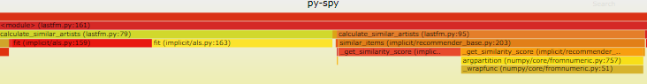
top实时查看每个函数运行时间并统计
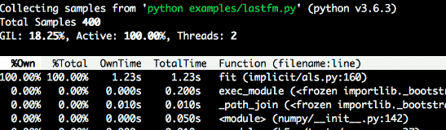
dump显示每个python线程的当前调用堆栈
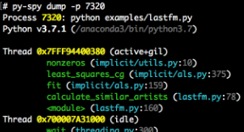
4. 使用py-spy调试MindSpore数据集加载
构造一个数据迭代很慢的场景
先上一个经典代码
test_dataset.py
import mindspore.dataset as ds
import numpy as np
import time
class DatasetGenerator:
def __init__(self):
pass
def __getitem__(self, item):
self.do_something()
return (np.array([item]),)
def do_something(self):
cnt = 0
for i in range(100000000):
cnt += 1
def __len__(self):
return 50
def test_generator_0():
data1 = ds.GeneratorDataset(DatasetGenerator(), ["data"])
start = time.time()
for item in data1.create_dict_iterator(num_epochs=1, output_numpy=True):
print("data time:", time.time() - start)
start = time.time()
虽然这个用例比较简单，但是确实会看到迭代的时候出数据很慢，运行一下可以看到
data time: 5.431891679763794
data time: 5.6114866733551025
data time: 5.38549542427063
data time: 5.577831268310547
基本上5秒才读出一条数据，50条数据就是250秒！这才50条数据，如果10w条呢，这个读取时间难以接受。
那么究竟问题出现在哪里呢？（虽然明眼能看到do_something这个函数有点问题，但是我们现在假装不知道）
我们需要py-spy帮我们定位一下问题。
使用py-spy的top功能查看调用栈和时间占比
我们重新运行一下这个脚本
python test_dataset.py &
注意我们允许的时候加了 & 使其可以在后台运行，同时返回一个pid，比如这样
我们得到了这个python的进程id 116079，有了这个pid之后，我们就可以利用py-spy给我们做实时分析了，接下来我们在命令行中输入
py-spy top --pid 116079
假如遇到这个提示
Permission Denied: Try running again with elevated permissions by going 'sudo env "PATH=$PATH" !!'
重新在命令行输入这个即可
sudo env "PATH=$PATH" !!
此时将会看到py-spy列出了调用栈及相关的函数用时占比：
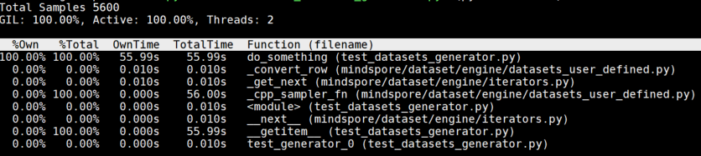
直观地从这个调用栈分析，do_something这个函数居然占用了100%的运行时间，运行超过了50+s，肯定有某些问题！或是处理逻辑太慢，或是写了死循环？
那么我们就可以快速来到代码的这里看看发生什么事了
def do_something(self):
cnt = 0
for i in range(100000000):
cnt += 1
天哪！这里居然有一个一亿次的循环加法，究竟是谁写的代码！（不是我） 我们可以通过优化这一部分代码，来提升整体数据处理的速度。
5. 总的来说
py-spy是一个挺方便的工具，帮助用户快速定位python的性能问题，除了top功能之外，py-spy也提供了dump功能把完整的堆栈写入到本地方便分析。当我们在 debug 一个线上正在运行的程序的时候，只需要提供进程id，py-spy就可以直接接入使用。

如何将自有数据高效的生成MindRecord格式数据集，并且防止爆内存
用户可以将自有数据转换成MindRecord数据集，然后使用MindDataset类进行加载并进一步进行预处理操作。
1. 生成MindRecord示例
生成图像类数据集 参考链接：转换CV类数据集
生成文本类数据集 参考链接：转换NLP类数据集
2. 多进程并发生成MindRecord示例
参考代码见附件1649685926954751897.rar
3. 生成MindRecord过程中可能遇到的问题
数据集太大，FileWriter.commit()的时候爆内存该怎么解决 答：可以组织一批数据之后，就调用 .write_raw_data(data_list)接口写入，再组织一批数据，再调用.write_raw_data(data_list2)，...，最后再调用.commit()完成。即：组织数据 -> write_raw_data(...) -> 组织数据 -> write_raw_data(...) -> ... -> commit()，具体参照 Step1 中示例。 参考链接：https://bbs.huaweicloud.com/forum/thread-145713-1-1.html

在使用Dataset处理数据过程中内存占用高，怎么优化
1. 背景说明
针对一些资源（CPU和Memory）比较紧张的环境，在进行数据预处理时会出现CPU占用过高，或者内存占用高的情况。
主要原因如下：
用户在使用mindspore.dataset进行数据集加载、预处理时，mindspore.dataset主要是使用Host侧CPU和Memory资源。
而Dataset的经典处理流程如下： **Dataset(...) -> .map(...) -> .map(...) -> .batch(...) -> .create_dict_iterator(...) 其中每个节点之间都有一个队列用来缓存数据（会占用内存），进而实现整个流程的Pipeline，另外部分参数的默认值（如：并行度高导致内存占用高）适用于服务器环境，所以对于CPU和Memory比较紧张的环境，需要通过配置、参数或者脚本优化来进一下的减少内存占用。
那么可以参考如下方法降低CPU/内存的占用。
2. 报错举例
日志报错输出 - LLVM ERROR: out of memory
参考链接：https://bbs.huaweicloud.com/forum/thread-152749-1-1.html
日志输出告警 - Memory consumption is more than ..., which may cause oom error. 参考链接：https://gitee.com/mindspore/mindspore/issues/I4JUOX
日志报错输出 - dataset/util/arena.cc ... cudaHostAlloc failed, ret[2], out of memory
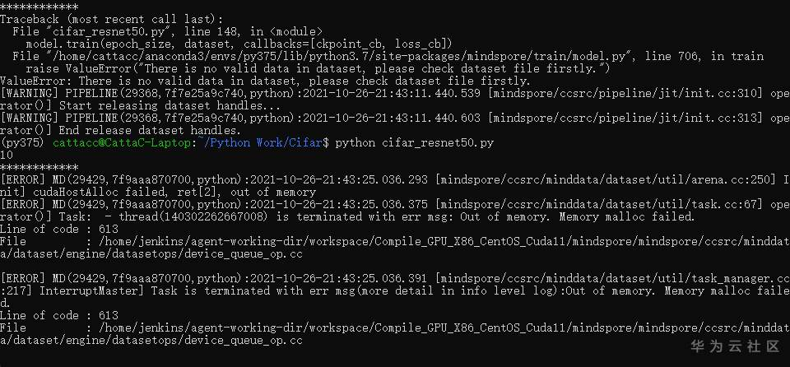
参考链接：https://bbs.huaweicloud.com/forum/thread-164821-1-1.html
3. 现有状态说明
以ImageNet数据集为例，其样本个数为128w+，典型的数据预处理流程如下：
import multiprocessing
import mindspore as ms
import mindspore.dataset as ds
from mindspore.communication.management import init, get_rank, get_group_size
dataset_path = &quot;/data2/ImageNet_Original/train&quot;
batch_size = 32
train_image_size = 224
data_set = ds.ImageFolderDataset(dataset_path, num_parallel_workers=12, shuffle=True)
mean = [0.485 * 255, 0.456 * 255, 0.406 * 255]
std = [0.229 * 255, 0.224 * 255, 0.225 * 255]
# define map operations
random_crop_decode_resize_op = ds.vision.c_transforms.RandomCropDecodeResize(train_image_size, scale=(0.08, 1.0), ratio=(0.75, 1.333)),
random_horizontal_flip_op = ds.vision.c_transforms.RandomHorizontalFlip(prob=0.5)
normalize_op = ds.vision.c_transforms.Normalize(mean=mean, std=std)
hwc2chw_op = ds.vision.c_transforms.HWC2CHW()
type_cast_op = ds.transforms.c_transforms.TypeCast(ms.int32)
data_set = data_set.map(operations=random_crop_decode_resize_op, input_columns=&quot;image&quot;, num_parallel_workers=12)
data_set = data_set.map(operations=random_horizontal_flip_op, input_columns=&quot;image&quot;, num_parallel_workers=12)
data_set = data_set.map(operations=normalize_op, input_columns=&quot;image&quot;, num_parallel_workers=12)
data_set = data_set.map(operations=hwc2chw_op, input_columns=&quot;image&quot;, num_parallel_workers=12)
data_set = data_set.map(operations=type_cast_op, input_columns=&quot;label&quot;, num_parallel_workers=12)
# apply batch operations
data_set = data_set.batch(batch_size, drop_remainder=True)
count = 0
for item in data_set.create_dict_iterator(output_numpy=True):
count += 1
if count % 1000 == 0:
print(&quot;count: {}&quot;.format(count))
机器配置如下：
CPU: Intel(R) Xeon(R) CPU E7-4890 v2 @ 2.80GHz ，核数：120 内存：250G
当前脚本运行后内存及cpu占用如下：
PID USER PR NI VIRT RES SHR S %CPU %MEM TIME+ COMMAND
xxxx xxx 20 0 11.0g 1.5g 66652 S 2993 0.6 19:43.85 python
3. 优化方法及效果
1) 通过配置预取大小减少内存占用
在定义数据集**Dataset对象前，设置Dataset数据处理预取的大小，ds.config.set_prefetch_size(2)。
脚本变化：
18d17
&lt;
27a27
&gt; ds.config.set_prefetch_size(2)
内存及CPU占用：
PID USER PR NI VIRT RES SHR S %CPU %MEM TIME+ COMMAND
xxxx xxx 20 0 10.9g 1.3g 67004 S 2483 0.5 23:37.22 python
2) 通过减少数据集加载类**Dataset参数num_parallel_workers减少内存占用
在定义**Dataset对象时，设置其参数num_parallel_workers为1。
脚本变化：
28c28
&lt; data_set = ds.ImageFolderDataset(dataset_path, num_parallel_workers=12, shuffle=True)
---
&gt; data_set = ds.ImageFolderDataset(dataset_path, num_parallel_workers=1, shuffle=True)
内存及CPU占用：
PID USER PR NI VIRT RES SHR S %CPU %MEM TIME+ COMMAND
xxxx xxx 20 0 9900300 1.0g 66652 S 1455 0.4 12:53.03 python
3) 通过减少数据预处理操作.map(...)参数num_parallel_workers减少内存占用
如果对**Dataset对象进一步使用了.map(...)操作，可以设置.map(...)的参数num_parallel_workers为1。
脚本变化：
40,44c40,44
&lt; data_set = data_set.map(operations=random_crop_decode_resize_op, input_columns=&quot;image&quot;, num_parallel_workers=12)
&lt; data_set = data_set.map(operations=random_horizontal_flip_op, input_columns=&quot;image&quot;, num_parallel_workers=12)
&lt; data_set = data_set.map(operations=normalize_op, input_columns=&quot;image&quot;, num_parallel_workers=12)
&lt; data_set = data_set.map(operations=hwc2chw_op, input_columns=&quot;image&quot;, num_parallel_workers=12)
&lt; data_set = data_set.map(operations=type_cast_op, input_columns=&quot;label&quot;, num_parallel_workers=12)
---
&gt; data_set = data_set.map(operations=random_crop_decode_resize_op, input_columns=&quot;image&quot;, num_parallel_workers=1)
&gt; data_set = data_set.map(operations=random_horizontal_flip_op, input_columns=&quot;image&quot;, num_parallel_workers=1)
&gt; data_set = data_set.map(operations=normalize_op, input_columns=&quot;image&quot;, num_parallel_workers=1)
&gt; data_set = data_set.map(operations=hwc2chw_op, input_columns=&quot;image&quot;, num_parallel_workers=1)
&gt; data_set = data_set.map(operations=type_cast_op, input_columns=&quot;label&quot;, num_parallel_workers=1)
内存及CPU占用：
PID USER PR NI VIRT RES SHR S %CPU %MEM TIME+ COMMAND
xxxx xxx 20 0 5845040 746140 66668 S 170.9 0.3 3:49.30 python
4) 通过减少数据batch操作.batch(...)参数num_parallel_workers减少内存占用
如果对**Dataset对象进一步使用了.batch(...)操作，可以设置.batch(...)的参数num_parallel_workers为1。
脚本变化：
47c47
&lt; data_set = data_set.batch(batch_size, drop_remainder=True)
---
&gt; data_set = data_set.batch(batch_size, drop_remainder=True, num_parallel_workers=1)
内存及CPU占用：
PID USER PR NI VIRT RES SHR S %CPU %MEM TIME+ COMMAND
xxxx xxx 20 0 5328916 496948 66652 S 187.4 0.2 3:25.25 python
5) 通过减少数据map操作.map(...)的个数来减少内存占用
如果有多个.map(...)操作，可以将多个.map(...)操作合并为一个。
脚本变化：
34,37c34,39
&lt; random_crop_decode_resize_op = ds.vision.c_transforms.RandomCropDecodeResize(train_image_size, scale=(0.08, 1.0), ratio=(0.75, 1.333)),
&lt; random_horizontal_flip_op = ds.vision.c_transforms.RandomHorizontalFlip(prob=0.5)
&lt; normalize_op = ds.vision.c_transforms.Normalize(mean=mean, std=std)
&lt; hwc2chw_op = ds.vision.c_transforms.HWC2CHW()
---
&gt; trans = [
&gt; ds.vision.c_transforms.RandomCropDecodeResize(train_image_size, scale=(0.08, 1.0), ratio=(0.75, 1.333)),
&gt; ds.vision.c_transforms.RandomHorizontalFlip(prob=0.5),
&gt; ds.vision.c_transforms.Normalize(mean=mean, std=std),
&gt; ds.vision.c_transforms.HWC2CHW()
&gt; ]
40,43c42
&lt; data_set = data_set.map(operations=random_crop_decode_resize_op, input_columns=&quot;image&quot;, num_parallel_workers=1)
&lt; data_set = data_set.map(operations=random_horizontal_flip_op, input_columns=&quot;image&quot;, num_parallel_workers=1)
&lt; data_set = data_set.map(operations=normalize_op, input_columns=&quot;image&quot;, num_parallel_workers=1)
&lt; data_set = data_set.map(operations=hwc2chw_op, input_columns=&quot;image&quot;, num_parallel_workers=1)
---
&gt; data_set = data_set.map(operations=trans, input_columns=&quot;image&quot;, num_parallel_workers=1)
内存及CPU占用：
PID USER PR NI VIRT RES SHR S %CPU %MEM TIME+ COMMAND
xxxx xxx 20 0 4665328 496364 66652 S 128.2 0.2 4:30.55 python
6) 通过减少数据shuffle操作.shuffle(...)的buffer_size大小来减少内存占用
如果有.shuffle(...)操作，减少buffer_size的大小，因为这个是内存缓存的shuffle，是需要缓存buffer_size大小样本在内存中进行shuffle，所以buffer_size越大，占用的内存也越大。
7) 通过减少数据.batch(...)参数batch_size的大小减少内存占用
如果有.batch(...)操作，减少batch_size的大小，可以减少batch操作缓存的数据量，尽而减少内存占用。
4. 总结
使用各种优化后内存、CPU占用如下：
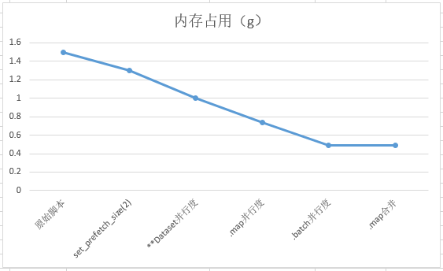
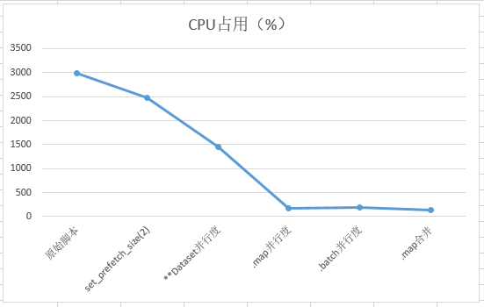

如何处理数据集加载多进程(multiprocessing)错误
1. 在MindSpore的数据集加载接口中，可以启动多进程模式加快数据处理速度，具体有2个API支持：
mindspore.dataset.GeneratorDataset
mindspore.dataset.GeneratorDataset(source, column_names=None, column_types=None, schema=None, num_samples=None, num_parallel_workers=1, shuffle=None, sampler=None, num_shards=None, shard_id=None, python_multiprocessing=True, max_rowsize=6)
mindspore.dataset.map
map(operations, input_columns=None, output_columns=None, column_order=None, num_parallel_workers=None, python_multiprocessing=False, cache=None, callbacks=None, max_rowsize=16, offload=None)
这两个API中，与多进程启动相关的参数是python_multiprocessing和max_rowsize。
python_multiprocessing决定是否启用多进程模式加快数据处理速度，而max_rowsize用于配置多进程模式下共享内存的大小，属于高级用法。
一般来说，只需要将python_multiprocessing设置为True在大多数情况下就可以适用。
2. 如果打开了多进程模式，可能会碰到以下的错误，这里总结了一些常见的错误和解决办法。
错误1：
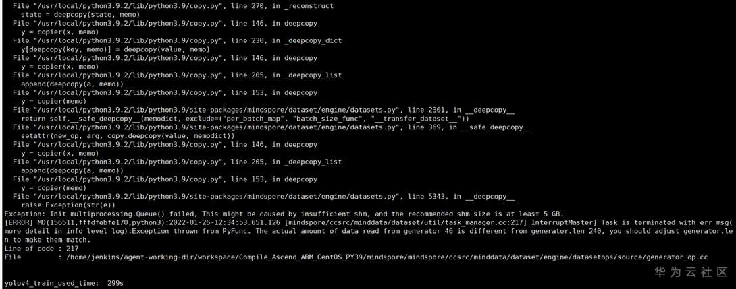
核心报错信息是 This might be caused by insufficient shm, and the recommended shm size is at least 5 GB.
原因：
系统可用的共享内存太小，可以通过 df -h 查看共享内存的大小，如下示例有500G的共享内存，妥妥的够用啦。
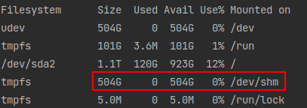
解决办法：
如果发现自身系统的 /dev/shm 不足5G，那确实会导致这个错误，有2个解决办法
关闭多进程模式，即设置python_multiprocessing=False。这样就会采用多线程模式进行加速，同样也会有一定的加速效果，也可以调节num_parallel_workers增加线程/进程数，以提高整体的数据处理效率。
申请更多的共享内存，可以参考博客上教程调整共享内存，如 https://blog.csdn.net/Sunny_Future/article/details/100569637
错误2：
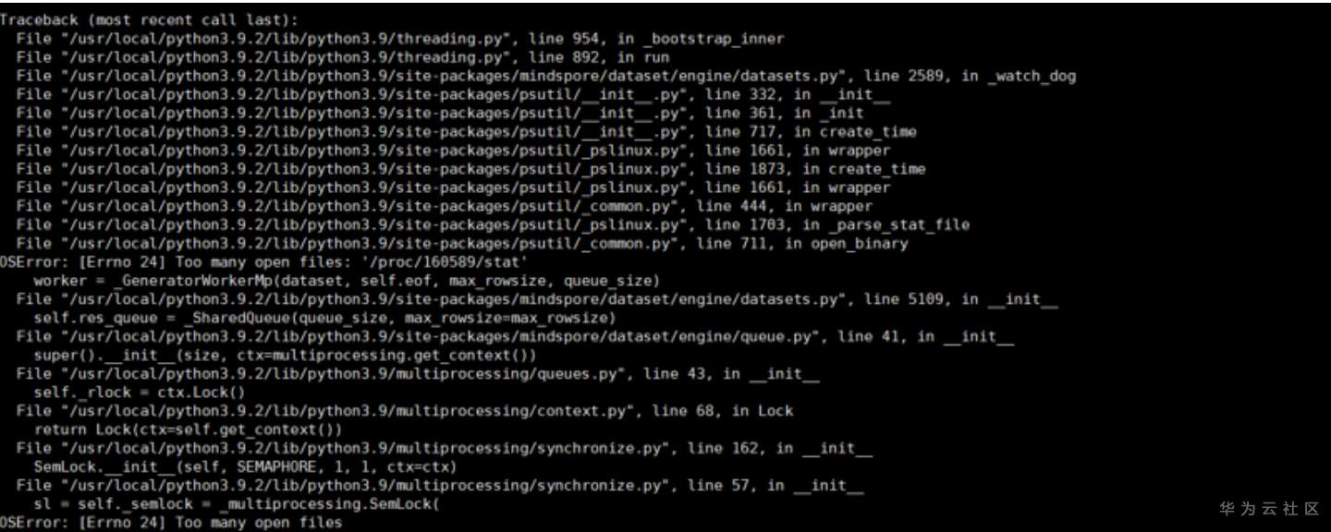
核心报错信息是 OSError: [Errno 24] Too many open files.
这个错误可能会在 非root用户 下使用 多进程模式 时触发
原因：
有几个可能的原因
如上一个错误所属，共享内存不足5G，导致无法使用。
如果发现/dev/shm超过5G，却还是这个错误，则可能是 非root用户可用资源的限制，可以通过 ulimit -a 查看非root用户可用资源
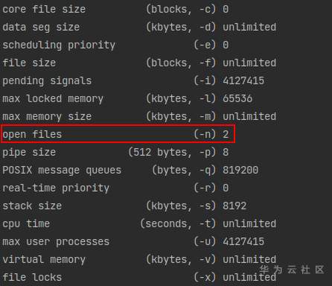
可以看到当前用户的可用 open files 数目只有2，这样很大程度就会抛出上述错误。
解决办法：
通过 ulimit -a 查看 open files 的数量，然后通过 ulimit -n 设置成较大的数值，如
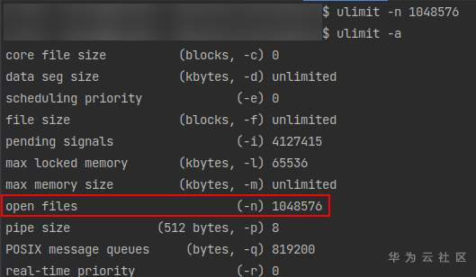
重新启动训练就可以啦。
错误3：
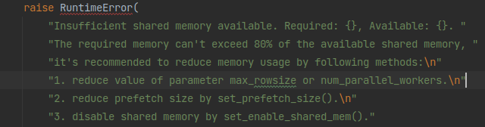
核心报错信息是 Insufficient shared memory available. Required: xxxxx, Available: xxxxx.
这个错误可能会在 共享内存不够/处理的数据块过大 时触发
3. 原因：
可能有其他进程也在使用共享内存，使用 df -h 查看 /dev/shm 当前的可用大小
当前正在处理的数据非常大，导致其占用了过多的共享内存，使得共享内存不够用了
4. 解决办法：
在允许的范围内，尽可能增大共享内存的大小，如 https://blog.csdn.net/Sunny_Future/article/details/100569637
检查数据处理时，是否正在处理过大的数据导致内存占用太多
通过 mindspore.dataset.config.set_prefetch_size() 减少数据管道中缓存的数据量
实在不行，通过 mindspore.dataset.config.set_enable_shared_mem(False) 关掉共享内存

MindRecord-Windows下中文路径问题Unexpected error. Failed to open file
1. MindRecord是MindSpore开发的一种高效数据格式。
此模块提供了一些方法帮助用户将不同数据集转换为MindRecord格式， 也提供了一些操作MindRecord数据文件的方法如读取、写入、检索等。 用户可以使用FileWriter API生成MindRecord格式数据集，并使用MindDataset API加载MindRecord格式数据集。
相关的API可以参考：mindspore.mindrecord
然而，在Windows平台上，且MindSpore版本 <= 1.5.0情况下，在MindRecord接口使用中文路径时，会出现如下错误：
RuntimeError: Unexpected error. Failed to open file, file path E:\大三上\深度学习\models-master\official\cv\ssd\MindRecord_COCO\test.mindrecord
File: mindspore\ccsrc\minddata\minrecord\meta\shard_header.cc
写入MindRecord的脚本：
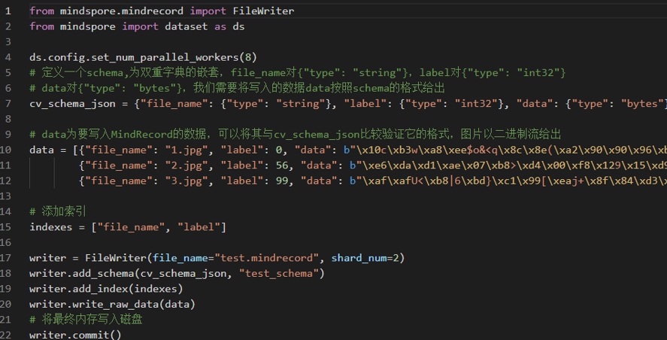
2. 运行错误：
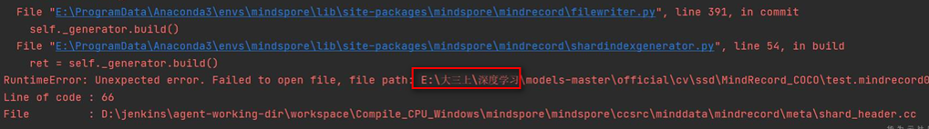
RuntimeError: Unexpected error. Failed to open file, file path E:\大三上\深度学习\models-master\official\cv\ssd\MindRecord_COCO\test.mindrecord
File: mindspore\ccsrc\minddata\minrecord\meta\shard_header.cc
3. 原因：
在MindSpore1.5.0以及之前版本，不支持Windows环境下MindSpore数据集格式在中文路径下的写入和读取。
4. 解决办法：
将MindRecord格式数据集的输出路径指定在纯英文路径下。
MindSpore升级到1.6.0之后版本。

MindRecord数据集格式-Windows下数据集报错Invalid file, DB file can not match
1. MindRecord是MindSpore开发的一种高效数据格式。
此模块提供了一些方法帮助用户将不同数据集转换为MindRecord格式， 也提供了一些操作MindRecord数据文件的方法如读取、写入、检索等。 用户可以使用FileWriter API生成MindRecord格式数据集，并使用MindDataset API加载MindRecord格式数据集。
相关的API可以参考：mindspore.mindrecord
在Windows平台上，且MindSpore版本 <= 1.4.0情况下，在生成MindRecord文件并将其移动位置（如MindRecord文件生成在A目录，再搬到B目录），会出现如下错误：
=========================>
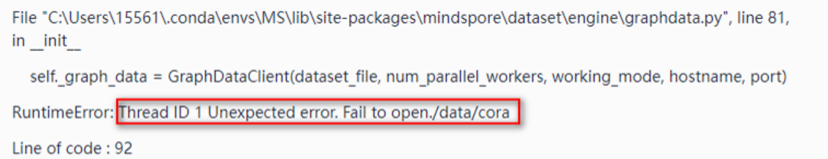
=========================>

由于MindSpore的版本差异，相同错误的错误信息可能不同，但一般就是这两种：
RuntimeError: Thread ID 1 Unexpected error. Fail to open ./data/cora
RuntimeError: Unexpected error. Invalid file, DB file can not match file
2. 原因分析：
MindSopore在windows下支持不完善，在MindSpore 1.4.0及之前版本，在Windows环境下生成MindRecord格式数据集文件，并且已经移动位置后，是不能被加载到MindSpore中使用的。但是新版本中已经解决了这个bug
3. 解决办法：
Windows环境下生成的MindRecord格式文件不要移动位置。
将MindSpore升级到1.5.0以及之后版本，重新生成MindRecord格式数据集。
4. 其他错误相关帖：
https://e.gitee.com/mind_spore/dashboard?issue=I49E80

数据集加载-GeneratorDataset卡住、卡死
MindSpore可以自定义Python数据源，通过迭代该数据源构造数据集。有点类似PyTorch的DataLoader。
相关的API可以参考：mindspore.dataset.GeneratorDataset
自定义GeneratorDataset处理数据集时，混用numpy.ndarray 和 mindspore.Tensor 的操作会出现卡死
GeneratorDataset接口自定义的数据集，脚本如下：
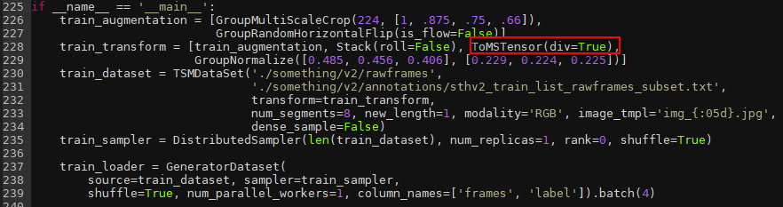
1. 原因分析：
猜测在自定义的数据处理中，存在numpy.ndarray -> mindspore.Tensor -> numpy.ndarray的混用过程，并且错误地使用numpy.array(Tensor)做转换，导致GIL锁得不到释放，GeneratorDataset不能正常工作。
打印堆栈分析后证明这个猜想，堆栈：
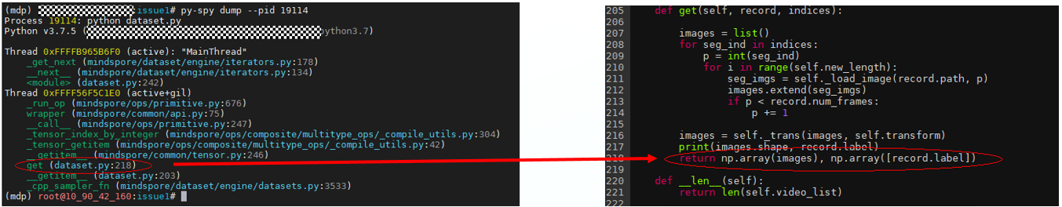
这个堆栈可以用py-spy这个工具获得，主要是为了看每一个进程目前运行的所在位置（神器啊！！！）
GeneratorDataset处理数据卡住问题，一般为竞争GIL导致的死锁问题，推荐使用 py-spy dump -pid {PID}来定位。
2. 解决办法：
在GeneratorDataset的第一个入参`source`的定义时，涉及到Python function中全部使用numpy.ndarray来替代Tensor
使用Tensor.asnumpy()方法替换numpy.array(Tensor)
对于这个问题，可以在代码的218行，把np.array(image)和np.array([record.label]) 换成 image.asnumpy()和record.label.asnumpy()
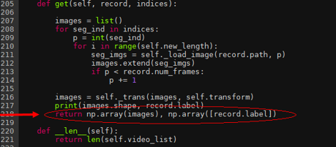

GeneratorDataset报错误Unexpected error. Invalid data type
1. MindSpore自定义Python数据源
通过迭代该数据源构造数据集。有点类似PyTorch的DataLoader。
相关的API可以参考：mindspore.dataset.GeneratorDataset
在ModelArt + GPU + MindSpore 1.2.0 环境下，使用GeneratorDataset接口加载自定义语音数据集，
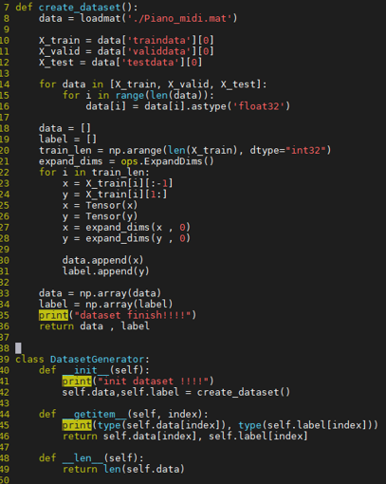
2. 报出如下错误：
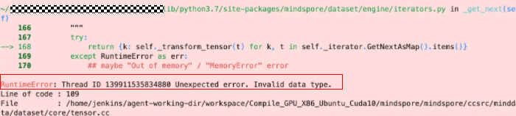
Unexpected error. Invalid data type.
Line of code : 109
File: /home/jenkins/agent-working-dir/workspace/Compile_GPU_x86_Ubuntu_Cuda10/mindspore/mindpore/ccsrc/mindata/dataset/core/tensor.cc
3. 原因分析：
问题出现的原因可能为，自定义的Datast 或map 操作中返回的是一个dict类型数据等，不是numpy array 或 numpy array 组成的元组（tuple）。因为其他类型（dict、object等）不是一个可控的数据类型同时也不明确其中的数据存储方式，因此报出Invalid type的错误。
4. 解决办法：
需要确认下自定义的数据处理部分是否返回了dict等，需要返回numpy array
或者检查一下自定义加载数据时，__getitem__ 函数需要返回值是 tuple，并且tuple的元素是 numpy类型。
这里给出一个例子，标注了几个重要的地方进行numpy 的转换，请确认相关位置的数据类型是否为numpy或tuple[numpy]
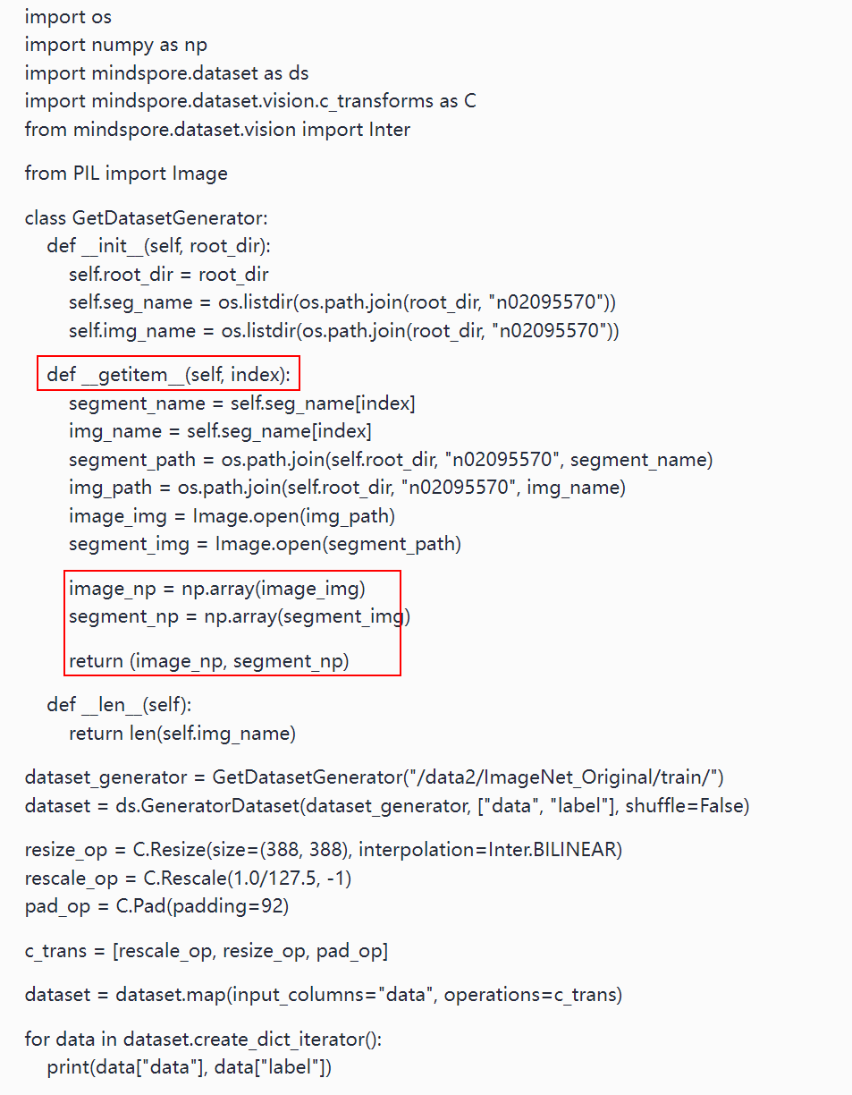
5. 其他错误相关帖：
https://gitee.com/mindspore/mindspore/issues/I4E08V

数据集加载-GeneratorDataset数据处理报错：The pointer[cnode] is null
MindSpore可以自定义Python数据源，通过迭代该数据源构造数据集。有点类似PyTorch的DataLoader。
1. 相关的API可以参考：mindspore.dataset.GeneratorDataset
在 MindSpore 1.5.0 + Pynative + GPU环境下，使用GeneratorDataset接口加载自定义集时，使用了网络算子或Tensor操作，比如下面这个就用了Tensor的slide操作
由于python不检查输入参数的类型，所以__call__函数的输入img在pynative模式下，会是一个Tensor类型的变量
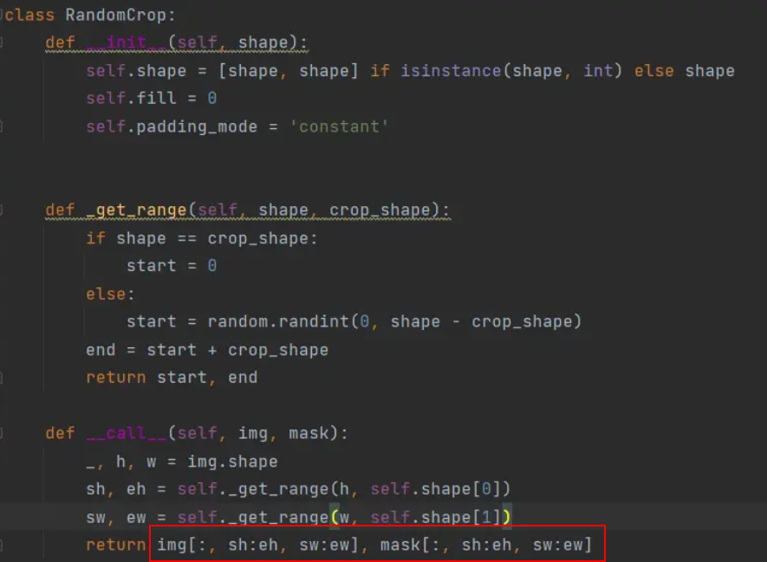
因此，如果将Tensor相关的操作放到数据集处理的map操作中，会报出如下错误：
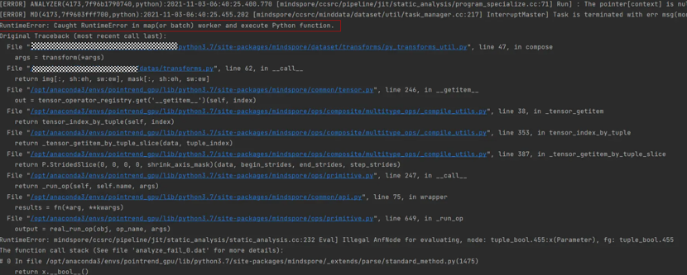
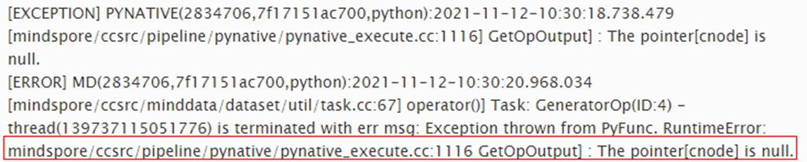
==================================================
Caught RuntimeError in map(or batch) worker and execute Python function
The pointer[cnode] is null
==================================================
2. 原因分析：
由于python不检查输入参数的类型，所以__call__函数的输入img在pynative模式下，会是一个Tensor类型的变量
Pynative模式时，__call__函数的输入img参数会是一个Tensor类型的变量，并且在__call__函数中，通过img[:, sh:eh, sw:ew]触发了Tensor的slice操作，会调用底层的算子进行执行。同时，由于数据集处理为并发执行，会启动多个线程/进程进行计算，而当前Tensor操作不支持并发执行，会引发一些异常。
3. 解决办法：
用户自定义的Pyfunc中，先把入参转为为Numpy类型，再通过Numpy相关操作实现相关功能。
即在__call__的第一行插入类型转换
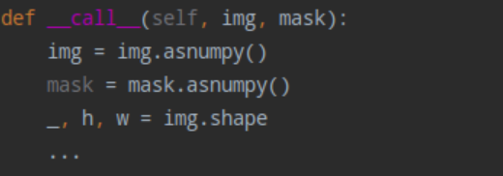
4. 其他错误相关帖：
https://gitee.com/mindspore/mindspore/issues/I4L06P
https://gitee.com/mindspore/mindspore/issues/I4GP4J

数据集报错【The data pipeline is not a tree】
使用MindSpore定义数据集的时候，有时候因为定义数据集过于复杂。
1. 出现了一个error
ValueError: The data pipeline is not a tree (i.e. one node has 2 consumers)
打开脚本一看，果然数据处理pipeline在定义上发生了分支，导致流水线无法确定分叉的走向：
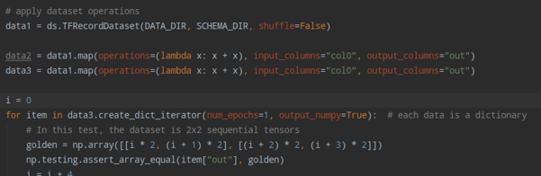
在这种情况相当于dataset1有两个消费节点dataset2, dataset3，如上面的代码所示：
dataset2 = dataset1.map(***)
dataset3 = dataset1.map(***)
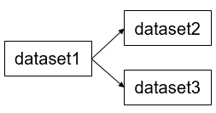
dataset定义上发生了分支，导致dataset1无法确定分叉的走向，究竟是走向dataset2，还是dataset3，所以这是错误的数据集定义方式
2. 解决办法：
通常保持同一个数据集名称，可以修改成如下
import mindspore.dataset as ds
import mindspore.dataset.vision.c_transforms as C
dataset1 = ds.TFRecordDataset(dataset_dir)
dataset1 = dataset1.map(operations=[C.Resize(256)], input_columns="image", num_parallel_workers=8)
dataset1 = dataset1.map(operations= C.CenterCrop, input_columns="image", num_parallel_workers=8)
一直保持同一个数据集名称即可解决

数据增强报错：Use Decode() for encoded data or ToPIL()
1. 使用GeneratorDataset进行数据加载
再基于map操作使用py_transforms做数据增强
关于py_transform: mindspore-dataset-vision-py-transforms
2. 报出了如下错误

TypeError: img should be PIL image. Got <class 'numpy.ndarray'>. Use Decode() for encoded data or ToPIL() for decoded data.
打开脚本分析一下：
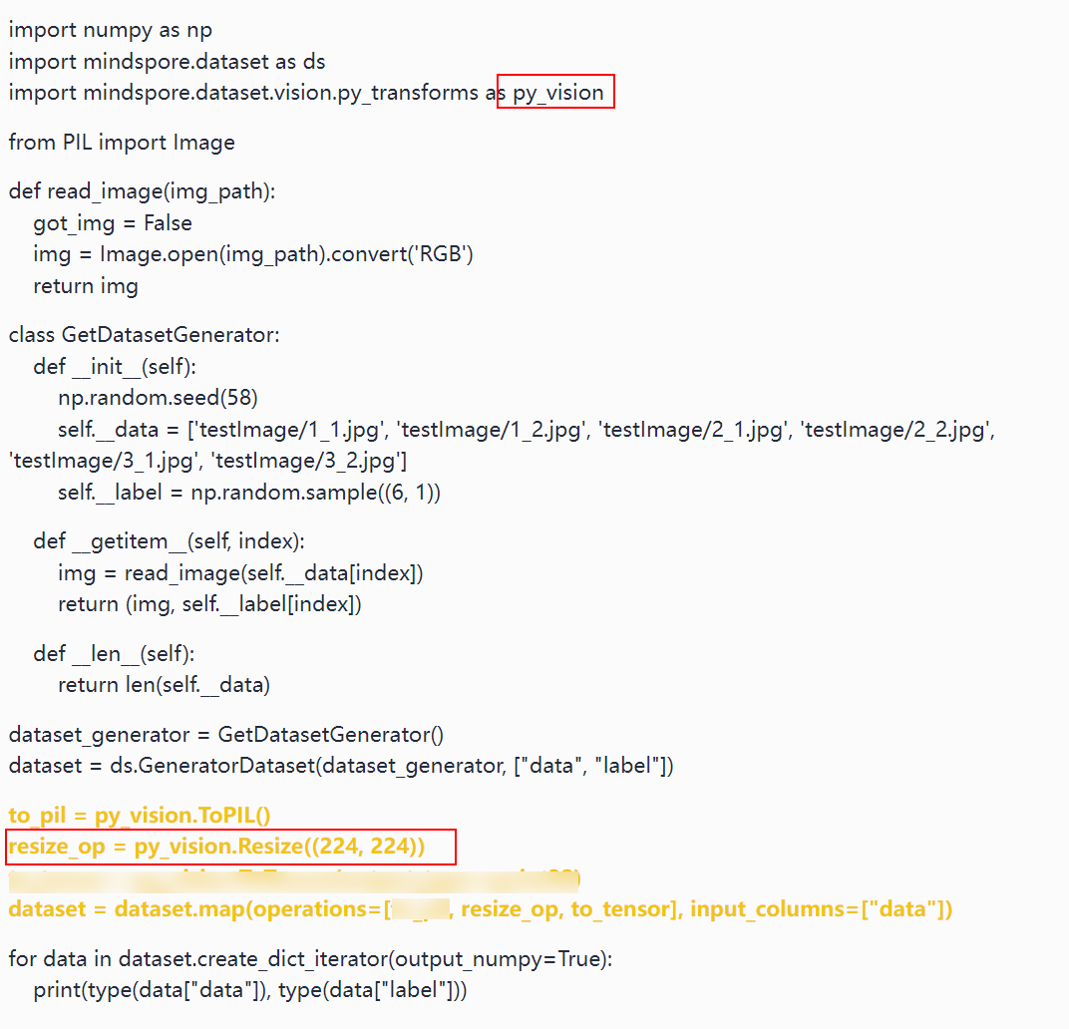
3. 原因分析
基于GeneratorDataset读取完数据，data 和 label字段转为numpy.ndarray，但是dataset.map中使用的resize_op，是py_transform的算子，py_transform的算子是基于PIL库实现的，其要求接收的数据类型为PIL.Image，因此对于输入的numpy类型数据，就会报出这个错误。
4. 解决办法
如果需要使用py_transforms算子进行处理的话，需要使用ToPIL算子转为PIL Image对象，然后才能Resize操作，并且在处理完后，也需要显示调用下 ToTensor转为Tensor。新增如下的to_pil操作即可
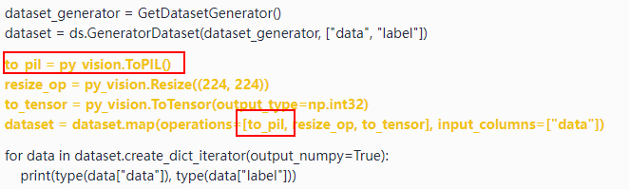

自定义数据增强报错args should be Numpy narray.Got<class tuple&gt
1. MindSpore自定义数据增强算子
切入到数据流水线中对数据进行处理
相关的API可以参考：mindspore.dataset.map
自定义函数写的不对的时候会出现这个错误：
Exception thrown from PyFunc. TypeError: args should be Numpy narray. Got <class 'tuple'>.
打开脚本分析一下：
自定义的Crop操作
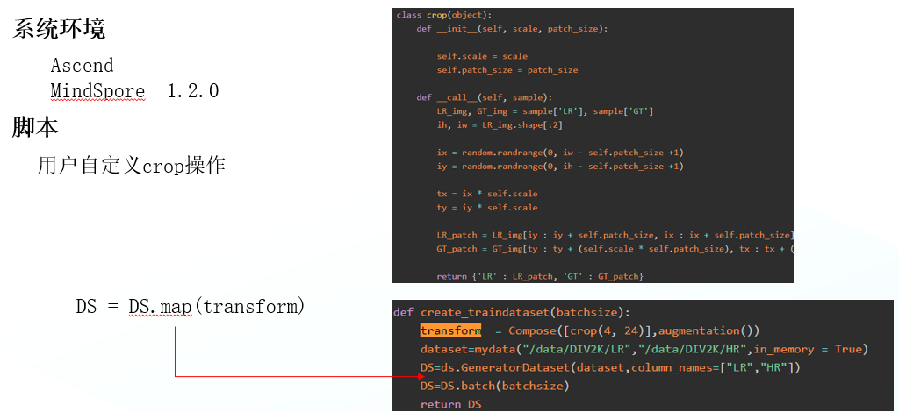
2. 原因分析
GeneratorDataset中存在两个数据列”LR”, “HR”，但是Crop类的__call__函数中除self外只有r入参sample，导致传入的数据类型转为tuple，与期望的numpy.ndarray不符合。
输入数据列（2个数据列）：
数据处理类的定义（仅接受单个数据列）：
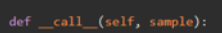
3. 解决办法
修改__call__的入参为个数，除self外入参个数需要与input_columns中的参数个数保持一致，忽略input_columns时默认为全部的数据列。
可以参考下面修改成__call__方法的入参数量，同时确保__call__方法返回的是numpy组成的tuple对象
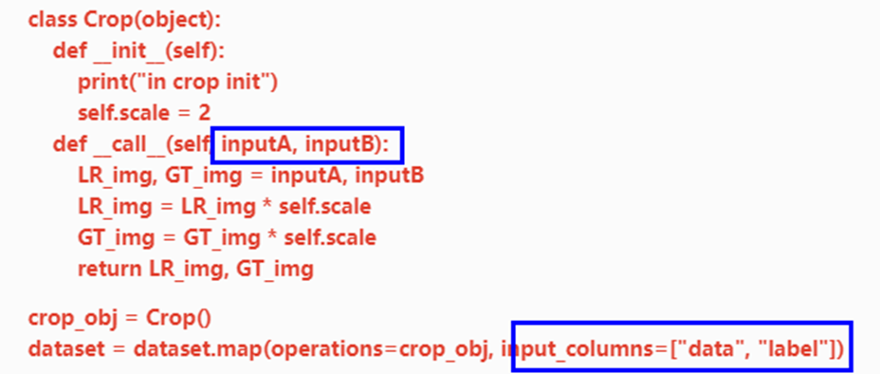

数据集加载-GeneratorDataset功能及常见问题
MindSpore支持用户通过自定义的方式构造输入的数据源，然后接入到MindData的流处理流程中，通过迭代该数据源获取数据集进行训练，有点类似PyTorch的DataLoader。
相关的API可以参考：mindspore.dataset.GeneratorDataset
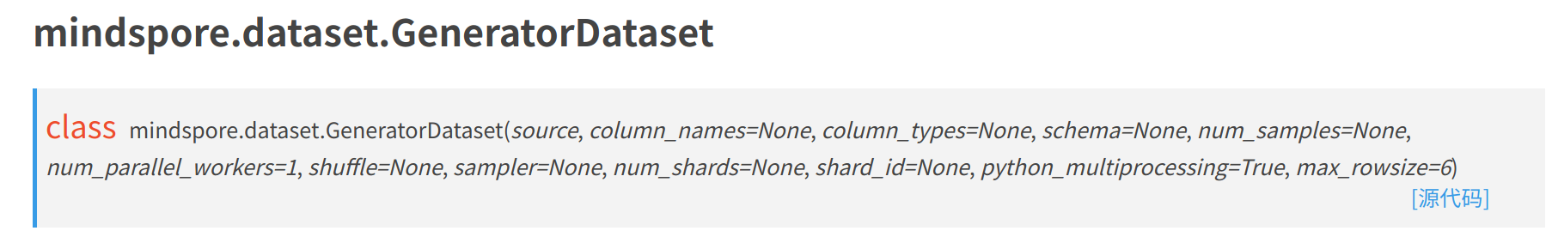
本文主要介绍GeneratorDataset的常用功能，用户常见的问题及解决方法。
###############################################
GeneratorDataset自定义数据集主要可以分为3类：
·可随机访问的自定义数据集
·生成器(python generator)式自定义数据集
·可迭代式的自定义数据集
###############################################
1. 构造可随机访问的数据集
先看一个例子
import numpy as np
import mindspore.dataset as ds
class DatasetGenerator:
def __init__(self):
self.data = [np.array([i]) for i in range(10)]
def __getitem__(self, item):
return self.data[item]
def __len__(self):
return 10
dataset = ds.GeneratorDataset(DatasetGenerator(), ["col1"])
for data in dataset.create_dict_iterator(output_numpy=True, num_epochs=1):
print(data["col1"])
可随机访问，意为数据集本身每一条数据都可以通过索引直接访问。因此构造的数据源本身是持有全量数据集的，如上述DatasetGenerator在__init__方法中自定义了。
常见问题1
错误代码：
class DatasetGenerator:
def __init__(self):
self.data = [np.array([i]) for i in range(10)]
def __getitem__(self, item):
return self.data[item]
错误提示：
RuntimeError: Attempt to construct a random access dataset, '__len__' method is required!
错误分析/修正方法： 错误提示缺少__len__方法，为什么需要这个方法呢？如上述所示，这是一个可随机访问的数据集，因此可以通过随机的索引访问任意数据，所以需要一个索引的范围来确定随机的范围，因此__len__方法是必须的。所以需要为DatasetGenerator加上此方法。
常见问题2
错误代码：
class DatasetGenerator:
def __init__(self):
self.data = [np.array([i]) for i in range(10)]
def __getitem__(self, item):
self.data["data"]
return self.data[item]
def __len__(self):
return 10
错误提示/修正方法：
RuntimeError: Exception thrown from PyFunc. TypeError: list indices must be integers or slices, not str
错误分析： 错误提示执行PyFunc的时候出错了（Exception thrown from PyFunc）。一般遇到这种错误，是因为出现了Python语法错误，MindSpore同时会在这句Error后附上抛出的Python异常，比如这里就是TypeError: list indices must be integers or slices, not str。遇到这种情况，第一时间先检查自定义的逻辑是否出现了语法错误，比如检查DatasetGenerator的__getitem__方法，发现对list的访问用了str下标，导致了一个python的异常。一般来说，可以直接定义这个类DatasetGenerator，单独调一下各个方法看是否出现了问题，快速排查。
常见问题3
错误代码：
class DatasetGenerator:
def __init__(self):
self.data = [np.array([i]) for i in range(10)]
def __getitem__(self, item):
return self.data[item]
def __len__(self):
return 10
dataset = ds.GeneratorDataset(DatasetGenerator(), ["col1", "col2"])
for data in dataset.create_dict_iterator(output_numpy=True, num_epochs=1):
print(data["col1"])
错误提示：
RuntimeError: Exception thrown from PyFunc. Invalid python function, the 'source' of 'GeneratorDataset' should return same number of NumPy arrays as specified in column_names, the size of column_names is:2 and number of returned NumPy array is:1
错误分析/修正方法： 错误提示size of column_names is:2 and number of returned NumPy array is:1。显然，2不等于1对吧，再对比一下代码，__getitem__返回的是1个元素，可是GeneratorDataset定义的input_columns参数却是["col1", "col2"]，显然这里会不匹配。
2. 生成器(python generator)式自定义数据集
先看一个例子
import numpy as np
import mindspore.dataset as ds
def my_generator(num):
for i in range(num):
yield np.array([i])
dataset = ds.GeneratorDataset(lambda: my_generator(10), ["col1"])
for data in dataset.create_dict_iterator(output_numpy=True, num_epochs=1):
print(data["col1"])
所谓生成器，就是指python generator。构造一个生成器传入到GeneratorDataset，MindSpore每次会从生成器中读取一条数据返回。请注意，此时shuffle是失效的，因为GeneratorDataset每次只能获取生成器的下一条数据，且不能知晓究竟有多少条数据，因此无法做到索引上的随机，上述例子无论运行多少遍输出顺序都是一样的。
常见问题1
错误代码：
def my_generator(num):
for i in range(num):
yield np.array([i])
dataset = ds.GeneratorDataset(my_generator(10), ["col1"])
print("get_dataset_size", dataset.get_dataset_size())
for data in dataset.create_dict_iterator(output_numpy=True, num_epochs=1):
print("mydata:", data["col1"])
错误提示： 不是ERROR，但会得到一个WARNING，同时发现mydata及相关的数据打印不出来
get_dataset_size 10
[WARNING] ME(24815:140518424966976,MainProcess):2022-06-10-11:38:11.314.445 [mindspore/dataset/engine/iterators.py:143] No records available.
错误分析/修正方法： python generator本身是特殊的，其本身的数据如果消耗完了，在对其进行访问，会一直得到StopIteration异常，而且不能重头开始生成。因此上述如果传入的是单一个generator实例，会导致其被消耗完了就没了，使得create_dict_iterator的时候再去访问generato会发现没有数据，从而打印出了这个warning。
修改方法： dataset = ds.GeneratorDataset(lambda: my_generator(10), ["col1"]) 构建一个lambda函数，每次都会生成一个新的generator，从而保证数据可以重新迭代。
3. 可迭代式的自定义数据集
先看一个例子
import numpy as np
import mindspore.dataset as ds
class IterableDataset:
def __init__(self):
self.count = 0
self.max = 10
def __iter__(self):
return self
def __next__(self):
if self.count >= self.max:
raise StopIteration
self.count += 1
return (np.array(self.count),)
dataset = ds.GeneratorDataset(IterableDataset(), ["col1"])
for data in dataset.create_dict_iterator(output_numpy=True, num_epochs=1):
print(data["col1"])
可迭代式的数据集，其实与上面的生成器式数据集的原理是一样的。只是一个是python generator，一个是iterable class，都可以通过nex()t方法迭代地获取数据。因此这里同样构造一个可迭代类传入到GeneratorDataset，MindSpore每次会从生成器中读取一条数据返回。请注意，此时shuffle是失效的，因为GeneratorDataset每次只能获取生成器的下一条数据，且不能知晓究竟有多少条数据，因此无法做到索引上的随机，上述例子无论运行多少遍输出顺序都是一样的。
常见问题1
错误代码：
class IterableDataset:
def __init__(self):
self.count = 0
self.max = 10
def __next__(self):
if self.count >= self.max:
raise StopIteration
self.count += 1
return (np.array(self.count),)
dataset = ds.GeneratorDataset(IterableDataset(), ["col1"])
for data in dataset.create_dict_iterator(output_numpy=True, num_epochs=1):
print(data["col1"])
错误提示：
TypeError: Input `source` function of GeneratorDataset should be callable, iterable or random accessible, commonly it should implement one of the method like yield, __getitem__ or __next__(__iter__).
错误分析/修正方法： 错误代码中构建的IterableDataset()其实是有类型缺失的。主要是缺少__getitem__方法或__iter__和__next__方法，从而无法判断此类是属于可随机访问数据的类，还是可迭代访问的类。由于缺失明显的类属性定义，MindSpore无法判断用户的预期行为是什么，具体可以参考这篇教程的样例进一步选择所需要的数据集类：https://www.mindspore.cn/tutorials/zh-CN/r1.7/advanced/dataset/custom.html。
常见问题2
错误代码：
class IterableDataset:
def __init__(self):
self.count = 0
self.max = 10
def __iter__(self):
return self
def __next__(self):
self.count += 1
return (np.array(self.count),)
dataset = ds.GeneratorDataset(IterableDataset(), ["col1"])
for data in dataset.create_dict_iterator(output_numpy=True, num_epochs=1):
print(data["col1"])
错误提示： 无错误提示，但是会发现数据集无限迭代，一直在打印
错误分析/修正方法： 可迭代式的数据集类不同于可随机访问数据集类的定义，其没有__len__属性，因此本身是不知道数据集到底迭代到什么时候应该结束。其也不同于python generator，也没有一个具体的数据内容范围信息。因此，想要在某个时间点/数据点结束此类的迭代，我们需要构造一些“异常”作为返回的信号。MindSpore可识别的结束信号，就是StopIteration，这个信号跟python generator的结束信号是一样的（比如一个python generator对象a，对a一直调用next(a)方法，当a数据消耗完了会抛出异常StopIteration）。因此StopIteration可以当成可迭代类数据集迭代结束的信号，从而结束返回。
修改方法： 在__next__方法中，设定一定的迭代次数条件，然后return StopIteration。

数据加载-【too many open files】错误
1. 使用GeneratorDataset加载自定义数据集
会根据num_parallel_workers来启动多线程或多线程来加载数据集，每个进程或者线程中都会尝试去打开数据集文件。
Linux一般默认允许同时打开的文件数为1024，当并发度过高 （num_parallel_workers）并且数据集文件较多，可能会导致出现 OSERROR: [Errno 24] Too many open files。
此时可以在shell环境上执行ulimit -n 65535来调整同时打开文件的阈值。
另外对Dataset对象进行“非常规”的操作，也有可能导致 Too many open files 错误。
1 import numpy as np
2 import mindspore.dataset as ds
3 import argparse
4 from mindspore import context
5 from datasets.online_adaptation_dataset import OnlineAdaptationDataset, OnlineAdaptationDatasetStorage
6
7 class MyAccessible:
8 def __init__(self):
9 self._data = np.random.sample((10, 2))
10 self._label = np.random.sample((10, 1))
11
12 def __getitem__(self, index):
13 return self._data[index], self._label[index]
14
15 def __len__(self):
16 return len(self._data)
17
18 class MyData:
19 def __init__(self, data):
20 self.data = data
21
22 def __getitem__(self, index):
23 return self.data.__getitem__(index)
24
25 if __name__ == '__main__':
26 parser = argparse.ArgumentParser(description='MindSpore LeNet Example')
27 parser.add_argument('--device_target', type=str, default="Ascend", choices=['Ascend', 'GPU', 'CPU'])
28
29 args = parser.parse_known_args()[0]
30 context.set_context(device_id=4, mode=context.PYNATIVE_MODE, device_target=args.device_target)
31 for i in range(10):
32 data = MyAccessible()
33 dataset = ds.GeneratorDataset(source=MyData(data), column_names=["data", "label"],num_parallel_workers=4, shuffle=True)
34 dataset = dataset.batch(batch_size=2)
35 import pdb;pdb.set_trace()
36 datas = iter(dataset)
37 print(next(datas))
38 datas = iter(dataset)
脚本中第36行使用iter()来创建迭代器对象后，在第37行中使用next(datas)读取迭代器中第一个元素，然后在第38行重复使用iter()来创建迭代器。
2. 原因分析
1. Mindspore提供了create_dict_iterator()和create_tuple_iterator()，分别返回dict迭代器和tuple迭代器，不建议直接使用iter()方法来生成迭代器。
create_dict_iterator()以及create_tuple_iterator()，可以设置num_epochs参数来控制迭代器的迭代次数，以及output_numpy参数来控制输出数据类型为numpy.ndarray或者Tensor。
2. 重复调用iter()会重复创建迭代器，而GeneratorDataset加载数据集时默认为多进程加载，每次打开的句柄在主进程停止前得不到释放，导致打开句柄数一直在增长。
3. 解决方法
第36行修改为
datas=dataset.create_tuple_iterator(num_epochs=1, output_numpy=True)
移除第38行

数据增强-【TypeError: Invalid with type】错误
用户在数据增强时会定义Python function来实现自定义的数据增强，其中在操作输入数据时必须要了解输入数据的类型才能实现正确的数据增强。
1. 尝试定义Python function实现裁剪图片四个角和中间
脚本如下：
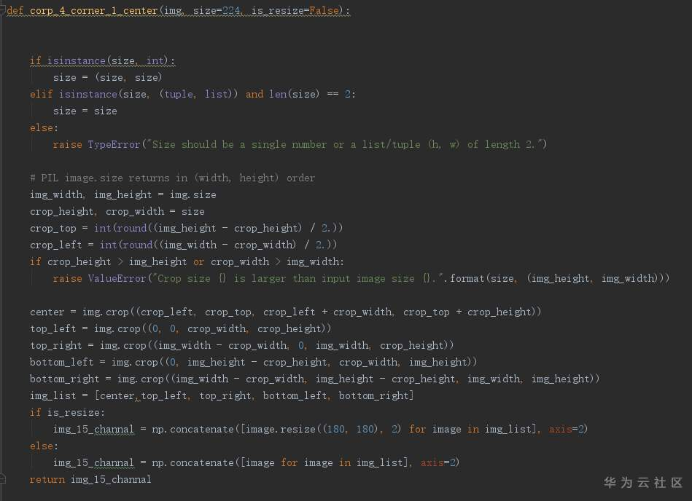
在py_transform基本上再调用自定义的数据增强，脚本如下：
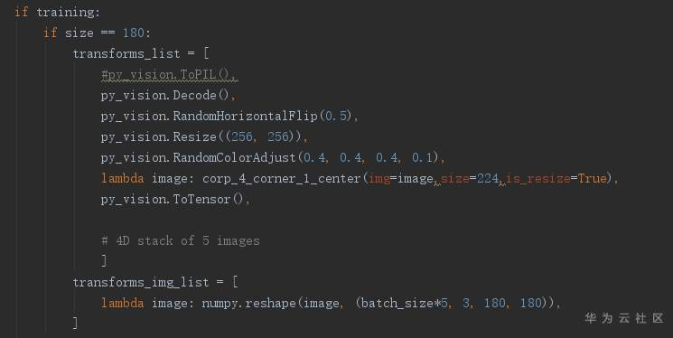
2. 报错如下
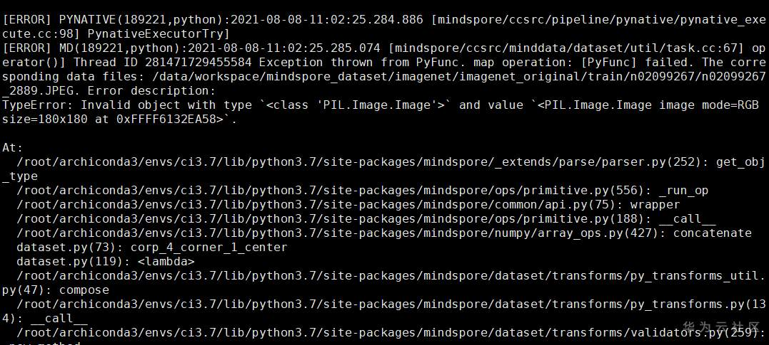
3. 原因分析
实际上报错信息中可以一步步定位出具体错误所在位置:1.PNG
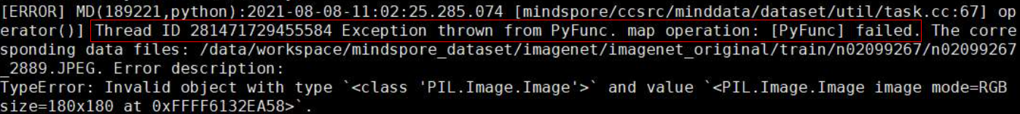
1. 错误发生位置在Map操作时传入的pyFunc，即自定义的Python数据增强函数。
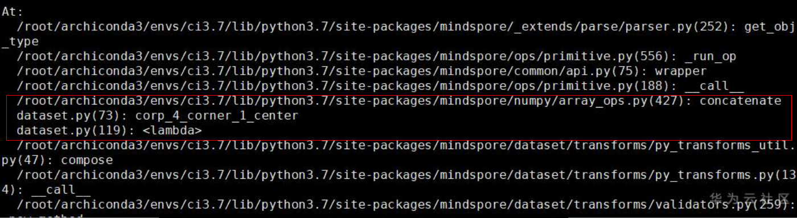
2. 查看Python的函数调用栈，错误发生在corp_4_corner_1_center 函数调用的np.concatenate函数中。
3. 查看numpy.concatenate函数的API，如下：
numpy.concatenate((a1, a2, ...), axis=0, out=None, dtype=None, casting="same_kind")
其中a1, a2均为numpy.array，除了在axis指示的维度，其他维度的shape必须一致。
可以得出报错原因为函数的函数为PIL.Image对象，与期望的Numpy array不符合。
4. 解决方法
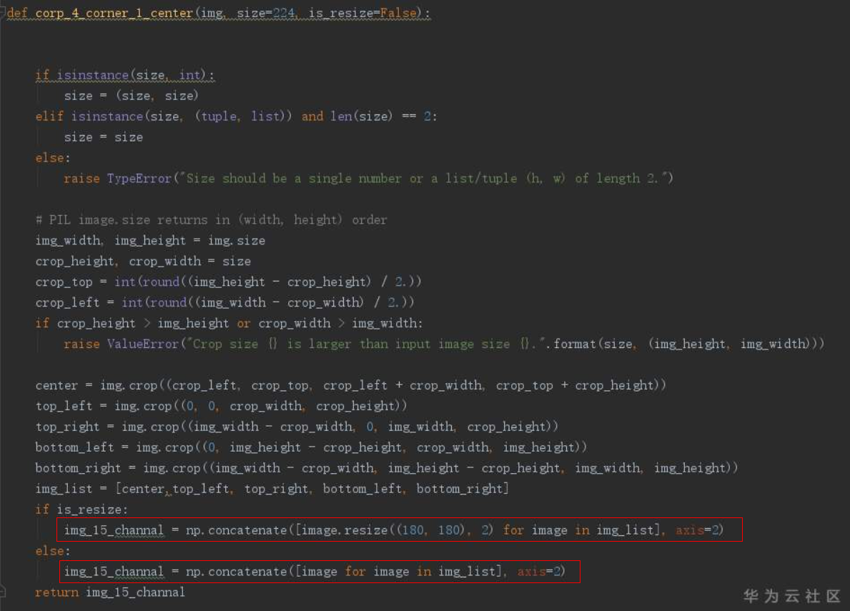
在np.concatenate函数前，将PIL.Image对象转为Numpy array。
5. 总结
1. 遇到报错时，阅读报错日志以及错误堆栈信息可以帮忙定位问题。
2. 调用第3方函数时，需要了解期望的入参的数据类型，不符合时需要做合适的转换。

数据集格式-【MindRecord File could not open successfully】错误
MindSpore数据集转换支持将CV、NLP类数据集、Cifar10\Cifar100, Imagenet公开数据集以及TFrecord格式数据集转换为MindSpore数据格式，可参考：MindSpore数据格式转换
在Ascend + Mindspore1.3上进行MindSpore数据格式转换
1. 脚本如下
1 from mindspore.mindrecord import FileWriter
2 data_record_path = './datasets/convert_dataset_to_mindrecord/data_to_mindrecord/test.mindrecord'
3 writer = FileWriter(file_name=data_record_path, shard_num=4)
4
5 # 定义schema
6 data_schema = {"file_name": {"type": "string"}, "label": {"type": "int32"}, "data": {"type": "bytes"}}
7 writer.add_schema(data_schema, "test_schema")
8
9 # 数据准备
10 file_name = "./datasets/convert_dataset_to_mindrecord/images/transform.jpg"
11 with open(file_name, "rb") as f:
12 bytes_data = f.read()
13 data = [{"file_name": "transform.jpg", "label": 1, "data": bytes_data}]
14
15 indexes = ["file_name", "label"]
16 writer.add_index(indexes)
17
18 # 数据写入
19 writer.write_raw_data(data)
20
21 # 生成本地数据
22 writer.commit()
出现如下报错信息：
MRMOpenError Traceback (most recent call last)
/tmp/ipykernel_108737/3747345416.py in <module>
17
18 # 数据写入
---> 19 writer.write_raw_data(data)
20
21 # 生成本地数据
/opt/nvme0n1/root/miniforge3/envs/mdp/lib/python3.7/site-packages/mindspore/mindrecord/filewriter.py in write_raw_data(self, raw_data, parallel_writer)
250 """
251 if not self._writer.is_open:
--> 252 self._writer.open(self._paths)
253 if not self._writer.get_shard_header():
254 self._writer.set_shard_header(self._header)
/opt/nvme0n1/root/miniforge3/envs/mdp/lib/python3.7/site-packages/mindspore/mindrecord/shardwriter.py in open(self, paths)
53 if ret != ms.MSRStatus.SUCCESS:
54 logger.error("Failed to open paths")
---> 55 raise MRMOpenError
56 self._is_open = True
57 return ret
MRMOpenError: [MRMOpenError]: MindRecord File could not open successfully.
2. 原因分析
MindSpore1.6.0版本之前，MindSpore格式数据集生成时不支持覆盖写，当输出目录下存在同名文件时，异常信息不能准确反应错误信息，此时需要查看日志信息。如下所示，日志中第2行提示输出目录下已经存在同名mindrecord文件，需要提前删除。
[ERROR] ME(108737:281473404131632,MainProcess):2022-04-11-17:39:33.512.803 [mindspore/mindrecord/shardwriter.py:54] Failed to open paths
[ERROR] MD(108737,ffffa2445930,python3.7):2022-04-11-17:39:33.512.713 [mindspore/ccsrc/minddata/mindrecord/io/shard_writer.cc:92] OpenDataFiles] MindRecord file already existed, please delete file: /opt/nvme0n1/l00475263/workspace/datasets/convert_dataset_to_mindrecord/data_to_mindrecord/test.mindrecord0
[ERROR] MD(108737,ffffa2445930,python3.7):2022-04-11-17:39:33.512.752 [mindspore/ccsrc/minddata/mindrecord/io/shard_writer.cc:167] Open] Open data files failed.
3. 解决办法
1. 代码中添加删除逻辑，保证每次输出前删除目录下的重名MindRecord文件。
2. MindSpore1.6.0之后版本，定义FileWriter对象时，可以加上overwrite=True来实现覆盖写。
代码中第3行修改为：
writer = FileWriter(file_name=data_record_path, shard_num=4, overwrite=True)

数据集加载-has no attribute child_sampler
Mindspore除了提供如下各类Sampler，也支持用户自定义Sampler进行自定义的采样操作，具体可以参考：自定义采样器
Mindspore会依据自定义Sampler中__iter__返回的索引值对样本进行采样。
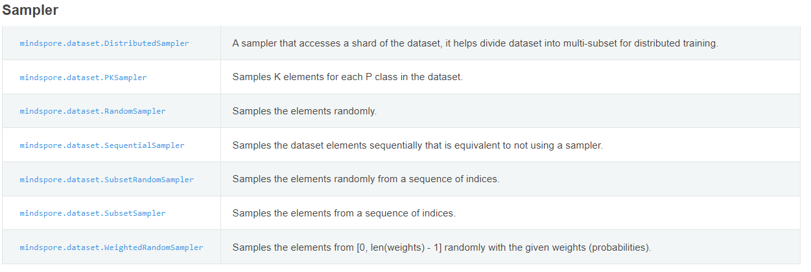
在CPU + MindSpore1.1.1进行定义
1. 自定义Sampler
1 class IdentitySampler(ds.Sampler):
2
3 """Sample person identities evenly in each batch.
4
5 Args:
6
7 train_color_label, train_thermal_label: labels of two modalities
8
9 color_pos, thermal_pos: positions of each identity
10
11 batchSize: batch size
12
13 """
14
15
16 def __init__(self, train_color_label, train_thermal_label, color_pos, thermal_pos, num_pos, batchSize, epoch):
17
18 uni_label = np.unique(train_color_label)
19
20 self.n_classes = len(uni_label)
21
22 N = np.maximum(len(train_color_label), len(train_thermal_label))
23
24 for j in range(int(N/(batchSize*num_pos))+1):
25
26 batch_idx = np.random.choice(uni_label, batchSize, replace = False)
27
28 for i in range(batchSize):
29
30 sample_color = np.random.choice(color_pos[batch_idx], num_pos)
31
32 sample_thermal = np.random.choice(thermal_pos[batch_idx], num_pos)
33
34 if j ==0 and i==0:
35
36 index1= sample_color
37
38 index2= sample_thermal
39
40 else:
41
42 index1 = np.hstack((index1, sample_color))
43
44 index2 = np.hstack((index2, sample_thermal))
45
46 self.index1 = index1
47
48 self.index2 = index2
49
50 self.N = N
51
52 self.num_samples = N
53
54 def __iter__(self):
55
56 # return iter(np.arange(len(self.index1)))
57
58 for i in range(len(self.index1)):
59
60 yield i
61
62 def __len__(self):
63
64 return self.N
在GeneratorDataset中使用自定义的Sampler，具体如下：
trainset = ds.GeneratorDataset(trainset_generator, ["color", "thermal","color_label", "thermal_label"], sampler=sampler).map(
operations=transform_train, input_columns=["color", "thermal"]
)
......
model = Model(net, loss_fn=criterion1, optimizer=optimizer_P, metrics=None)
model.train(1, trainset, callbacks=cb)
2. 出现如下报错信息
Traceback (most recent call last):
File "e:\PythonProject\DDAG_mindspore\train_ddag.py", line 284, in <module>
model.train(1, trainset, callbacks=cb)
File "D:\ProgramData\Anaconda3\envs\mindspore_cpu\lib\site-packages\mindspore\train\model.py", line
578, in train
dataset_size = train_dataset.get_dataset_size()
File "D:\ProgramData\Anaconda3\envs\mindspore_cpu\lib\site-packages\mindspore\dataset\engine\datasets.py", line 1455, in get_dataset_size
runtime_getter = self._init_size_getter()
File "D:\ProgramData\Anaconda3\envs\mindspore_cpu\lib\site-packages\mindspore\dataset\engine\datasets.py", line 1400, in _init_size_getter
ir_tree, api_tree = self.create_ir_tree()
File "D:\ProgramData\Anaconda3\envs\mindspore_cpu\lib\site-packages\mindspore\dataset\engine\datasets.py", line 157, in create_ir_tree
dataset = copy.deepcopy(self)
File "D:\ProgramData\Anaconda3\envs\mindspore_cpu\lib\copy.py", line 161, in deepcopy
y = copier(memo)
File "D:\ProgramData\Anaconda3\envs\mindspore_cpu\lib\site-packages\mindspore\dataset\engine\datasets.py", line 2367, in __deepcopy__
new_op.children = copy.deepcopy(self.children, memodict)
y = copier(x, memo)
File "D:\ProgramData\Anaconda3\envs\mindspore_cpu\lib\copy.py", line 215, in _deepcopy_list
append(deepcopy(a, memo))
File "D:\ProgramData\Anaconda3\envs\mindspore_cpu\lib\copy.py", line 161, in deepcopy
y = copier(memo)
File "D:\ProgramData\Anaconda3\envs\mindspore_cpu\lib\site-packages\mindspore\dataset\engine\datasets.py", line 3832, in __deepcopy__
sampler_instance = new_op.sampler.create()
File "D:\ProgramData\Anaconda3\envs\mindspore_cpu\lib\site-packages\mindspore\dataset\engine\samplers.py", line 90, in create
c_child_sampler = self.create_child()
File "D:\ProgramData\Anaconda3\envs\mindspore_cpu\lib\site-packages\mindspore\dataset\engine\samplers.py", line 102, in create_child
if self.child_sampler is not None:
AttributeError: 'IdentitySampler' object has no attribute 'child_sampler'
3. 原因分析
用户自定义的 IdentitySampler 虽然继承了父类 ds.sampler 但是在第16行的构造函数__init__中没有显式调用父类的构造函数，导致丢失父类中的 child_sampler 成员。
MindSpore中支持链式采样器，即多个采样器通过 child_sampler 串联起来形成一条链(chain)。
4. 解决办法
在自定义的 IdentitySampler 采样器中第17行 __init__ 中使用 super().__init__() 调用父类的构造函数。

数据集加载报错DictIterator has no attribute get_next
MindSpore中的Dataset调用create_dict_iterator()接口时，会拉起数据加载&处理的流水线，一些错误会在这个时间点发生。但是错误发生点可能不在这个接口本身，需要用户根据错误日志进一步分析来定位。
1. 介绍两类调用create_dict_iterator时发生的错误：
'DictIterator' has no attribute 'get_next'
1 #从测试集中取出一组样本，输入模型进行预测
2 test_ = ds_test.create_dict_iterator().get_next()
3 #利用key值选出样本
4 test = Tensor(test_['x'], mindspore.float32)
5
6 AttributeError: 'DictIterator' object has no attribute 'get_next'
2. 原因分析
create_dict_iterator()返回类型为DictIterator对象，其继承内部Iterator类，Iterator中通过实现__iter__()和__next__()两个内置函数实现迭代器协议。
1 class Iterator:
2 """
3 General Iterator over a dataset.
4
5 Attributes:
6 dataset: Dataset to be iterated over
7 """
8
9 def __init__(self, dataset, num_epochs=-1, output_numpy=False, do_copy=True):
10 ......
11
12 def __iter__(self):
13 return self
14
15 def __next__(self):
16 if not self._runtime_context:
17 logger.warning("Iterator does not have a running C++ pipeline." +
18 "It might because Iterator stop() had been called, or C++ pipeline crashed silently.")
19 raise RuntimeError("Iterator does not have a running C++ pipeline.")
20
21 data = self._get_next()
22 if not data:
23 if self.__index == 0:
24 logger.warning("No records available.")
25 if self.__ori_dataset.dataset_size is None:
26 self.__ori_dataset.dataset_size = self.__index
27 raise StopIteration
28 self.__index += 1
29
30 if self.offload_model is not None:
31 data = offload.apply_offload_iterators(data, self.offload_model)
32
33 return data
从Iterator定义可以看出，通过调用__next__方法可以取到下一条数据，第21行 data = self._get_next()表示实际取数据的实现定义子类DictIterator或者TupleIterator中_get_next()方法中。用户可以通过next(ds_test.create_dict_iterator()) 或者 for item in ds_test.create_dict_iterator(): 两种方式从迭代器中取下一条数据。
早期版本中get_next()为公开方法，通过ds_test.create_dict_iterator().get_next()可以取到下一个条dict类型的数据。
3. 解决办法
通过迭代器方式来获取处理后的数据。
1. next(ds_test.create_dict_iterator())
2. for item in ds_test.create_dict_iterator():
调用create_dict_iterator时报错无效的数据类型
用户使用GeneratorDataset来加载数据，并定义了如下：自定义的随机访问。
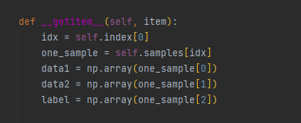
4. 报错信息如下
1 E:\anaconda\envs\mindspore\lib\site-packages\mindspore\dataset\engine\datasets.py:3533: VisibleDeprecationWarning: Creating an ndarray from ragged nested sequences (which is a list-or-tuple of lists-or-tuples-or ndarrays with different lengths or shapes) is deprecated. If you meant to do this, you must specify 'dtype=object' when creating the ndarray.
2 yield tuple([np.array(x, copy=False) for x in val])
3 Traceback (most recent call last):
4 File "C:/Users/wkml996/Desktop/hypertext/mindspore/project/main.py", line 18, in <module>
5 for data in train_iter.create_dict_iterator():
6 File "E:\anaconda\envs\mindspore\lib\site-packages\mindspore\dataset\engine\iterators.py", line 122, in __next__
7 data = self._get_next()
8 File "E:\anaconda\envs\mindspore\lib\site-packages\mindspore\dataset\engine\iterators.py", line 173, in _get_next
9 raise err
10 File "E:\anaconda\envs\mindspore\lib\site-packages\mindspore\dataset\engine\iterators.py", line 166, in _get_next
11 return {k: self._transform_tensor(t) for k, t in self._iterator.GetNextAsMap().items()}
12 RuntimeError: Unexpected error. Invalid data type.
13 Line of code : 114
14 File : D:\jenkins\agent-working-dir\workspace\Compile_CPU_Windows\mindspore\mindspore\ccsrc\minddata\dataset\core\tensor.cc
15
16 WARNING: Logging before InitGoogleLogging() is written to STDERR
17 [ERROR] MD(23788,2,?):2021-9-27 18:49:1 [mindspore\ccsrc\minddata\dataset\core\data_type.cc:159] FromNpArray] Cannot convert from numpy type. Unknown data type is returned!
18 [ERROR] MD(23788,2,?):2021-9-27 18:49:1 [mindspore\ccsrc\minddata\dataset\core\data_type.cc:159] FromNpArray] Cannot convert from numpy type. Unknown data type is returned!
19 [ERROR] MD(23788,2,?):2021-9-27 18:49:1 [mindspore\ccsrc\minddata\dataset\util\task_manager.cc:217] InterruptMaster] Task is terminated with err msg(more detail in info level log):Unexpected error. Invalid data type.
20 Line of code : 114
21 File : D:\jenkins\agent-working-dir\workspace\Compile_CPU_Windows\mindspore\mindspore\ccsrc\minddata\dataset\core\tensor.cc
22
23
24 进程已结束，退出代码为 1
~
~
5. 原因分析
错误信息第12行中提示"Invalid data type"，表示输入的Numpy array的dtype不符合预期，MindSpore支持输入dtype为int, float, str类型的Numpy array。
用户脚本中使用np.array()进行转换时，当输入数据为不同length或shape的list, tuple, ndarrays 组成的list或tuple时，输出的Numpy array的dtype为预期外的object类型，导致 MindSpore加载数据时出错。
比如： one_sample[0]为nd.array组成的list：one_sample[0] = [np.array([1,2]), np.array([1,2,3])]， 其中每个元素的dtype为int64，执行完np.array()转换后的data1的dtype为obejct类型，Mindspore在执行到Tensor的转换时抛出"Invalid data type"异常。
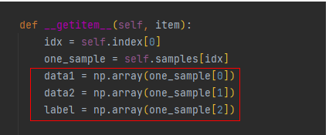
6. 解决方法
用户在脚本中调用np.array()将输入数据转为Numpy array后，需要进一步确认其数据类型。假设data1的dtype类型为object，需要在转换前保证每个元素的shape一致。

数据集加载报错-IndexError: list index out of range
MindSpore中用户使用GeneratorDataset来进行自定义数据集的加载，并支持多类输入源，用户可以定义yield生成器，迭代器以及使用魔术方法__getitem__的随机访问类。
详细可以参考：mindspore.dataset.GeneratorDataset
用户使用GeneratorDataset接口的大部分错误，主要集中在数据加载迭代器以及随机访问类中，下面会列举典型的几类错误：
1. 用户脚本
1 import mindspore.dataset as ds
2 import matplotlib.pyplot as plt
3 import mindspore.dataset.vision.py_transforms as py_trans
4 from mindspore.dataset.transforms.py_transforms import Compose
5 import mindspore.ops as ops
6 # from mindspore import Tensor
7
8 import numpy as np
9 from PIL import Image
10 import os
11 import random
12
13 from option import opt
14
15
16 class DatasetGenerator:
17 def __init__(self, path, train, format='.png'):
18 # self.size = size
19 self.format = format
20 self.train = train
21 if train:
22 self.haze_imgs_dir = os.listdir(os.path.join(path, 'train', 'hazy'))
23 self.haze_imgs = [os.path.join(path, 'train', 'hazy', img) for img in self.haze_imgs_dir]
24 self.clear_dir = os.path.join(path, 'train', 'gt')
25 else:
26 self.haze_imgs_dir = os.listdir(os.path.join(path, 'test', 'hazy'))
27 self.haze_imgs = [os.path.join(path, 'test', 'hazy', img) for img in self.haze_imgs_dir]
28 self.clear_dir = os.path.join(path, 'test', 'gt')
29 # print(self.haze_imgs_dir, self.clear_dir)
30
31 np.random.seed(58)
32 self.__random_seed = []
33 for _ in range(len(self.haze_imgs)):
34 self.__random_seed.append(random.randint(0, 1000000))
35 self.__index = -1
36
37 def __getitem__(self, index):
38 self.__index += 1
39
40 haze = Image.open(self.haze_imgs[index])
41 # if isinstance(self.size,int):
42 # while haze.size[0]<self.size or haze.size[1]<self.size :
43 # index=random.randint(0,20000)
44 # haze=Image.open(self.haze_imgs[index])
45 img = self.haze_imgs[index].split('\\')[-1]
46 # img=self.haze_imgs[index].split('/')[-1]
47 img_name = img.split('_')
48 # img_name=img.split('\\')[-1].split('_')
49 # print(img_name)
50 clear_name=f"{img_name[0]}_gt_{img_name[2]}"
51 # print(self.clear_dir, clear_name, os.path.join(self.clear_dir,clear_name))
52 clear=Image.open(os.path.join(self.clear_dir,clear_name))
53
54 w, h = clear.size
55 nw, nh = haze.size
56 left = (w - nw)/2
57 top = (h - nh)/2
58 right = (w + nw)/2
59 bottom = (h + nh)/2
60 clear = clear.crop((left, top, right, bottom))
61
62 return (haze, clear, index)
63
64 def __len__(self):
65 print(len(self.haze_imgs))
66 return len(self.haze_imgs)
67
68 def get_seed(self):
69 seed = self.__random_seed[self.__index]
70 return seed
71
72 def decode(img):
73 return Image.fromarray(img)
74
75 def set_random_seed(img_name, seed):
76 random.seed(seed)
77 return img_name
78
79 ds.config.set_seed(8)
80 # DATA_DIR = opt.data_url
81 DATA_DIR = 'C:\\Users\\44753\\Desktop\\NTIRE2021'
82
83 train_dataset_generator = DatasetGenerator(DATA_DIR, train=True)
84 train_dataset = ds.GeneratorDataset(train_dataset_generator, ["hazy", "gt", "img_name"], shuffle=True)
85 test_dataset_generator = DatasetGenerator(DATA_DIR, train=False)
86 test_dataset = ds.GeneratorDataset(test_dataset_generator, ["hazy", "gt", "img_name"], shuffle=False)
87
88 transforms_list = [
89 decode,
90 (lambda img_name: set_random_seed(img_name, train_dataset_generator.get_seed())),
91 py_trans.RandomCrop(opt.crop_size),
92 py_trans.ToTensor(),
93 ]
94 compose_trans = Compose(transforms_list)
95 train_dataset = train_dataset.map(operations=compose_trans, input_columns=["hazy"])
96 train_dataset = train_dataset.map(operations=compose_trans, input_columns=["gt"])
97 train_dataset = train_dataset.batch(opt.bs, drop_remainder=True)
98
99 if __name__ == '__main__':
100 for i in range(2):
101 print(i)
102 for batch in train_dataset.create_dict_iterator():
103 # print(batch)
104 # hazy = Tensor(batch["hazy"], dtype=mindspore.float32)
105 # clear = Tensor(batch["gt"], dtype=mindspore.float32)
106
107 print(batch["hazy"].shape, batch["gt"].shape)
2. 报错信息如下
可以看出数据第一轮可以正常迭代，第二轮出现IndexError: list index out of range 错误。
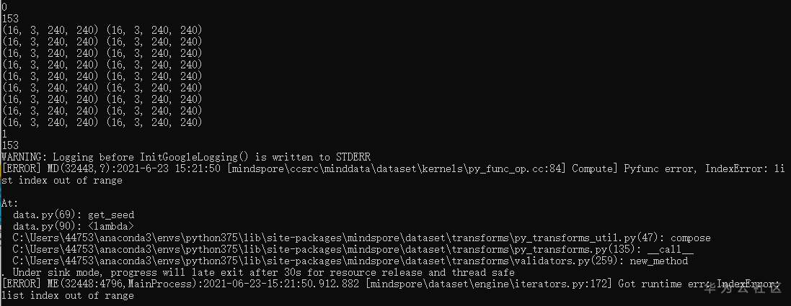
3. 原因分析
用户脚本中第37行利用魔术方法 def __getitem__(self, index)定义了随机访问的类，其中index参数作为样本\元素索引，外部可以直接使用index来进行数据的访问，外部不需要对其进行修改（如：每个迭代开始前的复位操作），而用代码第35行户另外自定义了__index，需要用户在每个迭代前进行复位操作，来保证不出现数组越界访问。
4. 解决方法
移除非必要的__index成员变量，或者在每次迭代前对__index赋值为0进行复位操作。

数据增强后，内存不足，自动退出
1. 报错描述
1.1 系统环境
ardware Environment(Ascend/GPU/CPU): Ascend Software Environment: – MindSpore version (source or binary): 1.6.0 – Python version (e.g., Python 3.7.5): 3.7.6 – OS platform and distribution (e.g., Linux Ubuntu 16.04): Ubuntu 4.15.0-74-generic – GCC/Compiler version (if compiled from source):
1.2 基本信息
1.2.1脚本
yolov4使用mosaic进行数据增强。 https://gitee.com/mindspore/models/tree/master/official/cv/yolov4
1.2.2报错
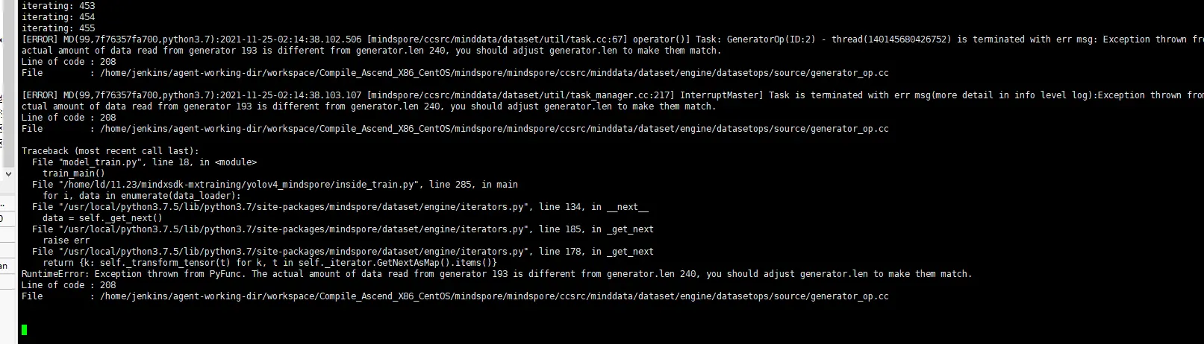
此报错信息不是导致退出的直接原因，可在日志中查看到有警告提示：“Memory consumption is more than...”，根据警告提示定位到是由于内存不足导致程序退出。
2. 原因分析
batch算子会实时监控内存占用率，mindspore在1.6.版本之前，内存占用率达到0.95时会告警退出。目前在minspore==1.6.0后版本已对该阈值进行更新，在内存占用超过0.8时会进行告警，用户可在发现内存不足之后及时进行处理。
3. 解决方法
用户在使用mindspore框架进行大数据训练时，需要多注意内存占用率，防止内存占用过高导致直接退出。当出现内存占用警告提示时，应该减少per_batch_map里面的内存占用。

报错RuntimeError: Invalid data, Page size
1. 报错描述
1.1 系统环境
ardware Environment(Ascend/GPU/CPU): CPU Software Environment: – MindSpore version (source or binary): 1.6.0 – Python version (e.g., Python 3.7.5): 3.7.6 – OS platform and distribution (e.g., Linux Ubuntu 16.04): Ubuntu 4.15.0-74-generic – GCC/Compiler version (if compiled from source):
1.2 基本信息
1.2.1脚本
此案例将自定义数据集转化成MindSpore Record数据格式。
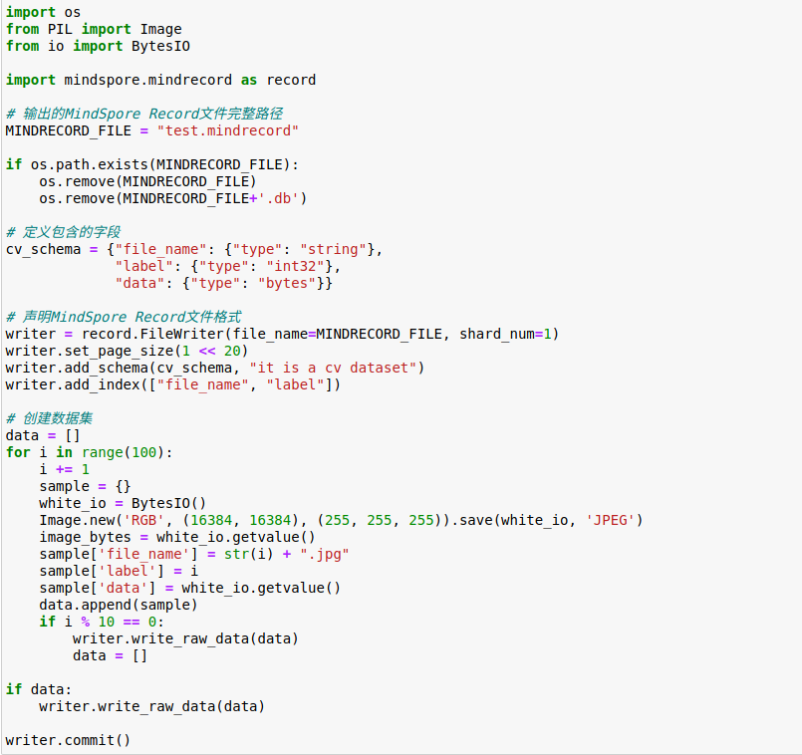
1.2.2报错
RuntimeError: Syntax error. Invalid data, Page size: 1048576 is too small to save a blob row. Please try to use the mindrecord api 'set_page_size' to enable 64MB page size. Line of code : 1153
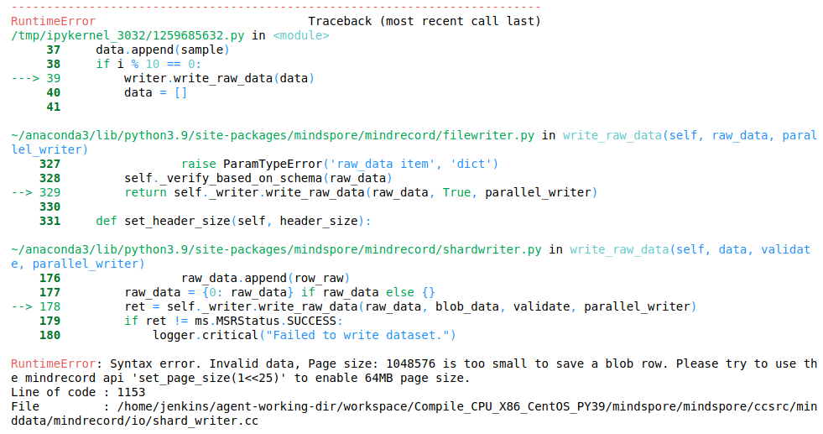
2. 原因分析
根据报错信息提示，Pagesize设置太小导致无法读取那么多数据。
3. 解决方法
参考提供的set_page_size API,将pagesize设置大一点。 图片.png
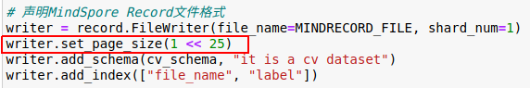
4. 总结
1.设置表示存储数据的区域的页面的大小，这些区域分为两种类型:row page和blob page。页面越大，可以存储的数据就越多。 2.不设置pagesize的时候，默认可储存样本大小为32MB，如果样本的大小大于默认大小，用户需要调用API来设置适当的大小。 3.pagesize可调节范围在321024(32KB)至2561024*1024(256MB)。
5. 参考文档
mindspore文档->API->mindspore.mindrecord->set_page_size
https://mindspore.cn/docs/zh-CN/r1.7/api_python/mindspore.mindrecord.html#mindspore.mindrecord.FileWriter.set_page_size

报错TypeError: parse() missing 1 required positional.
1. 报错描述
1.1 系统环境
ardware Environment(Ascend/GPU/CPU): CPU Software Environment: – MindSpore version (source or binary): 1.6.0 – Python version (e.g., Python 3.7.5): 3.7.6 – OS platform and distribution (e.g., Linux Ubuntu 16.04): Ubuntu 4.15.0-74-generic – GCC/Compiler version (if compiled from source):
1.2 基本信息
1.2.1脚本
此案例使用mindspore.dataset自定义数据集：
import os
import numpy as np
from PIL import Image
import mindspore.common.dtype as mstype
import mindspore.dataset as ds
import mindspore.dataset.transforms.c_transforms as C
import mindspore.dataset.vision.c_transforms as vc
class _dcp_Dataset:
def __init__(self,img_root_dir,device_target="CPU"):
if not os.path.exists(img_root_dir):
raise RuntimeError(f"the input image dir {img_root_dir} is invalid")
self.img_root_dir=img_root_dir
self.img_names=[i for i in os.listdir(img_root_dir) if i.endswith(".jpg")]
self.target=device_target
def __len__(self):
return len(self.img_names)
def __getitem__(self, index):
img_name=self.img_names[index]
im=Image.open(os.path.join(self.img_root_dir,img_name))
image=np.array(im)
label_str=img_name.split("_")[-1]
label_str=label_str.split(".")[0]
label=np.array(label_str)
return image,label
def creat_dataset(dataset_path,batch_size=2,num_shards=1,shard_id=0,device_target="CPU"):
dataset=_dcp_Dataset(dataset_path,device_target)
data_set=ds.GeneratorDataset(dataset,["image","label"],shuffle=True,num_shards=1,shard_id=0)
image_trans=[
vc.Resize((224,224)),
vc.RandomHorizontalFlip(),
vc.Rescale(1/255,shift=0),
vc.Normalize((0.4465, 0.4822, 0.4914), (0.2010, 0.1994, 0.2023)),
vc.HWC2CHW
]
label_trans=[C.TypeCast(mstype.int32)]
data_set=data_set.map(operations=image_trans,input_columns=["image"])
data_set=data_set.map(operations=label_trans,input_columns=["label"])
# data_set=data_set.shuffle(buffer_size=batch_size)
data_set=data_set.batch(batch_size=batch_size,drop_remainder=True)
# data_set=data_set.repeat(1)
return data_set
if __name__ == '__main__':
data=creat_dataset("./image_DCP")
print(data)
data_loader = data.create_dict_iterator()
for i, data in enumerate(data_loader):
print(i)
print(data)
1.2.2报错
报错信息：
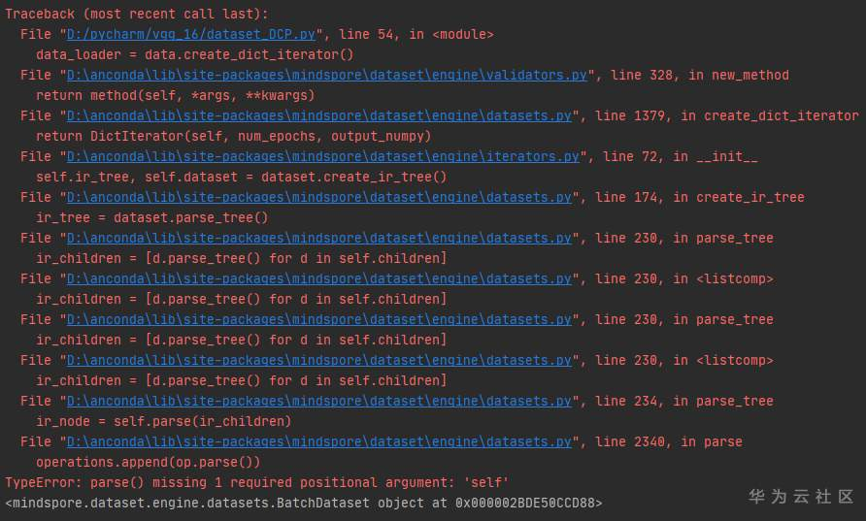
2. 原因分析以及解决办法
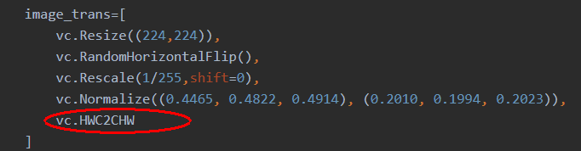
此处缺少(),将此处代码改为 vc.HWC2CHW() 可正常执行。
3. 总结
定位问题的步骤
例如：有 xxDataset -> map -> map -> batch 这样的数据处理流程。 可以按如下方式调试脚本：
只保留 xxDataset，然后运行下脚本，查看是否报错；
保留 xxDataset -> map，然后运行下脚本，查看是否报错；
保留 xxDataset -> map -> map，然后运行下脚本，查看是否报错；
保留 xxDataset -> map -> map -> batch，然后运行下脚本，查看是否报错；
按照上述的方法，可定位到是哪个map/batch出错了。

MindSpore报错RuntimeError: Exception thrown from PyFunc.
1. 报错描述
1.1 系统环境
ardware Environment(Ascend/GPU/CPU): CPU Software
Environment: – MindSpore version (source or binary): 1.6.0
Python version (e.g., Python 3.7.5): 3.7.6
OS platform and distribution (e.g., Linux Ubuntu 16.04): Ubuntu 4.15.0-74-generic – GCC/Compiler version (if compiled from source):
1.2 基本信息
1.2.1脚本
此案例使用自定义可迭代数据集进行训练，在训练过程中，第一个epoch数据正常迭代，第二个epoch就会报错，自定义数据代码如下：
import numpy as np
import mindspore.dataset as ds
from tqdm import tqdm
class IterDatasetGenerator:
def __init__(self, datax, datay, classes_per_it, num_samples, iterations):
self.__iterations = iterations
self.__data = datax
self.__labels = datay
self.__iter = 0
self.classes_per_it = classes_per_it
self.sample_per_class = num_samples
self.classes, self.counts = np.unique(self.__labels, return_counts=True)
self.idxs = range(len(self.__labels))
self.indexes = np.empty((len(self.classes), max(self.counts)), dtype=int) * np.nan
self.numel_per_class = np.zeros_like(self.classes)
for idx, label in tqdm(enumerate(self.__labels)):
label_idx = np.argwhere(self.classes == label).item()
self.indexes[label_idx, np.where(np.isnan(self.indexes[label_idx]))[0][0]] = idx
self.numel_per_class[label_idx] = int(self.numel_per_class[label_idx]) + 1
def __next__(self):
spc = self.sample_per_class
cpi = self.classes_per_it
if self.__iter >= self.__iterations:
raise StopIteration
else:
batch_size = spc * cpi
batch = np.random.randint(low=batch_size, high=10 * batch_size, size=(batch_size), dtype=np.int64)
c_idxs = np.random.permutation(len(self.classes))[:cpi]
for i, c in enumerate(self.classes[c_idxs]):
index = i*spc
ci = [c_i for c_i in range(len(self.classes)) if self.classes[c_i] == c][0]
label_idx = list(range(len(self.classes)))[ci]
sample_idxs = np.random.permutation(int(self.numel_per_class[label_idx]))[:spc]
ind = 0
for i in sample_idxs:
batch[index+ind] = self.indexes[label_idx]
ind = ind + 1
batch = batch[np.random.permutation(len(batch))]
data_x = []
data_y = []
for b in batch:
data_x.append(self.__data)
data_y.append(self.__labels)
self.__iter += 1
item = (data_x, data_y)
return item
def __iter__(self):
return self
def __len__(self):
return self.__iterations
np.random.seed(58)
data1 = np.random.sample((500,2))
data2 = np.random.sample((500,1))
dataset_generator = IterDatasetGenerator(data1,data2,5,10,10)
dataset = ds.GeneratorDataset(dataset_generator,["data","label"],shuffle=False)
epochs=3
for epoch in range(epochs):
for data in dataset.create_dict_iterator():
print("success")
1.2.2报错
报错信息：
RuntimeError: Exception thrown from PyFunc. Unable to fetch data from GeneratorDataset, try iterate the source function of GeneratorDataset or check value of num_epochs when create iterator.
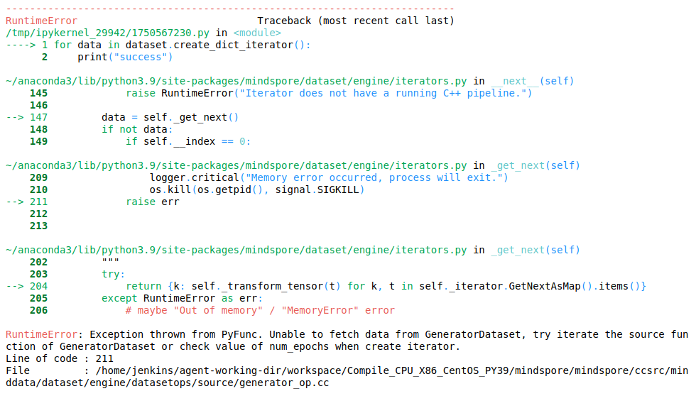
2. 原因分析
每次数据迭代的过程中，self.__iter会累加，第二个epoch的预取时，self.__iter已经累计到设置好的iterations的值，导致self.__iter >= self.__iterations，循环结束。
3. 解决方法
在def iter(self)：中加入清零操作，设置self.__iter = 0
import numpy as np
import mindspore.dataset as ds
from tqdm import tqdm
class IterDatasetGenerator:
def __init__(self, datax, datay, classes_per_it, num_samples, iterations):
self.__iterations = iterations
self.__data = datax
self.__labels = datay
self.__iter = 0
self.classes_per_it = classes_per_it
self.sample_per_class = num_samples
self.classes, self.counts = np.unique(self.__labels, return_counts=True)
self.idxs = range(len(self.__labels))
self.indexes = np.empty((len(self.classes), max(self.counts)), dtype=int) * np.nan
self.numel_per_class = np.zeros_like(self.classes)
for idx, label in tqdm(enumerate(self.__labels)):
label_idx = np.argwhere(self.classes == label).item()
self.indexes[label_idx, np.where(np.isnan(self.indexes[label_idx]))[0][0]] = idx
self.numel_per_class[label_idx] = int(self.numel_per_class[label_idx]) + 1
def __next__(self):
spc = self.sample_per_class
cpi = self.classes_per_it
if self.__iter >= self.__iterations:
raise StopIteration
else:
batch_size = spc * cpi
batch = np.random.randint(low=batch_size, high=10 * batch_size, size=(batch_size), dtype=np.int64)
c_idxs = np.random.permutation(len(self.classes))[:cpi]
for i, c in enumerate(self.classes[c_idxs]):
index = i*spc
ci = [c_i for c_i in range(len(self.classes)) if self.classes[c_i] == c][0]
label_idx = list(range(len(self.classes)))[ci]
sample_idxs = np.random.permutation(int(self.numel_per_class[label_idx]))[:spc]
ind = 0
for i in sample_idxs:
batch[index+ind] = self.indexes[label_idx]
ind = ind + 1
batch = batch[np.random.permutation(len(batch))]
data_x = []
data_y = []
for b in batch:
data_x.append(self.__data)
data_y.append(self.__labels)
self.__iter += 1
item = (data_x, data_y)
return item
def __iter__(self):
self.__iter = 0
return self
def __len__(self):
return self.__iterations
np.random.seed(58)
data1 = np.random.sample((500,2))
data2 = np.random.sample((500,1))
dataset_generator = IterDatasetGenerator(data1,data2,5,10,10)
dataset = ds.GeneratorDataset(dataset_generator,["data","label"],shuffle=False)
epochs=3
for epoch in range(epochs):
for data in dataset.create_dict_iterator():
print("success")
此时执行成功,输出如下：
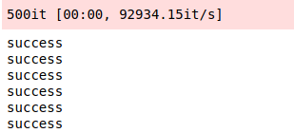
4. 类似问题
在mindspore1.3.0中，用户自定义训练，使用Generator dataset迭代数据报错。错误截图如下： 图片.png 此报错中，dataset 的 len 函数返回值是36，但是真实的 next 返回的数据量只有35条，导致报错，可将返回值改为小于35的数进行快速验证。
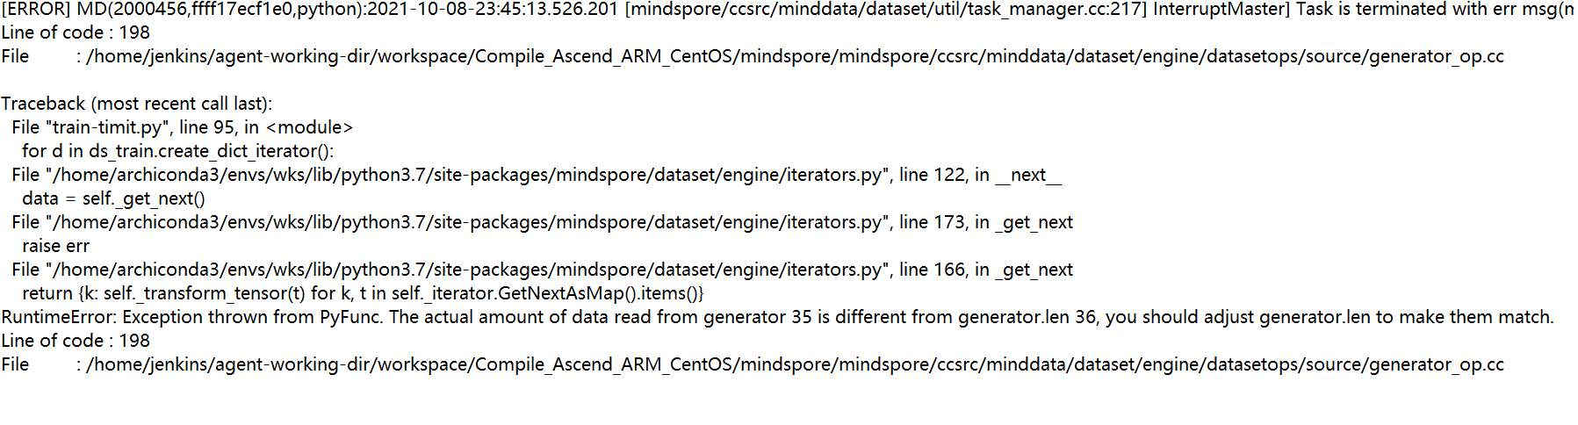
5. 总结
5.1 定位报错问题的步骤
1、找到报错的用户代码行：for data in dataset.create_dict_iterator():； 2、根据报错信息提示，无法从GeneratorDataset获取数据，检查是否在自定义数据的时候就出现问题。打印运行中的过程数据，发现第一个epoch数据读取完后，真实读取的数据条数与__len__是相等的，没有问题。但由于没有清零操作，在第二个epoch预取时self.__iter >= self.__iterations，循环结束，导致第二个epoch取不到数据报错。
5.2 此类问题分析
此类问题的根本原因是需要获取的数据索引与数据量对不上，在构造可迭代的的数据集类时需要注意每次运行后数据清零的问题，在快速验证时，也需要满足索引小于数据总量的条件。
6. 参考文档
mindspore文档->数据管道->数据加载->自定义数据集加载->构造可迭代的数据集类 https://www.mindspore.cn/doc/programming_guide/zh-CN/r1.1/dataset_loading.html#id7

报错GeneratorDataset num_workers=8, this value is ...
1. 报错描述
1.1 系统环境
Hardware Environment(Ascend/GPU/CPU): CPU Software Environment: – MindSpore version (source or binary): 1.2.0 – Python version (e.g., Python 3.7.5): 3.7.5 – OS platform and distribution (e.g., Linux Ubuntu 16.04): Ubuntu 4.15.0-74-generic – GCC/Compiler version (if compiled from source):
1.2 基本信息
1.2.1脚本
此案例运行官网的线型函数拟合示例，此前已成功安装mindspore。
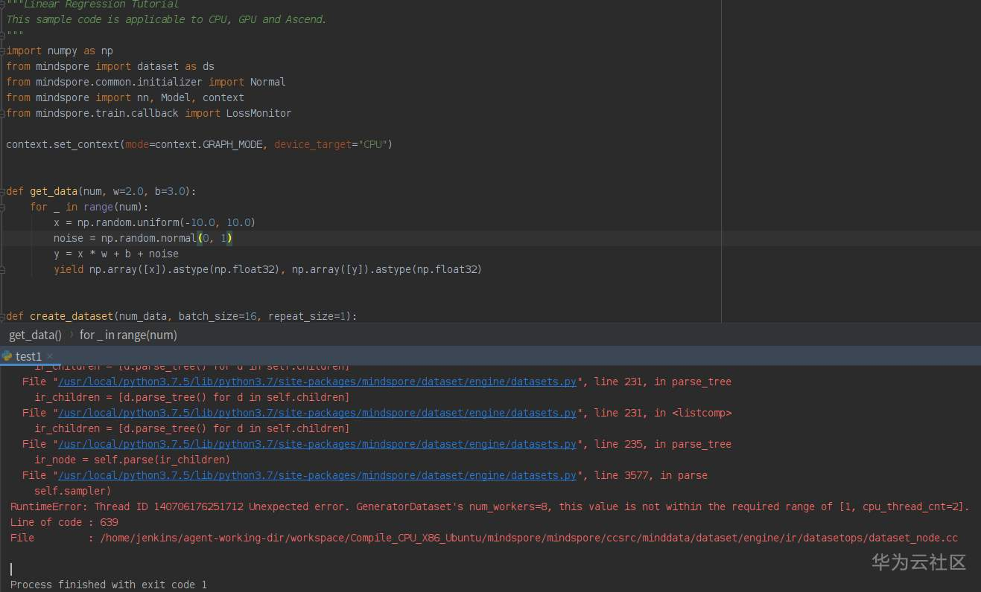
1.2.2报错
报错信息：
RuntimeError: Thread ID 140706176251712 Unexpected error. GeneratorDataset's num_workers=8, this value is not within the required range of [1, cpu_thread_cnt=2]. Line of code : 639 File : /home/jenkins/agent-working-dir/workspace/Compile_CPU_X86_Ubuntu/mindspore/mindspore/ccsrc/minddata/dataset/engine/ir/datasetops/dataset_node.cc
2. 原因分析
用户在运行时CPU的核数少于dataset模块生成数据时默认使用的核数的数量，mindspore在1.2.0中没有为硬件中CPU的核数进行自适应配置，当pc的配置不高时需要手动对CPU核数进行配置。
3. 解决方法
1.添加代码手动配置CPU核数： ds.config.set_num_parallel_workers(2) 2.使用更高版本的mindspore,目前的mindspore--1.6.0会根据硬件中CPU的核数自适应配置，避免出现cpu核数过低导致报错。
4. 总结
1.可根据报错信息的提示进行问题定位，此案例为CPU核数问题，可在官网教程与开源的MindSpore文档中搜寻设置CPU核数的方法。 2.目前MindSpore提供了一种自动数据调优的工具——Dataset AutoTune，用于在训练过程中根据环境资源的情况自动调整数据处理管道的并行度，此过程中会自动检测硬件中CPU的核数进行自适应配置。 3.MindSpore中config模块能够设置或获取数据处理的全局配置参数。
5. 参考文档
https://www.mindspore.cn/docs/zh-CN/r1.7/api_python/mindspore.dataset.config.html

报错RuntimeError: Exception thrown from PyFunc.
1. 报错描述
1.1 系统环境
ardware Environment(Ascend/GPU/CPU): CPU Software Environment: – MindSpore version (source or binary): 1.7.0 – Python version (e.g., Python 3.7.5): 3.7.6 – OS platform and distribution (e.g., Linux Ubuntu 16.04): Windows-10-10.0.19041-SP0 – GCC/Compiler version (if compiled from source):
1.2 基本信息
1.2.1脚本
此案例为创建一个做超分辨率的数据集，使用mindspore.dataset.GeneratorDataset接口实现自定义方式的进行数据集加载。
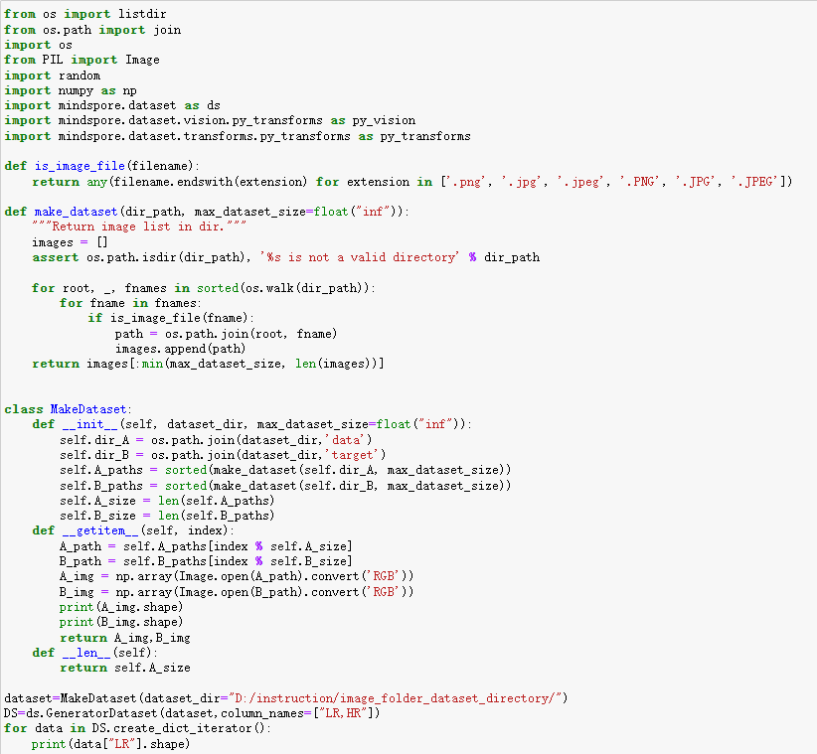
1.2.2报错
报错信息：
RuntimeError: Exception thrown from PyFunc. Invalid python function, the 'source' of 'GeneratorDataset' should return same number of NumPy arrays as specified in column_names, the size of column_names is:1 and number of returned NumPy array is:2
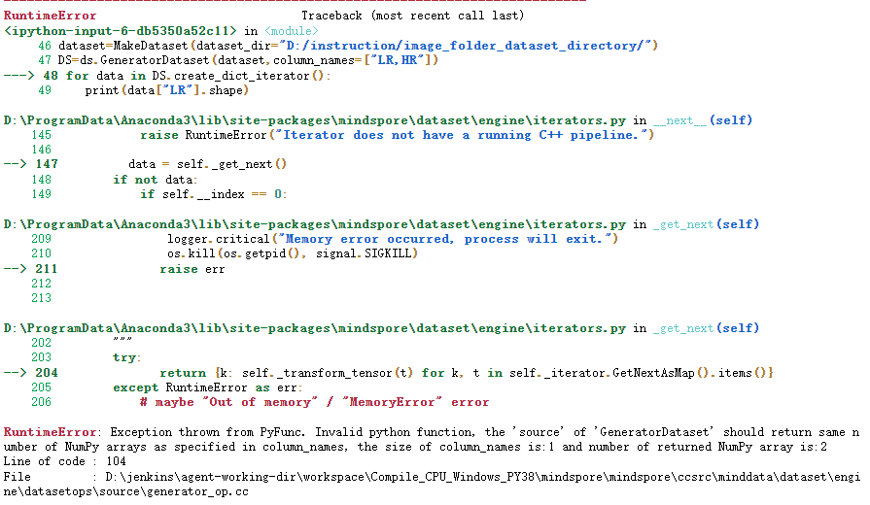
2. 原因分析
根据报错信息提示，GeneratorDataset中使用到的数据返回字段应与指定的列名个数一致，但目前指定列名个数为1，返回列数为2。按照数据返回列数分析，应定义两个列名， 但源码中：DS=ds.GeneratorDataset(dataset,column_names=["LR,HR"])，["LR,HR"]表示为一个字段，故应在此部分进行修改。
3. 解决方法
DS=ds.GeneratorDataset(dataset,column_names=["LR,HR"]) 改为与输入数据返回字段相匹配的形式： DS=ds.GeneratorDataset(dataset,column_names=["LR","HR"])
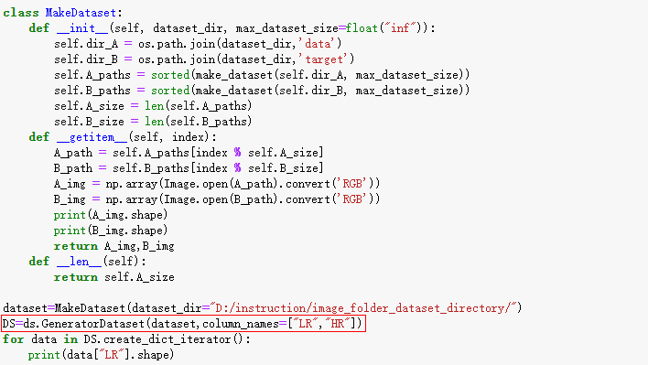
此时正常执行，可创建自定义数据集，输出如下：
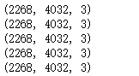
4. 总结
定位报错问题的步骤： 1、找到报错的用户代码行：for data in DS.create_dict_iterator():； 2、根据日志报错信息中的提示，定位到自定义数据返回时出现问题。GeneratorDataset返回与定义的columns字段不一致，导致报错。 3、自定义数据集创建时返回与定义的字段保持一致。
5. 参考文档
mindspore教程->数据处理->自定义数据集
https://www.mindspore.cn/tutorials/zh-CN/master/advanced/dataset/custom.html

报错RuntimeError: Unexpected error. Invalid data.
1. 报错描述
1.1 系统环境
ardware Environment(Ascend/GPU/CPU): CPU Software Environment: – MindSpore version (source or binary): 1.6.0 – Python version (e.g., Python 3.7.5): 3.7.6 – OS platform and distribution (e.g., Linux Ubuntu 16.04): Ubuntu 4.15.0-74-generic – GCC/Compiler version (if compiled from source):
1.2 基本信息
1.2.1脚本
此案例将自定义数据集转化成MindSpore Record数据格式
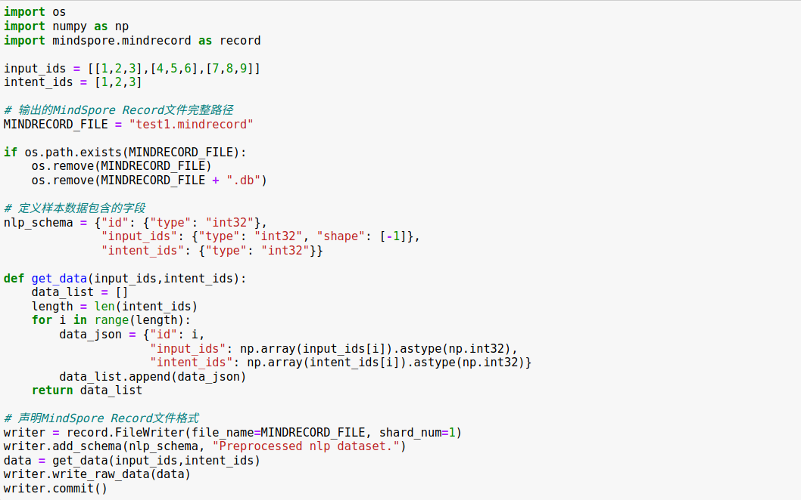
1.2.2报错
报错信息：
RuntimeError: Unexpected error. Invalid data, the number of schema should be positive but got: 0. Please check the input schema.
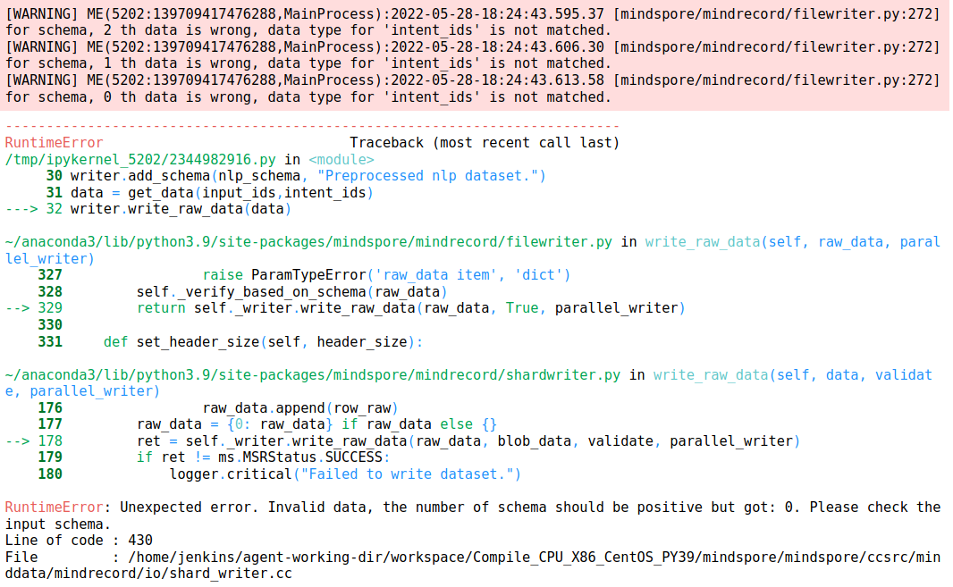
2. 原因分析
报错信息：“Invalid data”意为无效数据,分析为“intent_ids”定义的类型与实际使用到的数据类型不一致，导致匹配不到合适的数据。
3. 解决方法
将intent_label_ids改为输入数据使用到的类型。
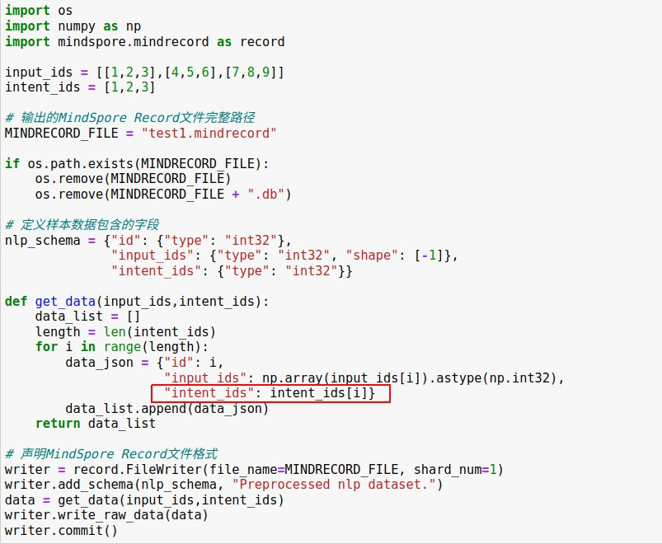
此时执行成功，读取MindSpore Record格式文件，并打印部分数据。
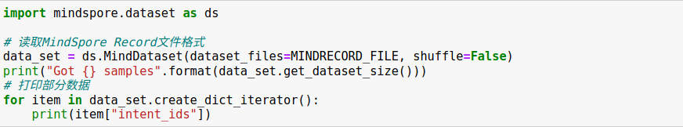
输出如下：
4. 总结
定位报错问题的步骤： 1、找到报错的用户代码行：writer.write_raw_data(data)； 2、根据日志报错信息中的提示：“Invalid data, the number of schema should be positive but got: 0. Please check the input schema.”定位到数据输入部分可能出现问题。结合前面的warning：“for schema, 0 th data is wrong, data type for 'intent_ids' is not matched.”可定位到intent_ids数据写入时出现报错，检查发现intent_ids是一维数组，遍历时输入为单个数据，而在代码中定义为numpy类型，导致数据读取时匹配不到相关类型数据。 3、数据输入与脚本中的类型定义需要保持一致。
5. 参考文档
mindspore教程->数据处理->格式转换
https://mindspore.cn/tutorials/zh-CN/master/advanced/dataset/record.html

图像类型错误导致执行报错：TypeError: img should be PIL image or NumPy array. Got <class 'list'>.
1. 系统环境
硬件环境(Ascend/GPU/CPU): GPU
软件环境: MindSpore 版本: 1.7.0
执行模式：动态图(PYNATIVE_MODE)
Python 版本: 3.7.6
操作系统平台: linux
2. 报错信息
2.1 问题描述
图像的类型应该是PIL image or NumPy array，但传入的是list类型的，导致执行报错。
2.2 报错信息
TypeError: img should be PIL image or NumPy array. Got <class 'list'>.
2.3 脚本代码
if __name__ == '__main__':
inputs = AFR.load_data('opencv_photo/input/')
targets = AFR.load_data('opencv_photo/target/')
adversarial = AFR.Attack(inputs, targets)
attack_method = "non-target attack"
adversarial_tensor, mask_tensor = adversarial.train(attack_method)
class Attack(object):
def __init__(self,input_img,target_img,seed=None):
if (seed != None): np.random.seed(seed)
self.MEAN = Tensor([0.485, 0.456, 0.406])
self.STD = Tensor([0.229, 0.224, 0.225])
self.LOSS = Tensor(0)
self.expand_dims = mindspore.ops.ExpandDims()
self.imageize = ToPILImage()
self.tensorize = ToTensor()
self.normalize = P.Normalize(mean=[0.485, 0.456, 0.406], std=[0.229, 0.224, 0.225])
self.resnet = get_net()
self.input_tensor = Tensor(self.normalize(self.tensorize(input_img)))
self.target_tensor = Tensor(self.normalize(self.tensorize(target_img)))
3. 根因分析
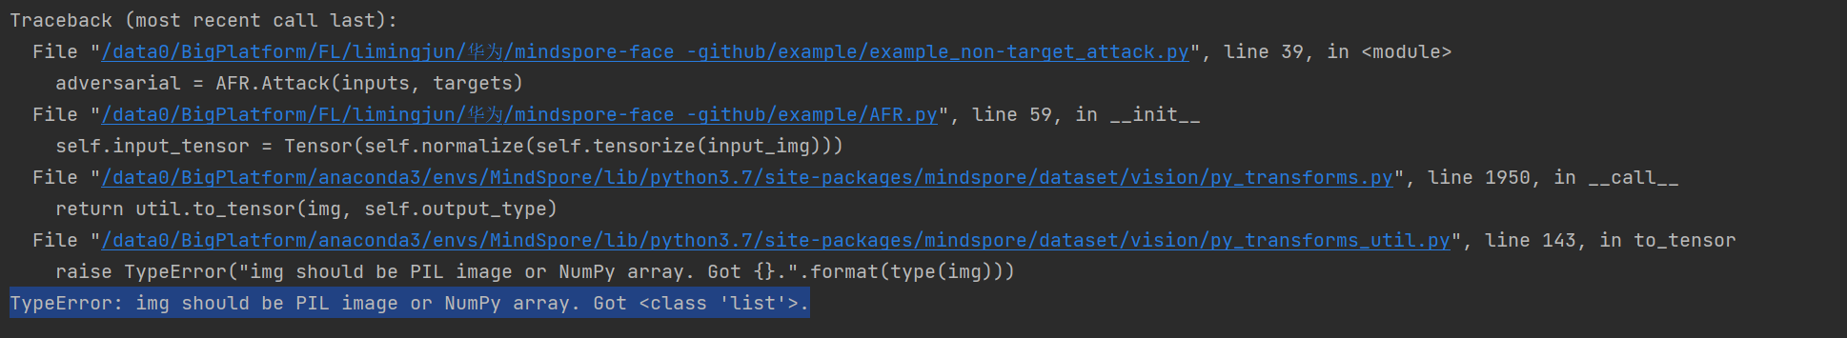
看报错信息，翻译的意思是img应该是PIL图像或NumPy数组。而不应该是list类型。定位到错误代码行self.input_tensor = Tensor(self.normalize(self.tensorize(input_img)))，说明是传入的input_img类型有问题。
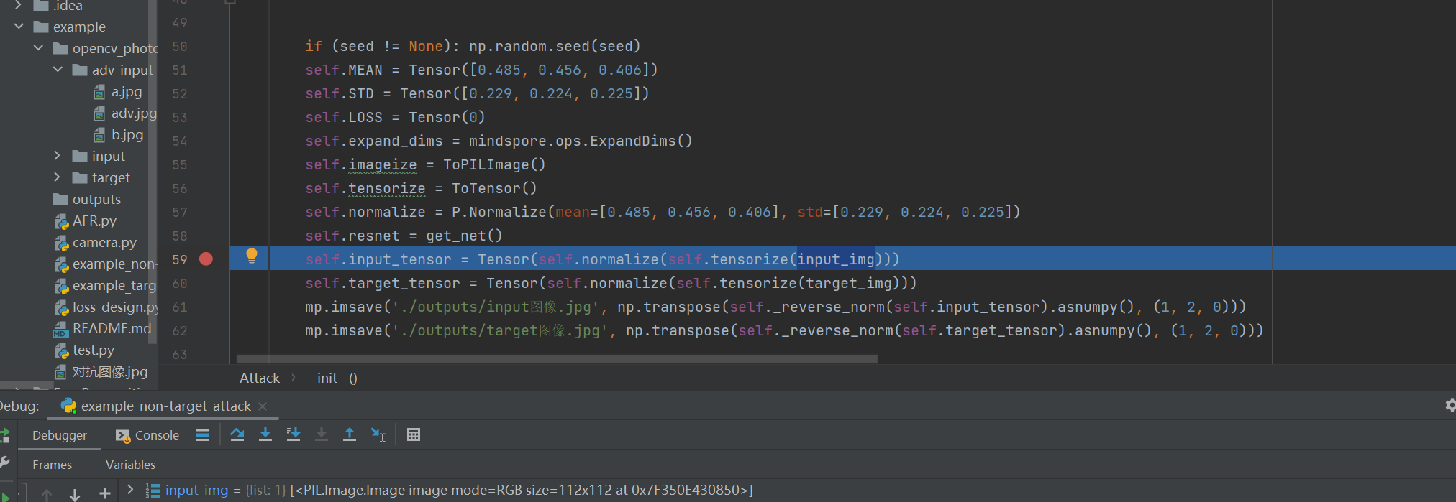
调试发现input_img类型是list。
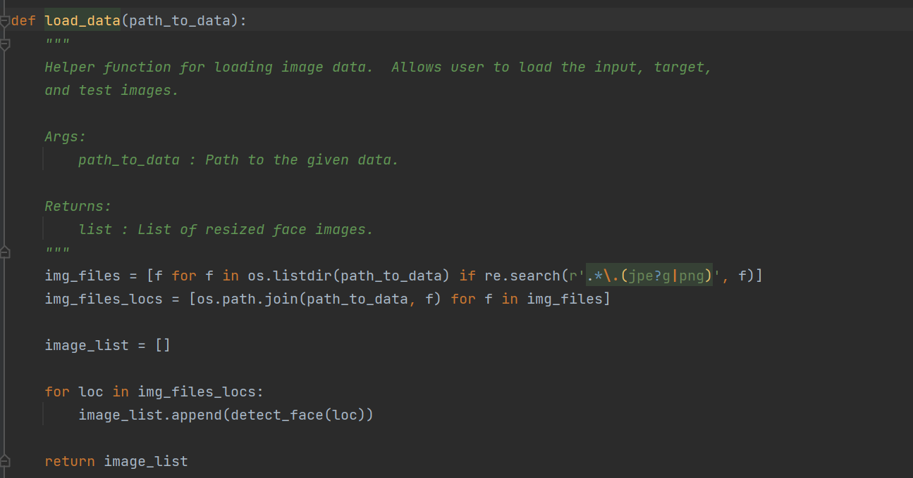
查看生成input_img的函数，发现input_img是被保存在一个列表中，所以处理图片时需要将list里面的图像拿出来。
4. 解决方案
解决方案说明：把图像从list中取出。
修改后代码：
if __name__ == '__main__':
inputs = AFR.load_data('opencv_photo/input/')
targets = AFR.load_data('opencv_photo/target/')
adversarial = AFR.Attack(inputs[0], targets[0])
attack_method = "non-target attack"
adversarial_tensor, mask_tensor = adversarial.train(attack_method)
inputs[0], targets[0]，即是从列表中取出具体的图片。
修改后正常运行。

通道顺序错误引起matplotlib.image.imsave执行报错:raise ValueError("Third dimension must be 3 or 4")
1. 系统环境
硬件环境(Ascend/GPU/CPU): GPU
软件环境: MindSpore 版本: 1.7.0
执行模式： 静态图(GRAPH)
Python 版本: 3.7.6
操作系统平台: linux
2. 报错信息
2.1 问题描述
将优化好的图像用matplotlib进行图片保存，由于没有将图像的通道进行转换，导致图像保存失败。
2.2 报错信息
raise ValueError("Third dimension must be 3 or 4") ValueError: Third dimension must be 3 or 4
2.3 脚本代码
import matplotlib.image as mp
context.set_context(mode=context.GRAPH_MODE, device_target="GPU")
adversarial_tensor, mask_tensor = adversarial.train(attack_method)
mp.imsave('./对抗图像.jpg', adversarial_tensor.asnumpy())
3. 根因分析
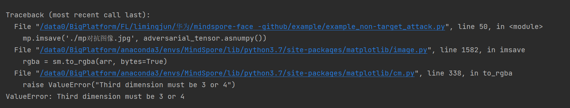
看报错信息ValueError:三维必须是3或4。说明维度的具体值有问题。
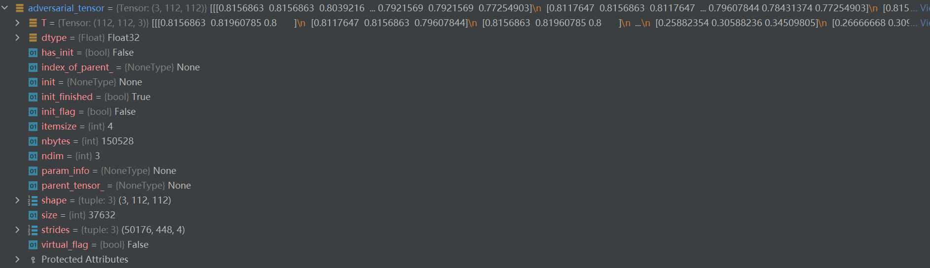
调试发现adversarial_tensor通道是（3，112，112）。通过查阅发现，Tensor的形状都是[C,H,W]格式，而要用matplotlib保存为图像需要的形状是[H,W,C]格式，所以需要对通道进行转换。
4. 解决方案
解决方案说明： 利用np.transpose函数来实现通道的转换。
修改后代码：
import matplotlib.image as mp
context.set_context(mode=context.GRAPH_MODE, device_target="GPU")
adversarial_tensor, mask_tensor = adversarial.train(attack_method)
mp.imsave("./对抗图像.jpg",
np.transpose(adversarial_tensor.asnumpy(), (1, 2, 0)))
正常执行结果adversarial_tensor可以保存为图片。

cv2.imwrite保存Tensor引起类型报错:cv2.error: OpenCV(4.6.0) :-1: error: (-5:Bad argument) in function 'imwrite'
1. 系统环境
硬件环境(Ascend/GPU/CPU): GPU
软件环境: MindSpore 版本: 1.7.0
执行模式： 静态图(GRAPH)
Python 版本: 3.7.6
操作系统平台: linux
2. 报错信息
2.1 问题描述
将优化好的图像用cv2进行图片保存，由于没有将tensor转换为numpy，导致cv2.imwrite运行失败。
2.2 报错信息
cv2.error: OpenCV(4.6.0) :-1: error: (-5:Bad argument) in function 'imwrite'
Overload resolution failed:
img is not a numpy array, neither a scalar
Expected Ptrcv::UMat for argument 'img'
2.3 脚本代码
import cv2
context.set_context(mode=context.GRAPH_MODE, device_target="GPU")
adversarial_tensor, mask_tensor = adversarial.train(attack_method)
cv2.imwrite("./cv2对抗图像.jpg",adversarial_tensor)
3. 根因分析
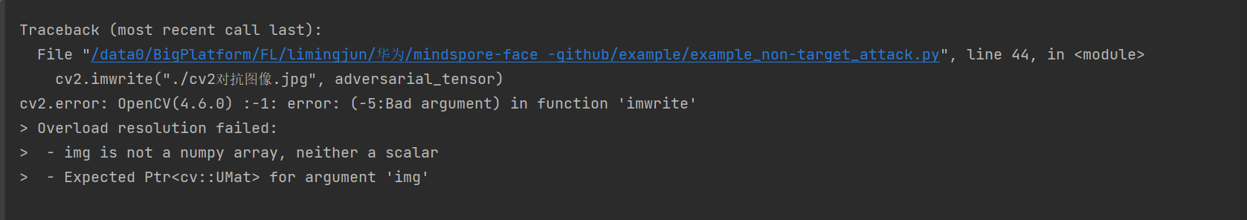
看报错信息img is not a numpy array，说明adversarial_tensor不是numpy类型，不能直接保存。
调试发现adversarial_tensor是Tensor类型。
4. 解决方案
解决方案说明：把adversarial_tensor类型转换为numpy类型
修改后代码：
import cv2
context.set_context(mode=context.GRAPH_MODE, device_target="GPU")
adversarial_tensor, mask_tensor = adversarial.train(attack_method)
cv2.imwrite("./cv2对抗图像.jpg",
np.transpose(adversarial_tensor.asnumpy(), (1, 2, 0)))
正常执行结果adversarial_tensor可以保存为图片。

cv2保存图片类型错误执行报错cv2. error: OpenCV(4.6.0) :-1: error: (-5:Bad argument) in function 'imwrite' - img is not a numpy array
1. 系统环境
硬件环境(Ascend/GPU/CPU): GPU
软件环境: MindSpore 版本: 1.7.0
执行模式： 静态图(GRAPH)
Python 版本: 3.7.6
操作系统平台: linux
2. 报错信息
2.1 问题描述
将优化好的图像用cv2进行图片保存，由于没有将tensor转换为numpy，导致cv2.imwrite运行失败。
2.2 脚本信息
import cv2
context.set_context(mode=context.GRAPH_MODE, device_target="GPU")
adversarial_tensor, mask_tensor = adversarial.train(attack_method)
cv2.imwrite("./cv2对抗图像.jpg",adversarial_tensor)
3. 根因分析
看报错信息img is not a numpy array，说明adversarial_tensor不是numpy类型，不能直接保存。
4. 解决方案
解决方案说明：把adversarial_tensor类型转换为numpy类型 修改后代码：
import cv2
context.set_context(mode=context.GRAPH_MODE, device_target="GPU")
adversarial_tensor, mask_tensor = adversarial.train(attack_method)
cv2.imwrite("./cv2对抗图像.jpg",
np.transpose(adversarial_tensor.asnumpy(), (1, 2, 0)))
正常执行结果adversarial_tensor可以保存为图片。

MindSpore报错RuntimeError: Invalid data, the number of schema should be positive but got: 0. Please checkthe input schema.
1. 系统环境
硬件环境(Ascend/GPU/CPU): CPU
软件环境: MindSpore 版本: 1.6.0
执行模式：不限模式
Python 版本: 3.7.5
操作系统平台: Ubuntu 16.04
2. 报错信息
2.1 问题描述
将自定义数据集转化成MindSpore Record数据格式出现问题。
RuntimeError: Unexpected error. Invalid data, the number of schema should be positive but got: 0. Please check the input schema.
2.2 脚本信息
import os
import numpy as np
import mindspore.mindrecord as record
input_ids = [[1,2,3],[4,5,6],[7,8,9]]
intent_ids = [1,2,3]
# 输出的MindSpore Record文件完整路径
MINDRECORD_FILE = "test1.mindrecord"
if os.path.exists(MINDRECORD_FILE):
os.remove(MINDRECORD_FILE)
os.remove(MINDRECORD_FILE +".db")
#定义样本数据包含的字段
nlp_schema = {"id": {"type": "int32"}, "input_ids": {"type": "int32","shape":[-1]}, "intent_ids": {"type": "int32"}}
def get_data(input_ids,intent_ids):
data_list = [ ]
length = len(intent_ids)
for i in range(length):
data_json = {"id": i,
"input_ids": np.array(input_ids[i]).astype(np.int32),
"intent_ids": np.array(intent_ids[i]).astype(np.int32)}
data_list.append(data json)
return data List
#声明MindSpore Record文件格式
writer = record.FileWriter(file_name=MINDRECORD_FILE, shard_num=1)
writer.add schema(nlp_schema,"preprocessed nlp dataset.")
data = get_data(input_ids,intent_ids)
writer.write_raw_data(data)
writer.co㎜it()
3. 根因分析
“Invalid data”意为无效数据,分析为“intent_ids”定义的类型与实际使用到的数据类型不一致，导致匹配不到合适的数据。从上面的代码可以看到id和intent_ids定义的类型是一样的，但是在get_data时候生成的data_json， 里面的id和intent_ids却不一样,一个是int32, 一个却是np.array。
4. 解决方案
在data_json中，把intent_ids改为跟id一样的int数据
代码：
import os
import numpy as np
import mindspore.mindrecord as record
input_ids = [[1,2,3],[4,5,6],[7,8,9]]
intent_ids = [1,2,3]
# 输出的MindSpore Record文件完整路径
MINDRECORD_FILE = "test1.mindrecord"
if os.path.exists(MINDRECORD_FILE):
os.remove(MINDRECORD_FILE)
os.remove(MINDRECORD_FILE +".db")
#定义样本数据包含的字段
nlp_schema = {"id": {"type": "int32"}, "input_ids": {"type": "int32","shape":[-1]}, "intent_ids": {"type": "int32"}}
def get_data(input_ids,intent_ids):
data_list = [ ]
length = len(intent_ids)
print("murongmeng_length", length)
for i in range(length):
data_json = {"id": i,
"input_ids": np.array(input_ids[i]).astype(np.int32),
#"intent_ids": np.array(intent_ids[i]).astype(np.int32)}
"intent_ids": i}
data_list.append(data_json)
print("murongmeng_data_list:", data_list)
return data_list
#声明MindSpore Record文件格式
writer = record.FileWriter(file_name=MINDRECORD_FILE, shard_num=1)
writer.add_schema(nlp_schema,"preprocessed nlp dataset.")
data = get_data(input_ids,intent_ids)
writer.write_raw_data(data)
writer.commit()
执行结果：
(wys_op) root@ubuntu:/home/wys# python test.py
murongmeng_length 3
murongmeng_data_list: [{'id': 0, 'input_ids': array([1, 2, 3], dtype=int32), 'intent_ids': 0}, {'id': 1, 'input_ids': array([4, 5, 6], dtype=int32), 'intent_ids': 1}, {'id': 2, 'input_ids': array([7, 8, 9], dtype=int32), 'intent_ids': 2}]
(wys_op) root@ubuntu:/home/wys#

MindSpore报错MRMOpenError: MindRecord File could not open successfully.
1. 系统环境
硬件环境(Ascend/GPU/CPU): Ascend/GPU/CPU
软件环境: MindSpore 版本: 1.5.0
执行模式： 不限
Python 版本: 3.7.6
操作系统平台: linux
2. 报错信息
2.1 问题描述
在Ascend + Mindspore1.5上进行MindSpore数据格式转换脚本如下：
from mindspore.mindrecord import FileWriter
data_record_path = './datasets/convert_dataset_to_mindrecord/data_to_mindrecord/test.mindrecord'
writer = FileWriter(file_name=data_record_path, shard_num=4)
# 定义schema
data_schema = {"file_name": {"type": "string"}, "label": {"type": "int32"}, "data": {"type": "bytes"}}
writer.add_schema(data_schema, "test_schema")
# 数据准备
file_name = "./datasets/convert_dataset_to_mindrecord/images/transform.jpg"
with open(file_name, "rb") as f:
bytes_data = f.read()
data = [{"file_name": "transform.jpg", "label": 1, "data": bytes_data}]
indexes = ["file_name", "label"]
writer.add_index(indexes)
# 数据写入
writer.write_raw_data(data)
# 生成本地数据
writer.commit()
2.2 报错信息
MRMOpenError Traceback (most recent call last)
/tmp/ipykernel_108737/3747345416.py in <module>
17
18 #
数据写入
---> 19 writer.write_raw_data(data)
20
21 #
生成本地数据
/opt/nvme0n1/root/miniforge3/envs/mdp/lib/python3.7/site-packages/mindspore/mindrecord/filewriter.py in write_raw_data(self, raw_data, parallel_writer)
250 """
251 if not self._writer.is_open:
--> 252 self._writer.open(self._paths)
253 if not self._writer.get_shard_header():
254 self._writer.set_shard_header(self._header)
/opt/nvme0n1/root/miniforge3/envs/mdp/lib/python3.7/site-packages/mindspore/mindrecord/shardwriter.py in open(self, paths)
53 if ret != ms.MSRStatus.SUCCESS:
54 logger.error("Failed to open paths")
---> 55 raise MRMOpenError
56 self._is_open = True
57 return ret
MRMOpenError: [MRMOpenError]: MindRecord File could not open successfully.
3. 根因分析
MindSpore1.6.0版本之前，MindSpore格式数据集生成时不支持覆盖写，当输出目录下存在同名文件时，异常信息不能准确反应错误信息，此时需要查看日志信息。如下所示，日志中第2行提示输出目录下已经存在同名mindrecord文件，需要提前删除。
[ERROR] ME(108737:281473404131632,MainProcess):2022-04-11-17:39:33.512.803 [mindspore/mindrecord/shardwriter.py:54] Failed to open paths
[ERROR] MD(108737,ffffa2445930,python3.7):2022-04-11-17:39:33.512.713 [mindspore/ccsrc/minddata/mindrecord/io/shard_writer.cc:92] OpenDataFiles] MindRecord file already existed, please delete file: /opt/nvme0n1/l00475263/workspace/datasets/convert_dataset_to_mindrecord/data_to_mindrecord/test.mindrecord0
[ERROR] MD(108737,ffffa2445930,python3.7):2022-04-11-17:39:33.512.752 [mindspore/ccsrc/minddata/mindrecord/io/shard_writer.cc:167] Open] Open data files failed.
4. 解决方案
将原代码中的：
writer = FileWriter(file_name=data_record_path, shard_num=4)
修改为：
writer = FileWriter(file_name=data_record_path, shard_num=4, overwrite=True)

MindSpore报错RuntimeError: Invalid python function, the 'source' of 'GeneratorDataset' should return same number ...
1. 系统环境
硬件环境(Ascend/GPU/CPU): Ascend/GPU/CPU
软件环境: MindSpore 版本: 1.7.0
执行模式： 不限
Python 版本: 3.7.5
操作系统平台: linux
2. 报错信息
2.1 问题描述
创建一个做超分辨率的数据集，使用mindspore.dataset.GeneratorDataset接口实现自定义方式的进行数据集加载。
2.2 脚本信息
from os import listdir
from os.path import join
import os
from PIL import Image
import random
import numpy as np
import mindspore.dataset as ds
import mindspore.dataset.vision.py_transforms as py_vision
import mindspore.dataset.transforms.py_transforms as py_transforms
def is_image_file(filename):
return any(filename.endswith(extension) for extension in ['.png','.jpg','jpeg','PNG','.JPG','.JPEG' ])
def make_dataset (dir_path, max_dataset_size=float("inf")):
"""Return image list in dir."""
inages = []
assert os.path.isdir(dir_path), '%s is not a valid directory' % dir_path
for root, _, fnanes in sorted(os, walk(dir_path)):
for fname in fnames:
if is_image_file(fname):
path = os.path.join(root, fname)
images.append(path)
return images[:min(max_dataset_size,len(images))]
class MakeDataset:
def __init__ (self,dataset_dir,max_dataset_size=float ("inf")):
self.dir_A = os.path.join(dataset_dir,'data')
self.dir_B = os.path.join(dataset_dir,'target')
self.A_paths = sorted(make_dataset(self.dir_A,max_dataset_size))
self.B_paths = sorted(make_dataset(self.dir_B,max_dataset_size))
self.A_size = len(self.A_paths)
self.B_size = len(self.B_paths)
def __getitem__ (self,index):
A_path = self.A_paths[index % self.A_size]
B_path = self.B_paths[index % self.B_size]
A_img = np.array(Image.open(A_path).convert('RGB'))
B_img = np.array(Image.open(B_path).convert('RGB'))
print(A_img.shape)
print(B_img.shape)
return A_img,B_img
def --len_- (self):
return self.A_size
dataset = MakeDataset(dataset_dir=″D:/instruction/image_folder_dataset_directory/")
DS = ds.GeneratorDataset(dataset,column_names=["LR,HR″]）
for data in DS.create_dict_iterator ():
print(data["LR"].shape)
2.3 报错信息
RuntimeError: Exception thrown from PyFunc. Invalid python function, the 'source' of 'GeneratorDataset' should return same number of NumPy arrays as specified in column_names, the size of column_names is:1 and number of returned NumPy array is:2
3. 根因分析
GeneratorDataset中使用到的数据返回字段应与指定的列名个数一致，但目前指定列名个数为1，返回列数为2。按照数据返回列数分析，应定义两个列名。
在上面代码中发现：
DS=ds.GeneratorDataset(dataset,column_names=["LR,HR"])
"LR,HR"]表示为一个字段，那么我们在这一部分进行修改。
DS=ds.GeneratorDataset(dataset,column_names=["LR","HR"])
4. 解决方案
from os import listdir
from os.path import join
import os
from PIL import Image
import random
import numpy as np
import mindspore.dataset as ds
import mindspore.dataset.vision.py_transforms as py_vision
import mindspore.dataset.transforms.py_transforms as py_transforms
def is_image_file(filename):
return any(filename.endswith(extension) for extension in ['.png','.jpg','jpeg','PNG','.JPG','.JPEG' ])
def make_dataset (dir_path, max_dataset_size=float("inf")):
"""Return image list in dir."""
inages = []
assert os.path.isdir(dir_path), '%s is not a valid directory' % dir_path
for root, _, fnanes in sorted(os, walk(dir_path)):
for fname in fnames:
if is_image_file(fname):
path = os.path.join(root, fname)
images.append(path)
return images[:min(max_dataset_size,len(images))]
class MakeDataset:
def __init__ (self,dataset_dir,max_dataset_size=float ("inf")):
self.dir_A = os.path.join(dataset_dir,'data')
self.dir_B = os.path.join(dataset_dir,'target')
self.A_paths = sorted(make_dataset(self.dir_A,max_dataset_size))
self.B_paths = sorted(make_dataset(self.dir_B,max_dataset_size))
self.A_size = len(self.A_paths)
self.B_size = len(self.B_paths)
def __getitem__ (self,index):
A_path = self.A_paths[index % self.A_size]
B_path = self.B_paths[index % self.B_size]
A_img = np.array(Image.open(A_path).convert('RGB'))
B_img = np.array(Image.open(B_path).convert('RGB'))
print(A_img.shape)
print(B_img.shape)
return A_img,B_img
def --len_- (self):
return self.A_size
dataset = MakeDataset(dataset_dir=″D:/instruction/image_folder_dataset_directory/")
DS = ds.GeneratorDataset(dataset,column_names=["LR","HR″]）
for data in DS.create_dict_iterator ():
print(data["LR"].shape)

MindSpore报错ValueError: when loss_fn is not None, train_dataset should return two elements, but got 3
1. 系统环境
硬件环境(Ascend/GPU/CPU): Ascend/GPU/CPU
软件环境: MindSpore 版本: 1.1.0
执行模式： 不限
Python 版本: 3.7.5
操作系统平台: linux
2. 报错信息
2.1 问题描述
自定义数据集在第一轮可正常遍历，但第二轮时出现list index out of range。
2.2 报错信息
ValueError: when loss_fn is not None, train_dataset should return two elements, but got 3
2.3 脚本信息
import mindspore.dataset as ds
import matplotlib.pyplot as plt
import mindspore.dataset.vision.py_transforms as py_trans
from mindspore.dataset.transforms.py_transforms import Compose
import mindspore.ops as ops
# from mindspore import Tensor
import numpy as np
from PIL import Image
import os
import random
from option import opt
class DatasetGenerator:
def __init__(self, path, train, format='.png'):
# self.size = size
self.format = format
self.train = train
if train:
self.haze_imgs_dir = os.listdir(os.path.join(path, 'train', 'hazy'))
self.haze_imgs = [os.path.join(path, 'train', 'hazy', img) for img in self.haze_imgs_dir]
self.clear_dir = os.path.join(path, 'train', 'gt')
else:
self.haze_imgs_dir = os.listdir(os.path.join(path, 'test', 'hazy'))
self.haze_imgs = [os.path.join(path, 'test', 'hazy', img) for img in self.haze_imgs_dir]
self.clear_dir = os.path.join(path, 'test', 'gt')
# print(self.haze_imgs_dir, self.clear_dir)
np.random.seed(58)
self.__random_seed = []
for _ in range(len(self.haze_imgs)):
self.__random_seed.append(random.randint(0, 1000000))
self.__index = -1
def __getitem__(self, index):
self.__index += 1
haze = Image.open(self.haze_imgs[index])
# if isinstance(self.size,int):
# while haze.size[0]<self.size or haze.size[1]<self.size :
# index=random.randint(0,20000)
# haze=Image.open(self.haze_imgs[index])
img = self.haze_imgs[index].split('\\')[-1]
# img=self.haze_imgs[index].split('/')[-1]
img_name = img.split('_')
# img_name=img.split('\\')[-1].split('_')
# print(img_name)
clear_name=f"{img_name[0]}_gt_{img_name[2]}"
# print(self.clear_dir, clear_name, os.path.join(self.clear_dir,clear_name))
clear=Image.open(os.path.join(self.clear_dir,clear_name))
w, h = clear.size
nw, nh = haze.size
left = (w - nw)/2
top = (h - nh)/2
right = (w + nw)/2
bottom = (h + nh)/2
clear = clear.crop((left, top, right, bottom))
return (haze, clear, index)
def __len__(self):
print(len(self.haze_imgs))
return len(self.haze_imgs)
def get_seed(self):
seed = self.__random_seed[self.__index]
return seed
def decode(img):
return Image.fromarray(img)
def set_random_seed(img_name, seed):
random.seed(seed)
return img_name
ds.config.set_seed(8)
# DATA_DIR = opt.data_url
DATA_DIR = 'C:\Users\kle\Desktop\NTIRE2021'
train_dataset_generator = DatasetGenerator(DATA_DIR, train=True)
train_dataset = ds.GeneratorDataset(train_dataset_generator, ["hazy", "gt", "img_name"], shuffle=True)
test_dataset_generator = DatasetGenerator(DATA_DIR, train=False)
test_dataset = ds.GeneratorDataset(test_dataset_generator, ["hazy", "gt", "img_name"], shuffle=False)
transforms_list = [
decode,
(lambda img_name: set_random_seed(img_name, train_dataset_generator.get_seed())),
py_trans.RandomCrop(opt.crop_size),
py_trans.ToTensor(),
]
compose_trans = Compose(transforms_list)
train_dataset = train_dataset.map(operations=compose_trans, input_columns=["hazy"])
train_dataset = train_dataset.map(operations=compose_trans, input_columns=["gt"])
train_dataset = train_dataset.batch(opt.bs, drop_remainder=True)
if __name__ == '__main__':
for i in range(2):
print(i)
for batch in train_dataset.create_dict_iterator():
# print(batch)
# hazy = Tensor(batch["hazy"], dtype=mindspore.float32)
# clear = Tensor(batch["gt"], dtype=mindspore.float32)
print(batch["hazy"].shape, batch["gt"].shape)
3. 根因分析
脚本中第37行利用魔术方法 def __getitem__(self, index)定义了随机访问的类，其中index参数作为样本\元素索引，外部可以直接使用index来进行数据的访问，外部不需要对其进行修改（如：每个迭代开始前的复位操作）。
但是在代码的第35行户另外自定义了__index，所以需要在每个迭代前进行复位操作，来保证不出现数组越界访问。
4. 解决方案
根据根因分析提供的信息，已经非常清楚，就是在另外每次迭代再重新使用__index时，每次迭代完后都进行了
self.__index = -1
造成了下次迭代没有复位的问题，那么可以很简单的让它等于初始值即可。
self.__index += 0

MindSpore数据类型转换结果不符合预期
1 系统环境
硬件环境(Ascend/GPU/CPU): GPU
MindSpore版本: 不限版本
执行模式（PyNative/ Graph）: PyNative
Python版本: 3.7.3
操作系统平台:不限
2 报错信息
2.1 问题描述
直接将Tensor从布尔值转换为浮点数，导致错误的结果。在类型转换前更改为numpy后，结果正确。
2.2 报错信息
想要得到的结果：
data = ms.Tensor(np.array([[0,0,0,0,0,0],[1,1,1,1,1,1],[1,1,1,1,1,1]]),ms.bool_)
print("data: \n",data)
print("inversed data: \n",~data)
new_data = ms.Tensor(~data.asnumpy(),ms.float32)
print("inversed data in float32:\n",new_data)
result = ops.ReduceSum()(new_data,0)
print("result: \n",result)
data:
[[False False False False False False]
[ True True True True True True]
[ True True True True True True]]
inversed data:
[[ True True True True True True]
[False False False False False False]
[False False False False False False]]
inversed data in float32:
[[1. 1. 1. 1. 1. 1.]
[0. 0. 0. 0. 0. 0.]
[0. 0. 0. 0. 0. 0.]]
result:
[1. 1. 1. 1. 1. 1.]
实际得到的结果：
data = ms.Tensor(np.array([[0,0,0,0,0,0],[1,1,1,1,1,1],[1,1,1,1,1,1]]),ms.bool_)
print("data: \n",data)
print("inversed data: \n",~data)
new_data = ms.Tensor(~data.asnumpy(),ms.float32)
print("inversed data in float32:\n",new_data)
result = ops.ReduceSum()(new_data,0)
print("result: \n",result)
data:
[[False False False False False False]
[ True True True True True True]
[ True True True True True True]]
inversed data:
[[ True True True True True True]
[False False False False False False]
[False False False False False False]]
inversed data in float32:
[[0. 0. 0. 0. 0. 0.]
[0. 0. 0. 0. 0. 0.]
[0. 0. 0. 0. 0. 0.]]
result:
[2.3694278e-38 3.6013371e-43 0.0000000e+00 0.0000000e+00 1.0000000e+01 7.0000000e+00]
2.3 脚本代码
import mindspore as ms
data = ms.Tensor(np.array([[0, 0, 0, 0, 0, 0], [1, 1, 1, 1, 1, 1], [1, 1, 1, 1, 1, 1]]), ms.bool_)
print(data)
print(~data)
new_data = ms.Tensor(~data, ms.float32)
print(new_data)
result = ops.ReduceSum()(new_data, 0)
print(result)
3 根因分析
new_data = ms.Tensor(~data, ms.float32)
如果需要转换Tensor的数据类型，建议使用Cast算子来进行操作。
不推荐使用Tensor( , <new_dtype>)修改Tensor的数据类型；使用Tensor()进行mindspore数据类型之间的转换可能会出错。
4 解决方案
修改代码如下，可得到预期输出：
import mindspore as ms
from mindspore import ops
data = ops.cast(ms.Tensor([[0, 0, 0, 0, 0, 0], [1, 1, 1, 1, 1, 1], [1, 1, 1, 1, 1, 1]]), ms.bool_)
print("data: \n", data)
print("inversed data: \n", ~data)
new_data = ops.cast(~data, ms.float32)
print("inversed data in float32:\n", new_data)
result = ops.ReduceSum()(new_data, 0)
print("result: \n", result)
data:
[[False False False False False False]
[ True True True True True True]
[ True True True True True True]]
inversed data:
[[ True True True True True True]
[False False False False False False]
[False False False False False False]]
inversed data in float32:
[[1. 1. 1. 1. 1. 1.]
[0. 0. 0. 0. 0. 0.]
[0. 0. 0. 0. 0. 0.]]
result:
[1. 1. 1. 1. 1. 1.]

MindSpore报错TypeError:parse() missing 1 required positional argument: ‘self’
1. 系统环境
硬件环境(Ascend/GPU/CPU): GPU
软件环境: MindSpore 版本: 1.7.0
执行模式（静态图/动态图）： 动态图
Python 版本: 3.7.6
操作系统平台: linux
2. 报错信息
2.1 问题描述
直接将Tensor从布尔值转换为浮点数，导致错误的结果。在类型转换前更改为numpy后，结果正确。
2.2 报错信息
想要得到的结果：
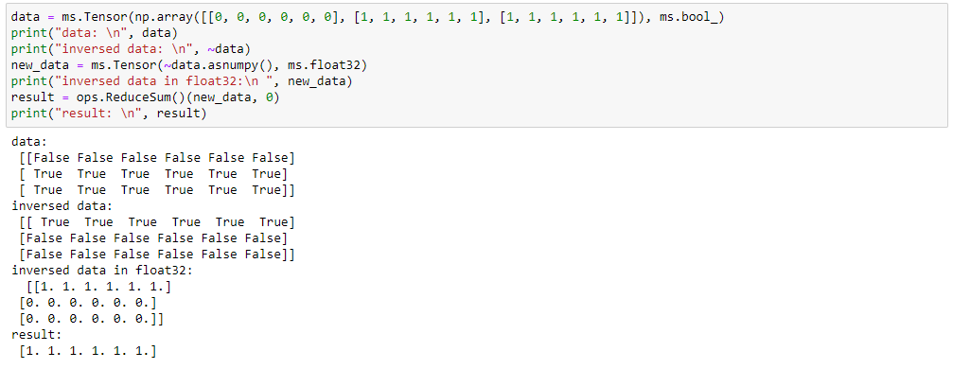实际得到的结果：
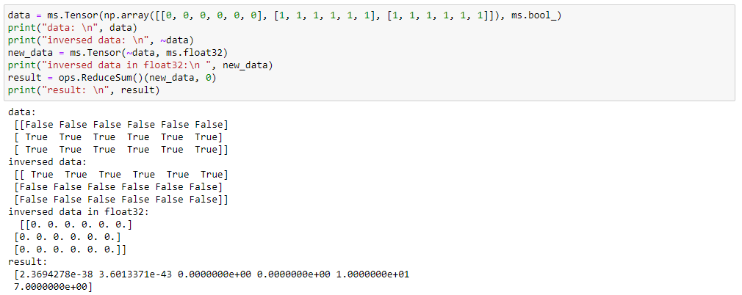2.3 脚本信息
import mindspore as ms
data = ms.Tensor(np.array([[0, 0, 0, 0, 0, 0], [1, 1, 1, 1, 1, 1], [1, 1, 1, 1, 1, 1]]), ms.bool_)
print(data)
print(~data)
new_data = ms.Tensor(~data, ms.float32)
print(new_data)
result = ops.ReduceSum()(new_data, 0)
print(result)
3. 根因分析
转换Tensor的数据类型，使用Tensor( , <new_dtype>)修改Tensor的数据类型导致，建议使用Cast算子来进行操作。
4. 解决方案
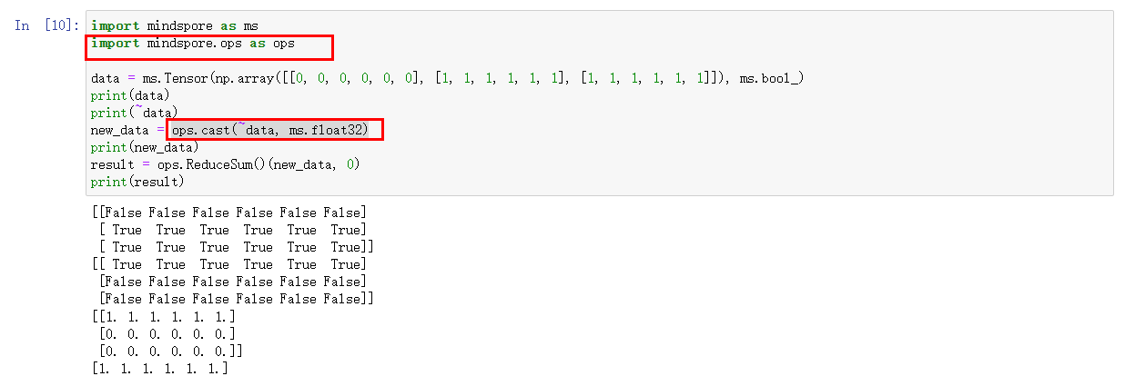

使用mindspore.ops.interpolate报错ValueError:For "scale_factor" option cannot currentiy be set with the mode = bilinear = 4D
1. 系统环境
硬件环境(Ascend/GPU/CPU): CPU
软件环境: MindSpore 版本: 2.0
执行模式（静态图/动态图）： 不限
Python 版本: 3.9
操作系统平台: linux
2. 报错信息
2.1 问题描述
img是三维的，（C，H，W），unsqueeze转换成4维后，想用bilinear模式的interpolate，但是却报错说不能设置 scale_factor。
2.2 报错信息
ValueError:For "interpolate" , "scale_factor" option cannot currentiy be set with the mode = bilinear and dim = 4D
2.3 脚本信息
import mindspore
from mindspore import Tensor, ops
import numpy as np
img = np.random.randn(3, 128, 128)
input = Tensor(img, mindspore.float32)
output = ops.interpolate(input.unsqueeze(0), mode='bilinear', scale_factor=2.0)
print(output)
3. 根因分析
查看文档：https://mindspore.cn/docs/zh-CN/r2.0/api_python/ops/mindspore.ops.interpolate.html?highlight=interpolate#mindspore.ops.interpolate
bilinear 模式下支持4d ，但是不支持scale_factor。
4. 解决方案
不支持scale_factor，但是size还是支持的。
mindspore.ops.interpolate(input, size=None, scale_factor=None, mode='nearest', align_corners=None, recompute_scale_factor=None)
按照给定的 size 或 scale_factor 根据 mode 设置的插值方式，对输入 input 调整大小。
size (Union[int, tuple[int], list[int]], 可选) - 目标大小。如果 size 为tuple或list，那么其长度应该和 input 去掉 N, C 的维度相同。 size 和 scale_factor 同时只能指定一个。默认值：None。
所以可以设置size，一样可以达到缩放的效果。
import mindspore
from mindspore import Tensor, ops
import numpy as np
img = np.random.randn(3, 128, 128)
input = Tensor(img, mindspore.float32)
output = ops.interpolate(input.unsqueeze(0), mode='bilinear', size=256)
print(output.shape)

新节点3mindspore.dataset.Dataset.split切分数据集时randomize=True时分割出的数据不够随机问题
1. 系统环境
硬件环境(Ascend/GPU/CPU): Ascend/GPU/CPU
软件环境: MindSpore 版本: 2.0.0
执行模式（静态图/动态图）： 不限
Python 版本: 3.9.7
操作系统平台: linux
2. 报错信息
2.1 问题描述
使用mindspore.dataset.Dataset.split切分数据集时，randomize=True切分出来的数据不够随机，数据集标签为0~23使用NumpySlicesDataset函数加载数据。
2.2 脚本信息
dataset = ds.NumpySlicesDataset((X,Y),['data','lable'],shuffle=False)
dataset = dataset.map(operations=ds.trainforms.TypeCast(ms.int32),input_columns="lable")
batch_size = 128
train_dataset,test_dataset = dataset.split([0.8,0.2],randomize=False)
train_dataset = train_dataset.batch(batch_size=batch_size)
test_dataset = test_dataset.batch(batch_size=128)
for data,label in test_dataset.create_tuple_iterator():
print(label)
3. 解决方案
创建数据集的时候打开shuffle操作，然后对数据集进行相应的切分。
dataset = ds.NumpySlicesDataset((X,Y),['data','lable'],shuffle=True)
dataset = dataset.map(operations=ds.trainforms.TypeCast(ms.int32),input_columns="lable")
batch_size = 128
train_dataset,test_dataset = dataset.split([0.8,0.2],randomize=False)
train_dataset = train_dataset.batch(batch_size=batch_size)
test_dataset = test_dataset.batch(batch_size=128)
for data,label in test_dataset.create_tuple_iterator():
print(label)

MindSpore拆分dataset输入给多输入模型
1. 系统环境
硬件环境(Ascend/GPU/CPU): Ascend/GPU/CPU
软件环境: MindSpore 版本: 2.0.0
执行模式（静态图/动态图）： 不限
Python 版本: 3.7.6
操作系统平台: linux
2. 报错信息
2.1 问题描述
当前模型是由四个小模型的输出横向拼接成一个大模型，需要把一个dataset在输入模型时横向拆分成4部分数据，分别输入给4个小模型，用mindspore该如何实现？
在tensorflow用的是如下代码实现上述功能的，即使用map把dataset拆分成4类数据分别输入4个小模型，把4个小模型的输出用keras.layers.Concatenate函数合并成一行：
2.2 脚本信息
dataset_map_func(*args):
"""
把dataset切片成4类数据，分别输入4个model。
feature_slice是一个dict，存储的是slice切片类型。
"""
feature = dict( ('input_'+c, tf.transpose(args[feature_slice[c]])) for c in ['1','2','3','4'])
return feature, label
x = keras.layers.Concatenate(axis=1)([model_1.output, model_2.output, model_3.output, model_4.output])
model = keras.Model(inputs=[model_1.input, model_2.input, model_3.input, model_4.input], outputs=outputs)
dataset = dataset.map(dataset_map_func)
3. 解决方案
可以参考如下的逻辑实现
dataset = GeneratorDataset(source=loader, column_names=["x1", "x2", "x3", "x4", "label"])
class Net(nn.Cell):
def __init__(self):
super(Net, self).__init__()
self.net1 = Net1()
self.net2 = Net2()
self.net3 = Net3()
self.net4 = Net4()
def construct(self, x1, x2, x3, x4):
y1 = self.net1(x)
y2 = self.net1(x)
y3 = self.net1(x)
y4 = self.net1(x)
return y1,y2,y3,y4
dataset_train = create_dataset()
network = Net()
opt = nn.Momentum()
loss_fn = nn.SoftmaxCrossEntropyWithLogits()
model = Model(network)
model .train(args.epoch_size, dataset_train)

使用ImageFolderDataset读取图片在进行PIL转化的时候出现报错
1. 系统环境
硬件环境(Ascend/GPU/CPU): Ascend/GPU/CPU
软件环境: MindSpore 版本: 1.7.0
执行模式（静态图/动态图）： 不限
Python 版本: 3.7.6
操作系统平台: linux
2. 报错信息
2.1 问题描述
定义了一个transforms的操作集合，通过ImageFolderDataset读取图片数据，transforms_list里面包含转ToPIL以及Resize操作，运行之后，会出现如下报错。显示图片的维度信息不对。
2.2 报错信息
Traceback (most recentcall ast):
File "tset_numpy.py", line 15, in<module>
for item in dataset.create_dict .iterator():
File"/home/shenwei/.conda/envs/㏕ib/python3.7/s ite-packages/mindspore/dataset/engine/iterators.py",line 152, in _next_
data = sef._get_next( )
File "/home/shenwei/.conda/envs/lib/python3.7/s ite-packages/mindspore/dataset/engine/iterators.py", line 277, in _get_next
raise err
File"/home/shenwei/.conda/envs/lib/python3.7/site-packages/mindspore/dataset/engine/iterators.py", line 260, in _get_next
-Python Call stack:
map operation: [PyFunc] failed. Thecorresponding data file is: /data2/shenwei/Minddata/test/mindspore/tests/ut/data/dataset/testpK/data/class1/2.jpg. Error description: valueÈrror: Traceback (most recentcall last):
File'"/home/shenwei/.conda/envs/shenweb/python3.7/s ite-packages/mindspore/dataset/transforms/py_transforms_util.py", line 63, in copose
args = transform(*args )
File "/home/shenwei/.conda/envs/lib/python3.7/s ite-packages/mindspore/dataset/transforms/transforms.py", Line 133, in _call_
return self._execute py( img)
File"/home/shenwei/.conda/envs/lib/python3.7/s ite-packages/mindspore/dataset/vision/transforms.py"，line 4739, in _execute_py
return util.to_pil( img)
File "/home/shenwei/ conda/envs/lib/python3.7/s ite-packages/mindspore/dataset/vis ion/py_transforms_util.py", line 178, in to_pil
raise ValueError("Thedimens ion of input image should be 2or 3. Got {}.".format(img.ndim))
ValueError: The dimens ion ofinput image should be 2 or 3. Got 1
- Dataset Pipeline Error Message:
ERROR Execute user Python code failed. check 'pvthon Call Stack' above
- C++ Call Stack: (For framework developers.
mindspore/ccsrc/minddata/dataset/engine/datasetops/map op/map iob.h(57)
2.3 脚本信息
import mindspore.dataset as ds
import mindspore.dataset.vision as vision
import nupy as np
from mindspore.dataset.transforms import Compose
from PIL import Image
image path = "/data2/shenwei/Minddata/test/mindspore/tests/ut/data/dataset/testPK/data"
transforms_List = Compose([vision.ToPIL(),vision.Resize((200, 200))])
# pipeline mode
dataset = ds.ImageFoderDataset(image_path, shuffle=False)
dataset = dataset.map(operations=transforms_list, input_coumns="image")
for item in dataset.create_dict_iterator():
print(item[″image"].shape)
print(item[″image"].dtype)
break
# eager mode
img = np.fromfile("/data2/shenwei/Minddata/test/mindspore/tests/ut/data/dataset/testPK/data/class1/Θ.jpg",np.uint8)
img = transforms_list(img)[0]
assert isinstance(img, Image.Image) print(type(img))
3. 根因分析
代码有两个错:(还有一些字符输入错误的暂不管)
1.ImageFolderDataset 读取目录下的图像文件后输入的就是一个图像, 所以第一步应该是做Decode
做完Decode后可以调用vision.ToPIL(), 或者直接调用Decode的时候指定参数, vision.Decode(to_pil=True)
2.eager mode下输入的是一个numpy, 是可以直接用vision.ToPIL()的，但是np.fromfile读取图像的rank是1 同样会报错, 所以要用Image.open后转numpy才行。
4. 解决方案
import mindspore.dataset as ds
import mindspore.dataset.vision as vision
import numpy as np
from mindspore.dataset.transforms import Compose
from PIL import Image
image_path="C:\\temp\\pic"
transforms_list = Compose([#vision.Decode(),
#vision.ToPIL(),
vision.Decode(to_pil=True),
vision.Resize((200, 200))])
#transforms_list = Compose([vision.ToPIL(),vision.Resize((200, 200))])
# pipeline mode
dataset = ds.ImageFolderDataset(image_path, shuffle=False)
dataset = dataset.map(operations=transforms_list, input_columns="image")
for item in dataset.create_dict_iterator():
print(item["image"].shape)
print(item["image"].dtype)
break
# eager mode
transforms_list1 = Compose([vision.ToPIL(),vision.Resize((200, 200))])
#img = np.fromfile("C:\\temp\\pic\\01\\000000000064.jpg",np.uint8)
img = Image.open("C:\\temp\\pic\\01\\000000000064.jpg")
img = np.array(img)
img = transforms_list1(img)[0]
assert isinstance(img, Image.Image)
print(type(img))

MindSpore如何对使用了自定义采样器的数据集进行分布式采样
1. 系统环境
硬件环境(Ascend/GPU/CPU): Ascend
软件环境: MindSpore 版本: 2.2.0
执行模式（静态图/动态图）： 不限
Python 版本: 3.7.5
操作系统平台: linux
2. 报错信息
2.1 问题描述
数据比较特殊，需要根据数据集的样本数执行特殊的采样：如果样本数是2的整数倍，则每2条样本取其1；如果样本数是3的整数倍，则每3条样本取其1；如果样本是5的整数倍，则每5条样本取其1；否则，每条样本都采样。但是我同时需要执行8卡训练，按照官方文档的说明，设置了数据集的num_shards和shard_id参数，但是会出现报错。
2.2 报错信息
dataset/test_s.py:31: in <module>
dataset = ds.GeneratorDataset(MyDataset("./image"), column_names=["image"],
../../../mindspore/python/mindspore/dataset/engine/validators.py:1136: in new_method
return method(self, *args, **kwargs)
../../../mindspore/python/mindspore/dataset/engine/datasets_user_defined.py:767: in __init__
super().__init__(num_parallel_workers=num_parallel_workers, sampler=sampler, num_samples=num_samples,
../../../mindspore/python/mindspore/dataset/engine/datasets.py:2362: in __init__
self.sampler = samplers.select_sampler(num_samples, sampler, shuffle, num_shards, shard_id)
../../../mindspore/python/mindspore/dataset/engine/samplers.py:55: in select_sampler
raise ValueError(
E ValueError: Conflicting arguments during sampler assignments. num_samples: None, num_shards: 8, shard_id: 0, shuffle: None.
2.3 脚本信息
import os
import cv2
import mindspore.dataset as ds
class MySampler:
def __init__(self, num_samples):
self.num_samples = num_samples
def __iter__(self):
if self.num_samples % 2 == 0:
interval = 2
elif self.num_samples % 3 == 0:
interval = 3
elif self.num_samples % 5 == 0:
interval = 5
else:
interval = 1
for i in range(0, self.num_samples, interval):
yield i
class MyDataset:
def __init__(self, dataset_dir):
self.data_file = [os.path.join(dataset_dir, filename) for filename in os.listdir(dataset_dir)]
def __getitem__(self, index):
image = cv2.imread(self.data_file[index])
return image
def __len__(self):
return len(self.data_file)
dataset_size = 20
dataset = ds.GeneratorDataset(MyDataset("./image"), column_names=["image"],
sampler=MySampler(dataset_size),
num_shards=8, shard_id=0)
for data in dataset.create_dict_iterator(output_numpy=True, num_epochs=1):
print(data)
3. 根因分析
分析报错代码，当自定义的sampler是BuiltinSampler的派生类时，不允许配置[num_shards, shard_id, shuffle, num_samples]参数。
if (isinstance(input_sampler, BuiltinSampler) and
(any(arg is not None for arg in [num_shards, shard_id, shuffle, num_samples]))):
raise ValueError(
'Conflicting arguments during sampler assignments. num_samples: {}, num_shards: {},'
' shard_id: {}, shuffle: {}.'.format(num_samples, num_shards, shard_id, shuffle))
4. 解决方案
避免自定义sampler从BuiltinSampler派生，最终代码如下
import os
import cv2
import mindspore.dataset as ds
class MySampler:
def __init__(self, dataset_size):
self.num_samples = dataset_size
def __iter__(self):
if self.num_samples % 2 == 0:
interval = 2
elif self.num_samples % 3 == 0:
interval = 3
elif self.num_samples % 5 == 0:
interval = 5
else:
interval = 1
for i in range(0, self.num_samples, interval):
yield i
class MyDataset:
def __init__(self, dataset_dir):
self.data_file = [os.path.join(dataset_dir, filename) for filename in os.listdir(dataset_dir)]
def __getitem__(self, index):
image = cv2.imread(self.data_file[index])
return image
def __len__(self):
return len(self.data_file)
dataset_size = 20
dataset = ds.GeneratorDataset(MyDataset("./image"), column_names=["image"],
sampler=MySampler(dataset_size),
num_shards=8, shard_id=0)
for data in dataset.create_dict_iterator(output_numpy=True, num_epochs=1):
print(data)

ImageFolderDataset读取图片在进行PIL转化的时候出现报错
1. 系统环境
硬件环境(Ascend/GPU/CPU): Ascend/GPU/CPU
软件环境: MindSpore 版本: 2.0.0
执行模式（静态图/动态图）： 不限
Python 版本: 3.7.5
操作系统平台: linux
2. 报错信息
2.1 问题描述
定义了一个transforms的操作集合，通过ImageFolderDataset读取图片数据，transforms_list里面包含转ToPIL以及Resize操作，运行之后，会出现如下报错。显示图片的维度信息不对。
2.2 报错信息
Traceback (most recentcall ast):
File "tset_numpy.py", line 15, in<module>
for item in dataset.create_dict .iterator():
File"/home/shenwei/.conda/envs/㏕ib/python3.7/s ite-packages/mindspore/dataset/engine/iterators.py",line 152, in _next_
data = sef._get_next( )
File "/home/shenwei/.conda/envs/lib/python3.7/s ite-packages/mindspore/dataset/engine/iterators.py", line 277, in _get_next
raise err
File"/home/shenwei/.conda/envs/lib/python3.7/site-packages/mindspore/dataset/engine/iterators.py", line 260, in _get_next
-Python Call stack:
map operation: [PyFunc] failed. Thecorresponding data file is: /data2/shenwei/Minddata/test/mindspore/tests/ut/data/dataset/testpK/data/class1/2.jpg. Error description: valueÈrror: Traceback (most recentcall last):
File'"/home/shenwei/.conda/envs/shenweb/python3.7/s ite-packages/mindspore/dataset/transforms/py_transforms_util.py", line 63, in copose
args = transform(*args )
File "/home/shenwei/.conda/envs/lib/python3.7/s ite-packages/mindspore/dataset/transforms/transforms.py", Line 133, in _call_
return self._execute py( img)
File"/home/shenwei/.conda/envs/lib/python3.7/s ite-packages/mindspore/dataset/vision/transforms.py"，line 4739, in _execute_py
return util.to_pil( img)
File "/home/shenwei/ conda/envs/lib/python3.7/s ite-packages/mindspore/dataset/vis ion/py_transforms_util.py", line 178, in to_pil
raise ValueError("Thedimens ion of input image should be 2or 3. Got {}.".format(img.ndim))
ValueError: The dimens ion ofinput image should be 2 or 3. Got 1
- Dataset Pipeline Error Message:
ERROR Execute user Python code failed. check 'pvthon Call Stack' above
- C++ Call Stack: (For framework developers.
mindspore/ccsrc/minddata/dataset/engine/datasetops/map op/map iob.h(57)
2.3 脚本信息
import mindspore.dataset as ds
import mindspore.dataset.vision as vision
import nupy as np
from mindspore.dataset.transforms import Compose
from PIL import Image
image path = "/data2/shenwei/Minddata/test/mindspore/tests/ut/data/dataset/testPK/data"
transforms_List = Compose([vision.ToPIL(),vision.Resize((200, 200))])
# pipeɩine mode
dataset = ds.ImageFoderDataset(image_path, shuffle=False)
dataset = dataset.map(operations=transforms_ɩist, input_coumns="image")
for item in dataset.create_dict_iterator():
print(item[″image"].shape)
print(item[″image"].dtype)
break
# eager mode
img = np.fromfile("/data2/shenwei/Minddata/test/mindspore/tests/ut/data/dataset/testPK/data/class1/Θ.jpg",np.uint8)
img = transforms_list(img)[0]
assert isinstance(img, Image.Image) print(type(img))
3. 根因分析
通过上面的报错可以发现实际的报错信息为“ValueError: The dimension of input image should be 2 or 3. Got 1.”意思是to_pil这个方法传入的图像数据的维度必须为2或者3，此处传入的图像的维度信息为1。所以校验报错。从代码中可以看出，无论是pipline还是eager模式，在读出此图片的时候都未进行解码操作，ImageFolderDataset有个主意点，如果在读取图片未指定其参数decode为True的话，那么传出来的对象将是一维的。所以问题的根因在这。
4. 解决方案
针对该问题的解决方案有两种：
1.在加载ImageFolderDataset的数据集的时候，将ImageFolderDataset的参数decode设置为True。然后在通过map去构建pipeline即可。
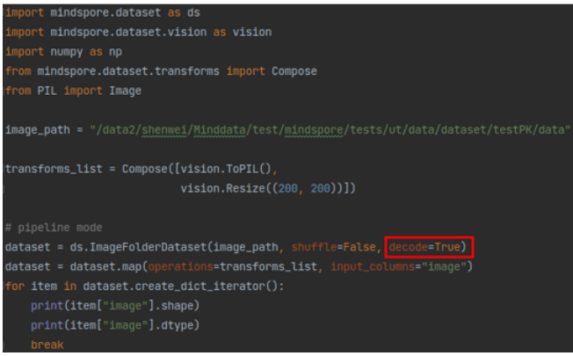2.在构建ImageFolderDataset数据集的时候不设置decode为True，在mapo操作中添加vision.Decode()操作也可以成功执行。Eager模式同样也是这么解决。
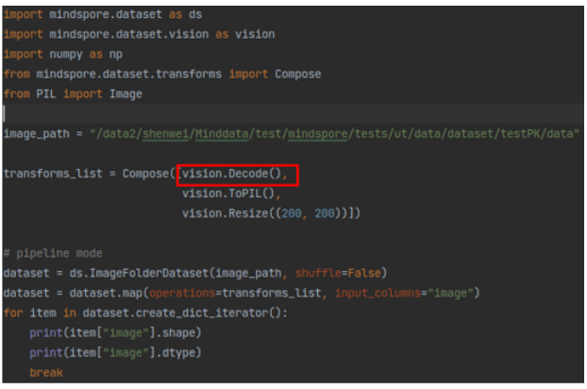

使用MindSpore读取数据报错RuntimeError:Exception thrown from dataset pipeline. Refer to 'Dataset Pipline Error Message'.
1. 系统环境
硬件环境(Ascend/GPU/CPU): Ascend/GPU/CPU
软件环境: MindSpore 版本: 2.2.0
执行模式（静态图/动态图）： 不限
Python 版本: 3.7.6
操作系统平台: linux
2. 报错信息
2.1 问题描述
使用MindSpore读取数据报错RuntimeError:Exception thrown from dataset pipeline. Refer to 'Dataset Pipline Error Message'。
2.3 脚本信息
from mindspore.dataset import MnistDataset
import matplotlib.pyplot as plt
# train_dataset = MnistDataset('MNIST_Data', usage='train', shuffle=True)
train_dataset = MnistDataset('MNIST_Data/train', usage='train', shuffle=True)
def visualize(dataset):
figure = plt.figure(figsize=(4, 4))
cols, rows = 3, 3
plt.subplots_adjust(wspace=0.5, hspace=0.5)
for idx, (image, label) in enumerate(dataset.create_tuple_iterator()):
figure.add_subplot(rows, cols, idx + 1)
plt.title(int(label))
plt.axis("off")
plt.imshow(image.asnumpy().squeeze(), cmap="gray")
if idx == cols + rows - 1:
break
plt.show()
visualize(train_dataset)
3. 根因分析
step1：开启pdb，单步执行，确认报错位置：
python -m pdb test.py
报错位置为 dataset.create_tuple_iterator()
step2：在mindspore.cn搜索接口文档
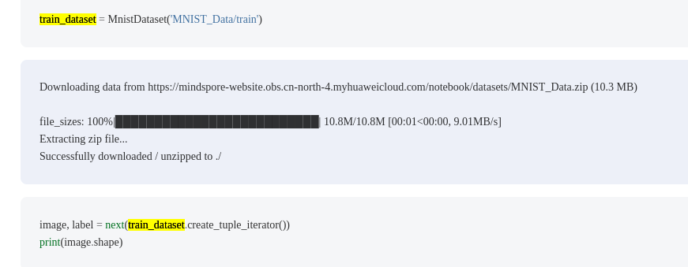从示例上可以看到：创建数据集时，首要指定train或者test子目录; 当前脚本只指定MNIST_Data目录，接口调用报错。
4. 解决方案
将MnistDataset入参从'MNIST_Data'改为'MNIST_Data/train'
train_dataset = MnistDataset('MNIST_Data/train', usage='train', shuffle=True)

使用MindSpore对vision.SlicePatches的数据集切分和合并
1. 系统环境
硬件环境(Ascend/GPU/CPU): Ascend/GPU/CPU
软件环境: MindSpore 版本: 2.0.0
执行模式（静态图/动态图）： 不限
Python 版本: 3.9
操作系统平台: linux
2. 报错信息
2.1 问题描述
采用以下方法将数据集进行切分，怎样将data切分出的["data0", "data1", "data2", "data3", "data4", "data5", "data6", "data7"]列按照顺序进行合并，合并成一列。
2.2 脚本信息
# num_h=1，num_w=8
num_h, num_w = split_size
slice_patches_op = vision.SlicePatches(num_h, num_w)
transforms_list = [slice_patches_op]
# data_cols = ["data0", "data1", "data2", "data3", "data4", "data5", "data6", "data7"]
data_cols = ['data' + str(x) for x in range(num_h * num_w)]
data_set = data_set.map(operations=transforms_list, input_columns=["data"], output_columns=data_cols)
3. 根因分析
SlicePatches 在水平和垂直方向上将Tensor切片为多个块。输出Tensor的数量等于 num_height*num_width
原数据集 ["data"]
切分为["data0", "data1", "data2", "data3", "data4", "data5", "data6", "data7"]
4. 解决方案
通过np.vstack将数据集中的对应的数据进行拼接
import numpy as np
import mindspore.dataset as ds
import mindspore.dataset.vision as vision
num_h=1
num_w=8
# num_h, num_w = split_size
slice_patches_op = vision.SlicePatches(num_h, num_w)
transforms_list = [slice_patches_op]
# data_cols = ["data0", "data1", "data2", "data3", "data4", "data5", "data6", "data7"]
data_cols = ['data' + str(x) for x in range(num_h * num_w)]
data = np.random.randint(0, 255, size=(1, 100, 96)).astype(np.uint8)
data_set = ds.NumpySlicesDataset(data, ["data"])
for item in data_set.create_dict_iterator(num_epochs=1, output_numpy=True):
print(len(item), item["data"].shape, item["data"].dtype)
data_set = data_set.map(operations=transforms_list, input_columns=["data"], output_columns=data_cols)
print(data_set)
for item in data_set.create_dict_iterator(num_epochs=1, output_numpy=True):
x = item["data0"]
for i in range(1,num_h * num_w):
x = np.vstack((x, item[f"data{i}"] ))
break
print(x.shape)
结果如下：
1 (100, 96) uint8
<mindspore.dataset.engine.datasets.MapDataset object at 0x0000029D81616198>
(800, 12)

MindSpore调用Dataset.batch()中per_batch_map函数出错
1. 系统环境
硬件环境(Ascend/GPU/CPU): Ascend/GPU/CPU
软件环境: MindSpore 版本: 2.2.10
执行模式（静态图/动态图）： 不限
Python 版本: 3.8
操作系统平台: linux
2. 报错信息
2.1 问题描述
当设置了per_batch_map字段，batch_size=1时报错，其中can_collator为：
def can_ collator(batch, BatchInfo):
"""
batch: [
image [batch_size, channel, maxHinbatch, maxwinbatch]
image_mask [batch_size, channel, maxHinbatch, maxwinbatch]
label [batch_size, maxLabelLen]
label mask [batch size, maxLabelLen]
...
]
"""
max_width, max_height, max_length =0,0,0
bs, channel = len(batch), batch[0][0].shape[0]
proper_items = [ ]
for item in batch:
if(
item[0]. shape[1] * max width > 1600 * 320
or item[0].shape[2] * max_height > 1600 * 320
):
continue
max_ height =
item[0].shape[1] if item[ø].shape[1] > max_height else max_height
)
max_width = item[0].shape[2] if item[ø].shape[2] > max_width else max_width
max_length = len(item[1]) if len(item[1]) > max_length else max_length
proper_items.append(item)
images = ops.zeros((len(proper_items) , channel, max_height, max_width), dtype=ms. float32
image_masks = ops.zeros(( len(proper_items), 1, max_height, max_width), dtype=ms.float32
labels = ops.zeros((len(proper_i tems), max_length), dtype=ms.int64
label_masks = ops.zeros(( len(proper_items), max_length), dtype=ms. int64)
for i in range(len(proper_items):
_, h, w = proper_items[i][0].shape
images[i][:, :h, :w] = proper_items[i][0]
image_masks[i][:, :h, :w] = 1
l = len(proper_items[i][1])
labels[i][:1] = proper_items[i][1]
label_masks[i][:1] = 1
return images, image_masks, labels, label_masks
2.2 报错信息
size=8
col_name-['images', 'image_masks', 'labels', 'label_masks']
Traceback (most recent call last):
File "/home/ma-user/work/ prtest/mindocr/tests/ut/test_can_dataset.py", line 111, in <module>
for data in data_ loader.create_dict_iterator():
File "/home/ma-user/ anaconda3/envs/Mindspore/lib/python3.7/site-packages/mindspore/dataset/engine/iterators.py", line 145, in __next_.
data = self._get_next()
File "/home/ma-user/anaconda3/envs/Mindspore/lib/python3.7/site-packages/mindspore/dataset/engine/ iterators .py", line 270, in _get_next
raise err
File "/home/ma-user/anaconda3/envs/Mindspore/1ib/python3.7/site-packages/mindspore/dataset/engine/iterators .py", line 253, in _get_next
return {k: self._transform md _to_output(t) for k, t in self._iterator GetNextAsMap(). items()}
RuntimeError: Exception thrown from user defined Python function in dataset.
Python Call stack:
TypeError: Traceback (most recent call last):
File "/home/ma-user/anaconda3/envs/Mindspore/1ib/python3.7/site-packages/mindspore/dataset/transforms/py_transforms_util.py", line 198, in __cal1
result = self.transform(*args)
TypeError: can_ collator() takes2 positional arguments but 3were given
Dataset Pipeline Error Message:
[ERROR] Execute user Python code failed, check 'Python Cal1 stack' above.
2.3 脚本信息
dataloader = ds.batch(
batch_size,
drop_remainder=drop_remainder,
num_parallel_workers=min(
num_workers, 2
), # set small workers for lite computation. ToDo: increase for batch-wise mapping
# input_columns=["image","label"],
output_columns=["images", "image_masks", "labels", "label_masks"],
per_batch_map=can_collator , # uncomment to use inner-batch transformation
)
return dataloader
3. 根因分析
从报错来看
TypeError: can_ collator() takes2 positional arguments but 3were given
因为输入是有两列，分别是image和label，因此传到can_collator函数分别是image列数据，label列数据， 和BatchInfo。
并不是上面理解的整个输入作为入参。
4. 解决方案
修改can_collator的入参定义如下。
def can_collator(image，label , BatchInfo):
内部的代码也要按照入参来修改。

使用MindSpore对vision.SlicePatches的数据集切分和合并
1. 系统环境
硬件环境(Ascend/GPU/CPU): Ascend/GPU/CPU
软件环境: MindSpore 版本: 2.0.0
执行模式（静态图/动态图）： 不限
Python 版本: 3.9
操作系统平台: linux
2. 报错信息
2.1 问题描述
采用以下方法将数据集进行切分，怎样将data切分出的["data0", "data1", "data2", "data3", "data4", "data5", "data6", "data7"]列按照顺序进行合并，合并成一列。
2.3 脚本信息
# num_h=1，num_w=8
num_h, num_w = split_size
slice_patches_op = vision.SlicePatches(num_h, num_w)
transforms_list = [slice_patches_op]
# data_cols = ["data0", "data1", "data2", "data3", "data4", "data5", "data6", "data7"]
data_cols = ['data' + str(x) for x in range(num_h * num_w)]
data_set = data_set.map(operations=transforms_list, input_columns=["data"], output_columns=data_cols)
3. 根因分析
在data0 - data7 是8个不同的数据，其中的一个列就只代表一种数据。如果想把这些数据都加起来可以参考。
# num_h=1，num_w=8
num_h, num_w = split_size
slice_patches_op = vision.SlicePatches(num_h, num_w)
transforms_list = [slice_patches_op]
# data_cols = ["data0", "data1", "data2", "data3", "data4", "data5", "data6", "data7"]
data_cols = ['data' + str(x) for x in range(num_h * num_w)]
data_set = data_set.map(operations=transforms_list, input_columns=["data"], output_columns=data_cols)
def merge_col(data0, data1, data2, data3, data4, data5, data6, data7):
data_X = data0+data1+data2+data3+data4+data5+data6+data7
return data_X
data_set = data_set.map(operations=merge_col, input_columns=data_cols, output_columns=["data_X"])
如果是一张size为4096*4096的图片，经过切分之后变成了8张4096*512的图片，现在想把这个8张4096*512的图片整合成一个数据集，之后进行训练，且样本的顺序为每张图片的切分顺序，data0-data7是8个不同的数据集，每个数据集共有10个样本。这里的合并是把这8列数据重新合成一列，这一列一共有8*10个样本。
data_set = data_set.map(operations=transforms_list, input_columns=["data"], output_columns=data_cols)
for data in data_set.create_dict_iterator(output_numpy=True):
data0,data1,data2,data3,data4,data5,data6,data7 = data
save or merge data locally...

报错：mindspore._c_expression.typing.TensorType object is not callable
1. 系统环境
硬件环境(Ascend/GPU/CPU): Ascend/GPU/CPU
软件环境: MindSpore 版本: 1.8.1
执行模式（静态图/动态图）： 不限
Python 版本: 3.9.13
操作系统平台: linux
2. 报错信息
2.1 问题描述
创建Tensor时报错。
2.2 报错信息
Traceback (most recent call last):
File "D:\test.py", line 3, in
t1 = mindspore.tensor([1,2,3])
TypeError: 'mindspore._c_expression.typing.TensorType' object is not callable
2.3 脚本信息
import mindspore
t1 = mindspore.tensor([1,2,3])
print(t1)
3. 根因分析
代码中Tensor错误的写成了小写tensor，应该为Tensor
mindspore源码里面__init__.py。
from .common import *
common\__init__.py
from . import dtype
common\dtype.py
tensor = typing.TensorType()
TensorType定义如下：
class TensorType(Type):
# no doc
def element_type(self): # real signature unknown; restored from __doc__
""" element_type(self: mindspore._c_expression.typing.TensorType) -> mindspore._c_expression.typing.Type """
pass
def __getstate__(self): # real signature unknown; restored from __doc__
""" __getstate__(self: mindspore._c_expression.typing.TensorType) -> tuple """
return ()
def __init__(self, *args, **kwargs): # real signature unknown; restored from __doc__
"""
__init__(*args, **kwargs)
Overloaded function.
1. __init__(self: mindspore._c_expression.typing.TensorType) -> None
2. __init__(self: mindspore._c_expression.typing.TensorType, element: mindspore._c_expression.typing.Type) -> None
"""
pass
def __setstate__(self, arg0): # real signature unknown; restored from __doc__
""" __setstate__(self: mindspore._c_expression.typing.TensorType, arg0: tuple) -> None """
pass
父类定义如下：
class Type(__pybind11_builtins.pybind11_object):
# no doc
def __deepcopy__(self, arg0): # real signature unknown; restored from __doc__
""" __deepcopy__(self: mindspore._c_expression.typing.Type, arg0: dict) -> mindspore._c_expression.typing.Type """
pass
def __eq__(self, arg0): # real signature unknown; restored from __doc__
""" __eq__(self: mindspore._c_expression.typing.Type, arg0: object) -> bool """
return False
def __hash__(self): # real signature unknown; restored from __doc__
""" __hash__(self: mindspore._c_expression.typing.Type) -> int """
return 0
def __init__(self, *args, **kwargs): # real signature unknown
pass
def __repr__(self): # real signature unknown; restored from __doc__
""" __repr__(self: mindspore._c_expression.typing.Type) -> str """
return ""
def __str__(self): # real signature unknown; restored from __doc__
""" __str__(self: mindspore._c_expression.typing.Type) -> str """
return ""
typing.TensorType()([1,2,3]) 这种方式是无法调用的，所以会报错。
common\__init__.py
from .tensor import Tensor, RowTensor, SparseTensor, COOTensor, CSRTensor
mindspore.Tensor 最终调用的是common\tensor.py里面的Tensor类
4. 解决方案
修改mindspore.tensor 为mindspore.Tensor
import mindspore
t1 = mindspore.Tensor([1,2,3])
print(t1)

Ascend print数据落盘使用
1. 系统环境
硬件环境(Ascend/GPU/CPU): Ascend/GPU/CPU
软件环境: MindSpore 版本: 2.2.10
执行模式（静态图/动态图）： 不限
Python 版本: 3.8
操作系统平台: linux
2. 报错信息
Ascend print数据落盘使用
3. 根因分析
mindspore的Print算子有两种模式，一种是直接打屏，还有一种是数据落盘，保存到二进制文件中。默认打印在屏幕上。也可以保存在文件中，通过 context 设置 print_file_path 参数。一旦设置，输出将保存在指定文件中。通过函数 mindspore.parse_print() 可以重新加载数据。而且print_file_path只在Ascend上设置生效。
4. 解决方案
1. 保存print的数据到文件中，关键的代码为：
context.set_context(print_file_path=print_file)
from mindspore import nn
from mindspore.ops import operations as ops
from mindspore import Tensor
import numpy as np
from mindspore import context
from mindspore.train.serialization import parse_print
print_file = "kkkk.log"
context.set_context(print_file_path=print_file)
class PrintDemo(nn.Cell):
def __init__(self):
super(PrintDemo, self).__init__()
self.print = ops.Print()
def construct(self, x, y):
self.print('Print Tensor x and Tensor y:', x, y)
return x
x = Tensor(np.ones([2, 1]).astype(np.int32))
y = Tensor(np.ones([2, 2]).astype(np.int32))
net = PrintDemo()
result = net(x, y)
2. 通过parse_print接口，读取保存的数据，关键代码为：
file = parse_print(print_file)
from mindspore import nn
from mindspore.ops import operations as ops
from mindspore import Tensor
import numpy as np
from mindspore import context
from mindspore.train.serialization import parse_print
print_file = "kkkk.log"
file = parse_print(print_file)
print("kkkk0", file[0])
print("kkkk1", file[1])
print("kkkk2", file[2])
两个不能放在同一个文件中执行，若是放在一个文件中执行，读取的时候会报错，说没有数据。

MindSpore在construct中进行标量计算
1. 系统环境
硬件环境(Ascend/GPU/CPU): Ascend
软件环境: MindSpore 版本: 1.8.0
执行模式（静态图/动态图）： 静态图
Python 版本: 3.7.5
操作系统平台: linux
2. 报错信息
2.1 问题描述
在MindSpore的Construct中实现标量计算，实例：
2.2 脚本信息
N=a.shape[0]
h,w = int(math.sqrt(N))，int(math.sqrt(N))
3. 解决方案
MindSpore中可以用@constexpr装饰的func来实现标量计算，例如上述实例可实现为：
@constexpr
def func(N):
h,w = int(math.sqrt(N))，int(math.sqrt(N))
class net(nn.Cell):
def construct(self, x):
N = x.shape[0]
h,w = func(N)

MindSpore报错：module 'mindspore.dataset.vision' has no attribute 'Normalize'
1. 系统环境
硬件环境(Ascend/GPU/CPU): Ascend/GPU/CPU
软件环境: MindSpore 版本: 1.5.0
执行模式： 不限
Python 版本: 3.7.6
操作系统平台: linux
2. 报错信息
2.1 问题描述
在华为modelarts上使用mindspore进行模型训练时报错，提示导入包时没有Normalize属性。
2.2 报错信息
AttributeError:module 'mindspore.dataset.vision' has no attribute 'Normalize'
3. 根因分析
这是因为MindSpore的版本问题。从1.8版本开始，mindspore.dataset.vision中加入了Normalize函数，用于进行归一化。但是本次实验使用的MindSpore版本为1.7，在旧版本中，Normalize函数所在的模块有变化，查阅资料发现其被放在了mindspore.dataset.vision.c_transforms模块下。
4. 解决方案
为了解决这一问题，可以修改模块的导入方式。打开datasets.py文件，将模块的导入语句修改为实际上Normalize函数所在的模块即可。
import mindspore.dataset.vision.c_transforms as C
import mindspore.dataset.transforms.c_transforms as C2

使用Dataset处理数据过程中如何优化内存占用高的问题
1. 背景说明
针对一些资源（CPU和Memory）比较紧张的环境，在进行数据预处理时会出现CPU占用过高，或者内存占用高的情况。
主要原因如下：
1.在使用mindspore.dataset进行数据集加载、预处理时，mindspore.dataset主要是使用Host侧CPU和Memory资源。
2.而Dataset的经典处理流程如下： **Dataset(...) → .map(...) → .map(...) → .batch(...) → .create_dict_iterator(...) 其中每个节点之间都有一个队列用来缓存数据（会占用内存），进而实现整个流程的Pipeline，另外部分参数的默认值（如：并行度高导致内存占用高）适用于服务器环境，所以对于CPU和Memory比较紧张的环境，需要通过配置、参数或者脚本优化来进一下的减少内存占用。
那么可以参考如下方法降低CPU/内存的占用。
2. 报错举例
1.日志报错输出 - LLVM ERROR: out of memory
参考链接：https://bbs.huaweicloud.com/forum/thread-152749-1-1.html
2.日志输出告警 - Memory consumption is more than …, which may cause oom error. 参考链接：https://gitee.com/mindspore/mindspore/issues/I4JUOX
3.日志报错输出 - dataset/util/arena.cc … cudaHostAlloc failed, ret[2], out of memory
参考链接：https://bbs.huaweicloud.com/forum/thread-164821-1-1.html
3. 现有状态说明
以ImageNet数据集为例，其样本个数为128w+，典型的数据预处理流程如下：
import multiprocessing
import mindspore as ms
import mindspore.dataset as ds
from mindspore.communication.management import init, get_rank, get_group_size
dataset_path = "/data2/ImageNet_Original/train"
batch_size = 32
train_image_size = 224
data_set = ds.ImageFolderDataset(dataset_path, num_parallel_workers=12, shuffle=True)
mean = [0.485 * 255, 0.456 * 255, 0.406 * 255]
std = [0.229 * 255, 0.224 * 255, 0.225 * 255]
# define map operations
random_crop_decode_resize_op = ds.vision.c_transforms.RandomCropDecodeResize(train_image_size, scale=(0.08, 1.0), ratio=(0.75, 1.333)),
random_horizontal_flip_op = ds.vision.c_transforms.RandomHorizontalFlip(prob=0.5)
normalize_op = ds.vision.c_transforms.Normalize(mean=mean, std=std)
hwc2chw_op = ds.vision.c_transforms.HWC2CHW()
type_cast_op = ds.transforms.c_transforms.TypeCast(ms.int32)
data_set = data_set.map(operations=random_crop_decode_resize_op, input_columns="image", num_parallel_workers=12)
data_set = data_set.map(operations=random_horizontal_flip_op, input_columns="image", num_parallel_workers=12)
data_set = data_set.map(operations=normalize_op, input_columns="image", num_parallel_workers=12)
data_set = data_set.map(operations=hwc2chw_op, input_columns="image", num_parallel_workers=12)
data_set = data_set.map(operations=type_cast_op, input_columns="label", num_parallel_workers=12)
# apply batch operations
data_set = data_set.batch(batch_size, drop_remainder=True)
count = 0
for item in data_set.create_dict_iterator(output_numpy=True):
count += 1
if count % 1000 == 0:
print("count: {}".format(count))
机器配置如下：
CPU: Intel(R) Xeon(R) CPU E7-4890 v2 @ 2.80GHz ，核数：120 内存：250G
当前脚本运行后内存及cpu占用如下：
PID USER PR NI VIRT RES SHR S %CPU %MEM TIME+ COMMAND
xxxx xxx 20 0 11.0g 1.5g 66652 S 2993 0.6 19:43.85 python
4. 优化方法及效果
1 通过配置预取大小减少内存占用
在定义数据集Dataset对象前，设置Dataset数据处理预取的大小，ds.config.set_prefetch_size(2)。
脚本变化：
ds.config.set_prefetch_size(2)
内存及CPU占用：
PID USER PR NI VIRT RES SHR S %CPU %MEM TIME+ COMMAND
xxxx xxx 20 0 10.9g 1.3g 67004 S 2483 0.5 23:37.22 python
2 通过减少数据集加载类Dataset参数num_parallel_workers减少内存占用
在定义Dataset对象时，设置其参数num_parallel_workers为1。
脚本变化：
28c28
data_set = ds.ImageFolderDataset(dataset_path, num_parallel_workers=12, shuffle=True)
---
data_set = ds.ImageFolderDataset(dataset_path, num_parallel_workers=1, shuffle=True)
内存及CPU占用：
PID USER PR NI VIRT RES SHR S %CPU %MEM TIME+ COMMAND
xxxx xxx 20 0 9900300 1.0g 66652 S 1455 0.4 12:53.03 python
3 通过减少数据预处理操作.map(...)参数num_parallel_workers减少内存占用
如果对**Dataset对象进一步使用了.map(...)操作，可以设置.map(...)的参数num_parallel_workers为1。
脚本变化：
40,44c40,44
data_set = data_set.map(operations=random_crop_decode_resize_op, input_columns="image", num_parallel_workers=12)
data_set = data_set.map(operations=random_horizontal_flip_op, input_columns="image", num_parallel_workers=12)
data_set = data_set.map(operations=normalize_op, input_columns="image", num_parallel_workers=12)
data_set = data_set.map(operations=hwc2chw_op, input_columns="image", num_parallel_workers=12)
data_set = data_set.map(operations=type_cast_op, input_columns="label", num_parallel_workers=12)
---
data_set = data_set.map(operations=random_crop_decode_resize_op, input_columns="image", num_parallel_workers=1)
data_set = data_set.map(operations=random_horizontal_flip_op, input_columns="image", num_parallel_workers=1)
data_set = data_set.map(operations=normalize_op, input_columns="image", num_parallel_workers=1)
data_set = data_set.map(operations=hwc2chw_op, input_columns="image", num_parallel_workers=1)
data_set = data_set.map(operations=type_cast_op, input_columns="label", num_parallel_workers=1)
内存及CPU占用：
PID USER PR NI VIRT RES SHR S %CPU %MEM TIME+ COMMAND
xxxx xxx 20 0 5845040 746140 66668 S 170.9 0.3 3:49.30 python
4 通过减少数据batch操作.batch(...)参数num_parallel_workers减少内存占用
如果对**Dataset对象进一步使用了.batch(...)操作，可以设置.batch(...)的参数num_parallel_workers为1。
脚本变化：
47c47
data_set = data_set.batch(batch_size, drop_remainder=True)
---
data_set = data_set.batch(batch_size, drop_remainder=True, num_parallel_workers=1)
内存及CPU占用：
PID USER PR NI VIRT RES SHR S %CPU %MEM TIME+ COMMAND
xxxx xxx 20 0 5328916 496948 66652 S 187.4 0.2 3:25.25 python
5 通过减少数据map操作.map(...)的个数来减少内存占用
如果有多个.map(...)操作，可以将多个.map(...)操作合并为一个。
脚本变化：
34,37c34,39
random_crop_decode_resize_op = ds.vision.c_transforms.RandomCropDecodeResize(train_image_size, scale=(0.08, 1.0), ratio=(0.75, 1.333)),
random_horizontal_flip_op = ds.vision.c_transforms.RandomHorizontalFlip(prob=0.5)
normalize_op = ds.vision.c_transforms.Normalize(mean=mean, std=std)
hwc2chw_op = ds.vision.c_transforms.HWC2CHW()
---
trans = [
ds.vision.c_transforms.RandomCropDecodeResize(train_image_size, scale=(0.08, 1.0), ratio=(0.75, 1.333)),
ds.vision.c_transforms.RandomHorizontalFlip(prob=0.5),
ds.vision.c_transforms.Normalize(mean=mean, std=std),
ds.vision.c_transforms.HWC2CHW()
]
40,43c42
data_set = data_set.map(operations=random_crop_decode_resize_op, input_columns="image", num_parallel_workers=1)
data_set = data_set.map(operations=random_horizontal_flip_op, input_columns="image", num_parallel_workers=1)
data_set = data_set.map(operations=normalize_op, input_columns="image", num_parallel_workers=1)
data_set = data_set.map(operations=hwc2chw_op, input_columns="image", num_parallel_workers=1)
---
data_set = data_set.map(operations=trans, input_columns="image", num_parallel_workers=1)
内存及CPU占用：
PID USER PR NI VIRT RES SHR S %CPU %MEM TIME+ COMMAND
xxxx xxx 20 0 4665328 496364 66652 S 128.2 0.2 4:30.55 python
6 通过减少数据shuffle操作.shuffle(...)的buffer_size大小来减少内存占用
如果有.shuffle(...)操作，减少buffer_size的大小，因为这个是内存缓存的shuffle，是需要缓存buffer_size大小样本在内存中进行shuffle，所以buffer_size越大，占用的内存也越大。
7 通过减少数据.batch(...)参数batch_size的大小减少内存占用
如果有.batch(...)操作，减少batch_size的大小，可以减少batch操作缓存的数据量，尽而减少内存占用。
5. 总结
使用各种优化后内存、CPU占用如下：
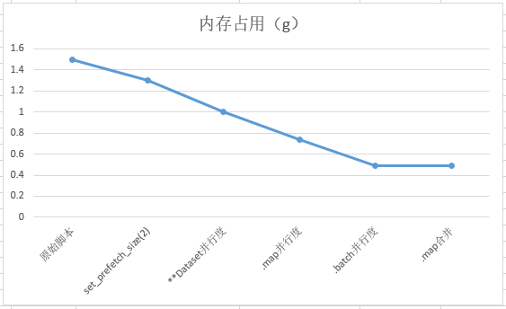
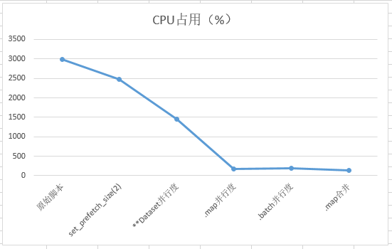

模型构建与训练报错案例
3.1 报错RuntimeError:Exceed function call depth limit 1000
3.2 报错:AttributeError: Tensor has no attribute
3.3 报错AttributeError:NoneType has no attribute...
3.4 报错:the dimension of logits must be equal to 2
3.5 报错ValueError:For 'Pad', all elements of paddings must be >= 0.
3.6 报错ValueError:For xx,the x shape:xx must be equal to xxx
3.7 报类型错误TypeError: For 'Tensor', the type of `input_data` should be one of ...
3.8 报错 ScatterNdUpdate这个算子在Ascend硬件上不支持input0是int32的数据类型
3.9 报错TypeError: ScalarAdd不支持bool类型，官网缺少说明
3.10 报RuntimeError:ReduceSum算子不支持8维及以上的输入而报错
3.11 报类型错误:Unsupported parameter type for python primitive...
3.12 报错RuntimeError: Primitive ScatterAdd's bprop not defined.
3.13 报运行时错误: For Conv2d,x shape的C_in除以group应等于weight的C_in
3.14 报错：alueError: For 'Reshape', the shape of 'input_x' is [65209], the value of 'input_shape' value is [16302, 4].
3.15 报错ValueError: For xxx,x和y的shape不支持 broadcast
3.16 报错“ValueError: For MatMul, the input dimensions必须相等
3.17 报错：Can not select a valid kernel info for [Default/Pow-op0] in AI CORE or AI CPU kernel info candidates list
3.18 报错：ValueError: `x rank` in `NLLLoss` should be int and must in [1, 2], but got `4` with type `int
3.19 报错：Select GPU kernel op[BatchNorm] fail! Incompatible data type!
3.20 报错：ValueError: For 'MirrorPad', paddings must be a Tensor with type of int64, but got None.
3.21 报错：For primitive[TensorSummary], the v rank 必须大于等于0
3.22 报错：TypeError: For 'CellList', each cell should be subclass of Cell, but got NoneType.
3.23 报错：task_fail_info or current_graph_ is nullptr
3.24 报错ValueError：`padding_idx` in `Embedding超出范围
3.25 报错ValueError: `seed2` in `StandardNormal` should be int and must >= 0
3.26 报错 Ascend 环境下ReduceMean不支持8维及其以上的输入
3.27 报错： Conv2D第三维输出数据类型必须是正整数或者SHP_ANY
3.28 报错：For 'TopK', the type of 'x' should be one of Tensor[Int32]
3.29 报错Minimum inputs size 0 does not match the requires signature size 2
3.30 报错ValueError: Currently `half_pixel_centers`=True only support in Ascend device_target, but got CPU
3.31 报错ValueError: For AvgPool输出形状的每一维都要大于零
3.32 报错TypeError: The function construct needs 0 positional argument and 0 default argument, but provided 1
3.33 报错Operator[ ] input( ) output( ) is not support
3.34 报错 sth should be initialized as a Parameter type in ...
3.35 报错：The 'add' operation does not support the type [kMetaTypeNone, Int64].
3.36 报错：When eval 'Tensor(self.data, mindspore.float32)' by using Fallback feature, an error occurred: data.
3.37 报错RuntimeError: Net parameters weight shape ((751, 512)) is different from parameter_dict's ((31789, 512))
3.38 GPU设备提示:The device with Cuda compute capability 5.2 is lower than the minimum required capability 5.3
3.39 GPU环境运行MindSpore报错：设卡失败 SetDevice failed
3.40 Ascend环境使用MindSpore报出如下错误: Total stream number xxx exceeds the limit of 1024, secrch details information in mindspore's FAQ.
3.41 LoadTask Distribute Task Failed 报错解决
3.42 GPU训练提示分配流失败[cudaStreamCreate failed]
3.43 GPU训练过程中报错：The memory alloc size is 0
3.44 报错：ValueError: For 'load_checkpoint', the checkpoint
3.45 加载checkpoint的时候报warning日志xxx parameters in the 'net' are not loaded, because they are not in the 'parameter_dict'
3.46 报错：ValueError: For 'context.set_context', package type xxx support 'device_target' type xxx, but got xxx.
3.47 PyNative模式下The pointer[top_cell_] is null错误
3.48 报错RuntimeError:alloc device memory failed, free memory size is less than half of total memory size.
3.49 报错ValueError: Please input the correct checkpoint
3.50 求导传入sens值时infer报错ValueError: For 'MatMul', the input dimensions must be equal
3.51 没有ckpt文件导致模型加载执行报错：please check whether the 'ckpt_file_name' is correct
3.52 Tensor张量shape不匹配导致执行报错：ValueError: For 'Sub', x.shape and y.shape are supposed to broadcast
3.53 自定义loss没有继承nn.Cell导致执行报错：ParseStatement] Unsupported statement 'Try'.
3.54 参数类型错误导致优化器执行报错：TypeError: For 'Optimizer', the argument parameters must be Iterable type
3.55 形参与实参的不对应导致ops.GradOperation执行报错：The parameters number of the function is 2, but the number of provided arguments is 1.
3.56 return回来的参数承接问题导致执行报错：AttributeError: 'tuple' object has no attribute 'asnumpy'
3.57 维度数错误引起模型输入错误：For primitive[Conv2D], the x shape size must be equal to 4, but got 3.
3.58 报错：The value parameter,it's name 'xxxx' already exsts. please set a unique name for the parameter .
3.59 construct方法名称错误引起损失函数执行报错:The 'sub' operation does not support the type [Tensor[Float32], None].
3.60 RuntimeError:The 'sub' operation does not support the type [Tensor[Float32], None].
3.61 注释不当报错：There are incorrect indentations in definition or comment of function: 'Net.construct'.
3.62 静态图执行卡死问题：For MakeTuple, the inputs should not be empty..node:xxxxxxxxxxxx
3.63 报错: module() takes at most 2 arguments (3 given)
3.64 报错ERROR：For 'ScatterNdAdd', the 3-th value of 'indices'[7] is out of range[4]scatterNdAdd.
3.65 使用ops.nonzero算子报错TypeError: Type Join Failed: dtype1 = Float32, dtype2 = Int64.
3.66 调用MindSpore内部函数时的语法错误TypeError: 'module' object is not callable
3.67 MindSpore在静态图模式下使用try语法报错RuntimeError: Unsupported statement 'Try'.
3.68 MindSpore报错: ValueError: For 'MatMul', the input dimensions must be equal, but got 'x1_col': 817920 and 'x2_row': 272640.
3.69 MindSpore 报错提示 DropoutGrad 的bprop反向未定义："Illegal primitive: Primitive DropoutGrad’s bprop not defined."
3.70 MindSpore报错The graph generated form MindIR is not support to execute in the PynativeMode,please convert to the GraphMode
3.71 MindSpore报错RuntimeError: For ’Optimizer’, the argument group params must not be empty.
3.72 使用mindspore.ops.MaxPool3D算子设置为ceil_mode=True时，在MindSpore1.8.1和1.9.0版本中计算结果不一致
3.73 Construct内报错和定位解决
3.74 gather算子报错：TypeError以及定位解决
3.75 报错：module() takes at most 2 arguments (3 given)
3.76 注释不当报错：There are incorrect indentations in definition or comment of function: 'Net.construct'.
3.77 MindSpore报错untimeError: Exceed function call depth limit 1000.
3.78 MindSpore图编译报错TypeError: ‘int’ object is not iterable.
3.79 MindSpore报错RuntimeError: The 'getitem' operation does not support the type [Func, Int64].
3.80 MindSpore cpu版本源码编译失败
3.81 MindSpore图编译报错TypeError: ‘int’ object is not iterable.
3.82 MindSpore的Cell.insert_child_to_cell 添加层会出现参数名重复
3.83 mindspore.numpy.unique() 不支持 0 shape tensor
3.84 MindSpore直接将Tensor从布尔值转换为浮点数导致错误Error: IndexError: index 1 is out of bounds for dimension with size 1
3.85 MindSpore中的mindspore.numpy.bincount 大数值情况下报ValueError定位与解决
3.86 使用mindspore.numpy.broadcast_to 算子报错及解决
3.87 使用MindSpore中的SoftMax()算子计算单一数据出错Run op inputs type is invalid!
3.88 CSRTensor 矩阵乘法计算出错RuntimeError:CUDA Error: cudaMemcpy failed.|Error Number: 700 an illegal memory access was encountered
3.89 Cell对象序列化失败-使用pickle.dumps保存到本地后重新加载失败
3.90 TopK算子返回的全零的Tensor的解决
3.91 在NPU上的切片操作x=x[:,::-1,:,:]不生效的分析解决
3.92 张量运算失败报错RuntimeError:Malloc for kernel output failed, Memory isn’t enough
3.93 MindSpore Dump功能使用经验
3.94 使用SymbolTree.get_network处理conv2d算子时报错NameError:name "Cell" is not defined
3.95 使用mindspore中Conv2dTranspose的outputpadding时，设置has_bias=True时失效
3.96 使用mindspore.ops.pad算子报错位置有误
3.97 使用mindspore.numpy.sqrt 计算结果不正确
3.98 函数变换获得梯度计算函数时报错AttributeError: module 'mindspore' has no attribute 'value_and_grad'
3.99 自定义ops.Custom报错TypeError: function output_tensor expects two inputs, but get 1
3.100 报错ValueError: Input buffer_size is not within the required interval of [2, 2147483647].
3.101 使用MindSpore的LayerNorm报错ValueError: For 'LayerNorm', gamma or beta shape must match input shape.
3.102 使用nn.pad报错RuntimeError:For 'Pad', output buffer memset failed
3.103 使用shard接口遇到空指针的报错RuntineError: The pointer [comm_lib_instance_] is null.
3.104 AttributeError: Tensor[Int64] object has no attribute: asnumpy
3.105 使用计算得到的Tensor进行slicing赋值时报错RuntimeError: The int64_t value(-1) is less than 0.
3.106 总loss由多个loss组成时的组合
3.107 使用classmindspore_rl.policy.EpsilonGreedyPolicy发现维度不匹配及解决
3.108 自定义Callback重载函数调用顺序错误及解决
3.109 MindSpore报错：all types should be same, but got [mindspore.tensor[float64], mindspore.tensor[float32]
3.110 MindSpore在GRAPH_MODE下初始化，报错提示当前的执行模式是禁用了任务下沉（TASK_SINK）
3.111 使用vision.ToPIL在一定情况下无效
3.112 MindSpore不能像torch的param.grad直接获取梯度问题
3.113 MindSpore跑resnet50报错For 'MatMul' the input dimensions must be equal, but got 'x1_col': 32768 and 'x2_row': 2048
3.114 新节点24使用piecewise_constant_lr造成梯度异常
3.115 MindSpore报错AttributeError: module 'mindspore.ops' has no attribute 'mm'
3.116 MindSpore报错'Resize' from mindspore.dataset.vision.c_transforms is deprecated
3.117 MindSpore中的text_format.Merge和text_format.Parse的区别
3.118 MindSpore如何将add_node函数添加节点信息到self.node中
3.119 如何读取MindSpore中的.pb文件中的节点
3.120 MindSpore报错Please try to reduce 'batch_size' or check whether exists extra large shape.及解决
3.121 MindSpore报错RuntimeError: Load op info form json config failed, version: Ascend310
3.122 MindSpore跑resnet50报错For 'MatMul' the input dimensions must be equal, but got 'x1_col': 32768 and 'x2_row': 2048
3.123 使用MindSpore的ops中的矩阵相乘算子进行int8的相乘运算时报错
3.124 使用Mindspore模型训练时出现梯度为0现象
3.125 MindSpore开启summary报错ValueError: not enough values to unpack (expected 4, got 0)
3.126 使用MindSpore实现梯度对数据求导retain_graph=True
3.127 使用SummaryRecord记录计算图报错：Failed to get proto for graph.
3.128 使用MindSpore的initializer生成的Tensor行为不符合预期
3.129 MindSpore的VIT报错[OneHot] failed. OneHot: index values should not bigger than num classes: 100, but got: 100.
3.130 MindSpore使用run_pyscf跑量子化学时报错Invalid cross-device link
3.131 算子编译过程中报错A module that was compiled using NumPy 1.x cannot be run in Numpy 2.0.0 .
3.132 MindSpore神经网络训练中的梯度消失问题
3.133 MindSpore报错：The supported input and output data types for the current operator are: node is Default/BitwiseAnd
3.134 MindSpore模型加载报错RuntimeError: build from file failed! Error is Common error code.
3.135 MindSpore模型转换报错RuntimeError: Can not find key SiLU in convert nap. Exporting SiLU operator is not yet supported.
3.136 MindSpore报错Kernel launch failed, msg: Acl compile and execute failed, op_type_:AvgPool3D
3.137 MindSpore报错“ValueError: For 'MatMul', the input dimensions必须相等
3.138 类型报错： 编译报错，编译时报错 “Shape Join Failed”
3.139 Asttokens版本稳定性性的问题
3.140 [MindSpore报错ValueError: x rank in NLLLoss should be int and must in [1, 2], but got 4 with type `int]
3.141 MindSpore PyNative模式下The pointer[top_cell_] is null错误
3.142 MindSpore报错ERROR:PyNative Only support STAND_ALONE,DATA_PARALLEL and AUTO_PARALLEL under shard function for ParallelMode
3.143 LeNet-5实际应用中报错以及调试过程
3.144 使用自定义数据集运行模型，报错TypeError: The predict type and infer type is not match, predict type is Tuple
3.145 MindSpore Dump功能使用经验
3.146 MindSpore 图算融合 GPU调试
3.147 MindSpore 静态图网络编译使用HyperMap优化编译性能
3.148 MindSpore 静态图网络编译使用Select算子优化编译性能
3.149 MindSpore 静态图网络编译使用编译缓存或者vmap优化性能
3.150 MindSpore模型权重功能无法保存更新后的权重
3.151 模型微调报错RuntimeError: Preprocess failed before run graph 1.
3.152 Mindspore训练plog中算子GatherV2_xxx_high_precision_xx报错
3.153 使用Profiler()函数，报错RuntimeError: The output path of profiler only supports alphabets(a-zA-Z)
3.154 使用dataset.create_dict_iterator()后，计算前向网络报错：untimeError: Illegal AnfNode for evaluating, node: @Batch
3.155 使用MindSpore静态图速度慢的问题
3.156 MindSpore报错refer to Ascend Error Message
3.157 Ascend上构建MindSpore报has no member named 'update output desc dpse' ;did you mean 'update_output_desc_dq'?
3.158 用ADGEN数据集评估时报错not support in PyNative RunOp!
3.159 使用mint.arctan2在图模式下报错RuntimeError: Compile graph kernel_graph0 failed.
3.160 模型训练时报错RuntimeError: aclnnFlashAttentionScoreGetWorkspaceSize call failed, please check!
3.161 运行MindCV案例报错Malloc for kernel input failed, Memory isn't enough, node:Default/ReduceMean-op0
3.162 使用mindspore.ops.Bernoulli在昇腾设备上训练报错RuntimeError: Sync stream failed:Ascend_0
3.163 使用mint.arctan2在图模式下报错RuntimeError: Compile graph kernel_graph0 failed.
3.164 MindCV训练报错ValueError: For 'context.set_context', the keyword argument jit_config is notrecognized!
3.165 GRAPH_MODE下运行ms_tensor = mint.ones_like(input_tensor, dtype=dtype)报错The pointer[device_address] is null.
3.166 使用mint.index_select 在图模式下求梯度报错AssertionError
3.167 使用mindspore.mint.where()报错The supported input and output data types for the current operator are: node is Default/Bitwis
3.168 使用mindspore.mint.gather函数计算出的结果错误
3.169 使用Modelarts训练yolov5出现报错TypeError: modelarts_pre_process() missing 1 required positional argument:’args’
3.170 使用mint.masked_select在图模式下报错Parse Lambda Function Fail. Node type must be Lambda, but got Call.
3.171 导入TextClassifier接口报错ModuleNotFoundError: No module named ‘mindnlp.models’
3.172 模型调用Pad接口填充报错For ‘Pad’, output buffer memset failed.
3.173 模型初始化和加载时间过长解决
3.174 静态式下报错TypeError: pynative模式不支持重新计算

报错RuntimeError:Exceed function call depth limit 1000
1. 报错描述
1.1 系统环境
Hardware Environment(Ascend/GPU/CPU): Ascend
Software Environment:
-- MindSpore version (source or binary): 1.6.0
-- Python version (e.g., Python 3.7.5): 3.7.6
-- OS platform and distribution (e.g., Linux Ubuntu 16.04): Ubuntu 4.15.0-74-generic
-- GCC/Compiler version (if compiled from source):
1.2 基本信息
1.2.1 脚本
训练脚本是通过构建Concat单算子网络，在特定的轴连接张量的例子。脚本如下：
1 context.set_context(mode=context.GRAPH_MODE, device_target=&quot;Ascend&quot;)
2 class Net(nn.Cell):
3 def __init__(self):
4 super(Net, self).__init__()
5 self.concat = ops.Concat()
6
7 def construct(self, x):
8 n = 1000
9 input_x = ()
10 for i in range(n):
11 input_x += (x,)
12 output = self.concat(input_x)
13 return output
14
15 net = Net()
16 input_x1 = Tensor(np.random.rand(1, 4, 16, 16), mindspore.float32)
17 output = net(input_x1)
18 print(f"输出结果：{output.shape}")
报错
这里报错信息如下：
Traceback (most recent call last):
File &quot;demo.py&quot;, line 17, in &lt;module&gt;
output = net(input_x1)
File &quot; /lib/python3.7/site-packages/mindspore/nn/cell.py&quot;, line 542, in __call__
out = self.compile_and_run(*args)
File &quot; lib/python3.7/site-packages/mindspore/nn/cell.py&quot;, line 872, in compile_and_run
self.compile(*inputs)
File &quot;/lib/python3.7/site-packages/mindspore/nn/cell.py&quot;, line 857, in compile
_cell_graph_executor.compile(self, *inputs, phase=self.phase, auto_parallel_mode=self._auto_parallel_mode)
File &quot;/lib/python3.7/site-packages/mindspore/common/api.py&quot;, line 712, in compile
result = self._graph_executor.compile(obj, args_list, phase, self._use_vm_mode())
RuntimeError: mindspore/ccsrc/pipeline/jit/static_analysis/evaluator.cc:100 EnterStackFrame] Exceed function call depth limit 1000, (function call depth: 1001, simulate call depth: 999).
It's always happened with complex construction of code or infinite recursion or loop.
Please check the code if it's has the infinite recursion or call 'context.set_context(max_call_depth=value)' to adjust this value.
If max_call_depth is set larger, the system max stack depth should be set larger too to avoid stack overflow.
For more details, please refer to the FAQ at https://www.mindspore.cn.
The function call stack (See file 'demo/rank_0/om/analyze_fail.dat' for more details):
\# 0 In file demo.py(10)
​ for i in range(n):
\# 1 In file /lib/python3.7/site-packages/mindspore/_extends/parse/standard_method.py(1441)
return it.__ms_hasnext__()
​
\# 2 In file /lib/python3.7/site-packages/mindspore/_extends/parse/standard_method.py(1860)
return len(xs) &gt; 0
原因分析
我们看报错信息，在RuntimeError中，写到Exceed function call depth limit 1000, (function call depth: 1001, simulate call depth: 999)，意思是超过函数调用深度限制1000，(函数调用深度:1001，模拟调用深度:999)，这是由于函数默认调用最大限度设置为1000，继续看报错信息，写到Please check the code if it's has the infinite recursion or call 'context.set_context(max_call_depth=value)' to adjust this value，即检查代码是否存在无限递归计算，或者调用**context.set_context(max_call_depth=value)**，调整函数深度限制的默认设置。
2. 解决方法
基于上面已知的原因，很容易做出如下修改：
1 context.set_context(mode=context.GRAPH_MODE, max_call_depth=20000,device_target=&quot;Ascend&quot;)
2 class Net(nn.Cell):
3 def __init__(self):
4 super(Net, self).__init__()
5 self.concat = ops.Concat()
6
7 def construct(self, x):
8 n = 1000
9 input_x = ()
10 for i in range(n):
11 input_x += (x,)
12 output = self.concat(input_x)
13 return output
14
15 net = Net()
16 input_x1 = Tensor(np.random.rand(1, 196, 80, 38), mindspore.float32)
17 output = net(input_x1)
18 print(f"输出结果：{output.shape}")
此时执行成功，输出如下：
输出结果：(1000, 196, 80, 38)
3. 总结
定位报错问题的步骤：
1、 找到报错的用户代码行：output = net(input_x1);
2、 根据日志报错信息中的关键字，缩小分析问题的范围: Exceed function call depth limit 1000, (function call depth: 1001, simulate call depth: 999);
3、 根据报错提示信息进行修改默认设置，call 'context.set_context(max_call_depth=value)' to adjust this value；
4、 需要重点关注变量定义、初始化的正确性。
4. 参考文档
4.1 Concat算子API接口

报错:AttributeError: Tensor has no attribute
1. 报错描述
1.1 系统环境
Hardware Environment(Ascend/GPU/CPU): Ascend
Software Environment:
-- MindSpore version (source or binary): 1.6.0
-- Python version (e.g., Python 3.7.5): 3.7.6
-- OS platform and distribution (e.g., Linux Ubuntu 16.04): 4.19.36-vhulk1907.1.0.h619.eulerosv2r8.aarch64
-- GCC/Compiler version (if compiled from source):
1.2 基本信息
1.2.1 脚本
训练脚本构建了一个简单的张量Tensor,并尝试去获取张量中的数据。脚本如下：
import mindspore
import numpy as np
from mindspore import Parametar, nn, ops, Tensor
a = Tensor(np.arange(10, 16).reshape(2, 3).astype(np.float32))
print(a.data)
1.2.2 报错
这里报错信息如下：
Traceback (most recent call last):
File "demo.py", line 4, in <module>
print(a.data)
AttributeError: 'Tensor' object has no attribute 'data'
2. 原因分析
​在MindSpore中，Tensor对象并无属性data。而在脚本中第4行代码发现了尝试通过调用Tensor张量的data属性，获取Tensor中的数据。
​通过官方文档查询Tensor可以发现，并未在官方公布属性中，查找到Tensor的data属性。
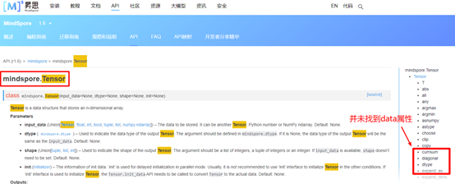
​其实，要想获取Tensor中的数据，可以直接打印该Tensor，也可以通过asnumpy属性转化为numpy进行输出，或者其他方法转换。
3. 解决方法
基于上面已知的原因，很容易做出如下修改：
import mindspore
import numpy as np
from mindspore import Parametar, nn, ops, Tensor
a = Tensor(np.arange(10, 16).reshape(2, 3).astype("float32"))
print(a.data)
此时执行成功，输出如下：
[[10. 11. 12.]
[13. 14. 15.]]
4. 总结
定位报错问题的步骤：
1、 找到报错的用户代码行： print(a.data)；
2、 根据日志报错信息中的关键字，缩小分析问题的范围：AttributeError，该关键字表示属性错误；
3、需要重点关注变量属性的正确性。
5. 参考文档
5.1 Tensor算子API接口

报错AttributeError:NoneType has no attribute...
1. 报错描述
1.1 系统环境
Hardware Environment(Ascend/GPU/CPU): Ascend
Software Environment:
-- MindSpore version (source or binary): 1.6.0
-- Python version (e.g., Python 3.7.5): 3.7.6
-- OS platform and distribution (e.g., Linux Ubuntu 16.04): Ubuntu 4.15.0-74-generic
-- GCC/Compiler version (if compiled from source):
1.2 基本信息
1.2.1 脚本
训练脚本是通过图模式测试自定义Parameter类，构建MatMul单算子网络的例子。脚本如下：
01 class my_paramter(Parameter):
02 def __init__(self, data, requires_grad):
03 super(my_paramter, self).__init__(data, requires_grad)
04 self.name = None
05
06 class Net(nn.Cell):
07 def __init__(self):
08 super(Net, self).__init__()
09 self.matmul = ops.MatMul()
10 self.weight = my_paramter(Tensor(np.ones((1, 2)), mindspore.float32),name='w', requires_grad=True)
11
12 def construct(self, x):
13 out = self.matmul(self.weight, x)
14 return out
15
16 net = Net()
17 x = Tensor(np.ones((2, 1)), mindspore.float32)
18 output = net(x)
19 print('output:',output)
1.2.2 报错
这里报错信息如下：
Traceback (most recent call last):
File &quot;demo.py&quot;, line 16, in &lt;module&gt;
net = Net()
File &quot;/home/test/demo.py&quot;, line 10, in __init__
self.weight = my_paramter(Tensor(np.ones((1, 2)), mindspore.float32),name='w', requires_grad=True)
File &quot;test/lib/python3.9/site-packages/mindspore/nn/cell.py&quot;, line 590, in __setattr__
self._set_attr_for_parameter(name, value)
File &quot;test/lib/python3.9/site-packages/mindspore/nn/cell.py&quot;, line 492, in _set_attr_for_parameter
self.insert_param_to_cell(name, value)
File &quot;test/lib/python3.9/site-packages/mindspore/nn/cell.py&quot;, line 798, in insert_param_to_cell
if isinstance(param, Parameter) and param.name == PARAMETER_NAME_DEFAULT:
File &quot;test/lib/python3.9/site-packages/mindspore/common/parameter.py&quot;, line 300, in name
return self.param_info.name
AttributeError: 'NoneType' object has no attribute 'name'.
原因分析 我们看报错信息，在AttributeError中，写到*'NoneType' object has no attribute 'name'*，意思是'NoneType'对象没有name属性，这是由于Parameter不允许派生子类，因此不能自行定义类Parameter。建议采用官方Parameter算子进行初始化。
2. 解决方法
基于上面已知的原因，很容易做出如下修改：
01 class Net(nn.Cell):
02 def __init__(self):
03 super(Net, self).__init__()
04 self.matmul = ops.MatMul()
05 self.weight = Parameter(Tensor(np.ones((1, 2)), mindspore.float32),name='w', requires_grad=True)
06
07 def construct(self, x):
08 out = self.matmul(self.weight, x)
09 return out
10
11 net = Net()
12 x = Tensor(np.ones((2, 1)), mindspore.float32)
13 output = net(x)
14 print('output:',output)
此时执行成功，输出如下：
output: [[2.]]
3. 总结
定位报错问题的步骤：
1、 找到报错的用户代码行：self.weight = my_paramter(Tensor(np.ones((1, 2)), mindspore.float32),name='w', requires_grad=True);
2、 根据日志报错信息中的关键字，缩小分析问题的范围: 'NoneType' object has no attribute 'name';
3、 需要重点关注变量定义、初始化的正确性。
4. 参考文档
4.1 API映射

报错:the dimension of logits must be equal to 2
1. 报错描述
1.1 系统环境
Hardware Environment(Ascend/GPU/CPU): Ascend Software Environment: -- MindSpore version (source or binary): 1.6.0 -- Python version (e.g., Python 3.7.5): 3.7.6 -- OS platform and distribution (e.g., Linux Ubuntu 16.04): Ubuntu 4.15.0-74-generic -- GCC/Compiler version (if compiled from source):
1.2 基本信息
1.2.1 脚本
训练脚本是通过构建SoftmaxCrossEntropyWithLogits的单算子网络，计算两个变量softmax 交叉熵的例子。脚本如下：
01 class Net(nn.Cell):
02 def __init__(self):
03 super(Net, self).__init__()
04 self.loss = nn.SoftmaxCrossEntropyWithLogits(sparse=False)
05
06 def construct(self, logits, labels):
07 output = self.loss(logits, labels)
08 return output
09
10 net = Net()
11 logits = Tensor(np.array([[[2, 4, 1, 4, 5], [2, 1, 2, 4, 3]]]), mindspore.float32)
12 labels = Tensor(np.array([[[0, 0, 0, 0, 1], [0, 0, 0, 1, 0]]]).astype(np.float32))
13 out = net(logits, labels)
14 print('out',out)
1.2.2 报错
这里报错信息如下：
Traceback (most recent call last):
File 'demo.py', line 13, in &lt;module&gt;
​ out = net(logits, labels)
…
ValueError: mindspore/core/utils/check_convert_utils.cc:395 CheckInteger] For primitive[SoftmaxCrossEntropyWithLogits], the dimension of logits must be equal to 2, but got 3.
The function call stack (See file ' rank_0/om/analyze_fail.dat' for more details):
\# 0 In file demo.py(04)
​ output = self.loss(logits, labels)
原因分析
我们看报错信息，在ValueError中，写到For primitive[SoftmaxCrossEntropyWithLogits], the dimension of logits must be equal to 2, but got 3，意思是传的logits应该等于2维，但是你传进去的logits的shape却是3维，查看官网对logits的描述可知，支持的shape为(N,C)。
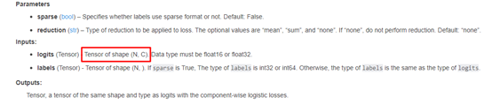
​对于3维数据，建议先reshape成2维(N*L, C)，然后再调用nn.SoftmaxCrossEntropyWithLogits接口，执行完后再reshape回 (N, 1)。
2. 解决方法
基于上面已知的原因，很容易做出如下修改：
1 class Net(nn.Cell):
2 def __init__(self):
3 super(Net, self).__init__()
4 self.loss = nn.SoftmaxCrossEntropyWithLogits(sparse=False)
5
6 def construct(self, logits, labels):
7 output = self.loss(logits, labels)
8 return output
9
10 net = Net()
11 logits = Tensor(np.array([[[2, 4, 1, 4, 5], [2, 1, 2, 4, 3]]]), mindspore.float32)
12 labels = Tensor(np.array([[[0, 0, 0, 0, 1], [0, 0, 0, 1, 0]]]).astype(np.float32))
13 L, N, C = logits.shape
14 logits,labels = logits.reshape(L*N, C),labels.reshape(L*N, C)
15 out = net(logits, labels)
16 out = out.reshape(N,1)
17 print('out',out)
此时执行成功，输出如下：
out [[0.5899297 ]
[0.52374405]]
3. 总结
定位报错问题的步骤：
1、找到报错的用户代码行：output = self.loss(logits, labels);
2、 根据日志报错信息中的关键字，缩小分析问题的范围the dimension of logits must be equal to 2, but got ;
3、需要重点关注变量定义、初始化的正确性。
4. 参考文档
4.1 SoftmaxCrossEntropyWithLogits算子API接口

报错ValueError:For 'Pad', all elements of paddings must be >= 0.
1. 报错描述
1.1 系统环境
Hardware Environment(Ascend/GPU/CPU): Ascend Software Environment: -- MindSpore version (source or binary): 1.6.0 -- Python version (e.g., Python 3.7.5): 3.7.6 -- OS platform and distribution (e.g., Linux Ubuntu 16.04): Ubuntu 4.15.0-74-generic -- GCC/Compiler version (if compiled from source):
1.2 基本信息
1.2.1 脚本
训练脚本是通过构建Pad的单算子网络，对输入张量进行边界填充。脚本如下：
01 class Net(nn.Cell):
02 def __init__(self):
03 super(Net, self).__init__()
04 self.pad_op = nn.Pad(((0, 0), (-1, 1)))
05
06 def construct(self, input_x):
07 output = self.pad_op(input_x)
08 return output
09 net = Net()
10
11 input_x = Tensor(np.ones([3, 3]),mindspore.float32)
12 output = net(input_x)
13 print('output shape',output.shape)
1.2.2 报错
这里报错信息如下：
[INFO] ANALYZER(169538,ffffb713b010,python):2022-04-07-11:09:58.692.494 [mindspore/ccsrc/pipeline/jit/static_analysis/async_eval_result.cc:103] Wait] Infer finished.
Traceback (most recent call last):
File &quot;pad.py&quot;, line 12, in &lt;module&gt;
output = net(input_x)
File &quot;/lib/python3.7/site-packages/mindspore/nn/cell.py&quot;, line 569, in __call__
out = self.compile_and_run(*args)
File &quot;/lib/python3.7/site-packages/mindspore/nn/cell.py&quot;, line 899, in compile_and_run
self.compile(*inputs)
File &quot;/lib/python3.7/site-packages/mindspore/nn/cell.py&quot;, line 884, in compile
_cell_graph_executor.compile(self, *inputs, phase=self.phase, auto_parallel_mode=self._auto_parallel_mode)
File &quot;/lib/python3.7/site-packages/mindspore/common/api.py&quot;, line 784, in compile
result = self._graph_executor.compile(obj, args_list, phase, self._use_vm_mode())
File &quot;/lib/python3.7/site-packages/mindspore/ops/primitive.py&quot;, line 575, in __infer__
out[track] = fn(*(x[track] for x in args))
File &quot;/lib/python3.7/site-packages/mindspore/ops/operations/nn_ops.py&quot;, line 3944, in infer_shape
raise ValueError(f&quot;For '{self.name}', all elements of paddings must be &gt;= 0.&quot;)
ValueError: For 'Pad', all elements of paddings must be &gt;= 0.
原因分析
我们看报错信息，在ValueError中，写到For 'Pad', all elements of paddings must be >= 0，意思是传的paddings必须大于等于0，根据这个报错和报错代码行很容易回溯到04行代码初始化padding属性值时，传入了负数-1，此时在API映射中查询pad可知，pytorch与MindSpore的pad算子存在使用差异（如图），
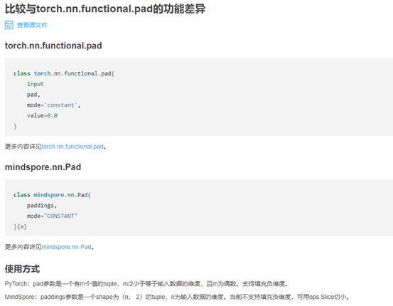
详见https://www.mindspore. cn/docs/migration_guide/zh-CN/r1.6/api_mapping/pytorch_diff/Pad.html。值得注意的是，在官网r1.3版本中写的是torch.nn.functional.pad和mindspore.ops.Pad功能一致，该处描述存在一定的缺陷，在r1.5分支及其以后分支中均已对两者的异同点进行了描述。
pytorch中能够传入负数，示例脚本如下：
1 x = torch.empty(3, 3)
2 pad = (-1, 1)
3 output = torch.nn.functional.pad(x, pad)
4 print('output shape',output.shape)
执行成功的输出如下：
output shape torch.Size([3, 3])
2. 解决方法
基于上面已知的原因，很容易做出如下修改：
01 class Net(nn.Cell):
02 def __init__(self):
03 super(Net, self).__init__()
04 self.pad_op = nn.Pad(((0, 0), (1, 1)))
05
06 def construct(self, input_x):
07 output = self.pad_op(input_x)
08 return output
09 net = Net()
10
11 input_x = Tensor(np.ones([3, 3]),mindspore.float32)
12 output = net(input_x)
13 print('output shape',output.shape)
此时执行成功，输出如下：
output shape (3, 5)
3. 总结
定位报错问题的步骤：
1、 找到报错的用户代码行：output = self.pad_op(input_x);
2、 根据日志报错信息中的关键字，缩小分析问题的范围： For 'Pad', all elements of paddings must be >= 0;
3、 查询不同版本上的API映射，与标杆算子进行对比；
4、 需要重点关注变量定义、初始化的正确性。
4. 参考文档
4.1 API映射

报错ValueError:For xx,the x shape:xx must be equal to xxx
1. 报错描述
1.1 系统环境
Hardware Environment(Ascend/GPU/CPU): Ascend
Software Environment:
-- MindSpore version (source or binary): 1.6.0
-- Python version (e.g., Python 3.7.5): 3.7.6
-- OS platform and distribution (e.g., Linux Ubuntu 16.04): Ubuntu 4.15.0-74-generic
-- GCC/Compiler version (if compiled from source):
1.2 基本信息
1.2.1 脚本
训练脚本是通过构建BinaryCrossEntropy单算子网络，计算两个变量二进制交叉熵的例子。脚本如下：
import mindspore.nn as nn
class Net(nn.Cell):
def __init__(self):
super(Net, self).__init__()
self.binary_cross_entropy = ops.BinaryCrossEntropy()
self.weight = None
def construct(self, logits, labels):
result = self.binary_cross_entropy(logits, labels)
return result
logits = Tensor(np.random.uniform(0, 1, (4, 3, 388, 388)).astype(np.float32))
labels = Tensor(np.random.randint(0, 2, (4, 2, 388, 388)).astype(np.float32))
net = Net()
out = net(logits, labels)
print(‘out:’,out)
1.2.2 报错
这里报错信息如下：
Traceback (most recent call last):
File "demo.py", line 14, in <module>
out = net(logits, labels)
File "../lib/python3.7/site-packages/mindspore/nn/cell.py", line 569, in __call__
out = self.compile_and_run(*args)
File "../lib/python3.7/site-packages/mindspore/nn/cell.py", line 899, in compile_and_run
self.compile(*inputs)
File "../lib/python3.7/site-packages/mindspore/nn/cell.py", line 884, in compile
_cell_graph_executor.compile(self, *inputs, phase=self.phase, auto_parallel_mode=self._auto_parallel_mode)
File "../lib/python3.7/site-packages/mindspore/common/api.py", line 784, in compile
result = self._graph_executor.compile(obj, args_list, phase, self._use_vm_mode())
ValueError: mindspore/core/utils/check_convert_utils.h:216 Check] For primitive[BinaryCrossEntropy], the x shape: [4,3,388,388,] must be equal to [4,2,388,388,]
The function call stack (See file 'demo/rank_0/om/analyze_fail.dat' for more details):
# 0 In file demo.py(08)
result = self.binary_cross_entropy(logits, labels, self.weight)
原因分析
我们看报错信息，在ValueError中，写到*For primitive[BinaryCrossEntropy], the x shape: [4,3,388,388,] must be equal to [4,2,388,388,]*，意思是传的labels的shape是 [4, 2, 388, 388]，但是你传进去的logits的shape却是[4, 3, 388, 388]，而所有的损失函数都会要求logits和labels的shape必须一样，在官网中对BinaryCrossEntropy输入logits和labels的shape做了限制说明。 ​
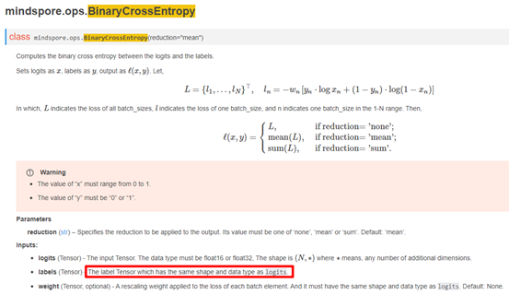
检查代码发现，12行代码labels的维度为确实不等于logits，此时需要检查传入值是否有问题，使logits和labels的shape相等。
2. 解决方法
基于上面已知的原因，很容易做出如下修改:
import mindspore.nn as nn
class Net(nn.Cell):
def __init__(self):
super(Net, self).__init__()
self.binary_cross_entropy = ops.BinaryCrossEntropy()
self.weight = None
def construct(self, logits, labels):
result = self.binary_cross_entropy(logits, labels)
return result
logits = Tensor(np.random.uniform(0, 1, (4, 3, 388, 388)).astype(np.float32))
labels = Tensor(np.random.randint(0, 2, (4, 3, 388, 388)).astype(np.float32))
net = Net()
out = net(logits, labels)
print(‘out:’,out)
此时执行成功，输出如下：
out: 1.0000657
3. 总结
定位报错问题的步骤：
1、找到报错的用户代码行：
result = self.binary_cross_entropy(logits, labels, self.weight);
2、 根据日志报错信息中的关键字，缩小分析问题的范围： the x shape: [4,3,388,388,] must be equal to [4,2,388,388,];
3、需要重点关注变量定义、初始化的正确性。
4. 参考文档
4.1 BinaryCrossEntropy算子API接口

报类型错误TypeError: For 'Tensor', the type of `input_data` should be one of ...
1. 报错描述
1.1 系统环境
Hardware Environment(Ascend/GPU/CPU): Ascend Software Environment: -- MindSpore version (source or binary): 1.6.0 -- Python version (e.g., Python 3.7.5): 3.7.6 -- OS platform and distribution (e.g., Linux Ubuntu 16.04): Ubuntu 4.15.0-74-generic -- GCC/Compiler version (if compiled from source):
1.2 基本信息
1.2.1 脚本
训练脚本如下：
from mindspore import Tensor
a = Tensor({1.1: -2.1})
output = a.abs()
print('result:',output)
1.2.2 报错
这里报错信息如下：
Traceback (most recent call last):
File &quot;demo.py&quot;, line 02, in &lt;module&gt;
a = Tensor({1.1: -2.1})
…
TypeError: For 'Tensor', the type of `input_data` should be one of '['Tensor', 'ndarray', 'str_', 'list', 'tuple', 'float', 'int', 'bool', 'complex']', but got '{1.1: -2.1}' with type 'dict'.
原因分析
​对于MindSpore 1.6版本，通过官方api接口，构建简单单算子用例。在报错信息中，写到*TypeError: For 'Tensor', the type of input_data should be one of '['Tensor', 'ndarray', 'str', 'list', 'tuple', 'float', 'int', 'bool', 'complex']', but got '{1.1: -2.1}' with type 'dict'*，首先报错类型是TypeError，即类型错误，在随后的描述中写到，传入的input_data类型应该是'['Tensor', 'ndarray', 'str_', 'list', 'tuple', 'float', 'int', 'bool', 'complex']中的一种，但是传入的却是字典类型。这点在官网对Tensor的介绍中也做了相应的描述。
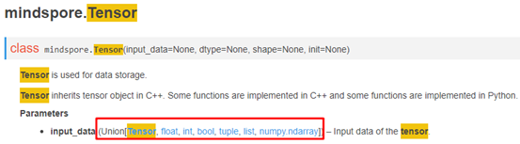
因此需要对传入的数据类型进行修改。
2. 解决方法
基于上面已知的原因，很容易做出如下修改：
from mindspore import Tensor
a = Tensor({1.1, -2.1})
output = a.abs()
print('result:',output)
此时执行成功，输出如下：
result: [1.1 2.1]
3. 总结
定位报错问题的步骤：
1、找到报错的用户代码行：a = Tensor({1.1: -2.1});
2、 根据日志报错信息中的关键字，缩小分析问题的范围： the type of input_data should be one of xxx, but got type 'dict';
3、需要重点关注变量定义、初始化的正确性。
4. 参考文档
4.1 Tensor算子API接口

报错 ScatterNdUpdate这个算子在Ascend硬件上不支持input0是int32的数据类型
1. 报错描述
1.1 系统环境
Hardware Environment(Ascend/GPU/CPU): Ascend Software Environment: -- MindSpore version (source or binary): 1.6.0 -- Python version (e.g., Python 3.7.5): 3.7.6 -- OS platform and distribution (e.g., Linux Ubuntu 16.04): Ubuntu 4.15.0-74-generic -- GCC/Compiler version (if compiled from source):
1.2 基本信息
1.2.1 脚本
训练脚本是通过构建ScatterNdUpdate的单算子网络，使用索引和输入张量的值更新张量值。脚本如下：
01 class Net(nn.Cell):
02 def __init__(self, x):
03 super(Net, self).__init__()
04 self.x = Parameter(x, name=&quot;x&quot;)
05 self.scatter_nd_update = ops.ScatterNdUpdate()
06
07 def construct(self, indices, updates):
08 output = self.scatter_nd_update(self.x, indices, updates)
09 return output
10 input_x = Tensor(np.array([[-2, 3, 6], [4, 5, -3]]), mindspore.int32)
11 net = Net(input_x)
12 indices = Tensor(np.array([[0, 0], [1, 1]]), mindspore.int32)
13 updates = Tensor(np.array([1.0, 2.2]), mindspore.float32)
14 output = net(indices, updates)
15 print('output', output)
1.2.2 报错
这里报错信息如下：
Traceback (most recent call last):
File 'demo.py', line 14, in &lt;module&gt;
​ output = net(indices, updates)
…
RuntimeError: mindspore/ccsrc/frontend/operator/composite/do_signature.cc:360 RaiseExceptionForConvertRefDtype] Data type conversion of 'Parameter' is not supported, so data type int32 cannot be converted to data type float32 automatically.
For more details, please refer at https://www.mindspore.cn/docs/note/zh-CN/master/operator_list_implicit.html.
The function call stack (See file ' /rank_0/om/analyze_fail.dat' for more details):
\# 0 In file demo.py(05)
​ output = self.scatter_nd_update(self.x, indices, updates)
原因分析
我们看报错信息，在RuntimeError中，写到Data type conversion of 'Parameter' is not supported, so data type int32 cannot be converted to data type float32 automatically，意思是传入Parameter的数据类型并不支持，因为int32不能转为float32，但是再接着看提示报错提示代码，*output = self.scatter_nd_update(self.x, indices, updates)*，结合Parameter和代码input_x = Tensor(np.array([[-2, 3, 6], [4, 5, -3]]), mindspore.int32)可知，该处数据类型需要进行转换为float32，此时用Cast算子将数据类型int32转为float32即可。
2. 解决方法
基于上面已知的原因，很容易做出如下修改：
01 class Net(nn.Cell):
02 def __init__(self,x):
03 super(Net, self).__init__()
04 self.x = Parameter(x,name=&quot;x&quot;)
05 self.scatter_nd_update = ops.ScatterNdUpdate(
06
07 def construct(self, indices, updates):
08 output = self.scatter_nd_update(self.x, indices, updates)
09 return output
10 input_x = Tensor(np.array([[-2, 3, 6], [4, 5, -3]]), mindspore.int32)
11 input_x = ops.Cast()(input_x, mindspore.float32)
12 net = Net(input_x)
13 indices = Tensor(np.array([[0, 0], [1, 1]]), mindspore.int32)
14 updates = Tensor(np.array([1.0, 2.2]), mindspore.float32)
15 output = net( indices, updates)
16 print('output', output)
此时执行成功，输出如下：
output [[ 1. 3. 6. ]
[ 4. 2.2 -3. ]]
3. 总结
定位报错问题的步骤：
1、找到报错的用户代码行：output = self.scatter_nd_update(self.x, indices, updates);
2、 根据日志报错信息中的关键字，缩小分析问题的范围：Data type conversion of 'Parameter' is not supported, so data type int32 cannot be converted to data type float32 automatically;
3、需要重点关注变量定义、初始化的正确性。
4. 参考文档
4.1 ScatterAdd算子API接口

报错TypeError: ScalarAdd不支持bool类型，官网缺少说明
1. 报错描述
1.1 系统环境
Hardware Environment(Ascend/GPU/CPU): Ascend Software Environment: -- MindSpore version (source or binary): 1.6.0 -- Python version (e.g., Python 3.7.5): 3.7.6 -- OS platform and distribution (e.g., Linux Ubuntu 16.04): Ubuntu 4.15.0-74-generic -- GCC/Compiler version (if compiled from source):
1.2 基本信息
1.2.1 脚本
训练脚本如下：
01 from mindspore import ops
02 x = False
03 y = True
04 output = ops.scalar_add(x, y)
05 print('output', output)
1.2.2 报错
这里报错信息如下：
[CRITICAL] ANALYZER(143497,ffffb898c010,python):2022-04-07-10:19:58.194.241 [mindspore/ccsrc/frontend/operator/cc_implementations.cc:227] ScalarAdd] Unsupported input type for ScalarAdd, type of x:BoolImm, value of x:false, type of y:BoolImm, value of y:true
Traceback (most recent call last):
File "demo.py", line 4, in <module>
output = ops.scalar_add(x, y)
File "/lib/python3.7/site-packages/mindspore/ops/primitive.py", line 294, in __call__
return _run_op(self, self.name, args)
File "/lib/python3.7/site-packages/mindspore/common/api.py", line 89, in wrapper
results = fn(*arg, **kwargs)
File "/lib/python3.7/site-packages/mindspore/ops/primitive.py", line 754, in _run_op
output = real_run_op(obj, op_name, args)
TypeError: mindspore/ccsrc/frontend/operator/cc_implementations.cc:227 ScalarAdd] Unsupported input type for ScalarAdd, type of x:BoolImm, value of x:false, type of y:BoolImm, value of y:true
原因分析
对于MindSpore 1.6版本，通过官方API接口，构建简单单算子用例。在报错信息中，写到Unsupported input type for ScalarAdd, type of x:BoolImm, value of x:false, type of y:BoolImm, value of y:true，意思是ScalarAdd不支持bool类型，需要对代码进行修正。在官网对scalar_add也做了相应的描述，即该算子用法和Python中的‘+’，显然，在Python中bool类型是不能进行求和运算。
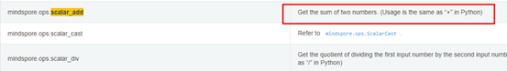
因此需要对传入的数据进行修改。
2. 解决方法
基于上面已知的原因，很容易做出如下修改：
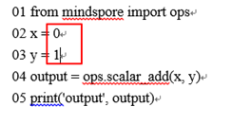
此时执行成功，输出如下：
result: 1
3. 总结
定位报错问题的步骤：
1、 找到报错的用户代码行：*output = ops.scalar_add(x, y)*；
2、 根据日志报错信息中的关键字，缩小分析问题的范围：Unsupported input type for ScalarAdd, type of x:BoolImm；
3、需要重点关注变量定义、初始化的正确性。
4. 参考文档
4.1 ScalarAdd算子API接口

报RuntimeError:ReduceSum算子不支持8维及以上的输入而报错
1. 报错描述
1.1 系统环境
Hardware Environment(Ascend/GPU/CPU): Ascend Software Environment: -- MindSpore version (source or binary): 1.6.0 -- Python version (e.g., Python 3.7.5): 3.7.6 -- OS platform and distribution (e.g., Linux Ubuntu 16.04): Ubuntu 4.15.0-74-generic -- GCC/Compiler version (if compiled from source):
1.2 基本信息
1.2.1 脚本
训练脚本是通过构建ReduceSum的单算子网络，通过对维度中的所有元素求和来减少张量的维度。脚本如下：
01 class Net(Cell):
02 def __init__(self, axis, keep_dims):
03 super().__init__()
04 self.reducesum = ops.ReduceSum(keep_dims=keep_dims)
05 self.axis = axis
06 def construct(self, input_x):
07 return self.reducesum(input_x, self.axis)
08
09 x = Tensor(np.random.randn(10, 5, 4, 4, 4, 4, 4, 4, 4, 4),mindspore.float32)
10 net = Net(axis=(1,), keep_dims=True)
11 out = net(x)
12 print(&quot;out&quot;,out.shape)
13 #print(out)
1.2.2 报错
这里报错信息如下：
Traceback (most recent call last):
File &quot;demo4.py&quot;, line 11, in &lt;module&gt;
out = net(x)
…
RuntimeError: ({'errCode': 'E80012', 'op_name': 'reduce_sum_d', 'param_name': 'x', 'min_value': 0, 'max_value': 8, 'real_value': 10}, 'In op, the num of dimensions of input/output[x] should be inthe range of [0, 8], but actually is [10].')
The function call stack:
In file demo4.py(07)/ return self.reducesum(input_x, self.axis)/
2. 原因分析
我们看报错信息：在RuntimeError中，max_value为8，而real_value却为10，显然超过了ReduceSum算子支持的维度，在后续提示中写到，输入参数维度应该在[0,8]之间,在官网中对ReduceSum也做了输入维度限制说明。
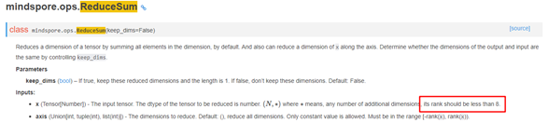
检查代码发现，09行代码维度为10，变量定义存在问题。需要将值设定为[0,8]。
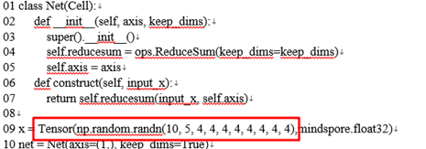
3. 解决方法
基于上面已知的原因，很容易做出如下修改：
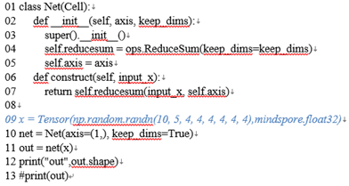
此时执行成功，输出如下：
out (10, 1, 4, 4, 4, 4, 4, 4)
4. 总结
定位报错问题的步骤：
1、 找到报错的用户代码行：return self.reducesum(input_x, self.axis);
2、 根据日志报错信息中的关键字，缩小分析问题的范围：should be in the range of [0, 8], but actually is [10];
3、需要重点关注变量定义、初始化的正确性。
5. 参考文档
5.1 ReduceSum算子API接口

报类型错误:Unsupported parameter type for python primitive...
1. 报错描述
1.1 系统环境
*Hardware Environment(Ascend/GPU/CPU): Ascend
Software Environment:
-- MindSpore version (source or binary): 1.6.0
-- Python version (e.g., Python 3.7.5): 3.7.6
-- OS platform and distribution (e.g., Linux Ubuntu 16.04): Ubuntu 4.15.0-74-generic
-- GCC/Compiler version (if compiled from source):
1.2 基本信息
1.2.1 脚本
训练脚本是通过对ReduceMean构建单算子网络，求维度中的所有元素的平均来减少张量的维度。脚本如下：
01 class Net(nn.Cell):
02 def __init__(self):
03 super(Net, self).__init__()
04 self.reduce_mean = ops.ReduceMean(keep_dims=True)
05
06 def construct(self, x):
07 out = self.reduce_mean(x, axis=(2, 3))
08 return out
09
10 net = Net()
11 x = Tensor(np.ones((3, 4, 5, 6), dtype=np.float32), mindspore.float32)
12 out = net(x)
13 print('out',out.shape)
1.2.2 报错
这里报错信息如下：
Traceback (most recent call last):
File 'demo.py', line 10, in &lt;module&gt;
​ out = net(x)
…
TypeError: mindspore/ccsrc/pipeline/jit/static_analysis/prim.cc:597 ConvertAbstractToPython] Unsupported parameter type for python primitive, the parameter value is KeywordArg[key : axis, value : (2, 3)]
The function call stack (See file 'rank_0/om/analyze_fail.dat' for more details):
\# 0 In file demo.py(07)
​ out = self.reduce_mean(x, axis=(2, 3))
原因分析
我们看报错信息，在TypeError中，写到*Unsupported parameter type for python primitive, the parameter value is KeywordArg[key : axis, value : (2, 3)]，意思是不支持以键值对的方式传参进行初始化，但是你传进去的是一个key为axis, value为(2, 3)的键值对，在之后的out = self.reduce_mean(x, axis=(2, 3))*提示中也指出了报错的代码内容，在官网的用例中也能发现，用例为传值的方式，而不是传键值对。
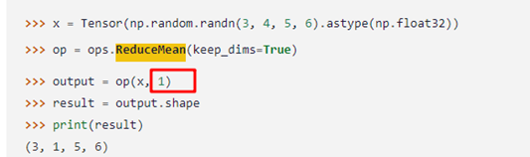
2. 解决方法
基于上面已知的原因，很容易做出如下修改：
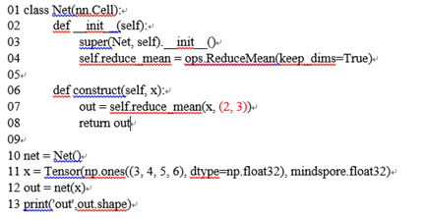
此时执行成功，输出如下：
out (3, 4, 1, 1)
3. 总结
定位报错问题的步骤：
1、找到报错的用户代码行：out = self.reduce_mean(x, axis=(2, 3)); 2、 根据日志报错信息中的关键字，缩小分析问题的范围：out = self.reduce_mean(x, axis=(2, 3)); 3、需要重点关注变量定义、初始化的正确性。
4. 参考文档
4.1 ReduceMean算子API接口

报错RuntimeError: Primitive ScatterAdd's bprop not defined.
1. 报错描述
1.1 系统环境
Hardware Environment(Ascend/GPU/CPU): Ascend
Software Environment:
-- MindSpore version (source or binary): 1.5.0
-- Python version (e.g., Python 3.7.5): 3.7.6
-- OS platform and distribution (e.g., Linux Ubuntu 16.04): Ubuntu 4.15.0-74-generic
-- GCC/Compiler version (if compiled from source):
1.2 基本信息
1.2.1 脚本
训练脚本是构建了ScatterAdd的单算子网络，通过加法运算更新输入张量的值。脚本如下：
01 class Net(nn.Cell):
02 def __init__(self,x):
03 super(Net, self).__init__()
04 self.x = Parameter(x,name=&quot;x&quot;)
05 self.scatter_add = ops.ScatterAdd()
06
07 def construct(self, indices, updates):
08 output = self.scatter_add(self.x, indices, updates)
09 return output
10
11 input_x = Parameter(Tensor(np.array([[0.0, 0.0, 0.0], [0.0, 0.0, 0.0]]), mindspore.float32), name=&quot;x&quot;)
12 indices = Tensor(np.array([[0, 1], [1, 1]]), mindspore.int32)
13 updates = Tensor(np.ones([2, 2, 3]), mindspore.float32)
14
15 grad_op = ops.GradOperation(get_all=True)
16 gradient_function = grad_op(Net(input_x))
17 g = gradient_function(indices, updates)
18 print('反向输出：',g)
1.2.2 报错
这里报错信息如下：
Traceback (most recent call last):
File "demo.py", line 17, in <module>
g = gradient_function(indices, updates)
File "/lib/python3.7/site-packages/mindspore/common/api.py", line 363, in staging_specialize
out = _MindsporeFunctionExecutor(func, ms_create_time, input_signature, process_obj)(*args)
File " /lib/python3.7/site-packages/mindspore/common/api.py", line 62, in wrapper
results = fn(*arg, **kwargs)
File " /lib/python3.7/site-packages/mindspore/common/api.py", line 276, in __call__
phase = self.compile(args_list, self.fn.__name__)
File " /lib/python3.7/site-packages/mindspore/common/api.py", line 259, in compile
is_compile = self._graph_executor.compile(self.fn, args_list, phase, True)
RuntimeError: mindspore/ccsrc/pipeline/jit/validator.cc:73 ValidateOperation] Illegal primitive: Primitive ScatterAdd's bprop not defined.
原因分析
我们看报错信息，在RuntimeError中，写到Illegal primitive: Primitive ScatterAdd's bprop not defined，意思是ScatterAdd的反向并未定义，但是你却在求ScatterAdd算子的反向。这是由于该算子反向并未实现，建议使用ops.TensorScatterAdd算子替换，该算子是支持反向的。其功能跟ops.ScatterNdAdd是一样的，而ScatterNdAdd算子是ScatterAdd算子的增强版，不过目前和ScatterAdd算子一样，均暂不支持反向计算。区别是ScatterNdAdd 会直接更新input x，而TensorScatterAdd是通过output返回计算结果。此外，算子之间的用法也不一样。因此，使用TensorScatterAdd替换时，需要注意根据算子要求重新传参。
2. 解决方法
基于上面已知的原因，可以参考如下计算TensorScatterAdd反向的示例：
01 super(Net, self).__init__()
02 self.x = Parameter(x,name=&quot;x&quot;)
03 self.scatter_add = ops.TensorScatterAdd()
04
05 def construct(self, indices, updates):
06 output = self.scatter_add(self.x, indices, updates)
07 return output
08
09 input_x = Tensor(np.array([[-0.1, 0.3, 3.6], [0.4, 0.5, -3.2]]), mindspore.float32)
10 indices = Tensor(np.array([[0, 0], [0, 0]]), mindspore.int32)
11 updates = Tensor(np.array([1.0, 2.2]), mindspore.float32)
12 grad_op = ops.GradOperation(get_all=True)
13 gradient_function = grad_op(Net(input_x))
14 g = gradient_function(indices, updates)
15 print('反向输出：',g)
此时执行成功，输出如下：
反向输出：
(Tensor(shape=[2, 2], dtype=Int32, value=([[0, 0],[0, 0]]), Tensor(shape=[2], dtype=Float32, value= [ 1.00000000e+00, 1.00000000e+00]))
3. 总结
定位报错问题的步骤：
1、找到报错的用户代码行：g = gradient_function(indices, updates);
2、 根据日志报错信息中的关键字，缩小分析问题的范围： Illegal primitive: Primitive ScatterAdd's bprop not defined;
3、 根据该报错信息，可在MindSpore社区提问或提问题单，转由开发人员定位问题根因，并找到解决方案。
4. 参考文档
4.1 TensorScatterAdd算子API
4.2 ScatterAdd算子API
4.3 ScatterNdAdd算子API

报运行时错误: For Conv2d,x shape的C_in除以group应等于weight的C_in
1. 报错描述
1.1 系统环境
Hardware Environment(Ascend/GPU/CPU): Ascend
Software Environment:
-- MindSpore version (source or binary): 1.6.0
-- Python version (e.g., Python 3.7.5): 3.7.6
-- OS platform and distribution (e.g., Linux Ubuntu 16.04): Ubuntu 4.15.0-74-generic
-- GCC/Compiler version (if compiled from source):
1.2 基本信息
1.2.1 脚本
训练脚本是通过构建Conv2d的单算子网络，对输入张量计算二维卷积。脚本如下：
01 class Net(nn.Cell):
02 def __init__(self,in_channels,out_channels,kernel_size):
03 super(Net, self).__init__()
04 self.in_channels = in_channels
05 self.out_channels = out_channels
06 self.kernel_size = kernel_size
07 self.conv2d = nn.Conv2d(self.in_channels,self.out_channels,self.kernel_size)
08
09 def construct(self, x):
10 result = self.conv2d(x)
11 return result
12
13 net = Net(in_channels=1, out_channels =240,kernel_size =4)
14 x = Tensor(np.ones([3, 3, 1024, 640]), mindspore.float32)
15 out = net(x)
16 print('out',out.shape)
1.2.2 报错
这里报错信息如下：
[CRITICAL] CORE(117119,ffff837a2010,python):2022-04-07-09:46:50.529.443 [build/mindspore/merge/mindspore/core/ops_merge.cc:6648] Conv2dInferShape] For 'Conv2D', 'C_in' of input 'x' shape divide by parameter 'group' should be equal to 'C_in' of input 'weight' shape: 1, but got 'C_in' of input 'x' shape: 3, and 'group': 1
Traceback (most recent call last):
File &quot;demo.py&quot;, line 15, in &lt;module&gt;
out = net(x)
File &quot;../lib/python3.7/site-packages/mindspore/nn/cell.py&quot;, line 576, in __call__
out = self.compile_and_run(*args)
File &quot;../lib/python3.7/site-packages/mindspore/nn/cell.py&quot;, line 942, in compile_and_run
self.compile(*inputs)
File &quot;../lib/python3.7/site-packages/mindspore/nn/cell.py&quot;, line 915, in compile
_cell_graph_executor.compile(self, *inputs, phase=self.phase, auto_parallel_mode=self._auto_parallel_mode)
File &quot;../lib/python3.7/site-packages/mindspore/common/api.py&quot;, line 791, in compile
result = self._graph_executor.compile(obj, args_list, phase, self._use_vm_mode())
RuntimeError: build/mindspore/merge/mindspore/core/ops_merge.cc:6648 Conv2dInferShape] For 'Conv2D', 'C_in' of input 'x' shape divide by parameter 'group' should be equal to 'C_in' of input 'weight' shape: 1, but got 'C_in' of input 'x' shape: 3, and 'group': 1
The function call stack (See file 'demo/rank_0/om/analyze_fail.dat' for more details):
# 0 In file demo.py(10)
result = self.conv2d (x)
^
# 1 In file ../lib/python3.7/site-packages/mindspore/nn/layer/conv.py(286)
if self.has_bias:
# 2 In file ../lib/python3.7/site-packages/mindspore/nn/layer/conv.py(285)
output = self.conv2d(x, self.weight)
原因分析
我们着看报错信息，在RuntimeError中，写到*'C_in' of input 'x' shape divide by parameter 'group' should be equal to 'C_in' of input 'weight' shape: 1, but got 'C_in' of input 'x' shape: 3, and 'group': 1*，意思是输入x shape中C_in 除以 group 必须要等于输入weight shape的C_in，即x_shape[C_in] / group 必须要 == w_shape[C_in] ，但是用户给的w_shape[C_in] 值是1，但是x_shape[C_in] / group 却==3，这个w_shape[C_in]就是权重的channels维的大小，也就是你传的in_channels属性值，检查一下是不是把nn.Conv2d初始化时的in_channels属性设置成1了，在官网中对C_in和in_channels也做了几乎一样的描述。
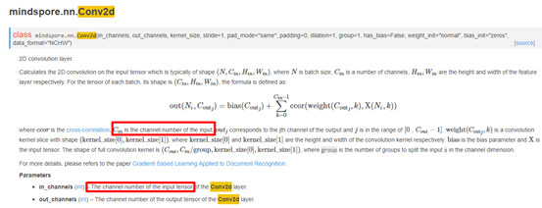
检查代码发现，13行代码in_channels确实不等于14行C_in值，此时将in_channels设置为数据相同的C_in值即可。
2. 解决方法
基于上面已知的原因，很容易做出如下修改：
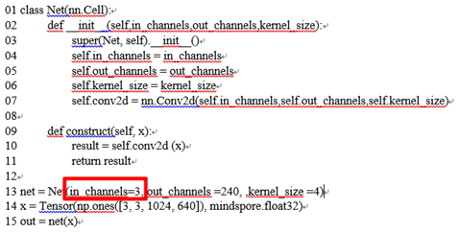
此时执行成功，输出如下：
out: (3, 240, 1024, 640)
3. 总结
定位报错问题的步骤：
1、 找到报错相关的用户代码行：result = self.conv2d (x) ； 2、 根据日志报错信息中的关键字，缩小分析问题的范围： 'C_in' of input 'x' shape divide by parameter 'group' should be equal to 'C_in' of input 'weight' shape: 1, but got 'C_in' of input 'x' shape: 3, and 'group': 1；
3、需要重点关注变量定义、初始化的正确性。
4. 参考文档
4.1 Conv2d算子API接口

报错：alueError: For 'Reshape', the shape of 'input_x' is [65209], the value of 'input_shape' value is [16302, 4].
1. 报错描述
1.1 系统环境
Hardware Environment(Ascend/GPU/CPU): Ascend Software Environment: -- MindSpore version (source or binary): 1.6.0 -- Python version (e.g., Python 3.7.5): 3.7.6 -- OS platform and distribution (e.g., Linux Ubuntu 16.04): Ubuntu 4.15.0-74-generic -- GCC/Compiler version (if compiled from source):
1.2 基本信息
1.2.1 脚本
脚本如下：
loc_data = mindspore.Tensor(np.random.randint(100, size=(1, 32760, 4)),mindspore.float32)
pos_idx = mindspore.Tensor(np.random.randint(2,size=(1, 32760, 4)),mindspore.int32)
pos_idx = ops.cast(pos_idx, mindspore.bool_)
loc_p = (ops.MaskedSelect()(loc_data, pos_idx))
loc_p = loc_p.view((-1,4))
print('result:',loc_p.shape)
1.2.2 报错
这里报错信息如下：
Traceback (most recent call last):
File 'demo.py', line 06, in &lt;module&gt;
loc_p = loc_p.view((-1,4))
…
ValueError: For 'Reshape', the shape of 'input_x' is [65209], the value of 'input_shape' value is [16302, 4]. The product of the shape of 'input_x' should be equal to product of 'input_shape', but product of the shape of 'input_x' is 65209, product of 'input_shape' is 65208.
原因分析
​我们来看报错信息，在ValueError中，写到The product of the shape of 'input_x' should be equal to product of 'input_shape'，but product of the shape of 'input_x' is 65209, product of 'input_shape' is 65208，说的是产生的input_x的shape应该等于input_shape，但两者的值并不相等，这是由于MaskedSelect是一个动态shape算子，它每次输出的shape是根据input数据的不同而变化的，导致执行loc_p.view((-1,4))进行reshape操作的时候，大部分时候都不满足reshape成(-1,4)的条件，所以报错。
​遇到此类问题时，建议调整算法解决。
2. 解决方法
基于上面已知的原因，可以进行丢弃小部分数据做出如下修改：
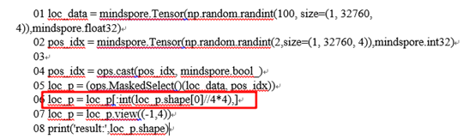
此时执行成功，输出如下：
result:(16421, 4)
3. 总结
定位报错问题的步骤：
1、到报错的用户代码行：*loc_p = loc_p.view((-1,4))*；
2、 根据日志报错信息中的关键字，缩小分析问题的范围： The product of the shape of 'input_x' should be equal to product of 'input_shape'；
3、 结合官网对API的相关介绍，查看传入到API时的参数是否符合要求；
4、 需要重点关注变量定义、初始化的正确性；
5、 具体的解决办法得根据具体的场景进行操作。
4. 参考文档
4.1 MaskedSelect算子API接口

报错ValueError: For xxx,x和y的shape不支持 broadcast
1. 报错描述
1.1 系统环境
Hardware Environment(Ascend/GPU/CPU): Ascend Software Environment: -- MindSpore version (source or binary): 1.6.0 -- Python version (e.g., Python 3.7.5): 3.7.6 -- OS platform and distribution (e.g., Linux Ubuntu 16.04): Ubuntu 4.15.0-74-generic -- GCC/Compiler version (if compiled from source):
1.2 基本信息
1.2.1 脚本
训练脚本是通过构建Abs的单算子网络，对输入两个张量做Sub运算后再计算Abs。脚本如下：
class Net(nn.Cell):
def __init__(self):
super(Net, self).__init__()
self.abs = ops.Abs()
def construct(self, x1,x2):
output = self.abs(x1 - x2)
return output
net = Net()
x1 = Tensor(np.ones((2, 5), dtype=np.float32), mindspore.float32)
x2 = Tensor(np.ones((3, 5), dtype=np.float32), mindspore.float32)
out = net(x1,x2)
print('out',out.shape)
2. 报错
这里报错信息如下：
The function call stack (See file '/demo/rank_0/om/analyze_fail.dat' for more details):
# 0 In file demo.py(7)
output = self.abs(x1 - x2)
^
Traceback (most recent call last):
File "demo.py", line 13, in <module>
out = net(x1,x2)
File "/lib/python3.7/site-packages/mindspore/nn/cell.py", line 576, in __call__
out = self.compile_and_run(*args)
File "/lib/python3.7/site-packages/mindspore/nn/cell.py", line 942, in compile_and_run
self.compile(*inputs)
File "/lib/python3.7/site-packages/mindspore/nn/cell.py", line 915, in compile
_cell_graph_executor.compile(self, *inputs, phase=self.phase, auto_parallel_mode=self._auto_parallel_mode)
File "/lib/python3.7/site-packages/mindspore/common/api.py", line 791, in compile
result = self._graph_executor.compile(obj, args_list, phase, self._use_vm_mode())
File "/lib/python3.7/site-packages/mindspore/ops/primitive.py", line 575, in __infer__
out[track] = fn(*(x[track] for x in args))
File "/lib/python3.7/site-packages/mindspore/ops/operations/math_ops.py", line 78, in infer_shape
return get_broadcast_shape(x_shape, y_shape, self.name)
File "/lib/python3.7/site-packages/mindspore/ops/_utils/utils.py", line 70, in get_broadcast_shape
raise ValueError(f"For '{prim_name}', {arg_name1}.shape and {arg_name2}.shape are supposed "
ValueError: For 'Sub', x.shape and y.shape are supposed to broadcast, where broadcast means that x.shape[i] = 1 or -1 or y.shape[i] = 1 or -1 or x.shape[i] = y.shape[i], but now x.shape and y.shape can not broadcast, got i: -2, x.shape: [2, 5], y.shape: [3, 5].
原因分析
我们看报错信息，在ValueError中，写到ValueError: For 'Sub', x.shape and y.shape are supposed to broadcast, where broadcast means that x.shape = 1 or -1 or y.shape = 1 or -1 or x.shape = y.shape，意思是abs的两个操作对象不能进行broadcast，broadcast的要求是x.shape = 1 or -1 or y.shape = 1 or -1 or x.shape = y.shape，而x.shape = y.shape要求两个参数的shape完全相等，在进一步的报错信息中也有写到but now x.shape and y.shape can not broadcast, got i: -2, x.shape: [2, 5], y.shape: [3, 5]，显然，x和y的第一个维度不等，这就是问题出现的原因了。关于BroadCast，在官网做了输入限制，对输入的Tensor要求shape必须相同。在其他的双输入算子中，有一定量算子用到了BroadCast操作，也应当注意这点。
3. 解决方法
基于上面已知的原因，很容易做出如下修改： 示例1：
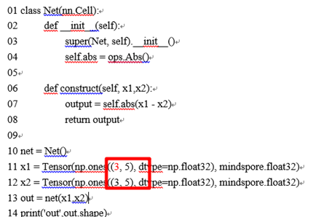
此时执行成功，输出如下：
out: (3, 5)
示例2：
class Net(nn.Cell):
def __init__(self):
​ super(Net, self).__init__()
​ self.abs = ops.Abs()
def construct(self, x1,x2):
​ output = self.abs(x1 - x2)
​ return output
net = Net()
x1 = Tensor(np.ones((5), dtype=np.float32), mindspore.float32)
x2 = Tensor(np.ones((3, 5), dtype=np.float32), mindspore.float32)
out = net(x1,x2)
print('out',out.shape)
此时执行成功，输出如下：
out: (3, 5)
4. 总结
定位报错问题的步骤：
1、找到报错的用户代码行：output = self.abs(x1 - x2);
2、 根据日志报错信息中的关键字，缩小分析问题的范围：x.shape: [2, 5], y.shape: [3, 5];
3、需要重点关注变量定义、初始化的正确性。
5. 参考文档
5.1 broadcast方法

报错“ValueError: For MatMul, the input dimensions必须相等
1. 报错描述
1.1 系统环境
Hardware Environment(Ascend/GPU/CPU): Ascend Software Environment: -- MindSpore version (source or binary): 1.6.0 -- Python version (e.g., Python 3.7.5): 3.7.6 -- OS platform and distribution (e.g., Linux Ubuntu 16.04): Ubuntu 4.15.0-74-generic -- GCC/Compiler version (if compiled from source):
1.2 基本信息
1.2.1 脚本
训练脚本是通过构建MatMul的单算子网络，对输入的两个张量计算矩阵乘积。脚本如下
01 class Net(nn.Cell):
02 def __init__(self):
03 super(Net, self).__init__()
04
05 def construct(self, x1, x2):
06 out = ops.matmul (x1, x2)
07 return out
08
09 net = Net()
10 x1 = Tensor(np.arange(32*12800).reshape(32, 12800), mindspore.float32)
11 x2 = Tensor(np.arange(10*1280).reshape(10, 1280), mindspore.float32)
12 out = net(x1, x2)
13 print('out',out.shape)
1.2.2 报错
这里报错信息如下：
The function call stack (See file '/rank_0/om/analyze_fail.dat' for more details):
# 0 In file demo.py(06)
out = ops.matmul (x1, x2)
^
# 1 In file /lib/python3.7/site-packages/mindspore/ops/composite/math_ops.py(810)
if not _check_same_type(dtype1, dtype2):
^
# 2 In file /lib/python3.7/site-packages/mindspore/ops/composite/math_ops.py(824)
if F.rank(x2) == 2:
# 3 In file /lib/python3.7/site-packages/mindspore/ops/composite/math_ops.py(825)
if F.rank(x1) &gt; 2:
# 4 In file /lib/python3.7/site-packages/mindspore/ops/composite/math_ops.py(827)
res = P.MatMul(False, transpose_b)(x1, x2)
^
Traceback (most recent call last):
File &quot;demo.py&quot;, line 12, in &lt;module&gt;
out = net(x1, x2)
File &quot;/lib/python3.7/site-packages/mindspore/nn/cell.py&quot;, line 586, in __call__
out = self.compile_and_run(*args)
File &quot;/lib/python3.7/site-packages/mindspore/nn/cell.py&quot;, line 964, in compile_and_run
self.compile(*inputs)
File &quot;/lib/python3.7/site-packages/mindspore/nn/cell.py&quot;, line 937, in compile
_cell_graph_executor.compile(self, *inputs, phase=self.phase, auto_parallel_mode=self._auto_parallel_mode)
File &quot;/lib/python3.7/site-packages/mindspore/common/api.py&quot;, line 1040, in compile
result = self._graph_executor.compile(obj, args_list, phase, self._use_vm_mode())
File &quot;/lib/python3.7/site-packages/mindspore/ops/primitive.py&quot;, line 467, in __check__
fn(*(x[track] for x in args))
File &quot;/lib/python3.7/site-packages/mindspore/ops/operations/math_ops.py&quot;, line 1430, in check_shape
raise ValueError(f&quot;For '{cls_name}', the input dimensions must be equal, but got 'x1_col': {x1_col} &quot;
ValueError: For 'MatMul', the input dimensions must be equal, but got 'x1_col': 12800 and 'x2_row': 10. And 'x' shape [32, 12800](transpose_a=False), 'y' shape [10, 1280](transpose_b=False).
原因分析
我们来看报错信息，在ValueError中，写到the input dimensions must be equal, but got 'x1_col': 12800 and 'x2_row': 10，结合官网对matmul算子的介绍(如下图)，即x1的最后一个维度和x2的倒数第二个维度需要保持一致，可知我们输入的x1、x2对应位置的维度12800、10不满足计算要求。
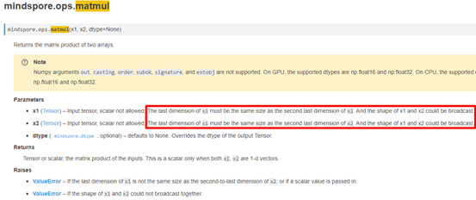
当然，在出现类似shape不匹配的问题时，通常在报错日志中会打印相应的图结构调用栈信息，也可以先从调用栈信息尝试定位错误位置。调用栈信息不够清晰时，可以考虑参考analyze_fail.dat文件辅助分析。
2. 解决方法
基于上面已知的原因，很容易做出如下修改： 此时执行成功，输出如下：
out（32，1280）
3. 总结
定位报错问题的步骤：
1、找到报错的用户代码行：out = ops.matmul (x1, x2);
2、 根据日志报错信息中的关键字，缩小分析问题的范围： For 'MatMul', the input dimensions must be equal, but got 'x1_col': 12800 and 'x2_row': 10.];
3、 结合官网对API的相关介绍，查看传入到API时的参数是否符合要求，也可以根据调用栈信息，参考analyze_fail.dat文件结合分析;
4、需要重点关注变量定义、初始化的正确性。
4. 参考文档
4.1 matmul算子API接口

报错：Can not select a valid kernel info for [Default/Pow-op0] in AI CORE or AI CPU kernel info candidates list
1. 报错描述
1.1 系统环境
Hardware Environment(Ascend/GPU/CPU): Ascend
Software Environment:
-- MindSpore version (source or binary): 1.6.0
-- Python version (e.g., Python 3.7.5): 3.7.6
-- OS platform and distribution (e.g., Linux Ubuntu 16.04): Ubuntu 4.15.0-74-generic
-- GCC/Compiler version (if compiled from source):
1.2 基本信息
1.2.1 脚本
训练脚本是通过构建Pow的单算子网络，对第一个输入的每个值进行幂运算。脚本如下：
01 class Net(nn.Cell):
02 def __init__(self):
03 super(Net, self).__init__()
04 self.pow = ops.Pow()
05 def construct(self, x,y):
06 output = self.pow(x, y)
07 return output
08 net = Net()
09 x = Tensor(np.array([1.0, 2.0, 4.0]), mindspore.float64) .astype(mindspore.float32)
10 y = 3.0
11 output = net(x, y)
12 print('output', output)
1.2.2 报错
这里报错信息如下：
Traceback (most recent call last):
File 'demo.py', line 11, in &lt;module&gt;
​ output = net(x, y)
…
TypeError: mindspore/ccsrc/runtime/device/ascend/kernel_select_ascend.cc:788 PrintNotMatchMessage] Can not select a valid kernel info for [Default/Pow-op0] in AI CORE or AI CPU kernel info candidates list:
AI CORE:
(&lt;Int8xDefaultFormat&gt;, &lt;Int8xDefaultFormat&gt;) -&gt; (&lt;Int8xDefaultFormat&gt;)
(&lt;UInt8xDefaultFormat&gt;, &lt;UInt8xDefaultFormat&gt;) -&gt; (&lt;UInt8xDefaultFormat&gt;)
(&lt;Int32xDefaultFormat&gt;, &lt;Int32xDefaultFormat&gt;) -&gt; (&lt;Int32xDefaultFormat&gt;)
(&lt;Float16xDefaultFormat&gt;, &lt;Float16xDefaultFormat&gt;) -&gt; (&lt;Float16xDefaultFormat&gt;)
(&lt;Float32xDefaultFormat&gt;, &lt;Float32xDefaultFormat&gt;) -&gt; (&lt;Float32xDefaultFormat&gt;)
AI CPU:
{}
Please check the given data type or shape:
AI CORE: : (&lt;Tensor[Float64], (3)&gt;, &lt;Tensor[Float64], (), value=...&gt;) -&gt; (&lt;Tensor[Float64], (3)&gt;)
AI CPU: : (&lt;Tensor[Float64], (3)&gt;, &lt;Tensor[Float64], (), value=...&gt;) -&gt; (&lt;Tensor[Float64], (3)&gt;)
For more details, please refer to 'Kernel Select Failed' at https://www.mindspore.cn
The function call stack:
In file demo.py(06)/ output = self.pow(x, y)/
原因分析
我们看报错信息，在TypeError中，写到Can not select a valid kernel info for [Default/Pow-op0] in AI CORE or AI CPU kernel info candidates list，结合后边列出的数据类型格式，不难猜出这是在提示传入的数据类型不在支持的类型范围内，支持的数据类型为：int8、uint8、int32、float16、float32，再结合*Please check the given data type or shape:AI CORE : (<Tensor[Float64], (3)>*可知，传入的数据类型为float64， 检查代码发现，09行代码传入的数据类型确实为float64，此时需要将该类型转化为其他支持类型。
2. 解决方法
基于上面已知的原因，很容易做出如下修改：
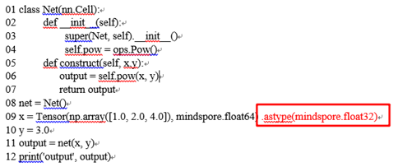
此时执行成功，输出如下：
output [ 1. 8. 64.]
3. 总结
定位报错问题的步骤：
1、 找到报错的用户代码行： output = self.pow(x, y);
2、 根据日志报错信息中的关键字，缩小分析问题的范围;
3、需要重点关注变量定义、初始化的正确性。
4. 参考文档
4.1 Pow算子API接口

报错：ValueError: `x rank` in `NLLLoss` should be int and must in [1, 2], but got `4` with type `int
1. 报错描述
1.1 系统环境
Hardware Environment(Ascend/GPU/CPU): Ascend Software Environment: -- MindSpore version (source or binary): 1.6.0 -- Python version (e.g., Python 3.7.5): 3.7.6 -- OS platform and distribution (e.g., Linux Ubuntu 16.04): Ubuntu 4.15.0-74-generic -- GCC/Compiler version (if compiled from source):
1.2 基本信息
1.2.1 脚本
根据标杆torch算子NLLLoss的用例，编写输入为(N, C, d1, d2)的用例，脚本如下：
01 loss = nn.NLLLoss()
02 input = torch.randn(5, 4, 8, 8)
03 m = nn.LogSoftmax(dim=1)
04 target = torch.empty(5, 8, 8, dtype=torch.long).random_(0, 4)
05 loss = loss(m(input), target)
06 print('torch_loss',loss)
07
08 m = mn.LogSoftmax(axis=1)
09 loss = ops.NLLLoss()
10 input = Tensor(np.random.randn(5, 4,8,8), mindspore.float32)
11 labels = Tensor([1, 0,1, 1], mindspore.int32)
12 weight = Tensor(np.random.rand(5,8,8), mindspore.float32)
13 loss, weight = loss(m(input), labels, weight)
14 print('mindspore_loss:',loss)
1.2.2 报错
这里报错信息如下：
Traceback (most recent call last):
File demo.py, line 13, in &lt;module&gt;
​ loss, weight = loss(m(input), labels, weight)
…
File &quot;/lib/python3.7/site-packages/mindspore/_checkparam.py&quot;, line 238, in check_int
return check_number(arg_value, value, rel, int, arg_name, prim_name)
File &quot; /lib/python3.7/site-packages/mindspore/_checkparam.py&quot;, line 168, in check_number
raise type_except(f'{prim_info} should be {arg_type.__name__} and must {rel_str}, '
ValueError: `x rank` in `NLLLoss` should be int and must in [1, 2], but got `4` with type `int
原因分析
​ 在MindSpore 1.6版本，利用对标算子的用例编写输入为(N, C, d1, d2)的用例。先看报错信息，在ValueError中，写到x rank in NLLLos should be int and must in [1, 2], but got 4 with type int，意思是传的NLLLoss的x_rank参数应该为int，而且应该在[1, 2]之间，但是你传进去的是int类型的4，由报错行数line13，检查传入数据可知我们传入了为4维的(5, 4, 8, 8)，而torch传入该类型数据能支持，这是由于目前MindSpore暂不支持(N,C,d1,d2,...,dK) with K≥1类型，这点在旧版本的PyTorch与MindSpore API映射对比中描述为功能一致，此处文档有误(见下图)，目前标杆算子和MindSpore框架支持的NLLLoss算子功能存在一定差异，MindSpore目前只支持 shape为(N,C)的数据(如下图所示)。
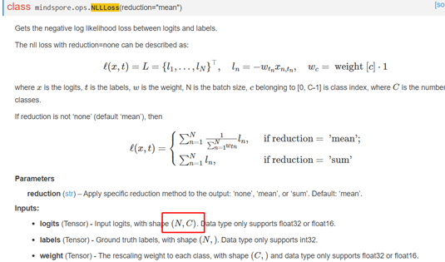
在新版本中的描述中已经进行修改。参考链接为：https://www.mindspore.cn/docs/migration_guide/zh-CN/r1.5/api_mapping/pytorch_diff/NLLLoss.html
2. 解决方法
​基于上面已知的原因，该算子存在部分输入不支持的情况，目前需要用户自己封装，该操作会对用户带来一定的困扰，我们将在后续统一考虑这种需求。
3. 总结
定位报错问题的步骤：
1、找到报错的用户代码行：*loss, weight = loss(m(input), labels, weight)*；
2、 根据日志报错信息中的关键字，缩小分析问题的范围：*loss, weight = loss(m(input), labels, weight)*；
3、需要重点关注变量定义、初始化的正确性。
4. 参考文档
4.1 NLLLoss算子API介绍

报错：Select GPU kernel op[BatchNorm] fail! Incompatible data type!
1. 报错描述
1.1 系统环境
Hardware Environment(Ascend/GPU/CPU): GPU
Software Environment:
– MindSpore version (source or binary): 1.5.2
– Python version (e.g., Python 3.7.5): 3.7.6
– OS platform and distribution (e.g., Linux Ubuntu 16.04): Ubuntu 4.15.0-74-generic
– GCC/Compiler version (if compiled from source):
1.2 基本信息
1.2.1 脚本
训练脚本是通过构建BatchNorm单算子网络，对Tensor做归一化处理。脚本如下：
01 class Net(nn.Cell):
02 def __init__(self):
03 super(Net, self).__init__()
04 self.batch_norm = ops.BatchNorm()
05 def construct(self,input_x, scale, bias, mean, variance):
06 output = self.batch_norm(input_x, scale, bias, mean, variance)
07 return output
08
09 net = Net()
10 input_x = Tensor(np.ones([2, 2]), mindspore.float16)
11 scale = Tensor(np.ones([2]), mindspore.float16)
12 bias = Tensor(np.ones([2]), mindspore.float16)
13 bias = Tensor(np.ones([2]), mindspore.float16)
14 mean = Tensor(np.ones([2]), mindspore.float16)
15 variance = Tensor(np.ones([2]), mindspore.float16)
16 output = net(input_x, scale, bias, mean, variance)
17 print(output)
1.2.2 报错
这里报错信息如下：
Traceback (most recent call last):
File "116945.py", line 22, in <module>
output = net(input_x, scale, bias, mean, variance)
File "/data2/llj/mindspores/r1.5/build/package/mindspore/nn/cell.py", line 407, in __call__
out = self.compile_and_run(*inputs)
File "/data2/llj/mindspores/r1.5/build/package/mindspore/nn/cell.py", line 734, in compile_and_run
self.compile(*inputs)
File "/data2/llj/mindspores/r1.5/build/package/mindspore/nn/cell.py", line 721, in compile
_cell_graph_executor.compile(self, *inputs, phase=self.phase, auto_parallel_mode=self._auto_parallel_mode)
File "/data2/llj/mindspores/r1.5/build/package/mindspore/common/api.py", line 551, in compile
result = self._graph_executor.compile(obj, args_list, phase, use_vm, self.queue_name)
TypeError: mindspore/ccsrc/runtime/device/gpu/kernel_info_setter.cc:355 PrintUnsupportedTypeException] Select GPU kernel op[BatchNorm] fail! Incompatible data type!
The supported data types are in[float32 float32 float32 float32 float32], out[float32 float32 float32 float32 float32]; in[float16 float32 float32 float32 float32], out[float16 float32 float32 float32 float32]; , but get in [float16 float16 float16 float16 float16 ] out [float16 float16 float16 float16 float16 ]
原因分析
我们看报错信息，在TypeError中，写到Select GPU kernel op[BatchNorm] fail! Incompatible data type!
The supported data types are in[float32 float32 float32 float32 float32], out[float32 float32 float32 float32 float32]; in[float16 float32 float32 float32 float32], out[float16 float32 float32 float32 float32]; , but get in [float16 float16 float16 float16 float16 ] out [float16 float16 float16 float16 float16 ]，大概意思是GPU环境下， 不支持当前输入的数据类型组合， 并说明了支持的数据类型组合是怎样的：全部为float32或者input_x为float16， 其余为float32。检查脚本的输入发现全部为float16类型， 因此报错。
2. 解决方法
基于上面已知的原因，很容易做出如下修改：
01 class Net(nn.Cell):
02 def __init__(self):
03 super(Net, self).__init__()
04 self.batch_norm = ops.BatchNorm()
05 def construct(self,input_x, scale, bias, mean, variance):
06 output = self.batch_norm(input_x, scale, bias, mean, variance)
07 return output
08
09 net = Net()
10 input_x = Tensor(np.ones([2, 2]), mindspore.float16)
11 scale = Tensor(np.ones([2]), mindspore.float32)
12 bias = Tensor(np.ones([2]), mindspore.float32)
13 mean = Tensor(np.ones([2]), mindspore.float32)
14 variance = Tensor(np.ones([2]), mindspore.float32)
15
16 output = net(input_x, scale, bias, mean, variance)
17 print(output)
此时执行成功，输出如下：
output: (Tensor(shape=[2, 2], dtype=Float16, value=
[[ 1.0000e+00, 1.0000e+00],
[ 1.0000e+00, 1.0000e+00]]), Tensor(shape=[2], dtype=Float32, value= [ 0.00000000e+00, 0.00000000e+00]), Tensor(shape=[2], dtype=Float32, value= [ 0.00000000e+00, 0.00000000e+00]), Tensor(shape=[2], dtype=Float32, value= [ 0.00000000e+00, 0.00000000e+00]), Tensor(shape=[2], dtype=Float32, value= [ 0.00000000e+00, 0.00000000e+00]))
3. 总结
定位报错问题的步骤：
1、找到报错的用户代码行： 16 output = net(input_x, scale, bias, mean, variance);
2、 根据日志报错信息中的关键字，缩小分析问题的范围：The supported data types are in[float32 float32 float32 float32 float32], out[float32 float32 float32 float32 float32]; in[float16 float32 float32 float32 float32], out[float16 float32 float32 float32 float32]; , but get in [float16 float16 float16 float16 float16 ] out [float16 float16 float16 float16 float16 ]
3、需要重点关注变量定义、初始化的正确性。
4. 参考文档
4.1 BatchNorm算子API接口

报错：ValueError: For 'MirrorPad', paddings must be a Tensor with type of int64, but got None.
1. 报错描述
1.1 系统环境
Hardware Environment(Ascend/GPU/CPU): CPU
Software Environment:
– MindSpore version (source or binary): 1.8.0
– Python version (e.g., Python 3.7.5): 3.7.6
– OS platform and distribution (e.g., Linux Ubuntu 16.04): Ubuntu 4.15.0-74-generic
– GCC/Compiler version (if compiled from source):
1.2 基本信息
1.2.1 脚本
训练脚本是通过构建MirrorPad的单算子网络，使用镜像值填充张量。脚本如下：
01 context.set_context(mode=context.GRAPH_MODE, device_target="CPU")
02 class Net(nn.Cell):
03 def __init__(self):
04 super(Net, self).__init__()
05 self.pad = ops.MirrorPad(mode="REFLECT")
06 def construct(self, x, paddings):
07 return self.pad(x, paddings)
08
09 x = Tensor(np.random.random(size=(2, 3)).astype(np.float32))
10 paddings = Tensor([[1, 1], [2, 2]])
11 pad = Net()
12 output = pad(x, paddings)
13 print(output.shape)
1.2.2 报错
这里报错信息如下：
Traceback (most recent call last):
File "99553.py", line 20, in <module>
output = pad(x, paddings)
File "/root/miniconda3/envs/high_llj/lib/python3.7/site-packages/mindspore/nn/cell.py", line 573, in __call__
out = self.compile_and_run(*args)
File "/root/miniconda3/envs/high_llj/lib/python3.7/site-packages/mindspore/nn/cell.py", line 956, in compile_and_run
self.compile(*inputs)
File "/root/miniconda3/envs/high_llj/lib/python3.7/site-packages/mindspore/nn/cell.py", line 929, in compile
_cell_graph_executor.compile(self, *inputs, phase=self.phase, auto_parallel_mode=self._auto_parallel_mode)
File "/root/miniconda3/envs/high_llj/lib/python3.7/site-packages/mindspore/common/api.py", line 1063, in compile
result = self._graph_executor.compile(obj, args_list, phase, self._use_vm_mode())
File "/root/miniconda3/envs/high_llj/lib/python3.7/site-packages/mindspore/ops/operations/nn_ops.py", line 4189, in __infer__
raise ValueError(f"For '{self.name}', paddings must be a Tensor with type of int64, "
ValueError: For 'MirrorPad', paddings must be a Tensor with type of int64, but got None.
原因分析
我们看报错信息，在ValueError中，写到ValueError: For 'MirrorPad', paddings must be a Tensor with type of int64, but got None.，意思是paddings必须是一个Tensor[INT64], 但是实际得到的是None， 结合脚本第10和12行发现paddings初始化值明明不是None，这是为什么呢。其实这是因为， 在mindspore的图模式下， 常量输入必须在构图的阶段传入， 否则在执行的时候传入就只能得到None。Ps. 在PYNATIVE_MODE不存在这个问题。
2. 解决方法
基于上面已知的原因，可以做出两种修改解决此问题。
# 第一种， 在PYNATIVE_MODE下跑脚本：
from mindspore import context
context.set_context(mode=context.PYNATIVE_MODE, device_target="CPU")
class Net(nn.Cell):
def __init__(self):
super(Net, self).__init__()
self.pad = ops.MirrorPad(mode="REFLECT")
def construct(self, x, paddings):
return self.pad(x, paddings)
x = Tensor(np.random.random(size=(2, 3)).astype(np.float32))
paddings = Tensor([[1, 1], [2, 2]])
pad = Net()
output = pad(x, paddings)
print(output shape: output.shape)
此时执行成功，输出如下：
output shape: (4, 7)
# 第二种，将paddings在构图的时候当作常量传入：
class Net(nn.Cell):
def __init__(self):
super(Net, self).__init__()
self.pad = ops.MirrorPad(mode="REFLECT")
self.paddings = Tensor([[1, 1], [2, 2]])
def construct(self, x):
return self.pad(x, self.paddings)
x = Tensor(np.random.random(size=(2, 3)).astype(np.float32))
pad = Net()
output = pad(x)
print("output shape: "output.shape)
此时执行成功，输出如下：
output shape: (4, 7)
3. 总结
定位报错问题的步骤：
1、找到报错的用户代码行：output = pad(x, paddings);
2、 ValueError: For 'MirrorPad', paddings must be a Tensor with type of int64, but got None;
3、需要重点关注变量定义、初始化的正确性。
4. 参考文档
4.1 MirrorPad算子API接口

报错：For primitive[TensorSummary], the v rank 必须大于等于0
1. 报错描述
1.1 系统环境
Hardware Environment(Ascend/GPU/CPU): Ascend Software Environment: -- MindSpore version (source or binary): 1.8.0 -- Python version (e.g., Python 3.7.5): 3.7.6 -- OS platform and distribution (e.g., Linux Ubuntu 16.04): Ubuntu 4.15.0-74-generic -- GCC/Compiler version (if compiled from source):
1.2 基本信息
1.2.1 脚本
训练脚本是通过构简单的算子网络，对输入两个张量做Add运算后再调用Tensor Summary。脚本如下：
01 class SummaryNet(nn.Cell):
02 def __init__(self,):
03 super(SummaryNet, self).__init__()
04 self.summary = ops.TensorSummary()
05 self.add = ops.Add()
06
07 def construct(self, x, y):
08 x = self.add(x, y)
09 name = &quot;x&quot;
10 self.summary(name, x.sum())
11 return x
12
13 x = Tensor(np.array([1, 2, 3]).astype(np.float32))
14 y = Tensor(np.array([4, 5, 6]).astype(np.float32))
15 summary_net = SummaryNet()(x, y)
16 print(&quot;out: &quot;, summary_net)
1.2.2 报错
这里报错信息如下：
Traceback (most recent call last):
File &quot;C:/Users/user1/PycharmProjects/q2_map/new/173735.py&quot;, line 22, in &lt;module&gt;
summary_net = SummaryNet()(x, y)
File &quot;C:\Users\user1\PycharmProjects\q2_map\lib\site-packages\mindspore\nn\cell.py&quot;, line 586, in __call__
out = self.compile_and_run(*args)
File &quot;C:\Users\user1\PycharmProjects\q2_map\lib\site-packages\mindspore\nn\cell.py&quot;, line 964, in compile_and_run
self.compile(*inputs)
File &quot;C:\Users\user1\PycharmProjects\q2_map\lib\site-packages\mindspore\nn\cell.py&quot;, line 937, in compile
_cell_graph_executor.compile(self, *inputs, phase=self.phase, auto_parallel_mode=self._auto_parallel_mode)
File &quot;C:\Users\user1\PycharmProjects\q2_map\lib\site-packages\mindspore\common\api.py&quot;, line 1006, in compile
result = self._graph_executor.compile(obj, args_list, phase, self._use_vm_mode())
ValueError: mindspore\core\utils\check_convert_utils.cc:397 CheckInteger] For primitive[TensorSummary], the v rank must be greater than or equal to 1, but got 0.
WARNING: Logging before InitGoogleLogging() is written to STDERR
[CRITICAL] CORE(6472,1,?):2022-6-17 15:47:53 [mindspore\core\utils\check_convert_utils.cc:397] CheckInteger] For primitive[TensorSummary], the v rank must be greater than or equal to 1, but got 0.
原因分析
我们看报错信息，在ValueError中，写到ValueError: For primitive[TensorSummary], the v rank must be greater than or equal to 1, but got 0. ，意思是对于TensorSummary，参数v的秩必须大于等于1， 但是得到了0. 因此需要检查一下擦传入TensorSummary的v的秩是不是符合要求的。检查脚本的第8行发现对x和y进行了求和操作， 结果是一个scalar（常数）， 因此报错。关于TensorSummary，在官网做了输入限制，对输入的Tensor要求rank必须大于等于1。 如果需要对标量数据进行搜集， 可以使用ScalarSummary算子。
2. 解决方法
基于上面已知的原因，很容易做出如下修改：
01 class SummaryNet(nn.Cell):
02 def __init__(self,):
03 super(SummaryNet, self).__init__()
04 self.summary = ops.ScalarSummary()
05 self.add = ops.Add()
06
07 def construct(self, x, y):
08 x = self.add(x, y)
09 name = &quot;x&quot;
10 self.summary(name, x.sum())
11 return x
12
13 x = Tensor(np.array([1, 2, 3]).astype(np.float32))
14 y = Tensor(np.array([4, 5, 6]).astype(np.float32))
15 summary_net = SummaryNet()(x, y)
16 print(&quot;out: &quot;, summary_net)
此时执行成功，输出如下：
out: [5. 7. 9.]
3. 总结
定位报错问题的步骤：
1、找到报错的用户代码行：* summary_net = SummaryNet()(x, y)*;
2、 根据日志报错信息中的关键字，缩小分析问题的范围* For primitive[TensorSummary], the v rank must be greater than or equal to 1, but got 0.* ;
3、需要重点关注变量定义、初始化的正确性。
4. 参考文档
4.1 TensorSummary算子API接口

报错：TypeError: For 'CellList', each cell should be subclass of Cell, but got NoneType.
1. 报错描述
1.1 系统环境
Hardware Environment(Ascend/GPU/CPU): Ascend Software
Environment: -- MindSpore version (source or binary): 1.8.0
Python version (e.g., Python 3.7.5): 3.7.6
OS platform and distribution (e.g., Linux Ubuntu 16.04): Ubuntu 4.15.0-74-generic -- GCC/Compiler version (if compiled from source):
1.2 基本信息
1.2.1 脚本
训练脚本是通过构建CellList的单算子网络，实现cell列表容器。脚本如下：
from mindspore import nn, Tensor
import numpy as np
class ListNoneExample(nn.Cell):
def __init__(self):
super(ListNoneExample, self).__init__()
self.lst = nn.CellList([nn.ReLU(), None, nn.ReLU()])
def construct(self, x):
output = []
for op in self.lst:
output.append(op(x))
return output
input = Tensor(np.random.normal(0, 2, (2, 1)).astype(np.float32))
example = ListNoneExample()
output = example(input)
print(output)
1.2.2 报错
这里报错信息如下：
Traceback (most recent call last):
File &quot;C:/Users/user1/PycharmProjects/q2_map/new/I3OGVW.py&quot;, line 31, in &lt;module&gt;
example = ListNoneExample()
File &quot;C:/Users/user1/PycharmProjects/q2_map/new/I3OGVW.py&quot;, line 19, in __init__
self.lst = nn.CellList([nn.ReLU(), None, nn.ReLU()])
File &quot;C:\Users\user1\PycharmProjects\q2_map\lib\site-packages\mindspore\nn\layer\container.py&quot;, line 310, in __init__
self.extend(args[0])
File &quot;C:\Users\user1\PycharmProjects\q2_map\lib\site-packages\mindspore\nn\layer\container.py&quot;, line 405, in extend
if _valid_cell(cell, cls_name):
File &quot;C:\Users\user1\PycharmProjects\q2_map\lib\site-packages\mindspore\nn\layer\container.py&quot;, line 39, in _valid_cell
raise TypeError(f'{msg_prefix} each cell should be subclass of Cell, but got {type(cell).__name__}.')
TypeError: For 'CellList', each cell should be subclass of Cell, but got NoneType.
原因分析
我们看报错信息，在TypeError中，写到For 'CellList', each cell should be subclass of Cell, but got NoneType. ，意思是对于CellList这个算子， 传入的每一个cell都因该是nn.Cell的子类， 但是得到了None类型。检查网络中初始化CellList的行为第4行， 发现传入了一个None， 因此报错。为了解决这个问题， 只需把这里的None换成一个继承于基类Cell类的对象， 就能实现相同的功能。
2. 解决方法
基于上面已知的原因，很容易做出如下修改：
from mindspore import nn, Tensor
import numpy as np
class NoneCell(nn.cell):
def __init__(self):
super(NoneCell, self).__init__()
def construct(self, x):
return x
class ListNoneExample(nn.Cell):
def __init__(self):
super(ListNoneExample, self).__init__()
self.lst = nn.CellList([nn.ReLU(), NoneCell(), nn.ReLU()])
def construct(self, x):
output = []
for op in self.lst:
output.append(op(x))
return output
input = Tensor(np.random.normal(0, 2, (2, 1)).astype(np.float32))
example = ListNoneExample()
output = example(input)
print(output)
此时执行成功，输出如下：
Output: (Tensor(shape=[2, 1], dtype=Float32, value=
[[1.09826946e+000],
[0.00000000e+000]]), Tensor(shape=[2, 1], dtype=Float32, value=
[[1.09826946e+000],
[-2.74355006e+000]]), Tensor(shape=[2, 1], dtype=Float32, value=
[[1.09826946e+000],
[0.00000000e+000]]))
3. 总结
定位报错问题的步骤：
1、找到报错的用户代码行：self.lst = nn.CellList([nn.ReLU(), None, nn.ReLU()]);
2、 根据日志报错信息中的关键字，缩小分析问题的范围each cell should be subclass of Cell, but got NoneType ;
3、需要重点关注变量定义、初始化的正确性。
4. 参考文档
4.1 CellList算子API接口

报错：task_fail_info or current_graph_ is nullptr
1. 报错描述
1.1 系统环境
Hardware Environment(Ascend/GPU/CPU): Ascend Software Environment: -- MindSpore version (source or binary): 1.8.0 -- Python version (e.g., Python 3.7.5): 3.7.6 -- OS platform and distribution (e.g., Linux Ubuntu 16.04): Ubuntu 4.15.0-74-generic -- GCC/Compiler version (if compiled from source):
1.2 基本信息
1.2.1 脚本
训练脚本是通过构建CTCGreedyDecoder的单算子网络，对输入中给出的 logits 执行贪婪解码（最佳路径）。脚本如下：
01 class Net(nn.Cell):
02 def __init__(self):
03 super(Net, self).__init__()
04 self.ctc_greedyDecoder = ops.CTCGreedyDecoder()
05
06 def construct(self, input_x, sequence_length):
07 return self.ctc_greedyDecoder(input_x, sequence_length)
08 net = Net()
09
10
11 inputs = Tensor(np.array([[[0.6, 0.4, 0.2], [0.8, 0.6, 0.3]],
12 [[0.0, 0.6, 0.0], [0.5, 0.4, 0.5]]]), mindspore.float32)
13 sequence_length = Tensor(np.array([4, 2]), mindspore.int32)
14
15 decoded_indices, decoded_values, decoded_shape, log_probability = net(inputs, sequence_length)
16 print(decoded_indices, decoded_values, decoded_shape, log_probability)
1.2.2 报错
这里报错信息如下：
[ERROR] DEVICE(172230,fffeae7fc160,python):2022-06-28-07:02:12.636.101 [mindspore/ccsrc/plugin/device/ascend/hal/device/ascend_kernel_runtime.cc:603] TaskFailCallback] Execute TaskFailCallback failed. task_fail_info or current_graph_ is nullptr
Traceback (most recent call last):
File &quot;CTCGreedyDecoder.py&quot;, line 26, in &lt;module&gt;
decoded_indices, decoded_values, decoded_shape, log_probability = net(inputs, sequence_length)
File &quot;/root/archiconda3/envs/lilinjie_high/lib/python3.7/site-packages/mindspore/nn/cell.py&quot;, line 573, in __call__
out = self.compile_and_run(*args)
File &quot;/root/archiconda3/envs/lilinjie_high/lib/python3.7/site-packages/mindspore/nn/cell.py&quot;, line 979, in compile_and_run
return _cell_graph_executor(self, *new_inputs, phase=self.phase)
File &quot;/root/archiconda3/envs/lilinjie_high/lib/python3.7/site-packages/mindspore/common/api.py&quot;, line 1128, in __call__
return self.run(obj, *args, phase=phase)
File &quot;/root/archiconda3/envs/lilinjie_high/lib/python3.7/site-packages/mindspore/common/api.py&quot;, line 1165, in run
return self._exec_pip(obj, *args, phase=phase_real)
File &quot;/root/archiconda3/envs/lilinjie_high/lib/python3.7/site-packages/mindspore/common/api.py&quot;, line 94, in wrapper
results = fn(*arg, **kwargs)
File &quot;/root/archiconda3/envs/lilinjie_high/lib/python3.7/site-packages/mindspore/common/api.py&quot;, line 1147, in _exec_pip
return self._graph_executor(args, phase)
RuntimeError: Call runtime rtStreamSynchronize failed. Op name: Default/CTCGreedyDecoder-op2
原因分析
我们看报错信息，在Error中，写到Execute TaskFailCallback failed. task_fail_info or current_graph_ is nullptr，虽然从这句报错里不能非常明确的发现问题处在哪个地方，这时候可以提取里面的关键词进行猜想验证， 里面出现了一个nullptr， 可能是出现了越界导致的。 再仔细查看下官网对各参数的描述，
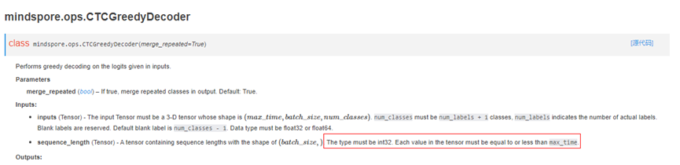
结合脚本第13行发现这个条件不被满足， 因此报错。
2. 解决方法
基于上面已知的原因，很容易做出如下修改：
01 class Net(nn.Cell):
02 def __init__(self):
03 super(Net, self).__init__()
04 self.ctc_greedyDecoder = ops.CTCGreedyDecoder()
05
06 def construct(self, input_x, sequence_length):
07 return self.ctc_greedyDecoder(input_x, sequence_length)
08 net = Net()
09
10
11 inputs = Tensor(np.array([[[0.6, 0.4, 0.2], [0.8, 0.6, 0.3]],
12 [[0.0, 0.6, 0.0], [0.5, 0.4, 0.5]]]), mindspore.float32)
13 sequence_length = Tensor(np.array([2, 2]), mindspore.int32)
14
15 decoded_indices, decoded_values, decoded_shape, log_probability = net(inputs, sequence_length)
16 print(decoded_indices, decoded_values, decoded_shape, log_probability)
此时执行成功，输出如下：
[[0 0]
[0 1]
[1 0]] [0 1 0] [2 2] [[-1.2]
[-1.3]]
3. 总结
定位报错问题的步骤：
1、找到报错的用户代码行：15 decoded_indices, decoded_values, decoded_shape, log_probability = net(inputs, sequence_length);
2、 根据日志报错信息中的关键字，缩小分析问题的范围* Execute TaskFailCallback failed. task_fail_info or current_graph_ is nullptr* ;
4. 参考文档
4.1 CTCGreedyDecoder算子API接口

报错ValueError：`padding_idx` in `Embedding超出范围
1. 报错描述
1.1 系统环境
Hardware Environment(Ascend/GPU/CPU): Ascend Software Environment: -- MindSpore version (source or binary): 1.8.0 -- Python version (e.g., Python 3.7.5): 3.7.6 -- OS platform and distribution (e.g., Linux Ubuntu 16.04): Ubuntu 4.15.0-74-generic -- GCC/Compiler version (if compiled from source):
1.2 基本信息
1.2.1 脚本
训练脚本是通过构建Embedding的单算子网络，完成嵌入层操作。脚本如下：
01 class Net(nn.Cell):
02 def __init__(self, vocab_size, embedding_size, use_one_hot, padding_idx=None):
03 super(Net, self).__init__()
04 self.op = nn.Embedding(vocab_size=vocab_size, embedding_size=embedding_size, use_one_hot=use_one_hot, padding_idx=padding_idx)
05
06 def construct(self, x):
07 output = self.op(x)
08 return output
09
10 input = Tensor(np.ones([8, 128]), mindspore.int32)
11 vocab_size = 2000
12 embedding_size = 768
13 use_one_hot = True
14 example = Net(vocab_size=vocab_size, embedding_size=embedding_size, use_one_hot=use_one_hot, padding_idx=10000)
15 output = example(input)
16 print(&quot;Output:&quot;, output.shape)
1.2.2 报错
这里报错信息如下：
Traceback (most recent call last):
File &quot;C:/Users/user1/PycharmProjects/q2_map/new/I3MRK3.py&quot;, line 26, in &lt;module&gt;
example = Net(vocab_size=vocab_size, embedding_size=embedding_size, use_one_hot=use_one_hot, padding_idx=10000)
File &quot;C:/Users/user1/PycharmProjects/q2_map/new/I3MRK3.py&quot;, line 12, in __init__
self.op = nn.Embedding(vocab_size=vocab_size, embedding_size=embedding_size, use_one_hot=use_one_hot, padding_idx=padding_idx)
File &quot;C:\Users\user1\PycharmProjects\q2_map\lib\site-packages\mindspore\nn\layer\embedding.py&quot;, line 111, in __init__
self.padding_idx = validator.check_int_range(padding_idx, 0, vocab_size, Rel.INC_BOTH,
File &quot;C:\Users\user1\PycharmProjects\q2_map\lib\site-packages\mindspore\_checkparam.py&quot;, line 413, in check_int_range
return check_number_range(arg_value, lower_limit, upper_limit, rel, int, arg_name, prim_name)
File &quot;C:\Users\user1\PycharmProjects\q2_map\lib\site-packages\mindspore\_checkparam.py&quot;, line 209, in check_number_range
raise ValueError(&quot;{} {} should be in range of {}, but got {} with type `{}`.&quot;.format(
ValueError: `padding_idx` in `Embedding` should be in range of [0, 2000], but got 10000 with type `int`.
原因分析
我们看报错信息，在ValueError中，写到padding_idx in Embedding should be in range of [0, 2000], but got 10000 with type int.，意思是Embedding 算子中的padding_idx’的值需要在0到2000之间， 但是得到的了10000。结合官网对Ebedding算子的用法说明， 发现对padding_idx已有明确规定， 其值需要满足在0到vocab_size之间：
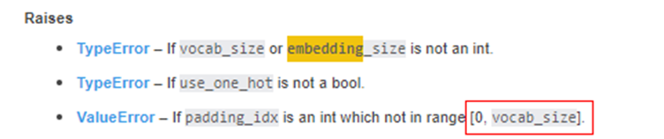
2. 解决方法
基于上面已知的原因，很容易做出如下修改：
01 class Net(nn.Cell):
02 def __init__(self, vocab_size, embedding_size, use_one_hot, padding_idx=None):
03 super(Net, self).__init__()
04 self.op = nn.Embedding(vocab_size=vocab_size, embedding_size=embedding_size, use_one_hot=use_one_hot, padding_idx=padding_idx)
05
06 def construct(self, x):
07 output = self.op(x)
08 return output
09
10 input = Tensor(np.ones([8, 128]), mindspore.int32)
11 vocab_size = 2000
12 embedding_size = 768
13 use_one_hot = True
14 example = Net(vocab_size=vocab_size, embedding_size=embedding_size, use_one_hot=use_one_hot, padding_idx=1000)
15 output = example(input)
16 print(&quot;Output:&quot;, output.shape)
此时执行成功，输出如下：
Output: (8, 128, 768)
3. 总结
定位报错问题的步骤：
1、找到报错的用户代码行：example = Net(vocab_size=vocab_size, embedding_size=embedding_size, use_one_hot=use_one_hot, padding_idx=10000);
2、 根据日志报错信息中的关键字，缩小分析问题的范围padding_idx in Embedding should be in range of [0, 2000], but got 10000 with type int.
4. 参考文档
4.1 Embedding算子API接口

报错ValueError: `seed2` in `StandardNormal` should be int and must >= 0
1. 报错描述
1.1 系统环境
Hardware Environment(Ascend/GPU/CPU): GPU Software Environment: -- MindSpore version (source or binary): 1.6.0 -- Python version (e.g., Python 3.7.5): 3.7.6 -- OS platform and distribution (e.g., Linux Ubuntu 16.04): Ubuntu 4.15.0-74-generic -- GCC/Compiler version (if compiled from source):
1.2 基本信息
1.2.1 脚本
训练脚本是通过构建StandardNormal的单算子网络，生成符合正态分布的随机数。脚本如下：
01 class Net(nn.Cell):
02 def __init__(self, seed=2, seed2=-3):
03 super(Net, self).__init__()
04 self.standard_normal = ops.StandardNormal(seed=seed, seed2=seed2)
05 def construct(self, output_shape):
06 output = self.standard_normal(output_shape)
07 return output
08
09 output_shape = (2, 3, 4)
10 net = Net()
11 output = net(output_shape)
12 print(&quot;OUTPUT: &quot;, output)
1.2.2 报错
这里报错信息如下：
Traceback (most recent call last):
File &quot;C:/Users/user1/PycharmProjects/q2_map/new/I4DSWV-standardNormal.py&quot;, line 16, in &lt;module&gt;
net = Net()
File &quot;C:/Users/user1/PycharmProjects/q2_map/new/I4DSWV-standardNormal.py&quot;, line 10, in __init__
self.standard_normal = ops.StandardNormal(seed=seed, seed2=seed2)
File &quot;C:\Users\user1\PycharmProjects\q2_map\lib\site-packages\mindspore\ops\primitive.py&quot;, line 687, in deco
fn(self, *args, **kwargs)
File &quot;C:\Users\user1\PycharmProjects\q2_map\lib\site-packages\mindspore\ops\operations\random_ops.py&quot;, line 67, in __init__
Validator.check_non_negative_int(seed2, &quot;seed2&quot;, self.name)
File &quot;C:\Users\user1\PycharmProjects\q2_map\lib\site-packages\mindspore\_checkparam.py&quot;, line 304, in check_non_negative_int
return check_number(arg_value, 0, Rel.GE, int, arg_name, prim_name)
File &quot;C:\Users\user1\PycharmProjects\q2_map\lib\site-packages\mindspore\_checkparam.py&quot;, line 168, in check_number
raise type_except(f'{prim_info} should be {arg_type.__name__} and must {rel_str}, '
ValueError: `seed2` in `StandardNormal` should be int and must &gt;= 0, but got `-3` with type `int`.
原因分析
我们看报错信息，在ValueError中，写到seed2 in StandardNormal should be int and must >= 0, but got -3 with type int，意思是StandardNormal算子里的seed2属性必须是大于等于0的整数， 但是得到了一个负数。官网对两个参数seed， seed2的范围都有进行说明：
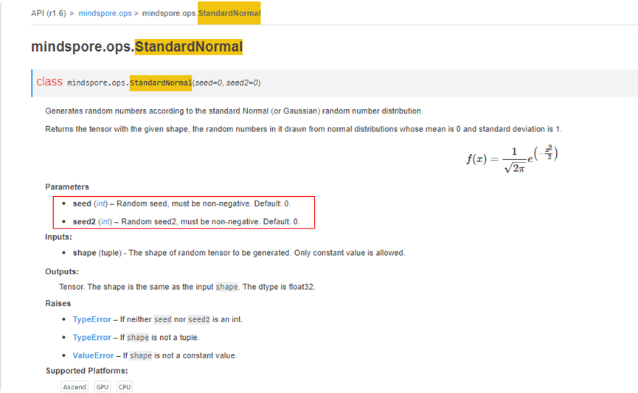
2. 解决方法
基于上面已知的原因，很容易做出如下修改：
01 class Net(nn.Cell):
02 def __init__(self, seed=2, seed2=3):
03 super(Net, self).__init__()
04 self.standard_normal = ops.StandardNormal(seed=seed, seed2=seed2)
05 def construct(self, output_shape):
06 output = self.standard_normal(output_shape)
07 return output
08
09 output_shape = (2, 3, 4)
10 net = Net()
11 output = net(output_shape)
12 print(&quot;OUTPUT: &quot;, output)
此时执行成功，输出如下：
OUTPUT: [[[-0.7503836 -1.4105444 1.689283 1.0585287 ] [ 0.19296396 -1.1577806 -0.9638309 -0.01727804] [ 0.3017666 -1.1502111 -0.3734214 -0.4361166 ]]
[[ 0.7154948 0.6556154 2.3681476 1.1285974 ] [-0.42168498 -0.2680572 -0.9242947 1.0003353 ] [-0.4574307 0.36757398 -0.28976655 0.4996464 ]]]
3. 总结
定位报错问题的步骤：
1、找到报错的用户代码行：self.standard_normal = ops.StandardNormal(seed=seed, seed2=seed2);
2、 根据日志报错信息中的关键字，缩小分析问题的范围t seed2 in StandardNormal should be int and must >= 0, but got ;
3、需要重点关注变量定义、初始化的正确性。
4. 参考文档
4.1 StandardNormal算子API接口

报错 Ascend 环境下ReduceMean不支持8维及其以上的输入
1. 报错描述
1.1 系统环境
Hardware Environment(Ascend/GPU/CPU): Ascend Software Environment: -- MindSpore version (source or binary): 1.8.0 -- Python version (e.g., Python 3.7.5): 3.7.6 -- OS platform and distribution (e.g., Linux Ubuntu 16.04): Ubuntu 4.15.0-74-generic -- GCC/Compiler version (if compiled from source):
1.2 基本信息
1.2.1 脚本
训练脚本是通过构建ReduceMean算子网络，对axis1进行求平均值归约。脚本如下：
01 class Net(nn.Cell):
02 def __init__(self, axis, keep_dims):
03 super().__init__()
04 self.reducemean = ops.ReduceMean(keep_dims=keep_dims)
05 self.axis = axis
06 def construct(self, input_x):
07 return self.reducemean(input_x, self.axis)
08 net = Net(axis=(1,), keep_dims=True)
09 x = Tensor(np.random.randn(1, 2, 3, 4, 5, 6, 7, 8, 9), mindspore.float32)
10 out = net(x)
11 print("out shape: ", out.shape)
1.2.2 报错
这里报错信息如下：
Traceback (most recent call last):
File "test.py", line 18, in <module>
out = net(x)
File "/root/archiconda3/envs/lh37_ascend/lib/python3.7/site-packages/mindspore/nn/cell.py", line 574, in __call__
out = self.compile_and_run(*args)
File "/root/archiconda3/envs/lh37_ascend/lib/python3.7/site-packages/mindspore/nn/cell.py", line 975, in compile_and_run
self.compile(*inputs)
File "/root/archiconda3/envs/lh37_ascend/lib/python3.7/site-packages/mindspore/nn/cell.py", line 948, in compile
jit_config_dict=self._jit_config_dict)
File "/root/archiconda3/envs/lh37_ascend/lib/python3.7/site-packages/mindspore/common/api.py", line 1092, in compile
result = self._graph_executor.compile(obj, args_list, phase, self._use_vm_mode())
RuntimeError: Single op compile failed, op: reduce_mean_d_1629966128061146056_6
except_msg: 2022-07-15 01:36:29.720449: Query except_msg:Traceback (most recent call last):
File "/root/archiconda3/envs/lh37_ascend/lib/python3.7/site-packages/te_fusion/parallel_compilation.py", line 1469, in run
relation_param=self._relation_param)
File "/root/archiconda3/envs/lh37_ascend/lib/python3.7/site-packages/te_fusion/fusion_manager.py", line 1283, in build_single_op
compile_info = call_op()
File "/root/archiconda3/envs/lh37_ascend/lib/python3.7/site-packages/te_fusion/fusion_manager.py", line 1270, in call_op
opfunc(*inputs, *outputs, *new_attrs, **kwargs)
File "/root/archiconda3/envs/lh37_ascend/lib/python3.7/site-packages/tbe/common/utils/para_check.py", line 537, in _in_wrapper
formal_parameter_list[i][1], op_name)
File "/root/archiconda3/envs/lh37_ascend/lib/python3.7/site-packages/tbe/common/utils/para_check.py", line 516, in _check_one_op_param
_check_input(op_param, param_name, param_type, op_name)
File "/root/archiconda3/envs/lh37_ascend/lib/python3.7/site-packages/tbe/common/utils/para_check.py", line 299, in _check_input
_check_input_output_dict(op_param, param_name, op_name)
File "/root/archiconda3/envs/lh37_ascend/lib/python3.7/site-packages/tbe/common/utils/para_check.py", line 223, in _check_input_output_dict
param_name=param_name)
File "/root/archiconda3/envs/lh37_ascend/lib/python3.7/site-packages/tbe/common/utils/para_check.py", line 689, in check_shape
_check_shape_range(max_rank, min_rank, param_name, shape)
File "/root/archiconda3/envs/lh37_ascend/lib/python3.7/site-packages/tbe/common/utils/para_check.py", line 727, in _check_shape_range
% (error_info['param_name'], min_rank, max_rank, len(shape)))
RuntimeError: ({'errCode': 'E80012', 'op_name': 'reduce_mean_d', 'param_name': 'input_x', 'min_value': 0, 'max_value': 8, 'real_value': 9}, 'In op, the num of dimensions of input/output[input_x] should be inthe range of [0, 8], but actually is [9].')
原因分析
我们看报错信息，在RuntimeError中，'In op, the num of dimensions of input/output[input_x] should be inthe range of [0, 8], but actually is [9].'意思是ReduceMean的输入为维度应该大于等于0，小于等于8，但实际值为9，显然超过了ReduceMean算子支持的维度。在官网中对ReduceSum也做了输入维度限制说明：
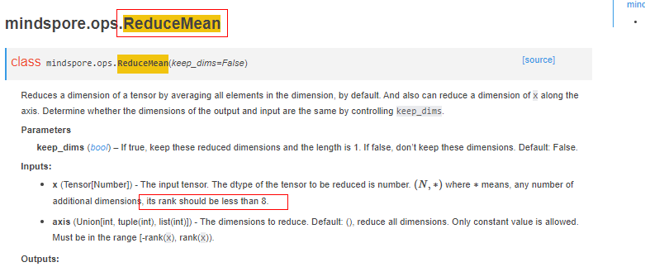
2. 解决方法
基于上面已知的原因，很容易做出如下修改：
01 class Net(nn.Cell):
02 def __init__(self, axis, keep_dims):
03 super().__init__()
04 self.reducemean = ops.ReduceMean(keep_dims=keep_dims)
05 self.axis = axis
06 def construct(self, input_x):
07 return self.reducemean(input_x, self.axis)
08 net = Net(axis=(1,), keep_dims=True)
09 x = Tensor(np.random.randn(2, 3, 4, 5, 6, 7, 8, 9), mindspore.float32)
10 out = net(x)
11 print("out shape: ", out.shape)
此时执行成功，输出如下：
out shape: (2, 1, 4, 5, 6, 7, 8, 9)
3. 总结
定位报错问题的步骤：
1、找到报错的用户代码行：out = net(x)；
2、根据日志报错信息中的关键字，缩小分析问题的范围：should be in the range of [0, 8], but actually is [10];
3、需要重点关注变量定义、初始化的正确性。
4. 参考文档
4.1 ReduceMean算子API接口

报错： Conv2D第三维输出数据类型必须是正整数或者SHP_ANY
1. 报错描述
1.1 系统环境
Hardware Environment(Ascend/GPU/CPU): Ascend Software Environment: -- MindSpore version (source or binary): 1.6.0 -- Python version (e.g., Python 3.7.5): 3.7.6 -- OS platform and distribution (e.g., Linux Ubuntu 16.04): Ubuntu 4.15.0-74-generic -- GCC/Compiler version (if compiled from source):
1.2 基本信息
1.2.1 脚本
训练脚本是通过构建Conv2D的单算子网络，来实现2d卷积操作的。脚本如下：
01 class Net(nn.Cell):
02 def __init__(self, in_channels, out_channels, kernel_size):
03 super(Net, self).__init__()
04 self.in_channels = in_channels
05 self.out_channels = out_channels
06 self.kernel_size = kernel_size
07 # self.pad_mode = &quot;valid&quot;
08 self.conv2d = nn.Conv2d(self.in_channels, self.out_channels, self.kernel_size, pad_mode=&quot;valid&quot;)
09
10 def construct(self, x):
11 return self.conv2d(x)
12
13 net = Net(in_channels=2, out_channels=10, kernel_size=64)
14 x = Tensor(np.random.randn(1, 2, 4, 64), mindspore.float32)
15 y = net(x).shape
16 print(&quot;otput shape: &quot;, y)
1.2.2 报错
这里报错信息如下：
Traceback (most recent call last):
File &quot;C:/Users/user1/PycharmProjects/q2_map/new/I4GYSL.py&quot;, line 20, in &lt;module&gt;
y = net(x).shape
File &quot;C:\Users\user1\PycharmProjects\q2_map\lib\site-packages\mindspore\nn\cell.py&quot;, line 586, in __call__
out = self.compile_and_run(*args)
File &quot;C:\Users\user1\PycharmProjects\q2_map\lib\site-packages\mindspore\nn\cell.py&quot;, line 964, in compile_and_run
self.compile(*inputs)
File &quot;C:\Users\user1\PycharmProjects\q2_map\lib\site-packages\mindspore\nn\cell.py&quot;, line 937, in compile
_cell_graph_executor.compile(self, *inputs, phase=self.phase, auto_parallel_mode=self._auto_parallel_mode)
File &quot;C:\Users\user1\PycharmProjects\q2_map\lib\site-packages\mindspore\common\api.py&quot;, line 1006, in compile
result = self._graph_executor.compile(obj, args_list, phase, self._use_vm_mode())
ValueError: build\mindspore\merge\mindspore\core\ops_merge.cc:6605 CheckShapeAnyAndPositive] Conv2D output_shape shape element [2] must be positive integer or SHP_ANY, but got -59
WARNING: Logging before InitGoogleLogging() is written to STDERR
[CRITICAL] CORE(2540,1,?):2022-6-28 21:12:34 [build\mindspore\merge\mindspore\core\ops_merge.cc:6605] CheckShapeAnyAndPositive] Conv2D output_shape shape element [2] must be positive integer or SHP_ANY, but got -59
原因分析
我们看报错信息，在ValueError中，写到Conv2D output_shape shape element [2] must be positive integer or SHP_ANY, but got -59，意思是Conv2d的输出形状的第三维也就是H-out应该是大于0的整数或者-1， 而实际得到的是-59. 结合官网API对Conv2 D的output描述，当pad_mode为“valid”时，选择第二组公式代入数据得到H-out为-59. 因此解决的方法有调整传入的参数大小或者将pad_mode设置为“same”
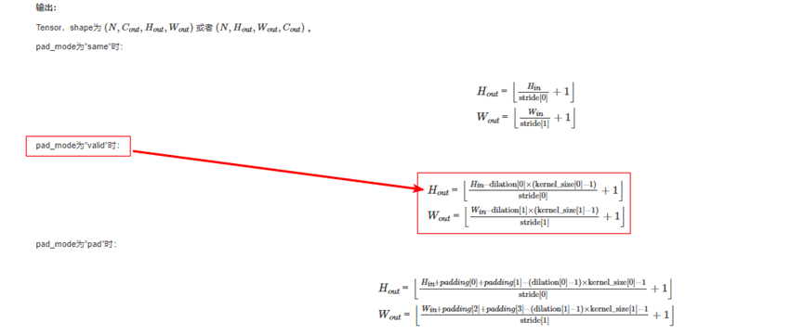
2. 解决方法
基于上面已知的原因，很容易做出如下修改：
01 class Net(nn.Cell):
02 def __init__(self, in_channels, out_channels, kernel_size):
03 super(Net, self).__init__()
04 self.in_channels = in_channels
05 self.out_channels = out_channels
06 self.kernel_size = kernel_size
07 # self.pad_mode = &quot;valid&quot;
08 self.conv2d = nn.Conv2d(self.in_channels, self.out_channels, self.kernel_size, pad_mode=&quot;valid&quot;)
09
10 def construct(self, x):
11 return self.conv2d(x)
12
13 net = Net(in_channels=2, out_channels=10, kernel_size=64)
14 x = Tensor(np.random.randn(1, 2, 64, 64), mindspore.float32)
15 y = net(x).shape
16 print(&quot;otput shape: &quot;, y)
此时执行成功，输出如下：
otput shape: (1, 10, 1, 1)
3. 总结
定位报错问题的步骤：
1、找到报错的用户代码行：y = net(x).shape;
2、 根据日志报错信息中的关键字，缩小分析问题的范围Conv2D output_shape shape element [2] must be positive integer or SHP_ANY, but got -59 ;
3、需要重点关注变量定义、初始化的正确性。
4. 参考文档
4.1 Conv2D算子API接口

报错：For 'TopK', the type of 'x' should be one of Tensor[Int32]
1. 报错描述
1.1 系统环境
Hardware Environment(Ascend/GPU/CPU): CPU Software Environment: -- MindSpore version (source or binary): 1.8.0 -- Python version (e.g., Python 3.7.5): 3.7.6 -- OS platform and distribution (e.g., Linux Ubuntu 16.04): Ubuntu 4.15.0-74-generic -- GCC/Compiler version (if compiled from source):
1.2 基本信息
1.2.1 脚本
训练脚本是通过构建TopK单算子网络计算Tensor最后一维的前k个最大值。脚本如下：
01 class Net(nn.Cell):
02 def __init__(self):
03 super(Net, self).__init__()
04 self.topk = ops.TopK(sorted=False)
05
06 def construct(self, x, k):
07 output = self.topk(x, k)
08 return output
09
10 net = Net()
11 x = Tensor(([[5, 2, 3, 3, 5], [5, 2, 9, 3, 5]]), mindspore.double)
12 k = 5
13 values, indices = net(x, k)
14 print(values, indices)
1.2.2 报错
这里报错信息如下：
Traceback (most recent call last):
File &quot;C:/Users/user1/PycharmProjects/q2_map/new/I4H30H.py&quot;, line 21, in &lt;module&gt;
values, indices = net(x, k)
File &quot;C:\Users\user1\PycharmProjects\q2_map\lib\site-packages\mindspore\nn\cell.py&quot;, line 586, in __call__
out = self.compile_and_run(*args)
File &quot;C:\Users\user1\PycharmProjects\q2_map\lib\site-packages\mindspore\nn\cell.py&quot;, line 964, in compile_and_run
self.compile(*inputs)
File &quot;C:\Users\user1\PycharmProjects\q2_map\lib\site-packages\mindspore\nn\cell.py&quot;, line 937, in compile
_cell_graph_executor.compile(self, *inputs, phase=self.phase, auto_parallel_mode=self._auto_parallel_mode)
File &quot;C:\Users\user1\PycharmProjects\q2_map\lib\site-packages\mindspore\common\api.py&quot;, line 1006, in compile
result = self._graph_executor.compile(obj, args_list, phase, self._use_vm_mode())
File &quot;C:\Users\user1\PycharmProjects\q2_map\lib\site-packages\mindspore\ops\operations\nn_ops.py&quot;, line 2178, in __infer__
validator.check_tensor_dtype_valid('x', x_dtype, valid_dtypes, self.name)
File &quot;C:\Users\user1\PycharmProjects\q2_map\lib\site-packages\mindspore\_checkparam.py&quot;, line 541, in check_tensor_dtype_valid
Validator.check_subclass(arg_name, arg_type, tensor_types, prim_name)
File &quot;C:\Users\user1\PycharmProjects\q2_map\lib\site-packages\mindspore\_checkparam.py&quot;, line 493, in check_subclass
raise TypeError(f&quot;For '{prim_name}', the type of '{arg_name}'&quot;
TypeError: For 'TopK', the type of 'x' should be one of Tensor[Int32], Tensor[Float16], Tensor[Float32], but got Tensor[Float64] . The supported data types depend on the hardware that executes the operator, please refer the official api document to get more information about the data type.
WARNING: Logging before InitGoogleLogging() is written to STDERR
[WARNING] UTILS(11576,1,?):2022-6-25 8:31:24 [mindspore\ccsrc\utils\comm_manager.cc:78] GetInstance] CommManager instance for CPU not found, return default instance.
[ERROR] ANALYZER(11576,1,?):2022-6-25 8:31:24 [mindspore\ccsrc\pipeline\jit\static_analysis\async_eval_result.cc:66] HandleException] Exception happened, check the information as below.
The function call stack (See file 'C:\Users\user1\PycharmProjects\q2_map\new\rank_0\om/analyze_fail.dat' for more details):
# 0 In file C:/Users/user1/PycharmProjects/q2_map/new/I4H30H.py(15)
output = self.topk(x, k)
^
原因分析
我们看报错信息，在TypeError中，写到For 'TopK', the type of 'x' should be one of Tensor[Int32], Tensor[Float16], Tensor[Float32], but got Tensor[Float64]，意思是对于TopK的输入类型必须是int32， float16或者float32， 而实际得到的是float64. 定位到代码第x行发现数据类型确实是float64， 解决的办法是调低数据精度。
2. 解决方法
基于上面已知的原因，很容易做出如下修改：
01 class Net(nn.Cell):
02 def __init__(self):
03 super(Net, self).__init__()
04 self.topk = ops.TopK(sorted=False)
05
06 def construct(self, x, k):
07 output = self.topk(x, k)
08 return output
09
10 net = Net()
11 x = Tensor(([[5, 2, 3, 3, 5], [5, 2, 9, 3, 5]]), mindspore.float32)
12 k = 5
13 values, indices = net(x, k)
14 print(values, indices)
此时执行成功，输出如下：
[[5. 2. 3. 3. 5.] [5. 2. 9. 3. 5.]] [[0 1 2 3 4] [0 1 2 3 4]]
3. 总结
定位报错问题的步骤：
1、找到报错的用户代码行：output = self.topk(x, k);
2、 根据日志报错信息中的关键字，缩小分析问题的范围For 'TopK', the type of 'x' should be one of Tensor[Int32], Tensor[Float16], Tensor[Float32] ;
3、需要重点关注变量定义、初始化的正确性。
4. 参考文档
4.1 TopK算子API接口

报错Minimum inputs size 0 does not match the requires signature size 2
1. 报错描述
1.1 系统环境
Hardware Environment(Ascend/GPU/CPU): GPU Software Environment: -- MindSpore version (source or binary): 1.5.2 -- Python version (e.g., Python 3.7.5): 3.7.6 -- OS platform and distribution (e.g., Linux Ubuntu 16.04): Ubuntu 4.15.0-74-generic -- GCC/Compiler version (if compiled from source):
1.2 基本信息
1.2.1 脚本
训练脚本是通过构建Minimum的单算子网络，计算输入Tensor对应元素的最小值。脚本如下：
01 class Net(nn.Cell):
02 def __init__(self):
03 super(Net, self).__init__()
04 self.minimum = ops.minumum()
05 def construct(self, x,y):
06 output = self.minimum(x, y)
07 return output
08 net = Net()
09 x = Tensor(np.array([1.0, 2.0, 4.0]), mindspore.float64) .astype(mindspore.float32)
10 y = Tensor(np.array([3.0, 5.0, 6.0]), mindspore.float64) .astype(mindspore.float32)
11 output = net(x, y)
12 print('output', output)
1.2.2 报错
这里报错信息如下：
[EXCEPTION] PYNATIVE(95109,7fe22ea22740,python):2022-06-14-21:59:02.837.339 [mindspore/ccsrc/pipeline/pynative/pynative_execute.cc:1331] SetImplicitCast] Minimum inputs size 0 does not match the requires signature size 2
Traceback (most recent call last):
File &quot;182168.py&quot;, line 36, in &lt;module&gt;
net = Net()
File &quot;182168.py&quot;, line 24, in __init__
self.minimum = ops.minimum()
File &quot;/data2/llj/mindspores/r1.5/build/package/mindspore/ops/primitive.py&quot;, line 247, in __call__
return _run_op(self, self.name, args)
File &quot;/data2/llj/mindspores/r1.5/build/package/mindspore/common/api.py&quot;, line 78, in wrapper
results = fn(*arg, **kwargs)
File &quot;/data2/llj/mindspores/r1.5/build/package/mindspore/ops/primitive.py&quot;, line 682, in _run_op
output = real_run_op(obj, op_name, args)
ValueError: mindspore/ccsrc/pipeline/pynative/pynative_execute.cc:1331 SetImplicitCast] Minimum inputs size 0 does not match the requires signature size 2
原因分析
我们看报错信息，在ValueError中，写到Minimum inputs size 0 does not match the requires signature size 2，大概意思是需要两个输入， 但实际没有输入。结合第11行发现其实是传入了两个输入的。所以问题可能就不是出在这一行， 我们可以在3， 5， 11行后面分别加上一个打印标记， 看程序执行到了哪个位置。执行后发现只打印了1， 说明问题就出在第四行， 仔细检查发现第四行初始化Minimum算子的时候minimum用的小写， 相当于直接调用了函数式接口minimum算子， 所以报错没有传入参数。
2. 解决方法
基于上面已知的原因，很容易做出如下修改：
01 class Net(nn.Cell):
02 def __init__(self):
03 super(Net, self).__init__()
04 self.minimum = ops.Minimum()
05 def construct(self, x,y):
06 output = self.minimum(x, y)
07 return output
08 net = Net()
09 x = Tensor(np.array([1.0, 2.0, 4.0]), mindspore.float64) .astype(mindspore.float32)
10 y = Tensor(np.array([3.0, 5.0, 6.0]), mindspore.float64) .astype(mindspore.float32)
11 output = net(x, y)
12 print('output', output)
此时执行成功，输出如下：
output [1. 2. 3.]
3. 总结
定位报错问题的步骤：
1、找到报错的用户代码行：self.minimum = ops.minimum();
2、 根据日志报错信息中的关键字，缩小分析问题的范围Minimum inputs size 0 does not match the requires signature size 2 ;
3、需要重点关注变量定义、初始化的正确性。
4. 参考文档
4.1 Minimum算子API接口

报错ValueError: Currently `half_pixel_centers`=True only support in Ascend device_target, but got CPU
1. 报错描述
1.1 系统环境
Hardware Environment(Ascend/GPU/CPU): CPU Software Environment: -- MindSpore version (source or binary): 1.8.0 -- Python version (e.g., Python 3.7.5): 3.7.6 -- OS platform and distribution (e.g., Linux Ubuntu 16.04): Ubuntu 4.15.0-74-generic -- GCC/Compiler version (if compiled from source):
1.2 基本信息
1.2.1 脚本
调用ResizeBilinear算子，用双线性插值调整输入Tensor为指定的大小。脚本如下：
01 context.set_context(device_target='CPU')
02 x = Tensor([[[[1, 2, 3, 4, 5], [1, 2, 3, 4, 5]]]], mindspore.float32)
03 resize_bilinear = ops.ResizeBilinear((5, 5), half_pixel_centers=True)
04 output = resize_bilinear(x)
05 print(output)
1.2.2 报错
这里报错信息如下：
Traceback (most recent call last):
File &quot;C:/Users/user1/PycharmProjects/q2_map/new/ResizeBilinear.py&quot;, line 7, in &lt;module&gt;
resize_bilinear = ops.ResizeBilinear((5, 5), half_pixel_centers=True)
File &quot;C:\Users\user1\PycharmProjects\q2_map\lib\site-packages\mindspore\ops\primitive.py&quot;, line 687, in deco
fn(self, *args, **kwargs)
File &quot;C:\Users\user1\PycharmProjects\q2_map\lib\site-packages\mindspore\ops\operations\nn_ops.py&quot;, line 3263, in __init__
raise ValueError(f&quot;Currently `half_pixel_centers`=True only support in Ascend device_target, &quot;
ValueError: Currently `half_pixel_centers`=True only support in Ascend device_target, but got CPU
原因分析
我们看报错信息，在ValueError中，写到Currently half_pixel_centers=True only support in Ascend device_target, but got CPU，意思是只支持在Ascend环境下half_pixel_centers属性才能设置为True。这一点官网API作了说明：
2. 解决方法
基于上面已知的原因，很容易做出如下修改：
01 context.set_context(device_target='Ascend')
02 x = Tensor([[[[1, 2, 3, 4, 5], [1, 2, 3, 4, 5]]]], mindspore.float32)
03 resize_bilinear = ops.ResizeBilinear((5, 5), half_pixel_centers=True)
04 output = resize_bilinear(x)
05 print(output)
此时执行成功，输出如下：
[[[[1. 2. 3. 4. 5.] [1. 2. 3. 4. 5.] [1. 2. 3. 4. 5.] [1. 2. 3. 4. 5.] [1. 2. 3. 4. 5.]]]]
3. 总结
定位报错问题的步骤：
1、找到报错的用户代码行：* resize_bilinear = ops.ResizeBilinear((5, 5), half_pixel_centers=True)*;
2、 根据日志报错信息中的关键字，缩小分析问题的范围Currently half_pixel_centers=True only support in Ascend device_target, but got CPU ;
4. 参考文档
4.1 ResizeBilinear算子API接口

报错ValueError: For AvgPool输出形状的每一维都要大于零
1. 报错描述
1.1 系统环境
Hardware Environment(Ascend/GPU/CPU): Ascend Software Environment: -- MindSpore version (source or binary): 1.8.0 -- Python version (e.g., Python 3.7.5): 3.7.6 -- OS platform and distribution (e.g., Linux Ubuntu 16.04): Ubuntu 4.15.0-74-generic -- GCC/Compiler version (if compiled from source):
1.2 基本信息
1.2.1 脚本
训练脚本是通过构建AvgPool的单算子网络，对输入的多维数据进行二维平均池化运算。脚本如下：
01 class Net(nn.Cell):
02 def __init__(self):
03 super(Net, self).__init__()
04 self.avgpool_op = ops.AvgPool(pad_mode=&quot;VALID&quot;, kernel_size=32, strides=1)
05
06 def construct(self, x):
07 result = self.avgpool_op(x)
08 return result
09
10 x = Tensor(np.arange(128 * 20 * 32 * 65).reshape(65, 32, 20, 128),mindspore.float32)
11 net = Net()
12 output = net(x)
13 print(output)
1.2.2 报错
这里报错信息如下：
Traceback (most recent call last):
File &quot;avgpool.py&quot;, line 17, in &lt;module&gt;
output = net(x)
File &quot;/root/archiconda3/envs/lilinjie_high/lib/python3.7/site-packages/mindspore/nn/cell.py&quot;, line 573, in __call__
out = self.compile_and_run(*args)
File &quot;/root/archiconda3/envs/lilinjie_high/lib/python3.7/site-packages/mindspore/nn/cell.py&quot;, line 956, in compile_and_run
self.compile(*inputs)
File &quot;/root/archiconda3/envs/lilinjie_high/lib/python3.7/site-packages/mindspore/nn/cell.py&quot;, line 929, in compile
_cell_graph_executor.compile(self, *inputs, phase=self.phase, auto_parallel_mode=self._auto_parallel_mode)
File &quot;/root/archiconda3/envs/lilinjie_high/lib/python3.7/site-packages/mindspore/common/api.py&quot;, line 1063, in compile
result = self._graph_executor.compile(obj, args_list, phase, self._use_vm_mode())
File &quot;/root/archiconda3/envs/lilinjie_high/lib/python3.7/site-packages/mindspore/ops/primitive.py&quot;, line 575, in __infer__
out[track] = fn(*(x[track] for x in args))
File &quot;/root/archiconda3/envs/lilinjie_high/lib/python3.7/site-packages/mindspore/ops/operations/nn_ops.py&quot;, line 1572, in infer_shape
raise ValueError(f&quot;For '{self.name}', the each element of the output shape must be larger than 0, &quot;
ValueError: For 'AvgPool', the each element of the output shape must be larger than 0, but got output shape: [65, 32, -3, 105]. The input shape: [65, 32, 20, 128], kernel size: (1, 1, 24, 24), strides: (1, 1, 1, 1).Please check the official api documents for more information about the output.
原因分析
我们看报错信息，在ValueError中，写到For'AvgPool', the each element of the output shape must be larger than 0, but got output shape: [65, 32, -3, 105].意思是输出形状的每一个值都应该大于零， 实际出现了负数， 一般输出数据范围不合理很可能是因为输入没有满足要求导致， 因此我们可以从排查各个输入的有效性着手。仔细查看官网API描述， 再结合我们输入的数据， strides=1在合理范围内， 但是kernel_size=32不合理，文档说明了在Ascend环境下，kernel_size的高度和宽度相乘应小于256, 而32*32=1024。因此我们可以调小kernel_size的高度或者宽度来解决这个问题。
2. 解决方法
基于上面已知的原因，很容易做出如下修改：
01 class Net(nn.Cell):
02 def __init__(self):
03 super(Net, self).__init__()
04 self.avgpool_op = ops.AvgPool(pad_mode=&quot;VALID&quot;, kernel_size=15, strides=1)
05
06 def construct(self, x):
07 result = self.avgpool_op(x)
08 return result
09
10 x = Tensor(np.arange(128 * 20 * 32 * 65).reshape(65, 32, 20, 128),mindspore.float32)
11 net = Net()
12 output = net(x)
13 print(output)
此时执行成功，输出如下：
(65, 32, 6, 114)
3. 总结
定位报错问题的步骤：
1、找到报错的用户代码行：output = net(x);
2、 根据日志报错信息中的关键字，缩小分析问题的范围* the each element of the output shape must be larger than 0* ;
3、需要重点关注变量定义、初始化的正确性。
4. 参考文档
4.1 AvgPool算子API接口

报错TypeError: The function construct needs 0 positional argument and 0 default argument, but provided 1
1. 系统环境
Hardware Environment(Ascend/GPU/CPU): ALL Software Environment: MindSpore version (source or binary): 1.6.0 & Earlier versions Python version (e.g., Python 3.7.5): 3.7.6 OS platform and distribution (e.g., Linux Ubuntu 16.04): Ubuntu GCC/Compiler version (if compiled from source):
2. python代码样例
from mindspore.nn import Cell
class Net(Cell):
def construct(x):
return x
net = Net()
net(2)
3. 报错信息
Traceback (most recent call last): File "error_map/01/param_not_match.py", line 10, in net(2) File "/usr/local/python3.7/lib/python3.7/site-packages/mindspore/nn/cell.py", line 469, in call self._check_construct_args(*args, **kwargs) File "/usr/local/python3.7/lib/python3.7/site-packages/mindspore/nn/cell.py", line 400, in _check_construct_args f"The function construct needs {positional_args} positional argument and {default_args} default " TypeError: The function construct needs 0 positional argument and 0 default argument, but provided 1
4. 原因分析
首先查看报错信息“TypeError: The function construct needs 0 positional argument and 0 default argument, but provided 1”
报错信息直译为：函数construct需要0个位置参数和0个默认参数，但提供了1个
为了理解报错信息的含义，需要解释两个名词positional argument和default argument。要解释这两个名词首先要理解什么是argument(调用时输入的实参，有具体的值)，说argument就必须要说Parameter(函数定义时声明的形参，没有具体的值)。以样例代码为列函数def construct(x)定义中的x是Parameter, net(2)中的2是argument。positional argument是需要通过输入顺序(位置)来识别具体输入和Parameter绑定关系的argument。 Python官方资料中并没有default argument这个概念，只有default value；含有default value的Parameter在函数调用时可以不输入对应的argument， 框架在函数调用时会使用default value作为argument。
理解位置参数和默认参数后，可以将报错信息更直白表述为：类Net的construct函数需要0个入参，但提供了1个
这样一来文字本身的含义是清晰了， 但依然存在两个疑问：
什么时候如何调用了类Net的construct函数？
类Net的construct函数原型def construct(x)有一个入参数x，为何报错信息胡扯需要0个入参?
疑问1的答案是：
MindSpore框架代码为类nn.Cell重写了魔法函数__call__，并在__call__中调用了construct，重写 __call__的效果是可以像调用函数一样调用类实例，例如样例代码中的：net(2)；感兴趣的同学可以自行查看框架发布包中nn.Cell.__call__的定义。
疑问2的答案是：
construct是通过Net的Instance methods机制调用的， construct的首个入参是由Python框架插入的类实例(与函数声明中的第一个Parameter对应，一般叫作self， 样例中叫x)，调用时输入的2其实是它的第2个argument。经过python框架的调用原型为 construct(net, 2)，它有2个arguments。
用如下Python原生代码会报类似错误：TypeError: construct() takes 1 positional argument but 2 were given
class Net:
def construct(x):
print(str(x))
net = Net()
net.construct(1)
MindSpore的报错信息是站在直接调用Instance methods角度来报的，它并不认为Python框架插入的类实例为用户输入argument，从def construct(x)的声明来看，它不需要调用方提供arguments，所以样例代码中MindSpore报错:“TypeError: The function construct needs 0 positional argument and 0 default argument, but provided 1”
5. 解决方法
通过上一章节的分析可以看出def construct(x):的定义是错误的，缺少了self入参，其正确定义为：def construct(self, x):
6. 平台改进点
报错信息上尽量与原生python保持一致，方便开发者进行理解。
优化后报错信息如下：
Traceback (most recent call last): File "/home/zhangzhaoju/ms_dev/error_map/01/param_not_match.py", line 10, in net(2) File "/usr/local/python3.7/lib/python3.7/site-packages/mindspore/nn/cell.py", line 475, in call self._check_construct_args(*args, **kwargs) File "/usr/local/python3.7/lib/python3.7/site-packages/mindspore/nn/cell.py", line 402, in _check_construct_args raise TypeError(f"Method construct() of class {self.class.name}, " TypeError: Method construct() of class Net takes 0 positional arguments but 1 were given.
7. 总结
MindSpore前端语法是Python语法的子集， 撰写模型时需要遵循Python语法。学习一些python语言的书籍，对于MindSpore运行机制理解和问题定位很有帮助。
8. 参考文档
魔法函数原理：https://docs.python.org/3/reference/datamodel.html#special-method-names
实例函数原理：https://docs.python.org/3/reference/datamodel.html#the-standard-type-hierarchy(instanse method 章节)

报错Operator[ ] input( ) output( ) is not support
1. 系统环境
Hardware Environment(Ascend/GPU/CPU): ALL Software Environment: MindSpore version (source or binary): 1.6.0 & Earlier versions Python version (e.g., Python 3.7.5): 3.7.6 OS platform and distribution (e.g., Linux Ubuntu 16.04): Ubuntu GCC/Compiler version (if compiled from source): gcc 9.4.0
python代码样例
from mindspore import context, ops, ms_function, Tensor, dtype
@ms_function
def test_logic(x, y):
z = x and y
return z and x
x = Tensor(True, dtype.bool_)
y = Tensor(True, dtype.bool_)
grad = ops.GradOperation(get_all=True)
grad_net = grad(test_logic)
out = grad_net(x, y)
2. 报错信息
Traceback (most recent call last):
File "test_backward_tensor.py", line 14, in <module>
out = grad_net(x, y)
File "C:\Users\46638\miniconda3\envs\mindspore\lib\site-packages\mindspore\common\api.py", line 360, in staging_specialize
out = _MindsporeFunctionExecutor(func, ms_create_time, input_signature, process_obj)(*args)
File "C:\Users\46638\miniconda3\envs\mindspore\lib\site-packages\mindspore\common\api.py", line 61, in wrapper
results = fn(*arg, **kwargs)
File "C:\Users\46638\miniconda3\envs\mindspore\lib\site-packages\mindspore\common\api.py", line 273, in __call__
phase = self.compile(args_list, self.fn.__name__)
File "C:\Users\46638\miniconda3\envs\mindspore\lib\site-packages\mindspore\common\api.py", line 256, in compile
is_compile = self._graph_executor.compile(self.fn, args_list, phase, True)
TypeError: mindspore\ccsrc\runtime\device\cpu\kernel_select_cpu.cc:217 KernelNotSupportException] Operator[AddN] input(kNumberTypeBool,kNumberTypeBool) output(kNumberTypeBool) is not supported. This error means the current input type is not supported, please refer to the MindSpore doc for supported types.
The function call stack:
In file C:\Users\46638\miniconda3\envs\mindspore\lib\site-packages\mindspore\ops\composite\multitype_ops\add_impl.py(287)/ return F.addn((x, y))/
报错信息中提示，当前算子AddN的输入类型(kNumberTypeBool,kNumberTypeBool)和输出类型kNumberTypeBool不支持。 同时，定位到报错代码行：return F.addn((x, y))，这里没有定位到用户的代码行。
3. 原因分析
MindSpore当前对数据类型为bool的Tensor[后续简称Tensor(bool)]支持能力较弱，仅有少量算子支持Tensor(bool)类型的数据参与运算。若在正向图中使用了支持Tensor(bool)类型的算子且正向图语法正确，由于反向图求解全导数会引入AddN，AddN不支持Tensor(bool)类型，反向图运行就会抛出该异常。
上述代码正向处理可以用公式表示为：r = f(z, x), z = z(x, y) 对应的全导数公式为：dr/dx = df/dz * dz/dx + df/dx， 函数f(z,x)和z(x,y)均为逻辑运算符and； 正向图中的and算子支持Tensor(bool)类型，反向图求全导数时引入的AddN不支持Tensor(bool) 类型， 此时该错误无法对应到具体的正向代码行。
4. 解决方法
遇到这类问题请去除对Tensor(bool)类型的使用，本例中将输入数据Tensor(bool)替换为bool即可解决问题。
from mindspore import context, ops, ms_function, Tensor, dtype
@ms_function
def test_logic(x, y):
z = x and y
return z and x
x = True
y = True
grad = ops.GradOperation(get_all=True)
grad_net = grad(test_logic)
out = grad_net(x, y)
5. 总结
MindSpore当前对数据类型支持能力当前还不完善，在使用过程中如果遇到数据类型相关的错误，请参考官方API接口的文档说明。
6. 参考文档
FAQ

报错 sth should be initialized as a Parameter type in ...
1. 系统环境
Hardware Environment(Ascend/GPU/CPU): ALL Software Environment: MindSpore version (source or binary): 1.6.0 & Earlier versions Python version (e.g., Python 3.7.5): 3.7.6 OS platform and distribution (e.g., Linux Ubuntu 16.04): Ubuntu GCC/Compiler version (if compiled from source): gcc 9.4.0
2. python代码样例
在网络中定义一个参数，并在训练过程中更新值，如下：
from mindspore import nn, Tensor, Parameter
import numpy as np
class Net(nn.Cell):
def __init__(self):
super(Net, self).__init__()
self.val = 2.0
def construct(self, x):
self.val = x
return 0
net = Net()
output = net(1.0)
执行代码发现报错。
3. 报错信息
Traceback (most recent call last):
File "test_var.py", line 15, in <module>
output = net(1.0)
File "C:\Users\46638\miniconda3\envs\mindspore\lib\site-packages\mindspore\nn\cell.py", line 477, in __call__
out = self.compile_and_run(*args)
File "C:\Users\46638\miniconda3\envs\mindspore\lib\site-packages\mindspore\nn\cell.py", line 803, in compile_and_run
self.compile(*inputs)
File "C:\Users\46638\miniconda3\envs\mindspore\lib\site-packages\mindspore\nn\cell.py", line 790, in compile
_cell_graph_executor.compile(self, *inputs, phase=self.phase, auto_parallel_mode=self._auto_parallel_mode)
File "C:\Users\46638\miniconda3\envs\mindspore\lib\site-packages\mindspore\common\api.py", line 632, in compile
result = self._graph_executor.compile(obj, args_list, phase, self._use_vm_mode())
TypeError: mindspore\ccsrc\pipeline\jit\parse\parse.cc:1923 HandleAssignClassMember] 'self.val' should be initialized as a 'Parameter' type in the '__init__' function, but got '2.0' with type 'float.
In file test_var.py(11)
self.val = x
4. 原因分析
报错信息提示，变量self.val不支持在construct函数中直接赋值，需要使用Parameter进行初始化。此时可以查询mindspore官网中Parameter接口的使用说明。
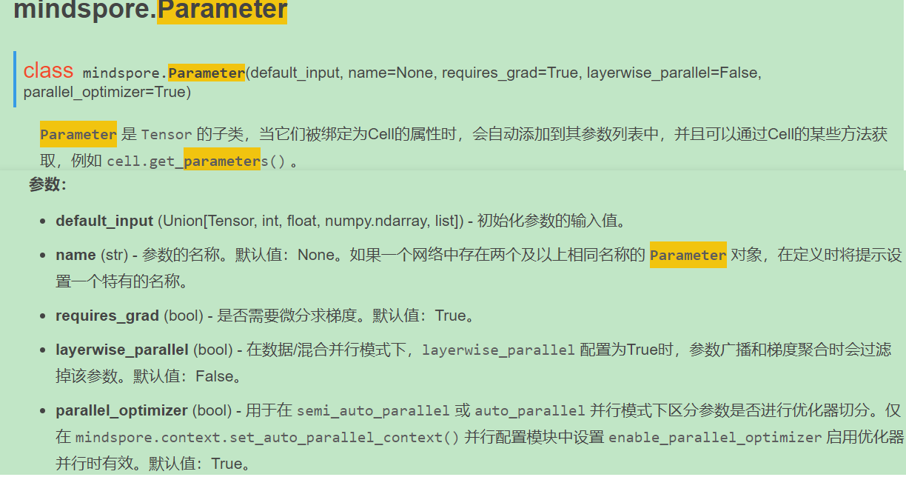
在样例中发现，参数需要在__init__方法中初始化。
5. 解决方法
from mindspore import nn, Tensor, Parameter
import mindspore as ms
import numpy as np
class Net(nn.Cell):
def __init__(self):
super(Net, self).__init__()
self.val = Parameter(Tensor(1.0, ms.float32), name="var")
def construct(self, x):
self.val = x
return 0
net = Net()
output = net(Tensor(2.0, ms.float32))
6. 总结
Cell网络中的变量需要在__init__中进行定义，并且使用Parameter接口进行初始化。
7. 参考文档
Parameter

报错：The 'add' operation does not support the type [kMetaTypeNone, Int64].
1. 系统环境
Hardware Environment(Ascend/GPU/CPU): All Software Environment: MindSpore version (source or binary): 1.6.0 & Earlier versions Python version (e.g., Python 3.7.5): 3.7.6 OS platform and distribution (e.g., Linux Ubuntu 16.04): Ubuntu GCC/Compiler version (if compiled from source): gcc 9.4.0
2. python代码样例
from mindspore import nn
class Net(nn.Cell):
def __init__(self):
super(Net, self).__init__()
def construct(self, x):
return self.y + x
net = Net()
output = net(1)
3. 报错信息
Traceback (most recent call last):
File "test_self.py", line 11, in <module>
output = net(1)
File "mindspore\nn\cell.py", line 477, in __call__
out = self.compile_and_run(*args)
File "mindspore\nn\cell.py", line 803, in compile_and_run
self.compile(*inputs)
File "mindspore\nn\cell.py", line 790, in compile
_cell_graph_executor.compile(self, *inputs, phase=self.phase, auto_parallel_mode=self._auto_parallel_mode)
File "mindspore\common\api.py", line 632, in compile
result = self._graph_executor.compile(obj, args_list, phase, self._use_vm_mode())
RuntimeError: mindspore\ccsrc\frontend\operator\composite\multitype_funcgraph.cc:162 GenerateFromTypes] The 'add' operation does not support the type [kMetaTypeNone, Int64].
The supported types of overload function `add` is: [Tuple, Tuple], [RowTensor, Tensor], [Tensor, Tensor], [List, List], [Tensor, List], [List, Tensor], [String, String], [Tuple, Tensor], [kMetaTypeNone, kMetaTypeNone], [Number, Number], [Number, Tensor], [Tensor, Number], [Tensor, Tuple].
The function call stack (See file 'rank_0/om/analyze_fail.dat' for more details):
# 0 In file test_self.py(8)
return self.y + x
4. 原因分析
首先看报错日志信息：
RuntimeError: The 'add' operation does not support the type [kMetaTypeNone, Int64].
The supported types of overload function `add` is: [Tuple, Tuple],[RowTensor, Tensor], [Tensor, Tensor], [List, List],[Tensor, List], [List, Tensor], [String, String], [Tuple, Tensor], [kMetaTypeNone, kMetaTypeNone], [Number, Number], [Number, Tensor], [Tensor, Number], [Tensor, Tuple].
上述日志信息的大致意思是add加法操作符不支持类型[kMetaTypeNone, Int64], 此外，还给出了该操作符支持的参数类型列表：
[Tuple, Tuple], [RowTensor, Tensor], [Tensor, Tensor], [List, List], [Tensor, List], [List, Tensor], [String, String], [Tuple, Tensor], [kMetaTypeNone, kMetaTypeNone], [Number, Number], [Number, Tensor], [Tensor, Number], [Tensor, Tuple]
在这里的疑问是，kMetaTypeNone什么类型， 哪里引入的类型报错？我们继续看报错信息。
在The function call stack:后面打印了函数的调用栈，对应的是用户代码行return self.y + x。就是说，该加法操作引入了不支持的参数类型。
**在mindspore中，construct函数里使用未定义的变量将作为None处理，对应的类型也就是kMetaTypeNone**。关于mindspore中变量的定义与使用，详情可参考官网：https://www.mindspore.cn/docs/note/zh-CN/r1.6/static_graph_syntax_support.html?highlight=kMetaTypeNone
在样例源码中，我们可以发现，变量self.y并没有定义，使用未定义的变量导致了编译报错。
5. 解决方法
由于执行报错是因使用未定义变量引起，因此，解决的方法便是在网络的初始化函数__init__(self):中定义该变量。需要注意的是，只有将变量定义为self的成员变量，才能够在construct(self, x)方法中使用。
from mindspore import nn
class Net(nn.Cell):
def __init__(self):
super(Net, self).__init__()
self.y = 1.0
def construct(self, x):
return self.y + x
net = Net()
output = net(1)
如果将self.y = 1.0写成y = 1.0, 同样会因为变量未定义而报错。
6. 总结
MindSpore前端语法是Python语法的子集， 撰写模型时需要遵循Python语法。学习掌握一些python语言的特性，对于MindSpore运行机制理解和问题定位很有帮助。
7. 参考文档
mindspore静态语法：https://www.mindspore.cn/docs/note/zh-CN/r1.6/static_graph_syntax_support.html

报错：When eval 'Tensor(self.data, mindspore.float32)' by using Fallback feature, an error occurred: data.
1. 系统环境
Hardware Environment(Ascend/GPU/CPU): GPU
Software Environment:
MindSpore version (source or binary): 1.6.0
Python version (e.g., Python 3.7.5): 3.7.6
OS platform and distribution (e.g., Linux Ubuntu 16.04): Ubuntu
GCC/Compiler version (if compiled from source):
2. 脚本
训练脚本是通过图模式测试Tensor的初始化，并使用了JIT（just in time） Fallback特性。脚本如下：
01 class Net(nn.Cell):
02 def __init__(self):
03 super(Net, self).__init__()
04 self.bias_add = ops.BiasAdd(data_format=&quot;NCHW&quot;)
05 data = np.random.random(3).reshape((3,1))
06 def construct(self, x):
07 y = Tensor(self.data, mindspore.float32)
08 x = self.bias_add(x,y)
09 return x
10
11 x = Tensor(np.arange(6).reshape((2,3)), mindspore.float32)
12 net = Net()
13 out = net(x)
14 print(&quot;out:&quot;, out.shape)
15 print(out)
3. 报错
报错信息如下：
[ERROR] ME(52672:139874759677760,MainProcess):2022-01-13-16:08:13.907.399 [mindspore/_extends/parse/parser.py:565] When eval 'Tensor(self.data, mindspore.float32)' by using Fallback feature, an error occurred: data. You can try to turn off the Fallback feature by 'export MS_DEV_ENABLE_FALLBACK=0'.
[ERROR] ANALYZER(52672,7f37215d1740,python):2022-01-13-16:08:13.908.581 [mindspore/ccsrc/pipeline/jit/static_analysis/async_eval_result.cc:66] HandleException] Exception happened, check the information as below.
The function call stack (See file '/opt/sdc/l00476171/proj/turtorial/rank_0/om/analyze_fail.dat' for more details):
\# 0 In file test_biasAdd.py(23)
y = Tensor(self.data, mindspore.float32)
^
Traceback (most recent call last):
File &quot;test_biasAdd.py&quot;, line 31, in &lt;module&gt;
out = net(x)
.......
NameError: data
4. 原因分析
在MindSpore r1.5及以前的版本，静态图模式不支持静态图的常量场景，即不支持在construct中创建和使用Tensor。而在脚本中第7行代码发现了在construct中创建tensor对象并使用。
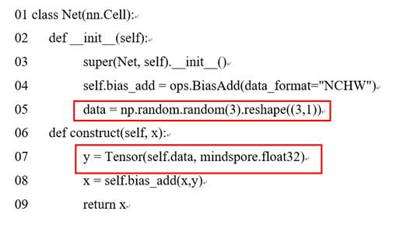
看报错信息：When eval 'Tensor(self.data, mindspore.float32)' by using Fallback feature。从官网找到Fallback feature可以在construct中创建常量tensor对象，此时init方法中初始化的data就是常量，可以确认不是Fallback feature引起的报错。

继续看报错信息：an error occurred: data。data是定义的网络属性参数，检查代码对比代码行05和07，发现原来是data变量定义存在问题。05行代码中初始定义的是data, 表示一个临时的局部变量，不是Net的属性参数, 在07行获取self.data时, 此时self.data没有定义所以引起了报错。
5. 解决方法
基于上述报错原因，很容易做出如下修改：
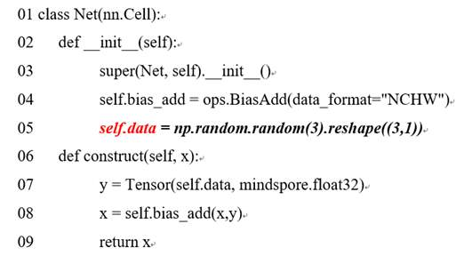
此时执行成功，输出如下：
[WARNING] PIPELINE(49927,7fc3d7296740,python):2022-01-13-18:01:54.153.611 [mindspore/ccsrc/pipeline/jit/pipeline.cc:1171] CheckInterpretNodeLineInfos] Found unsupported syntax in Graph mode, those codes would be fallen back to Python interpreter:
#1: In file test_biasAdd.py(23)
y = Tensor(self.data, mindspore.float32)
^
out: (2, 3)
[[0.0907748 1.1973865 2.1838439]
[3.0907748 4.1973867 5.1838436]]
由输出日志信息看出，需要使用JIT Fallback特性来支持的语句，会打印了提示信息和对应代码行:
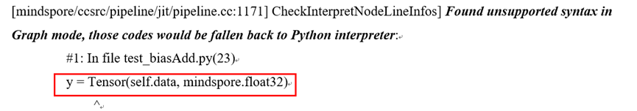
6. 总结
定位报错问题的一般流程是：
1、首先找到报错的用户代码行： y = Tensor(self.data, mindspore.float32)
2、然后根据日志报错信息中的关键字，缩小分析问题的范围：Fallback feature
3、报错信息需要Traceback中的报错信息：NameError: data。

报错RuntimeError: Net parameters weight shape ((751, 512)) is different from parameter_dict's ((31789, 512))
1. 系统环境
Hardware Environment(Ascend/GPU/CPU): ALL
Software Environment:
MindSpore version (source or binary): 1.6.0 &amp; Earlier versions
Python version (e.g., Python 3.7.5): 3.7.6
OS platform and distribution (e.g., Linux Ubuntu 16.04): Ubuntu
GCC/Compiler version (if compiled from source):
2. python代码样例
net = Net()
param_dict = load_checkpoint("net.ckpt")
load_param_into_net(net, param_dict)
3. 报错信息
RuntimeError: Net parameters weight shape ((751, 512)) is different from parameter_dict's ((31789, 512))
4. 原因分析
报错信息为：网络中参数的shape和ckpt中的shape不一致，无法正确加载。
加载checkpoint的流程为，首先读取checkpoint文件中的权重信息，把它们转化成dict，key值为parameter 的name，value为Parameter。
然后去遍历网络中的所有参数，依次在ckpt_dict中去查找，当查找到了同名的parameter后，就会进行加载操作。
如果这时发现网络中参数的shape与ckpt中参数的shape不一致，框架就不知道按照哪个shape为准了，就会报错。
5. 解决方法
遇到此问题的场景大多是加载ckpt的网络与保存ckpt的网络结构不一致。 可能是网络类型不一样，可能是网络的超参不一样导致的网络结构不一致。 此时，需要确定保存和加载时的网络结构是否一致。 可以使用network.parameters_dict方法获取网络中的参数； 使用param_dict = load_checkpoint("net.ckpt")方法获取checkpoint中的参数字典，再对比二者的差异。
6. 参考文档
checkpoint 用法可以参考: 保存与加载

GPU设备提示:The device with Cuda compute capability 5.2 is lower than the minimum required capability 5.3
1. 现象描述
按照官网正确安装mindspore 以及cuda驱动和库文件后，运行官网加法示例，输出结果全零。 或者执行matmul算子时报 cuBLAS Error: cublasGemmEx failed等情况。 相关案例：https://bbs.huaweicloud.com/forum/thread-149034-1-1.html
2. 原因分析
一般是因为当前使用的GPU设备算力不够引起。 当前mindspore限制显卡算力为最低5.3，显卡算力的可在Nivida官网查询。
3. 解决方法
在mindspore-1.6版本之后，mindspore对使用者的GPU显卡进行了算力识别，如使用者的GPU算力小于5.3，会有相应的日志提醒。
The device with Cuda compute capability 5.2 is lower than the minimum required capability 5.3, this may cause some unexpected problems and severely affect the results. Eg: the outputs are all zeros. Device with a compute capability > 5.3 is required, and it is recommended to use devices with a compute capability >= 7
由于是算力由硬件设备决定，暂无法通过软件方式规避，因此直接的解决方式是升级显卡设备。 或者使用CPU设备进行mindspore的使用。

GPU环境运行MindSpore报错：设卡失败 SetDevice failed
1. 系统环境
硬件环境(Ascend/GPU/CPU): GPU
软件环境: MindSpore 版本: 2.0.0
执行模式（静态图/动态图）： 不限
Python 版本: 3.7.6
操作系统平台: linux
2. 报错信息
在GPU环境上安装MindSpore，运行后报错提示设卡失败，如"SetDevice for id: 7 failed......"这类错误。
3. 根因分析
在此类错误一般原因：设卡的device id越界，超出了可用GPU卡总数。
4. 解决方案
设卡失败后，MindSpore会有ERROR日志提示：
"SetDevice for id: index failed,... Please make sure that the 'device_id' set in context is in the range:[0, total number of GPU). If the environment variable 'CUDA_VISIBLE_DEVICES' is set, the total number of GPU will be the number set in the environment variable 'CUDA_VISIBLE_DEVICES'. For example, if export CUDA_VISIBLE_DEVICES=4,5,6, the 'device_id' can be 0,1,2 at the moment, 'device_id' starts from 0, and 'device_id'=0 means using GPU of number 4.
日志中给出了设卡样例，提示MindSpore需要的逻辑device id和物理卡号的对应关系。
- 如果是执行单卡脚本遇到设卡失败，请确保 context中设置的device_id 小于环境中GPU卡的总数（如果export了 CUDA_VISIBLE_DEVICES环境变量，则GPU卡的总数修正为CUDA_VISIBLE_DEVICES变量中设置的GPU卡的总数），例如， export CUDA_VISIBLE_DEVICES=4,5,6，则可用的卡为3张，分别对应物理环境中的4号5号和6号卡，如果在context中设置了device_id，则需要确保其小于3，可以取值0,1,2，如果设置为0，则表示使用4号GPU卡。
- 如果是执行多卡训练遇到设卡失败，请确保脚本期望执行的分布式并行数不超过物理环境中GPU卡的总数（如果export了 CUDA_VISIBLE_DEVICES环境变量，则需要保证环境变量中设置的GPU卡数不少于分布式并行数），例如执行单机8卡训练，则需要确保物理环境中至少有8张卡（如果export 了CUDA_VISIBLE_DEVICES环境变量，则需要保证CUDA_VISIBLE_DEVICES中设置的卡数不少于8张，例如， 可以export CUDA_VISIBLE_DEVICES=0,1,2,3,4,5,6,7 ）。

Ascend环境使用MindSpore报出如下错误: Total stream number xxx exceeds the limit of 1024, secrch details information in mindspore's FAQ.
1. 现象描述
Ascend环境使用MindSpore报出如下错误:
AssignAllNodesStream] Total stream number xxx exceeds the limit of 1024, secrch details information in mindspore's FAQ.
2. 原因分析
出现上述报错的原因一般是网络模型规模巨大，使用的流资源的数量超出了Ascend的流资源数量限制。 流资源是Ascend平台的一种硬件资源，通过为每个算子分配流，可以控制算子的执行顺序。同一条流上的算子按顺序串行执行，不同流上的算子可以并行执行，每条流上可以分配的算子数量有限，流资源总的数量也是有限的。
3. 解决办法
使用MindSpore r1.6及后续版本可解决此问题 在MindSpore r1.6之前版本，流资源的数量限制是1024条，在r1.6及后续版本，可用的流资源的数量增加到2016条，可解决此问题。 若不升级MindSpore版本，则需考虑缩减模型规模。

LoadTask Distribute Task Failed 报错解决
1. 系统环境
硬件环境(Ascend/GPU/CPU): Ascend
软件环境: MindSpore 版本: 1.6.1
执行模式（静态图/动态图）： 不限
Python 版本: 3.7.6
操作系统平台: linux
2. 报错信息
2.1 问题描述
在分布式运行环境中，需要bash启动脚本和python文件，分别如下：
将下述的bash脚本另存为 run.sh
#!/bin/bash
set -e
EXEC_PATH=$(pwd)
export HCCL_CONNECT_TIMEOUT=120 # 避免复现需要很长时间，设置超时为120s
export RANK_SIZE=8
export RANK_TABLE_FILE=${EXEC_PATH}/rank_table_8pcs.json
for((i=0;i&lt;4;i++))
do
rm -rf device$i
mkdir device$i
cp ./train.py ./device$i
cd ./device$i
export DEVICE_ID=$i
export RANK_ID=$i
echo &quot;start training for device $i&quot;
env &gt; env$i.log
python ./train.py &gt; train.log$i 2&gt;&amp;1 &amp;
cd ../
done
echo &quot;The program launch succeed, the log is under device0/train.log0.&quot;
将下述的脚本命名为run.py
&quot;&quot;&quot;Operator Parallel Example&quot;&quot;&quot;
import numpy as np
from mindspore import context, Parameter
from mindspore.nn import Cell, Momentum
from mindspore.ops import operations as P
from mindspore.train import Model
from mindspore.nn.loss import SoftmaxCrossEntropyWithLogits
import mindspore.dataset as ds
import mindspore.communication.management as D
from mindspore.train.callback import LossMonitor
from mindspore.train.callback import ModelCheckpoint
from mindspore.common.initializer import initializer
step_per_epoch = 4
def get_dataset(*inputs):
def generate():
for _ in range(step_per_epoch):
yield inputs
return generate
class Net(Cell):
&quot;&quot;&quot;define net&quot;&quot;&quot;
def __init__(self):
super().__init__()
self.matmul = P.MatMul().shard(((2, 4), (4, 1)))
self.weight = Parameter(initializer(&quot;normal&quot;, [32, 16]), &quot;w1&quot;)
self.relu = P.ReLU().shard(((8, 1),))
def construct(self, x):
out = self.matmul(x, self.weight)
out = self.relu(out)
return out
if __name__ == &quot;__main__&quot;:
context.set_context(mode=context.GRAPH_MODE, device_target=&quot;Ascend&quot;, save_graphs=True)
D.init()
rank = D.get_rank()
context.set_auto_parallel_context(parallel_mode=&quot;semi_auto_parallel&quot;, device_num=8, full_batch=True)
np.random.seed(1)
input_data = np.random.rand(16, 32).astype(np.float32)
label_data = np.random.rand(16, 16).astype(np.float32)
fake_dataset = get_dataset(input_data, label_data)
net = Net()
callback = [LossMonitor(), ModelCheckpoint(directory=&quot;{}&quot;.format(rank))]
dataset = ds.GeneratorDataset(fake_dataset, [&quot;input&quot;, &quot;label&quot;])
loss = SoftmaxCrossEntropyWithLogits()
learning_rate = 0.001
momentum = 0.1
epoch_size = 1
opt = Momentum(net.trainable_params(), learning_rate, momentum)
model = Model(net, loss_fn=loss, optimizer=opt)
model.train(epoch_size, dataset, callbacks=callback, dataset_sink_mode=False)
对应的rank_table如下，命名为rank_table_8pcs.json
{
&quot;version&quot;: &quot;1.0&quot;,
&quot;server_count&quot;: &quot;1&quot;,
&quot;server_list&quot;: [
{
&quot;server_id&quot;: &quot;10.90.41.205&quot;,
&quot;device&quot;: [
{
&quot;device_id&quot;: &quot;0&quot;,
&quot;device_ip&quot;: &quot;192.98.92.107&quot;,
&quot;rank_id&quot;: &quot;0&quot;
},
{
&quot;device_id&quot;: &quot;1&quot;,
&quot;device_ip&quot;: &quot;192.98.93.107&quot;,
&quot;rank_id&quot;: &quot;1&quot;
},
{
&quot;device_id&quot;: &quot;2&quot;,
&quot;device_ip&quot;: &quot;192.98.94.107&quot;,
&quot;rank_id&quot;: &quot;2&quot;
},
{
&quot;device_id&quot;: &quot;3&quot;,
&quot;device_ip&quot;: &quot;192.98.95.107&quot;,
&quot;rank_id&quot;: &quot;3&quot;
},
{
&quot;device_id&quot;: &quot;4&quot;,
&quot;device_ip&quot;: &quot;192.98.92.108&quot;,
&quot;rank_id&quot;: &quot;4&quot;
},
{
&quot;device_id&quot;: &quot;5&quot;,
&quot;device_ip&quot;: &quot;192.98.93.108&quot;,
&quot;rank_id&quot;: &quot;5&quot;
},
{
&quot;device_id&quot;: &quot;6&quot;,
&quot;device_ip&quot;: &quot;192.98.94.108&quot;,
&quot;rank_id&quot;: &quot;6&quot;
},
{
&quot;device_id&quot;: &quot;7&quot;,
&quot;device_ip&quot;: &quot;192.98.95.108&quot;,
&quot;rank_id&quot;: &quot;7&quot;
}
],
&quot;host_nic_ip&quot;: &quot;reserve&quot;
}
],
&quot;status&quot;: &quot;completed&quot;
}
假设本地拥有8个Ascend 910设备，那么可以设置启动命令如下
bash run.sh 8
日志文件输出在当前执行目录下：device0/train.log0
2.2 报错信息
[CRITICAL] GE(88778,7f440899a740,python):2022-03-10-18:22:59.846.306 [mindspore/ccsrc/plugin/device/ascend/hal/device/ge_runtime/task/hccl_task.cc:100] Distribute] davinci_model : load task fail, return ret: 1343225860
[CRITICAL] DEVICE(88778,7f440899a740,python):2022-03-10-18:22:59.846.792 [mindspore/ccsrc/plugin/device/ascend/hal/device/ascend_kernel_runtime.cc:560] LoadTask] Distribute Task Failed,
error msg: mindspore/ccsrc/plugin/device/ascend/hal/device/ge_runtime/task/hccl_task.cc:100 Distribute] davinci_model : load task fail, return ret: 1343225860
[ERROR] DEVICE(88778,7f440899a740,python):2022-03-10-18:22:59.846.859 [mindspore/ccsrc/plugin/device/ascend/hal/hardware/ascend_device_context.cc:641] ReportErrorMessage] Ascend error occurred, error message:
EI9999: Inner Error!
EI9999 connected p2p timeout, timeout:120 s.local logicDevid:0,remote physic id:4 The possible causes are as follows:1.the connectionbetween this device and the target device is abnormal 2.an exception occurredat the target devices 3.The ranktable is not matched.[FUNC:WaitP2PConnected][FILE:p2p_mgmt.cc][LINE:228]
[CRITICAL] DEVICE(88778,7f440899a740,python):2022-03-10-18:22:59.846.878 [mindspore/ccsrc/plugin/device/ascend/hal/hardware/ascend_device_context.cc:413] PreprocessBeforeRunGraph] Preprocess failed before run graph 1,
error msg: mindspore/ccsrc/plugin/device/ascend/hal/device/ascend_kernel_runtime.cc:560 LoadTask] Distribute Task Failed,
error msg: mindspore/ccsrc/plugin/device/ascend/hal/device/ge_runtime/task/hccl_task.cc:100 Distribute] davinci_model : load task fail, return ret: 1343225860
Traceback (most recent call last):
File &quot;/rootmodels/test_matmul_net.py&quot;, line 91, in &lt;module&gt;
run_net(args.shape)
File &quot;/rootmodels/test_matmul_net.py&quot;, line 81, in run_net
model.train(1, ds_train2, callbacks=[LossMonitor()], dataset_sink_mode=True)
File &quot;/rootmindspore/build/package/mindspore/train/model.py&quot;, line 777, in train
sink_size=sink_size)
File &quot;/rootmindspore/build/package/mindspore/train/model.py&quot;, line 86, in wrapper
func(self, *args, **kwargs)
File &quot;/rootmindspore/build/package/mindspore/train/model.py&quot;, line 543, in _train
self._train_dataset_sink_process(epoch, train_dataset, list_callback, cb_params, sink_size)
File &quot;/rootmindspore/build/package/mindspore/train/model.py&quot;, line 611, in _train_dataset_sink_process
outputs = train_network(*inputs)
File &quot;/rootmindspore/build/package/mindspore/nn/cell.py&quot;, line 542, in __call__
out = self.compile_and_run(*args)
File &quot;/rootmindspore/build/package/mindspore/nn/cell.py&quot;, line 872, in compile_and_run
self.compile(*inputs)
File &quot;/rootmindspore/build/package/mindspore/nn/cell.py&quot;, line 857, in compile
_cell_graph_executor.compile(self, *inputs, phase=self.phase, auto_parallel_mode=self._auto_parallel_mode)
File &quot;/rootmindspore/build/package/mindspore/common/api.py&quot;, line 712, in compile
result = self._graph_executor.compile(obj, args_list, phase, self._use_vm_mode())
RuntimeError: mindspore/ccsrc/plugin/device/ascend/hal/hardware/ascend_device_context.cc:413 PreprocessBeforeRunGraph] Preprocess failed before run graph 1,
error msg: mindspore/ccsrc/plugin/device/ascend/hal/device/ascend_kernel_runtime.cc:560 LoadTask] Distribute Task Failed,
error msg: mindspore/ccsrc/plugin/device/ascend/hal/device/ge_runtime/task/hccl_task.cc:100 Distribute] davinci_model : load task fail, return ret: 1343225860
3. 解决方案
从上往下分别是MindSpore报错信息为LoadTask的日志，以及打印的ReportErrorMessage中具体的报错信息，以及MindSpore报错的具体信息。 其中关键信息如下。
EI9999 connected p2p timeout, timeout:120 s.local logicDevid:0,remote physic id:4 The possible causes are as follows:1.the connectionbetween this device and the target device is abnormal 2.an exception occurredat the target devices 3.The ranktable is not matched.[FUNC:WaitP2PConnected][FILE:p2p_mgmt.cc][LINE:228]
这个日志信息表示p2p连接超过了120s。本地是卡0(local logicDevid:0)，想要连接的目标是卡4(remote physic id:4)。因此可以判断两卡之间的网络连接是否正常，卡4的程序是否正常。
回过来我们想要查看卡4的日志，却发现没有日志。进而判断是否是程序没有成功启动？
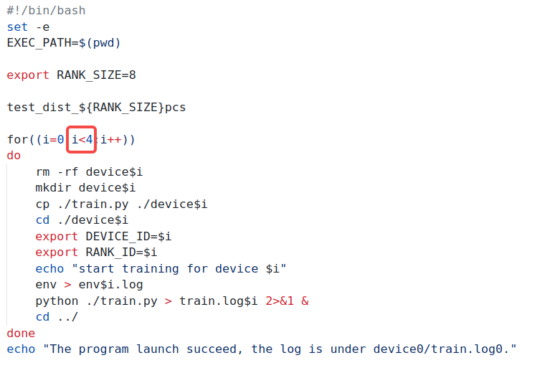看下启动脚本，发现里面只运行了4个进程，但是我们配置的rank_table却是8卡的。因此，只有03卡启动了程序，48卡并没有进程在启动。卡0无法连接卡4，因此造成上述的报错，解决方法：将bash启动脚本中的4改成8，如下所示：
#!/bin/bash
set -e
EXEC_PATH=$(pwd)
export RANK_SIZE=8
test_dist_${RANK_SIZE}pcs
for((i=0;i&lt;8;i++))
do
rm -rf device$i
mkdir device$i
cp ./train.py ./device$i
cd ./device$i
export DEVICE_ID=$i
export RANK_ID=$i
echo &quot;start training for device $i&quot;
env &gt; env$i.log
python ./train.py &gt; train.log$i 2&gt;&amp;1 &amp;
cd ../
done
echo &quot;The program launch succeed, the log is under device0/train.log0.&quot;

GPU训练提示分配流失败[cudaStreamCreate failed]
1. 现象描述
按照官网正确安装mindspore 执行GPU训练，提示“Failed to create CUDA stream | Error Number: 0”
2. 原因分析
此处error number 0不代表错误码为0，只是代表分配流操作失败，具体cuda返回的错误码可以在上文日志中看到，可能提示：
cudaStreamCreate failed, ret[XXX], "cuda error string"
一般来说GPU流失败很有可能是由于Nvidia驱动和cuda版本不匹配，
nvidia驱动版本需要高于cuda版本
官方给出的版本配套要求：https://docs.nvidia.com/cuda/cuda-toolkit-release-notes/index.html
3. 解决方法
根据官方版本配套要求，重新安装对应版本的Nvidia驱动，即可启动训练。

GPU训练过程中报错：The memory alloc size is 0
1. 现象描述
GPU上网络运行过程中出现内存申请大小为0的错误，报错日志中有如下信息：
The memory alloc size is 0
2. 原因分析
该错误出现是由于内存申请的时候调用接口时传入的申请size为0，因此报错，碰到场景非常少，一般原因是数据集读取的数据是空导致size为0
3. 排查步骤和解决方法
步骤1：排查数据集中读取的数据是否有问题，可以通过context.set_context(save_graphs=True)保存图，然后观察*_validate*.ir这一类ir是否生成，如果未生成则说明图还未执行就报错了，基本上就确认了数据集读取数据出现问题了，可以自行排查或者联系MindData开发人员确认。
步骤2：如果前面步骤确认没有问题的话，需要MindSpore开发人员详细分析了，context.set_context(save_graphs=True)同时export GLOG_v=1保存执行日志，将保存的图和日志打包发给开发人员排查确认。

报错：ValueError: For 'load_checkpoint', the checkpoint
1. 系统环境
Hardware Environment(Ascend/GPU/CPU): ALL
Software Environment:
MindSpore version (source or binary): 1.7.0 &amp; Earlier versions
Python version (e.g., Python 3.7.5): 3.7.6
OS platform and distribution (e.g., Linux Ubuntu 16.04): Ubuntu
GCC/Compiler version (if compiled from source):
2. python代码样例
net = Net()
param_dict = load_checkpoint("error.ckpt")
3. 报错信息
ValueError: For 'load_checkpoint', the checkpoint file: /home/error.ckpt does not exist, please check whether the 'ckpt_file_name' is correct.
4. 原因分析
报错信息为：加载checkpoint时，没有找到脚本中指定的文件。
加载checkpoint时，会去找`load_checkpoint`方法中`ckpt_file_name`参数指定的文件。
如果没有找到这个文件，会报ValueError错误。
5. 解决方法
报错信息中，会把指定文件的绝对路径打印出来，可以根据打印出的信息，查看系统上有没有这个文件。
6. 参考文档
checkpoint 用法可以参考: 保存与加载

加载checkpoint的时候报warning日志xxx parameters in the 'net' are not loaded, because they are not in the 'parameter_dict'
1. 系统环境
Hardware Environment(Ascend/GPU/CPU): ALL
Software Environment:
MindSpore version (source or binary): 1.7.0 &amp; Earlier versions
Python version (e.g., Python 3.7.5): 3.7.6
OS platform and distribution (e.g., Linux Ubuntu 16.04): Ubuntu
GCC/Compiler version (if compiled from source):
2. python代码样例
net = Net()
load_checkpoint(&quot;net.ckpt&quot;, net=net)
3. 报错信息
Warnning: [mindspore/train/serialization.py] xxx parameters in the 'net' are not loaded, because they are not in the 'parameter_dict'
4. 原因分析
报错信息为：把checkpoint文件中的参数加载到网络中时，发现网络中的一些参数没有被加载上。
具体原因为，checkpoint文件中没有那些参数，导致加载时找不到对应的参数。
5. 解决方法
产生这种告警的情况大部分是，训练和加载checkpoint时的网络结构不一致导致的。 首先排查网络定义，是否一致，其次排查是否有超参导致两者内部结构发生变化。 如无结果，可以使用network.parameters_dict方法获取网络中的参数； 使用param_dict = load_checkpoint(&quot;net.ckpt&quot;)方法获取checkpoint中的参数字典，再对比二者的差异。
6. 参考文档
checkpoint 用法可以参考: 保存与加载

报错：ValueError: For 'context.set_context', package type xxx support 'device_target' type xxx, but got xxx.
1. 系统环境
Hardware Environment(Ascend/GPU/CPU): ALL
Software Environment:
MindSpore version (source or binary): 1.7.0 &amp; Earlier versions
Python version (e.g., Python 3.7.5): 3.7.6
OS platform and distribution (e.g., Linux Ubuntu 16.04): Ubuntu
GCC/Compiler version (if compiled from source):
2. python代码样例
from mindspore import context
context.set_context(device_target=Ascend)
3. 报错信息
ValueError: For 'context.set_context', package type xxx support 'device_target' type xxx, but got xxx.)
4. 原因分析
context.set_context方法为设置脚本运行的后端，有Ascend、GPU、CPU。 Ascend、GPU环境可以运行CPU后端，CPU环境不能运行Ascend、GPU后端，Ascend和GPU互相不能切换。 如果脚本设置的运行后端与脚本运行的硬件不匹配，则会报这个错误。
5. 解决方法
查看当前运行的硬件，在context.set_context中设置对应的即可。
6. 参考文档
具体可参考可以参考: 配置运行信息

PyNative模式下The pointer[top_cell_] is null错误
1. 现象回顾
MindSpore动态图下可以使用自定义数据集进行网络训练，但是当使用自定义数据集时，一不小心就会出现以下错误：
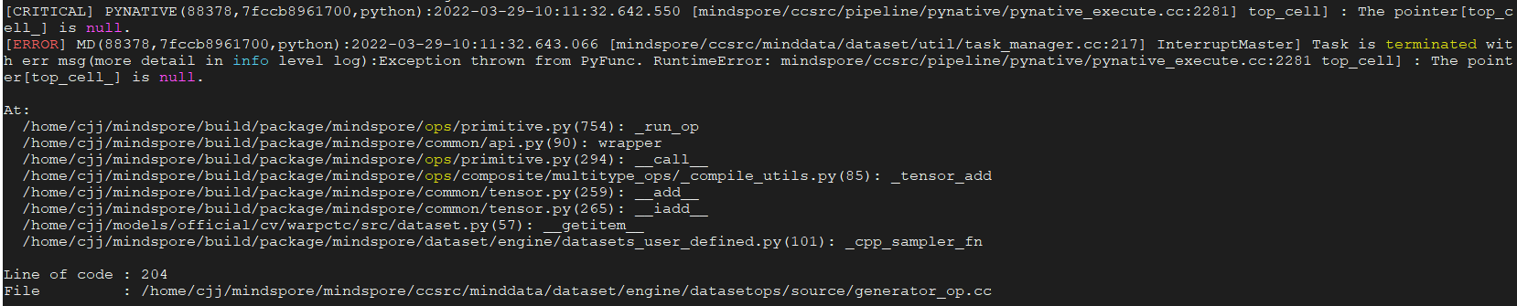
当出现该错误时，只是看到有一个指针为空了，但是python的调用栈却是在数据集里面。于是打开相应的自定义数据集脚本：
/home/cjj/models/official/cv/warpctc/src/dataset.py(57)
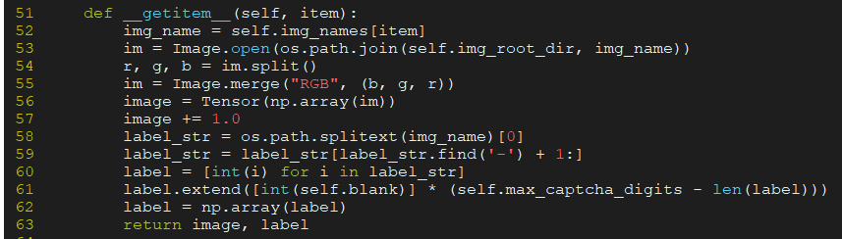
发现此处有一个 image += 1.0的tensor操作。于是将该操作删除后，发现程序正常运行。
2. 根因分析
该错误根因隐藏较深，由于MindSpore框架对于单算子的执行只支持单线程操作，但是在自定义数据集__getitem__函数中使用了Tensor的运算操作，即会调到框架的算子执行，由于数据集的处理使用了多线程操作，因此导致整体的执行顺序错乱，出现空指针的错误。因此到看到空指针错误且错误在generator.cc中时，就是在数据集中错误使用了Tensor的运算操作。
3. 解决方案
1、根据提示的调用栈信息，找到自定义数据集脚本中出错的位置。
2、将自定义数据集中的Tensor操作改为使用原生numpy进行计算。

报错RuntimeError:alloc device memory failed, free memory size is less than half of total memory size.
1. 现象描述
在Ascend环境安装MindSpore，运行网络脚本时，报如下错误
RuntimeError: mindspore/ccsrc/plugin/device/ascend/hal/device/ascend_memory_adapter.cc:47 Initialize] Malloc device memory failed, free memory size is less than half of total memory size.Device 0 Device HBM total size:34359738368 Device HBM free size:1929908224 may be other processes occupying this card, check as: ps -ef|grep python
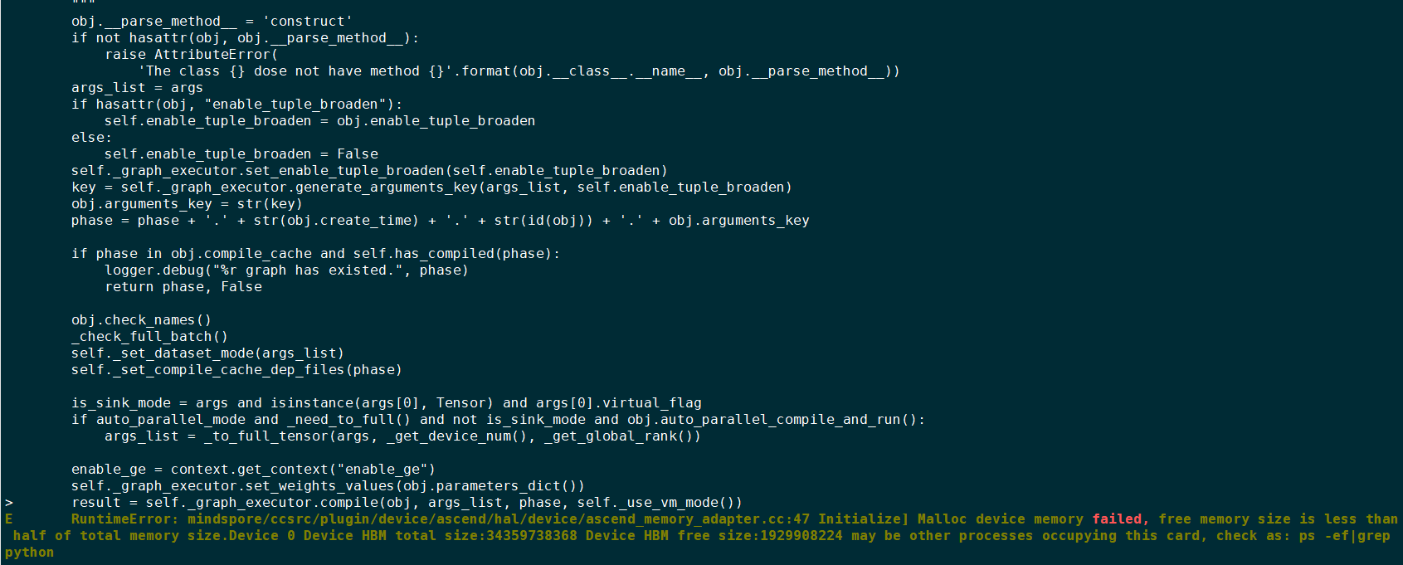
2. 原因分析
出现此类错误是因为运行网络脚本的设备被占用，当前MindSpore框架在Ascend环境只支持每张卡运行一个网络脚本
3. 解决办法
方法一：切换空闲设备
使用npu-smi info查询设备的使用情况，在当前问题场景主要查看HBM-Usage的使用情况，如下图2、3、6卡是空闲设备，npu-smi的详细使用方法
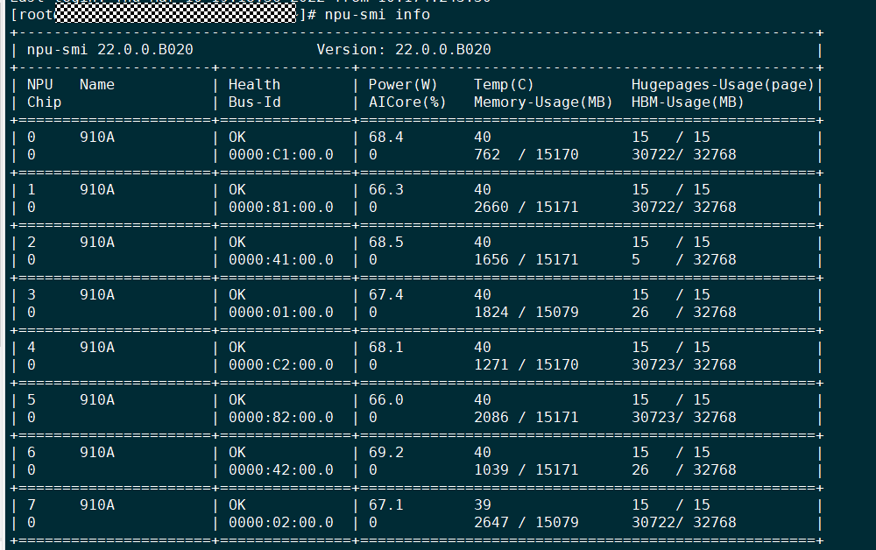
切换使用未被占用的device， export DEVICE_ID={device_id} //device_id取值0~7
重新执行训练脚本
方法二：杀死占用设备的网络脚本（不建议）
查询是否存在其他程序占用设备
ps -ef | grep python
若判断程序为无用进程可选择杀死进程
kill {pid}
重新执行网络脚本

报错ValueError: Please input the correct checkpoint
1. 系统环境
Hardware Environment(Ascend/GPU/CPU): ALL
Software Environment:
MindSpore version (source or binary): 1.7.0 &amp; Earlier versions
Python version (e.g., Python 3.7.5): 3.7.6
OS platform and distribution (e.g., Linux Ubuntu 16.04): Ubuntu
GCC/Compiler version (if compiled from source):
2. python代码样例
net = Net()
param_dict = load_checkpoint("error.ckpt")
3. 报错信息
ValueError: For 'load_checkpoint', the checkpoint file: /home/error.ckpt does not exist, please check whether the 'ckpt_file_name' is correct.
4. 原因分析
报错信息为：加载checkpoint时，没有找到脚本中指定的文件。
加载checkpoint时，会去找load_checkpoint方法中ckpt_file_name参数指定的文件。
如果没有找到这个文件，会报ValueError错误。
5. 解决方法
报错信息中，会把指定文件的绝对路径打印出来，可以根据打印出的信息，查看系统上有没有这个文件。
6. 参考文档
checkpoint 用法可以参考: 保存与加载

求导传入sens值时infer报错ValueError: For 'MatMul', the input dimensions must be equal
1. 报错描述
1.1 系统环境
Hardware Environment(Ascend/GPU/CPU): GPU Software Environment:
MindSpore version (source or binary): 1.7.0
Python version (e.g., Python 3.7.5): 3.7.5
OS platform and distribution (e.g., Linux Ubuntu 16.04): Ubuntu 18.04.4 LTS
GCC/Compiler version (if compiled from source): 7.5.0
1.2 基本信息
1.2.1源码
import numpy as np
import mindspore.nn as nn
import mindspore.ops as ops
from mindspore import Tensor
from mindspore import ParameterTuple, Parameter
from mindspore import dtype as mstype
x = Tensor([[0.8, 0.6, 0.2], [1.8, 1.3, 1.1]], dtype=mstype.float32)
y = Tensor([[0.11, 3.3, 1.1], [1.1, 0.2, 1.4], [1.1, 2.2, 0.3]], dtype=mstype.float32)
class Net(nn.Cell):
def __init__(self):
super(Net, self).__init__()
self.matmul = ops.MatMul()
self.z = Parameter(Tensor(np.array([1.0], np.float32)), name='z')
def construct(self, x, y):
x = x * self.z
out = self.matmul(x, y)
return out
class GradNetWrtN(nn.Cell):
def __init__(self, net):
super(GradNetWrtN, self).__init__()
self.net = net
self.grad_op = ops.GradOperation(sens_param=True)
self.grad_wrt_output = Tensor([[0.1, 0.6, 0.2]], dtype=mstype.float32)
def construct(self, x, y):
gradient_function = self.grad_op(self.net)
return gradient_function(x, y, self.grad_wrt_output)
output = GradNetWrtN(Net())(x, y)
print(output)
1.2.2报错
报错信息：
ValueError: For 'MatMul', the input dimensions must be equal, but got 'x1_col': 2 and 'x2_row': 1. And 'x' shape [2, 3](transpose_a=True), 'y' shape [1, 3](transpose_b=False).
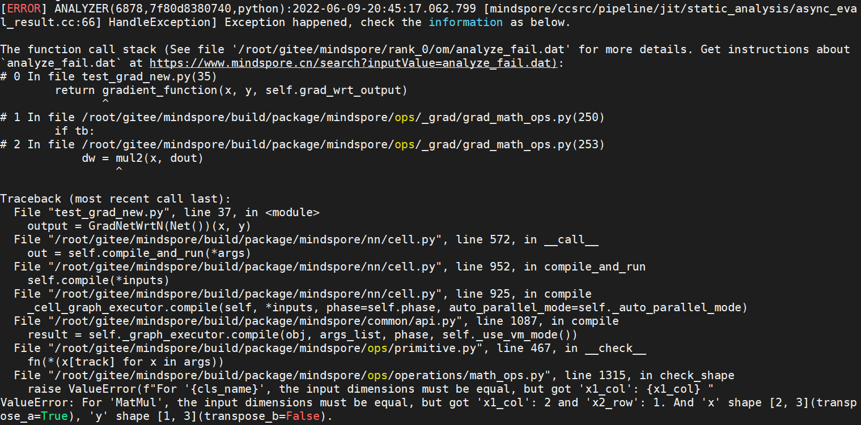
2. 原因分析
根据报错信息，是MatMul算子在infer shape时检查输入的shape不正确，具体是x1的列数不等于x2的行数。
打开报错提供的debug文件/root/gitee/mindspore/rank_0/om/analyze_fail.dat，截取部分如下：
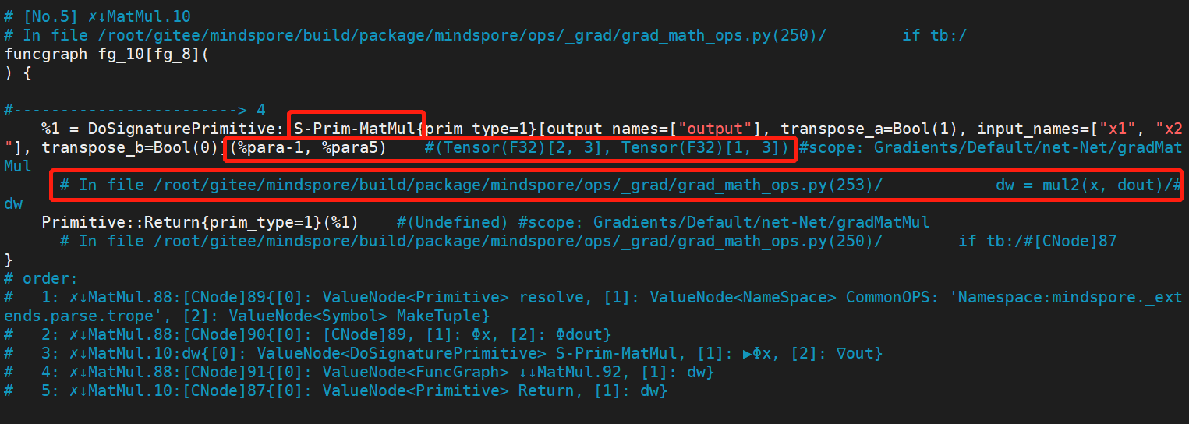
参考analyze_fail.dat文件分析指导，可知是第一个红框的MatMul在infer shape时报错。然后再看第二个红框，该算子的第一个输入的shape为(2, 3)，第二个输入的shape为(1, 3)，跟报错信息吻合（注意这里MatMul的transpose_a属性为True）。最后我们看第三个红框，该MatMul是在grad_math_ops.py文件中的253行被调用的，是MatMul算子的反向传播规则生成的算子，MatMul算子的反向传播规则如下所示：
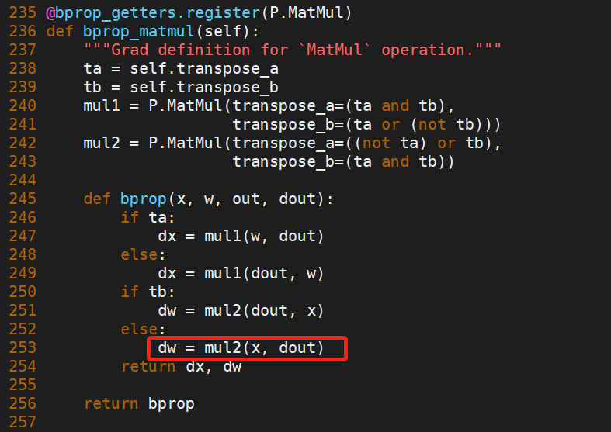
我们看到这个MatMul算子的两个输入，分别是x和dout，x的shape确认是对的，那就是dout的shape是错误的。
从反向自动微分的机制我们知道，反向部分的第一个算子是从正向部分的最后一个算子的反向传播规则生成的。而正向网络只有一个MatMul算子，且是最后的一个算子，所以infer shape报错的这个反向MatMul算子，是从这一个正向的MatMul算子的反向传播规则生成的（此用例比较简单，正向网络中只有一个MatMul算子，更复杂的用例可以参考analyze_fail.dat文件分析指导，结合算子输入输出推断出某个反向算子是从哪个正向算子的反向传播规则生成的），而且是反向部分的第一个算子。因此这个反向MatMul的第二个输入dout只能从外部传进来，也就是用例中传的self.grad_wrt_output。也就是self.grad_wrt_output的shape是错误的。
3. 解决方法
GradOperation传入的sens值，是脚本从外部传入的关于正向网络输出的梯度，能起到梯度值缩放的作用。既然是关于正向网络输出的梯度，那么sens值的shape是需要跟正向网络的输出shape（可以通过调用一下正向网络，打印它的输出shape得到）一致的。我们把上面用例的self.grad_wrt_output的值改一下，如下：
self.grad_wrt_output = Tensor([[0.1, 0.6, 0.2], [0.8, 1.3, 1.1]], dtype=mstype.float32)
最后就可以解决该问题了。 在MindSpore官方教程的自动微分章节里也能看到相关指导：
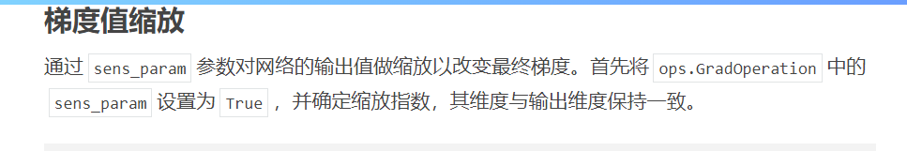
4. 总结
执行MindSpore用例报错时，要善于利用报错信息去分析问题，也可以多看看官方教程。
5 参考文档
梯度值缩放
如何根据analyze_fail.dat文件分析图推导失败的原因

没有ckpt文件导致模型加载执行报错：please check whether the 'ckpt_file_name' is correct
1. 系统环境
硬件环境(Ascend/GPU/CPU): GPU
软件环境: MindSpore 版本: 1.7.0
执行模式：动态图(PYNATIVE_MODE) – Python 版本: 3.7.6
操作系统平台: linux
2. 报错信息
2.1 问题描述
没有下载对应模型的ckpt文件，导致模型加载执行报错。
2.2 报错信息
ValueError: For 'load_checkpoint', the checkpoint file: /data0/BigPlatform/FL/limingjun/华为/mindspore-face -github/example/facerecognition_ascend_v170_ms1mv2_research_cv_acc90.ckpt does not exist, please check whether the 'ckpt_file_name' is correct.
2.3 脚本代码
def get_net():
log_path = os.path.join(config.ckpt_path, 'logs')
config.logger = get_logger(log_path, config.local_rank)
config.device_target = 'GPU'
'''get_model'''
net = get_backbone(config)
if config.fp16:
net.add_flags_recursive(fp16=True)
config.weight = "./facerecognition_ascend_v170_ms1mv2_research_cv_acc90.ckpt"
param_dict = load_checkpoint(config.weight)
param_dict_new = {}
for key, value in param_dict.items():
if key.startswith('moments.'):
continue
elif key.startswith('network.'):
param_dict_new[key[8:]] = value
else:
param_dict_new[key] = value
load_param_into_net(net, param_dict_new)
config.logger.info('INFO, ------------- load model success--------------')
if config.device_target == 'GPU':
print("GPU")
net.to_float(mstype.float32)
net.set_train(False)
return net
3. 根因分析
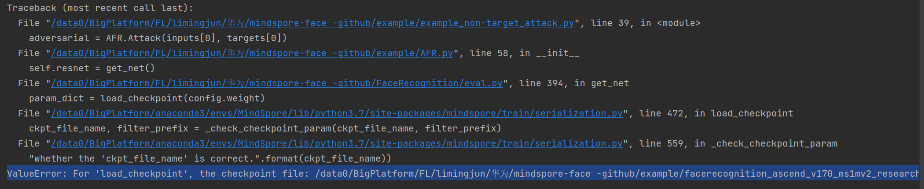
看报错信息，翻译说明ckpt不存在，请检查“ckpt_file_name”是否正确。
mindspore需要下载对应模型参数的ckpt文件。 https://www.mindspore.cn/resources/hub/ 这官网提供相关模型的下载网址。 除了下载对应的ckpt文件，也可以通过mindspore_hub库导出。

4. 解决方案
解决方案说明：下载ckpt文件
修改后代码：
def get_net():
log_path = os.path.join(config.ckpt_path, 'logs')
config.logger = get_logger(log_path, config.local_rank)
config.device_target = 'GPU'
'''get_model'''
net = get_backbone(config)
if config.fp16:
net.add_flags_recursive(fp16=True)
config.weight = "../FaceRecognition/facerecognition_ascend_v170_ms1mv2_research_cv_acc90.ckpt"
param_dict = load_checkpoint(config.weight)
param_dict_new = {}
for key, value in param_dict.items():
if key.startswith('moments.'):
continue
elif key.startswith('network.'):
param_dict_new[key[8:]] = value
else:
param_dict_new[key] = value
load_param_into_net(net, param_dict_new)
config.logger.info('INFO, ------------- load model success--------------')
if config.device_target == 'GPU':
print("GPU")
net.to_float(mstype.float32)
net.set_train(False)
return net
正常导入ckpt文件后，模型可以正常的加载。

Tensor张量shape不匹配导致执行报错：ValueError: For 'Sub', x.shape and y.shape are supposed to broadcast
1. 系统环境
硬件环境(Ascend/GPU/CPU): GPU
软件环境: MindSpore 版本: 1.7.0
执行模式： 动态图(PYNATIVE_MODE)
Python 版本: 3.7.6
操作系统平台: linux
2. 报错信息
2.1 问题描述
某Tensor张量通道与其他Tensor张量通道不匹配导致运行报错。
2.2 报错信息
ValueError: For 'Sub', x.shape and y.shape are supposed to broadcast, where broadcast means that x.shape[i] = 1 or -1 or y.shape[i] = 1 or -1 or x.shape[i] = y.shape[i], but now x.shape and y.shape can not broadcast, got i: -3, x.shape: [112, 112, 3], y.shape: [3, 1, 1].
2.3 脚本代码
class MyWithLossCell(nn.Cell):
def __init__(self,net,loss_fn,input_tensor):
super(MyWithLossCell, self).__init__(auto_prefix=False)
self.net = net
self._loss_fn = loss_fn
self.STD = Tensor([0.229, 0.224, 0.225])
self.MEAN = Tensor([0.485, 0.456, 0.406])
self.expand_dims = mindspore.ops.ExpandDims()
self.normalize = P.Normalize(mean=[0.485, 0.456, 0.406], std=[0.229, 0.224, 0.225])
self.tensorize = ToTensor()
self.input_tensor = input_tensor
self.input_emb = self.net(self.expand_dims(self.input_tensor, 0))
def construct(self,mask_tensor):
ref = mask_tensor
adversarial_tensor = mindspore.numpy.where((ref == 0), self.input_tensor, (mask_tensor - self.MEAN[:, None, None] )/ self.STD[:, None, None])
adversarial_emb = self.net(self.expand_dims(adversarial_tensor, 0))
loss = self._loss_fn( adversarial_emb,self.input_emb,mask_tensor)
return loss
@property
def backbone_network(self):
return self.net
3. 根因分析
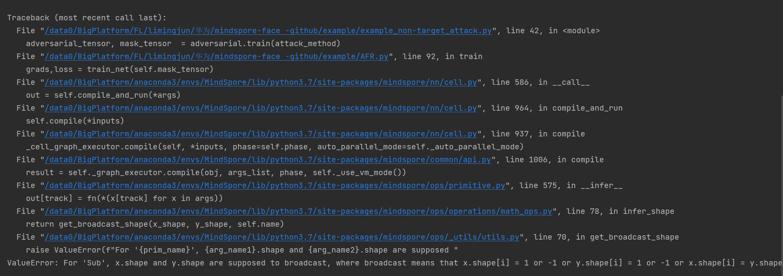
看报错信息，翻译意思是x.shape[i] = 1或-1或y.shape[i] = 1或-1或x.shape[i] = y.shape[i]，但现在x.shape和y.shape不能广播，得到i: -3, x.shape: [112,12,3]， y.shape:[3,1,1]。这说明x和y的shape不匹配。
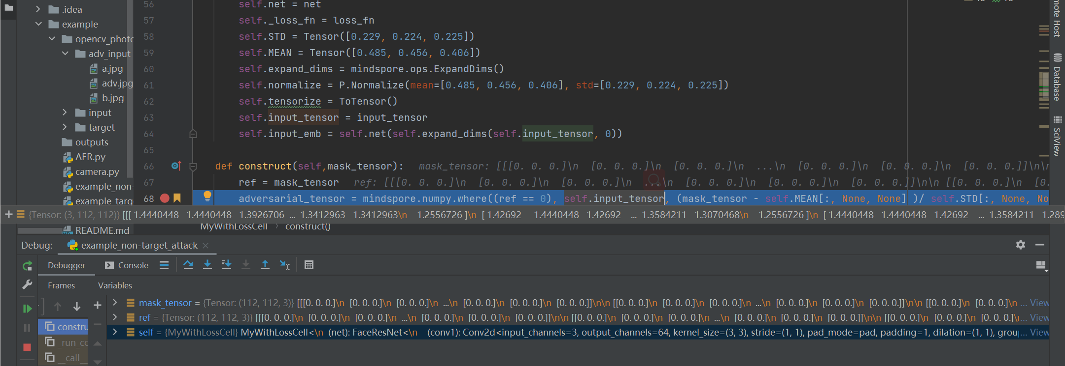
调试发现input_tensor的shape是(3,112,112),而mask_tensor是(112,112,3),shape不匹配。
4. 解决方案
解决方案说明：将mask_tensor和input_tensor的shape进行统一。
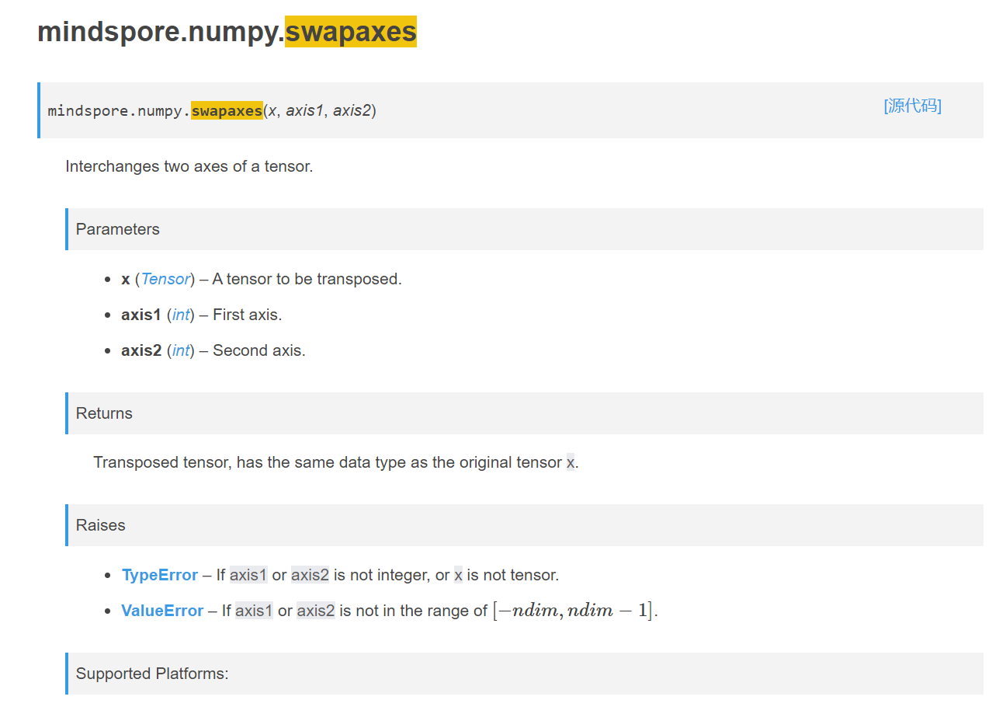
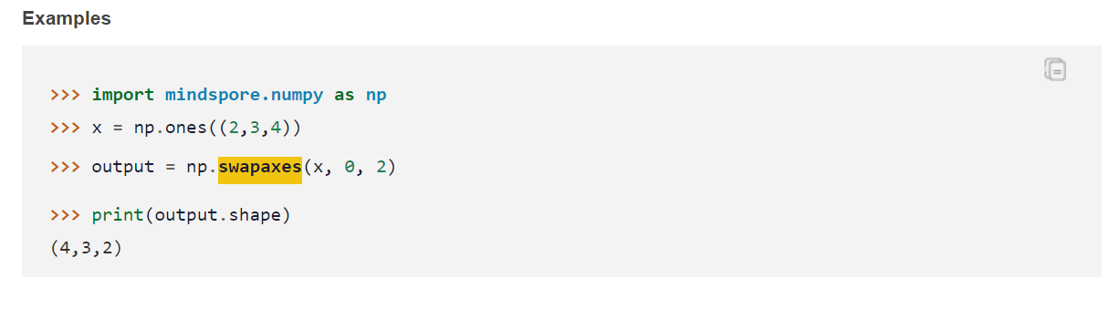
查看mindspore文档发现，利用swapaxes可以交换张量的两个轴。
修改后代码：
def _create_mask(self, face_image):
mask = Image.new('RGB', face_image.size, color=(0, 0, 0))
d = ImageDraw.Draw(mask)
landmarks = fr.face_landmarks(np.array(face_image))
area = [landmark
for landmark in landmarks[0]['chin']
if landmark[1] > max(landmarks[0]['nose_tip'])[1]]
area.append(landmarks[0]['nose_bridge'][1])
d.polygon(area, fill=(255, 255, 255))
mask_array = np.array(mask)
mask_array = mask_array.astype(np.float32)
for i in range(mask_array.shape[0]):
for j in range(mask_array.shape[1]):
for k in range(mask_array.shape[2]):
if mask_array[i][j][k] == 255.:
mask_array[i][j][k] = 0.5
else:
mask_array[i][j][k] = 0
mask_tensor = Tensor(mask_array)
mask_tensor = mask_tensor.swapaxes(0, 2).swapaxes(1, 2)
mask_tensor.requires_grad = True
return mask_tensor
找到生成mask_tensor的函数，在最原始端对mask_tensor的shape进行更改。
修改后代码正常运行。

自定义loss没有继承nn.Cell导致执行报错：ParseStatement] Unsupported statement 'Try'.
1. 系统环境
硬件环境(Ascend/GPU/CPU): GPU
软件环境: MindSpore 版本: 1.7.0
执行模式： 动态图(PYNATIVE_MODE)
Python 版本: 3.7.6
操作系统平台: linux
2. 报错信息
2.1 问题描述
自定义的loss函数中没有继承nn.Cell,并且没有实现construct函数。导致mindspore不支持。
2.2 报错信息
[mindspore \ccsrc\pipeline \jit\parse\parse . cc :584] ParseStatement] Unsupported statement 'Try'.
2.3 脚本代码
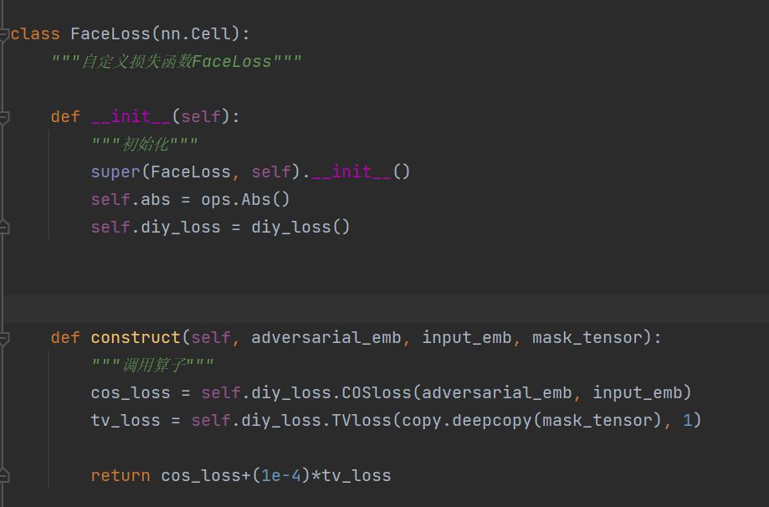
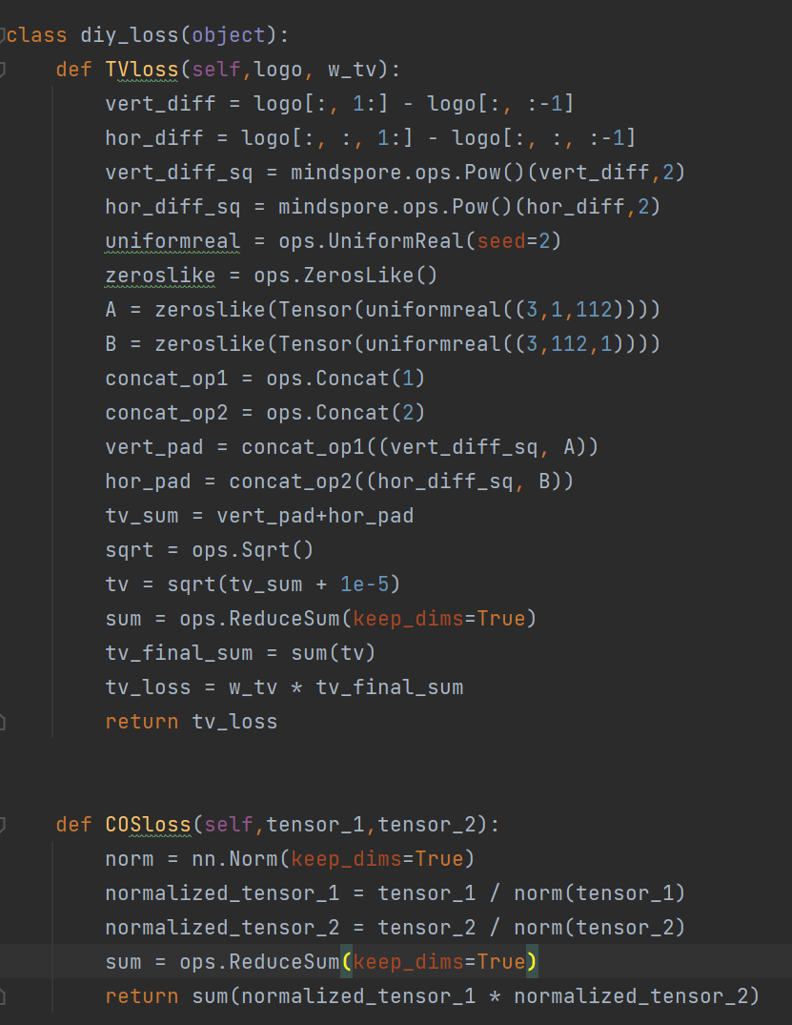
3. 根因分析
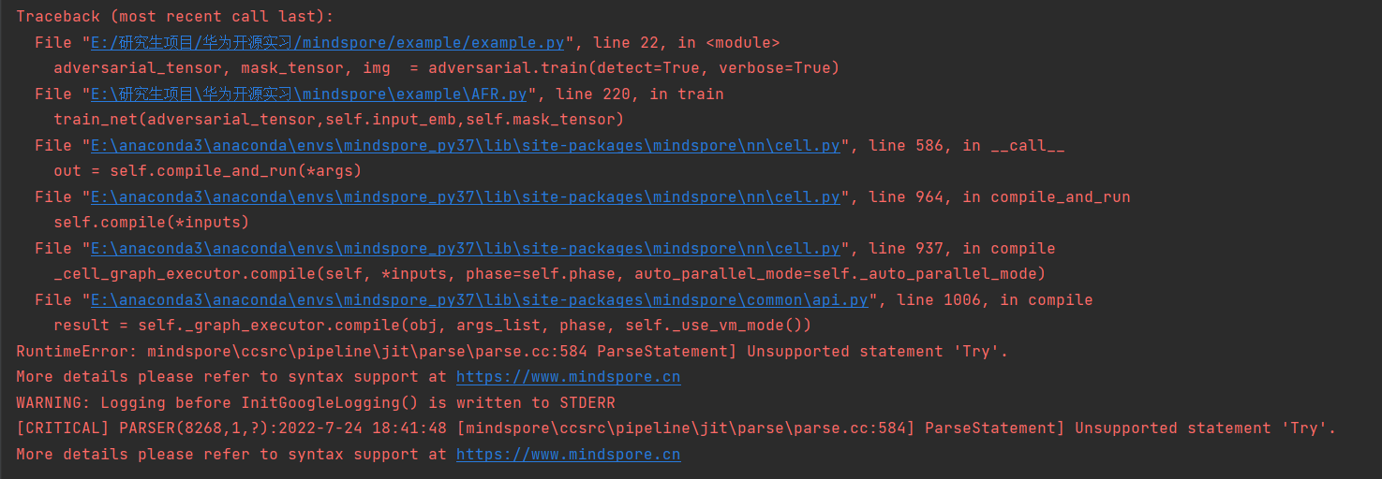
从报错信息较难看出具体出错的原因。经过调试发现在FaceLoss函数init中不支持diy_loss函数这样的写法。也需要继承nn.cell同时编写construct函数。
4. 补充知识
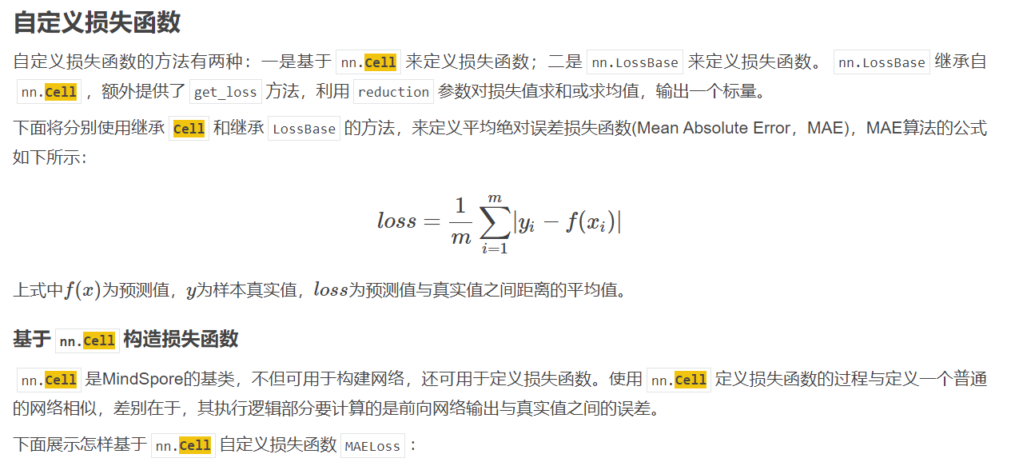
从mindspore文档也发现都需要继承nn.cell。
网络基本单元 Cell 当用户需要自定义网络时，需要继承Cell类，并重写__init__方法和construct方法。损失函数、优化器和模型层等本质上也属于网络结构，也需要继承Cell类才能实现功能，同样用户也可以根据业务需求自定义这部分内容。
5. 解决方案
解决方案说明：重写diy_loss函数，继承nn.cell同时编写construct函数。
修改后代码：
class diy_loss(nn.Cell):
def __init__(self,target_emb):
super(diy_loss, self).__init__()
self.uniformreal = ops.UniformReal(seed=2)
self.sum = ops.ReduceSum(keep_dims=False)
self.norm = nn.Norm(keep_dims=True)
self.zeroslike = ops.ZerosLike()
self.concat_op1 = ops.Concat(1)
self.concat_op2 = ops.Concat(2)
self.pow = ops.Pow()
self.reduce_sum = ops.operations.ReduceSum()
self.target_emb = target_emb
self.abs = ops.Abs()
self.reduce_mean = ops.ReduceMean()
def construct(self, adversarial_emb,input_emb,mask_tensor):
vert_diff = mask_tensor[:, 1:] - mask_tensor[:, :-1]
hor_diff = mask_tensor[:, :, 1:] - mask_tensor[:, :, :-1]
vert_diff_sq = self.pow(vert_diff, 2)
hor_diff_sq = self.pow(hor_diff, 2)
A = self.zeroslike(Tensor(self.uniformreal((3, 1, 112))))
B = self.zeroslike(Tensor(self.uniformreal((3, 112, 1))))
vert_pad = self.concat_op1((vert_diff_sq, A))
hor_pad = self.concat_op2((hor_diff_sq, B))
tv_sum = vert_pad + hor_pad
tv = ops.functional.sqrt(tv_sum + 1e-5)
tv_final_sum = self.sum(tv)
tv_loss = (1e-4) * tv_final_sum
print("tv_loss:",tv_loss)
prod_sum = self.reduce_sum(adversarial_emb * self.target_emb, (1,))
square1 = self.reduce_sum(ops.functional.square(adversarial_emb), (1,))
square2 = self.reduce_sum(ops.functional.square(self.target_emb), (1,))
denom = ops.functional.sqrt(square1) * ops.functional.sqrt(square2)
cos_loss = -(prod_sum / denom)
print("dis_loss:", cos_loss)
return tv_loss+cos_loss
修改后可以正常运行。

参数类型错误导致优化器执行报错：TypeError: For 'Optimizer', the argument parameters must be Iterable type
1. 系统环境
硬件环境(Ascend/GPU/CPU): GPU
软件环境: MindSpore 版本: 1.7.0
执行模式： 静态图(GRAPH)
Python 版本: 3.7.6
操作系统平台: linux
2. 报错信息
2.1 问题描述
将需要优化的参数放入优化器中，直接将Tensor类型的参数放入，由于优化器需要的数据类型是Iterable，导致执行报错。
2.2 报错信息
TypeError: For 'Optimizer', the argument parameters must be Iterable type, but got <class 'mindspore.common.tensor.Tensor'>.
2.3 脚本代码
class Attack(object):
def __init__(self,input_img,target_img,seed=None):
if (seed != None): np.random.seed(seed)
self.MEAN = Tensor([0.485, 0.456, 0.406])
self.STD = Tensor([0.229, 0.224, 0.225])
self.LOSS = Tensor(0)
self.expand_dims = mindspore.ops.ExpandDims()
self.imageize = ToPILImage()
self.tensorize = ToTensor()
self.normalize = P.Normalize(mean=[0.485, 0.456, 0.406], std=[0.229, 0.224, 0.225])
self.resnet = get_net()
self.input_tensor = Tensor(self.normalize(self.tensorize(input_img)))
self.target_tensor = Tensor(self.normalize(self.tensorize(target_img)))
mp.imsave('./outputs/input图像.jpg', np.transpose(self._reverse_norm(self.input_tensor).asnumpy(), (1, 2, 0)))
mp.imsave('./outputs/target图像.jpg', np.transpose(self._reverse_norm(self.target_tensor).asnumpy(), (1, 2, 0)))
self.input_emb = self.resnet(self.expand_dims(self.input_tensor,0))
self.target_emb = self.resnet(self.expand_dims(self.target_tensor,0))
self.adversarial_emb = None
self.mask_tensor = self._create_mask(input_img)
self.ref = self.mask_tensor
self.opt = nn.Adam(self.mask_tensor, learning_rate=0.01, weight_decay=0.0001)
3. 根因分析
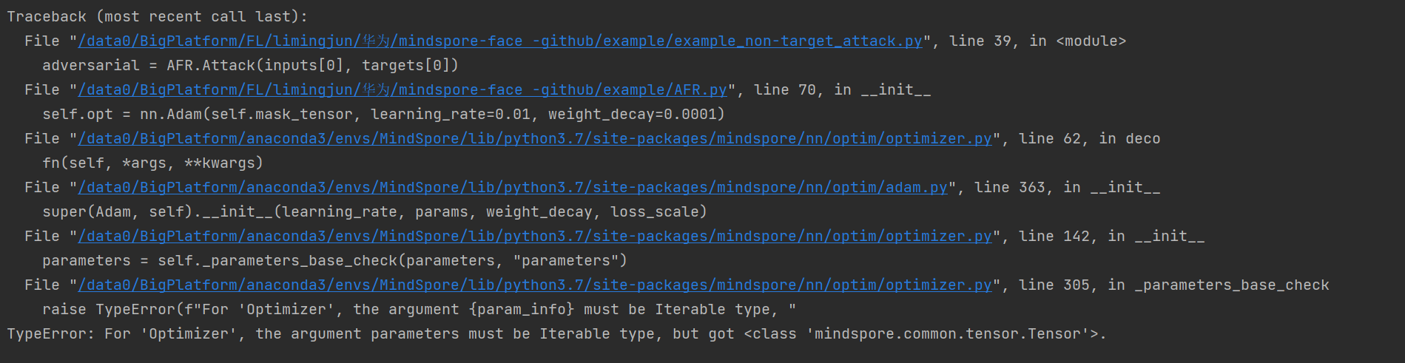
看报错信息，翻译意思是实参参数必须是Iterable类型，即是可迭代的。
调试发现self.mask_tensor是Tensor类型，不能进行迭代。
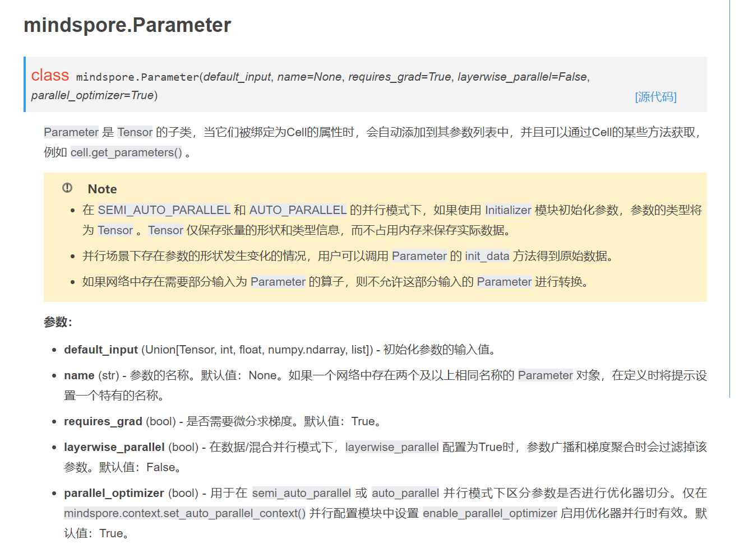
通过查看文档，可以通过Parameter()更好的对训练参数进行设置。同时Python里有大量内置的iterable类型，如： list，str，tuple，dict等，可以将参数包装成list实现可迭代化。
4. 解决方案
解决方案说明：把self.mask_tensor改成list类型：[Parameter(self.mask_tensor)]，来实现可迭代化。
修改后代码：
class Attack(object):
def __init__(self,input_img,target_img,seed=None):
if (seed != None): np.random.seed(seed)
self.MEAN = Tensor([0.485, 0.456, 0.406])
self.STD = Tensor([0.229, 0.224, 0.225])
self.LOSS = Tensor(0)
self.expand_dims = mindspore.ops.ExpandDims()
self.imageize = ToPILImage()
self.tensorize = ToTensor()
self.normalize = P.Normalize(mean=[0.485, 0.456, 0.406], std=[0.229, 0.224, 0.225])
self.resnet = get_net()
self.input_tensor = Tensor(self.normalize(self.tensorize(input_img)))
self.target_tensor = Tensor(self.normalize(self.tensorize(target_img)))
mp.imsave('./outputs/input图像.jpg', np.transpose(self._reverse_norm(self.input_tensor).asnumpy(), (1, 2, 0)))
mp.imsave('./outputs/target图像.jpg', np.transpose(self._reverse_norm(self.target_tensor).asnumpy(), (1, 2, 0)))
self.input_emb = self.resnet(self.expand_dims(self.input_tensor,0))
self.target_emb = self.resnet(self.expand_dims(self.target_tensor,0))
self.adversarial_emb = None
self.mask_tensor = self._create_mask(input_img)
self.ref = self.mask_tensor
self.opt = nn.Adam([Parameter(self.mask_tensor)], learning_rate=0.01, weight_decay=0.0001)
修改后程序正常运行。

形参与实参的不对应导致ops.GradOperation执行报错：The parameters number of the function is 2, but the number of provided arguments is 1.
1. 系统环境
硬件环境(Ascend/GPU/CPU): GPU
软件环境: MindSpore 版本: 1.7.0
执行模式： 静态图(GRAPH) – Python 版本: 3.7.6
操作系统平台: linux
2. 报错信息
2.1 问题描述
自定义训练网络中，进行反向传播计算梯度时，少给ops.GradOperation传入了一个参数导致执行报错。
2.2 报错信息
TypeError: mindspore/ccsrc/pipeline/jit/static_analysis/stack_frame.cc:101 DoJump] The parameters number of the function is 2, but the number of provided arguments is 1.
2.3 脚本代码
class TrainOneStepCell(nn.Cell):
def __init__(self, network, optimizer, sens=1.0):
super(TrainOneStepCell, self).__init__(auto_prefix=False)
self.network = network
self.network.set_grad()
self.optimizer = optimizer
self.weights = self.optimizer.parameters
self.grad = ops.GradOperation(get_by_list=True, sens_param=True)
def construct(self,*inputs):
"""Defines the computation performed."""
loss = self.network(*inputs)
grads = self.grad(self.network, self.weights)(*inputs)
self.optimizer(grads)
return grads,loss
3. 根因分析
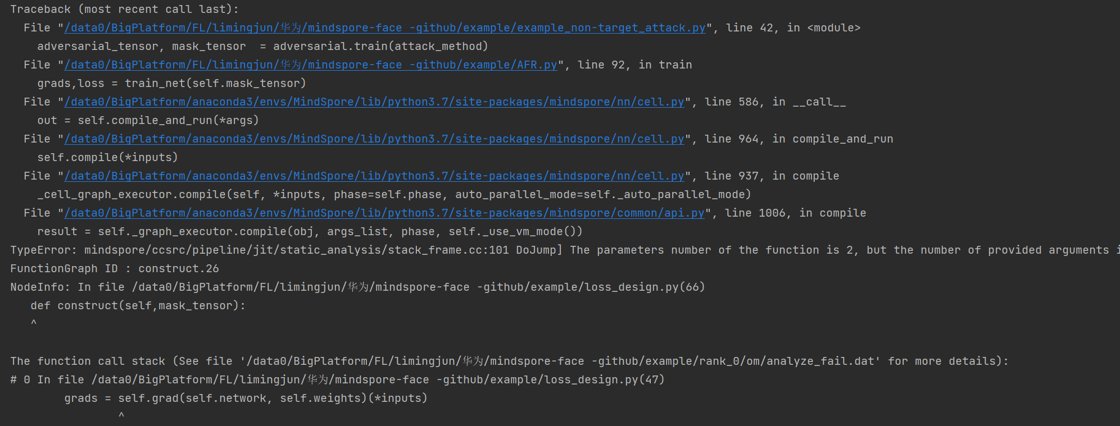
看报错信息，翻译意思就是函数的形参数为2，但提供的实参数为1。
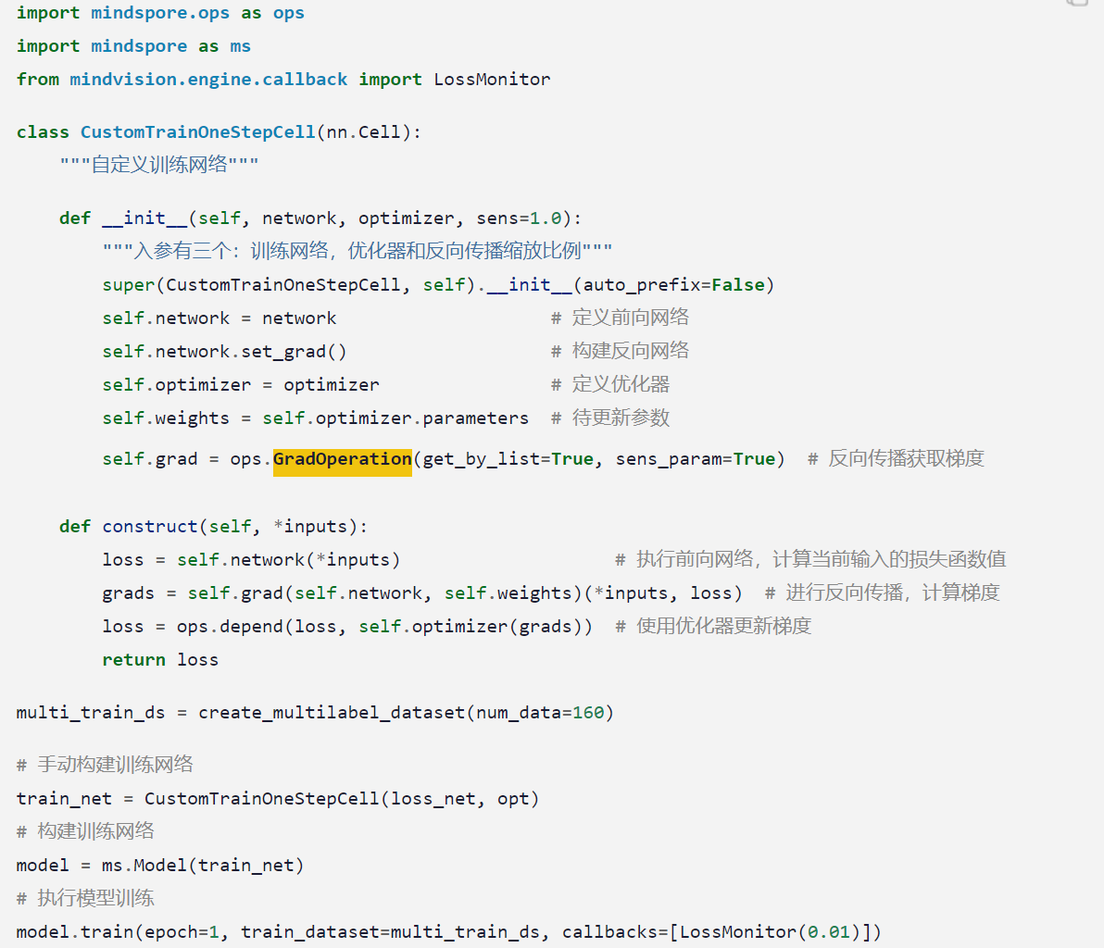
查看官网文档关于自定义训练网络的设置，再进行反向传播，计算梯度时需要将loss传入。原因是因为反向传播需要根据loss值进行计算。
4. 解决方案
解决方案说明：根据官网文档，将loss值传入self.grad。
修改后代码：
class TrainOneStepCell(nn.Cell):
def __init__(self, network, optimizer, sens=1.0):
super(TrainOneStepCell, self).__init__(auto_prefix=False)
self.network = network
self.network.set_grad()
self.optimizer = optimizer
self.weights = self.optimizer.parameters
self.grad = ops.GradOperation(get_by_list=True, sens_param=True)
def construct(self,*inputs):
"""Defines the computation performed."""
loss = self.network(*inputs)
grads = self.grad(self.network, self.weights)(*inputs,loss)
self.optimizer(grads)
return grads,loss
修改后，程序正常训练。

return回来的参数承接问题导致执行报错：AttributeError: 'tuple' object has no attribute 'asnumpy'
1. 系统环境
硬件环境(Ascend/GPU/CPU): GPU
软件环境: MindSpore 版本: 1.7.0
执行模式： 静态图(GRAPH)
Python 版本: 3.7.6
操作系统平台: linux
2. 报错信息
2.1 问题描述
调用函数return时只用了一个参数来承接return回来的参数，由于return有两个参数，导致承接的参数类型出现问题。。
2.2 报错信息
AttributeError: 'tuple' object has no attribute 'asnumpy'
2.3 脚本代码
def train(self,attack_method):
if attack_method == "non-target attack":
LOSS = FaceLoss_no_target_attack(self.target_emb)
if attack_method == "target_attack":
LOSS = FaceLoss_target_attack(self.target_emb)
net_with_criterion = MyWithLossCell(self.resnet, LOSS,self.input_tensor)
train_net = TrainOneStepCell(net_with_criterion, self.opt)
for i in range(1):
self.mask_tensor = Tensor(self.pm)
loss = train_net(self.mask_tensor)
print("epoch %d ,loss: %f \n " % (i, loss.asnumpy().item()))
3. 根因分析
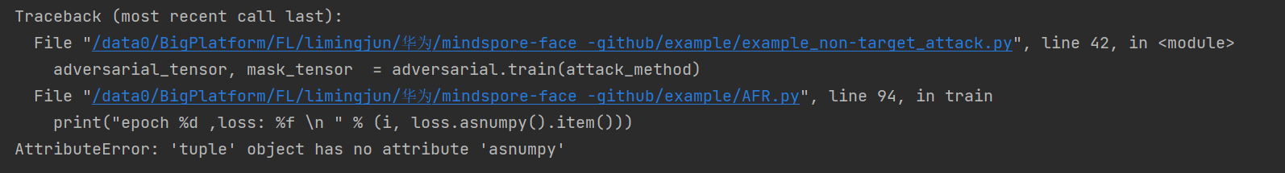
看报错信息'tuple'对象没有属性'asnumpy'。说明loss的类型有问题。
调试发现，loss的tuple中有两个。
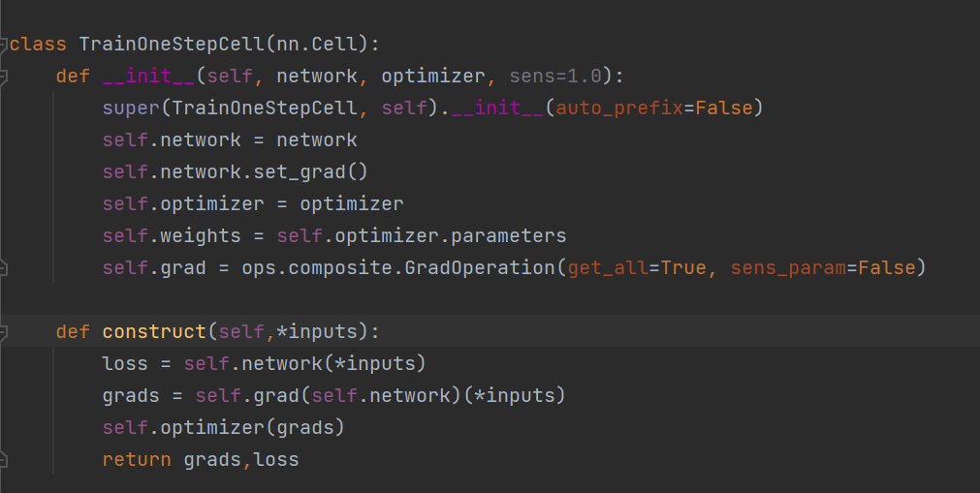
查看具体的TrainOneStepCell函数，发现return有两个参数。而我们只用了一个loss参数进行承接，导致loss包含了两个参数。导致打印loss值时报了错误。
4. 解决方案
解决方案说明：增加一个参数来承接return回来的参数。
修改后代码：
def train(self,attack_method):
if attack_method == "non-target attack":
LOSS = FaceLoss_no_target_attack(self.target_emb)
if attack_method == "target_attack":
LOSS = FaceLoss_target_attack(self.target_emb)
net_with_criterion = MyWithLossCell(self.resnet, LOSS,self.input_tensor)
train_net = TrainOneStepCell(net_with_criterion, self.opt)
for i in range(1):
self.mask_tensor = Tensor(self.pm)
grads, loss = train_net(self.mask_tensor)
print("epoch %d ,loss: %f \n " % (i, loss.asnumpy().item()))
结果loss值可以正常打印。

维度数错误引起模型输入错误：For primitive[Conv2D], the x shape size must be equal to 4, but got 3.
1. 系统环境
硬件环境(Ascend/GPU/CPU): GPU
软件环境: MindSpore 版本: 1.7.0
执行模式： 静态图(GRAPH)
Python 版本: 3.7.6
操作系统平台: linux
2. 报错信息
2.1 问题描述
将处理好的图像tensor向量输入到模型，由于tensor的维度数未和模型的输入设置匹配导致运行错误。
2.2 报错信息
ValueError: mindspore/core/utils/check_convert_utils.cc:397 CheckInteger] For primitive[Conv2D], the x shape size must be equal to 4, but got 3.
2.3 脚本代码
if __name__ == '__main__':
inputs = AFR.load_data('opencv_photo/input/')
targets = AFR.load_data('opencv_photo/target/')
adversarial = AFR.Attack(inputs[0], targets[0])
class Attack(object):
if (seed != None): np.random.seed(seed)
self.MEAN = Tensor([0.485, 0.456, 0.406])
self.STD = Tensor([0.229, 0.224, 0.225])
self.LOSS = Tensor(0)
self.imageize = ToPILImage()
self.tensorize = ToTensor()
self.normalize = P.Normalize(mean=[0.485, 0.456, 0.406], std=[0.229, 0.224, 0.225])
self.resnet = get_net()
self.input_tensor = Tensor(self.normalize(self.tensorize(input_img)))
self.target_tensor Tensor(self.normalize(self.tensorize(target_img)))
self.input_emb = self.resnet(self.input_tensor)
3. 根因分析
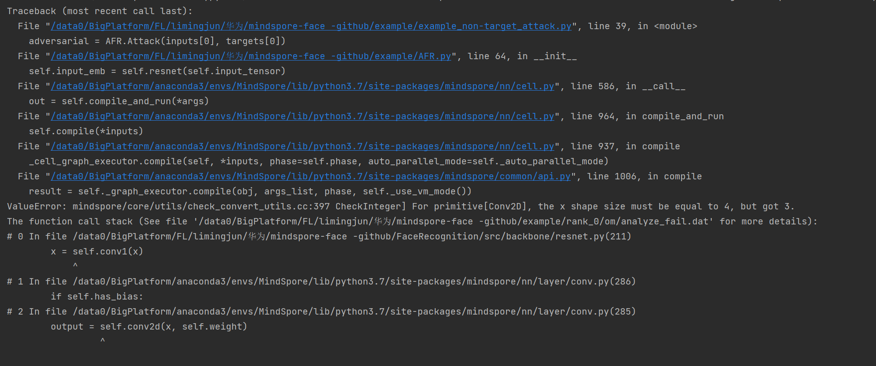
看报错信息the x shape size must be equal to 4, but got 3. 意思是x形状的大小必须等于4，但得到了3。
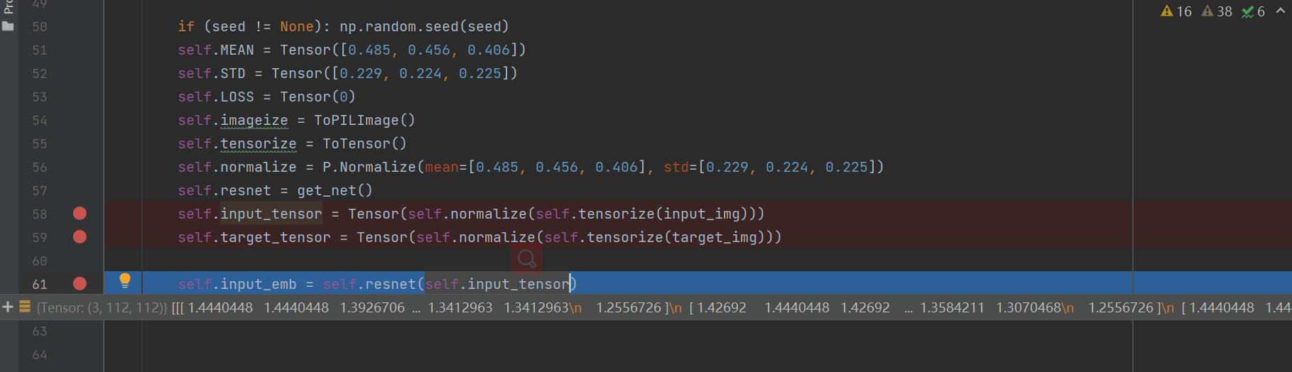
调试发现self.input_tensor的维度数为3，需要增加一维。
4. 解决方案
解决方案说明：对self.input_tensor的维度数进行扩充，来匹配模型的输入。增加的一维就是batch数。利用mindspore.ops.ExpandDims()来进行维度的扩充。
修改后代码：
class Attack(object):
if (seed != None): np.random.seed(seed)
self.MEAN = Tensor([0.485, 0.456, 0.406])
self.STD = Tensor([0.229, 0.224, 0.225])
self.LOSS = Tensor(0)
self.expand_dims = mindspore.ops.ExpandDims()
self.imageize = ToPILImage()
self.tensorize = ToTensor()
self.normalize = P.Normalize(mean=[0.485, 0.456, 0.406], std=[0.229, 0.224, 0.225])
self.resnet = get_net()
self.input_tensor = Tensor(self.normalize(self.tensorize(input_img)))
self.target_tensor Tensor(self.normalize(self.tensorize(target_img)))
self.input_emb = self.resnet(self.expand_dims(self.input_tensor,0))
正常执行结self.input_tensor可以输入到模型得到正确的输出结果。

报错：The value parameter,it's name 'xxxx' already exsts. please set a unique name for the parameter .
1. 系统环境
硬件环境(Ascend/GPU/CPU): GPU
软件环境: MindSpore 版本: 1.9.0
执行模式： 动态图 PYNATIVE
Python 版本: 3.7.5
操作系统平台: Linux
2. 报错信息
2.1 问题描述
两个网络中的层有相同名称时报错
2.2 报错信息
附件示例和图片示例感觉不太一样，以附件为准
2.3 脚本代码
import mindspore.nn as nn
from mindspore.common.parameter import ParameterTuple, Parameter
class FullyConnectedNet(nn.Cell):
def __init__(self, input_size, hidden_size, output_size):
super(FullyConnectedNet, self).__init__(auto_prefix=False)
self.linear1 = nn.Dense( input_size, hidden_size, weight_init="XavierUniform")
self.linear2 = nn.Dense(hidden_size, output_size, weight_init="XavierUniform")
self.relu = nn.ReLU()
def construct(self, x):
x = self.relu(self.linear1(x))
x = self.linear2(x)
return x
class EmaUpdate(nn.Cell):
def __init__(self, policy_net, target_net):
super(EmaUpdate, self).__init__()
self.policy_param = ParameterTuple(policy_net.get_parameters())
self.target_param = ParameterTuple(target_net.get_parameters())
def construct(self, x):
return x
policy_net = FullyConnectedNet(4, 100, 2)
target_net = FullyConnectedNet(4, 100, 2)
ema_update = EmaUpdate(policy_net, target_net)
3. 根因分析
1. FullyConnectedNet网络中auto_prefix=False， 因此没有给网络参数的名称添加前缀， 两个参数的name都叫做'weight'， 重名
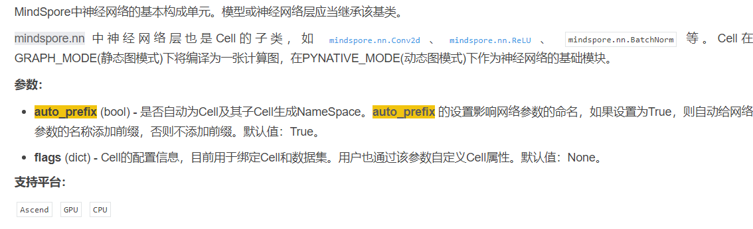
2. 而当把参数给ParameterTuple的时候，ParameterTuple对名字的唯一性有要求，因此就会报错，说'weight'已经存在
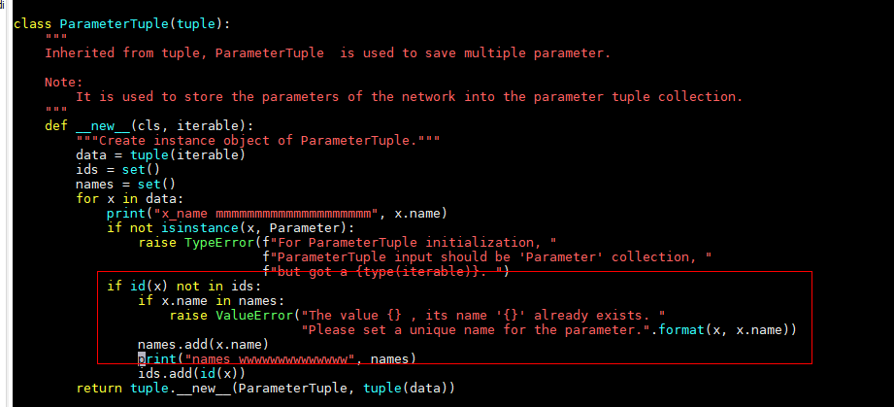
4. 解决方案
解决方案说明：把FullyConnectedNet网络的auto_prefix=False改成auto_prefix=True, 或者不设置，因为默认就是True, 这样自动给网络参数的名称添加前缀，一个叫linear1.weight 一个叫linear2.weight， ParameterTuple就不会报错
修改后代码：
import mindspore.nn as nn
from mindspore.common.parameter import ParameterTuple, Parameter
from mindspore import context
context.set_context(mode=context.PYNATIVE_MODE)
class FullyConnectedNet(nn.Cell):
def __init__(self, input_size, hidden_size, output_size):
super(FullyConnectedNet, self).__init__(auto_prefix=True)
self.linear1 = nn.Dense(input_size, hidden_size, weight_init="XavierUniform")
self.linear2 = nn.Dense(hidden_size, output_size, weight_init="XavierUniform")
self.relu = nn.ReLU()
def construct(self, x):
x = self.relu(self.linear1(x))
x = self.linear2(x)
return x
class EmaUpdate(nn.Cell):
def __init__(self, policy_net, target_net):
super(EmaUpdate, self).__init__()
self.policy_param = ParameterTuple(policy_net.get_parameters())
self.target_param = ParameterTuple(target_net.get_parameters())
def construct(self, x):
return x
policy_net = FullyConnectedNet(4, 100, 2)
target_net = FullyConnectedNet(4, 100, 2)
print("mmmmmmmmmmmmm", policy_net.trainable_params())
print("wwwwwwwww", target_net.trainable_params())
ema_update = EmaUpdate(policy_net, target_net)
执行后的结果
用例pass且打印想要的参数
mmmmmmmmmmmmm [Parameter (name=linear1.weight, shape=(100, 4), dtype=Float32, requires_grad=True), Parameter (name=linear1.bias, shape=(100,), dtype=Float32, requires_grad=True), Parameter (name=linear2.weight, shape=(2, 100), dtype=Float32, requires_grad=True), Parameter (name=linear2.bias, shape=(2,), dtype=Float32, requires_grad=True)]
wwwwwwwww [Parameter (name=linear1.weight, shape=(100, 4), dtype=Float32, requires_grad=True), Parameter (name=linear1.bias, shape=(100,), dtype=Float32, requires_grad=True), Parameter (name=linear2.weight, shape=(2, 100), dtype=Float32, requires_grad=True), Parameter (name=linear2.bias, shape=(2,), dtype=Float32, requires_grad=True)]
x_name mmmmmmmmmmmmmmmmmmmm linear1.weight
names wwwwwwwwwwwwww {'linear1.weight'}
x_name mmmmmmmmmmmmmmmmmmmm linear1.bias
names wwwwwwwwwwwwww {'linear1.bias', 'linear1.weight'}
x_name mmmmmmmmmmmmmmmmmmmm linear2.weight
names wwwwwwwwwwwwww {'linear1.bias', 'linear1.weight', 'linear2.weight'}
x_name mmmmmmmmmmmmmmmmmmmm linear2.bias
names wwwwwwwwwwwwww {'linear1.bias', 'linear1.weight', 'linear2.bias', 'linear2.weight'} ---ParameterTuple1
x_name mmmmmmmmmmmmmmmmmmmm linear1.weight
names wwwwwwwwwwwwww {'linear1.weight'}
x_name mmmmmmmmmmmmmmmmmmmm linear1.bias
names wwwwwwwwwwwwww {'linear1.bias', 'linear1.weight'}
x_name mmmmmmmmmmmmmmmmmmmm linear2.weight
names wwwwwwwwwwwwww {'linear1.bias', 'linear1.weight', 'linear2.weight'}
x_name mmmmmmmmmmmmmmmmmmmm linear2.bias
names wwwwwwwwwwwwww {'linear1.bias', 'linear1.weight', 'linear2.bias', 'linear2.weight'} ---ParameterTuple2

construct方法名称错误引起损失函数执行报错:The 'sub' operation does not support the type [Tensor[Float32], None].
1. 系统环境
硬件环境(Ascend/GPU/CPU): CPU
软件环境: MindSpore 版本: 1.8.0
执行模式： 静态图(GRAPH)
Python 版本: 3.7.6
操作系统平台: Windows
2. 报错信息
2.1 问题描述
在自定义Cell网络中，construct函数名称错误定义了新的函数，导致基类Cell的construct没有实现引起报错。
2.2 报错信息
RuntimeError:The 'sub' operation does not support the type [Tensor[Float32], None].
2.3 脚本代码
from mindspore import nn, Tensor
import numpy as np
import mindspore
class Net(nn.Cell):
def constuct(self, x):
return x
def main():
x = Tensor(np.array([1, 2, 3]), mindspore.float32)
net = Net()
y = net(x)
loss = nn.MSELoss()
out = loss(x, y)
print("out=", out)
3. 根因分析
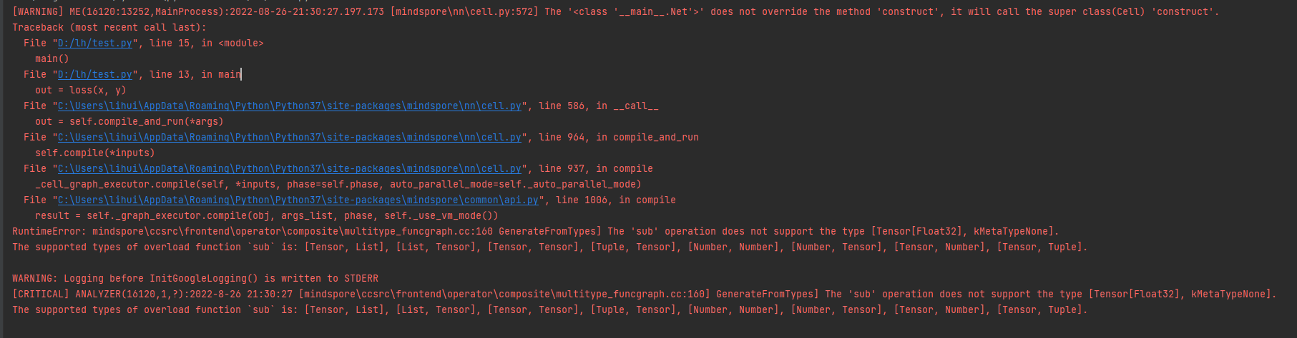
看报错信息，WARNING Net没有重载'construct'方法。 代码里面写成了constuct
最终报错是sub不支持[Tensor[Float32], kMetaTypeNone]
如果Net没有重载'construct'方法，调用了父类的'construct'方法
父类的实现
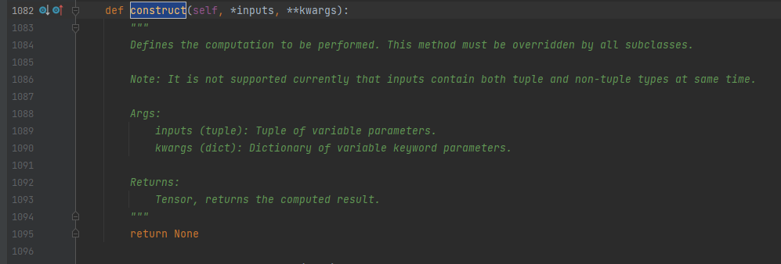
也就是Net的返回值永远是None，然后将None传入到nn.MSELoss()中
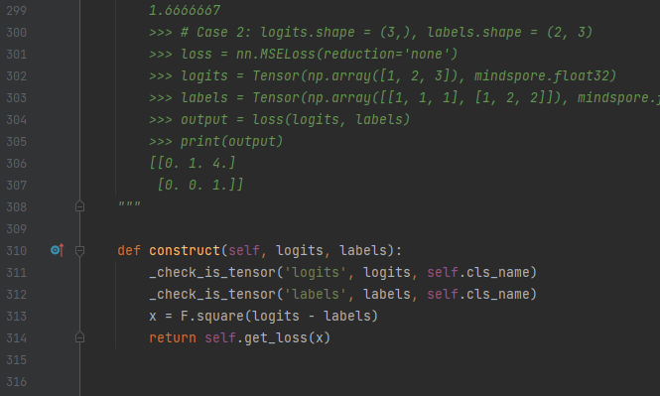
313行 MSELoss会把两个入参相减，然后取平方。
两个参数一个是Tensor另一个是None，所以报sub操作类型不支持。
此时，切换到PYNATIVE_MODE跑下看看
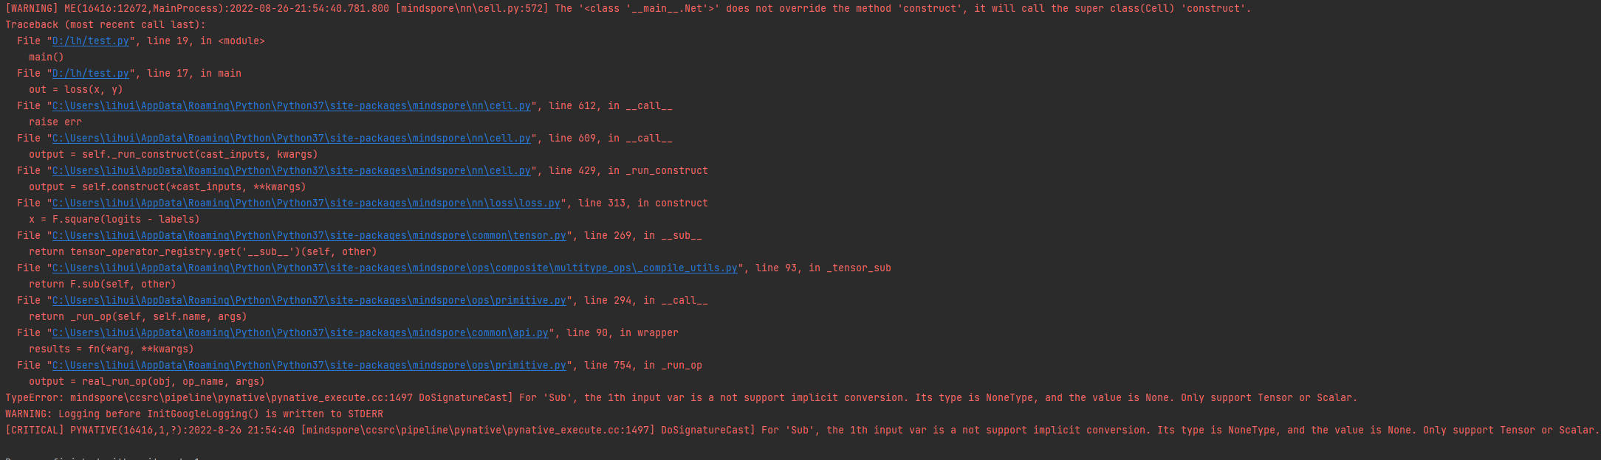
PYNATIVE_MODE下整个流程更加清晰明了。
4. 解决方案
解决方案说明：把constuct修改成construct
修改后代码：
from mindspore import nn, Tensor
import numpy as np
import mindspore
class Net(nn.Cell):
def construct(self, x):
return x
def main():
x = Tensor(np.array([1, 2, 3]), mindspore.float32)
net = Net()
y = net(x)
loss = nn.MSELoss()
out = loss(x, y)
print("out=", out)
正常执行结果
out= 0.0

RuntimeError:The 'sub' operation does not support the type [Tensor[Float32], None].
1. 系统环境
硬件环境(Ascend/GPU/CPU): Ascend/GPU/CPU
软件环境: MindSpore 版本: 1.8.0
执行模式： 静态图(GRAPH)
Python 版本: 3.7.6
操作系统平台: Linux
2. 报错信息
2.1 问题描述
在自定义Cell网络中，construct函数名称错误定义了新的函数，导致基类Cell的construct没有实现引起报错。
2.2 报错信息
RuntimeError:The 'sub' operation does not support the type [Tensor[Float32], None].
2.3 脚本代码
from mindspore import nn, Tensor
import numpy as np
import mindspore
class Net(nn.Cell):
def constuct(self, x):
return x
def main():
x = Tensor(np.array([1, 2, 3]), mindspore.float32)
net = Net()
y = net(x)
loss = nn.MSELoss()
out = loss(x, y)
print("out=", out)
3. 根因分析
提示：首先看报错信息，找到不正常的地方，然后查看告警信息提示：
[WARNING] ME(173836:281472951834496,MainProcess):2022-08-16-10:23:45.508.861 [mindspore/nn/cell.py:559] The '' does not override the method 'construct', it will call the super class(Cell) 'construct'.
意思是有nn.Cell的类并没有自定义construct函数功能, 因此该类会自动调用Cell基类的construct函数
因此可以知道我们需要自定义Net的construct函数，但是参考代码发现用户将construct错误拼写为constuct导致错误
4. 解决方案
解决方案说明：将constuct修改为construct即可
修改后代码：
from mindspore import nn, Tensor
import numpy as np
import mindspore
class Net(nn.Cell):
def construct(self, x):
return x
def main():
x = Tensor(np.array([1, 2, 3]), mindspore.float32)
net = Net()
y = net(x)
loss = nn.MSELoss()
out = loss(x, y)
print("out=", out)

注释不当报错：There are incorrect indentations in definition or comment of function: 'Net.construct'.
1. 系统环境
硬件环境(Ascend/GPU/CPU): Ascend/GPU/CPU
软件环境: MindSpore 版本: 1.8.0
执行模式： 静态图 GRAPH
Python 版本: 3.7.6
操作系统平台: Linux
2. 报错信息
2.1 问题描述
在Cell网络construct函数中，使用注释不正确导致的报错问题。
2.2 报错信息
IndentationError:There are incorrect indentations in definition or comment of function: 'Net.construct'.
2.3 脚本代码
from mindspore import context,nn
context.set_context(device_target="CPU")
class Net(nn.Cell):
def __init__(self):
super(Net, self).__init__()
self.y = 2.0
def construct(self, x):
# x + 2.0
return x + self.y # commit after code
net = Net()
print(net(1))
3. 根因分析
报错信息是construct函数的定义或注释有缩进问题
但是python语法对类内部的注释并没有特别的限制， mindspore框架应该对construct代码进行处理的时候抛出的异常
相关异常信息：
mindspore/_extends/parse/parser.py", line 829
827 try:
828 ast_tokens = asttokens.ASTTokens(src, parse=True)
829 except IndentationError as idt_err:
830 idt_err.filename = self.filename
831 idt_err.lineno = self.line_offset
832 idt_err.msg = f"There are incorrect indentations in definition or comment of function: " \
833 f"'{self.function_name}'."
834 raise idt_err
835 ast_tokens_cache = (ast_tokens, self.col_offset)
836 Parser.ast_cache[hexstr] = ast_tokens_cache
调用asttokens.ASTTokens 发生了异常，该处代码会将construct的代码进行处理，该函数抛出了IndentationError
为了看为什么加注释为什么会导致异常，于是将src的具体内容打印出来。
异常情况下src:
def construct(self, x):
# x + 2.0
return x + self.y # commit after code
正常情况下src:
def construct(self, x):
# x + 2.0
return x + self.y # commit after code
所以mindspore应该是把construct这段的内容前面的空格整体去除了，而且应该去掉几个空格是按照整段代码中空格数最少的那一行来处理的。
823 src = dedent(original_src)
textwrap模块的dedent函数删除字符串中的前导空格，它解决了python代码缩进与书写多行字符串的冲突问题，避免在全局定义多行字符串。
所以注释的#不能超过def
至少定义时如下：
def construct(self, x):
# x + 2.0
return x + self.y # commit after code
4. 解决方案
解决方案说明：construct的注释要与代码行对齐
修改后代码：
from mindspore import context,nn
context.set_context(device_target="CPU")
class Net(nn.Cell):
def __init__(self):
super(Net, self).__init__()
self.y = 2.0
def construct(self, x):
# x + 2.0
return x + self.y # commit after code
net = Net()
print(net(1))
print的结果是 3.0

静态图执行卡死问题：For MakeTuple, the inputs should not be empty..node:xxxxxxxxxxxx
1. 训练进程表现为行卡死
MindSpore进行训练不断打印如下info日志.
[INFO] ANALYZER(37828,fff0caffd1e0,python):2022-08-24-14:23:54.040.917 [mindspore/ccsrc/pipeline/jit/static_analysis/prim.cc:1559] EvalPrim] For MakeTuple, the inputs should not be empty. node: ↓_tensor_getitem_by_tuple_slice.509:[CNode]511{[0]: ValueNode MakeTuple}
[INFO] ANALYZER(37828,fff0caffd1e0,python):2022-08-24-14:23:54.041.199 [mindspore/ccsrc/pipeline/jit/static_analysis/prim.cc:1559] EvalPrim] For MakeTuple, the inputs should not be empty. node: ↓_tensor_getitem_by_tuple_slice.509:[CNode]513{[0]: ValueNode MakeTuple}
[INFO] ANALYZER(37828,fff0ca7fc1e0,python):2022-08-24-14:23:54.221.939 [mindspore/ccsrc/pipeline/jit/static_analysis/prim.cc:1559] EvalPrim] For MakeTuple, the inputs should not be empty. node: ↓_tensor_getitem_by_tuple_slice.509:[CNode]511{[0]: ValueNode MakeTuple}
或者
查询mindspore 进入abstract_specialize 阶段后（info 日志打印 Status record: start abstract_specialize action. 即进入此阶段）卡主不动.
2. 请检查construct函数中是否使用了控制流语句
大概率是因为控制流语句不符合静态图语法限制
网络构建此页面搜索“约束”

报错: module() takes at most 2 arguments (3 given)
1. 报错描述
1.1 系统环境
Environment(Ascend/GPU/CPU): CPU
Software Environment:
– MindSpore version (source or binary): 1.8.0
– Python version (e.g., Python 3.7.5): 3.7.5
– OS platform and distribution (e.g., Linux Ubuntu 16.04): win10
– CUDA version : NA
1.2 基本信息
1.2.1脚本
如下所示，定义一个基于基类nn.cell的网络， 实现一个简单的功能：展平输入的Tensor数据。
from mindspore import nn
from mindspore import set_context
import mindspore as ms
set_context(mode=ms.PYNATIVE_MODE)
class Net(nn.cell):
def __init__(self):
super().__init__()
self.flatten = nn.Flatten()
def construct(self, x):
return self.flatten(x)
def test_compile_cell():
net = Net()
print("network:")
print(net)
if __name__ == "__main__":
test_compile_cell()
1.2.2 报错信息
网络发生如下报错。其实，注释掉def test_compile_cell方法及其调用， 执行脚本依然报错。意味着Net(nn.cell) 的定义就已经发生了错误。
Traceback (most recent call last):
File "test_compiler_cell.py", line 9, in <module>
class Net(nn.cell):
TypeError: module() takes at most 2 arguments (3 given)
2. 原因分析及解决方法
此处想要导入类，如上代码所示只是导入了模块：mindspore/python/mindspore/nn/cell.py，Python的模块名与类名是在两个不同的名字空间中，初学者很容易将其弄混淆。
python 类 用来描述具有相同的属性和方法的对象的集合。它定义了该集合中每个对象所共有的属性和方法。对象是类的实例
python 模块 模块，在Python可理解为对应于一个文件。
根据上面代码，想使用nn.cell作为基类定义网络，但其实际上是一个模块，所以错误。 真正的基类应该是nn.Cell，即mindspore/python/mindspore/nn/cell.py文件中定义的python类对象，它是MindSpore中神经网络的基本构成单元。
修改后的网络定义：
class Net(nn.Cell):
def __init__(self):
super().__init__()
self.flatten = nn.Flatten()
def construct(self, x):
return self.flatten(x)
3. 参考
【1】 mindspore.nn.Cell
【2】 python 模块与类

报错ERROR：For 'ScatterNdAdd', the 3-th value of 'indices'[7] is out of range[4]scatterNdAdd.
1 系统环境
硬件环境(Ascend/GPU/CPU): CPU
MindSpore版本: 1.8
执行模式（动态图）: 不限模式
Python版本: 3.7.5
操作系统平台: 不限
2 报错信息
2.1 问题描述
使用MindSpore-CPU1.8版本中的scatterNdAdd算子出现问题
2.2 报错信息
[ERROR] KERNEL(15937,7fad8d68a0c0,python3):2022-11-23-16:35:44.911.179 [mindspore/ccsrc/plugin/device/cpu/kernel/scatter_nd_arithmetic_cpu_kernel.cc:189] LaunchKernel] For 'ScatterNdAdd', the 3-th value of 'indices'[7] is out of range[4].
2.3 脚本代码
def test_scatterNdAdd():
context.set_context(mode=context.PYNATIVE_MODE, device_target='CPU')
input_x = Parameter(Tensor(np.array([[1, 2], [3, 4], [5, 6], [7, 8]]), mindspore.float32), name="x")
indices = Tensor(np.array([[2], [4], [1], [7]]), mindspore.int32)
updates = Tensor(np.array([[0, 1], [2, 3], [4, 5], [6, 7]]), mindspore.float32)
output = ops.scatter_nd_add(input_x, indices, updates, False)
print(output)
3 根因分析
根因：传入到Scatter_nd_add算子的参数不合规，超出算子规范。
算子说明参考：https://www.mindspore.cn/docs/zh-CN/r1.8/api_python/ops/mindspore.ops.scatter_nd_add.html#mindspore.ops.scatter_nd_add
原因：input_x只有4个内容，indices中的[4]、[7]超出维度范围，更正即可。
4 解决方案
修改变量indices的内容在维度范围内。
def test_scatterNdAdd():
context.set_context(mode=context.PYNATIVE_MODE, device_target='CPU')
input_x = Parameter(Tensor(np.array([[1, 2], [3, 4], [5, 6], [7, 8]]), mindspore.float32), name="x")
indices = Tensor(np.array([[2], [0], [1], [3]]), mindspore.int32)
updates = Tensor(np.array([[0, 1], [2, 3], [4, 5], [6, 7]]), mindspore.float32)
output = ops.scatter_nd_add(input_x, indices, updates, False)
print(output)

使用ops.nonzero算子报错TypeError: Type Join Failed: dtype1 = Float32, dtype2 = Int64.
1 系统环境
硬件环境(Ascend/GPU/CPU): Ascend/GPU/CPU
MindSpore版本: mindspore=1.9.0
执行模式（动态图）:GRAPH/PYNATIVE
Python版本: Python=3.9
操作系统平台: win10
2 报错信息
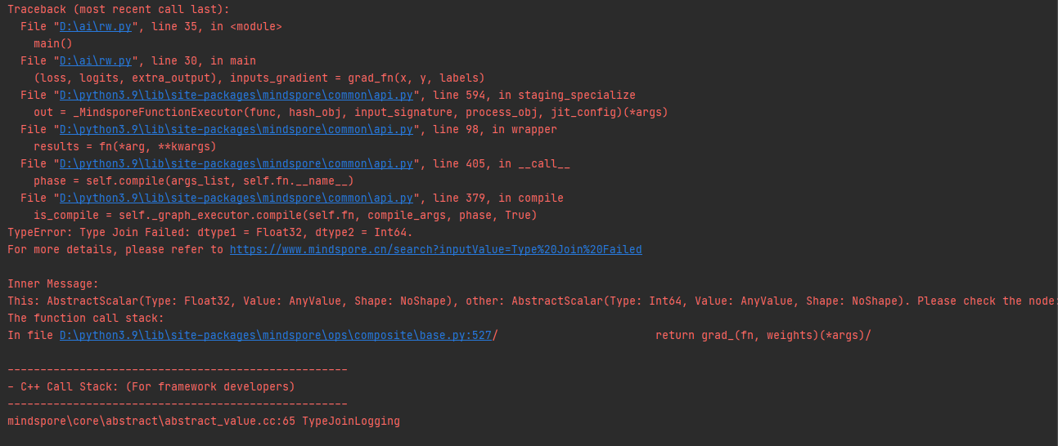
2.1 问题描述
It raised TypeError: Type Join Failed: dtype1 = Float32, dtype2 = Int64.
2.2 脚本代码
import numpy as np
import mindspore as ms
import mindspore.ops as ops
from mindspore import Tensor, nn, context
class Graph(nn.Cell):
def __init__(self):
super().__init__()
self.net = nn.Dense(10, 1)
def construct(self, x, y):
logits = self.net(x)
extra_output = ops.nonzero(y > 0)
return logits, extra_output
def main():
context.set_context(mode=context.GRAPH_MODE)
net = Graph()
x = Tensor(np.random.randn(16, 10), dtype=ms.float32)
y = Tensor([0, 0, 1, 1])
labels = Tensor(np.random.randn(16, 1), dtype=ms.float32)
logit, extra_output = net(x, y)
assert extra_output.shape == (2, 1)
loss_fn = nn.MSELoss()
def forward(x, y, labels):
logits, extra_output = net(x, y)
loss = loss_fn(logits, labels)
return loss, logits, extra_output
grad_fn = ops.value_and_grad(forward, grad_position=None, weights=net.trainable_params(), has_aux=True)
# raised TypeError here
(loss, logits, extra_output), inputs_gradient = grad_fn(x, y, labels)
assert extra_output.shape == (2, 1)
if __name__ == '__main__':
main()
3 根因分析
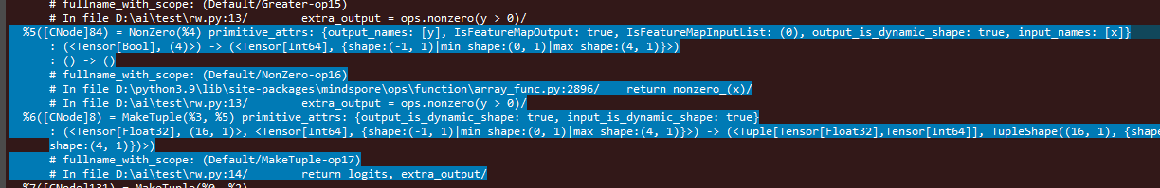
value_and_grad 是同时计算网络的正向输出和梯度。
Graph网络输出是一个tuple，（logits, extra_output）
logits是nn.Dense的输出结果，类型float32
extra_output是ops.nonzero的输出结果，类型int64
梯度计算时由于MindSpore采用的是反向自动微分机制， 会对输出结果求和后再对输入求导。
当输出类型不一致的情况下就会报错。
4 解决方案
两种方法
1.把nonzero算子的返回值转换成float32，转换的算子是Cast
2.使用返回值是float32的算子
比如ops.count_nonzero
第1种方案：
import numpy as np
import mindspore as ms
import mindspore.ops as ops
from mindspore import Tensor, nn, context
class Graph(nn.Cell):
def __init__(self):
super().__init__()
self.net = nn.Dense(10, 1)
self.cast = ops.Cast()
def construct(self, x, y):
logits = self.net(x)
extra_output = ops.nonzero(y > 0)
extra_output = self.cast(extra_output, ms.float32)
return logits, extra_output
def main():
context.set_context(mode=context.GRAPH_MODE)
net = Graph()
x = Tensor(np.random.randn(16, 10), dtype=ms.float32)
y = Tensor([0, 0, 1, 1])
labels = Tensor(np.random.randn(16, 1), dtype=ms.float32)
logit, extra_output = net(x, y)
print(extra_output.shape)
print(extra_output)
assert extra_output.shape == (2, 1)
loss_fn = nn.MSELoss()
def forward(x, y, labels):
logits, extra_output = net(x, y)
loss = loss_fn(logits, labels)
return loss, logits, extra_output
grad_fn = ops.value_and_grad(forward, grad_position=None, weights=net.trainable_params(), has_aux=True)
# raised TypeError here
(loss, logits, extra_output), inputs_gradient = grad_fn(x, y, labels)
assert extra_output.shape == (2, 1)
if __name__ == '__main__':
main()
第2种方案：
import numpy as np
import mindspore as ms
import mindspore.ops as ops
from mindspore import Tensor, nn, context
class Graph(nn.Cell):
def __init__(self):
super().__init__()
self.net = nn.Dense(10, 1)
def construct(self, x, y):
logits = self.net(x)
extra_output = ops.count_nonzero(x=y, keep_dims=True, dtype=ms.float32)
return logits, extra_output
def main():
context.set_context(mode=context.GRAPH_MODE)
net = Graph()
x = Tensor(np.random.randn(16, 10), dtype=ms.float32)
y = Tensor([0, 0, 1, 1])
labels = Tensor(np.random.randn(16, 1), dtype=ms.float32)
logit, extra_output = net(x, y)
#assert extra_output.shape == (2, 1)
loss_fn = nn.MSELoss()
def forward(x, y, labels):
logits, extra_output = net(x, y)
loss = loss_fn(logits, labels)
return loss, logits, extra_output
grad_fn = ops.value_and_grad(forward, grad_position=None, weights=net.trainable_params(), has_aux=True)
# raised TypeError here
(loss, logits, extra_output), inputs_gradient = grad_fn(x, y, labels)
#assert extra_output.shape == (2, 1)
if __name__ == '__main__':
main()
最终可以正常执行

调用MindSpore内部函数时的语法错误TypeError: 'module' object is not callable
1系统环境
硬件环境(Ascend/GPU/CPU): Ascend/GPU/CPU
MindSpore版本: 不限
执行模式（动态图）:不限
Python版本: Python=3.7.5
操作系统平台: 不限
2 报错信息
2.1 问题描述
代码调用函数时，语法错误。
2.2 报错信息
/root/miniconda3/envs/bin/python /mnt/d/06_project/trouble-shooter/tests/proposer/master/test_front_initializer.py
Traceback (most recent call last):
File "/mnt/d/06_project/trouble-shooter/tests/proposer/master/test_front_initializer.py", line 6, in
tensor1 = initializer(data, [1, 2, 3], mindspore.float32)
TypeError: 'module' object is not callable
2.3 脚本代码
import numpy as np
import mindspore
from mindspore import Tensor
from mindspore.common import initializer
data = Tensor(np.zeros([1, 2, 3]), mindspore.float32)
tensor1 = initializer(data, [1, 2, 3], mindspore.float32)
3 根因分析
1.根据报错看出可能是方法引用的不对，首先看看包的位置在哪里呢
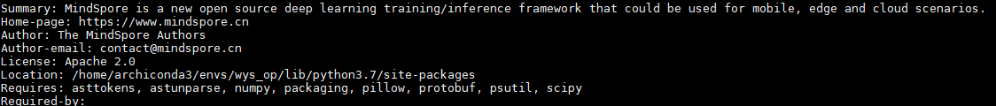
2.在包的安装位置中找到函数的定义的地方
grep -irn "def initializer" /home/archiconda3/envs/wys_op/lib/python3.7/site-packages
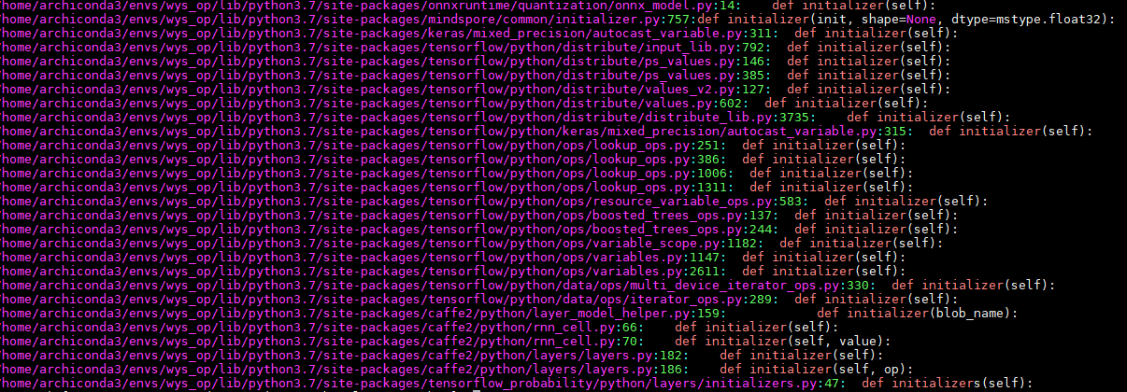
3.至此，我们找到函数的定义地方以及官网代码，至此我们的bug也解决了
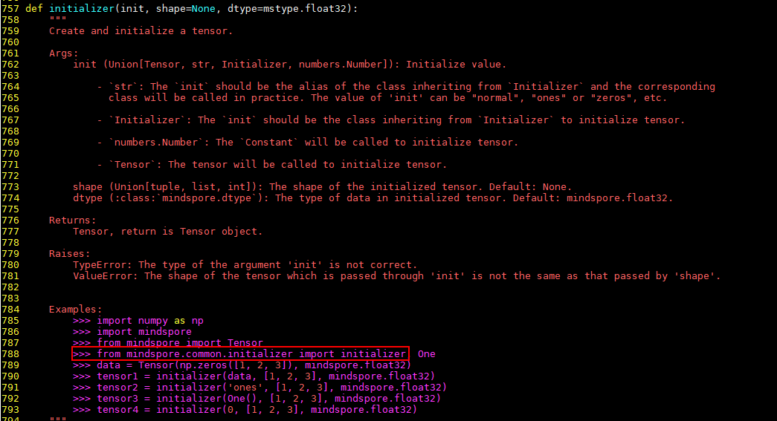
4 解决方案
import numpy as np
import mindspore
from mindspore import Tensor
from mindspore.common.initializer import initializer
data = Tensor(np.zeros([1, 2, 3]), mindspore.float32)
tensor1 = initializer(data, [1, 2, 3], mindspore.float32)
print(tensor1)

MindSpore在静态图模式下使用try语法报错RuntimeError: Unsupported statement 'Try'.
1 系统环境
硬件环境(Ascend/GPU/CPU): CPU
MindSpore版本: 1.9.0
执行模式（动态图/静态图）: 静态图
Python版本: 3.7
操作系统平台:linux
2 报错信息
2.1 报错信息
/root/miniconda3/envs/bin/python /mnt/d/06_project/trouble-shooter/tests/proposer/master/test_compiler_get_context.py
Traceback (most recent call last):
File "/mnt/d/06_project/trouble-shooter/troubleshooter/proposer/proposal_action.py", line 43, in proposal_wrapper
return func(*args, **kw)
File "/mnt/d/06_project/trouble-shooter/tests/proposer/master/test_compiler_get_context.py", line 93, in test2
out = net(input1, input2)
File "/root/miniconda3/envs/lib/python3.7/site-packages/mindspore/nn/cell.py", line 615, in __call__
out = self.compile_and_run(*args)
File "/root/miniconda3/envs/lib/python3.7/site-packages/mindspore/nn/cell.py", line 934, in compile_and_run
self.compile(*inputs)
File "/root/miniconda3/envs/lib/python3.7/site-packages/mindspore/nn/cell.py", line 908, in compile
jit_config_dict=self._jit_config_dict)
File "/root/miniconda3/envs/lib/python3.7/site-packages/mindspore/common/api.py", line 1363, in compile
result = self._graph_executor.compile(obj, args_list, phase, self._use_vm_mode())
RuntimeError: Unsupported statement 'Try'.
More details please refer to syntax support at https://www.mindspore.cn
----------------------------------------------------
- The Traceback of Net Construct Code:
----------------------------------------------------
# In file /root/miniconda3/envs/lib/python3.7/site-packages/mindspore/context.py:462
try:
----------------------------------------------------
- C++ Call Stack: (For framework developers)
----------------------------------------------------
mindspore/ccsrc/pipeline/jit/parse/parse.cc:774 ParseStatement
2.2 脚本代码
"""
This is a python code template
"""
import mindspore.context as context
import mindspore.nn as nn
from mindspore import Tensor
from mindspore.nn import Cell
from mindspore import ops
from mindspore import dtype as mstype
import mindspore
context.set_context(mode=mindspore.GRAPH_MODE, pynative_synchronize=False)
class Net1(nn.Cell):
def __init__(self):
super().__init__()
self.add = ops.Add()
self.sub = ops.Sub()
self.mul = ops.Mul()
self.div = ops.Div()
def func(x, y):
context.get_context("device_target")
return self.div(x, y)
def construct(self, x, y):
a = self.sub(x, 1)
b = self.add(a, y)
c = self.mul(b, self.func(a, b))
return c
def test2():
input1 = Tensor(3, mstype.float32)
input2 = Tensor(2, mstype.float32)
net = Net1()
out = net(input1, input2)
print(out)
if __name__ == '__main__':
test2()
3 根因分析
可能原因: 静态图模式下，网络的construct函数、@ms_function修饰的函数、@ms.jit修饰的函数中出现如下问题：
1）直接或者间接使用了try语法，此语法静态图模式不支持;
2）直接或间接的调用了MindSpore的get_context接口（get_context接口会使用try语法），此接口不能在construct等函数中调用;
补充说明：
此处是间接使用了try语法，mindspore静态图目前不支持try语法，可以参考官网静态图语法支持的链接：
https://www.mindspore.cn/docs/zh-CN/r1.9/note/static_graph_syntax_support.html 里面并没有try语句
而且为什么间接使用了try语法，是因为直接调用get_context接口，具体可以通过代码查看，
get_context接口调用了函数_context（），而_context（）里面调用了try语法
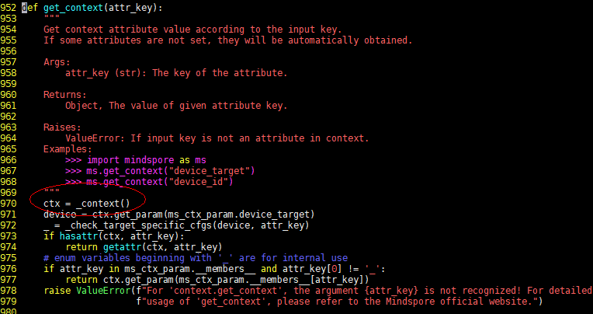
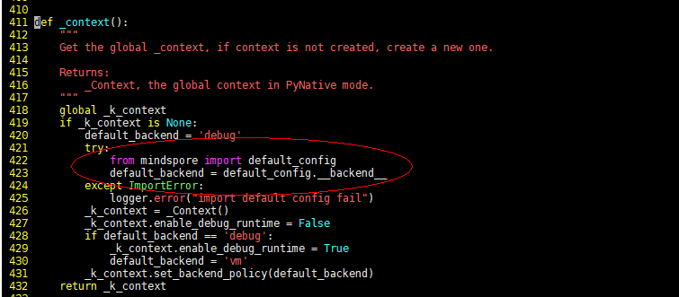
get_context() 是在def func（）被调用，def func（）是在def construct()被调用
因此而报错
处理建议:
1）将try语法在函数中移除;
2）函数中调用的get_context()接口，迁移到函数外调用;
补充说明：
此处由于是间接调用try, 而且try是在mindspore代码里面的
不能修改mindspore代码删除try， 因此就把get_context()迁移到函数外使用即可
4 解决方案
最终方案：
函数中调用的get_context()接口，迁移到函数外调用;
代码：
"""
This is a python code template
"""
import mindspore.context as context
import mindspore.nn as nn
from mindspore import Tensor
from mindspore.nn import Cell
from mindspore import ops
from mindspore import dtype as mstype
import mindspore
context.set_context(mode=mindspore.GRAPH_MODE, pynative_synchronize=False)
class Net1(nn.Cell):
def __init__(self):
super().__init__()
self.add = ops.Add()
self.sub = ops.Sub()
self.mul = ops.Mul()
self.div = ops.Div()
def func(x, y):
#context.get_context("device_target")
return self.div(x, y)
def construct(self, x, y):
a = self.sub(x, 1)
b = self.add(a, y)
c = self.mul(b, self.func(a, b))
return c
def test2():
context.get_context("device_target")
input1 = Tensor(3, mstype.float32)
input2 = Tensor(2, mstype.float32)
net = Net1()
out = net(input1, input2)
print(out)
if __name__ == '__main__':
test2()
最终调试结果：

MindSpore报错: ValueError: For 'MatMul', the input dimensions must be equal, but got 'x1_col': 817920 and 'x2_row': 272640.
1. 系统环境
硬件环境(Ascend/GPU/CPU): Ascend/GPU/CPU
MindSpore版本: 不限
执行模式（动态图）: 不限模式
Python版本: 3.7.5
操作系统平台: Ubuntu 16.04
2. 报错信息
2.1报错信息
[ERROR] ANALYZER(8534,ffffb5cca780,python):2022-11-30-10:59:18.593.719 [mindspore/ccsrc/pipeline/jit/static_analysis/async_eval_result.cc:66] HandleException] Exception happened, check the information as below.
The function call stack (See file '/home/ma-user/work/rank_0/om/analyze_fail.dat' for more details):
# 0 In file /home/ma-user/anaconda3/envs/MindSpore/lib/python3.7/site-packages/mindspore/nn/wrap/cell_wrapper.py(373)
loss = self.network(*inputs)
^
# 1 In file /home/ma-user/anaconda3/envs/MindSpore/lib/python3.7/site-packages/mindspore/nn/wrap/cell_wrapper.py(111)
out = self._backbone(data)
^
# 2 In file /home/ma-user/anaconda3/envs/MindSpore/lib/python3.7/site-packages/mindspore/nn/layer/basic.py(323)
if len(x_shape) != 2:
# 3 In file /home/ma-user/anaconda3/envs/MindSpore/lib/python3.7/site-packages/mindspore/nn/layer/basic.py(326)
if self.has_bias:
# 4 In file /home/ma-user/anaconda3/envs/MindSpore/lib/python3.7/site-packages/mindspore/nn/layer/basic.py(325)
x = self.matmul(x, self.weight)
^
---------------------------------------------------------------------------
ValueError Traceback (most recent call last)
/tmp/ipykernel_8534/2891349598.py in
1 model = ms.train.Model(net, loss, opt, metrics={'acc', 'loss'})
----> 2 model.train(25, ds_train, callbacks=[LossMonitor(per_print_times=ds_train.get_dataset_size())], dataset_sink_mode=False)
3 metrics = model.eval(ds_test)
4 print(metrics)
~/anaconda3/envs/MindSpore/lib/python3.7/site-packages/mindspore/train/model.py in train(self, epoch, train_dataset, callbacks, dataset_sink_mode, sink_size)
904 callbacks=callbacks,
905 dataset_sink_mode=dataset_sink_mode,
--> 906 sink_size=sink_size)
907
908 def build(self, train_dataset=None, valid_dataset=None, sink_size=-1, epoch=1, jit_config=None):
~/anaconda3/envs/MindSpore/lib/python3.7/site-packages/mindspore/train/model.py in wrapper(self, *args, **kwargs)
85 raise e
86 else:
---> 87 func(self, *args, **kwargs)
88 return wrapper
89
~/anaconda3/envs/MindSpore/lib/python3.7/site-packages/mindspore/train/model.py in _train(self, epoch, train_dataset, callbacks, dataset_sink_mode, sink_size)
540 self._check_reuse_dataset(train_dataset)
541 if not dataset_sink_mode:
--> 542 self._train_process(epoch, train_dataset, list_callback, cb_params)
543 elif context.get_context("device_target") == "CPU":
544 logger.info("The CPU cannot support dataset sink mode currently."
~/anaconda3/envs/MindSpore/lib/python3.7/site-packages/mindspore/train/model.py in _train_process(self, epoch, train_dataset, list_callback, cb_params)
792 cb_params.train_dataset_element = next_element
793 list_callback.step_begin(run_context)
--> 794 outputs = self._train_network(*next_element)
795 cb_params.net_outputs = outputs
796 if self._loss_scale_manager and self._loss_scale_manager.get_drop_overflow_update():
~/anaconda3/envs/MindSpore/lib/python3.7/site-packages/mindspore/nn/cell.py in __call__(self, *args, **kwargs)
584 logger.warning(f"For 'Cell', it's not support hook function in graph mode. If you want to use hook "
585 f"function, please use context.set_context to set pynative mode.")
--> 586 out = self.compile_and_run(*args)
587 return out
588
~/anaconda3/envs/MindSpore/lib/python3.7/site-packages/mindspore/nn/cell.py in compile_and_run(self, *inputs)
962 """
963 self._auto_parallel_compile_and_run = True
--> 964 self.compile(*inputs)
965
966 new_inputs = []
~/anaconda3/envs/MindSpore/lib/python3.7/site-packages/mindspore/nn/cell.py in compile(self, *inputs)
935 """
936 if self._dynamic_shape_inputs is None or self._dynamic_shape_inputs[0] is None:
--> 937 _cell_graph_executor.compile(self, *inputs, phase=self.phase, auto_parallel_mode=self._auto_parallel_mode)
938 else:
939 self._check_compile_dynamic_shape(*inputs)
~/anaconda3/envs/MindSpore/lib/python3.7/site-packages/mindspore/common/api.py in compile(self, obj, phase, do_convert, auto_parallel_mode, *args)
1004 enable_ge = context.get_context("enable_ge")
1005 self._graph_executor.set_weights_values(obj.parameters_dict())
-> 1006 result = self._graph_executor.compile(obj, args_list, phase, self._use_vm_mode())
1007 obj.compile_cache.add(phase)
1008 if not result:
~/anaconda3/envs/MindSpore/lib/python3.7/site-packages/mindspore/ops/primitive.py in __check__(self, *args)
465 for track in tracks:
466 fn = getattr(self, 'check_' + track)
--> 467 fn(*(x[track] for x in args))
468
469
~/anaconda3/envs/MindSpore/lib/python3.7/site-packages/mindspore/ops/operations/math_ops.py in check_shape(self, x1, x2)
1387 if np.all(np.array(x1) != -1) and np.all(np.array(x2) != -1):
1388 if x1_col != x2_row:
-> 1389 raise ValueError(f"For '{cls_name}', the input dimensions must be equal, but got 'x1_col': {x1_col} "
1390 f"and 'x2_row': {x2_row}. And 'x' shape {x1}(transpose_a={self.transpose_a}), "
1391 f"'y' shape {x2}(transpose_b={self.transpose_b}).")
ValueError: For 'MatMul', the input dimensions must be equal, but got 'x1_col': 817920 and 'x2_row': 272640. And 'x' shape [32, 817920](transpose_a=False), 'y' shape [3, 272640](transpose_b=True).
2.2脚本代码
import numpy as np
import mindspore as ms
from mindspore import nn
from mindspore import context
from mindspore import dataset
from mindspore.train.callback import LossMonitor
#当前实验选择算力为Ascend，如果在本地体验，参数device_target设置为"CPU”
context.set_context(mode=context.PYNATIVE_MODE, device_target="CPU")
#要筛选的分辨率条件
targetWidth=426
targetHeight=640
targetChannal=3
#读取animal文件夹下所有文件的名字
rootDir='animal'
fileNameList=['cat','elephant','sheep']
label_map = {
'cat': 0,
'elephant': 1,
'sheep': 2
}
X,Y=[],[]
for fileName in fileNameList:
for imgName in range(100):
img=np.random.randn(targetWidth, targetHeight, targetChannal)
if(len(img.shape)==3):
width,height,channal=img.shape
if width==targetWidth and height==targetHeight and channal==targetChannal:#符合筛选条件的样本留下放到X，其标签放到Y
X.append(img.flatten())
Y.append(label_map[fileName])#类别
#print(X,Y)
#划分训练集和测试集合
sampleNum=len(X)
train_idx = np.random.choice(sampleNum, int(sampleNum*0.8), replace=False)#取80%的样本作为训练集
test_idx = np.array(list(set(range(sampleNum)) - set(train_idx)))#剩下的样本作为测试集
X_train=[X[i].astype(np.float32) for i in range(len(X)) if i in train_idx]
Y_train=[Y[i] for i in range(len(Y)) if i in train_idx]
X_test=[X[i].astype(np.float32) for i in range(len(X)) if i in test_idx]
Y_test=[Y[i] for i in range(len(Y)) if i in test_idx]
XY_train = list(zip(X_train, Y_train))
ds_train = dataset.GeneratorDataset(XY_train, ['x', 'y'])
# ds_train.set_dataset_size(sampleNum)
ds_train = ds_train.shuffle(buffer_size=sampleNum).batch(32, drop_remainder=True)
XY_test = list(zip(X_test, Y_test))
ds_test = dataset.GeneratorDataset(XY_test, ['x', 'y'])
ds_test = ds_test.batch(30)#具体作用
#print(XY_test)
for e in X_train:
print(e.shape)
net = nn.Dense(targetWidth*targetHeight, 3)
loss = nn.loss.SoftmaxCrossEntropyWithLogits(sparse=True, reduction='mean')
opt = nn.optim.Momentum(net.trainable_params(), learning_rate=0.05, momentum=0.9)
model = ms.train.Model(net, loss, opt, metrics={'acc', 'loss'})
model.train(25, ds_train, callbacks=[LossMonitor(per_print_times=ds_train.get_dataset_size())], dataset_sink_mode=False)
metrics = model.eval(ds_test)
print(metrics)
3. 根因分析
根据报错信息的最后一行，可以定位到时是算子MatMul计算出错、
ValueError: For 'MatMul', the input dimensions must be equal, but got 'x1_col': 817920 and 'x2_row': 272640. And 'x' shape [32, 817920] (transpose_a=False), 'y' shape [3, 272640] (transpose_b=True).
而网络只有一层Dense和loss函数组成，因此只可能在Dense里调用了MatMul函数，Dense的任务就是在初始化时创建一个weight矩阵，矩阵的shape由初始化时传入的in_channels 和 out_channels决定，
class Dense(Cell):
def __init__(self,
in_channels,
out_channels,
weight_init='normal',
bias_init='zeros',
has_bias=True,
activation=None):
"""Initialize Dense."""
...
self.weight = Parameter(initializer(weight_init, [out_channels, in_channels]), name="weight")
...
def construct(self, x):
...
x = self.matmul(x, self.weight)
...
在本例中weight矩阵的shape为3 × 272640
nn.Dense(targetWidth*targetHeight, 3)
根据矩阵乘法的知识 x1_col和x2_row必须相等，而在本例中，x1_col == 817920 and x2_row == 272640，不满足矩阵乘法要求，从而导致报错。根据Dense中matmul调用的位置关系，x1对应输入图片数据，x2对应self.weight，weight矩阵的shape为3 × 272640(weight转置后相乘，因为transpose_b=True)，因此应该检查输入图片的shape为何为817920。
接下来检查输入数据集的构建方式，通过Image.open(imgDir)打开图片，在根据targetWidth、targetHeight和targetChannal筛选样本，筛选后的样本shape为[targetWidth, targetHeight, targetChannal]，最后将数据flatten后加入到链表X中。此时发现，数据构建时其实用到了三个维度，width,height和channal，而Dense中的创建权重矩阵只用了两个维度width和height，因此自然不能完成矩阵乘法的运算。
4. 解决方案
创建权重矩阵时加上channal维度，
net = nn.Dense(targetWidth*targetHeight*targetChannal, 3)

MindSpore 报错提示 DropoutGrad 的bprop反向未定义："Illegal primitive: Primitive DropoutGrad’s bprop not defined."
1. 系统环境
硬件环境(Ascend/GPU/CPU): CPU
软件环境: MindSpore 版本: 1.7.0
执行模式（静态图/动态图）： 静态图
Python 版本: 3.7.6
操作系统平台: linux
2. 报错信息
2.1 问题描述
执行网络代码时，报错提示DropoutGrad的反向未定义。
2.2 报错信息
Illegal primitive: Primitive DropoutGrad’s bprop not defined.
2.3 脚本信息
import numpy as np
import mindspore.nn as nn
import mindspore.ops as ops
from mindspore import Tensor
from mindspore import context
from mindspore import dtype as mstype
from mindspore.ops.operations import _grad_ops as P
context.set_context(mode=context.GRAPH_MODE, device_target="CPU")
class Net(nn.Cell):
def __init__(self, keep_prob=0.5):
super(Net, self).__init__()
self.dropout_grad = P.DropoutGrad(keep_prob)
def construct(self, output, mask):
return self.dropout_grad(output, mask)
class GradSec(nn.Cell):
def __init__(self, network):
super(GradSec, self).__init__()
self.grad = ops.GradOperation()
self.network = network
def construct(self, x, mask):
gout = self.grad(self.network)(x, mask)
return gout
in_tensor = Tensor(np.array([[[3., 1., 2.]], [[4., 1., 4.]]]), mstype.float16)
in_mask = Tensor(np.array([[[1., 0, 0]], [[0., 0., 1.]]]), mstype.float16)
dropout_grad = Net(0.3333333333)
second_grad = GradSec(dropout_grad)
output = second_grad(in_tensor, in_mask)
print(output)
3. 根因分析
MindSpore 1.7.0版本执行网络代码时，报错Illegal primitive: Primitive DropoutGrad’s bprop not defined。
分析报错信息，发现是未定义DropoutGrad的反向，即Dropout的二阶反向。需要在MindSpore源码中补齐该功能。
4. 解决方案
通过社区提需求的方式，反馈该问题。开发人员在MindSpore源码中增加Dropout的二阶反向。
相关代码可查阅：https://gitee.com/mindspore/mindspore/pulls/36778
修复后，执行该用例，可以正常打印出结果。
[[[3. 0. 0.]]
[[0. 0. 3.]]]
该问题已在MindSpore 1.7.0版本解决，后续版本不再复现。

MindSpore报错The graph generated form MindIR is not support to execute in the PynativeMode,please convert to the GraphMode
1 系统环境
硬件环境(Ascend/GPU/CPU): Ascend/GPU/CPU
MindSpore版本: 1.9.0
执行模式（PyNative/ Graph）: 不设置模式
Python版本: 3.7.5
操作系统平台: 不限
2 报错信息
2.1 问题描述
运行教程中的示例代码出现报错
2.2 报错信息
RuntimeError: The graph generated form MindIR is not support to execute in the PynativeMode, please convert to the GraphMode.
2.3 脚本代码
import mindspore.nn as nn
net = nn.Conv2d(1,1,kernel_size=3,weight_init="ones")
input = Tensor(np.ones([1,1,3,3]).astype(np.float32))
print (input)
ms.export(net,input,file_name="net",file_foemat="MINDIR")
graph = ms.load("net.mindir")
net = nn.GraphCell(graph)
output = net(input)
print(out_put)
3 根因分析
1、在MindSpore1.9.0版本中默认模式更改，该问题是用例没有设置默认导致的，可以在用例中添加设置图模式。
2、未引入mindspore并设置别名ms，需要在开始import mindspore as ms
3、未引入numpy并设置别名np，需要在开始import numpy as np
4、ms.export函数参数名file_foemat拼写错误，需要改成改成file_format
5、print(out_put)中的out_put参数错误，需要改成output
4 解决方案
import mindspore as ms
import numpy as np
import mindspore.nn as nn
net = nn.Conv2d(1,1,kernel_size=3,weight_init="ones")
input = ms.Tensor(np.ones([1,1,3,3]).astype(np.float32))
print(input)
ms.export(net,input,file_name="net",file_foemat="MINDIR")
mindspore.set_context(mode=mindspore.GRAPH_MODE)
graph = ms.load("net.mindir")
net = nn.GraphCell(graph)
output = net(input)
print(out_put)
[[[[1. 1. 1.]
[1. 1. 1.]
[1. 1. 1.]]]]
[[[[4. 6. 4.]
[6. 9. 6.]
[4. 6. 4.]]]]

MindSpore报错RuntimeError: For ’Optimizer’, the argument group params must not be empty.
1 系统环境
硬件环境(Ascend/GPU/CPU): Ascend/GPU/CPU
MindSpore版本: 不限
执行模式（PyNative/ Graph）: 不限
Python版本: Python=3.7.5
操作系统平台: Linux
2 报错信息
2.1问题描述
使用MindSpore中的mindspore.nn.Optimizer出现报错
2.2报错信息
RuntimeError: For ’Optimizer’, the argument group params must not be empty.
2.3脚本代码
from mindspore import nn
net = Net()
conv_params = list(filter(lambda x: 'conv' in x.name, net.trainable_params()))
no_conv_params = list(filter(lambda x: 'conv' not in x.name, net.trainable_params()))
group_params = [{'params': conv_params, 'lr': 0.05},{'params': no_conv_params, 'lr': 0.01}]
optim = nn.Momentum(group_params, learning_rate=0.1, momentum=0.9, weight_decay=0.0)
conv_lr = optim.get_lr_parameter(conv_params)
print(conv_lr[0].asnumpy())
3 根因分析
报错原因为：params里面不能为空，实例代码中的隐含条件是，Net应该是一个包含卷积操作的网络。本示例代码中没有展示网络定义。
以下代码，构造一个没包含params的Net，可以看到报错：RuntimeError: For ’Optimizer’, the argument group params must not be empty.
import numpy as np
import mindspore.ops as ops
from mindspore import nn, Tensor, Parameter
class Net(nn.Cell):
def __init__(self):
super(Net, self).__init__()
self.matmul = ops.MatMul()
def construct(self, x):
out = self.matmul(x, x)
return out
net = Net()
conv_params = list(filter(lambda x: 'conv' in x.name, net.trainable_params()))
no_conv_params = list(filter(lambda x: 'conv' not in x.name, net.trainable_params()))
group_params = [{'params': conv_params, 'lr': 0.05}, {'params': no_conv_params, 'lr': 0.01}]
optim = nn.Momentum(group_params, learning_rate=0.1, momentum=0.9, weight_decay=0.0)
conv_lr = optim.get_lr_parameter(conv_params)
print(conv_lr[0].asnumpy())
4 解决方案
修改代码如下，解决报错：
import numpy as np
import mindspore.ops as ops
from mindspore import nn, Tensor, Parameter
class Net(nn.Cell):
def __init__(self):
super(Net, self).__init__()
self.matmul = ops.MatMul()
self.conv = nn.Conv2d(1, 6, 5, pad_mode="valid")
self.param = Parameter(Tensor(np.array([1.0], np.float32)))
def construct(self, x):
x = self.conv(x)
x = x * self.param
out = self.matmul(x, x)
return out
net = Net()
conv_params = list(filter(lambda x: 'conv' in x.name, net.trainable_params()))
no_conv_params = list(filter(lambda x: 'conv' not in x.name, net.trainable_params()))
group_params = [{'params': conv_params, 'lr': 0.05}, {'params': no_conv_params, 'lr': 0.01}]
optim = nn.Momentum(group_params, learning_rate=0.1, momentum=0.9, weight_decay=0.0)
conv_lr = optim.get_lr_parameter(conv_params)
print(conv_lr[0].asnumpy())

使用mindspore.ops.MaxPool3D算子设置为ceil_mode=True时，在MindSpore1.8.1和1.9.0版本中计算结果不一致
1 系统环境
硬件环境(Ascend/GPU/CPU): Ascend/GPU/CPU
MindSpore版本: 1.8.1、1.9.0
执行模式（PyNative/ Graph）: 不限模式
Python版本: 3.9.13
操作系统平台: win10
2 报错信息
2.1 问题描述
mindspore 1.9.0 mindspore.ops.MaxPool3D在ceil_mode=True时计算结果出现问题
2.2 报错信息
1.8.1
mindspore version: 1.8.1
input shape: (4, 3, 6, 6, 5)
res shape: (4, 3, 3, 3, 2)
no ceil res shape: (4, 3, 2, 2, 2)
1.9.0
mindspore version: 1.9.0
input shape: (4, 3, 6, 6, 5)
res shape: (4, 3, 2, 2, 2)
no ceil res shape: (4, 3, 2, 2, 2)
2.3 脚本代码
import mindspore as ms
import numpy as np
print(f"mindspore version: {ms.__version__}")
a = ms.Tensor(np.random.randn(4, 3, 6, 6, 5), ms.float32)
print(f"input shape: {a.shape}")
maxpool = ms.ops.MaxPool3D(kernel_size=3, strides=2, pad_mode="pad", pad_list=0, ceil_mode=True)
res = maxpool(a)
print(f"res shape: {res.shape}")
maxpool = ms.ops.MaxPool3D(kernel_size=3, strides=2, pad_mode="pad", pad_list=0, ceil_mode=False)
res = maxpool(a)
print(f"no ceil res shape: {res.shape}")
3 根因分析
1.9版本开始移植python侧infer到cpp侧，python 中整数相除会保存浮点数结果，cpp 中忽略了此处细节，使用int型保存结果，造成整除，ceil失去意义。
代码如下
if (pad_mode == PadMode::VALID) {
out_d = in_d == -1 ? -1 : MaxPool3DCeilDiv((in_d - (kernel_d - 1)), stride_d);
out_h = in_h == -1 ? -1 : MaxPool3DCeilDiv((in_h - (kernel_h - 1)), stride_h);
out_w = in_w == -1 ? -1 : MaxPool3DCeilDiv((in_w - (kernel_w - 1)), stride_w);
} else if (pad_mode == PadMode::SAME) {
out_d = in_d == -1 ? -1 : MaxPool3DCeilDiv(in_d, stride_d);
out_h = in_h == -1 ? -1 : MaxPool3DCeilDiv(in_h, stride_h);
out_w = in_w == -1 ? -1 : MaxPool3DCeilDiv(in_w, stride_w);
} else {
double out_d_tmp =
in_d == -1
? -1
: static_cast<double>(in_d + pad_list[kInputIndex0] + pad_list[kInputIndex1] - kernel_d) / stride_d + 1;
double out_h_tmp =
in_h == -1
? -1
: static_cast<double>(in_h + pad_list[kInputIndex2] + pad_list[kInputIndex3] - kernel_h) / stride_h + 1;
double out_w_tmp =
in_w == -1
? -1
: static_cast<double>(in_w + pad_list[kInputIndex4] + pad_list[kInputIndex5] - kernel_w) / stride_w + 1;
if (ceil_mode) {
out_d = DoubleToLong(std::ceil(out_d_tmp));
out_h = DoubleToLong(std::ceil(out_h_tmp));
out_w = DoubleToLong(std::ceil(out_w_tmp));
} else {
out_d = DoubleToLong(std::floor(out_d_tmp));
out_h = DoubleToLong(std::floor(out_h_tmp));
out_w = DoubleToLong(std::floor(out_w_tmp));
}
int64_t out_d = 0;
int64_t out_h = 0;
int64_t out_w = 0;
out_d out_h out_w都是定义的int类型，后面的(in_d + pad_list[kInputIndex0] + pad_list[kInputIndex1] - kernel_d) / stride_d + 1返回的直接就是去掉小数的整数，因此后面再做ceil和floor操作已经没有意义了
4 解决方案
可以在Cpp infer中使用浮点数保存中间计算结果，确保ceil生效，和python侧逻辑保持一致。
if (pad_mode == PadMode::VALID) {
out_d = in_d == -1 ? -1 : MaxPool3DCeilDiv((in_d - (kernel_d - 1)), stride_d);
out_h = in_h == -1 ? -1 : MaxPool3DCeilDiv((in_h - (kernel_h - 1)), stride_h);
out_w = in_w == -1 ? -1 : MaxPool3DCeilDiv((in_w - (kernel_w - 1)), stride_w);
} else if (pad_mode == PadMode::SAME) {
out_d = in_d == -1 ? -1 : MaxPool3DCeilDiv(in_d, stride_d);
out_h = in_h == -1 ? -1 : MaxPool3DCeilDiv(in_h, stride_h);
out_w = in_w == -1 ? -1 : MaxPool3DCeilDiv(in_w, stride_w);
} else {
double out_d_tmp =
in_d == -1
? -1
: static_cast<double>(in_d + pad_list[kInputIndex0] + pad_list[kInputIndex1] - kernel_d) / stride_d + 1;
double out_h_tmp =
in_h == -1
? -1
: static_cast<double>(in_h + pad_list[kInputIndex2] + pad_list[kInputIndex3] - kernel_h) / stride_h + 1;
double out_w_tmp =
in_w == -1
? -1
: static_cast<double>(in_w + pad_list[kInputIndex4] + pad_list[kInputIndex5] - kernel_w) / stride_w + 1;
if (ceil_mode) {
out_d = DoubleToLong(std::ceil(out_d_tmp));
out_h = DoubleToLong(std::ceil(out_h_tmp));
out_w = DoubleToLong(std::ceil(out_w_tmp));
} else {
out_d = DoubleToLong(std::floor(out_d_tmp));
out_h = DoubleToLong(std::floor(out_h_tmp));
out_w = DoubleToLong(std::floor(out_w_tmp));
}

Construct内报错和定位解决
1. 系统环境
硬件环境(Ascend/GPU/CPU): CPU
软件环境: MindSpore 版本: 1.9
执行模式（静态图/动态图）： 不限
Python 版本: 3.7.6
操作系统平台: linux
2. 报错信息
2.1 问题描述
有一个模型，在construct里进行了一些计算，计算完毕后想删除某个tensor。
2.2 报错信息
Traceback (most recent call last):
File "D:/cons.py", line 11, in <module>
m(1, 2)
File "D:\python3.7\lib\site-packages\mindspore\nn\cell.py", line 622, in __call__
out = self.compile_and_run(*args)
File "D:\python3.7\lib\site-packages\mindspore\nn\cell.py", line 1007, in compile_and_run
self.compile(*inputs)
File "D:\python3.7\lib\site-packages\mindspore\nn\cell.py", line 979, in compile
jit_config_dict=self._jit_config_dict)
File "D:\python3.7\lib\site-packages\mindspore\common\api.py", line 1147, in compile
result = self._graph_executor.compile(obj, args_list, phase, self._use_vm_mode())
RuntimeError: Unsupported statement 'Delete'.
More details please refer to syntax support at https://www.mindspore.cn
----------------------------------------------------
- The Traceback of Net Construct Code:
----------------------------------------------------
# In file D:/cons.py:9
del a
^
----------------------------------------------------
- C++ Call Stack: (For framework developers)
----------------------------------------------------
mindspore\ccsrc\pipeline\jit\parse\parse.cc:772 mindspore::parse::Parser::ParseStatement
Process finished with exit code 1
2.3 脚本信息
from mindspore import nn
import mindspore as ms
ms.set_context(mode=ms.GRAPH_MODE)
class Model(nn.Cell):
def construct(self, x, y):
a = x + 1
y = a + y
del a
return y
m = Model()
m(1, 2)
3. 根因分析
在Graph模式下，Python代码并不是由Python解释器去执行，而是将代码编译成静态计算图，然后执行静态计算图。
由于语法解析的限制，当前在编译构图时，支持的数据类型、语法以及相关操作并没有完全与Python语法保持一致，部分使用受限。
具体参考：https://www.mindspore.cn/docs/zh-CN/r1.8/note/static_graph_syntax_support.html
出错的代码
https://gitee.com/mindspore/mindspore/blob/master/mindspore/ccsrc/pipeline/jit/parse/parse.cc
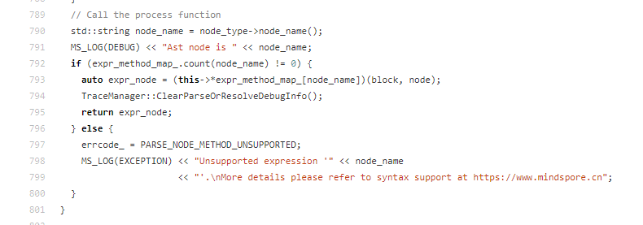从说明文档和代码上都能看出del不被支持。
4. 解决方案
不用del，将变量置None。
from mindspore import nn
import mindspore as ms
ms.set_context(mode=ms.GRAPH_MODE)
class Model(nn.Cell):
def construct(self, x, y):
a = x + 1
y = a + y
a = None
return y
m = Model()
m(1, 2)

gather算子报错：TypeError以及定位解决
1. 系统
环境
硬件环境(Ascend/GPU/CPU): CPU
软件环境: MindSpore 版本: 1.9
执行模式（静态图/动态图）： 不限
Python 版本: 3.7.6
操作系统平台: linux
2. 报错信息
2.1 问题描述
有一个模型，在construct里进行了一些计算，计算完毕后想删除某个tensor。
2.2 报错信息
Traceback (most recent call last):
File "D:/cons.py", line 11, in <module>
m(1, 2)
File "D:\python3.7\lib\site-packages\mindspore\nn\cell.py", line 622, in __call__
out = self.compile_and_run(*args)
File "D:\python3.7\lib\site-packages\mindspore\nn\cell.py", line 1007, in compile_and_run
self.compile(*inputs)
File "D:\python3.7\lib\site-packages\mindspore\nn\cell.py", line 979, in compile
jit_config_dict=self._jit_config_dict)
File "D:\python3.7\lib\site-packages\mindspore\common\api.py", line 1147, in compile
result = self._graph_executor.compile(obj, args_list, phase, self._use_vm_mode())
RuntimeError: Unsupported statement 'Delete'.
More details please refer to syntax support at https://www.mindspore.cn
----------------------------------------------------
- The Traceback of Net Construct Code:
----------------------------------------------------
# In file D:/cons.py:9
del a
^
----------------------------------------------------
- C++ Call Stack: (For framework developers)
----------------------------------------------------
mindspore\ccsrc\pipeline\jit\parse\parse.cc:772 mindspore::parse::Parser::ParseStatement
Process finished with exit code 1
2.3 脚本信息
from mindspore import nn
import mindspore as ms
ms.set_context(mode=ms.GRAPH_MODE)
class Model(nn.Cell):
def construct(self, x, y):
a = x + 1
y = a + y
del a
return y
m = Model()
m(1, 2)
3. 根因分析
在Graph模式下，Python代码并不是由Python解释器去执行，而是将代码编译成静态计算图，然后执行静态计算图。
由于语法解析的限制，当前在编译构图时，支持的数据类型、语法以及相关操作并没有完全与Python语法保持一致，部分使用受限。
具体参考：https://www.mindspore.cn/docs/zh-CN/r1.8/note/static_graph_syntax_support.html
出错的代码
https://gitee.com/mindspore/mindspore/blob/master/mindspore/ccsrc/pipeline/jit/parse/parse.cc
从说明文档和代码上都能看出del不被支持。
4. 解决方案
不用del，将变量置None。
from mindspore import nn
import mindspore as ms
ms.set_context(mode=ms.GRAPH_MODE)
class Model(nn.Cell):
def construct(self, x, y):
a = x + 1
y = a + y
a = None
return y
m = Model()
m(1, 2)

报错：module() takes at most 2 arguments (3 given)
1. 系统环境
硬件环境(Ascend/GPU/CPU): CPU
软件环境: MindSpore 版本: 1.8.1
执行模式（静态图/动态图）： 不限
Python 版本: 3.7.6
操作系统平台: linux
2. 报错信息
2.1 问题描述
1.网络创建失败
2.Tensor创建失败
2.2 报错信息
报错一：
TypeError: module() takes at most 2 arguments (3 given)
报错二：
TypeError: 'mindspore._c_expression.typing.TensorType' object is not callable
2.3 脚本信息
代码一：
import mindspore.nn as nn
import mindspore.ops as ops
class MyCell(nn.cell):
def _init__(self, forward_net):
super(MyCelL, self)._init__(auto_prefix=False)
sef.relu = ops.ReLU()
self.net = forward_net
代码二：
import mindspore
t1 = mindspore.tensor([[1,2,3],[3,4,5]])
# = { 'dΘ':[1,2,3],'d1':mindspore.Tensor(a),'c....}
print(t1)
3. 根因分析
nn.cell 其实是模块，为文件mindspore/nn/cell.py
当模块作为类继承的父类就会报TypeError: module() takes at most 2 arguments (3 given)
nn.Cell 为mindspore/nn/cell.py模块里面的Cell类。
mindspore.tensor其实指向的是typing.TensorType() 是无法调用的。
4. 解决方案
代码一：
import mindspore.nn as nn
import mindspore.ops as ops
class MyCell(nn.Cell):
def __init__(self, forward_net):
super(MyCell, self).__init__(auto_prefix=False)
self.relu = ops.ReLU()
self.net = forward_net
代码二：
import mindspore
t1 = mindspore.Tensor([[1,2,3],[3,4,5]])
# = { 'dΘ':[1,2,3],'d1':mindspore.Tensor(a),'c....}
print(t1)

注释不当报错：There are incorrect indentations in definition or comment of function: 'Net.construct'.
1. 系统环境
硬件环境(Ascend/GPU/CPU): Ascend/GPU/CPU
软件环境: MindSpore 版本: 1.8.0
执行模式（静态图/动态图）： 不限
Python 版本: 3.7.6
操作系统平台: linux
2. 报错信息
2.1 问题描述
在Cell网络construct函数中，使用注释不正确导致的报错问题。
2.2 报错信息
IndentationError:There are incorrect indentations in definition or comment of function: 'Net.construct'.
2.3 脚本信息
from mindspore import context,nn
context.set_context(device_target="CPU")
class Net(nn.Cell):
def __init__(self):
super(Net, self).__init__()
self.y = 2.0
def construct(self, x):
# x + 2.0
return x + self.y # commit after code
net = Net()
print(net(1))
3. 根因分析
报错信息是construct函数的定义或注释有缩进问题
但是python语法对类内部的注释并没有特别的限制， mindspore框架应该对construct代码进行处理的时候抛出的异常
相关异常信息：
mindspore/_extends/parse/parser.py", line 829
827 try:
828 ast_tokens = asttokens.ASTTokens(src, parse=True)
829 except IndentationError as idt_err:
830 idt_err.filename = self.filename
831 idt_err.lineno = self.line_offset
832 idt_err.msg = f"There are incorrect indentations in definition or comment of function: " \
833 f"'{self.function_name}'."
834 raise idt_err
835 ast_tokens_cache = (ast_tokens, self.col_offset)
836 Parser.ast_cache[hexstr] = ast_tokens_cache
调用asttokens.ASTTokens 发生了异常，该处代码会将construct的代码进行处理，该函数抛出了IndentationError
为了看为什么加注释为什么会导致异常，于是将src的具体内容打印出来。
异常情况下src:
def construct(self, x):
# x + 2.0
return x + self.y # commit after code
正常情况下src:
def construct(self, x):
# x + 2.0
return x + self.y # commit after code
所以mindspore应该是把construct这段的内容前面的空格整体去除了，而且应该去掉几个空格是按照整段代码中空格数最少的那一行来处理的。
823 src = dedent(original_src)
textwrap模块的dedent函数删除字符串中的前导空格，它解决了python代码缩进与书写多行字符串的冲突问题，避免在全局定义多行字符串。
所以注释的#不能超过def
至少定义时如下：
def construct(self, x):
# x + 2.0
return x + self.y # commit after code
4. 解决方案
解决方案说明：construct的注释要与代码行对齐
修改后代码：
from mindspore import context,nn
context.set_context(device_target="CPU")
class Net(nn.Cell):
def __init__(self):
super(Net, self).__init__()
self.y = 2.0
def construct(self, x):
# x + 2.0
return x + self.y # commit after code
net = Net()
print(net(1))

MindSpore报错untimeError: Exceed function call depth limit 1000.
1. 系统环境
硬件环境(Ascend/GPU/CPU): CPU
软件环境: MindSpore 版本: 1.9.0
执行模式（静态图/动态图）： 静态图
Python 版本: 3.7.6
操作系统平台: linux
2. 报错信息
2.1 问题描述
在CPU平台上，调用GRU可以处理的数据的长度受限。
2.2 报错信息
RuntimeError: Exceed function call depth limit 1000, (function call depth: 1001, simulate call depth: 999).
It's always happened with complex construction of code or infinite recursion or loop.
Please check the code if it's has the infinite recursion or call 'context.set_context(max_call_depth=value)' to adjust this value.
If max_call_depth is set larger, the system max stack depth should be set larger too to avoid stack overflow.
For more details, please refer to the FAQ at https://www.mindspore.cn.
2.3 脚本信息
from mindspore import nn,Tensor
import numpy as np
net = nn.GRU(10, 16, 2, has_bias=True, batch_first=True, bidirectional=False)
x = Tensor(np.ones([3, 500, 10]).astype(np.float32)) #序列长度改成500就会报错
h0 = Tensor(np.ones([1 * 2, 3, 16]).astype(np.float32))
output, hn = net(x, h0)
print(output.shape)
3. 根因分析
CPU上该算子由小算子拼接实现，有个步骤需循环seq_len次，在静态图模式下，会有复杂度过高的问题。或者使用动态图模式。
4. 解决方案
尝试1：设置为动态图模式
from mindspore import nn,Tensor
import numpy as np
ms.set_context(mode=ms.PYNATIVE_MODE)
net = nn.GRU(10, 16, 2, has_bias=True, batch_first=True, bidirectional=False)
x = Tensor(np.ones([3, 500, 10]).astype(np.float32)) #序列长度改成500就会报错
h0 = Tensor(np.ones([1 * 2, 3, 16]).astype(np.float32))
output, hn = net(x, h0)
print(output.shape)
尝试2：使用MindSpore2.0.0版本，默认是动态图模式。

MindSpore图编译报错TypeError: ‘int’ object is not iterable.
1. 系统环境
硬件环境(Ascend/GPU/CPU): Ascend
软件环境: MindSpore 版本: 1.7.0
执行模式（静态图/动态图）： 静态图
Python 版本: 3.7.6
操作系统平台: linux
2. 报错信息
2.1 问题描述
运行示例代码出现报错。
2.2 报错信息
TypeError: ‘int’ object is not iterable.
2.3 脚本信息
import mindspore
from mindspore import ms_function
a = mindspore.Tensor([0, 0, 1, 1])
b = mindspore.Tensor([1, 1, 0, 0])
@ms_function
def func(a, b):
return a & b
print(func(a, b))
3. 根因分析
在MindSpore1.7.0版本中，图模式不支持“&”运算符。
针对此问题，目前的r1.7分支不支持，针对mindspore的最新版本包已支持此用例。因此用户有两种方法可以解决。
第一种，升级为最新的mindspore包。
第二种，根据语法的意图，实现两个tensor的元素逐渐与运算。
4. 解决方案
根据根因分析的第二种方法，示例代码如下：
import mindspore
from mindspore import ms_function
from mindspore import ops
a = mindspore.Tensor([0, 0, 1, 1])
b = mindspore.Tensor([1, 1, 0, 0])
@ms_function
def func(a, b):
output = ops.bitwise_and(a, b)
return output
out=func(a, b)
print("#########running result start############")
print(out)
print("#########running result end###########")

MindSpore报错RuntimeError: The 'getitem' operation does not support the type [Func, Int64].
1. 系统环境
硬件环境(Ascend/GPU/CPU): CPU
软件环境: MindSpore 版本: 1.7.0
执行模式（静态图/动态图）： 静态图
Python 版本: 3.7.6
操作系统平台: linux
2. 报错信息
2.1 问题描述
静态图模式下的construct函数中对SequentialCell通过下标访问元素出错，“SequentialCell[-1]” 语法不支持。
2.2 报错信息
RuntimeError: The 'getitem' operation does not support the type [Func, Int64].
2.3 脚本信息
from mindspore import nn
from mindspore.nn import Cell
from mindspore import context
import mindspore
from mindspore.ops import operations as op
import numpy as np
from mindspore import Tensor
context.set_context(mode=context.GRAPH_MODE)
class Network(nn.Cell):
def __init__(self):
super().__init__()
self.flatten = nn.Flatten()
self.dense_relu_sequential = nn.SequentialCell(
nn.Dense(28*28, 512),
nn.ReLU(),
nn.Dense(512, 512),
nn.ReLU(),
nn.Dense(512, 10)
)
self.print = op.Print()
def construct(self, x):
x = self.flatten(x)
logits = self.dense_relu_sequential[-1](x)
return logits
X = Tensor(np.ones((1, 16, 32), np.float32))
model = Network()
logits = model(X)
3. 根因分析
静态图模式不支持SequentialCell的getitem操作。如果需要执行getitem操作，建议使用nn.CellList。
4. 解决方案
将SequentialCell换成CellList即可
CellList可以像普通Python列表一样使用，其包含的Cell均已初始化。
from mindspore import nn
from mindspore.nn import Cell
from mindspore import context
import mindspore
from mindspore.ops import operations as op
import numpy as np
from mindspore import Tensor
context.set_context(mode=context.GRAPH_MODE)
class Network(nn.Cell):
def __init__(self):
super().__init__()
self.flatten = nn.Flatten()
self.dense_relu_sequential = nn.CellList(
[nn.Dense(28*28, 512),
nn.ReLU(),
nn.Dense(512, 512),
nn.ReLU(),
nn.Dense(512, 10)]
)
self.print = op.Print()
def construct(self, x):
x = self.flatten(x)
logits = self.dense_relu_sequential[-1](x)
return logits
X = Tensor(np.ones((1, 16, 32), np.float32))
model = Network()
logits = model(X)

MindSpore cpu版本源码编译失败
1. 系统环境
硬件环境(Ascend/GPU/CPU): CPU
软件环境: MindSpore 版本: 2.0.0
执行模式（静态图/动态图）： 不限
Python 版本: 3.7.6
操作系统平台: linux
2. 报错信息
2.1 问题描述
直接将Tensor从布尔值转换为浮点数，导致错误的结果。在类型转换前更改为numpy后，结果正确。
在github codespace上拉取最新分支后，直接通过vscode 的cmake插件进行build编译安装：
/usr/bin/cmake --no-warn-unused-cli -DCMAKE_EXPORT_COMPILE_COMMANDS:BOOL=TRUE -DCMAKE_BUILD_TYPE:STRING=Debug
2.2 报错信息
[cmake] CMake Error at mindspore/ccsrc/CMakeLists.txt:440 (add_library):
[cmake] Target "mindspore_backend" links to target "mindspore::ssl" but the target
[cmake] was not found. Perhaps a find_package() call is missing for an IMPORTED
[cmake] target, or an ALIAS target is missing?
[cmake]
[cmake]
[cmake] CMake Error at mindspore/ccsrc/CMakeLists.txt:440 (add_library):
[cmake] Target "mindspore_backend" links to target "mindspore::crypto" but the
[cmake] target was not found. Perhaps a find_package() call is missing for an
[cmake] IMPORTED target, or an ALIAS target is missing?
[cmake]
[cmake]
[cmake] CMake Error at mindspore/core/CMakeLists.txt:91 (add_library):
[cmake] Target "mindspore_core" links to target "mindspore::crypto" but the target
[cmake] was not found. Perhaps a find_package() call is missing for an IMPORTED
[cmake] target, or an ALIAS target is missing?
2.3 脚本信息
import mindspore as ms
data = ms.Tensor(np.array([[0, 0, 0, 0, 0, 0], [1, 1, 1, 1, 1, 1], [1, 1, 1, 1, 1, 1]]), ms.bool_)
print(data)
print(~data)
new_data = ms.Tensor(~data, ms.float32)
print(new_data)
result = ops.ReduceSum()(new_data, 0)
print(result)
3. 根因分析
[cmake] CMake Error at mindspore/ccsrc/CMakeLists.txt:440 (add_library):
[cmake] Target "mindspore_backend" links to target "mindspore::ssl" but the target
[cmake] was not found. Perhaps a find_package() call is missing for an IMPORTED
从报错信息来看，是由于使用系统vscode自带的CMake进行编译导致的，主要原因是使用系统CMake编译的过程中，找不到openssl等编译所需相关依赖库。
接下来也是由于缺少编译所需的相关库库导致找不到crypto等。
[cmake] CMake Error at mindspore/ccsrc/CMakeLists.txt:440 (add_library):
[cmake] Target "mindspore_backend" links to target "mindspore::crypto" but the
[cmake] target was not found. Perhaps a find_package() call is missing for an
[cmake] IMPORTED target, or an ALIAS target is missing?
[cmake]
[cmake]
[cmake] CMake Error at mindspore/core/CMakeLists.txt:91 (add_library):
[cmake] Target "mindspore_core" links to target "mindspore::crypto" but the target
[cmake] was not found. Perhaps a find_package() call is missing for an IMPORTED
[cmake] target, or an ALIAS target is missing?
查看日志可以发现，使用build.sh脚本安装则会自动安装相关依赖库。
pkg name:openssl,openssl
openssl config hash: 35bb35a37f90f3a65347c55514f4c6bb6d2b2372d4a87613e269714b151d0ae7
_FIND:/home/xt/mindspore/build/mindspore/.mslib/openssl_1.1.1k_35bb35a37f90f3a65347c55514f4c6bb6d2b2372d4a87613e269714b151d0ae7
not find ssl in path: /home/xt/mindspore/build/mindspore/.mslib/openssl_1.1.1k_35bb35a37f90f3a65347c55514f4c6bb6d2b2372d4a87613e269714b151d0ae7/lib
download: , openssl , https://gitee.com/mirrors/openssl/repository/archive/OpenSSL_1_1_1k.tar.gz
-- Populating openssl
-- Configuring done
-- Generating done
-- Build files have been written to: /home/xt/mindspore/build/mindspore/_deps/openssl-subbuild
Configuring OpenSSL version 1.1.1k (0x101010bfL) for linux-x86_64
Using os-specific seed configuration
Creating configdata.pm
Creating Makefile
**********************************************************************
*** ***
*** OpenSSL has been successfully configured ***
*** ***
*** If you encounter a problem while building, please open an ***
*** issue on GitHub <https://github.com/openssl/openssl/issues> ***
*** and include the output from the following command: ***
*** ***
*** perl configdata.pm --dump ***
*** ***
*** (If you are new to OpenSSL, you might want to consult the ***
*** 'Troubleshooting' section in the INSTALL file first) ***
*** ***
**********************************************************************
4. 解决方案
(1) 按照官网安装所需工具：Python、GCC等相关依赖工具
https://gitee.com/mindspore/docs/blob/master/install/mindspore_cpu_install_source.md
(2) 下载最新版2.0代码块
https://gitee.com/mindspore
git@gitee.com:mindspore/mindspore.git
(3) 执行脚本，编译MindSpore
cd mindspore
conda activate py39_ms20
bash build.sh -e cpu -j4 -S on
输出一下日志，则编译成功
success building mindspore project!
---------------- MindSpore: build end ----------------
(4) 安装源码
pip install output/mindspore-*.whl -i https://pypi.tuna.tsinghua.edu.cn/simple
安装成功输出一下日志
Installing collected packages: six, psutil, protobuf, pillow, packaging, numpy, scipy, astunparse, asttokens, mindspore Successfully installed asttokens-2.2.1 astunparse-1.6.3 mindspore-2.0.0 numpy-1.24.2 packaging-23.0 pillow-9.4.0 protobuf-4.22.0 psutil-5.9.4 scipy-1.10.1 six-1.16.0
(5) 验证版本
python -c "import mindspore;mindspore.run_check()"
输出 MindSpore version: 2.0.0 The result of multiplication calculation is correct, MindSpore has been installed successfully!
至此,源码安装MindSpore2.0完成
示例代码测试
(1) 分析源代码缺少相关依赖包引入，补全如下
import mindspore as ms
import numpy as np
from mindspore import ops
(2) 运行源码报错如下
[ERROR] DEVICE(1510258,7f148dd97180,python):2023-02-28-08:35:02.149.178 [mindspore/ccsrc/plugin/device/cpu/hal/device/cpu_device_address.cc:166] SyncDeviceToHost] Types not match. Device type: Bool, host type: Float32!
Traceback (most recent call last):
File "/home/xt/mindspore/test.py", line 9, in <module>
print(new_data)
File "/home/xt/anaconda3/envs/py39_ms20/lib/python3.9/site-packages/mindspore/common/tensor.py", line 444, in __str__
return str(self.asnumpy())
File "/home/xt/anaconda3/envs/py39_ms20/lib/python3.9/site-packages/mindspore/common/tensor.py", line 714, in asnumpy
return Tensor_.asnumpy(self)
RuntimeError: SyncDeviceToHost failed.
从日志来看，是由于数据类型导致，在创建新的Tensor 前进行数据格式转换，修改如下：
import mindspore as ms
import numpy as np
from mindspore import ops
data = ms.Tensor(np.array([[0, 0, 0, 0, 0, 0], [1, 1, 1, 1, 1, 1], [1, 1, 1, 1, 1, 1]]), ms.bool_)
print(data)
print(~data)
new_data = ms.Tensor(~data, ms.float32)
print(new_data)
result = ops.ReduceSum()(new_data, 0)
print(result)
成功输出
[[False False False False False False]
[ True True True True True True]
[ True True True True True True]]
[[ True True True True True True]
[False False False False False False]
[False False False False False False]]
[[1. 1. 1. 1. 1. 1.]
[0. 0. 0. 0. 0. 0.]
[0. 0. 0. 0. 0. 0.]]
[1. 1. 1. 1. 1. 1.]
至此，完成编译和示例测试

MindSpore图编译报错TypeError: ‘int’ object is not iterable.
1. 系统环境
硬件环境(Ascend/GPU/CPU): Ascend
软件环境: MindSpore 版本: 1.7.0
执行模式（静态图/动态图）： 不限
Python 版本: 3.7.6
操作系统平台: linux
2. 报错信息
2.1 问题描述
运行示例代码出现报错。
2.2 报错信息
TypeError: ‘int’ object is not iterable.
2.3 脚本信息
import mindspore
from mindspore import ms_function
a = mindspore.Tensor([0, 0, 1, 1])
b = mindspore.Tensor([1, 1, 0, 0])
@ms_function
def func(a, b):
return a & b
print(func(a, b))
3. 根因分析
首先在昇腾910的notebook环境中运行脚本代码，最终一大段报错，其最早指向了func这个函数。
TypeError Traceback (most recent call last)
/tmp/ipykernel_10012/3214807805.py in <module>
9 return a & b
10
---> 11 print(func(a, b))
又因为ms_function是将Python函数编译为一张可调用的MindSpore图。所以猜测可能是运算符出了问题。
4. 解决方案
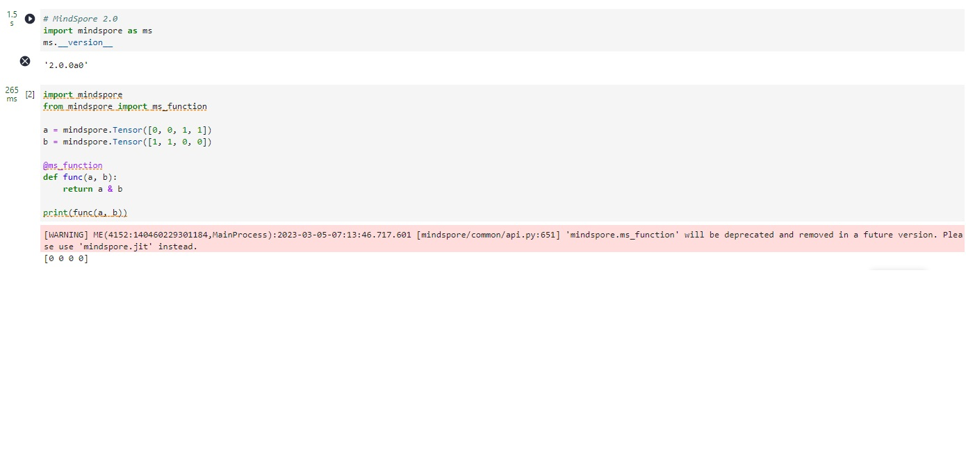首先是升级MindSpore到最新版本，在2.0.0alpha版本中，上面的代码可以正常运行

MindSpore的Cell.insert_child_to_cell 添加层会出现参数名重复
1. 系统环境
硬件环境(Ascend/GPU/CPU): Ascend/GPU/CPU
软件环境: MindSpore 版本: 2.0.0
执行模式（静态图/动态图）： 不限
Python 版本: 3.7.6
操作系统平台: linux
2. 报错信息
2.1 问题描述
运行示例代码出现报错。
2.2 报错信息
raise ValueError("The value {} , its name '{}' already exists. " ValueError: The value Parameter (name=0.conv1.weight, shape=(128, 64, 3, 3), dtype=Float32, requires_grad=True) , its name '0.conv1.weight' already exists. Please set a unique name for the parameter.
2.3 脚本信息
import mindspore
from mindspore import nn
import mindspore.ops as ops
class Residual(nn.Cell):
"""The Residual block of ResNet."""
def __init__(self, input_channels, num_channels,
use_1x1conv=False, strides=1):
super().__init__()
self.conv1 = nn.Conv2d(input_channels, num_channels,
kernel_size=3, padding=1, stride=strides, pad_mode='pad')
self.conv2 = nn.Conv2d(num_channels, num_channels,
kernel_size=3, padding=1, pad_mode='pad')
if use_1x1conv:
self.conv3 = nn.Conv2d(input_channels, num_channels,
kernel_size=1, stride=strides)
else:
self.conv3 = None
self.bn1 = nn.BatchNorm2d(num_channels)
self.bn2 = nn.BatchNorm2d(num_channels)
def forward(self, X):
Y = ops.relu(self.bn1(self.conv1(X)))
Y = self.bn2(self.conv2(Y))
if self.conv3:
X = self.conv3(X)
Y += X
return ops.relu(Y)
def resnet_block(in_channels, out_channels, num_residuals,
first_block=False):
blk = []
for i in range(num_residuals):
if i == 0 and not first_block:
blk.append(Residual(in_channels, out_channels,
use_1x1conv=True, strides=2))
nn.Conv2d(in_channels, out_channels,
kernel_size=3, padding=1, stride=2, pad_mode='pad')
else:
blk.append(Residual(out_channels, out_channels))
return nn.SequentialCell(*blk)
# net = resnet_block(10,3, 3)
net = nn.SequentialCell(
nn.Conv2d(3, 64, kernel_size=3, stride=1, padding=1, pad_mode='pad'),
nn.BatchNorm2d(64),
nn.ReLU())
net.insert_child_to_cell("resnet_block1", resnet_block(64, 64, 2, first_block=True))
net.insert_child_to_cell("resnet_block2", resnet_block(64, 128, 2))
trainer = nn.Adam(net.trainable_params(), learning_rate=0.001)
3. 根因分析
当前框架容器类命名机制某些场景会失效,导致cell里Parameter重复，导致训练时报错。
理论上框架应该能避免这种情况，但是这种场景比较特殊。两次调用了insert_child_to_cell，且两次都插入了相同的网络Residual （resnet_block里面两次都最终插入了Residual 网络）
所以在第一次插入的时候自动生成了前缀，0.conv1.weight
然后第二次插入的时候仍然自动生成前缀依然是0.conv1.weight，这种情况下就参数名重复了。
如下是仅仅执行一次insert_child_to_cell的情况下打印参数列表。插入一次的情况下是不会报错的。再次insert_child_to_cell后就会报错了。
net.insert_child_to_cell("resnet_block1", resnet_block(64, 64, 2, first_block=True))
print(net.trainable_params())
[Parameter (name=0.weight, shape=(64, 3, 3, 3), dtype=Float32, requires_grad=True),
Parameter (name=1.gamma, shape=(64,), dtype=Float32, requires_grad=True),
Parameter (name=1.beta, shape=(64,), dtype=Float32, requires_grad=True),
Parameter (name=0.conv1.weight, shape=(64, 64, 3, 3), dtype=Float32, requires_grad=True),
Parameter (name=0.conv2.weight, shape=(64, 64, 3, 3), dtype=Float32, requires_grad=True),
Parameter (name=0.bn1.gamma, shape=(64,), dtype=Float32, requires_grad=True),
Parameter (name=0.bn1.beta, shape=(64,), dtype=Float32, requires_grad=True),
Parameter (name=0.bn2.gamma, shape=(64,), dtype=Float32, requires_grad=True),
Parameter (name=0.bn2.beta, shape=(64,), dtype=Float32, requires_grad=True),
Parameter (name=1.conv1.weight, shape=(64, 64, 3, 3), dtype=Float32, requires_grad=True),
Parameter (name=1.conv2.weight, shape=(64, 64, 3, 3), dtype=Float32, requires_grad=True),
Parameter (name=1.bn1.gamma, shape=(64,), dtype=Float32, requires_grad=True),
Parameter (name=1.bn1.beta, shape=(64,), dtype=Float32, requires_grad=True),
Parameter (name=1.bn2.gamma, shape=(64,), dtype=Float32, requires_grad=True),
Parameter (name=1.bn2.beta, shape=(64,), dtype=Float32, requires_grad=True)]
4. 解决方案
通过CellList来管理，从而规避多个 Cell 间的同名 Paramete
把两次insert_child_to_cell合并成一次，插入一个CellList。
cell_list = nn.CellList()
cell_list.append(resnet_block(64, 64, 2, first_block=True))
cell_list.append(resnet_block(64, 128, 2))
net.insert_child_to_cell("resnet_blocks", cell_list)
最终打印的网络参数如下，可以看到CellList里面的参数是0.0 0.1.0的前缀
[Parameter (name=0.weight, shape=(64, 3, 3, 3), dtype=Float32, requires_grad=True),
Parameter (name=1.gamma, shape=(64,), dtype=Float32, requires_grad=True),
Parameter (name=1.beta, shape=(64,), dtype=Float32, requires_grad=True),
Parameter (name=0.0.conv1.weight, shape=(64, 64, 3, 3), dtype=Float32, requires_grad=True),
Parameter (name=0.0.conv2.weight, shape=(64, 64, 3, 3), dtype=Float32, requires_grad=True),
Parameter (name=0.0.bn1.gamma, shape=(64,), dtype=Float32, requires_grad=True),
Parameter (name=0.0.bn1.beta, shape=(64,), dtype=Float32, requires_grad=True),
Parameter (name=0.0.bn2.gamma, shape=(64,), dtype=Float32, requires_grad=True),
Parameter (name=0.0.bn2.beta, shape=(64,), dtype=Float32, requires_grad=True),
Parameter (name=0.1.conv1.weight, shape=(64, 64, 3, 3), dtype=Float32, requires_grad=True),
Parameter (name=0.1.conv2.weight, shape=(64, 64, 3, 3), dtype=Float32, requires_grad=True),
Parameter (name=0.1.bn1.gamma, shape=(64,), dtype=Float32, requires_grad=True),
Parameter (name=0.1.bn1.beta, shape=(64,), dtype=Float32, requires_grad=True),
Parameter (name=0.1.bn2.gamma, shape=(64,), dtype=Float32, requires_grad=True),
Parameter (name=0.1.bn2.beta, shape=(64,), dtype=Float32, requires_grad=True),
Parameter (name=0.1.0.conv1.weight, shape=(128, 64, 3, 3), dtype=Float32, requires_grad=True),
Parameter (name=0.1.0.conv2.weight, shape=(128, 128, 3, 3), dtype=Float32, requires_grad=True),
Parameter (name=0.1.0.conv3.weight, shape=(128, 64, 1, 1), dtype=Float32, requires_grad=True),
Parameter (name=0.1.0.bn1.gamma, shape=(128,), dtype=Float32, requires_grad=True),
Parameter (name=0.1.0.bn1.beta, shape=(128,), dtype=Float32, requires_grad=True),
Parameter (name=0.1.0.bn2.gamma, shape=(128,), dtype=Float32, requires_grad=True),
Parameter (name=0.1.0.bn2.beta, shape=(128,), dtype=Float32, requires_grad=True),
Parameter (name=0.1.1.conv1.weight, shape=(128, 128, 3, 3), dtype=Float32, requires_grad=True),
Parameter (name=0.1.1.conv2.weight, shape=(128, 128, 3, 3), dtype=Float32, requires_grad=True),
Parameter (name=0.1.1.bn1.gamma, shape=(128,), dtype=Float32, requires_grad=True),
Parameter (name=0.1.1.bn1.beta, shape=(128,), dtype=Float32, requires_grad=True),
Parameter (name=0.1.1.bn2.gamma, shape=(128,), dtype=Float32, requires_grad=True),
Parameter (name=0.1.1.bn2.beta, shape=(128,), dtype=Float32, requires_grad=True)]

mindspore.numpy.unique() 不支持 0 shape tensor
1. 系统环境
硬件环境(Ascend/GPU/CPU): Ascend/GPU/CPU
软件环境: MindSpore 版本: 2.0.0
执行模式（静态图/动态图）： 不限
Python 版本: 3.9.15
操作系统平台: linux
2. 报错信息
2.1 问题描述
mindspore.numpy.unique() 不支持 0 shape tensor。
2.2 报错信息
RuntimeError: Malloc for kernel output failed, Memory isn't enough, node:Default/Unique-op0
----------------------------------------------------
- C++ Call Stack: (For framework developers)
----------------------------------------------------
mindspore/ccsrc/runtime/pynative/run_op_helper.cc:473 LaunchKernels
2.3 脚本信息
a = ms.Tensor([])
ms.numpy.unique(a)
3. 根因分析
应该是环境配置或参数配置（比如batch size等）等问题引发的，需要排查一下。
4. 解决方案
linux环境中（Python3.9，mindpsore2.0.0）代码内容：
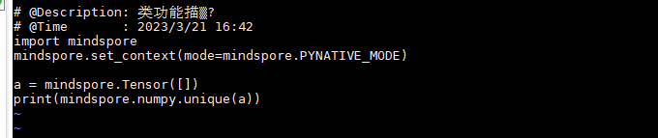执行结果：
window（Python3.9，mindpsore1.7.0）也可以正常执行。

MindSpore直接将Tensor从布尔值转换为浮点数导致错误Error: IndexError: index 1 is out of bounds for dimension with size 1
1. 系统环境
硬件环境(Ascend/GPU/CPU): GPU
软件环境: MindSpore 版本: 1.9.0
执行模式（静态图/动态图）： 静态图
Python 版本: 3.7.6
操作系统平台: linux
2. 报错信息
2.1 问题描述
直接将Tensor从布尔值转换为浮点数，导致错误的结果。在类型转换前更改为numpy后，结果正确。
2.2 报错信息
Error: IndexError: index 1 is out of bounds for dimension with size 1
2.3 脚本信息
import mindspore as ms
import mindspore.nn as nn
import mindspore.ops as ops
from mindspore import Tensor
class ConditionalNet(nn.Cell):
def __init__(self):
super().__init__()
self.bool_list = Tensor([True, False]) # works ok if self.bool_list = [True, False]
self.y = Tensor([1])
self.z = Tensor([3, 4])
def construct(self):
output = []
for i in range(len(self.bool_list)):
if self.bool_list[i]:
output.append(self.y[i])
else:
output.append(self.z[i])
return ops.stack(output)
if __name__ == '__main__':
ms.set_context(mode=ms.GRAPH_MODE)
net = ConditionalNet()
print(net()) # expected: 1, 4
3. 根因分析
这个问题如果把模式修改成pynative模式的话，就能正常运行不报错。
所以问题就出在GRAPH模式上，图模式是需要先编译成图再运行的。
4. 解决方案
self.bool_list = Tensor([True, False]) 修改成self.bool_list = [True, False]。

MindSpore中的mindspore.numpy.bincount 大数值情况下报ValueError定位与解决
1. 系统环境
硬件环境(Ascend/GPU/CPU): GPU
软件环境: MindSpore 版本: 1.9.0
执行模式（静态图/动态图）： 动态图
Python 版本: 3.7.6
操作系统平台: linux
2. 报错信息
2.1 问题描述
mindspore.numpy.bincount GPU环境中在大数值情况下报错。
2.2 报错信息
ValueError: The total size of the tensor exceeds the max_limit of 2 Giga-elements, which is 2500000000 elements ([const vector][50000, 50000]).
----------------------------------------------------
- C++ Call Stack: (For framework developers)
----------------------------------------------------
mindspore/ccsrc/plugin/device/gpu/kernel/gpu_kernel.h:402 CheckTensorSize
2.3 脚本信息
from mindspore import context
import mindspore as ms
import mindspore.numpy as np
b = np.bincount(np.arange(50000))
print(b)
3. 根因分析
在ModelArts的环境中安装好MindSpore1.9.0，并指定GPU运行这段代码：
%%time
ms.set_context(device_target=GPU)
from mindspore import context
import mindspore as ms
import mindspore.numpy as np
b = np.bincount(np.arange(50000))
print(b)
运行环境是八核的E5 2690V4，64GB内存，16GB的Tesla P100显卡
得到的结果是：
在卡住了3.4分钟后，报错
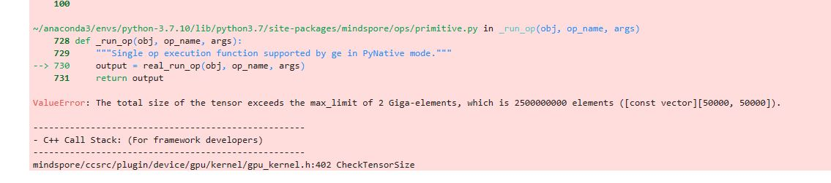最后的报错内容是：
报错内容是Tensor的长度超出了限制。
然后我们再运行一遍相同代码，很快啊，就得到了新的报错。
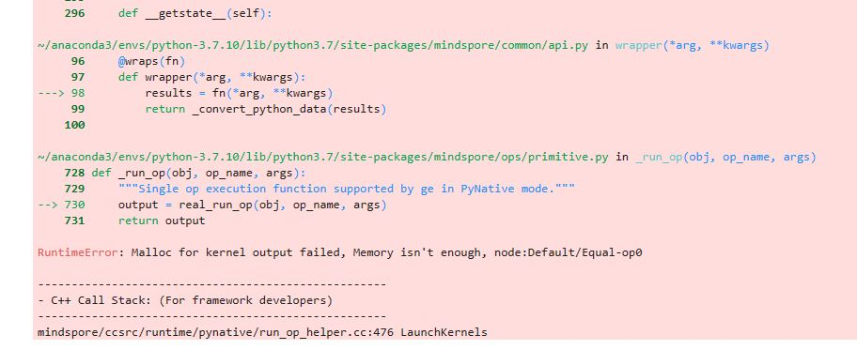这次直接告诉我们，显存不够了。
鉴于Notebook的配置中内存是显存的4倍，我们直接切换CPU运行程序
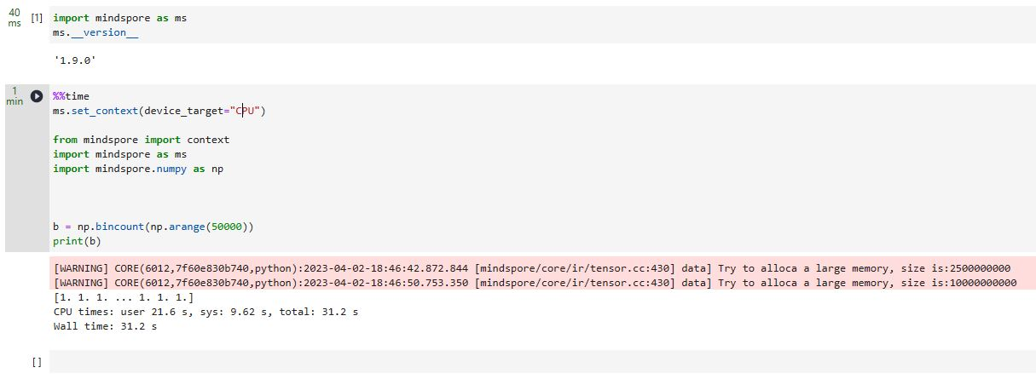经过了30秒后，得到了正确的运行结果。因此可以得出结论，显存不够导致了上述代码的报错。
4. 解决方案
升级MindSpore版本
根据前面的分析，首先考虑MindSpore升级。
我们升级到2.0.0版本，发现相同代码仍会报错
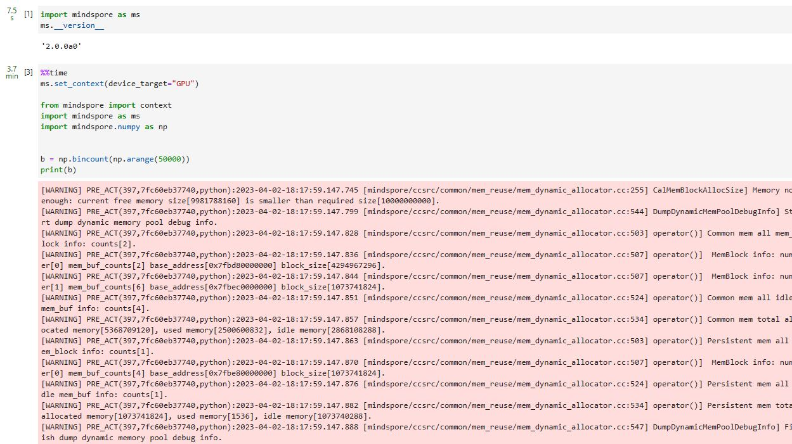因此，无法通过简单的升级版本解决问题。
4.2指定到使用CPU。
无论是1.9.0版本还是2.0.0a版本，都可以指定CPU完成计算
经过多次实验比较，在1.9版本中，运行需要的时间平均是30s
而在2.0.0alpha版本中，运行所需要的时间大约是20s
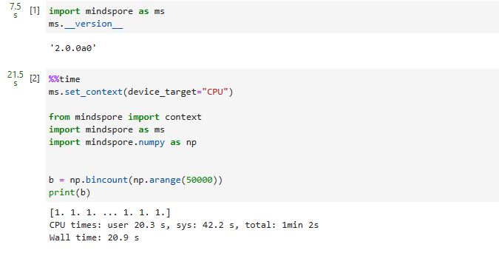可以发现，升级版本带来了效率的提升。
4.3直接使用Numpy，这里有惊喜
鉴于Numpy只会用CPU进行计算，所以将代码改成使用numpy计算
%%time
from mindspore import context
import mindspore as ms
import numpy as np
b = np.bincount(np.arange(50000))
print(b)
然后会惊奇的发现，运行时间大大减少
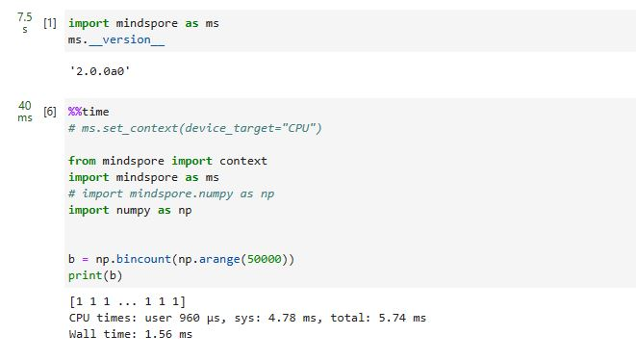为了减少误差，进行了多次实验对比，
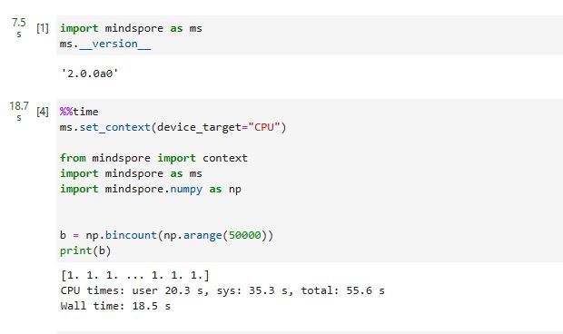最终取三次实验的平均数，发现Numpy和mindspore.numpy在这个函数的效率上相差上千倍。
综合而言，使用numpy计算完成，再转换Tensor等后续操作是这个报错的最优解。

使用mindspore.numpy.broadcast_to 算子报错及解决
1. 系统环境
硬件环境(Ascend/GPU/CPU): Ascend/GPU/CPU
软件环境: MindSpore 版本: 2.0.0
执行模式（静态图/动态图）： 不限
Python 版本: 3.7.6
操作系统平台: linux
2. 报错信息
2.1 问题描述
官方demo 能跑通
import mindspore.numpy as np
x = np.array([1, 2, 3])
output = np.broadcast_to(x, (3, 3))
print(output)
shape改成（3，4）后报错。
import mindspore.numpy as np
x = np.array([1, 2, 3])
output = np.broadcast_to(x, (3, 4))
print(output)
2.2 报错信息
>>> ms.numpy.broadcast_to(A,(3,4))
Traceback (most recent call last):
File "<stdin>", line 1, in <module>
File "/home/ma-user/miniconda3/envs/py38ms1.9/lib/python3.8/site-packages/mindspore/numpy/array_ops.py", line 1290, in broadcast_to
return _raise_value_error('cannot broadcast with ', shape)
File "/home/ma-user/miniconda3/envs/py38ms1.9/lib/python3.8/site-packages/mindspore/ops/primitive.py", line 716, in __call__
return fn(*args)
File "/home/ma-user/miniconda3/envs/py38ms1.9/lib/python3.8/site-packages/mindspore/numpy/utils_const.py", line 227, in _raise_value_error
raise ValueError(info + f"{param}")
ValueError: cannot broadcast with (3, 4)
2.3 脚本信息
import mindspore.numpy as np
x = np.array([1, 2, 3])
output = np.broadcast_to(x, (3, 4))
print(output)
3. 根因分析
用户代码执行报错的具体原因如下：
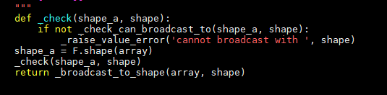
代码的报错根因分析是_check_can_broadcast_to函数报错，接下来看下_check_can_broadcast_to具体实现
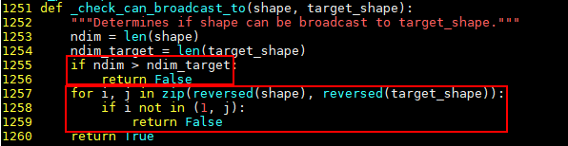
针对用户使用的样例，我们的实际调用就是_check_can_broadcast_to((3,), (3,4)))，
首先分析if 分支代码块，我们的用户是满足要求的
其实我们再看for代码块，reversed是反转的作用，zip是压缩的作用。
最后我们的i 是3，j=4.代码的1258行是判定i 是否等于1或者等于j,显然3即不等于4也不等于1.代码就会返回False。
4. 解决方案
针对_check_can_broadcast_to（）代码的分析，我们可以的了解到输入np.array的shape（3，），所以我们目标shape(N,3），N可以是任意维度任意数值。
import mindspore.numpy as np
>>> output = np.broadcast_to(x, (4,3 ))
>>> print(output)
[[1 2 3]
[1 2 3]
[1 2 3]
[1 2 3]]
>>> output = np.broadcast_to(x, (4,2,3))
>>> print(output)
[[[1 2 3]
[1 2 3]]
[[1 2 3]
[1 2 3]]
[[1 2 3]
[1 2 3]]
[[1 2 3]
[1 2 3]]]

使用MindSpore中的SoftMax()算子计算单一数据出错Run op inputs type is invalid!
1. 系统环境
硬件环境(Ascend/GPU/CPU): CPU
软件环境: MindSpore 版本: 1.9.0
执行模式（静态图/动态图）： 动态图
Python 版本: 3.7.6
操作系统平台: linux
2. 报错信息
2.1 问题描述
针对shape为（1，）的输入，SoftMax的输出结果应该为1，但是MindSpore直接抛出异常。
2.2 报错信息
Run op inputs type is invalid!
2.3 脚本信息
import mindspore as ms
print(ms.ops.Softmax(-1)(ms.Tensor(np.ones(1)), ms.float32))
3. 根因分析
1.Softmax类报错
在1.9.0的环境下运行Softmax代码
首先明确出问题的API：ms.ops.Softmax，与这个类紧密相关的是ms.ops.softmax函数（大小写区别）
在1.9.0版本的API文档中，可以看出，ms.ops.Softmax函数输入量应该是Tensor和指定的轴：
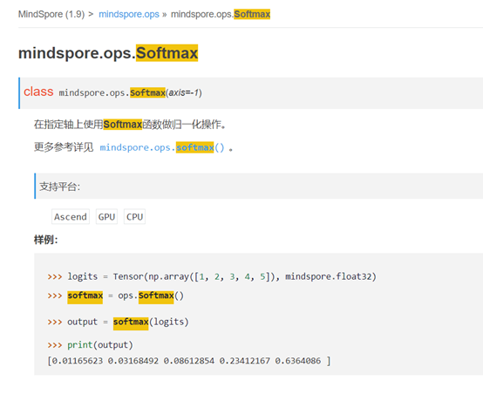
而在报错的代码中：
print(ms.ops.Softmax(-1)(ms.Tensor(np.ones(1)), ms.float32))
我们可以看到输入的量有三个：轴-1，Tensor和dtype数据类型
因此，这与API文档相背离，所以报错。
2.使用softmax函数
Softmax类来源于softmax函数，使用softmax函数是否可以避免报错？
观察softmax的API文档，发现不支持指定数据类型，因此替换了也会报错。
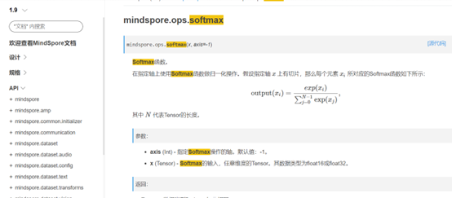
3.更高版本的MindSpore会有解决办法吗
对于python类Softmax，从1.9.0到2.0.0alpha到2.0.0rc1，都是只有axis一个输入量，因此不能输入dtype这个参数。
而对于函数softmax，1.9.0和2.0.0alpha中，都不能输入dtype。
但是在2.0.0rc1最新版本中，增加了dtype这个输入项。
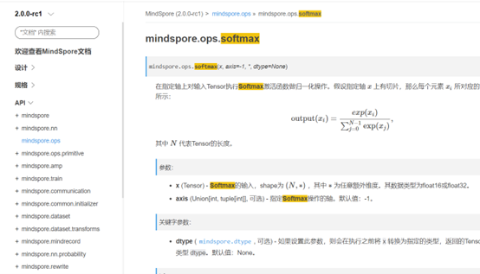
4. 解决方案
根据根因分析：ms.ops.Softmax的输入量出现了问题，因此有以下解决方法：
1.输入量改为指定了浮点精度的MindSpore的Tensor
x = ms.Tensor(np.ones(1), ms.float32) print(ms.ops.Softmax(-1)(x))
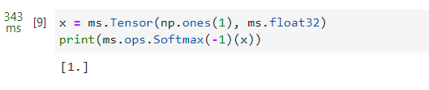
2.用softmax而非Softmax实现相同效果：输入量需要先指定浮点精度
x = ms.Tensor(np.ones(1), ms.float32) print(ms.ops.softmax(x))
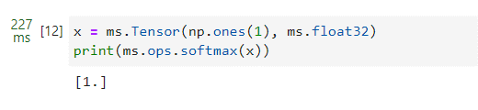
3.升级MindSpore版本，并改用2.0.0rc1中的softmax函数，这时函数支持在softmax中指定dtype
x = ms.Tensor(np.ones(1)) print(ms.ops.softmax(x,dtype=ms.float32))
这时候，就可以不在Tensor中指定数据类型/精度，而是在softmax函数中指定dtype。
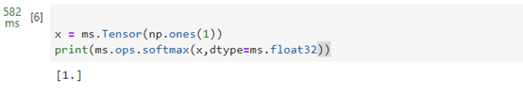
4.鉴于2.0.0rc1中已经给softmax函数指定了dtype的能力，那么可能在未来，Softmax类也可以直接支持dtype的输入，也就意味着上述报错的代码不会报错了。

CSRTensor 矩阵乘法计算出错RuntimeError:CUDA Error: cudaMemcpy failed.|Error Number: 700 an illegal memory access was encountered
1. 系统环境
硬件环境(Ascend/GPU/CPU): GPU
软件环境: MindSpore 版本: 2.0.0
执行模式（静态图/动态图）： 动态图
Python 版本: 3.7.6
操作系统平台: linux
2. 报错信息
2.1 问题描述
问题描述 CSRTensor 矩阵乘法在GPU下计算报错。
2.2 报错信息
RuntimeError:CUDA Error: cudaMemcpy failed. | Error Number: 700 an illegal memory access was encountered
2.3 脚本信息
import mindspore as ms
a = ms.numpy.ones((7600, 7600), ms.float32).to_csr()
b = ms.numpy.ones((7600, 7600), ms.float32).to_csr()
a.mm(b)
3. 根因分析
3.1根据报错信息，可以确定该问题GPU算子执行时，出现显存访问越界，问题缩小到如下：
void SparseMatrixSparseMatMulGpuKernelMod::Compute(cusparseHandle_t handle, cusparseMatDescr_t desc, csrgemm2Info_t info, const int m, const int n, const int k, float *A_val, const int *const A_colind, const int *const A_rowptr, const int A_nnz, float *B_val, const int *const B_colind, const int *const B_rowptr, const int B_nnz, float **C_val, int **const C_colind, int **const C_rowptr, int *const C_nnz) { float alpha = 1.0; size_t buffer_size; cusparseScsrgemm2_bufferSizeExt(handle, m, n, k, &alpha, desc, A_nnz, A_rowptr, A_colind, desc, B_nnz, B_rowptr, B_colind, NULL, desc, B_nnz, B_rowptr, B_colind, info, &buffer_size); void *buffer = NULL; buffer = allocator.AllocTensorMem(buffer_size); cusparseXcsrgemm2Nnz(handle, m, n, k, desc, A_nnz, A_rowptr, A_colind, desc, B_nnz, B_rowptr, B_colind, desc, B_nnz, B_rowptr, B_colind, desc, *C_rowptr, C_nnz, info, buffer); cusparseScsrgemm2(handle, m, n, k, &alpha, desc, A_nnz, A_val, A_rowptr, A_colind, desc, B_nnz, B_val, B_rowptr, B_colind, NULL, desc, B_nnz, B_val, B_rowptr, B_colind, desc, *C_val, *C_rowptr, *C_colind, info, buffer); allocator.FreeTensorMem(buffer); }
3.2 修改算子输入Tensor维度，可以看到当维度较小时结果正常，使用高维度报错，怀疑显存分配问题导致，结合代码怀疑和*C_val, *C_rowptr, *C_colind相关
3.3 分析代码，当前算子维度推导逻辑中，支持最大值为100000，在修改MAX_LENGTH = 7600 * 7600后用例可以正常执行
namespace mindspore { namespace ops { namespace { const int MAX_LENGTH = 100000; ... abstract::TupleShapePtr SparseMatrixSparseMatMulInferShape(const PrimitivePtr &primitive, const std::vector<AbstractBasePtr> &input_args) { ... ShapeVector col_shape = {abstract::Shape::kShapeDimAny}; ShapeVector values_shape = {abstract::Shape::kShapeDimAny}; ShapeVector infer_shape_max = {MAX_LENGTH}; y_col_shape = std::make_shared<abstract::Shape>(col_shape, infer_shape_max); y_values_shape = std::make_shared<abstract::Shape>(values_shape, infer_shape_max); ...
综上：SparseMatrixSparseMatMul算子在维度推导时设置了最大支持的维度，算子实际输入的维度超过了支持的范围，并没有做合适的保护，导致内存访问越界。
4. 解决方案
4.1 修改算子推导代码，使用环境变量控制SparseMatrixSparseMatMul支持维度
diff --git a/mindspore/core/ops/sparse_matrix_sparse_mat_mul.cc b/mindspore/core/ops/sparse_matrix_sparse_mat_mul.cc index 5cd42fb3be9..2ca80a7643f 100644--- a/mindspore/core/ops/sparse_matrix_sparse_mat_mul.cc +++ b/mindspore/core/ops/sparse_matrix_sparse_mat_mul.cc @@ -122,7 +122,12 @@ abstract::TupleShapePtr SparseMatrixSparseMatMulInferShape(const PrimitivePtr &p ShapeVector col_shape = {abstract::Shape::kShapeDimAny}; ShapeVector values_shape = {abstract::Shape::kShapeDimAny}; ShapeVector infer_shape_min = {1}; - ShapeVector infer_shape_max = {MAX_LENGTH}; + int64_t max_length = MAX_LENGTH; + const char *max_length_char = std::getenv("MAX_SPARSE_MM_LENGTH"); + if (max_length_char != nullptr) { + max_length = atol(max_length_char); + } + ShapeVector infer_shape_max = {max_length}; y_col_shape = std::make_shared<abstract::Shape>(col_shape, infer_shape_min, infer_shape_max); y_values_shape = std::make_shared<abstract::Shape>(values_shape, infer_shape_min, infer_shape_max);
4.2 导出环境变量，后再次执行用例，结果正常
(py37) ➜ temp export MAX_SPARSE_MM_LENGTH=231040000(py37) ➜ temp cat sparse_matmul.py import mindspore as ms a = ms.numpy.ones((7600, 7600), ms.float32).to_csr() b = ms.numpy.ones((7600, 7600), ms.float32).to_csr() a.mm(b) (py37) ➜ temp python sparse_matmul.py [WARNING] ME(89158:139873739707328,MainProcess):2023-04-23-12:05:46.164.508 [mindspore/run_check/_check_version.py:102] MindSpore version 2.0.0a0 and cuda version 11.7.60 does not match, CUDA version [['10.1', '11.1', '11.6']] are supported by MindSpore officially. Please refer to the installation guide for version matching information: https://www.mindspore.cn/install. (py37) ➜ temp

Cell对象序列化失败-使用pickle.dumps保存到本地后重新加载失败
1. 系统环境
硬件环境(Ascend/GPU/CPU): CPU
软件环境: MindSpore 版本: 2.0.0
执行模式（静态图/动态图）： 不限
Python 版本: 3.7.6
操作系统平台: linux
2. 报错信息
2.1 问题描述
使用第三方工具包pickle保存mindspore框架搭建的vgg16模型及pytorch框架的搭建的vgg16模型。pytorch框架搭建的vgg16模型可以正常保存并重新读取加载，但mindspore框架搭建的模型则读取失败。
2.2 报错信息
File "D:\Anaconda3\lib\site-packages\mindspore\common\parameter.py", line 210, in __new__
init_data_flag = bool(isinstance(default_input, Tensor) and default_input.has_init)
File "D:\Anaconda3\lib\site-packages\mindspore\common\tensor.py", line 503, in has_init
return self.init is not None
AttributeError: 'Tensor' object has no attribute 'init'
3. 根因分析
pickle在反序列化的时候会创建对应的对象.
最终报错是parameter的创建失败,所以问题等价于含有parameter的模型反序列化失败, 首先简化下出错的代码。
import mindspore as ms
import numpy as np
from mindspore import nn, ops, Tensor, Parameter
import pickle
class Network(nn.Cell):
def __init__(self):
super().__init__()
self.w = Parameter(Tensor(np.random.randn(5, 3), ms.float32), name='weight')
self.b = Parameter(Tensor(np.random.randn(3,), ms.float32), name='bias')
#self.w = Tensor(np.random.randn(5, 3), ms.float32)
#self.b = Tensor(np.random.randn(3,), ms.float32)
def construct(self, x):
out = ops.matmul(x, self.w)
out = out + self.b
return out
x = ops.ones(5, ms.float32)
model = Network()
with open("d:\\pic2.txt",'wb') as f:
pickle.dump(model,f)
with open("d:\\pic2.txt",'rb') as f:
b = pickle.load(f)
print('out: ', b(x))
4. 解决方案
修改mindspore\common\tensor.py line 503
@property
def has_init(self):
"""Whether tensor is initialized."""
if hasattr(self, 'init'):
return self.init is not None
return None

TopK算子返回的全零的Tensor的解决
1. 系统环境
硬件环境(Ascend/GPU/CPU): GPU
软件环境: MindSpore 版本: 1.10.1
执行模式（静态图/动态图）： 动态图
Python 版本: 3.7.6
操作系统平台: linux
2. 报错信息
2.1 问题描述
在使用ops.top_k算子进行计算时（详见下方用例），会出现计算结果错误。
预期结果
如果正确执行，输出应该类似于如下结果：
$ python3 run_topk.py 26756342
实际执行结果如下，返回的是一个全零的Tensor：
$ python3 run_topk.py 0
备注：经过一定数值范围的测试，发现在K值选取1~128范围之间的返回结果有可能是正确的，或者两个打印模块同时打印输出结果也是正确的，唯独单次打印K值大于128的情况，返回结果异常。
2.2 脚本信息
# run_topk.py
import os
os.environ['GLOG_v']='4'
import numpy as np
import mindspore as ms
from mindspore import Tensor, ops, nn
class TopKNet(nn.Cell):
def __init__(self):
super().__init__()
self.top_k = ops.top_k
def construct(self, x, num):
x, ids = self.top_k(x, num)
return ids
np.random.seed(1)
input_x = Tensor(np.random.random((1, 648, 648)), ms.float16)
print (TopKNet()(input_x, 128).sum())
# print (TopKNet()(input_x, 129).sum())
直接运行上述用例，得到一个大的整数结果，这是正确场景；
注释第一个打印输出，取消第二个打印输出的注释，也就是选取前129个最大的值；
再次执行案例，得到的结果是0，或者是一个异常值。
3. 根因分析
这是因为在mindspore关于topk的cuda代码中，一个核函数在做数据交换的时候，发生了数据类型强转(float和int)。导致当index的数值较大时(7 * 2388 * 2388+289)，会出现精度损失。
4. 解决方案
第一个办法，可以将mindspore/ccsrc/plugin/device/gpu/kernel/cuda_impl/topk_lib.cuh这个位置下的58行进行修改
修改前
T b_tmp = b[i_1];
修改后
S b_tmp = b[i_1];
第二个办法是使用2.0版本的，这个更方便可靠。

在NPU上的切片操作x=x[:,::-1,:,:]不生效的分析解决
1. 系统环境
硬件环境(Ascend/GPU/CPU): Ascend/GPU
软件环境: MindSpore 版本: 1.9.0
执行模式（静态图/动态图）： 不限
Python 版本: 3.7.6
操作系统平台: linux
2. 报错信息
2.1 问题描述
NPU上的切片操作x=x[:,::-1,:,:]不生效，在GPU上生效。
2.2 脚本信息
import os
import cv2
import sys
import numpy as np
import mindspore
from mindspore import context
from mindspore import nn
if __name__ == '__main__':
device_id = int(os.getenv('DEVICE_ID'), 0)
context.set_context(mode=context.PYNATIVE_MODE, device_target="Ascend",
device_id=device_id, save_graphs=False)
# context.set_context(mode=context.GRAPH_MODE, device_target="GPU", save_graphs=False)
#create backbone
x=cv2.imread('0100000000.jpg').transpose(2,0,1).astype(np.float32)
x=mindspore.Tensor(x)[None,:,:,:]
x=x[:,::-1,:,:]
print(x)
Tensor(shape=[1，3,1080，1920]，dtype=Float32, value=
[[[[ 9.100000000+01, 9.100000000+81, 9.180000000+01...7.000080880+88, 7.080808880+80, 7.000000000+00],
[ 9.100000000+01, 9.100000000+01, 9.100000000+01...7.000000000+80, 7.000008000+00, 7.000000000+00]，
[ 8.900000000+01, 8.980000000+01, 8.900000000+01...7.000000000+00, 7.000008080+00, 7.000000000+00],
...
[ 5.500000000+01, 5.400000080+01, 5.480808080+01...1.000000000+01, 1.000000080+01, 1.000000000+01]，
[ 5.000000000+01, 5.000000000+01, 5.000008000+01...9.000000000+00, 9.000800000+00, 9.000000000+00],
[ 5.000000000+01, 5.000000000+01, 4.900000000+01...8.000000000+00, 8.080808080+88, 8.000000000+00]],
[[ 4.400000000+01, 4.400000000+01, 4.400000000+01...1.000000000+01, 1.000008000+01, 1.000000ø00+01],
[ 4.400000000+01, 4.400000000+01, 4.400000000+01...1.000000000+01, 1.000000000+01, 1.000000000+01]，
[ 4.400000000+01, 4.400000000+01, 4.400000000+01...1.000000000+01, 1.000000080+01, 1.000000000+01],
...
[ 4.500000000+01, 4.400000000+01, 4.400000080+01...1.000000000+01, 1.000000000+01, 1.000800080+01],
[ 4.100000000+01, 4.100008000+01, 4.100008000+01...9.080080880+80, 9.080808080+88, 9.000000000+00],
[ 4.100000000+01, 4.100000000+01, 4.000000000+01...8.000000000+00, 8.000000000+00, 8.000000000+00]],
[[ 4.000000000+01, 4.000000000+01, 4.000000000+01...1.400000000+01, 1.400000000+01, 1.400008000+01]，
[ 4.000000000+01, 4.080000000+01, 4.000000000+01...1.400000000+01, 1.480000000+01, 1.400000000+01]，
[ 4.000000000+01, 4.000000000+01, 4.000000000+01...1.400000000+01, 1.400000000+01, 1.400000000+01]，
...
[ 3.500000000+01, 3.400000000+01, 3.480808080+01...1.088000000+01, 1.080808080+01, 1.000000080+01]，
[ 3.100000000+01, 3.100000000+01, 3.100000000+01...9.000000000+00, 9.000000000+00, 9.000000000+00],
[ 3.100000000+01, 3.100000000+01, 3.000008080+01...8.000000000+00, 8.000000000+00, 8.000000000+00]]]]）
3. 根因分析
在进行切片操时，是会转换成算子ScatterNdUpdate进行计算，这个算子在ascend 上没有所能支持的规格。
4. 解决方案
x=cv2.imread('0100000000.jpg').transpose(2,0,1).astype(np.float32)
可以将要切片的数据在这一步转换成fp16或者fp32的类型。

张量运算失败报错RuntimeError:Malloc for kernel output failed, Memory isn’t enough
1. 系统环境
硬件环境(Ascend/GPU/CPU): GPU
软件环境: MindSpore 版本: 1.10.1
执行模式（静态图/动态图）： 动态图
Python 版本: 3.7.6
操作系统平台: linux
2. 报错信息
2.1 问题描述
在python的交互界面下运行脚本，环境显存为24G，在执行print(ms.ops.add(a,b))语句前显存占用为0，在执行完毕print(ms.ops.add(a,b))语句后，抛出错误，显存占用为18647M，未得到释放。
2.2 报错信息
RuntimeError:Malloc for kernel output failed, Memory isn’t enough, node:Default/Add-op0
2.3 脚本信息
import mindspore as ms
import numpy as np
ms.set_context(device_target="GPU")
a=ms.Tensor(np.ones([999,999,999]))
b=ms.Tensor(np.ones([999,999,999]))
print(ms.ops.add(a,b))
3. 根因分析
应该是因为在python的交互界面进行执行失败后，对象a和b并没有释放，所以此时的a和b对应的显存也不会被释放。
4. 解决方案
可以先用nvidia-smi查看下GPU的进程，具体进程调用GPU的情况可以用这个命令查看: pmap -d PID，
最后删除掉进程 kill id。

MindSpore Dump功能使用经验
1. 系统环境
硬件环境(Ascend/GPU/CPU): Ascend/GPU/CPU
软件环境: MindSpore 版本: 1.7.0
执行模式（静态图/动态图）： 不限
Python 版本: 3.7.6
操作系统平台: linux
2. 报错信息
2.1 问题描述
使用MindSpore开发算法时，发现算法的执行结果和预期不一致，原始脚本逻辑如下：
init() # 初始化集合通信... prob = net1(...) # net1执行结果正常... score = net2(...) # net2结果和预期不一致
由于算法需要使用模型并行功能，不太适合使用PyNative方式定位这个问题。这种情况下，可以采用异步Dump，将net2的计算过程dump到文件中，用于进一步分析。 备注：MindSpore提供了Dump功能，用来将模型训练中的图以及算子的输入输出数据保存到磁盘文件。
考虑到dump数据会降低执行速度，导致问题复现较慢；而且dump过多的数据，导致后期筛选困难。因此只想要dump net2的计算结果。按照官方文档，只需要导出环境变量MINDSPORE_DUMP_CONFIG，即可导出计算中间数据：
init() # 初始化集合通信... prob = net1(...) # net1执行结果正常... os.environ["MINDSPORE_DUMP_CONFIG"]="/path/dump.json"score = net2(...) # net2结果和预期不一致
重新执行完毕后，发现在指定目录下并未生成数据文件。
3. 根因分析
阅读MindSpore源码，发现框架只会在GeDeviceContext::InitGe()中读取MINDSPORE_DUMP_CONFIG环境变量的信息，而每个MindSpore进程只会执行一次GeDeviceContext初始化。
通过export GLOG_v=1打开info级别日志，发现MindSpore是在初始化集合通信时执行GeDeviceContext初始化。
[INFO] DISTRIBUTED(153924,ffff94c6da70,python3):2023-07-22-11:00:35.823.355 [mindspore/ccsrc/distributed/collective/collective_manager.cc:157] Initialize] Start initializing collective communication for backend: Ascend
...
[INFO] DEVICE(153924,ffff94c6da70,python3):2023-07-22-11:00:43.723.045 [mindspore/ccsrc/plugin/device/ascend/hal/hardware/ge_device_context.cc:124] InitGe] Init ge successful, ge reference = 1.
也就是说，在init()之后再导出MINDSPORE_DUMP_CONFIG并不会真正生效
4. 解决方案
基于当前MindSpore实现，并不能精确dump某个net的计算过程数据。最终还需要在执行脚本前，先export MINDSPORE_DUMP_CONFIG="/path/dump.json"来实现全量dump。

使用SymbolTree.get_network处理conv2d算子时报错NameError:name "Cell" is not defined
1. 系统环境
硬件环境(Ascend/GPU/CPU): CPU
软件环境: MindSpore 版本: 2.0.0
执行模式（静态图/动态图）： 不限
Python 版本: 3.9
操作系统平台: linux
2. 报错信息
2.1 问题描述
在执行stree.get_network()语句时报错，报错信息如下图所示：
2.2 报错信息
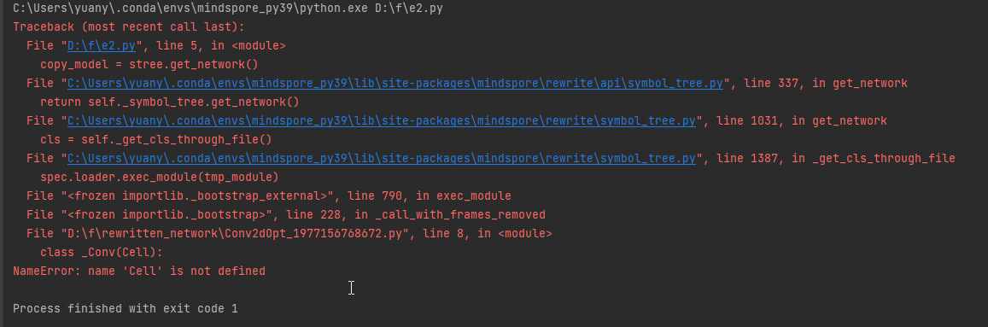2.3 脚本信息
import mindspore.nn as nn
from mindspore.rewrite import SymbolTree
old_model=nn.Conv2d(3,64,1,1)
stree = SymbolTree.create(old_model)
copy_model = stree.get_network()
3. 根因分析
涉及两个接口create 和 get_network
首先看Conv2d 继承了_Conv，_Conv又继承了Cell， 因此SymbolTree.create(old_model）old_model也是个Cell对象，因此不会报错。
class Conv2d(_Conv):
class _Conv(Cell):
报的错是get_network返回的。获取SymbolTree所对应的生成的网络对象。
def _get_cls_through_file(self):
"""
Load rewritten network class of current SymbolTree.
1. Get source code of current SymbolTree.
2. Saving source code to a tempfile.
3. Import rewritten network class using "__import__" function.
Returns:
A class handle.
"""
self._update_container()
file_path = os.getcwd()
file_path = os.path.join(file_path, "rewritten_network")
if not os.path.exists(file_path):
os.mkdir(file_path)
file_name = "{0}_{1}.py".format(self._opt_cls_name, id(self))
network_file = os.path.join(file_path, file_name)
with os.fdopen(os.open(network_file, os.O_WRONLY | os.O_CREAT, stat.S_IRWXU), 'wb') as f:
source = self.get_code()
f.write(source.encode('utf-8'))
f.flush()
os.fsync(f)
调用的是上面的函数，从当前网络中获取所对应的生成的网络对象的源码，然后再进行导入。
问题就出在这，自动生成的代码如下。
import sys
sys.path.append('C:\\Users\\yuany\\.conda\\envs\\mindspore_py39\\lib\\site-packages\\mindspore\\nn\\layer')
import mindspore
import numpy as np
from mindspore._extends import cell_attr_register
class _Conv(Cell):
'\n Applies a N-D convolution over an input signal composed of several input planes.\n '
def __init__(self, obj):
super(_Conv, self).__init__()
for (key, value) in obj.__dict__.items():
setattr(self, key, value)
def construct(self, *inputs):
'Must be overridden by all subclasses.'
raise NotImplementedError
def extend_repr(self):
s = 'input_channels={}, output_channels={}, kernel_size={}, stride={}, pad_mode={}, padding={}, dilation={}, group={}, has_bias={}, weight_init={}, bias_init={}, format={}'.format(self.in_channels, self.out_channels, self.kernel_size, self.stride, self.pad_mode, self.padding, self.dilation, self.group, self.has_bias, self.weight_init, self.bias_init, self.data_format)
return s
class Conv2dOpt(_Conv):
'\n Calculates the 2D convolution on the input tensor.\n The input is typically of shape :math:`(N, C_{in}, H_{in}, W_{in})`,\n where :math:`N` is batch size, :math:`C_{in}` is a number of channels,\n :math:`H_{in}, W_{in}` are the height and width of the feature layer respectively.\n For the tensor of each batch, its shape is :math:`(C_{in}, H_{in}, W_{in})`, the formula is defined as:\n\n .. math::\n\n \\text{out}(N_i, C_{\\text{out}_j}) = \\text{bias}(C_{\\text{out}_j}) +\n \\sum_{k = 0}^{C_{in} - 1} \\text{ccor}({\\text{weight}(C_{\\text{out}_j}, k), \\text{X}(N_i, k)})\n\n where :math:`ccor` is the `cross-correlation <https://en.wikipedia.org/wiki/Cross-correlation>`_,\n :math:`C_{in}` is the channel number of the input, :math:`out_{j}` corresponds to the :math:`j`-th channel of\n the output and :math:`j` is in the range of :math:`[0, C_{out}-1]`. :math:`\\text{weight}(C_{\\text{out}_j}, k)`\n is a convolution kernel slice with shape :math:`(\\text{kernel_size[0]}, \\text{kernel_size[1]})`,\n where :math:`\\text{kernel_size[0]}` and :math:`\\text{kernel_size[1]}` are the height and width of the convolution\n kernel respectively. :math:`\\text{bias}` is the bias parameter and :math:`\\text{X}` is the input tensor.\n In this case, `data_format` of the input tensor is \'NCHW\' and the shape of full convolution kernel is\n :math:`(C_{out}, C_{in} / \\text{group}, \\text{kernel_size[0]}, \\text{kernel_size[1]})`,\n where `group` is the number of groups to split the input `x` in the channel dimension. If `data_format` of the\n input tensor is \'NHWC\', the shape of full convolution kernel will be\n :math:`(C_{out}, \\text{kernel_size[0]}, \\text{kernel_size[1]}), C_{in} / \\text{group}`.\n\n For more details, please refers to the paper `Gradient Based Learning Applied to Document\n Recognition <http://vision.stanford.edu/cs598_spring07/papers/Lecun98.pdf>`_.\n\n Note:\n On Ascend platform, only group convolution in depthwise convolution scenarios is supported.\n That is, when `group>1`, condition `in\\_channels` = `out\\_channels` = `group` must be satisfied.\n\n Args:\n in_channels (int): The channel number of the input tensor of the Conv2d layer.\n out_channels (int): The channel number of the output tensor of the Conv2d layer.\n kernel_size (Union[int, tuple[int]]): Specifies the height and width of the 2D convolution kernel.\n The data type is an integer or a tuple of two integers. An integer represents the height\n and width of the convolution kernel. A tuple of two integers represents the height\n and width of the convolution kernel respectively.\n stride (Union[int, tuple[int]]): The movement stride of the 2D convolution kernel.\n The data type is an integer or a tuple of two integers. An integer represents the movement step size\n in both height and width directions. A tuple of two integers represents the movement step size in the height\n and width directions respectively. Default: 1.\n pad_mode (str): Specifies padding mode. The optional values are\n "same", "valid", "pad". Default: "same".\n\n - same: The width of the output is the same as the value of the input divided by `stride`.\n If this mode is set, the value of `padding` must be 0.\n\n - valid: Returns a valid calculated output without padding. Excess pixels that do not satisfy the\n calculation will be discarded. If this mode is set, the value of `padding` must be 0.\n\n - pad: Pads the input. Padding `padding` size of zero on both sides of the input.\n If this mode is set, the value of `padding` must be greater than or equal to 0.\n\n padding (Union[int, tuple[int]]): The number of padding on the height and width directions of the input.\n The data type is an integer or a tuple of four integers. If `padding` is an integer,\n then the top, bottom, left, and right padding are all equal to `padding`.\n If `padding` is a tuple of 4 integers, then the top, bottom, left, and right padding\n is equal to `padding[0]`, `padding[1]`, `padding[2]`, and `padding[3]` respectively.\n The value should be greater than or equal to 0. Default: 0.\n dilation (Union[int, tuple[int]]): Dilation size of 2D convolution kernel.\n The data type is an integer or a tuple of two integers. If :math:`k > 1`, the kernel is sampled\n every `k` elements. The value of `k` on the height and width directions is in range of [1, H]\n and [1, W] respectively. Default: 1.\n group (int): Splits filter into groups, `in_channels` and `out_channels` must be\n divisible by `group`. If the group is equal to `in_channels` and `out_channels`,\n this 2D convolution layer also can be called 2D depthwise convolution layer. Default: 1.\n has_bias (bool): Whether the Conv2d layer has a bias parameter. Default: False.\n weight_init (Union[Tensor, str, Initializer, numbers.Number]): Initialization method of weight parameter.\n It can be a Tensor, a string, an Initializer or a numbers.Number. When a string is specified,\n values from \'TruncatedNormal\', \'Normal\', \'Uniform\', \'HeUniform\' and \'XavierUniform\' distributions as well\n as constant \'One\' and \'Zero\' distributions are possible. Alias \'xavier_uniform\', \'he_uniform\', \'ones\'\n and \'zeros\' are acceptable. Uppercase and lowercase are both acceptable. Refer to the values of\n Initializer for more details. Default: \'normal\'.\n bias_init (Union[Tensor, str, Initializer, numbers.Number]): Initialization method of bias parameter.\n Available initialization methods are the same as \'weight_init\'. Refer to the values of\n Initializer for more details. Default: \'zeros\'.\n data_format (str): The optional value for data format, is \'NHWC\' or \'NCHW\'.\n Default: \'NCHW\'.\n\n Inputs:\n - **x** (Tensor) - Tensor of shape :math:`(N, C_{in}, H_{in}, W_{in})` \\\n or :math:`(N, H_{in}, W_{in}, C_{in})`.\n\n Outputs:\n Tensor of shape :math:`(N, C_{out}, H_{out}, W_{out})` or :math:`(N, H_{out}, W_{out}, C_{out})`.\n\n pad_mode is \'same\':\n\n .. math::\n \\begin{array}{ll} \\\\\n H_{out} = \\left \\lceil{\\frac{H_{in}}{\\text{stride[0]}}} \\right \\rceil \\\\\n W_{out} = \\left \\lceil{\\frac{W_{in}}{\\text{stride[1]}}} \\right \\rceil \\\\\n \\end{array}\n\n pad_mode is \'valid\':\n\n .. math::\n \\begin{array}{ll} \\\\\n H_{out} = \\left \\lceil{\\frac{H_{in} - \\text{dilation[0]} \\times (\\text{kernel_size[0]} - 1) }\n {\\text{stride[0]}}} \\right \\rceil \\\\\n W_{out} = \\left \\lceil{\\frac{W_{in} - \\text{dilation[1]} \\times (\\text{kernel_size[1]} - 1) }\n {\\text{stride[1]}}} \\right \\rceil \\\\\n \\end{array}\n\n pad_mode is \'pad\':\n\n .. math::\n \\begin{array}{ll} \\\\\n H_{out} = \\left \\lfloor{\\frac{H_{in} + padding[0] + padding[1] - (\\text{kernel_size[0]} - 1) \\times\n \\text{dilation[0]} - 1 }{\\text{stride[0]}} + 1} \\right \\rfloor \\\\\n W_{out} = \\left \\lfloor{\\frac{W_{in} + padding[2] + padding[3] - (\\text{kernel_size[1]} - 1) \\times\n \\text{dilation[1]} - 1 }{\\text{stride[1]}} + 1} \\right \\rfloor \\\\\n \\end{array}\n\n Raises:\n TypeError: If `in_channels`, `out_channels` or `group` is not an int.\n TypeError: If `kernel_size`, `stride`, `padding` or `dilation` is neither an int not a tuple.\n ValueError: If `in_channels`, `out_channels`, `kernel_size`, `stride` or `dilation` is less than 1.\n ValueError: If `padding` is less than 0.\n ValueError: If `pad_mode` is not one of \'same\', \'valid\', \'pad\'.\n ValueError: If `padding` is a tuple whose length is not equal to 4.\n ValueError: If `pad_mode` is not equal to \'pad\' and `padding` is not equal to (0, 0, 0, 0).\n ValueError: If `data_format` is neither \'NCHW\' not \'NHWC\'.\n\n Supported Platforms:\n ``Ascend`` ``GPU`` ``CPU``\n\n Examples:\n >>> net = nn.Conv2d(120, 240, 4, has_bias=False, weight_init=\'normal\')\n >>> x = Tensor(np.ones([1, 120, 1024, 640]), mindspore.float32)\n >>> output = net(x).shape\n >>> print(output)\n (1, 240, 1024, 640)\n '
@cell_attr_register
def __init__(self, obj):
super(Conv2dOpt, self).__init__(obj)
for (key, value) in obj.__dict__.items():
setattr(self, key, value)
def construct(self, x):
self_weight = self.weight
output = self.conv2d(x, self_weight)
# If node has been replaced by False branch.
return output
以上代码的路径是在当前代码的rewritten_network目录下。
从上面的代码可以看出，它把nn.Conv2d(3,64,1,1)作为网络，获取的是nn.Conv2d的定义。
而nn.Conv2d是系统定义的，所以导入肯定会出错。即使解决Cell的导入问题，最终代码也不能运行，因为会有循环导入的问题存在。
4. 解决方案
创建一个网络，然后再进行create操作。
import mindspore.nn as nn
from mindspore.rewrite import SymbolTree
class Net(nn.Cell):
def construct(self, x):
x = nn.Conv2d(3, 64, 1, 1)(x)
return x
old_model = Net()
stree = SymbolTree.create(old_model)
copy_model = stree.get_network()
rewritten_network下生成的代码如下：可以看出自动获取的网络对象的定义代码是正确的。
import sys
sys.path.append('D:\\f')
import mindspore
from mindspore import nn
import mindspore.nn as nn
import numpy as np
class NetOpt(nn.Cell):
def __init__(self, obj):
super().__init__()
for (key, value) in obj.__dict__.items():
setattr(self, key, value)
def construct(self, x):
x_1 = nn.Conv2d(3, 64, 1, 1)(x)
return x_1

使用mindspore中Conv2dTranspose的outputpadding时，设置has_bias=True时失效
1. 系统环境
硬件环境(Ascend/GPU/CPU): Ascend/GPU/CPU
软件环境: MindSpore 版本: 2.0.0
执行模式（静态图/动态图）： 不限
Python 版本: 3.7.6
操作系统平台: linux
2. 报错信息
2.1 问题描述
使用随机生成的tensor in_t经过Conv2d生成缩小后的tensor然后再用Conv2dTranspose恢复原始大小，但设置has_bias=True后 output_padding=1的设置失效了。
2.2 脚本信息
import mindspore as ms
import mindspore.nn as nn
from mindspore import Tensor
import mindspore.common.initializer as init
in_t = Tensor(shape = (1,256,32,32),dtype = ms.float32,init = init.Normal())
conv = nn.Conv2d(256,256,3,2,padding = 3//2,pad_mode = "pad",has_bias = True)
conv_t = nn.Conv2dTranspose(256,256,3,padding = 1,stride = 2,pad_mode = "pad",output_padding = 1,has_bias = True)
conv_tt = nn.Conv2dTranspose(256,256,3,padding = 1,stride = 2,pad_mode = "pad",output_padding = 1)
out1 = conv(in_t)
out2 = conv_t(out1)
out3 = conv_tt(out1)
print(out1.shape,out2.shape,out3.shape)
3. 根因分析
上面的结果输出是(1, 256, 16, 16) (1, 256, 31, 31) (1, 256, 32, 32)
设置has_bias=True后 output_padding=1的设置失效了，于是看下nn.Conv2dTranspose的网络定义。
def construct(self, x):
n, _, h, w = self.shape(x)
h_out = _deconv_output_length(self.is_valid, self.is_same, self.is_pad, h, self.kernel_size[0],
self.stride[0], self.dilation[0], self.padding_top + self.padding_bottom)
w_out = _deconv_output_length(self.is_valid, self.is_same, self.is_pad, w, self.kernel_size[1],
self.stride[1], self.dilation[1], self.padding_left + self.padding_right)
if self.has_bias:
return self.bias_add(self.conv2d_transpose(x, self.weight, (n, self.out_channels, h_out, w_out)),
self.bias)
conv2d_trans_ret = self.conv2d_transpose(x, self.weight, (n, self.out_channels, h_out, w_out))
if isinstance(self.output_padding, tuple):
if self.output_padding[0] < 0 or self.output_padding[0] >= max(self.dilation[0], self.stride[0]):
raise ValueError("output_padding[0] must be in range of [0, max(stride_h, dilation_h)).")
if self.output_padding[1] < 0 or self.output_padding[1] >= max(self.dilation[1], self.stride[1]):
raise ValueError("output_padding[1] must be in range of [0, max(stride_w, dilation_w)).")
if not self.is_pad and (self.output_padding[0] > 0 or self.output_padding[1] > 0):
raise ValueError("when output_padding is not zero, pad_mode must be 'pad'")
pad = P.Pad(paddings=((0, 0), (0, 0), (0, self.output_padding[0]), (0, self.output_padding[1])))
return pad(conv2d_trans_ret)
if self.output_padding == 0:
return conv2d_trans_ret
if self.output_padding < 0 or self.output_padding >= max(self.dilation[0], self.stride[0]):
raise ValueError("output_padding must be in range of [0, max(stride_h, dilation_h)).")
if self.output_padding < 0 or self.output_padding >= max(self.dilation[1], self.stride[1]):
raise ValueError("output_padding must be in range of [0, max(stride_w, dilation_w)).")
if not self.is_pad and self.output_padding > 0:
raise ValueError("when output_padding is not zero, pad_mode must be 'pad'")
pad = P.Pad(paddings=((0, 0), (0, 0), (0, self.output_padding), (0, self.output_padding)))
return pad(conv2d_trans_ret)
从上面的代码上可以看出
if self.has_bias:
return self.bias_add(self.conv2d_transpose(x, self.weight, (n, self.out_channels, h_out, w_out)),
self.bias)
当has_bias=True 时直接就return了，但是下方还有关于output_padding的相关处理流程没有走。
4. 解决方案
修改代码，has_bias=True的时候不直接return，而是继续走完下面的流程。
if self.has_bias:
conv2d_trans_ret = self.bias_add(self.conv2d_transpose(x, self.weight, (n, self.out_channels, h_out, w_out)),
self.bias)
else:
conv2d_trans_ret = self.conv2d_transpose(x, self.weight, (n, self.out_channels, h_out, w_out))

使用mindspore.ops.pad算子报错位置有误
1. 系统环境
硬件环境(Ascend/GPU/CPU): GPU
软件环境: MindSpore 版本: 2.0
执行模式（静态图/动态图）： 不限
Python 版本: 3.7.6
操作系统平台: linux
2. 报错信息
2.1 问题描述
执行以下代码会由于处理的数据过大抛出内存溢出的异常，不过奇怪的是pad运算可以正常执行，但是却在执行第10行print运算结果的时候报错，应该在执行第8行的时候就报错。
2.2 报错信息
[WARNING] PRE_ACT(505232,7efd06d50700,python):2023-07-14-16:49:38.341.247 [mindspore/ccsrc/backend/common/mem_reuse/mem_dynamic_allocator.cc:267] CalMemBlockAllocSize] Memory not enough: current free memory size[13904707584] is smaller than required size[17374927872].
[WARNING] PRE_ACT(505232,7efd06d50700,python):2023-07-14-16:49:38.341.300 [mindspore/ccsrc/backend/common/mem_reuse/mem_dynamic_allocator.cc:564] DumpDynamicMemPoolDebugInfo] Start dump dynamic memory pool debug info.
[WARNING] PRE_ACT(505232,7efd06d50700,python):2023-07-14-16:49:38.341.318 [mindspore/ccsrc/backend/common/mem_reuse/mem_dynamic_allocator.cc:523] operator()] Common mem all mem_block info: counts[2].
[WARNING] PRE_ACT(505232,7efd06d50700,python):2023-07-14-16:49:38.341.336 [mindspore/ccsrc/backend/common/mem_reuse/mem_dynamic_allocator.cc:527] operator()] MemBlock info: number[0] mem_buf_counts[4] base_address[0x7ef18c000000] block_size[8589934592].
[WARNING] PRE_ACT(505232,7efd06d50700,python):2023-07-14-16:49:38.341.359 [mindspore/ccsrc/backend/common/mem_reuse/mem_dynamic_allocator.cc:527] operator()] MemBlock info: number[1] mem_buf_counts[1] base_address[0x7ef408000000] block_size[1073741824].
[WARNING] PRE_ACT(505232,7efd06d50700,python):2023-07-14-16:49:38.341.376 [mindspore/ccsrc/backend/common/mem_reuse/mem_dynamic_allocator.cc:544] operator()] Common mem all idle mem_buf info: counts[2].
[WARNING] PRE_ACT(505232,7efd06d50700,python):2023-07-14-16:49:38.341.394 [mindspore/ccsrc/backend/common/mem_reuse/mem_dynamic_allocator.cc:554] operator()] Common mem total allocated memory[9663676416], used memory[7904168960], idle memory[1759507456].
[WARNING] PRE_ACT(505232,7efd06d50700,python):2023-07-14-16:49:38.341.410 [mindspore/ccsrc/backend/common/mem_reuse/mem_dynamic_allocator.cc:523] operator()] Persistent mem all mem_block info: counts[0].
[WARNING] PRE_ACT(505232,7efd06d50700,python):2023-07-14-16:49:38.341.426 [mindspore/ccsrc/backend/common/mem_reuse/mem_dynamic_allocator.cc:544] operator()] Persistent mem all idle mem_buf info: counts[0].
[WARNING] PRE_ACT(505232,7efd06d50700,python):2023-07-14-16:49:38.341.441 [mindspore/ccsrc/backend/common/mem_reuse/mem_dynamic_allocator.cc:554] operator()] Persistent mem total allocated memory[0], used memory[0], idle memory[0].
[WARNING] PRE_ACT(505232,7efd06d50700,python):2023-07-14-16:49:38.341.457 [mindspore/ccsrc/backend/common/mem_reuse/mem_dynamic_allocator.cc:567] DumpDynamicMemPoolDebugInfo] Finish dump dynamic memory pool debug info.
[ERROR] DEVICE(505232,7efd06d50700,python):2023-07-14-16:49:38.341.481 [mindspore/ccsrc/runtime/pynative/run_op_helper.cc:372] MallocForKernelOutput] Allocate output memory failed, node:Default/PadV3-op0
[WARNING] DEVICE(505232,7efd06d50700,python):2023-07-14-16:49:38.348.445 [mindspore/ccsrc/runtime/pynative/async/async_queue.cc:67] WorkerLoop] Run task failed, error msg:Malloc for kernel output failed, Memory isn't enough, node:Default/PadV3-op0
----------------------------------------------------
- C++ Call Stack: (For framework developers)
----------------------------------------------------
mindspore/ccsrc/runtime/pynative/run_op_helper.cc:643 LaunchKernels
---------------------------------------------------------------------------
RuntimeError Traceback (most recent call last)
/data1/myz/netsv/utils/Test.py in <module>
42 print("mindspore time: ", end_time - start_time)
43
---> 44 print(dead.shape)
45
46
~/miniconda3/lib/python3.7/site-packages/mindspore/common/_stub_tensor.py in shape(self)
88 if self.stub:
89 if not hasattr(self, "stub_shape"):
---> 90 self.stub_shape = self.stub.get_shape()
91 return self.stub_shape
92 return self.tensor.shape
RuntimeError: Malloc for kernel output failed, Memory isn't enough, node:Default/PadV3-op0
----------------------------------------------------
- C++ Call Stack: (For framework developers)
----------------------------------------------------
mindspore/ccsrc/runtime/pynative/run_op_helper.cc:643 LaunchKernels
2.3 脚本信息
import mindspore
import mindspore.ops as ops
mindspore.set_context(device_target="GPU", device_id=1)
np_tensor = np.random.randn(20, 999, 999, 99)
dead = mindspore.Tensor(np_tensor, mindspore.float32)
padding = (0, 99, 99, 0)
start_time = time.time()
dead = ops.pad(dead, padding, mode="constant", value=0)
end_time = time.time()
print("mindspore time: ", end_time - start_time)
print(dead.shape)
3. 根因分析
tensor的shape过大，导致算子任意属性都打印不出来，不止shape。
要继续往下走，可将shape改小。
4. 解决方案
将shape修改小点，可正常print
import mindspore
import mindspore.ops as ops
import numpy as np
import time
mindspore.set_context(device_target="GPU", device_id=0)
mindspore.set_context(mode=mindspore.GRAPH_MODE)
np_tensor = np.random.randn(20, 1, 1, 1)
dead = mindspore.Tensor(np_tensor, mindspore.float32)
padding = (0, 1, 1, 0)
start_time = time.time()
dead = ops.pad(dead, padding, mode="constant", value=0)
end_time = time.time()
print("mindspore time: ", end_time - start_time)
print(dead.shape)

使用mindspore.numpy.sqrt 计算结果不正确
1. 系统环境
硬件环境(Ascend/GPU/CPU): Ascend/GPU/CPU
软件环境: MindSpore 版本: 2.0.0
执行模式（静态图/动态图）： 不限
Python 版本: 3.7.6
操作系统平台: linux
2. 报错信息
2.1 问题描述
mindspore.numpy.sqrt 在图模式下 int输入结果不对，在pynative模式报错。两种模式结果不一致。全部报错，或者全部为 2.236。
2.2 脚本信息
import mindspore as ms
import mindspore.nn as nn
class TestModel(nn.Cell):
def construct(self, x):
x = ms.numpy.sqrt(x.shape[-1])
return x
inputs = ms.Tensor([1, 2, 3, 4, 5])
model = TestModel()
ms.set_context(mode=0)
print(model(inputs))
ms.set_context(mode=1)
print(model(inputs))
3. 根因分析
整形输入目前算子不支持，所以需要更改输入类型。又在construct里面的x.shape[-1]会将数据转为整形，所以我们需要使用tensor里面的value方法将数据提出来并且保持数据类型。
4. 解决方案
修改对应的数据类型即可输出正确的结果。
import mindspore as ms
import mindspore.nn as nn
class TestModel(nn.Cell):
def construct(self, x):
x = ms.numpy.sqrt(x[-1].value())
return x
inputs = ms.Tensor([1, 2, 3, 4, 5], ms.float32)
model = TestModel()
ms.set_context(mode=0)
print(model(inputs))
ms.set_context(mode=1)
print(model(inputs))

函数变换获得梯度计算函数时报错AttributeError: module 'mindspore' has no attribute 'value_and_grad'
1. 系统环境
硬件环境(Ascend/GPU/CPU): CPU
软件环境: MindSpore 版本: 1.10.0
执行模式（静态图/动态图）： 不限
Python 版本: 3.8
操作系统平台: linux
2. 报错信息
2.1 问题描述
快速入门教程中的“模型训练”，通过函数变换获得梯度计算函数时,出现报错。
2.2 报错信息
AttributeError: module 'mindspore' has no attribute 'value_and_grad'
2.3 脚本信息
# Get gradient function
grad_fn = mindspore.value_and_grad(forward_fn, None, optimizer.parameters, has_aux=True)
3. 根因分析
查看1.10的apimindspore.ops.value_and_grad
value_and_grad是在ops下面的，所以
mindspore.value_and_grad会报错，应该修改为mindspore.ops.value_and_grad
4. 解决方案
grad_fn = mindspore.ops.value_and_grad(forward_fn, None, optimizer.parameters, has_aux=True)

自定义ops.Custom报错TypeError: function output_tensor expects two inputs, but get 1
1. 系统环境
硬件环境(Ascend/GPU/CPU): Ascend
软件环境: MindSpore 版本: 1.7.0
执行模式（静态图/动态图）： 不限
Python 版本: 3.7.6
操作系统平台: linux
2. 报错信息
2.1 问题描述
MindSpore自定义算子使用ops.Custom注册遇到问题。
2.2 报错信息
TypeError: In the function ascend_add written in the Hybrid DSL, function output_tensor expects two inputs, but get 1
2.3 脚本信息
import mindspore as ms
from mindspore import nn, ops
from mindspore.ops import ms_hybrid
import numpy as np
import time
@ms_hybrid
def ascend_add(a, b):
c = output_tensor(a.shape, dtype=a.dtype)
for arg in grid(a.shape):
c[arg] = a[arg] + b[arg]
return c
def cpu_add(a, b):
c = np.zeros(a.shape, dtype=a.dtype)
for i in range(a.shape[0]):
for j in range(a.shape[1]):
c[i, j] = a[i, j] + b[i, j]
return c
np_x = np.random.normal(0, 1, [4, 4]).astype(np.float32)
np_y = np.random.normal(0, 1, [4, 4]).astype(np.float32)
start = time.time()
input_x = ms.Tensor(np_x)
input_y = ms.Tensor(np_y)
test_op_akg = ops.Custom(ascend_add)
for _ in range(1000):
c = test_op_akg(input_x, input_y)
#for _ in range(1000):
end = time.time()
print(end-start)
start = time.time()
for _ in range(1000):
c = cpu_add(np_x, np_y)
end = time.time()
print(end-start)
3. 根因分析
查看https://www.mindspore.cn/tutorials/experts/zh-CN/r2.1/operation/ms_kernel.html?&highlight=ms_hybrid
可以看到 output_tensor的使用规则是：output_tensor(shape, dtype)， 而给的脚本的用法是output_tensor(a.shape, dtype=a.dtype)用法错误，导致报错。
4. 解决方案
把output_tensor(a.shape, dtype=a.dtype) 改成output_tensor(a.shape, a.dtype)
import mindspore as ms
from mindspore import nn, ops
from mindspore.ops import ms_hybrid
import numpy as np
import time
@ms_hybrid
def ascend_add(a, b):
c = output_tensor(a.shape, a.dtype)
for arg in grid(a.shape):
c[arg] = a[arg] + b[arg]
return c
def cpu_add(a, b):
c = np.zeros(a.shape, dtype=a.dtype)
for i in range(a.shape[0]):
for j in range(a.shape[1]):
c[i, j] = a[i, j] + b[i, j]
return c
np_x = np.random.normal(0, 1, [4, 4]).astype(np.float32)
np_y = np.random.normal(0, 1, [4, 4]).astype(np.float32)
start = time.time()
input_x = ms.Tensor(np_x)
input_y = ms.Tensor(np_y)
test_op_akg = ops.Custom(ascend_add)
for _ in range(1000):
c = test_op_akg(input_x, input_y)
#for _ in range(1000):
end = time.time()
print(end-start)
start = time.time()
for _ in range(1000):
c = cpu_add(np_x, np_y)
end = time.time()
print(end-start)

报错ValueError: Input buffer_size is not within the required interval of [2, 2147483647].
1. 系统环境
硬件环境(Ascend/GPU/CPU): Ascend/GPU/CPU
软件环境: MindSpore 版本: 2.0.0
执行模式（静态图/动态图）： 不限
Python 版本: 3.7.6
操作系统平台: linux
2. 报错信息
2.1 问题描述
运行这里（https://openi.pcl.ac.cn/drizzlezyk/ddpm2/src/branch/master/train.py）的代码和数据，python train.py，报错ValueError: Input buffer_size is not within the required interval of [2, 2147483647].
2.2 报错信息
ValueError: Input buffer_size is not within the required interval of [2, 2147483647].
2.3 脚本信息
import ddpm as ddpm
import argparse
import os
from mindspore import context
from mindspore.communication.management import init
from mindspore.context import ParallelMode
import time
from upload import UploadOutput
import moxing as mox
def parse_args():
parser = argparse.ArgumentParser(description="train ddpm",
formatter_class=argparse.ArgumentDefaultsHelpFormatter)
parser.add_argument('--pretrain_path',
type=str,
default=None,
help='the pretrain model path')
parser.add_argument('--data_url',
type=str,
default="C:\\Users\\Administrator\\PycharmProjects\\DDPM\\datasets\\test",
help='training data file path')
parser.add_argument('--train_url',
default='./results',
type=str,
help='the path model and fig save path')
parser.add_argument('--steps',
default=20000,
type=int,
help='training steps')
parser.add_argument('--save_every',
default=5000,
type=int,
help='save_every')
parser.add_argument('--num_samples',
default=4,
type=int,
help='num_samples must have a square root, like 4, 9, 16 ...')
parser.add_argument('--device_target',
default="Ascend",
type=str,
help='device target')
parser.add_argument('--image_size',
default=200,
type=int,
help='image size')
args, _ = parser.parse_known_args()
return args
def ObsToEnv(obs_data_url, data_dir):
try:
mox.file.copy_parallel(obs_data_url, data_dir)
print("Successfully Download {} to {}".format(obs_data_url, data_dir))
except Exception as e:
print('moxing download {} to {} failed: '.format(obs_data_url, data_dir) + str(e))
f = open("/cache/download_input.txt", 'w')
f.close()
try:
if os.path.exists("/cache/download_input.txt"):
print("download_input succeed")
except Exception as e:
print("download_input failed")
return
def ObsUrlToEnv(obs_ckpt_url, ckpt_url):
try:
mox.file.copy(obs_ckpt_url, ckpt_url)
print("Successfully Download {} to {}".format(obs_ckpt_url,ckpt_url))
except Exception as e:
print('moxing download {} to {} failed: '.format(obs_ckpt_url, ckpt_url) + str(e))
return
def EnvToObs(train_dir, obs_train_url):
try:
mox.file.copy_parallel(train_dir, obs_train_url)
print("Successfully Upload {} to {}".format(train_dir,obs_train_url))
except Exception as e:
print('moxing upload {} to {} failed: '.format(train_dir,obs_train_url) + str(e))
return
def DownloadFromQizhi(obs_data_url, data_dir):
device_num = int(os.getenv('RANK_SIZE'))
if device_num == 1:
ObsToEnv(obs_data_url, data_dir)
# context.set_context(device_target=args_opt.device_target)
if device_num > 1:
# set device_id and init for multi-card training
context.set_context(mode=context.GRAPH_MODE,
device_target=args_opt.device_target,
device_id=int(os.getenv('ASCEND_DEVICE_ID')))
context.reset_auto_parallel_context()
context.set_auto_parallel_context(device_num=device_num,
parallel_mode=ParallelMode.DATA_PARALLEL,
gradients_mean=True,
parameter_broadcast=True)
init()
local_rank = int(os.getenv('RANK_ID'))
if local_rank % 8 == 0:
ObsToEnv(obs_data_url, data_dir)
while not os.path.exists("/cache/download_input.txt"):
time.sleep(1)
return
def UploadToQizhi(train_dir, obs_train_url):
device_num = int(os.getenv('RANK_SIZE'))
local_rank = int(os.getenv('RANK_ID'))
if device_num == 1:
EnvToObs(train_dir, obs_train_url)
if device_num > 1:
if local_rank % 8 == 0:
EnvToObs(train_dir, obs_train_url)
return
def train_ddpm():
steps = args_opt.steps
image_size = args_opt.image_size
data_dir = '/cache/data'
train_dir = '/cache/output'
ckpt_url = '/cache/checkpoint.ckpt'
try:
if not os.path.exists(data_dir):
os.makedirs(data_dir)
if not os.path.exists(train_dir):
os.makedirs(train_dir)
except Exception as e:
print("path already exists")
# ObsUrlToEnv(args_opt.ckpt_url, ckpt_url)
DownloadFromQizhi(args_opt.data_url, data_dir)
print("List /cache/data: ", os.listdir(data_dir))
model = ddpm.Unet(
dim=image_size,
out_dim=3,
dim_mults=(1, 2, 4, 8)
)
diffusion = ddpm.GaussianDiffusion(
model,
image_size=image_size,
timesteps=20, # number of time steps
sampling_timesteps=10,
loss_type='l2' # L1 or L2
)
trainer = ddpm.Trainer(
diffusion,
os.path.join(data_dir, 'test'),
train_batch_size=1,
train_lr=8e-5,
train_num_steps=steps, # total training steps
gradient_accumulate_every=1, # gradient accumulation steps
ema_decay=0.995, # exponential moving average decay
save_and_sample_every=args_opt.save_every, # image sampling and step
num_samples=4,
results_folder=train_dir,
distributed=False
)
if args_opt.pretrain_path:
trainer.load(args_opt.pretrain_path)
trainer.train()
UploadToQizhi(train_dir, args_opt.train_url)
if __name__ == '__main__':
args_opt = parse_args()
train_ddpm()
3. 根因分析
创建数据集时，当数据集中的文件过大或者过小时，shuffle()接口检测失败。
4. 解决方案
手动设置buffer_size，buffer_size和数据集样本大小解耦。
def create_dataset(folder, image_size, extensions=None, augment_horizontal_flip=False,
batch_size=32, shuffle=True, num_workers=cpu_count()):
extensions = ['.jpg', '.jpeg', '.png', '.tiff'] if not extensions else extensions
dataset = ImageFolderDataset(folder, num_parallel_workers=num_workers, shuffle=False,
extensions=extensions, decode=True)
transformers = [
# CenterCrop(image_size*2),
transformer.RandomHorizontalFlip() if augment_horizontal_flip else nn.Identity(),
transformer.Resize([image_size, image_size], transformer.Inter.BILINEAR),
transformer.ToTensor()
]
dataset = dataset.project('image')
dataset = dataset.map(transformers, 'image')
if shuffle:
dataset = dataset.shuffle(buffer_size=1000)
dataset = dataset.batch(batch_size, drop_remainder=False)
return dataset

使用MindSpore的LayerNorm报错ValueError: For 'LayerNorm', gamma or beta shape must match input shape.
1. 系统环境
硬件环境(Ascend/GPU/CPU): Ascend/GPU/CPU
软件环境: MindSpore 版本: 2.0
执行模式（静态图/动态图）： 不限
Python 版本: 3.7.6
操作系统平台: linux
2. 报错信息
2.1 问题描述
将begin_norm_axis=1, begin_params_axis=1固定，并未实现与PyTorch完全一致的的功能。
2.2 报错信息
ValueError Traceback (most recent call last)
Cell In[12], line 3
1 add_norm = AddNorm([3, 4], 0.5)
2 add_norm.set_train(False)
----> 3 add_norm(ops.ones((2, 3, 4)), ops.ones((2, 3, 4))).shape
File ~/anaconda3/envs/MindSpore/lib/python3.9/site-packages/mindspore/nn/cell.py:664, in Cell.__call__(self, *args, **kwargs)
662 except Exception as err:
663 _pynative_executor.clear_res()
--> 664 raise err
666 if isinstance(output, Parameter):
667 output = output.data
File ~/anaconda3/envs/MindSpore/lib/python3.9/site-packages/mindspore/nn/cell.py:661, in Cell.__call__(self, *args, **kwargs)
659 _pynative_executor.new_graph(self, *args, **kwargs)
660 output = self._run_construct(args, kwargs)
--> 661 _pynative_executor.end_graph(self, output, *args, **kwargs)
662 except Exception as err:
663 _pynative_executor.clear_res()
File ~/anaconda3/envs/MindSpore/lib/python3.9/site-packages/mindspore/common/api.py:1304, in _PyNativeExecutor.end_graph(self, obj, output, *args, **kwargs)
1291 def end_graph(self, obj, output, *args, **kwargs):
1292 """
1293 Clean resources after building forward and backward graph.
1294
(...)
1302 None.
1303 """
-> 1304 self._executor.end_graph(obj, output, *args, *(kwargs.values()))
ValueError: For 'LayerNorm', gamma or beta shape must match input shape, but got input shape: [const vector][2, 3, 4], gamma shape: [const vector][3, 4], beta shape: [const vector][3, 4].
----------------------------------------------------
- C++ Call Stack: (For framework developers)
----------------------------------------------------
mindspore/core/ops/layer_norm.cc:111 InferShape
2.3 脚本信息
class AddNorm(nn.Cell):
"""残差连接后进行层规范化"""
def __init__(self, normalized_shape, dropout, **kwargs):
super(AddNorm, self).__init__(**kwargs)
self.dropout = nn.Dropout(p=dropout)
self.ln = nn.LayerNorm(normalized_shape) #begin_norm_axis=1, begin_params_axis=1需要增加
def construct(self, X, Y):
return self.ln(self.dropout(Y) + X)
add_norm = AddNorm([3, 4], 0.5)
add_norm.set_train(False)
add_norm(ops.ones((2, 3, 4)), ops.ones((2, 3, 4))).shape
3. 根因分析
问题出在nn.LayerNorm这个算子上，单独把算子抽出来看。
如下代码就能复现问题，normalized_shape取[3, 4]， 输入shape[2, 3, 4]，报错是一样的。
import mindspore as ms
import numpy as np
x = ms.Tensor(np.ones([2, 3, 4]), ms.float32)
m = ms.nn.LayerNorm([3, 4])
output = m(x).shape
print(output)
gamma和beta的shape都等于normalized_shape，最终调用的是算子ops.LayerNorm。所以报错信息才会有For 'LayerNorm', gamma or beta shape must match input shape。
4. 解决方案
nn.LayerNorm的参数 begin_norm_axis设置为1， 同时begin_params_axis也设置为1。
import mindspore as ms
import numpy as np
x = ms.Tensor(np.ones([2, 3, 4]), ms.float32)
m = ms.nn.LayerNorm([3, 4],begin_norm_axis =1,begin_params_axis=1)
output = m(x).shape
print(output)

使用nn.pad报错RuntimeError:For 'Pad', output buffer memset failed
1. 系统环境
硬件环境(Ascend/GPU/CPU): Ascend/GPU/CPU
软件环境: MindSpore 版本: 2.0.0
执行模式（静态图/动态图）： 不限
Python 版本: 3.9
操作系统平台: linux
2. 报错信息
2.1 问题描述
执行代码为将一个形状为（300,400）的随机张量转换为(200,210,500,2,5)的张量（缺少的部分使用pad填充）。使用pytorch和mindspore各自实现了一套转换的函数，pytorch可以正常执行成功，mindspore执行失败。
2.2 脚本信息
import mindspore.nn
import torch
import numpy as np
import mindspore as ms
def torch_output_fix(input_data, target_shape):
r"""
:param input_data:
:param target_shape:
:return: input_data in target shape
example:
data = torch.tensor(np.random.randn(1, 3, 32, 32))
output_data = output_fix(data, target_shape=[1, 64, 224, 224])
"""
# print(input_data.shape)
# print(target_shape)
flatten = torch.nn.Flatten()
elements = get_element_nums(input_data)
b1 = input_data.shape[0]
s1 = elements // b1
target_elements = 1
for shape in target_shape:
target_elements *= shape
b2 = target_shape[0]
s2 = target_elements // b2
det = elements - target_elements
if det == 0:
return torch.reshape(input_data, target_shape)
x1 = s2 - s1
x2 = b2 - b1
out = flatten(input_data)
if x1 > 0:
out = torch.nn.functional.pad(out, (0, x1))
elif x1 < 0:
out = torch.index_select(out, dim=-1,
index=torch.tensor([i for i in range(s2)], dtype=torch.int64))
if x2 > 0:
out = torch.transpose(out, dim0=1, dim1=0)
out = torch.nn.functional.pad(out, (0, x2))
out = torch.transpose(out, dim1=1, dim0=0)
elif x2 < 0:
out = torch.index_select(out, dim=0,
index=torch.tensor([i for i in range(b2)], dtype=torch.int64))
return torch.reshape(out, target_shape)
def ms_output_fix(input_data, target_shape):
flatten = mindspore.nn.Flatten()
elements = get_element_nums(input_data)
b1 = input_data.shape[0]
s1 = elements // b1
target_elements = 1
for shape in target_shape:
target_elements *= shape
b2 = target_shape[0]
s2 = target_elements // b2
det = elements - target_elements
x1 = s2 - s1
x2 = b2 - b1
if det == 0:
return ms.ops.Reshape()(input_data, tuple(target_shape))
out = flatten(input_data)
if x1 > 0:
out = ms.nn.Pad(paddings=((0, 0), (0, x1)))(out)
elif x1 < 0:
out = ms.ops.Slice()(out, (0, 0), (-1, s2))
if x2 > 0:
out = ms.nn.Pad(paddings=((x2, 0), (0, 0)))(out)
elif x2 < 0:
out = ms.ops.Slice()(out, (0, 0), (b2, -1))
return ms.ops.Reshape()(out, tuple(target_shape))
def get_element_nums(data):
if isinstance(data, tuple):
data = list(tuple)
shape = data.shape
res = 1
for i in shape:
res *= i
return res
if __name__ == '__main__':
input_size,output_size=(300,400),(200, 210, 500,2,5)
torch_data = torch.tensor(np.random.randn(*input_size))
print(torch_output_fix(torch_data, target_shape=output_size).shape)
ms_data = ms.Tensor(np.random.randn(*input_size))
print(ms_output_fix(ms_data, target_shape=output_size).shape)
3. 根因分析
首先简化问题复现，出问题在nn.Pad, 然后就是参数和输入shape。
import mindspore
from mindspore import Tensor, nn, ops
import numpy as np
class Net(nn.Cell):
def __init__(self):
super(Net, self).__init__()
self.pad = nn.Pad(paddings=((0, 0), (0, 1049600)))
def construct(self, x):
return self.pad(x)
x = Tensor(np.random.randn(300, 400))
pad = Net()
output = pad(x)
print(output)
auto *outputs_addr = reinterpret_cast<T *>(outputs[0]->addr);
if (memset_s(outputs_addr, outputs[0]->size, 0, outputs[0]->size) != EOK) {
MS_LOG(EXCEPTION) << "For '" << kernel_name_ << "', output buffer memset failed.";
}
采用了安全函数memset_s ，内存操作是有限制的，代码里面的值已经超出了范围，所以会报错。
4. 解决方案
减小output的值
input_size,output_size=(300,400),(20, 21, 500,2,5)

使用shard接口遇到空指针的报错RuntineError: The pointer [comm_lib_instance_] is null.
1. 系统环境
硬件环境(Ascend/GPU/CPU): GPU
软件环境: MindSpore 版本: 2.0.0
执行模式（静态图/动态图）： 不限
Python 版本: 3.7.6
操作系统平台: linux
2. 报错信息
2.1 问题描述
在__init__按照如下方法使用shard方法：
self.w_q = nn.Dense(dim,
n_heads * self.head_dim,
has_bias=False)
self.w_q.shard(in_strategy=((parallel_config.data_parallel, 1, 1),),
out_strategy=(None,),
parameter_plan={"self.w_q.weight": (parallel_config.model_parallel, 1)},
device="GPU")
2.2 报错信息
RuntimeError: The pointer[comm_lib_instance_] is null.
3. 根因分析
仔细看报错，是在使用shard时报错的，对比官网cell.shard并没有使用错误，但shard是分布式才使能的。
if __name__ == "__main__":里面却并没有init（）
4. 解决方案
加上init（），并使用mpirun启动，能够执行成功，代码更新如下
import mindspore
from mindspore import nn, ops
from mindspore import numpy as mnp
from mindspore.communication import init
# from model import Test
class ParallelConfig():
def __init__(self, data_parallel=1, model_parallel=1):
self.data_parallel = data_parallel
self.model_parallel = model_parallel
import mindspore
from mindspore import nn, ops
from mindspore import numpy as mnp
class Test(nn.Cell):
def __init__(self, dim=512, n_layers=8, n_heads=8, vocab_size=-1, multiple_of=256, norm_eps=1e-5,
max_batch_size=32, max_seq_len=2048, parallel_config=None, ):
super().__init__()
self.n_local_heads = n_heads // 2
self.head_dim = dim // n_heads
self.w_q = nn.Dense(dim, n_heads * self.head_dim, has_bias=False)
self.w_q.shard(in_strategy=((parallel_config.data_parallel, 1, 1), ), out_strategy=(None, ),
parameter_plan={"self.w_q.weight": (parallel_config.model_parallel, 1)},
device="GPU")
def construct(self, _x):
bsz, seqien, _ = _x.shape
x_q = self.w_q(_x)
return x_q
if __name__ == "__main__":
mindspore.set_context(mode=mindspore.PYNATIVE_MODE)
mindspore.set_auto_parallel_context(device_num=2)
mindspore.set_auto_parallel_context(parallel_mode="auto_parallel")
mindspore.set_auto_parallel_context(search_mode="sharding_propagation")
init()
batch_size = 2
dim1 = 8
n_heads = 4
input = mnp.ones((batch_size, 16, dim1))
Config = ParallelConfig()
attn = Test(dim=dim1, n_heads=n_heads, parallel_config=Config)
output = attn(input)
print(output)
启动命令为mpirun -n 2 --allow-run-as-root python test.py能够输出output

AttributeError: Tensor[Int64] object has no attribute: asnumpy
1. 系统环境
硬件环境(Ascend/GPU/CPU): Ascend
软件环境: MindSpore 版本: 1.10.1
执行模式（静态图/动态图）： 静态图
Python 版本: 3.9
操作系统平台: linux
2. 报错信息
2.1 问题描述
在图模式+Ascend下h_s = int(H_start[idx_H].asnumpy())报错AttributeError: Tensor[Int64] object has no attribute: asnumpy。
2.2 报错信息
AttributeError: Tensor[Int64] object has no attribute: asnumpy
2.3 脚本信息
import mindspore.numpy as np
from mindspore import dtype as mstype
from mindspore import ops, Tensor, context, nn
class AdaptiveAvgPool2d(nn.Cell):
def __init__(self, output_size):
"""Initialize AdaptiveAvgPool2d."""
super(AdaptiveAvgPool2d, self).__init__()
self.output_size = output_size
def adaptive_avgpool2d(self, inputs):
""" NCHW """
H = self.output_size[0]
W = self.output_size[1]
H_start = ops.Cast()(np.arange(start=0, stop=H, dtype=mstype.float32) * (inputs.shape[-2] / H), mstype.int64)
H_end = ops.Cast()(np.ceil(((np.arange(start=0, stop=H, dtype=mstype.float32)+1) * (inputs.shape[-2] / H))), mstype.int64)
W_start = ops.Cast()(np.arange(start=0, stop=W, dtype=mstype.float32) * (inputs.shape[-1] / W), mstype.int64)
W_end = ops.Cast()(np.ceil(((np.arange(start=0, stop=W, dtype=mstype.float32)+1) * (inputs.shape[-1] / W))), mstype.int64)
pooled2 = []
for idx_H in range(H):
pooled1 = []
for idx_W in range(W):
h_s = int(H_start[idx_H].asnumpy())
h_e = int(H_end[idx_H].asnumpy())
w_s = int(W_start[idx_W].asnumpy())
w_e = int(W_end[idx_W].asnumpy())
res = inputs[:, :, h_s:h_e, w_s:w_e]
pooled1.append(ops.ReduceMean(keep_dims=True)(res, (-2,-1)))
pooled1 = ops.Concat(-1)(pooled1)
pooled2.append(pooled1)
pooled2 = ops.Concat(-2)(pooled2)
return pooled2
def construct(self, x):
x = self.adaptive_avgpool2d(x)
return x
a=AdaptiveAvgPool2d((3,3))
x=Tensor(np.randn(3,12,12,12))
print(a(x))
3. 根因分析
图模式下asnumpy()的操作不支持, 使用最新2.0以上版本就可以在图模式下支持asnumpy()了。
4. 解决方案
从代码上看,H_start 没必要从numpy 转Tensor再转成numpy, 所以去掉转换的过程。
import mindspore.numpy as np
from mindspore import dtype as mstype
from mindspore import ops, Tensor, context, nn
class AdaptiveAvgPool2d(nn.Cell):
def __init__(self, output_size):
super(AdaptiveAvgPool2d, self).__init__()
self.output_size = output_size
def adaptive_avgpool2d(self, inputs):
""" NCHW """
H = self.output_size[0]
W = self.output_size[1]
H_start = np.arange(start=0, stop=H, dtype=mstype.float32) * (inputs.shape[-2] / H)
H_end = np.ceil(((np.arange(start=0, stop=H, dtype=mstype.float32) + 1) * (inputs.shape[-2] / H)))
W_start = np.arange(start=0, stop=W, dtype=mstype.float32) * (inputs.shape[-1] / W)
W_end = np.ceil(((np.arange(start=0, stop=W, dtype=mstype.float32) + 1) * (inputs.shape[-1] / W)))
H_start = H_start.astype(np.int64)
H_end= H_end.astype(np.int64)
W_start= W_start.astype(np.int64)
W_end= W_end.astype(np.int64)
pooled2 = []
for idx_H in range(H):
pooled1 = []
for idx_W in range(W):
h_s = H_start[idx_H]
h_e = H_end[idx_H]
w_s = W_start[idx_W]
w_e = W_end[idx_W]
res = inputs[:, :, h_s:h_e, w_s:w_e]
pooled1.append(ops.ReduceMean(keep_dims=True)(res, (-2,-1)))
pooled1 = ops.Concat(-1)(pooled1)
pooled2.append(pooled1)
pooled2 = ops.Concat(-2)(pooled2)
return pooled2
def construct(self, x):
x = self.adaptive_avgpool2d(x)
return x
a=AdaptiveAvgPool2d((3,3))
x=Tensor(np.randn(3,12,12,12))
print(a(x))

使用计算得到的Tensor进行slicing赋值时报错RuntimeError: The int64_t value(-1) is less than 0.
1. 系统环境
硬件环境(Ascend/GPU/CPU): CPU
软件环境: MindSpore 版本: 1.8.1
执行模式（静态图/动态图）： 不限
Python 版本: 3.9.13
操作系统平台: linux
2. 报错信息
2.1 问题描述
使用计算得到的Tensor进行slicing赋值时报错，但使用自己初始化的Tensor时不会。
2.2 报错信息
Traceback (most recent call last):
File "C:\Program Files\JetBrains\PyCharm 2022.3.1\plugins\python\helpers\pydev\_pydevd_bundle\pydevd_exec2.py", line 3, in Exec
exec(exp, global_vars, local_vars)
File "<input>", line 1, in <module>
File "C:\Users\Anaconda3\envs\gtn\lib\site-packages\mindspore\common\tensor.py", line 344, in __setitem__
out = tensor_operator_registry.get('__setitem__')(self, index, value)
File "C:\Users\Anaconda3\envs\gtn\lib\site-packages\mindspore\ops\composite\multitype_ops\_compile_utils.py", line 65, in _tensor_setitem
return tensor_setitem_by_tensor(self, index, value)
File "C:\Users\Anaconda3\envs\gtn\lib\site-packages\mindspore\ops\composite\multitype_ops\_compile_utils.py", line 792, in tensor_setitem_by_tensor
return tensor_setitem_by_tensor_with_number(self, index, value)
File "C:\Users\Anaconda3\envs\gtn\lib\site-packages\mindspore\ops\composite\multitype_ops\_compile_utils.py", line 874, in tensor_setitem_by_tensor_with_number
return tensor_setitem_by_tensor_with_tensor(data, index, value)
File "C:\Users\Anaconda3\envs\gtn\lib\site-packages\mindspore\ops\composite\multitype_ops\_compile_utils.py", line 864, in tensor_setitem_by_tensor_with_tensor
return _tensor_setitem_by_int_tensor_with_tensor(data, index, value_tensor)
File "C:\Users\Anaconda3\envs\gtn\lib\site-packages\mindspore\ops\composite\multitype_ops\_compile_utils.py", line 834, in _tensor_setitem_by_int_tensor_with_tensor
index = F.select(index < 0, index + F.shape(data)[0], index)
File "C:\Users\Anaconda3\envs\gtn\lib\site-packages\mindspore\common\tensor.py", line 329, in __lt__
out = tensor_operator_registry.get('__lt__')(self, other)
File "C:\Users\w84266017\Anaconda3\envs\gtn\lib\site-packages\mindspore\ops\primitive.py", line 294, in __call__
return _run_op(self, self.name, args)
File "C:\Users\Anaconda3\envs\gtn\lib\site-packages\mindspore\common\api.py", line 98, in wrapper
results = fn(*arg, **kwargs)
File "C:\Users\Anaconda3\envs\gtn\lib\site-packages\mindspore\ops\primitive.py", line 748, in _run_op
output = real_run_op(obj, op_name, args)
RuntimeError: The int64_t value(-1) is less than 0.
----------------------------------------------------
- C++ Call Stack: (For framework developers)
----------------------------------------------------
mindspore/core/utils/convert_utils_base.h:66 LongToSize
2.3 脚本信息
import mindspore as ms
a = ms.Tensor([[1, 2, 3],
[4, 5, 6],
[7, 8, 9]])
b = ms.Tensor([2, 3, 3])
index = ms.Tensor([0])
a[index] = 1
a
重现问题脚本
import mindspore as ms
a = ms.Tensor([[1, 2, 3],
[4, 5, 6],
[7, 8, 9]])
b = ms.Tensor([2, 3, 3])
# to get index of "2", which should be [0]
index = (b == 2).nonzero().squeeze()
a[index] = 1 # bug here
a
期待结果
Tensor(shape=[3, 3], dtype=Int32, value=
[[1, 1, 1],
[4, 5, 6],
[7, 8, 9]])
3. 根因分析
index = (b == 2).nonzero().squeeze() 和 index = ms.Tensor([0])的差别在于
前者会进行图编译, 在图编译过程中, 直接取index的值为-1
4. 解决方案
对 index的值进行类型转换,这样图编译的时候就是获取实际运行的值,而不是-1
import mindspore as ms
a = ms.Tensor([[1, 2, 3],
[4, 5, 6],
[7, 8, 9]])
b = ms.Tensor([2, 3, 3])
# to get index of "2", which should be [0]
index = (b == 2).nonzero().squeeze()
a[int(index)] = 1
a

总loss由多个loss组成时的组合
1. 系统环境
硬件环境(Ascend/GPU/CPU): Ascend/GPU/CPU
软件环境: MindSpore 版本: 2.0.0
执行模式（静态图/动态图）： 不限
Python 版本: 3.7.6
操作系统平台: linux
2. 报错信息
2.1 问题描述
损失函数返回loss1和loss2， 网络中的loss被定义为loss=alpha*loss1 + beta*loss2，其中alpha和beta是参数。使用pytorch的思路描述的话，类似于：
loss1, loss2 = loss_fn(output, target)
loss = alpha*loss1 + beta*loss2
loss.backward()
在自定义返回多个值的loss函数后仍需自定义TrainOneStepCell，使用类似如下的方法实现损失函数返回多个值：
net = Net()
loss_fn = MyLoss()
loss_with_net = MyWithLossCell(net, loss_fn)
train_net = MyTrainOneStepCell(loss_with_net, optim)
model = Model(net=train_net, loss_fn=None, optimizer=None)
似于pytorch中整合最终loss=alpha*loss1 + beta*loss2和loss.backward()的步骤应该在以上哪一步实现？
3. 根因分析
可以自定义损失函数，继承框架中的基类 nn.LossBase，重写 construct 方法。
4. 解决方案
样例如下：
class MyLoss(nn.LossBase):
def __init__(self, alpha=0.5, beta=0.5):
super(MyLoss, self).__init__()
self.alpha = alpha
self.beta = beta
def construct(self, logits, labels):
return self.alpha * loss_fn1(logits, labels) + self.beta * loss_fn2(logits, labels)
net = Net()
loss_fn = MyLoss()
loss_with_net = MyWithLossCell(net, loss_fn)
train_net = MyTrainOneStepCell(loss_with_net, optim)
model = Model(net=train_net, loss_fn=None, optimizer=None)

使用classmindspore_rl.policy.EpsilonGreedyPolicy发现维度不匹配及解决
1. 系统环境
硬件环境(Ascend/GPU/CPU): Ascend/GPU/CP
软件环境: MindSpore 版本: 1.7.0
执行模式（静态图/动态图）： 不限
Python 版本: 3.7.6
操作系统平台: linux
2. 报错信息
2.1 问题描述
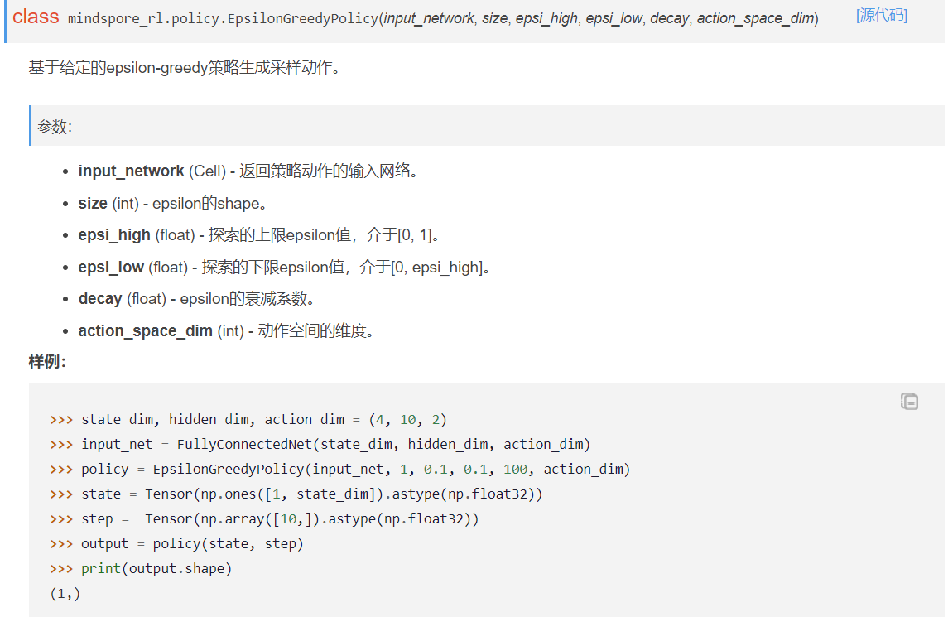这里输入的action_dim是2，输出的output不应该就是action吗？请问为什么是一维的？调试过程中发现RandomPolicy只能输出一维的，修改之后再RandomPolicy中运行测试代码，可以返回多维的动作，但在EpsilonGreedyPolicy中调用后，仍然返回的是一维的动作。
2.2 脚本信息
state_dim, hidden_dim, action_dim = 4, 10, 2
input_net = FullyConnectedNet(state_dim, hidden_dim, action_dim)
policy = GreedyPolicy(input_net)
state = Tensor(np.ones([2, 4]).astype(np.float32))
output = policy(state)
print(output.shape)
3. 根因分析
MindRL中的算法都使用MindSpore的Graph Mode（即图模式），代码会被编译成整图后再执行，和TensorFlow 1.x的执行模式相同。
4. 解决方案
可以通过修改train.py中的GRAPH_MODE到PYNATIVE_MODE，并且注释xxx_trainer.py中的@ms.jit / @jit方法，使代码通过PyNative模式执行（和Pytorch一致）。

自定义Callback重载函数调用顺序错误及解决
1. 系统环境
硬件环境(Ascend/GPU/CPU): Ascend/GPU/CPU
软件环境: MindSpore 版本: 1.7.0
执行模式（静态图/动态图）： 不限
Python 版本: 3.7.6
操作系统平台: linux
2. 报错信息
2.1 问题描述
自定义Callback的函数调用顺序违背方法的名称。现有调用顺序为on_train_epoch_begin -> on_train_step_* -> on_eval_epoch_begin -> on_eval_step_* -> on_eval_epoch_end -> on_train_epoch_end。
这导致train_epoch内含了eval_epoch。这样的运行流程导致设计callback的回显内容时增加了不必要的麻烦，并且逻辑上也不直观。
当前结构：
on_train_epoch_begin
on_train_step_*
on_eval_epoch_begin
on_eval_step_*
on-eval_epoch_end
on_train_epoch_end
期望结构：
on_train_epoch_begin
on_train_step_*
on_train_epoch_end
on_eval_epoch_begin
on_eval_step_*
on-eval_epoch_end
3. 根因分析
分析当前结构和期望结构发现， 当前结构是变训练边推理，期望是先训练后推理，查看当前代码是用的是model.fit，根据官网介绍model.fit就是边训练边推理。
4. 解决方案
要达到先训练后推理，可将model.fit换成model.train和model.eval，代码如下。
epoch = 4
for i in range(epoch):
model.train(i+1, train_ds, callbacks=[callback1], dataset_sink_mode=False)
model.eval(val_ds, callbacks=[callback1], dataset_sink_mode=False)
可以达到先训练后推理。

MindSpore报错：all types should be same, but got [mindspore.tensor[float64], mindspore.tensor[float32]
1. 系统环境
硬件环境(Ascend/GPU/CPU): Ascend
软件环境: MindSpore 版本: 2.1
执行模式（静态图/动态图）：静态图
Python 版本: 3.7.6
操作系统平台: linux
2. 报错信息
2.1 问题描述
训练网络，动态图可以正常产生loss，静态图编译报错。
2.2 报错信息
[ERROR] ANALYZER(711187,fffd1d0131d0,python):2023-10-12-03:28:24.426.772 [mindspore/ccsrc/pipeline/jit/static_analysis/async_eval_result.cc:69] HandleException] Exception happened, check the information as below.
The function call stack (See file '/home/mindspore/hezhiyu/bevformer/rank_0/om/analyze_fail.ir' for more details. Get instructions about `analyze_fail.ir` at https://www.mindspore.cn/search?inputValue=analyze_fail.ir):
# 0 In file /home/mindspore/hezhiyu/bevformer/mindauto/utils/train_step_wrapper.py:95
if not self.is_cpu_device:
^
# 1 In file /home/mindspore/hezhiyu/bevformer/mindauto/utils/train_step_wrapper.py:91
loss = self.network(*inputs) # mini-batch loss
^
# 2 In file /home/mindspore/hezhiyu/bevformer/mindauto/models/bevformer.py:231
if self.training:
# 3 In file /home/mindspore/hezhiyu/bevformer/mindauto/models/bevformer.py:243
return self.forward_train(**new_args)
^
# 4 In file /home/mindspore/hezhiyu/bevformer/mindauto/models/bevformer.py:315
if self.use_grid_mask:
# 5 In file /home/mindspore/hezhiyu/bevformer/mindauto/models/bevformer.py:316
prev_bev = self.obtain_history_bev(prev_grid_img,
^
# 6 In file /home/mindspore/hezhiyu/bevformer/mindauto/models/bevformer.py:257
for i in range(len_queue):
# 7 In file /home/mindspore/hezhiyu/bevformer/mindauto/models/bevformer.py:316
prev_bev = self.obtain_history_bev(prev_grid_img,
^
# 8 In file /home/mindspore/hezhiyu/bevformer/mindauto/models/bevformer.py:257
for i in range(len_queue):
# 9 In file /home/mindspore/hezhiyu/bevformer/mindauto/models/bevformer.py:316
prev_bev = self.obtain_history_bev(prev_grid_img,
^
# 10 In file /home/mindspore/hezhiyu/bevformer/mindauto/models/bevformer.py:263
prev_bev = self.pts_bbox_head(
# 11 In file /home/mindspore/hezhiyu/bevformer/mindauto/models/heads/bevformer_head.py:154
if only_bev: # only use encoder to obtain BEV features, TODO: refine the workaround
^
# 12 In file /home/mindspore/hezhiyu/bevformer/mindauto/models/heads/bevformer_head.py:155
return self.transformer.get_bev_features(
# 13 In file /home/mindspore/hezhiyu/bevformer/mindauto/models/heads/bevformer_head.py:155
return self.transformer.get_bev_features(
^
# 14 In file /home/mindspore/hezhiyu/bevformer/mindauto/models/transformer/transformer.py:451
for lvl, feat in enumerate(mlvl_feats):
^
# 15 In file /home/mindspore/hezhiyu/bevformer/mindauto/models/heads/bevformer_head.py:155
return self.transformer.get_bev_features(
^
# 16 In file /home/mindspore/hezhiyu/bevformer/mindauto/models/transformer/transformer.py:451
for lvl, feat in enumerate(mlvl_feats):
^
# 17 In file /home/mindspore/hezhiyu/bevformer/mindauto/models/transformer/transformer.py:468
bev_embed = self.encoder(
# 18 In file /home/mindspore/hezhiyu/bevformer/mindauto/models/transformer/encoder.py:178
if prev_bev is not None:
# 19 In file /home/mindspore/hezhiyu/bevformer/mindauto/models/transformer/encoder.py:180
prev_bev = ops.stack([prev_bev, bev_query], 1).reshape(bs * 2, len_bev, -1)
^
# 20 In file /home/mindspore/.conda/envs/bevformer/lib/python3.8/site-packages/mindspore/ops/function/array_func.py:2207
return _stack(tensors)
^
Traceback (most recent call last):
File "tools/train.py", line 233, in <module>
main(config)
File "tools/train.py", line 215, in main
model.train(
File "/home/mindspore/.conda/envs/bevformer/lib/python3.8/site-packages/mindspore/train/model.py", line 1061, in train
self._train(epoch,
File "/home/mindspore/.conda/envs/bevformer/lib/python3.8/site-packages/mindspore/train/model.py", line 113, in wrapper
func(self, *args, **kwargs)
File "/home/mindspore/.conda/envs/bevformer/lib/python3.8/site-packages/mindspore/train/model.py", line 613, in _train
self._train_process(epoch, train_dataset, list_callback, cb_params, initial_epoch, valid_infos)
File "/home/mindspore/.conda/envs/bevformer/lib/python3.8/site-packages/mindspore/train/model.py", line 914, in _train_process
outputs = self._train_network(*next_element)
File "/home/mindspore/.conda/envs/bevformer/lib/python3.8/site-packages/mindspore/nn/cell.py", line 639, in __call__
out = self.compile_and_run(*args, **kwargs)
File "/home/mindspore/.conda/envs/bevformer/lib/python3.8/site-packages/mindspore/nn/cell.py", line 963, in compile_and_run
self.compile(*args, **kwargs)
File "/home/mindspore/.conda/envs/bevformer/lib/python3.8/site-packages/mindspore/nn/cell.py", line 940, in compile
_cell_graph_executor.compile(self, phase=self.phase,
File "/home/mindspore/.conda/envs/bevformer/lib/python3.8/site-packages/mindspore/common/api.py", line 1625, in compile
result = self._graph_executor.compile(obj, args, kwargs, phase, self._use_vm_mode())
File "/home/mindspore/.conda/envs/bevformer/lib/python3.8/site-packages/mindspore/ops/operations/array_ops.py", line 3108, in __infer__
all_shape = _get_stack_shape(value, x_shape, x_type, self.axis, self.name)
File "/home/mindspore/.conda/envs/bevformer/lib/python3.8/site-packages/mindspore/ops/operations/array_ops.py", line 3002, in _get_stack_shape
raise TypeError("For \'{}\', all types should be same, but got {}".format(prim_name, x_type))
TypeError: For 'Stack', all types should be same, but got [mindspore.tensor[float64], mindspore.tensor[float32]]
3. 根因分析
静态图和动态图的区别可以参考官网说明：https://www.mindspore.cn/docs/zh-CN/r2.1/design/dynamic_graph_and_static_graph.html
静态图有控制流语法限制，支持语法可从官网查询到：https://www.mindspore.cn/docs/zh-CN/r2.1/note/static_graph_syntax_support.html
分析代码发现有部分有控制流，使用note打开产生的analyze_fail.ir文件，查找是否产生了Any类型
当控制流产生，静态图编译时会将不同分支产生的不同数据类型转成Any类型，找到产生Any的地方：prev_bev = prev_bev.permute(1, 0, 2).astype(ms.float32)。
: (<Int64, NoShape>, <Int64, NoShape>, <Int64, NoShape>, <Int64, NoShape>) -> (<Tensor[Float32], (2, 2500, 1, 2)>)
#scope: (Default/network-BEVFormer/pts_bbox_head-BEVFormerHead/transformer-PerceptionTransformer/encoder-BEVFormerEncoder)
# In file /home/mindspore/hezhiyu/bevformer/mindauto/models/transformer/encoder.py:181/ hybird_ref_2d = ops.stack([shift_ref_2d, ref_2d], 1).reshape(/
%25([CNode]8228) = getattr(%para1614_prev_bev, "permute")
: (<Any(Tensor)[Float64], (-2)>, <String, NoShape>) -> (<Any(Tensor)[Float64], (-2)>)
#scope: (Default/network-BEVFormer/pts_bbox_head-BEVFormerHead/transformer-PerceptionTransformer/encoder-BEVFormerEncoder)
# In file /home/mindspore/hezhiyu/bevformer/mindauto/models/transformer/encoder.py:179/ prev_bev = prev_bev.permute(1, 0, 2).astype(ms.float32)/
%26([CNode]8229) = %25(I64(1), I64(0), I64(2))
该处代码逻辑有的时候是None，有的时候又是某一种shape的tensor，还有判断条件会进行permute，因此静态图产生了Any类型数据，Cast不生效。
4. 解决方案
统一数据类型，修改控制流跑通代码。

MindSpore在GRAPH_MODE下初始化，报错提示当前的执行模式是禁用了任务下沉（TASK_SINK）
1. 系统环境
硬件环境(Ascend/GPU/CPU): Ascend/GPU/CPU
软件环境: MindSpore 版本: 2.1.0
执行模式（静态图/动态图）： 静态图
Python 版本: 3.9
操作系统平台: linux
2. 报错信息
2.1 问题描述
参考如下的mindspore文档，使用mindspore2.1环境，cann6.3，训练代码正常。
在代码中加上异构存储管理就提示RuntimeError: HCCL is initialized in GRAPH_MODE but current execution mode is GRAPH_MODE disable TASK_SINK. （HCCL（华为集群通信库）已经在图模式（GRAPH_MODE）下初始化，但当前的执行模式是禁用了任务下沉（TASK_SINK）的图模式）。
2.2 报错信息
RuntimeError: HCCL is initialized in GRAPH_MODE but current execution mode is GRAPH_MODE disable TASK_SINK.
2.3 脚本信息
import mindspore
offload_config = {"offload_param":"cpu","auto_offload":False,"offload_cpu_size":"512GB","offload_disk_size":"1024GB","offload_path":"./offload/","host_mem_block_size":"1GB","enable_aio":True,"enable_pinned_mem":True}
mindspore.set_context(mode=mindspore.GRAPH_MODE,memory_offload="ON",max_device_memory="30GB")
mindspore.set_offload_context(offload_config=offload_config)
3. 根因分析
当开启异构训练时，启动脚本需要采用mpi方式启动。
4. 解决方案
可以进行如下的修改。
#!/bin/bash
# applicable to Ascend or GPU
echo "=============================================================================================================="
echo "Please run the script as: "
echo "bash run.sh BATCH_SIZE MEMORY_OFFLOAD"
echo "For example: bash run.sh 96 ON"
echo "=============================================================================================================="
set -e
EXEC_PATH=$(pwd)
BATCH_SIZE=$1
MEMORY_OFFLOAD=$2
OFFLOAD_PARAM="cpu"
AUTO_OFFLOAD=true
OFFLOAD_CPU_SIZE="512GB"
OFFLOAD_DISK_SIZE="1024GB"
EXEC_PATH=$(pwd)
if [ ! -d "${EXEC_PATH}/cifar-10-binary" ]; then
if [ ! -f "${EXEC_PATH}/cifar-10-binary.tar.gz" ]; then
wget http://mindspore-website.obs.cn-north-4.myhuaweicloud.com/notebook/datasets/cifar-10-binary.tar.gz
fi
tar -zxvf cifar-10-binary.tar.gz
fi
export DATA_PATH=${EXEC_PATH}/cifar-10-batches-bin
mpirun -n 8 --output-filename log_output --merge-stderr-to-stdout python train.py \
--batch_size=$BATCH_SIZE --memory_offload=$MEMORY_OFFLOAD \
--offload_param=$OFFLOAD_PARAM --auto_offload=$AUTO_OFFLOAD \
--offload_cpu_size=$OFFLOAD_CPU_SIZE --offload_disk_size=$OFFLOAD_DISK_SIZE \
--host_mem_block_size="1GB" --enable_pinned_mem=true --enable_aio=true

使用vision.ToPIL在一定情况下无效
1. 系统环境
硬件环境(Ascend/GPU/CPU): Ascend/GPU/CPU
软件环境: MindSpore 版本: 2.0.0
执行模式（静态图/动态图）： 不限
Python 版本: 3.9.7
操作系统平台: linux
2. 报错信息
2.1 问题描述
定义了一连串的transforms，知道vision.RandomGrayscale要求是PIL作为输入，因此在这个transform前加了vision.ToPIL()，可是为什么会报错提示说输入仍然是个numpy呢？ vision.ToPIL()这个操作好像没有生效。
2.2 报错信息
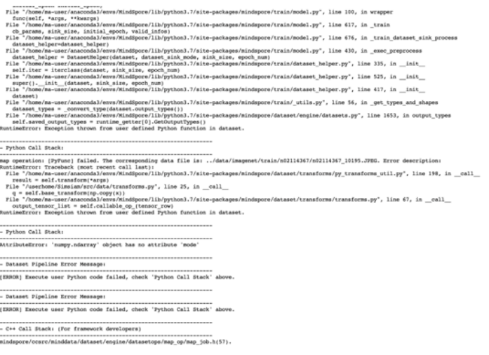
2.3 脚本信息
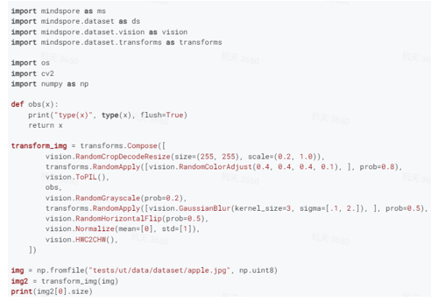
3. 根因分析
从源码的角度分析一下，源码其实安装在conda下，在命令行里使用pip show mindspore就可以查看到
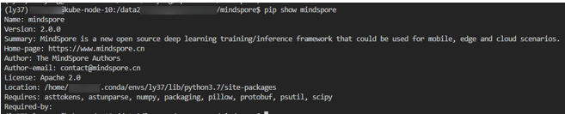
那么mindspore的源码就位于：/home/xxxx/.conda/envs/ly37/lib/python3.7/site-packages/mindspore
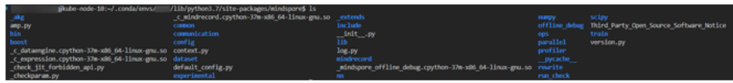按照报错提示的python路径，我在dataset里面搜索Compose算子，开始分析源码 mindspore/dataset/transforms/transforms.py
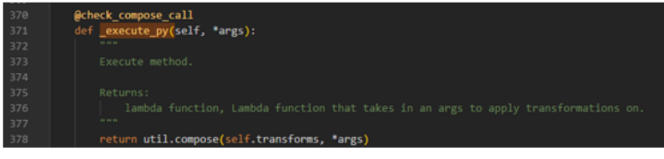
如果调用到了_execute_py函数，那么util.compose函数是会循环执行transfomrs.Compose中的数据增强算子的，这样vision.ToPIL肯定会返回一个Pillow对象给vision.RandomGrayscale，这样按理说不会出错。但当我在_execute_py里面添加一行打印
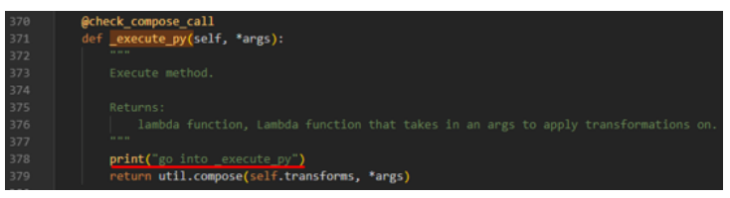
发现其竟然没有打印出来，那么肯定哪里的逻辑有点问题了。
由于是以function call的形式调用transfomrs.Compose，那么一定是触发了他的__call__方法，但是这个类里没有定义，最后在他的父类里找到了方法定义。
mindspore/dataset/transforms/transforms.py
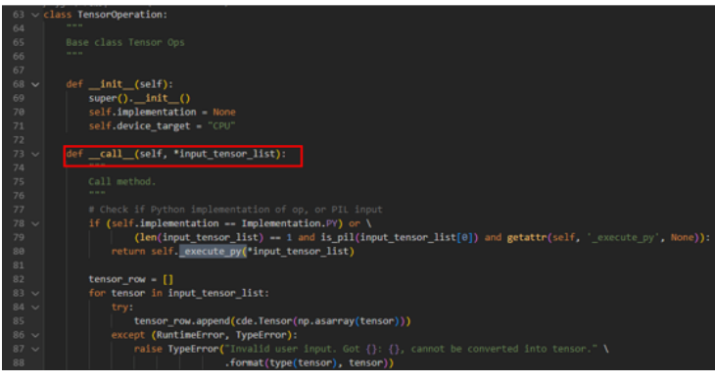
发现__call__方法里其实有分支是调用_execute_py方法的，但是为什么没走进去呢。如果78行的if条件是False，那么他肯定走了下面的分支导致计算出错，通过添加打印我也确认了这点，发现确实只打印了"go into other branch "
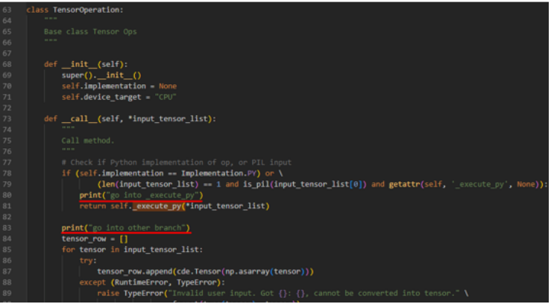
那么问题来了，if条件是用来判断什么的呢，导致他条件为False，于是我也把所有的if条件打印了一下，发现and前后两个条件都是False。
这下就有点不大知道怎么往下看了。不过我也粗略尝试了一下，我想要不直接帮vision.Compose重载一个__call__方法让他直接调用_execute_py会怎么样。
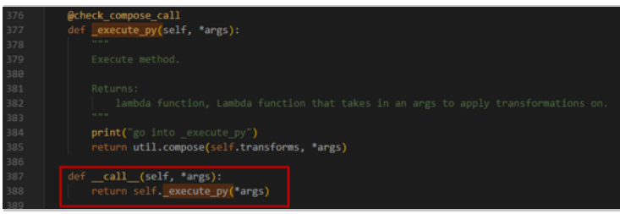
可以运行成功！
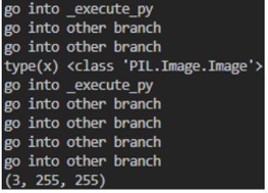
4. 解决方案
由于RandomGrayscale需要是一个Pillow的输入，那我就构造一个给他呗，把代码改成这样。
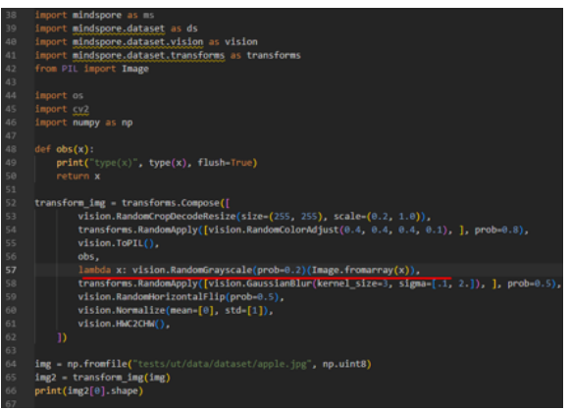
通过灵活的python lambda表达式，我把输入先用Pillow的函数包装一层，然后再传给vision.RandomGrayscale不就好了，事实证明这么写确实也有效，结果如下：
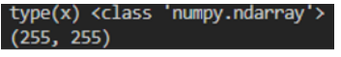

MindSpore不能像torch的param.grad直接获取梯度问题
1. 系统环境
硬件环境(Ascend/GPU/CPU): GPU
软件环境: MindSpore 版本: 2.0
执行模式（静态图/动态图）： 不限
Python 版本: 3.7.6
操作系统平台: linux
2. 报错信息
2.1 问题描述
torch代码，对于parameter变量，例如X，可以直接X.grad获取梯度，torch封装在内部逻辑中，不需要额外的代码计算梯度，MindSpore不能像torch的param.grad直接获取梯度。
2.2 脚本信息
import torch
x = torch.tensor(2., requires_grad=True)
y = torch.tensor(3., requires_grad=True)
z = x * x * y
z.backward()
print(x.grad, y.grad)
# Out:
# tensor(12.) tensor(4.)
x = torch.tensor(2.).requires_grad_()
y = torch.tensor(3.).requires_grad_()
z = x * x * y
grad_x = torch.autograd.grad(outputs=z, inputs=x)
print(grad_x[0])
3. 根因分析
PyTorch：使用torch.autograd.backward计算给定Tensor关于叶子节点的梯度总和，反向传播计算Tensor的梯度时，只计算requires_grad=True的叶子节点的梯度。使用torch.autograd.grad计算并返回输出关于输入的梯度总和，如果only_inputs为True，仅返回与指定输入相关的梯度列表。
MindSpore：计算梯度，当grad_position设置为int或者tuple int类型，将会计算对应输入位置的梯度。如果设置了weights，将会计算网络的变量的参数。当has_aux设置为True时，只有fn的第一个输出参与梯度计算，此时fn至少具备两个输出。
4. 解决方案
on设置为int或者tuple int类型，将会计算对应输入位置的梯度。如果设置了weights，将会计算网络的变量的参数。当has_aux设置为True时，只有fn的第一个输出参与梯度计算，此时fn至少具备两个输出。
import numpy as np
import mindspore.nn as nn
import mindspore as ms
from mindspore import ops
# In MindSpore：
class Net(nn.Cell):
def __init__(self):
super(Net, self).__init__()
self.matmul = ops.MatMul()
self.z = ms.Parameter(ms.Tensor(np.array([1.0], np.float32)), name='z')
def construct(self, x, y):
x = x * self.z
out = self.matmul(x, y)
return out
class GradNetWrtX(nn.Cell):
def __init__(self, net):
super(GradNetWrtX, self).__init__()
self.net = net
def construct(self, x, y):
gradient_function = ms.grad(self.net)
return gradient_function(x, y)
x = ms.Tensor([[0.5, 0.6, 0.4], [1.2, 1.3, 1.1]], dtype=ms.float32)
y = ms.Tensor([[0.01, 0.3, 1.1], [0.1, 0.2, 1.3], [2.1, 1.2, 3.3]], dtype=ms.float32)
output = GradNetWrtX(Net())(x, y)
print(output)

MindSpore跑resnet50报错For 'MatMul' the input dimensions must be equal, but got 'x1_col': 32768 and 'x2_row': 2048
1. 系统环境
硬件环境(Ascend/GPU/CPU): Ascend/GPU/CPU
软件环境: MindSpore 版本: 2.1.0
执行模式（静态图/动态图）： 不限
Python 版本: 3.7.6
操作系统平台: linux
2. 报错信息
2.1 问题描述
使用的imagenet数据，图像size设置为(128,128)，然后报错。
2.2 报错信息
ValueError: For 'MatMul' the input dimensions must be equal, but got 'x1_col': 32768 and 'x2_row': 2048.
2.3 脚本信息
from download import download
import mindspore as ms
import mindspore.dataset as ds
import mindspore.dataset.vision as vision
import mindspore.dataset.transforms as transforms
from mindspore import dtype as mstype
batch_size = 32 # Batch size
image_size = 128 # Image size of training data
workers = 2 # Number of parallel workers
num_classes = 1000 # Number of classes
def create_dataset(data_set, usage, resize, batch_size, workers):
trans = []
trans += [
vision.Resize((128, 128)),
vision.Rescale(1.0 / 255.0, 0.0),
vision.HWC2CHW()
]
target_trans = transforms.TypeCast(mstype.int32)
data_set = data_set.map(operations=trans,
input_columns='image',
num_parallel_workers=workers)
data_set = data_set.map(operations=target_trans,
input_columns='label',
num_parallel_workers=workers)
data_set = data_set.batch(batch_size)
return data_set
import mindspore
from mindspore.dataset import vision, transforms
import mindspore.dataset as ds
trainset = ds.ImageFolderDataset("./imagenet2012/train", decode=True)
testset = ds.ImageFolderDataset("./imagenet2012/val", decode=True)
dataset_train = create_dataset(trainset,
usage="train",
resize=image_size,
batch_size=batch_size,
workers=workers)
dataset_val = create_dataset(testset,
usage="test",
resize=image_size,
batch_size=batch_size,
workers=workers)
step_size_val = dataset_val.get_dataset_size()
step_size_train = dataset_train.get_dataset_size()
import matplotlib.pyplot as plt
import numpy as np
data_iter = next(dataset_train.create_dict_iterator())
images = data_iter["image"].asnumpy()
labels = data_iter["label"].asnumpy()
print(f"Image shape: {images.shape}, Label shape: {labels.shape}")
print(f"Labels: {labels[:6]}")
classes = []
with open('./imagenet2012/imagenet-classes.txt', "r") as f:
for line in f:
line = line.rstrip()
if line:
classes.append(line)
plt.figure()
for i in range(6):
plt.subplot(2, 3, i + 1)
image_trans = np.transpose(images[i], (1, 2, 0))
mean = np.array([0.4914, 0.4822, 0.4465])
std = np.array([0.2023, 0.1994, 0.2010])
image_trans = std * image_trans + mean
image_trans = np.clip(image_trans, 0, 1)
plt.title(f"{classes[labels[i]]}")
plt.imshow(image_trans)
plt.axis("off")
plt.show()
images.shape
from typing import Type, Union, List, Optional
import mindspore.nn as nn
from mindspore.common.initializer import Normal
# Initialize the parameters of the convolutional layer and BatchNorm layer
weight_init = Normal(mean=0, sigma=0.02)
gamma_init = Normal(mean=1, sigma=0.02)
class ResidualBlockBase(nn.Cell):
expansion: int = 1 # The number of convolution kernels at the last layer is the same as that of convolution kernels at the first layer.
def __init__(self, in_channel: int, out_channel: int,
stride: int = 1, norm: Optional[nn.Cell] = None,
down_sample: Optional[nn.Cell] = None) -> None:
super(ResidualBlockBase, self).__init__()
if not norm:
self.norm = nn.BatchNorm2d(out_channel)
else:
self.norm = norm
self.conv1 = nn.Conv2d(in_channel, out_channel,
kernel_size=3, stride=stride,
weight_init=weight_init)
self.conv2 = nn.Conv2d(in_channel, out_channel,
kernel_size=3, weight_init=weight_init)
self.relu = nn.ReLU()
self.down_sample = down_sample
def construct(self, x):
"""ResidualBlockBase construct."""
identity = x # shortcut
out = self.conv1(x) # First layer of the main body: 3 x 3 convolutional layer
out = self.norm(out)
out = self.relu(out)
out = self.conv2(out) # Second layer of the main body: 3 x 3 convolutional layer
out = self.norm(out)
if self.down_sample is not None:
identity = self.down_sample(x)
out += identity # output the sum of the main body and the shortcuts
out = self.relu(out)
return out
class ResidualBlock(nn.Cell):
expansion = 4 # The number of convolution kernels at the last layer is four times that of convolution kernels at the first layer.
def __init__(self, in_channel: int, out_channel: int,
stride: int = 1, down_sample: Optional[nn.Cell] = None) -> None:
super(ResidualBlock, self).__init__()
self.conv1 = nn.Conv2d(in_channel, out_channel,
kernel_size=1, weight_init=weight_init)
self.norm1 = nn.BatchNorm2d(out_channel)
self.conv2 = nn.Conv2d(out_channel, out_channel,
kernel_size=3, stride=stride,
weight_init=weight_init)
self.norm2 = nn.BatchNorm2d(out_channel)
self.conv3 = nn.Conv2d(out_channel, out_channel * self.expansion,
kernel_size=1, weight_init=weight_init)
self.norm3 = nn.BatchNorm2d(out_channel * self.expansion)
self.relu = nn.ReLU()
self.down_sample = down_sample
def construct(self, x):
identity = x # shortcut
out = self.conv1(x) # First layer of the main body: 1 x 1 convolutional layer
out = self.norm1(out)
out = self.relu(out)
out = self.conv2(out) # Second layer of the main body: 3 x 3 convolutional layer
out = self.norm2(out)
out = self.relu(out)
out = self.conv3(out) # Third layer of the main body: 1 x 1 convolutional layer
out = self.norm3(out)
if self.down_sample is not None:
identity = self.down_sample(x)
out += identity # The output is the sum of the main body and the shortcut.
out = self.relu(out)
return out
def make_layer(last_out_channel, block: Type[Union[ResidualBlockBase, ResidualBlock]],
channel: int, block_nums: int, stride: int = 1):
down_sample = None # shortcuts
if stride != 1 or last_out_channel != channel * block.expansion:
down_sample = nn.SequentialCell([
nn.Conv2d(last_out_channel, channel * block.expansion,
kernel_size=1, stride=stride, weight_init=weight_init),
nn.BatchNorm2d(channel * block.expansion, gamma_init=gamma_init)
])
layers = []
layers.append(block(last_out_channel, channel, stride=stride, down_sample=down_sample))
in_channel = channel * block.expansion
# Stack residual networks.
for _ in range(1, block_nums):
layers.append(block(in_channel, channel))
return nn.SequentialCell(layers)
from mindspore import load_checkpoint, load_param_into_net
class ResNet(nn.Cell):
def __init__(self, block: Type[Union[ResidualBlockBase, ResidualBlock]],
layer_nums: List[int], num_classes: int, input_channel: int) -> None:
super(ResNet, self).__init__()
self.relu = nn.ReLU()
# At the first convolutional layer, the number of the input channels is 3 (color image) and that of the output channels is 64.
self.conv1 = nn.Conv2d(3, 64, kernel_size=7, stride=2, weight_init=weight_init)
self.norm = nn.BatchNorm2d(64)
# Maximum pooling layer, reducing the image size
self.max_pool = nn.MaxPool2d(kernel_size=3, stride=2, pad_mode='same')
# Define each residual network structure block
self.layer1 = make_layer(64, block, 64, layer_nums[0])
self.layer2 = make_layer(64 * block.expansion, block, 128, layer_nums[1], stride=2)
self.layer3 = make_layer(128 * block.expansion, block, 256, layer_nums[2], stride=2)
self.layer4 = make_layer(256 * block.expansion, block, 512, layer_nums[3], stride=2)
# average pooling layer
self.avg_pool = nn.AvgPool2d()
# flattern layer
self.flatten = nn.Flatten()
# fully-connected layer
self.fc = nn.Dense(in_channels=input_channel, out_channels=num_classes)
def construct(self, x):
x = self.conv1(x)
x = self.norm(x)
x = self.relu(x)
x = self.max_pool(x)
x = self.layer1(x)
x = self.layer2(x)
x = self.layer3(x)
x = self.layer4(x)
x = self.avg_pool(x)
x = self.flatten(x)
x = self.fc(x)
return x
def _resnet(model_url: str, block: Type[Union[ResidualBlockBase, ResidualBlock]],
layers: List[int], num_classes: int, pretrained: bool, pretrained_ckpt: str,
input_channel: int):
model = ResNet(block, layers, num_classes, input_channel)
if pretrained:
# load pre-trained models
download(url=model_url, path=pretrained_ckpt, replace=True)
param_dict = load_checkpoint(pretrained_ckpt)
load_param_into_net(model, param_dict)
return model
def resnet50(num_classes: int = 1000, pretrained: bool = False):
"ResNet50 model"
resnet50_url = "https://obs.dualstack.cn-north-4.myhuaweicloud.com/mindspore-website/notebook/models/application/resnet50_224_new.ckpt"
resnet50_ckpt = "./LoadPretrainedModel/resnet50_224_new.ckpt"
return _resnet(resnet50_url, ResidualBlock, [3, 4, 6, 3], num_classes,
pretrained, resnet50_ckpt, 2048)
in_channel
# Define the ResNet50 network.
network = resnet50(pretrained=True)
# Size of the input layer of the fully-connected layer
in_channel = network.fc.in_channels
fc = nn.Dense(in_channels=in_channel, out_channels=1000)
# Reset the fully-connected layer.
network.fc = fc
# Set the learning rate
num_epochs = 5
lr = nn.cosine_decay_lr(min_lr=0.00001, max_lr=0.001, total_step=step_size_train * num_epochs,
step_per_epoch=step_size_train, decay_epoch=num_epochs)
# Define optimizer and loss function
opt = nn.Momentum(params=network.trainable_params(), learning_rate=lr, momentum=0.9)
loss_fn = nn.SoftmaxCrossEntropyWithLogits(sparse=True, reduction='mean')
def forward_fn(inputs, targets):
logits = network(inputs)
loss = loss_fn(logits, targets)
return loss
grad_fn = ms.value_and_grad(forward_fn, None, opt.parameters)
def train_step(inputs, targets):
loss, grads = grad_fn(inputs, targets)
opt(grads)
return loss
import os
# Creating Iterators
data_loader_train = dataset_train.create_tuple_iterator(num_epochs=num_epochs)
data_loader_val = dataset_val.create_tuple_iterator(num_epochs=num_epochs)
# Optimal model storage path
best_acc = 0
best_ckpt_dir = "./BestCheckpoint"
best_ckpt_path = "./BestCheckpoint/resnet50-best.ckpt"
if not os.path.exists(best_ckpt_dir):
os.mkdir(best_ckpt_dir)
import mindspore.ops as ops
def train(data_loader, epoch):
"""Model taining"""
losses = []
network.set_train(True)
for i, (images, labels) in enumerate(data_loader):
loss = train_step(images, labels)
if i % 100 == 0 or i == step_size_train - 1:
print('Epoch: [%3d/%3d], Steps: [%3d/%3d], Train Loss: [%5.3f]' %
(epoch + 1, num_epochs, i + 1, step_size_train, loss))
losses.append(loss)
return sum(losses) / len(losses)
def evaluate(data_loader):
"""Model Evaluation"""
network.set_train(False)
correct_num = 0.0 # Number of correct predictions
total_num = 0.0 # Total number of predictions
for images, labels in data_loader:
logits = network(images)
pred = logits.argmax(axis=1) # Prediction results
correct = ops.equal(pred, labels).reshape((-1, ))
correct_num += correct.sum().asnumpy()
total_num += correct.shape[0]
acc = correct_num / total_num # Accuracy
return acc
# Start training loop
print("Start Training Loop ...")
for epoch in range(num_epochs):
curr_loss = train(data_loader_train, epoch)
curr_acc = evaluate(data_loader_val)
print("-" * 50)
print("Epoch: [%3d/%3d], Average Train Loss: [%5.3f], Accuracy: [%5.3f]" % (
epoch+1, num_epochs, curr_loss, curr_acc
))
print("-" * 50)
# Save the model that has achieved the highest prediction accuracy
if curr_acc > best_acc:
best_acc = curr_acc
ms.save_checkpoint(network, best_ckpt_path)
print("=" * 80)
print(f"End of validation the best Accuracy is: {best_acc: 5.3f}, "
f"save the best ckpt file in {best_ckpt_path}", flush=True)
3. 根因分析
根据报错，可以看到是MatMul算子维度不匹配，脚本中只有ResNet网络中全连接层用到了Matmul：
self.fc = nn.Dense(in_channels=input_channel, out_channels=num_classes)
在脚本中加入打印，可以看到x的维度是(32, 32768), w的维度是(1000, 2048)。
def construct(self, x):
x = self.conv1(x)
x = self.norm(x)
x = self.relu(x)
x = self.max_pool(x)
x = self.layer1(x)
x = self.layer2(x)
x = self.layer3(x)
x = self.layer4(x)
x = self.avg_pool(x)
x = self.flatten(x)
print(f"x shape={x.shape}, w shape={self.fc.weight.shape}:", x.shape)
x = self.fc(x)
return x
由于x和w不满足矩阵乘法维度要求，最终脚本执行报错。这通常是由于修改了网络的输入（如数据预处理的图片size），但没有修改维度敏感算子导致。
4. 解决方案
将脚本中将input_channel从2048改为32768即可。
def resnet50(num_classes: int = 1000, pretrained: bool = False):
... ...
# 将input_channel从2048改为32768
return _resnet(resnet50_url, ResidualBlock, [3, 4, 6, 3], num_classes,
pretrained, resnet50_ckpt, 32768)

新节点24使用piecewise_constant_lr造成梯度异常
1. 系统环境
硬件环境(Ascend/GPU/CPU): Ascend/GPU/CPU
软件环境: MindSpore 版本: 2.1.1
执行模式（静态图/动态图）： 不限
Python 版本: 3.9
操作系统平台: linux
2. 报错信息
2.1 问题描述
使用官网入门实例https://gitee.com/mindspore/docs/blob/r2.1/tutorials/source_zh_cn/beginner/quick_start.ipynb。然后对学习率进行了修改，使用了动态学习率出现梯度异常问题。最后一行注释的代码是官方原始代码，学习率为固定常量 lr=0.1。
2.2 报错信息
原官方代码运行结果
Epoch 1
loss: 2.315734 [ 0/9381]
loss: 0.335083 [100/9381]
loss: 8.289867 [200/9381]
loss: 0.320835 [300/9381]
loss: 0.218015 [400/9381]
loss: 0.288610 [500/9381]
loss: 0.149030 [600/9381]
loss: 0.081295 [700/9381]
loss: 0.140247 [800/9381]
loss: 0.175849 [900/9381]
新增动态学习率后的运行结果
Epoch 1
loss: 2.309528 [ 0/9381]
loss: 2.198998 [100/9381]
loss: 2.167274 [200/9381]
loss: 2.155498 [300/9381]
loss: 2.148228 [400/9381]
loss: 2.139027 [500/9381]
loss: 2.106419 [600/9381]
loss: 2.123494 [700/9381]
loss: 2.160592 [800/9381]
loss: 2.184410 [900/9381]
2.3 脚本信息
class Network(nn.Cell):
def __init__(self):
super().__init__()
self.flatten = nn.Flatten()
self.dense_relu_sequential = nn.SequentialCell(
nn.Dense(28*28, 512),
nn.ReLU(),
nn.Dense(512, 512),
nn.ReLU(),
nn.Dense(512, 10)
)
def construct(self, x):
x = self.flatten(x)
logits = self.dense_relu_sequential(x)
return logits
model = Network()
print(model)
milestone = [1,3,10,100]
learning_rates = [0.1,0.05,0.01,0.001]
lr = nn.piecewise_constant_lr(milestone,learning_rates)
loss_fn = nn.CrossEntropyLoss()
optimizer = nn.SGD(model.trainable_params(),learning_rate=lr)
# optimizer = nn.SGD(model.trainable_params(),learning_rate=0.1)
3. 根因分析
piecewise_constant_lr
milestone = [1,3,10,100]
learning_rates = [0.1,0.05,0.01,0.001]
step 1-3 学习率 0.1
step 3-10 学习率 0.05
step 10 -100 学习率0.01
step 100之后学习率0.001
看loss变化情况, 这个lr的太小了,会导致无法收敛
可以修改milestone或learning_rates的值
milestone = [1,100,500,700]
或
learning_rates = [1.0,0.5,0.2,0.1]
4. 解决方案
loss_fn = nn.CrossEntropyLoss()
milestone = [1,100,500,700]
learning_rates = [0.1,0.05,0.01,0.001]
lr = nn.piecewise_constant_lr(milestone,learning_rates)
optimizer = nn.SGD(model.trainable_params(), lr)
或者
loss_fn = nn.CrossEntropyLoss()
milestone = [1,3,10,100]
learning_rates = [1.0,0.5,0.2,0.1]
lr = nn.piecewise_constant_lr(milestone,learning_rates)
optimizer = nn.SGD(model.trainable_params(), lr)

MindSpore报错AttributeError: module 'mindspore.ops' has no attribute 'mm'
1. 系统环境
硬件环境(Ascend/GPU/CPU): Ascend/GPU/CPU
软件环境: MindSpore 版本: 1.10.0
执行模式（静态图/动态图）： 不限
Python 版本: 3.7.6
操作系统平台: linux
2. 报错信息
2.1 报错信息
Traceback (most recent call last):
File "C:\Users\emcon\anaconda3\lib\site-packages\IPython\core\interactiveshell.py", line 3437, in run_code
exec(code_obj, self.user_global_ns, self.user_ns)
File "<ipython-input-43-eb21821cfaa2>", line 1, in <module>
mm = ops.mm()
AttributeError: module 'mindspore.ops' has no attribute 'mm'
2.2 脚本信息
import mindspore as ms
import mindspore.ops as ops
import numpy as np
x1 = ms.Tensor(np.random.rand(2,3))
x2 = ms.Tensor(np.random.rand(3,4))
out = ops.mm(x1,x2)
print(out.shape)
3. 根因分析
从结果上看1.10版本是没有ops.mm的。
4. 解决方案
既然没有mm就用ops.matmul来代替。
import mindspore as ms
import mindspore.ops as ops
import numpy as np
x1 = ms.Tensor(np.random.rand(2,3))
x2 = ms.Tensor(np.random.rand(3,4))
out = ops.matmul(x1,x2)
print(out.shape)

MindSpore报错'Resize' from mindspore.dataset.vision.c_transforms is deprecated
1. 系统环境
硬件环境(Ascend/GPU/CPU): Ascend/GPU/CPU
软件环境: MindSpore 版本: 1.10.0；mindvision=0.1.0
执行模式（静态图/动态图）： 不限
Python 版本: 3.7.6
操作系统平台: linux
2. 报错信息
2.1 报错信息
[WARNING] ME(2285:140565113722688,MainProcess):2023-10-07-11:49:35.271.471 [mindspore/dataset/core/validator_helpers.py:806] 'Resize' from mindspore.dataset.vision.c_transforms is deprecated from version 1.8 and will be removed in a future version. Use 'Resize' from mindspore.dataset.vision instead.
[WARNING] ME(2285:140565113722688,MainProcess):2023-10-07-11:49:35.272.486 [mindspore/dataset/core/validator_helpers.py:806] 'Rescale' from mindspore.dataset.vision.c_transforms is deprecated from version 1.8 and will be removed in a future version. Use 'Rescale' from mindspore.dataset.vision instead.
[WARNING] ME(2285:140565113722688,MainProcess):2023-10-07-11:49:35.273.343 [mindspore/dataset/core/validator_helpers.py:806] 'HWC2CHW' from mindspore.dataset.vision.c_transforms is deprecated from version 1.8 and will be removed in a future version. Use 'HWC2CHW' from mindspore.dataset.vision instead.
2.2 脚本信息
from mindvision.dataset import Mnist
download_train = Mnist(path="./mnist", split="train", resize=32, download=True)
download_eval = Mnist(path="./mnist", split="test", resize=32, download=True)
dataset_train = download_train.run()
dataset_eval = download_eval.run()
3. 根因分析
其实只是 WARNING出错的是Mnist的default_transform方法 使用了mindspore.dataset.vision.c_transforms的Resize, Rescale,HWC2CHW
def default_transform(self):
"""Set the default transform for Mnist dataset."""
rescale = 1.0 / 255.0
shift = 0.0
rescale_nml = 1 / 0.3081
shift_nml = -1 * 0.1307 / 0.3081
# define map operations
trans = [
Resize(size=self.resize, interpolation=Inter.LINEAR),
Rescale(rescale, shift),
Rescale(rescale_nml, shift_nml),
HWC2CHW(),
]
return trans
有这个警告是因为这几个方法加了@deprecated_c_vision()这个装饰器.
Resize, Rescale,HWC2CHW 的 __init__方法上都加了类似的装饰器
@deprecated_c_vision()
@check_resize_interpolation
def __init__(self, size, interpolation=Inter.LINEAR):
if isinstance(size, int):
size = (size,)
self.size = size
self.interpolation = interpolation
最新的mindspore已经不使用mindvision， 而是直接使用mindspore.dataset
https://www.mindspore.cn/docs/zh-CN/r2.2/api_python/mindspore.dataset.html
所以有第二种解法。
4. 解决方案
第一种:修改mnist.py，这个直接修改mindvision的代码。
添加导入
from mindspore.dataset.vision import Resize,Rescale,HWC2CHW
trans = [
Resize(size=self.resize, interpolation=Inter.LINEAR),
Rescale(rescale, shift),
Rescale(rescale_nml, shift_nml),
HWC2CHW(),
]
第二种代码：
import mindspore.dataset as ds
mnist_dataset_dir = "E:\\MNIST_Data"
dataset_train = ds.MnistDataset(dataset_dir=mnist_dataset_dir, usage='train')
dataset_eval = ds.MnistDataset(dataset_dir=mnist_dataset_dir, usage='test')

MindSpore中的text_format.Merge和text_format.Parse的区别
1. 系统环境
MindSpore中的text_format.Merge和text_format.Parse都是用于处理文本格式的协议缓冲区数据，它们的主要区别如下:
2. 作用对象不同
text_format.Merge:用于将文本内容合并到已存在的协议缓冲区消息对象中。
text_format.Parse:会从文本内容中解析并生成一个新的协议缓冲区消息对象。
3. 使用方式不同
text_format.Merge:需要提前创建消息对象，作为第二个参数传入，文本内容会合并到这个对象中。
msg = Message()
text_format.Merge(text, msg)
text_format.Parse:不需要提前创建，会直接从文本内容中解析生成消息对象。
msg = text_format.Parse(text)
4. 错误处理不同
text_format.Merge:解析错误会抛出异常。
text_format.Parse:解析错误会返回None。
5. 性能不同
text_format.Merge:需要重复解析文本内容，效率较低。
text_format.Parse:只解析一次，效率较高。
所以，在已经有消息对象的情况下，推荐使用text_format.Merge;如果只有文本内容，想生成消息对象，则推荐使用text_format.Parse。
在图解析场景下，我们已经有了图定义的消息对象，所以text_format.Merge更合适。

MindSpore如何将add_node函数添加节点信息到self.node中
1. 系统环境
硬件环境(Ascend/GPU/CPU): GPU
软件环境: MindSpore 版本: 2.0
执行模式（静态图/动态图）： 不限
Python 版本: 3.7.6
操作系统平台: linux
2. 报错信息
2.1 问题描述
原本需要：name，id=node_def.name，op_type，scope，output_type，
topo_id就是self.node_id，而node_id是由node_def.name传入的，在.pb文件中，.name是每个节点的编号，full_name才是它的真正名字
3. 根因分析
最终，通过graph中的add_node函数添加节点信息到self.node中。
4. 解决方案
def add_node(self,node):
node.internal_id = self._node_id_counter
self._node_id_counter += 1
self.node.append(node)
self.name_nodes[node.name] = node

如何读取MindSpore中的.pb文件中的节点
1. 系统环境
硬件环境(Ascend/GPU/CPU): GPU
软件环境: MindSpore 版本: 2.0
执行模式（静态图/动态图）： 不限
Python 版本: 3.7.6
操作系统平台: linux
2. 解决方案
修改逻辑：首先，需要适配节点的node_mapper匹配算法的逻辑，则需要以下Node的参数。
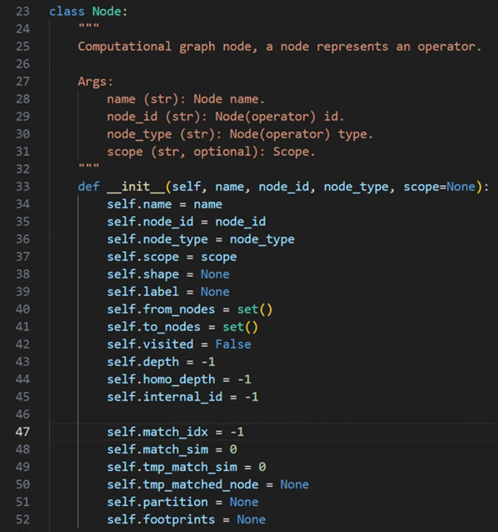
其次，原本.pb文件中node的name属性即是各个node的id，full_name属性才是node的name，而.pbtxt文件中，没有node_id，name属性就是该节点的名称。同时，发现topo_id实际上就是直接取的node_id的值，除了计数外并没有其他作用，故直接设置一个新的id参数，每过一个节点迭代+1，仅用作节点计数区分使用。
之后，由于.pbtxt文件中没有parameters参数的节点，删除相应的处理操作，并且，设置新的node_map参数，通过内部存储各个节点的name来找出各个节点之间边的关系。
最终，通过onnx的ModelProto()方法来实现整个读取节点的方式。

MindSpore报错Please try to reduce 'batch_size' or check whether exists extra large shape.及解决
1. 系统环境
硬件环境(Ascend/GPU/CPU): Ascend/GPU/CPU
软件环境: MindSpore 版本: 2.0.0
执行模式（静态图/动态图）： 不限
Python 版本: 3.7.6
操作系统平台: linux
2. 报错信息
2.1 问题描述
进行分布式配置后，运行脚本出现如下你报错。
2.2 报错信息
RuntimeError: Preprocess failed before run graph 1.
----------------------------------------------------
- Framework Error Message:
----------------------------------------------------
Out of Memory!!! Request memory size: 13518844928B, Memory Statistic:
Device HBM memory size: 32768M
MindSpore Used memory size: 30720M
MindSpore memory base address: 0x124180000000
Total Static Memory size: 19792M
Total Dynamic memory size: 0M
Dynamic memory size of this graph: 0M
Please try to reduce 'batch_size' or check whether exists extra large shape. For more details, please refer to 'Out of Memory' at https://www.mindspore.cn .
----------------------------------------------------
- C++ Call Stack: (For framework developers)
----------------------------------------------------
mindspore/ccsrc/plugin/device/ascend/hal/hardware/ascend_kernel_executor.cc:244 PreprocessBeforeRunGraph
mindspore/ccsrc/plugin/device/ascend/hal/device/ascend_memory_adapter.cc:169 MallocDynamicDevMem
3. 根因分析
Please try to reduce 'batch_size' or check whether exists extra large shape. For more details, please refer to 'Out of Memory' at https://www.mindspore.cn .
根据这里报错信息提示，是本地的硬件环境的限制，应该减小'batch_size'，这样减小一下每次都计算。
4. 解决方案
1. 启动程序之前先npu-smi info看下分布式使用的卡是否被其他程序占用，确保每张卡都没有程序占用再启动
2. 把batch size降低1试一下是否能跑起来， 如果代码中指代的batch size是全局batch size=8，device_num=8的时候，单卡的batch size就已经是1了，还跑不起来就说明机器配置有限跑不了当前的代码。

MindSpore报错RuntimeError: Load op info form json config failed, version: Ascend310
1. 系统环境
硬件环境(Ascend/GPU/CPU): Ascend
软件环境: MindSpore 版本: 2.0.0
执行模式（静态图/动态图）： 不限
Python 版本: 3.7.6
操作系统平台: linux
2. 报错信息
2.1 报错信息
[mindspore/ccsrc/kernel/oplib/op_info_utils.cc:172] LoadOpInfoJson] Get op info json suffix path failed, soc_version: Ascend310
[ERROR] KERNEL(2130,7fc13dcf4700,python):2023-10-25-16:52:29.160.750 [mindspore/ccsrc/kernel/oplib/op_info_utils.cc:111] GenerateOpInfos] Load op info json failed, version: Ascend310
Traceback (most recent call last):
File "pipeline.py", line 8, in <module>
task_pipeline('请介绍一下马斯克')
File "/root/anaconda3/envs/chatglm/lib/python3.7/site-packages/mindformers/pipeline/base_pipeline.py", line 123, in __call__
outputs = self.run_single(inputs, preprocess_params, forward_params, postprocess_params)
File "/root/anaconda3/envs/chatglm/lib/python3.7/site-packages/mindformers/pipeline/base_pipeline.py", line 154, in run_single
model_outputs = self.forward(model_inputs, **forward_params)
File "/root/anaconda3/envs/chatglm/lib/python3.7/site-packages/mindformers/pipeline/text_generation_pipeline.py", line 145, in forward
output_ids = self.network.generate(input_ids, **forward_params)
File "/root/anaconda3/envs/chatglm/lib/python3.7/site-packages/mindformers/models/text_generator.py", line 466, in generate
streamer=streamer)
File "/root/anaconda3/envs/chatglm/lib/python3.7/site-packages/mindformers/models/glm/glm.py", line 505, in _forward
attention_mask=Tensor(attention_mask, mstype.float32)
File "/root/anaconda3/envs/chatglm/lib/python3.7/site-packages/mindspore/nn/cell.py", line 662, in __call__
raise err
File "/root/anaconda3/envs/chatglm/lib/python3.7/site-packages/mindspore/nn/cell.py", line 659, in __call__
_pynative_executor.end_graph(self, output, *args, **kwargs)
File "/root/anaconda3/envs/chatglm/lib/python3.7/site-packages/mindspore/common/api.py", line 1304, in end_graph
self._executor.end_graph(obj, output, *args, *(kwargs.values()))
RuntimeError: Load op info form json config failed, version: Ascend310
----------------------------------------------------
- C++ Call Stack: (For framework developers)
----------------------------------------------------
mindspore/ccsrc/plugin/device/ascend/hal/device/ascend_kernel_runtime.cc:431 Init
[ERROR] PIPELINE(2130,7fc4b488b740,python):2023-10-25-16:52:29.181.777 [mindspore/ccsrc/pipeline/jit/pipeline.cc:2311] ClearResAtexit] Check exception before process exit: Load op info form json config failed, version: Ascend310
----------------------------------------------------
- C++ Call Stack: (For framework developers)
----------------------------------------------------
mindspore/ccsrc/plugin/device/ascend/hal/device/ascend_kernel_runtime.cc:431 Init
2.2 脚本信息
import mindspore.context
from mindformers import pipeline
mindspore.context.set_context(device_target="Ascend")
task_pipeline = pipeline(task='text_generation', model='glm_6b', max_length=2048)
task_pipeline('请介绍一下马斯克')
3. 根因分析
动态学习率是基于train_step，而不是epoch次数。
4. 解决方案
如果想按 epoch 次数进行动态学习率变化，则需要对 milestone 进行修改。
# steps_per_epoch 每一轮训练所进行的步数
train_dataset = mindspore.dataset.Dataset
steps_per_epoch = train_dataset.get_dataset_size()
# learning_rates = 0.05 if epoch <= 5
# learning_rates = 0.01 if 5 < epoch <= 10
# learning_rates = 0.005 if 10 < epoch <= 15
milestone = [i * steps_per_epoch for i in [5, 10, 15]]
learning_rates = [0.05, 0.01, 0.005]
lr = nn.piecewise_constant_lr(milestone, learning_rates)
optimizer = nn.SGD(network.trainable_params(), learning_rate=lr)

MindSpore跑resnet50报错For 'MatMul' the input dimensions must be equal, but got 'x1_col': 32768 and 'x2_row': 2048
1. 系统环境
硬件环境(Ascend/GPU/CPU): Ascend/GPU/CPU
软件环境: MindSpore 版本: 2.1.0
执行模式（静态图/动态图）： 不限
Python 版本: 3.7.6
操作系统平台: linux
2. 报错信息
2.1 问题描述
使用的imagenet数据，图像size设置为(128,128)，然后报错。
2.2 报错信息
ValueError: For 'MatMul' the input dimensions must be equal, but got 'x1_col': 32768 and 'x2_row': 2048.
2.3 脚本信息
from download import download
import mindspore as ms
import mindspore.dataset as ds
import mindspore.dataset.vision as vision
import mindspore.dataset.transforms as transforms
from mindspore import dtype as mstype
batch_size = 32 # Batch size
image_size = 128 # Image size of training data
workers = 2 # Number of parallel workers
num_classes = 1000 # Number of classes
def create_dataset(data_set, usage, resize, batch_size, workers):
trans = []
trans += [
vision.Resize((128, 128)),
vision.Rescale(1.0 / 255.0, 0.0),
vision.HWC2CHW()
]
target_trans = transforms.TypeCast(mstype.int32)
data_set = data_set.map(operations=trans,
input_columns='image',
num_parallel_workers=workers)
data_set = data_set.map(operations=target_trans,
input_columns='label',
num_parallel_workers=workers)
data_set = data_set.batch(batch_size)
return data_set
import mindspore
from mindspore.dataset import vision, transforms
import mindspore.dataset as ds
trainset = ds.ImageFolderDataset("./imagenet2012/train", decode=True)
testset = ds.ImageFolderDataset("./imagenet2012/val", decode=True)
dataset_train = create_dataset(trainset,
usage="train",
resize=image_size,
batch_size=batch_size,
workers=workers)
dataset_val = create_dataset(testset,
usage="test",
resize=image_size,
batch_size=batch_size,
workers=workers)
step_size_val = dataset_val.get_dataset_size()
step_size_train = dataset_train.get_dataset_size()
import matplotlib.pyplot as plt
import numpy as np
data_iter = next(dataset_train.create_dict_iterator())
images = data_iter["image"].asnumpy()
labels = data_iter["label"].asnumpy()
print(f"Image shape: {images.shape}, Label shape: {labels.shape}")
print(f"Labels: {labels[:6]}")
classes = []
with open('./imagenet2012/imagenet-classes.txt', "r") as f:
for line in f:
line = line.rstrip()
if line:
classes.append(line)
plt.figure()
for i in range(6):
plt.subplot(2, 3, i + 1)
image_trans = np.transpose(images[i], (1, 2, 0))
mean = np.array([0.4914, 0.4822, 0.4465])
std = np.array([0.2023, 0.1994, 0.2010])
image_trans = std * image_trans + mean
image_trans = np.clip(image_trans, 0, 1)
plt.title(f"{classes[labels[i]]}")
plt.imshow(image_trans)
plt.axis("off")
plt.show()
images.shape
from typing import Type, Union, List, Optional
import mindspore.nn as nn
from mindspore.common.initializer import Normal
# Initialize the parameters of the convolutional layer and BatchNorm layer
weight_init = Normal(mean=0, sigma=0.02)
gamma_init = Normal(mean=1, sigma=0.02)
class ResidualBlockBase(nn.Cell):
expansion: int = 1 # The number of convolution kernels at the last layer is the same as that of convolution kernels at the first layer.
def __init__(self, in_channel: int, out_channel: int,
stride: int = 1, norm: Optional[nn.Cell] = None,
down_sample: Optional[nn.Cell] = None) -> None:
super(ResidualBlockBase, self).__init__()
if not norm:
self.norm = nn.BatchNorm2d(out_channel)
else:
self.norm = norm
self.conv1 = nn.Conv2d(in_channel, out_channel,
kernel_size=3, stride=stride,
weight_init=weight_init)
self.conv2 = nn.Conv2d(in_channel, out_channel,
kernel_size=3, weight_init=weight_init)
self.relu = nn.ReLU()
self.down_sample = down_sample
def construct(self, x):
"""ResidualBlockBase construct."""
identity = x # shortcut
out = self.conv1(x) # First layer of the main body: 3 x 3 convolutional layer
out = self.norm(out)
out = self.relu(out)
out = self.conv2(out) # Second layer of the main body: 3 x 3 convolutional layer
out = self.norm(out)
if self.down_sample is not None:
identity = self.down_sample(x)
out += identity # output the sum of the main body and the shortcuts
out = self.relu(out)
return out
class ResidualBlock(nn.Cell):
expansion = 4 # The number of convolution kernels at the last layer is four times that of convolution kernels at the first layer.
def __init__(self, in_channel: int, out_channel: int,
stride: int = 1, down_sample: Optional[nn.Cell] = None) -> None:
super(ResidualBlock, self).__init__()
self.conv1 = nn.Conv2d(in_channel, out_channel,
kernel_size=1, weight_init=weight_init)
self.norm1 = nn.BatchNorm2d(out_channel)
self.conv2 = nn.Conv2d(out_channel, out_channel,
kernel_size=3, stride=stride,
weight_init=weight_init)
self.norm2 = nn.BatchNorm2d(out_channel)
self.conv3 = nn.Conv2d(out_channel, out_channel * self.expansion,
kernel_size=1, weight_init=weight_init)
self.norm3 = nn.BatchNorm2d(out_channel * self.expansion)
self.relu = nn.ReLU()
self.down_sample = down_sample
def construct(self, x):
identity = x # shortcut
out = self.conv1(x) # First layer of the main body: 1 x 1 convolutional layer
out = self.norm1(out)
out = self.relu(out)
out = self.conv2(out) # Second layer of the main body: 3 x 3 convolutional layer
out = self.norm2(out)
out = self.relu(out)
out = self.conv3(out) # Third layer of the main body: 1 x 1 convolutional layer
out = self.norm3(out)
if self.down_sample is not None:
identity = self.down_sample(x)
out += identity # The output is the sum of the main body and the shortcut.
out = self.relu(out)
return out
def make_layer(last_out_channel, block: Type[Union[ResidualBlockBase, ResidualBlock]],
channel: int, block_nums: int, stride: int = 1):
down_sample = None # shortcuts
if stride != 1 or last_out_channel != channel * block.expansion:
down_sample = nn.SequentialCell([
nn.Conv2d(last_out_channel, channel * block.expansion,
kernel_size=1, stride=stride, weight_init=weight_init),
nn.BatchNorm2d(channel * block.expansion, gamma_init=gamma_init)
])
layers = []
layers.append(block(last_out_channel, channel, stride=stride, down_sample=down_sample))
in_channel = channel * block.expansion
# Stack residual networks.
for _ in range(1, block_nums):
layers.append(block(in_channel, channel))
return nn.SequentialCell(layers)
from mindspore import load_checkpoint, load_param_into_net
class ResNet(nn.Cell):
def __init__(self, block: Type[Union[ResidualBlockBase, ResidualBlock]],
layer_nums: List[int], num_classes: int, input_channel: int) -> None:
super(ResNet, self).__init__()
self.relu = nn.ReLU()
# At the first convolutional layer, the number of the input channels is 3 (color image) and that of the output channels is 64.
self.conv1 = nn.Conv2d(3, 64, kernel_size=7, stride=2, weight_init=weight_init)
self.norm = nn.BatchNorm2d(64)
# Maximum pooling layer, reducing the image size
self.max_pool = nn.MaxPool2d(kernel_size=3, stride=2, pad_mode='same')
# Define each residual network structure block
self.layer1 = make_layer(64, block, 64, layer_nums[0])
self.layer2 = make_layer(64 * block.expansion, block, 128, layer_nums[1], stride=2)
self.layer3 = make_layer(128 * block.expansion, block, 256, layer_nums[2], stride=2)
self.layer4 = make_layer(256 * block.expansion, block, 512, layer_nums[3], stride=2)
# average pooling layer
self.avg_pool = nn.AvgPool2d()
# flattern layer
self.flatten = nn.Flatten()
# fully-connected layer
self.fc = nn.Dense(in_channels=input_channel, out_channels=num_classes)
def construct(self, x):
x = self.conv1(x)
x = self.norm(x)
x = self.relu(x)
x = self.max_pool(x)
x = self.layer1(x)
x = self.layer2(x)
x = self.layer3(x)
x = self.layer4(x)
x = self.avg_pool(x)
x = self.flatten(x)
x = self.fc(x)
return x
def _resnet(model_url: str, block: Type[Union[ResidualBlockBase, ResidualBlock]],
layers: List[int], num_classes: int, pretrained: bool, pretrained_ckpt: str,
input_channel: int):
model = ResNet(block, layers, num_classes, input_channel)
if pretrained:
# load pre-trained models
download(url=model_url, path=pretrained_ckpt, replace=True)
param_dict = load_checkpoint(pretrained_ckpt)
load_param_into_net(model, param_dict)
return model
def resnet50(num_classes: int = 1000, pretrained: bool = False):
"ResNet50 model"
resnet50_url = "https://obs.dualstack.cn-north-4.myhuaweicloud.com/mindspore-website/notebook/models/application/resnet50_224_new.ckpt"
resnet50_ckpt = "./LoadPretrainedModel/resnet50_224_new.ckpt"
return _resnet(resnet50_url, ResidualBlock, [3, 4, 6, 3], num_classes,
pretrained, resnet50_ckpt, 2048)
in_channel
# Define the ResNet50 network.
network = resnet50(pretrained=True)
# Size of the input layer of the fully-connected layer
in_channel = network.fc.in_channels
fc = nn.Dense(in_channels=in_channel, out_channels=1000)
# Reset the fully-connected layer.
network.fc = fc
# Set the learning rate
num_epochs = 5
lr = nn.cosine_decay_lr(min_lr=0.00001, max_lr=0.001, total_step=step_size_train * num_epochs,
step_per_epoch=step_size_train, decay_epoch=num_epochs)
# Define optimizer and loss function
opt = nn.Momentum(params=network.trainable_params(), learning_rate=lr, momentum=0.9)
loss_fn = nn.SoftmaxCrossEntropyWithLogits(sparse=True, reduction='mean')
def forward_fn(inputs, targets):
logits = network(inputs)
loss = loss_fn(logits, targets)
return loss
grad_fn = ms.value_and_grad(forward_fn, None, opt.parameters)
def train_step(inputs, targets):
loss, grads = grad_fn(inputs, targets)
opt(grads)
return loss
import os
# Creating Iterators
data_loader_train = dataset_train.create_tuple_iterator(num_epochs=num_epochs)
data_loader_val = dataset_val.create_tuple_iterator(num_epochs=num_epochs)
# Optimal model storage path
best_acc = 0
best_ckpt_dir = "./BestCheckpoint"
best_ckpt_path = "./BestCheckpoint/resnet50-best.ckpt"
if not os.path.exists(best_ckpt_dir):
os.mkdir(best_ckpt_dir)
import mindspore.ops as ops
def train(data_loader, epoch):
"""Model taining"""
losses = []
network.set_train(True)
for i, (images, labels) in enumerate(data_loader):
loss = train_step(images, labels)
if i % 100 == 0 or i == step_size_train - 1:
print('Epoch: [%3d/%3d], Steps: [%3d/%3d], Train Loss: [%5.3f]' %
(epoch + 1, num_epochs, i + 1, step_size_train, loss))
losses.append(loss)
return sum(losses) / len(losses)
def evaluate(data_loader):
"""Model Evaluation"""
network.set_train(False)
correct_num = 0.0 # Number of correct predictions
total_num = 0.0 # Total number of predictions
for images, labels in data_loader:
logits = network(images)
pred = logits.argmax(axis=1) # Prediction results
correct = ops.equal(pred, labels).reshape((-1, ))
correct_num += correct.sum().asnumpy()
total_num += correct.shape[0]
acc = correct_num / total_num # Accuracy
return acc
# Start training loop
print("Start Training Loop ...")
for epoch in range(num_epochs):
curr_loss = train(data_loader_train, epoch)
curr_acc = evaluate(data_loader_val)
print("-" * 50)
print("Epoch: [%3d/%3d], Average Train Loss: [%5.3f], Accuracy: [%5.3f]" % (
epoch+1, num_epochs, curr_loss, curr_acc
))
print("-" * 50)
# Save the model that has achieved the highest prediction accuracy
if curr_acc > best_acc:
best_acc = curr_acc
ms.save_checkpoint(network, best_ckpt_path)
print("=" * 80)
print(f"End of validation the best Accuracy is: {best_acc: 5.3f}, "
f"save the best ckpt file in {best_ckpt_path}", flush=True)
3. 根因分析
从报错看是输入维度不匹配的问题。
'x' shape [32, 32768](transpose_a=False), 'y' shape [1000, 2048](transpose_b=True)
1000 是num_classes，2048是设置的input_channel，结合Resnet50分析。
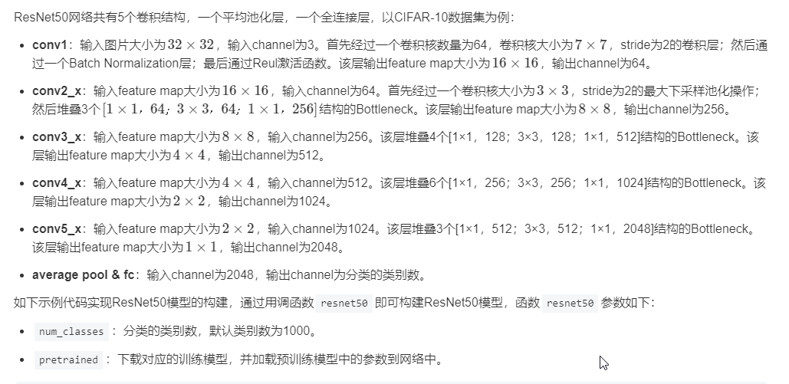当图像尺寸修改为128*128时，每一层网络的输出也相应扩大了4*4 =16倍
所以最终 平均池化全连接操作的输入也是原来的16倍，变成了2048*16 = 32768
4. 解决方案
因为代码里面会去加载预训练权重，而预训练权重是在图像32*32的情况下训练出来的，因此需要修改代码两处地方。
image_size = 32
vision.Resize((32, 32))
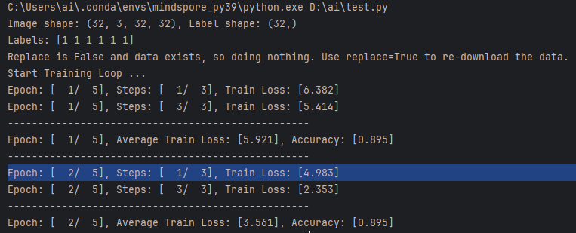

使用MindSpore的ops中的矩阵相乘算子进行int8的相乘运算时报错
1. 系统环境
硬件环境(Ascend/GPU/CPU): Ascend
软件环境: MindSpore 版本: 2.2.10
执行模式（静态图/动态图）： 不限
Python 版本: 3.7.6
操作系统平台: linux
2. 报错信息
2.1 问题描述
使用mindspore2.2的ops中的矩阵相乘算子进行int8的相乘运算时，出现以下报错。
2.2 报错信息
TypeError: For primitive[MatMul], the input argument[x] must be a type of {Tensor[BFloat16], Tensor[Float16], Tensor[Float32], Tensor[Int32], Tensor[Int64], Tensor[UInt8]}, but got Tensor[Int8].
2.3 脚本信息
import mindspore as ms
import mindspore.ops as ops
import numpy as np
x = ms.Tensor(np.ones([1,3]).astype(np.int8))
y = ms.Tensor(np.ones([3,1]).astype(np.int8))
op = ops.matmul
z = op(x,y)
print(z)
3. 根因分析
ascend上ops.matmul 不支持int8, 计算时会报错，目前2.2 版本ascend上只支持这些类型{Tensor[BFloat16], Tensor[Float16], Tensor[Float32], Tensor[Int32], Tensor[Int64], Tensor[UInt8]}。
4. 解决方案
修改输入dtype为支持的数据类型，Tensor[BFloat16], Tensor[Float16], Tensor[Float32], Tensor[Int32], Tensor[Int64], Tensor[UInt8] 这些都可以。
下面是以int32为例：
>>> >>> import mindspore as ms
>>> import mindspore.ops as ops
>>> import numpy as np
>>> x = ms.Tensor(np.ones([1,3]).astype(np.int32))
>>> y = ms.Tensor(np.ones([3,1]).astype(np.int32))
>>> op = ops.matmul
>>> z = op(x,y)
>>> print(z)
[[3]]

使用Mindspore模型训练时出现梯度为0现象
1. 系统环境
硬件环境(Ascend/GPU/CPU): Ascend/GPU/CPU
软件环境: MindSpore 版本: 2.2.0
执行模式（静态图/动态图）： 不限
Python 版本: 3.7.6
操作系统平台: linux
2. 报错信息
2.1 问题描述
使用Mindspore模型训练时出现梯度为0现象。
2.2 脚本信息
def forward_fn(inputs, targets):
logits = model(inputs)
loss = criterion(logits, targets)
return loss, logits
# get grad function
grad_fn = ms.value_and_grad(forward_fn, None, optimizer.parameters, has_aux=True)
# define train step function
def train_step(inputs, targets):
(loss, logits), grads = grad_fn(inputs, targets) # get values and gradients
print('grads=',grads)
optimizer(grads) # update gradient
return loss, logits
3. 根因分析
分析代码，梯度是在value_and_grad中获取的，看看官网的介绍，第三个位置的weight需要net.trainable_params() 获取，代码里的net是model。
4. 解决方案
修改
optimizer.parameters为 model.trainable_params()
# get grad function
grad_fn = ms.value_and_grad(forward_fn, None, model.trainable_params(), has_aux=True)

MindSpore开启summary报错ValueError: not enough values to unpack (expected 4, got 0)
1. 系统环境
硬件环境(Ascend/GPU/CPU): Ascend
软件环境: MindSpore 版本: 2.1.1
执行模式（静态图/动态图）： 不限
Python 版本: 3.7.6
操作系统平台: linux
2. 报错信息
2.1 问题描述
在Ascend+MindSpore2.1.1环境中，配置2机16卡全参训练，开启profile时可以启动训练，但是在使用profile收集性能数据时出现问题，报错如下。
2.2 报错信息
Thu 21 Sep 2023 11:00:57 [INFO] [MSVP] [2328699] msprof_common . py: start analyzing data in "/home/wizardcoder/ 1_wizardcoder-mindformers-916/research/output/profile/rank_15/p rofiler/ PROF_000001_20230921085903388_FMDGQIRGMNNQRFFB/device_7"
Thu 21 Sep 2023 11:00:57 [INFO] [MSVP] [2328699] msprof_common .py: It may take few minutes, please be patient Thu 21 sep 2023 11:01:07 [INFo] [MsvP] [2328699] msprof_common.py: Analysis data in "/home/wizardcode r/1_wizardcoder-mindformers -916/research/output/profile/rank_15/p rofiler/PROF_0€ 0001 20230921085903388 FMDGQIRGMNNQRFFB/device 7" finished [WARNING] ME(1932377:28147 3783364672, MainProcess): 2023-09-21- 11:04:05.598.182 [mindspore/pro filer/profiling.py:1102] [Profiler] Can not found cube fops and vector fops data in the
summary [WARNINGÍ ME (1932377:281473783364672, MainProcess):2023-09-21 -11:04:05.994.536 [mindspore/prof iler/parser/memory_usage_parser.py:135] The memory file does not exist! Please ignore th
warning if you are running heterogeneous training. [WARNING] ME(1932377:281473783364672,MainProcess):2023-09-21-11:04:05.994.877 [mindspore/profiler/profiling.py:1134l The file </home/wizardcoder/1_wizardcoder -mindformers-916/resear ch/output/profile/rank_15/profi ler/memory_usage_15.pb> not found "aceback (most recent call last): File "wizardcoder/run_wizardcoder.py", line 149, in <module>
device id=args.device id) File "wizardcoder/run wizardcoder.py", line 81, in main
task.train(train checkpo int=ckpt,resume=resume) File- "/home/wizardcoder/1_wizardcoder-mindformers-916/mindformers/trainer/trainer.py" , line 423, in train is full config=True — **kwargs) File " /home/wizardcoder/1 wizardcoder-mindformers-916/mindformers/t rainer/causal_language_modeling/causal_language_modeling.py", line 106, in train **kwargs) File "/home/wizardcoder/1_wizardcoder-mindformers-916/mindformers/t rainer/base_trainer.py", line 644, in training_process
initial epoch=config.runner_config.initial_epoch) File "/root/anaconda3/envs/wizardcoder/lib/python3.7/site-packages/mindspore/train/model.py" , line 1066, in train
initial epoch=init ial epoch) File "/root/anaconda3/envs/wizar dcoder/lib/python3.7/site-packages/mindspore/train/model.py" , line 113, in wrapper func(self. *args, **kwargs) File "/root/anaconda3/envs/wizardcode r/Lib/python3.7/site-packages/mindspore/t rain/model.py", line 613, in _train self. train process(epoch, train dataset, list callback, cb params, initial epoch, valid infos) File "/root/anaconda3/envs /wizardcoder/lib/python3.7/site-packages/mindspore/train/model.py", line 921, in _train_process list callback.on train_step_end(run context) File "7root/anaconda3/envs /wizardcoder/lib/python3.7/site-packages/mindspore/t rain/callback/_callback .py", line 412, in on_train_step_end
cb.on train step end( run context) File "/root/anaconda3/envs7wizardcode r/lib/python3.7/site-packages /mindspore/train/callback/_callback .py", line 254, in on_train_step_end self.step_end(run_context) File "/home7wizardcoder/1_wizardcoder-mindformers -916/mindformers/core/cal Lback/callback.py", line 630, in step_end self.profiler.analyse() File " "/root/anaconda3/envs/wizardcode r/lib/python3.7/site-packages/mindspore/profiler/profiling.py", line 579, in analyse self. ascend analyse()
File Cself.ascend graph analyse() /root/anacondas/enws/wizardeoder/Lib/pythona.7/site-packages/mindspore/prefiter/profiling. py, Line 970, in ascend anatys File "/root/anaconda3/envs /wizardcoder/lib/python3.7/site-packages /mindspore/profiler/profiling.py", line 1205, in ascend graph analyse self. ascend graph hccl analyse(source path) File "/root/anaconda3/envs/wizardcoder/lib/python3.7/site-packages/mindspore/profiler/profiling.py" . line 1153. in ascend graph hccl analyse
File "7root/anaconda3/envs/wizardcoder/lib/python3.7/s ite-packages/mindspore/profiler/parser/ascend_hccl _generator.py", line 148, in parse raw = self._iteration_analyse(hccl_detail data, iteration_ id) File "/root/anaconda3/envs/wizardcoder/lib/python3.7/site-packages/mindspore/profiler/parser/as cend hccl_generator.py", line 222, in _iteration_analyse link info = self. link info analyse(hccl detail data)
File "7root/anaconda3/envs/wizardcoder/lib/python3.7/site-packages/mindspore/profiler/parser/ascend_hccl_generator.py", line 247, in _link_info_analyse transport_information[ 'RDMA'] = self. rdma_analyse(groupby_t ransport)
File "/root7anaconda3/envs/wizardcoder/Tib/python3.7/site-packages/mindspore/profiler/parser/ascend _hcc l_generator.py", line 102, in _rdma_analyse
thread_groups, _, _, _ = np.unique(groupby_transport['tid']) ValueError: not enough values to unpack (expected 4, got 0)
3. 根因分析
应该和两机网络通信有关。
4. 解决方案
File "/root7anaconda3/envs/wizardcoder/Tib/python3.7/site-packages/mindspore/profiler/parser/ascend _hcc l_generator.py", line 102, in _rdma_analyse
thread_groups, _, _, _ = np.unique(groupby_transport['tid']) ValueError: not enough values to unpack (expected 4, got 0)
解决办法是把上面报错提示中的“_, _, _”去掉。

使用MindSpore实现梯度对数据求导retain_graph=True
1. 系统环境
硬件环境(Ascend/GPU/CPU): Ascend/GPU/CPU
软件环境: MindSpore 版本: 2.2.0
执行模式（静态图/动态图）： 不限
Python 版本: 3.7.6
操作系统平台: linux
2. 报错信息
2.1 问题描述
假设输入数据x和标签y，通过模型反向传播mindspore.gard获取到了模型的梯度g，现在需要将梯度g进行一定的运算（假设为f(g)），最后f(g)需要对最初的数据x进行求导，如果使用Torch的话，在求梯度g的时候只要 retain_graph=True，MindSpore该如何实现呢？
3. 解决方案
在第一次求梯度g的时候，不调用MindSpore的 NLLLoss() 即可，然而MindSpore自带的交叉熵损失也自动调用了 NLLLoss()，因此也需要重写。
def _loss_fn(self, logits, labels):
logs = ops.log(ops.softmax(logits))
loss = self._nll_loss(logs, labels)
return loss
def _nll_loss(self, logits, labels):
loss = [-logs[i, int(j)] for i, j in enumerate(labels)]
loss = ops.stack(loss).mean()
return loss

使用SummaryRecord记录计算图报错：Failed to get proto for graph.
1. 系统环境
硬件环境(Ascend/GPU/CPU): Ascend/GPU/CPU
软件环境: MindSpore 版本: 2.2.0
执行模式（静态图/动态图）： 不限
Python 版本: 3.7.6
操作系统平台: linux
2. 报错信息
2.1 问题描述
使用SummaryRecord记录计算图报错：Failed to get proto for graph.
2.2 报错信息
[ERROR] ME(21058:139964592719680,MainProcess):2024-03-03-14:51:26.699.488 [mindspore/train/summary/summary_record.py:384] Failed to get proto for graph.
[ERROR] ME(21058:139964592719680,MainProcess):2024-03-03-14:51:28.649.745 [mindspore/train/summary/summary_record.py:384] Failed to get proto for graph.
2.3 脚本信息
class AutoEncoderResNet(nn.Cell):
def __init__(self):
super().__init__()
self.logdir = "./log/AutoEncoder-ResNet"
if not os.path.exists(self.logdir):
os.makedirs(self.logdir)
num = len(os.listdir(self.logdir))
self.logdir = os.path.join(self.logdir,"summary_"+str(num))
self.encoder = ResNet(ResidualBlockBase,[3,4,6,3],512,512)
self.decoder = ResNetInv(ResidualBlockBaseInv,[3,4,6,3],512,512)
self.sigmoid = nn.Sigmoid()
def construct(self, x):
return self.decode(self.encode(x),False)
def train(self,batch=32,epoch=50):
from data.CIFAR10 import getCIFAR10
dataset = getCIFAR10()
dataset = dataset.batch(batch)
print("start training")
print("step per epoch:",len(dataset))
opt = nn.Adam(self.trainable_params(),learning_rate=1e-4)
loss_fn = nn.MSELoss()
def forward(image):
y_hat = self(image)
loss = loss_fn(y_hat,image)
return loss,y_hat
grad_fn = ms.value_and_grad(forward,None,opt.parameters,has_aux=True)
def train_step(image):
(loss, y_hat),grad = grad_fn(image)
opt(grad)
return loss,y_hat
import tqdm
weight_path = "./weights/AutoEncoder-ResNet"
if not os.path.exists(weight_path):
os.makedirs(weight_path)
from mindspore import SummaryRecord
with SummaryRecord(log_dir=self.logdir,network=self) as summary_writer:
summary_writer.set_mode("train")
......
3. 根因分析
PyNative模式导致报错Failed to get proto for graph.
4. 解决方案
将模型运行的模式设置为graph。
ms.set_context(mode=ms.GRAPH_MODE)
并将jit_level设置为o0

使用MindSpore的initializer生成的Tensor行为不符合预期
1. 系统环境
硬件环境(Ascend/GPU/CPU): Ascend/GPU/CPU
软件环境: MindSpore 版本: 2.3.0
执行模式（静态图/动态图）： 不限
Python 版本: 3.7.6
操作系统平台: linux
2. 报错信息
2.1 问题描述
y没有成功复制x而是变成了0。如果把x换成普通的Tensor就没问题。
2.2 脚本信息
from mindspore.common.initializer import initializer
n, m = 5, 3
x = initializer(init='normal', shape=(n, m))
y = x.copy()
print(x)
print(y)
输出如下：
[[-9.8994775e-03 -2.8827513e-05 -1.1877520e-02]
[-2.8584851e-03 -1.4535164e-02 -1.7329855e-02]
[-1.1603085e-03 2.8330029e-04 -8.1528882e-03]
[-1.4099754e-02 -1.1020763e-02 3.4321868e-03]
[ 1.7921604e-02 1.4062168e-02 -4.5925970e-03]]
[[0. 0. 0.]
[0. 0. 0.]
[0. 0. 0.]
[0. 0. 0.]
[0. 0. 0.]]
3. 根因分析
Initializer本意是用于在并行模式中延迟Tensor的数据的初始化，而非初始化Tensor。如果必须使用Initializer来初始化Tensor，大多情况下需要在初始化之后使用 mindspore.Tensor.init_data() 。
4. 解决方案
调用初始化接口 Tensor.init_data()
from mindspore.common.initializer import initializer
n, m = 5, 3
x = initializer(init='normal', shape=(n, m))
x.init_data()
y = x.copy()
print(x)
print(y)
结果如下：
[[ 0.00939345 0.00237236 -0.01005815]
[-0.00203028 0.00010801 0.00289919]
[ 0.00403657 -0.00706848 0.00969519]
[ 0.01585527 -0.01843719 -0.01486818]
[ 0.00146939 -0.00700254 -0.00083044]]
[[ 0.00939345 0.00237236 -0.01005815]
[-0.00203028 0.00010801 0.00289919]
[ 0.00403657 -0.00706848 0.00969519]
[ 0.01585527 -0.01843719 -0.01486818]
[ 0.00146939 -0.00700254 -0.00083044]]

MindSpore的VIT报错[OneHot] failed. OneHot: index values should not bigger than num classes: 100, but got: 100.
1. 系统环境
硬件环境(Ascend/GPU/CPU): Ascend/GPU/CPU
软件环境: MindSpore 版本: 2.0.0
执行模式（静态图/动态图）： 不限
Python 版本: 3.9
操作系统平台: linux
2. 报错信息
2.1 问题描述
使用Imagenet数据集，设置了100个类型的图片分类。
{'autoaugment': 1,
'backbone': 'vit_base_patch32',
'batch_size': 8,
'beta1': 0.9,
'beta2': 0.999,
'class_num': 100,
'config_path': 'vit_patch32_imagenet2012_config_standalone.yml',
'crop_min': 0.05,
'dataset_path': '/data/zx_cv/vit/models-master/VIT/cache/datasets/imagenet_cifa/tiny-new/datasets/train',
'enable_modelarts': 0,
'eval_batch_size': 4,
'eval_image_size': 224,
'eval_interval': 1,
'eval_num_workers': 2,
'eval_offset': -1,
'eval_path': '/data/zx_cv/vit/models-master/VIT/cache/datasets/imagenet_cifa/tiny-new/datasets/val',
'gc_flag': 0,
'interpolation': 'BILINEAR',
'keep_checkpoint_max': 3,
'label_smooth_factor': 0.1,
'loss_name': 'ce_smooth_mixup',
'loss_scale': 1024,
'lr_decay_mode': 'cosine',
'lr_init': 0.001,
'lr_max': 0.00044375,
'lr_min': 1e-08,
'max_epoch': 300,
'mixup': 0.2,
'no_weight_decay_filter': 'beta,bias',
'open_profiler': 0,
'opt': 'adamw',
'pretrained': '',
'save_checkpoint': 1,
'save_checkpoint_epochs': 8,
'save_checkpoint_path': './outputs',
'train_image_size': 224,
'train_num_workers': 1,
'use_label_smooth': 1,
'vit_config_path': 'src.vit.VitConfig',
'warmup_epochs': 0,
'weight_decay': 0.05}
Please check the above information for the configurations
standalone training
########################################
{'auto_tune': 0,
'autoaugment': 1,
'aux_factor': 0.4,
'backbone': 'vit_base_patch32',
'batch_size': 8,
'beta1': 0.9,
'beta2': 0.999,
'class_num': 100,
'config_path': 'vit_patch32_imagenet2012_config_standalone.yml',
'crop_min': 0.05,
'dataset_name': 'imagenet',
'dataset_path': '/data/zx_cv/vit/models-master/VIT/cache/datasets/imagenet_cifa/tiny-new/datasets/train',
'device_id': 0,
'device_num': 1,
'enable_modelarts': 0,
'eval_batch_size': 4,
'eval_engine': 'imagenet',
'eval_image_size': 224,
'eval_interval': 1,
'eval_num_workers': 2,
'eval_offset': 0,
'eval_path': '/data/zx_cv/vit/models-master/VIT/cache/datasets/imagenet_cifa/tiny-new/datasets/val',
'gc_flag': 0,
'interpolation': 'BILINEAR',
'keep_checkpoint_max': 3,
'label_smooth_factor': 0.1,
'local_rank': 0,
'logger': <LOGGER mindspore-benchmark (NOTSET)>,
'loss_name': 'ce_smooth_mixup',
'loss_scale': 1024,
'lr_decay_mode': 'cosine',
'lr_init': 0.001,
'lr_max': 0.00044375,
'lr_min': 1e-08,
'max_epoch': 300,
'mixup': 0.2,
'no_weight_decay_filter': 'beta,bias',
'open_profiler': 0,
'opt': 'adamw',
'poly_power': 2,
'pretrained': '',
'save_checkpoint': 1,
'save_checkpoint_epochs': 8,
'save_checkpoint_path': './outputs',
'seed': 1,
'split_point': 0.4,
'train_image_size': 224,
'train_num_workers': 1,
'use_label_smooth': 1,
'vit_config_path': 'src.vit.VitConfig',
'warmup_epochs': 0,
'weight_decay': 0.05}
########################################
get vit_config_path
split_point=0.4
============================================================
{'auto_tune': 0,
'autoaugment': 1,
'aux_factor': 0.4,
'backbone': 'vit_base_patch32',
'batch_size': 8,
'beta1': 0.9,
'beta2': 0.999,
'class_num': 100,
'config_path': 'vit_patch32_imagenet2012_config_standalone.yml',
'crop_min': 0.05,
'dataset_name': 'imagenet',
'dataset_path': '/data/zx_cv/vit/models-master/VIT/cache/datasets/imagenet_cifa/tiny-new/datasets/train',
'device_id': 0,
'device_num': 1,
'enable_modelarts': 0,
'eval_batch_size': 4,
'eval_engine': 'imagenet',
'eval_image_size': 224,
'eval_interval': 1,
'eval_num_workers': 2,
'eval_offset': 0,
'eval_path': '/data/zx_cv/vit/models-master/VIT/cache/datasets/imagenet_cifa/tiny-new/datasets/val',
'gc_flag': 0,
'interpolation': 'BILINEAR',
'keep_checkpoint_max': 3,
'label_smooth_factor': 0.1,
'local_rank': 0,
'logger': <LOGGER mindspore-benchmark (NOTSET)>,
'loss_name': 'ce_smooth_mixup',
'loss_scale': 1024,
'lr_decay_mode': 'cosine',
'lr_init': 0.001,
'lr_max': 0.00044375,
'lr_min': 1e-08,
'max_epoch': 300,
'mixup': 0.2,
'no_weight_decay_filter': 'beta,bias',
'open_profiler': 0,
'opt': 'adamw',
'poly_power': 2,
'pretrained': '',
'save_checkpoint': 1,
'save_checkpoint_epochs': 8,
'save_checkpoint_path': './outputs',
'seed': 1,
'split_point': 0.4,
'train_image_size': 224,
'train_num_workers': 1,
'use_label_smooth': 1,
'vit_config_path': 'src.vit.VitConfig',
'warmup_epochs': 0,
'weight_decay': 0.05}
============================================================
3. 根因分析
imagenet数据集是class=100，但是0-100表示的是101个类，不是100个类，所以需要设置成0-99。
4. 解决方案
将代码中的'class_num': 100,修改为'class_num': 99.
{'autoaugment': 1,
'backbone': 'vit_base_patch32',
'batch_size': 8,
'beta1': 0.9,
'beta2': 0.999,
'class_num': 99,
'config_path': 'vit_patch32_imagenet2012_config_standalone.yml',
'crop_min': 0.05,
'dataset_path': '/data/zx_cv/vit/models-master/VIT/cache/datasets/imagenet_cifa/tiny-new/datasets/train',
'enable_modelarts': 0,
'eval_batch_size': 4,
'eval_image_size': 224,
'eval_interval': 1,
'eval_num_workers': 2,
'eval_offset': -1,
'eval_path': '/data/zx_cv/vit/models-master/VIT/cache/datasets/imagenet_cifa/tiny-new/datasets/val',
'gc_flag': 0,
'interpolation': 'BILINEAR',
'keep_checkpoint_max': 3,
'label_smooth_factor': 0.1,
'loss_name': 'ce_smooth_mixup',
'loss_scale': 1024,
'lr_decay_mode': 'cosine',
'lr_init': 0.001,
'lr_max': 0.00044375,
'lr_min': 1e-08,
'max_epoch': 300,
'mixup': 0.2,
'no_weight_decay_filter': 'beta,bias',
'open_profiler': 0,
'opt': 'adamw',
'pretrained': '',
'save_checkpoint': 1,
'save_checkpoint_epochs': 8,
'save_checkpoint_path': './outputs',
'train_image_size': 224,
'train_num_workers': 1,
'use_label_smooth': 1,
'vit_config_path': 'src.vit.VitConfig',
'warmup_epochs': 0,
'weight_decay': 0.05}
Please check the above information for the configurations
standalone training
########################################
{'auto_tune': 0,
'autoaugment': 1,
'aux_factor': 0.4,
'backbone': 'vit_base_patch32',
'batch_size': 8,
'beta1': 0.9,
'beta2': 0.999,
'class_num': 99,
'config_path': 'vit_patch32_imagenet2012_config_standalone.yml',
'crop_min': 0.05,
'dataset_name': 'imagenet',
'dataset_path': '/data/zx_cv/vit/models-master/VIT/cache/datasets/imagenet_cifa/tiny-new/datasets/train',
'device_id': 0,
'device_num': 1,
'enable_modelarts': 0,
'eval_batch_size': 4,
'eval_engine': 'imagenet',
'eval_image_size': 224,
'eval_interval': 1,
'eval_num_workers': 2,
'eval_offset': 0,
'eval_path': '/data/zx_cv/vit/models-master/VIT/cache/datasets/imagenet_cifa/tiny-new/datasets/val',
'gc_flag': 0,
'interpolation': 'BILINEAR',
'keep_checkpoint_max': 3,
'label_smooth_factor': 0.1,
'local_rank': 0,
'logger': <LOGGER mindspore-benchmark (NOTSET)>,
'loss_name': 'ce_smooth_mixup',
'loss_scale': 1024,
'lr_decay_mode': 'cosine',
'lr_init': 0.001,
'lr_max': 0.00044375,
'lr_min': 1e-08,
'max_epoch': 300,
'mixup': 0.2,
'no_weight_decay_filter': 'beta,bias',
'open_profiler': 0,
'opt': 'adamw',
'poly_power': 2,
'pretrained': '',
'save_checkpoint': 1,
'save_checkpoint_epochs': 8,
'save_checkpoint_path': './outputs',
'seed': 1,
'split_point': 0.4,
'train_image_size': 224,
'train_num_workers': 1,
'use_label_smooth': 1,
'vit_config_path': 'src.vit.VitConfig',
'warmup_epochs': 0,
'weight_decay': 0.05}
########################################
get vit_config_path
split_point=0.4
============================================================
{'auto_tune': 0,
'autoaugment': 1,
'aux_factor': 0.4,
'backbone': 'vit_base_patch32',
'batch_size': 8,
'beta1': 0.9,
'beta2': 0.999,
'class_num': 99,
'config_path': 'vit_patch32_imagenet2012_config_standalone.yml',
'crop_min': 0.05,
'dataset_name': 'imagenet',
'dataset_path': '/data/zx_cv/vit/models-master/VIT/cache/datasets/imagenet_cifa/tiny-new/datasets/train',
'device_id': 0,
'device_num': 1,
'enable_modelarts': 0,
'eval_batch_size': 4,
'eval_engine': 'imagenet',
'eval_image_size': 224,
'eval_interval': 1,
'eval_num_workers': 2,
'eval_offset': 0,
'eval_path': '/data/zx_cv/vit/models-master/VIT/cache/datasets/imagenet_cifa/tiny-new/datasets/val',
'gc_flag': 0,
'interpolation': 'BILINEAR',
'keep_checkpoint_max': 3,
'label_smooth_factor': 0.1,
'local_rank': 0,
'logger': <LOGGER mindspore-benchmark (NOTSET)>,
'loss_name': 'ce_smooth_mixup',
'loss_scale': 1024,
'lr_decay_mode': 'cosine',
'lr_init': 0.001,
'lr_max': 0.00044375,
'lr_min': 1e-08,
'max_epoch': 300,
'mixup': 0.2,
'no_weight_decay_filter': 'beta,bias',
'open_profiler': 0,
'opt': 'adamw',
'poly_power': 2,
'pretrained': '',
'save_checkpoint': 1,
'save_checkpoint_epochs': 8,
'save_checkpoint_path': './outputs',
'seed': 1,
'split_point': 0.4,
'train_image_size': 224,
'train_num_workers': 1,
'use_label_smooth': 1,
'vit_config_path': 'src.vit.VitConfig',
'warmup_epochs': 0,
'weight_decay': 0.05}
============================================================

MindSpore使用run_pyscf跑量子化学时报错Invalid cross-device link
1. 系统环境
硬件环境(Ascend/GPU/CPU): Ascend/GPU/CPU
软件环境: MindSpore 版本: 2.0.0
执行模式（静态图/动态图）： 不限
Python 版本: 3.9
操作系统平台: linux
2. 报错信息
2.1 问题描述
MindSpore使用run_pyscf跑量子化学时报错Invalid cross-device link。
2.2 报错信息
Traceback (most recent call last):
File "/usr/lib/python3.7/shutil.py", line 566, in move
os.rename(src, real_dst)
OSError: [Errno 18] Invalid cross-device link: 'ddce6e68-a287-4612-91c1-775b3d9852b5.hdf5' -> '/usr/local/lib/python3.7/dist-packages/openfermion/testing/data/H1-Li1_sto3g_singlet.hdf5'
During handling of the above exception, another exception occurred:
Traceback (most recent call last):
File "fci.py", line 31, in <module>
run_fci=1
File "/usr/local/lib/python3.7/dist-packages/openfermionpyscf/_run_pyscf.py", line 205, in run_pyscf
pyscf_molecular_data.save()
File "/usr/local/lib/python3.7/dist-packages/openfermion/chem/molecular_data.py", line 846, in save
shutil.move("{}.hdf5".format(tmp_name), "{}.hdf5".format(self.filename))
File "/usr/lib/python3.7/shutil.py", line 580, in move
copy_function(src, real_dst)
File "/usr/lib/python3.7/shutil.py", line 266, in copy2
copyfile(src, dst, follow_symlinks=follow_symlinks)
File "/usr/lib/python3.7/shutil.py", line 121, in copyfile
with open(dst, 'wb') as fdst:
PermissionError: [Errno 13] Permission denied: '/usr/local/lib/python3.7/dist-packages/openfermion/testing/data/H1-Li1_sto3g_singlet.hdf5'
2.3 脚本信息
from openfermion.chem import MolecularData
from openfermionpyscf import run_pyscf
from mindquantum.core.gates import X
from mindquantum.core.circuit import Circuit
from mindquantum.core.operators import Hamiltonian
from mindquantum.simulator import Simulator
from mindquantum.algorithm.nisq import generate_uccsd
import mindspore as ms
ms.set_context(mode=ms.PYNATIVE_MODE, device_target="CPU")
dist = 1.5
geometry = [
["Li", [0.0, 0.0, 0.0 * dist]],
["H", [0.0, 0.0, 1.0 * dist]],
]
basis = "sto3g"
spin = 0
print("Geometry: \n", geometry)
molecule_of = MolecularData(
geometry,
basis,
multiplicity=2 * spin + 1
)
molecule_of = run_pyscf(
molecule_of,
run_scf=1,
run_ccsd=1,
run_fci=1
)
print("Hartree-Fock energy: %20.16f Ha" % (molecule_of.hf_energy))
print("CCSD energy: %20.16f Ha" % (molecule_of.ccsd_energy))
print("FCI energy: %20.16f Ha" % (molecule_of.fci_energy))
3. 根因分析
这是由于分子文件默认存储到了系统目录，权限不足导致的。
4. 解决方案
将data_directory='./'传入到MolecularData中。
from openfermion.chem import MolecularData
from openfermionpyscf import run_pyscf
from mindquantum.core.gates import X
from mindquantum.core.circuit import Circuit
from mindquantum.core.operators import Hamiltonian
from mindquantum.simulator import Simulator
from mindquantum.algorithm.nisq import generate_uccsd
import mindspore as ms
ms.set_context(mode=ms.PYNATIVE_MODE, device_target="CPU")
dist = 1.5
geometry = [
["Li", [0.0, 0.0, 0.0 * dist]],
["H", [0.0, 0.0, 1.0 * dist]],
]
basis = "sto3g"
spin = 0
print("Geometry: \n", geometry)
molecule_of = MolecularData(geometry, basis, multiplicity=2 * spin + 1, data_directory='./')
molecule_of = run_pyscf(
molecule_of,
run_scf=1,
run_ccsd=1,
run_fci=1
)
print("Hartree-Fock energy: %20.16f Ha" % (molecule_of.hf_energy))
print("CCSD energy: %20.16f Ha" % (molecule_of.ccsd_energy))
print("FCI energy: %20.16f Ha" % (molecule_of.fci_energy))

算子编译过程中报错A module that was compiled using NumPy 1.x cannot be run in Numpy 2.0.0 .
1. 系统环境
硬件环境(Ascend/GPU/CPU): Ascend/GPU/CPU
软件环境: MindSpore 版本: 2.0.0
执行模式（静态图/动态图）： 不限
Python 版本: 3.9
操作系统平台: linux
2. 报错信息
2.1 问题描述
算子编译过程中部分模块与numpy2.0版本不兼容。
(mindie) root@ubuntu:/usr/local/Ascend/MindIE-LLM/examples/models# source /usr/local/Ascend/MindIE-LLM/set_env.sh
A module that was compiled using NumPy 1.x cannot be run in Numpy 2.0.0 as it may crash. To support both with and 2.x versions of NumPy, modules must be compiled with NumPy 2.0.
Some module may need to rebuildinstead e.g. with 'pybind11>=2.12'.
If you are a user of the module, the easiest solution will be to downgrade to 'numpy<2' or try to upgrade the affected module.
We expect that some modules willoneed time to support NumPy 2.
Traceback (most recent call last): File "<string>", line 1, in <module>
File "/root/anaconda3/envs/mindie/l ib/python3. 10/site-packages/torch/_ init_.py", line 1382, in <modules>
from .functional import * # noqa: F403
File "/root/anaconda3/envs/m indie/l ib/python3.10/s ite-pac kages/torch/functional.py", line 7, in <module>
import torch.nn.functional as F
File "/root/anaconda3/envs/mindie/Lib/python3.10/stte-packages/torch/nn/_ init_.pyahen", line 1, in <module>
from .modules import * # noqa: F403
File "/root/anaconda3/envs/mindie/l ib/python3.10/site-packages/t orch/nn/modules/_init__.py" , line 35, in <module>
from .transformer import Trans formerEncoder, TransformerDecoder, \
File "/root/anaconda3/envs/mindie/lib/python3,10/site-packages/torch/nn/modules/transformer .py" , line 20, in <module>
device: torch.device = torch.deviceltorch. C. get default device( )), # torch.device('cpu')
/root/anaconda3/envs/mindie/tib/python3. 10/site-packages/torch/nn/modules/transformer .py:20: Userwarn ing: Failed to initialize NumPy: _ARRAY_APIenotfound, (Trigge red internally at /pytorch/torch/csrc/utils/tensor numpy.cpp:84.)
device: torch.device = torch.device( torch. C. get default device( )), # torch.device('cpu')
3. 根因分析
本机环境安装numpy 版本 2.X，但是安装的torch是在numpy 1.X版本下编译的，因此会报错。报错代码行
File "/root/anaconda3/envs/mindie/lib/python3,10/site-packages/torch/nn/modules/transformer .py" , line 20, in <module> device: torch.device = torch.deviceltorch. C. get default device( )), # torch.device('cpu')
具体报错信息里面也写的很明确
A module that was compiled using NumPy 1.x cannot be run in Numpy 2.0.0 as it may crash. To support both with and 2.x versions of NumPy, modules must be compiled with NumPy 2.0.
Some module may need to rebuildinstead e.g. with 'pybind11>=2.12'.
If you are a user of the module, the easiest solution will be to downgrade to 'numpy<2' or try to upgrade the affected module.
We expect that some modules willoneed time to support NumPy 2.
4. 解决方案
1.卸载numpy 2.X版本，安装numpy 1.X版本，例如1.21.2
pip uninstall numpy -y
pip install numpy==1.21.2
2.更新pytorch到最新版本
torch最新版本2.3.1应该已经加入了numpy 2.x的支持
不过其他组件有可能会报错，稳妥的解决版本还是方案1。

MindSpore神经网络训练中的梯度消失问题
1. 系统环境
硬件环境(Ascend/GPU/CPU): Ascend/GPU/CPU
软件环境: MindSpore 版本: 1.7.0
执行模式（静态图/动态图）： 不限
Python 版本: 3.7.6
操作系统平台: linux
2. 报错信息
2.1 问题描述
在使用MindSpore训练一个深层神经网络时，发现训练过程中的损失函数并没有显著下降。通过查看每一层的梯度，发现梯度逐渐变小，最终几乎为零，即出现了梯度消失的问题。
3. 解决方案
方法一：使用ReLU激活函数
ReLU（Rectified Linear Unit）激活函数可以有效缓解梯度消失问题。它在正区间的导数恒为1，从而避免了梯度消失。
方法二：批量归一化（Batch Normalization）
批量归一化通过在每一层之后对数据进行归一化，确保数据分布稳定，缓解梯度消失问题。
方法三：使用残差网络（Residual Network）
残差网络通过引入残差连接，使得梯度可以直接传递到前面的层，避免梯度消失。
实践代码
下面是使用MindSpore实现上述解决方案的代码示例。
1. 安装MindSpore
pip install mindspore
#### 2. 导入必要的库
```python
import mindspore
from mindspore import nn, Tensor, context
import numpy as np
context.set_context(mode=context.GRAPH_MODE, device_target="CPU")
3. 定义数据集
from mindspore.dataset import MnistDataset
def create_dataset(batch_size=32):
mnist_path = "./MNIST_Data"
train_dataset = MnistDataset(mnist_path, usage='train')
train_dataset = train_dataset.batch(batch_size)
return train_dataset
train_dataset = create_dataset()
4. 定义神经网络模型
使用ReLU激活函数和批量归一化。
class Net(nn.Cell):
def __init__(self):
super(Net, self).__init__()
self.conv1 = nn.Conv2d(1, 32, kernel_size=3, pad_mode='pad', padding=1)
self.bn1 = nn.BatchNorm2d(32)
self.relu = nn.ReLU()
self.pool = nn.MaxPool2d(kernel_size=2, stride=2)
self.flatten = nn.Flatten()
self.fc1 = nn.Dense(32*14*14, 128)
self.fc2 = nn.Dense(128, 10)
def construct(self, x):
x = self.pool(self.relu(self.bn1(self.conv1(x))))
x = self.flatten(x)
x = self.relu(self.fc1(x))
x = self.fc2(x)
return x
net = Net()
5. 定义损失函数和优化器
loss = nn.SoftmaxCrossEntropyWithLogits(sparse=True, reduction='mean')
optimizer = nn.Adam(net.trainable_params(), learning_rate=0.001)
6. 训练模型
model = mindspore.Model(net, loss_fn=loss, optimizer=optimizer, metrics={'accuracy'})
model.train(epoch=10, train_dataset=train_dataset, callbacks=[mindspore.LossMonitor()])
训练过程中的损失变化
使用以下代码记录训练过程中每一轮的损失值，并绘制损失曲线。
import matplotlib.pyplot as plt
class LossMonitor(mindspore.Callback):
def __init__(self):
super(LossMonitor, self).__init__()
self.losses = []
def step_end(self, run_context):
cb_params = run_context.original_args()
loss = cb_params.net_outputs
self.losses.append(loss.asnumpy())
print(f"loss: {loss.asnumpy()}")
loss_monitor = LossMonitor()
model.train(epoch=10, train_dataset=train_dataset, callbacks=[loss_monitor])
# 绘制损失曲线
plt.plot(loss_monitor.losses)
plt.xlabel('Steps')
plt.ylabel('Loss')
plt.title('Training Loss Curve')
plt.show()
结果分析
训练完成后，我们可以看到损失值逐渐减小，证明我们的解决方案有效缓解了梯度消失问题。
通过本文的实践，我们成功解决了MindSpore训练中的梯度消失问题。通过使用ReLU激活函数、批量归一化和残差网络等技术，我们不仅改善了模型的训练效果，也为后续的深层神经网络训练提供了参考。希望本文的经验和方法对大家在实际项目中有所帮助。

MindSpore报错：The supported input and output data types for the current operator are: node is Default/BitwiseAnd
1. 系统环境
硬件环境(Ascend/GPU/CPU): Ascend
软件环境: MindSpore 版本: 2.3.0
执行模式（静态图/动态图）： 不限
Python 版本: 3.8.5
操作系统平台: linux
2. 报错信息
2.1 报错信息
Traceback (most recent call last):
File "<stdin>", line 1, in <module>
File "/home/user/miniconda3/envs/ms/lib/python3.8/site-packages/mindspore/common/_stub_tensor.py", line 48, in fun
arg = (stub.stub_sync(),) + arg[1:]
File "/home/user/miniconda3/envs/ms/lib/python3.8/site-packages/mindspore/common/_stub_tensor.py", line 159, in stub_sync
val = self.stub.get_value()
TypeError: The supported input and output data types for the current operator are: node is Default/BitwiseAnd-op0
InputDesc [0] support {int16,int32,int64,int8,uint16,uint32,uint64,uint8,}
InputDesc [1] support {int16,int32,int64,int8,uint16,uint32,uint64,uint8,}
OutputDesc [0] support {int16,int32,int64,int8,uint16,uint32,uint64,uint8,}
But current operator's input and output data types is:
InputDesc [0] is Bool
InputDesc [1] is Bool
OutputDesc [0] is Bool
2.2 脚本信息
mask = (label_inds == gti) & (pos_mask > 0)
3. 根因分析
根据报错信息可以知道，BitwiseAnd算子不支持bool数据类型，因此
首先确认BitwiseAnd是哪个运算符输入的，通过将代码拆分，再次执行可以看到是 & 符号引入的
x = (label_inds == gti)
y = (pos_mask > 0)
mask = x & y
接下来确认数据类型：打印x和y的类型，可以看到x和y是bool类型的Tensor
4. 解决方案
基于上面已知的原因，很容易做出如下修改：
import mindspore as ms
x = (label_inds == gti).to(ms.int32)
y = (pos_mask > 0).to(ms.int32)
mask = (x & y).to(ms.bool_)
再次执行，模型可以顺利跑通。

MindSpore模型加载报错RuntimeError: build from file failed! Error is Common error code.
1. 系统环境
硬件环境(Ascend/GPU/CPU): Ascend
软件环境: MindSpore 版本: 2.2.13
执行模式（静态图/动态图）： 不限
Python 版本: 3.9
操作系统平台: linux
2. 报错信息
2.1 问题描述
运行mindspore/mindspore/lite/examples/cloud_infer/quick_start_python/quick_start_cloud_infer_python.py脚本时，输出结果和文档也一致，但是运行过程会报warning:
2.2 报错信息
[WARNING] LITE( 14505, 7f48893eb680,python3):2024-07-31-14:45:46.239.787 [mindspore/lite/tools /optimizer/common/gllo_ut ils.cc:1107] GenTransposeNode] Convert abstract failed for node: Default/backbone-MobileNetV2Backbone/features- Sequent ialCell/0-ConvBNReLU/features -SequentialCell/1 -BatchNorm2d/TupleGetI tem-op192_post [WARNING] LITE(14505,7f48893eb680 ,python3):2024-07-31-14:45:46.239.808 [mindspore/lite/tools/optimizer/common/gllo_utils.cc:1107] GenTransposeNode] Convert abstract failed for node: Default/backbone-MobileNetV2Backbone/features -Sequent ialCell/17-InvertedResidual/conv-Sequent ialcell/2 -Conv2d/Conv2D-op194_pre_0
[WARNING] LITE(14505,7f48893eb680 ,python3):2024-07-31-14:45:46.239.828 [mindspore/l ite/tools/optimizer/common/gllo_utils.cc:1107] GenTransposeNode] Convert abstract failed for node: Default/backbone-Mob ileNetV2Backbone/features -Sequentialcel l/17-InvertedRes idual/conv-SequentialCell/2-Conv2d/Conv20-op194_post [WARNING] LITE( 14505,7f48893eb680 ,python3):2024-07-31-14:45:46.239.848 [mindspore/l ite/tools/opt imizer/common/gl lo_utils.cc:1107] GenTransposeNode] Convert abstract failed for node: Default/backbone-MobileNetV2Backbone/features -Sequent ialCell/17-InvertedRes idual/conv-Sequent ialcell/3-BatchNo rm2d/BatchNorm-op195_pre_0 [WARNING] LITE(14505, 7f48893eb680,python3):2024-07-31-. 14:45:46.239.869 [mindspo re/lite/tools/optimizer/common/gllo_utils.cc:1107] GenTransposeNode] Convert abstract failed for node: Default/backbone-MobileNetV2Backbone/features- SequentialCell/0-ConvBNReLU/features -SequentialCell/1 -BatchNorm2d/TupleGetI tem-op196_post [WARNING] LITE( 14505,7f48893eb680,python3):2024-07-31-i4:45:46.239.889 [mindspore/lite/ tools/opt imizer/common/gllo_utils.cc:1107] GenTransposehlode] Convert abstract failed for node: Default/backbone-MobileNetV2Backbone/features -Sequent ialCell/18-ConvBNReLU/features-Sequentialcell/0-Conv2d/Conv2D-op197_pre_0 [WARNING] LITE(14505,7f48893eb680, python3):2024-07-31-14:45:46.239.909 [mindspore/lite/tools/optimiz er/common/gllo_utils.cc:1107] GenTransposeNode] Convert abstract failed for
node: Default/backbone-Mob ileNetV2Backbone/features-SequentialCell/18 -ConvBNReLU/features -Sequent ialCell/0-Conv2d/Conv2D-op197_post
[WARNING] LITE(14505,7f48893eb680,python3):2024-07-31-14:45:46.239.929 [mindspore/lite/tools /optimizer/common/gllo_ut ils.cc:1107] GenTransposeNode] Convert abstract failed for
node: Default/backbone-Mob ileNetV2Backbone/features -SequentialCell/18 -ConvBNReLU/features -SequertialCell/1-BatchNorm2d/BatchNorm-op198_pre_0
[WARNING] LITE( 14505,7f48893eb680 ,python3):2024-07-31-14:45:46.239.950 [mindspore/lite/ tools/optimizer/common/gllo_utils . cc:1107] GenTransposeNode] Convert abstract failed for node: Default/backbone-MobileNetV2Backbone/features- SequentialCell/0-ConvBNReLU/features -SequentialCell/1-BatchNorm2d/TupleGetItem-op199_post
[WARNING] LITE( 14505,7f48893eb680 ,python3):2024-07-31-14:45:46.893.990 [mindspore/l ite/tools/optimizer/common/gllo_utils.cc:1107] GenTransposeNode] Convert abstract failed for
node: Default/backbone-MobileNetV2Backbone/featu res-SequentialCell/0-ConvBNReLU/features -SequentialCell/0-Conv2d/Conv2D-opO_pre_0
[WARNING] ME( 14505,7f48893eb680 ,python3):2024-07-31-14:45:46.927.145 [mindspore/l ite/src/extendrt/numa_adapter . cc:36] NUMAAdapter] Open libnuma.so failed!try libnuma.so.1 aga in
tensor's name is:shape1 data size is:4000 tensor elements num is:1000
output data is: 5.3937547e-05 0.00037763786 0.00034193686 0.00037316754 0.00022436169 9.953917e-05 0.00025308868 0.00032044895 0.00025788433 0.00018915901 0.00079509866 0.00338
2262 0.0016214572 0.0010760546 0.0023826156 0.0011769629 0.00088481285 0.000534926 0.0006929171 0.0010826243 0.0005747609 0.0014443205 0.0010454883 0.0016276307 0.00034437355 0
.0001039985 0.00022641376 0.00035307938 0.00014567627 0.00051178376 0.00016933997 0.00075814105 9.704676e-05 0.00066705025 0.00087511574 0.00034623547 0.00026317223 0.000319407
0.0015627446 0.0004044049 0.0008798965 0.0005202293 0.00044808138 0.0006453716 0.00044969268 0.0003431648 0.0009871059 0.00020436312 7.405098e-05 8.805057e-05
当把例子中的设备从cpu改成ascend，在构建模型处报错：
[ERROR] ME( 15817,7f6610386680,python3):2024-07-31-16:28: 16.656.831_ [mindspore/l ite/src/extendrt/kernel /ascend/plugin/ascend_kernel_plugin.cc:50] Register] DLSo0pen failed, so p ath: /usr/local/python3.7.5/lib/python3.7/site-packages/mindspore_lite/l ib/libascend kernel_plugin.so
[ERROR] ME( 15817,7f6610386680,python3):2024-07-31-16:28: 16.656.840 [mindspore/lite/src/extendrt/sess ion/s ingle_op_sess ion.cc:56] AscendInit] Failed to register Ascend plugin
[ERROR] ME( 15817,7f6610386680,Python3):2024-07-31-16:28:16.656.855 [mindspore/lite/src/extendrt/sess ion/s ingle_op_sess ion.cc:84] Init] Init ascend failed. ERROR] ME( 15817,7f6610386680,python3):2024-07-31- 16:28: 16.656.866 [mindspore/lite/src/extendrt/session/single_op_sess ion.cc:559] Single0psess ionCreator] Init session failed.
(ERROR] ME( 15817,7f6610386680,python3):2024-07-31-16:28:16.656.878 [mindspore/lite/src/extendrt/cxx_api/model/model_impl.cc:375] BuildByBufferImpl] Create sess ion failed.
Traceback (most recent call last):
File "quick_start_cloudinfer_python.py", line 31, in <module>
model.build_from_file(MODEL PATH , mslite.ModelType.MINDIR, context
File "/usr/local/python3.7.5/T ib/python3.7/s ite-packages/mindspore_lite/model.py", line 111, in wrapper
return func(*args, **kwargs
File "/usr/local/python3.7.5/1 ib/python3.7/s ite-packages/mindspore_l ite/model.py", line 263, in build_from_file
f"build_from_file failed! Error is {ret.ToString( )}")
RuntimeError:build from file - failed! Error is Common error code.
3. 根因分析
从报错信息Register] DLSo0pen failed, so path: /usr/local/python3.7.5/lib/python3.7/site-packages/mindspore_lite/lib/libascend kernel_plugin.so
可以看出是昇腾CANN环境变量未设置
4. 解决方案
执行cann安装目录下的set_env.sh。

MindSpore模型转换报错RuntimeError: Can not find key SiLU in convert nap. Exporting SiLU operator is not yet supported.
1. 系统环境
硬件环境(Ascend/GPU/CPU): Ascend/GPU/CPU
软件环境: MindSpore 版本: 2.2.10
执行模式（静态图/动态图）： 不限
Python 版本: 3.8
操作系统平台: linux
2. 报错信息
2.1 问题描述
在用mindspore的如下脚本加载模型保存文件的时候，出现了如下报错。
2.2 报错信息
Traceback (most recent call last):
File "C: \Users\24305\PycharmProjec1tslyolov5_6ltrainlonnx.py" , line 86, in <module>
ms.export(model, input_tensor, file_name='lenet', f ile_format='ONNX')
File "C:\Users\24305\.anacondalenvs\mindspore_py39_2.2.10\lib\site-packages\mindspore\trainlserialization.py", line 1659, in export
Lexport(net, file_name, file_format, *inputs, ★*kwargs)
File "C: \Users124305\.anacondalenvs\mindspore py39_2.2.10\lib\site-packages\mindsporeltra.inlserialization.py", line 1713, in _export
_save_onnx(net, file_name, ★inputs, **kwargs)
File "c: \users\24305\.anacondalenvslmindspore_py39_2.2.10\lib\site-packagesImindsporeltrainlserialization.py", line 1770, in _save_onnx
onnx_stream = _executor.-get_func_graph_proto(net, graph_id)
File "C: \Users\24305\.anaconda\envsAmindspore_py39_2.2.10\liblsite-packages\mindsporelcommonlapi.py", line 1667, in _get_func_graph_proto
return self._graph_executor.get_func_graph_proto(exec_id, ir_type, incremental)
RuntimeError: Can not find key SiLU in convert nap. Exporting SiLU operator is not yet supported.
2.3 脚本信息
ckpt_file = 'C:/Users/24305/PycharmProjects/yolov5_6/train/runs/2024.09.03-10.11.55/weights/yolov5s-6_8.ckpt'
param_dict = load_checkpoint(ckpt_file)
load_param_into_net(model, param_dict)
input_tensor = Tensor(np.ones([1, 3, 256, 256]).astype(np.float32))
ms.export(model, input_tensor, file_name='lenet', file_format='ONNX')
print("ONNX model exported successfully.")
3. 根因分析
上面报错是转换过程中无法转换SiLU算子
查看相关文档https://mindspore-lab.github.io/mindyolo/zh/tutorials/deployment/#_11
导出ONNX需要调整nn.SiLU算子，采用sigmoid算子底层实现
4. 解决方案
此处需要修改mindyolo的代码实现，mindyolo/models/layers/conv.py里面的nn.SiLU()
添加如下自定义层并替换mindyolo中所有的nn.SiLU
class EdgeSiLU(nn.Cell):
"""
SiLU activation function: x * sigmoid(x). To support for onnx export with nn.SiLU.
"""
def __init__(self):
super().__init__()
def construct(self, x):
return x * ops.sigmoid(x)

MindSpore报错Kernel launch failed, msg: Acl compile and execute failed, op_type_:AvgPool3D
1. 系统环境
硬件环境(Ascend/GPU/CPU): Ascend
软件环境: MindSpore 版本: 2.3.0
执行模式（静态图/动态图）： 不限
Python 版本: 3.8
操作系统平台: linux
2. 报错信息
2.1 问题描述
执行如下脚本时报错。
2.2 报错信息
[ERROR] KERNEL (110510, ffff9e802ebe, python) :2024-@9-19-10:20:53.977.250 [mindspore/ccsrc/plugin/device/ascend/kernel/acl/acl_kernel_mod.cc:261] Launch] Kernel launch failed, msg: Acl compile and execute failed, op_type_:AvgPoo0l13D
2.3 脚本信息
x = ops.randn((1,216,64,64), dtype=ms.float32)
out = ops.avg_pool2d(x, 2, stride=2, ceil_mode=True)
print(out.shape)
3. 根因分析
报错详细信息如下
[ERROR] KERNEL(100,fffe38f9f120,python):2024-10-28-14:49:50.966.185 [mindspore/ccsrc/plugin/device/ascend/kernel/acl/acl_kernel_mod.cc:260] Launch] Kernel launch failed, msg: Acl compile and execute failed, op_type_:AvgPool3D
上面的报错是调用cann的AvgPool3D报错。这该是和cann对接的问题，是mindspore实现的问题。
avg_pool2d的实现如下，最终调用了AvgPool3D算子。而avg_pool3d在Ascend下同样存在问题。在CPU下是正常的。
if not isinstance(input_x, (Tensor, Tensor_)):
raise TypeError("For avg_pool2d, the input input_x must be tensor")
kernel_size = _check_avgpool_2d_kernel_size(kernel_size)
stride = _check_avgpool_2d_stride(stride)
padding = _check_avgpool_2d_padding(padding)
_check_avg_pool2d_type_and_value(ceil_mode, count_include_pad, divisor_override)
squeeze_op = _get_cache_prim(P.Squeeze)(2)
avg_pool_op = _get_cache_prim(P.AvgPool3D)(kernel_size=kernel_size,
strides=stride,
pad_mode='pad',
pad=padding,
ceil_mode=ceil_mode,
count_include_pad=count_include_pad,
divisor_override=divisor_override)
input_x = expand_dims_(input_x, 2)
input_x = avg_pool_op(input_x)
input_x = squeeze_op(input_x)
return input_x
4. 解决方案
除了ops的avg_pool2d，nn层也同样有mindspore.nn.AvgPool2d的实现。
https://www.mindspore.cn/docs/zh-CN/r2.3.1/api_python/nn/mindspore.nn.AvgPool2d.html?highlight=avgpool2d
注意ceil_mode=True也不能设置。因为底层对应cann只支持输入为NCHW格式。
import mindspore as ms
from mindspore import ops
import numpy as np
pool = ms.nn.AvgPool2d(kernel_size=2, stride=2)
x = ops.randn((1,216,64,64), dtype=ms.float32)
output = pool(x)
print(output.shape)

MindSpore报错“ValueError: For 'MatMul', the input dimensions必须相等
1. 系统环境
硬件环境(Ascend/GPU/CPU): Ascend/GPU/CPU
软件环境: MindSpore 版本: 1.6.0
执行模式（静态图/动态图）： 不限
Python 版本: 3.7
操作系统平台: linux
2. 报错信息
2.1 问题描述
训练脚本是通过构建MatMul的单算子网络，对输入的两个张量计算矩阵乘积。脚本如下：
2.2 报错信息
The function call stack (See file '/rank_0/om/analyze_fail.dat' for more details):
# 0 In file demo.py(06)
out = ops.matmul (x1, x2)
^
# 1 In file /lib/python3.7/site-packages/mindspore/ops/composite/math_ops.py(810)
if not _check_same_type(dtype1, dtype2):
^
# 2 In file /lib/python3.7/site-packages/mindspore/ops/composite/math_ops.py(824)
if F.rank(x2) == 2:
# 3 In file /lib/python3.7/site-packages/mindspore/ops/composite/math_ops.py(825)
if F.rank(x1) &gt; 2:
# 4 In file /lib/python3.7/site-packages/mindspore/ops/composite/math_ops.py(827)
res = P.MatMul(False, transpose_b)(x1, x2)
^
Traceback (most recent call last):
File &quot;demo.py&quot;, line 12, in &lt;module&gt;
out = net(x1, x2)
File &quot;/lib/python3.7/site-packages/mindspore/nn/cell.py&quot;, line 586, in __call__
out = self.compile_and_run(*args)
File &quot;/lib/python3.7/site-packages/mindspore/nn/cell.py&quot;, line 964, in compile_and_run
self.compile(*inputs)
File &quot;/lib/python3.7/site-packages/mindspore/nn/cell.py&quot;, line 937, in compile
_cell_graph_executor.compile(self, *inputs, phase=self.phase, auto_parallel_mode=self._auto_parallel_mode)
File &quot;/lib/python3.7/site-packages/mindspore/common/api.py&quot;, line 1040, in compile
result = self._graph_executor.compile(obj, args_list, phase, self._use_vm_mode())
File &quot;/lib/python3.7/site-packages/mindspore/ops/primitive.py&quot;, line 467, in __check__
fn(*(x[track] for x in args))
File &quot;/lib/python3.7/site-packages/mindspore/ops/operations/math_ops.py&quot;, line 1430, in check_shape
raise ValueError(f&quot;For '{cls_name}', the input dimensions must be equal, but got 'x1_col': {x1_col} &quot;
ValueError: For 'MatMul', the input dimensions must be equal, but got 'x1_col': 12800 and 'x2_row': 10. And 'x' shape [32, 12800](transpose_a=False), 'y' shape [10, 1280](transpose_b=False).
2.3 脚本信息
class Net(nn.Cell):
def __init__(self):
super(Net, self).__init__()
def construct(self, x1, x2):
out = ops.matmul (x1, x2)
return out
net = Net()
x1 = Tensor(np.arange(32*12800).reshape(32, 12800), mindspore.float32)
x2 = Tensor(np.arange(10*1280).reshape(10, 1280), mindspore.float32)
out = net(x1, x2)
print('out',out.shape)
3. 根因分析
我们来看报错信息，在ValueError中，写到the input dimensions must be equal, but got 'x1_col': 12800 and 'x2_row': 10，结合官网对matmul算子的介绍(如下图)，即x1的最后一个维度和x2的倒数第二个维度需要保持一致，可知我们输入的x1、x2对应位置的维度12800、10不满足计算要求。
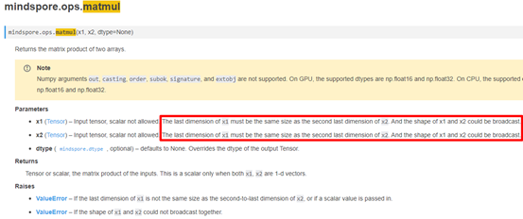
当然，在出现类似shape不匹配的问题时，通常在报错日志中会打印相应的图结构调用栈信息，也可以先从调用栈信息尝试定位错误位置。调用栈信息不够清晰时，可以考虑参考analyze_fail.dat文件辅助分析。
4. 解决方案
基于上面已知的原因，很容易做出如下修改：
class Net(nn.Cell):
def __init__(self):
super(Net, self).__init__()
def construct(self, x1, x2):
out = ops.matmul (x1, x2)
return out
net = Net()
x1 = Tensor(np.arange(32*12800).reshape(32, 12800), mindspore.float32)
x2 = Tensor(np.arange(10*1280).reshape(10, 1280), mindspore.float32)
out = net(x1, x2)
print('out',out.shape)
此时执行成功，输出如下：
out（32，1280）

类型报错： 编译报错，编译时报错 “Shape Join Failed”
1. 系统环境
硬件环境(Ascend/GPU/CPU): GPU
软件环境: MindSpore 版本: 2.0.0
执行模式（静态图/动态图）： 静态图
Python 版本: 3.7.5
操作系统平台: linux
2. 报错信息
2.1 问题描述
在环境配置完毕后，开始执行下面的代码，出现Shape Join Failed。
2.2 报错信息
Traceback (most recent call last):
File "D:/ai.py", line 24, in
out = net(input_x, input_a, input_b)
File "D:\python3.7\lib\site-packages\mindspore\nn\cell.py", line 622, in __call__
out = self.compile_and_run(*args)
File "D:\python3.7\lib\site-packages\mindspore\nn\cell.py", line 1007, in compile_and_run
self.compile(*inputs)
File "D:\python3.7\lib\site-packages\mindspore\nn\cell.py", line 979, in compile
jit_config_dict=self._jit_config_dict)
File "D:\python3.7\lib\site-packages\mindspore\common\api.py", line 1147, in compile
result = self._graph_executor.compile(obj, args_list, phase, self._use_vm_mode())
RuntimeError: Cannot join the return values of different branches, perhaps you need to make them equal.
Shape Join Failed: shape1 = (2, 3, 4, 5), shape2 = ().
For more details, please refer to https://www.mindspore.cn/search?inputValue=Shape%20Join%20Failed
Inner Message:
The abstract type of the return value of the current branch is AbstractTensor(shape: (), element: AbstractScalar(Type: Float32, Value: AnyValue, Shape: NoShape), value_ptr: 000001D93E556DB0, value: AnyValue), and that of the previous branch is AbstractTensor(shape: (2, 3, 4, 5), element: AbstractScalar(Type: Float32, Value: AnyValue, Shape: NoShape), value_ptr: 000001D93E556DB0, value: AnyValue).
The node is @Default.6:[CNode]7{[0]: @Default.6:[CNode]8{[0]: ValueNode Switch, [1]: [CNode]13, [2]: ValueNode ?Default.4, [3]: ValueNode ?Default.5}}, true branch: ?Default.4, false branch: ?Default.5
----------------------------------------------------
- The Traceback of Net Construct Code:
----------------------------------------------------
The function call stack (See file 'D:\rank_0\om/analyze_fail.dat' for more details. Get instructions about `analyze_fail.dat` at https://www.mindspore.cn/search?inputValue=analyze_fail.dat):
# 0 In file D:/ai.py:15
if a > b:
----------------------------------------------------
- C++ Call Stack: (For framework developers)
----------------------------------------------------
mindspore\ccsrc\pipeline\jit\static_analysis\static_analysis.cc:877 mindspore::abstract::AnalysisEngine::ProcessEvalResults
2.3 脚本信息
import numpy as np
import mindspore as ms
import mindspore.ops as ops
from mindspore import nn, Tensor, context
context.set_context(mode=context.GRAPH_MODE)
class Net(nn.Cell):
def __init__(self):
super().__init__()
self.relu = ops.ReLU()
self.reducesum = ops.ReduceSum()
def construct(self, x, a, b):
if a > b:
return self.relu(x)
else:
return self.reducesum(x)
input_x = Tensor(np.random.rand(2, 3, 4, 5).astype(np.float32))
input_a = Tensor(2, ms.float32)
input_b = Tensor(6, ms.float32)
net = Net()
out = net(input_x, input_a, input_b)
3. 根因分析
静态图模式下，Python代码并不是由Python解释器去执行，而是将代码编译成静态计算图，然后执行静态计算图。MindSpore支持的控制流语法涉及if语句、for语句以及while语句。
RuntimeError: Cannot join the return values of different branches, perhaps you need to make them equal.
Shape Join Failed: shape1 = (2, 3, 4, 5), shape2 = ().
由报错信息可知，报错原因是if语句不同分支返回值的维度shape不一致:一个是2*3*4*5的四位Tensor，另一个是标量，导致编译报错。
4. 解决方案
ReduceSum默认情况下，输出Tensor各维度上的和，以达到对所有维度进行归约的目的。
可以通过指定 keep_dims 参数，来控制输出和输入的维度是否相同。
将代码中的
self.reducesum = ops.ReduceSum()
修改为
self.reducesum = ops.ReduceSum(keep_dims=True)

Asttokens版本稳定性性的问题
1. 系统环境
硬件环境(Ascend/GPU/CPU): Ascend/GPU/CPU
软件环境: MindSpore 版本: 2.0.4
执行模式（静态图/动态图）： 不限
Python 版本: 3.8
操作系统平台: linux
2. 报错信息
2.1 问题描述
Asttokens版本稳定性性的问题，2.0.4版本会出现以下的报错信息。
2.2 报错信息
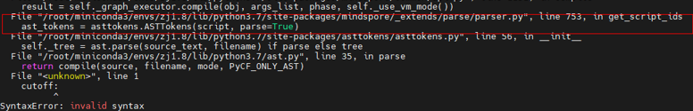
3. 根因分析
在MindSpore1.7.0版本下动静态图模式下可以在计算过程中使用python的一些内置函数比如weight()和axis()等方法，在1.7.0以上版本的静态图模式下必须将相关的调用接口替换成mindspore的内置接口后才可以运行比如原生numpy中的方法会有以下类似的报错出现。
4. 解决方案
而在动态图模式下是没有相关问题出现：
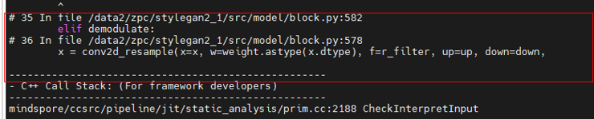
当把numpy中的方法替换成mindspore.numpy后静态图模式下可以正常运行。

[MindSpore报错ValueError: x rank in NLLLoss should be int and must in [1, 2], but got 4 with type `int]
1. 系统环境
硬件环境(Ascend/GPU/CPU): Ascend/GPU/CPU
软件环境: MindSpore 版本: 1.6.0
执行模式（静态图/动态图）： 不限
Python 版本: 3.7.6
操作系统平台: linux
2. 报错信息
2.1 问题描述
根据标杆torch算子NLLLoss的用例，编写输入为(N, C, d1, d2)的用例，脚本如下：
2.2 报错信息
01 loss = nn.NLLLoss()
02 input = torch.randn(5, 4, 8, 8)
03 m = nn.LogSoftmax(dim=1)
04 target = torch.empty(5, 8, 8, dtype=torch.long).random_(0, 4)
05 loss = loss(m(input), target)
06 print('torch_loss',loss)
07
08 m = mn.LogSoftmax(axis=1)
09 loss = ops.NLLLoss()
10 input = Tensor(np.random.randn(5, 4,8,8), mindspore.float32)
11 labels = Tensor([1, 0,1, 1], mindspore.int32)
12 weight = Tensor(np.random.rand(5,8,8), mindspore.float32)
13 loss, weight = loss(m(input), labels, weight)
14 print('mindspore_loss:',loss)
2.3 脚本信息
Traceback (most recent call last):
File demo.py, line 13, in &lt;module&gt;
loss, weight = loss(m(input), labels, weight)
…
File &quot;/lib/python3.7/site-packages/mindspore/_checkparam.py&quot;, line 238, in check_int
return check_number(arg_value, value, rel, int, arg_name, prim_name)
File &quot; /lib/python3.7/site-packages/mindspore/_checkparam.py&quot;, line 168, in check_number
raise type_except(f'{prim_info} should be {arg_type.__name__} and must {rel_str}, '
ValueError: `x rank` in `NLLLoss` should be int and must in [1, 2], but got `4` with type `int
3. 根因分析
在MindSpore 1.6版本，利用对标算子的用例编写输入为(N, C, d1, d2)的用例。先看报错信息，在ValueError中，写到x rank in NLLLos should be int and must in [1, 2], but got 4 with type int，意思是传的NLLLoss的x_rank参数应该为int，而且应该在[1, 2]之间，但是你传进去的是int类型的4，由报错行数line13，检查传入数据可知我们传入了为4维的(5, 4, 8, 8)，而torch传入该类型数据能支持，这是由于目前MindSpore暂不支持(N,C,d1,d2,...,dK) with K≥1类型，这点在旧版本的PyTorch与MindSpore API映射对比中描述为功能一致，此处文档有误(见下图)，目前标杆算子和MindSpore框架支持的NLLLoss算子功能存在一定差异，MindSpore目前只支持 shape为(N,C)的数据(如下图所示)。
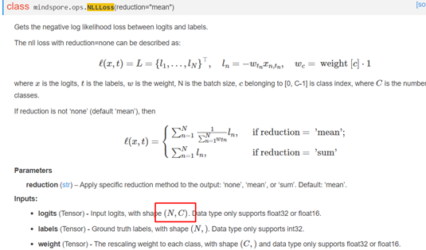
在新版本中的描述中已经进行修改。参考链接为：https://www.mindspore.cn/docs/migration_guide/zh-CN/r1.5/api_mapping/pytorch_diff/NLLLoss.html 。
4. 解决方案
基于上面已知的原因，该算子存在部分输入不支持的情况，目前需要用户自己封装。

MindSpore PyNative模式下The pointer[top_cell_] is null错误
1. 系统环境
硬件环境(Ascend/GPU/CPU): Ascend/GPU/CPU
软件环境: MindSpore 版本: 2.2.10
执行模式（静态图/动态图）： 不限
Python 版本: 3.8
操作系统平台: linux
2. 报错信息
2.1 问题描述
MindSpore动态图下可以使用自定义数据集进行网络训练，但是当使用自定义数据集时，一不小心就会出现以下错误：
2.2 报错信息
3. 根因分析
当出现该错误时，只是看到有一个指针为空了，但是python的调用栈却是在数据集里面。于是打开相应的自定义数据集脚本：/home/cjj/models/official/cv/warpctc/src/dataset.py(57)
发现此处有一个 image += 1.0的tensor操作。于是将该操作删除后，发现程序正常运行。
该错误根因隐藏较深，由于MindSpore框架对于单算子的执行只支持单线程操作，但是在自定义数据集__getitem__函数中使用了Tensor的运算操作，即会调到框架的算子执行，由于数据集的处理使用了多线程操作，因此导致整体的执行顺序错乱，出现空指针的错误。因此到看到空指针错误且错误在generator.cc中时，就是在数据集中错误使用了Tensor的运算操作。
4. 解决方案
1、根据提示的调用栈信息，找到自定义数据集脚本中出错的位置。
2、将自定义数据集中的Tensor操作改为使用原生numpy进行计算。

MindSpore报错ERROR:PyNative Only support STAND_ALONE,DATA_PARALLEL and AUTO_PARALLEL under shard function for ParallelMode
1. 系统环境
硬件环境(Ascend/GPU/CPU): Ascend
软件环境: MindSpore 版本: 1.6.1
执行模式（静态图/动态图）： 动态图
Python 版本: 3.7.5
操作系统平台: linux
2. 报错信息
2.1 问题描述
当PyNative模式下配置为SEMI_AUTO_PARALLEL模式，遇到报错PyNative Only support STAND_ALONE, DATA_PARALLEL and AUTO_PARALLEL under shard function for ParallelMode, but got SEMI_AUTO_PARALLEL。
2.2 test.py文件内容
import mindspore.dataset as ds
import mindspore.communication.management as D
from mindspore.train.callback import LossMonitor
from mindspore.train.callback import ModelCheckpoint
from mindspore.common.initializer import initializer
step_per_epoch = 4
def get_dataset(*inputs):
def generate():
for _ in range(step_per_epoch):
yield inputs
return generate
class Net(Cell):
"""define net"""
def __init__(self):
super().__init__()
self.matmul = P.MatMul().shard(((2, 4), (4, 1)))
self.weight = Parameter(initializer("normal", [32, 16]), "w1")
self.relu = P.ReLU().shard(((8, 1),))
def construct(self, x):
out = self.matmul(x, self.weight)
out = self.relu(out)
return out
if __name__ == "__main__":
context.set_context(mode=context.PYNATIVE_MODE, device_target="Ascend", save_graphs=True)
D.init()
rank = D.get_rank()
context.set_auto_parallel_context(parallel_mode="semi_auto_parallel", device_num=8, full_batch=True)
np.random.seed(1)
input_data = np.random.rand(16, 32).astype(np.float32)
label_data = np.random.rand(16, 16).astype(np.float32)
fake_dataset = get_dataset(input_data, label_data)
net = Net()
callback = [LossMonitor(), ModelCheckpoint(directory="{}".format(rank))]
dataset = ds.GeneratorDataset(fake_dataset, ["input", "label"])
loss = SoftmaxCrossEntropyWithLogits()
learning_rate = 0.001
momentum = 0.1
epoch_size = 1
opt = Momentum(net.trainable_params(), learning_rate, momentum)
model = Model(net, loss_fn=loss, optimizer=opt)
model.train(epoch_size, dataset, callbacks=callback, dataset_sink_mode=False)
2.3 脚本信息
ulimit -u unlimited
ulimit -SHn 65535
export DEVICE_NUM=$1
export RANK_SIZE=$1
RANK_TABLE_FILE=$(realpath $2)
export RANK_TABLE_FILE
echo "RANK_TABLE_FILE=${RANK_TABLE_FILE}"
export SERVER_ID=0
rank_start=$((DEVICE_NUM * SERVER_ID))
for((i=0; i<$1; i++));
do
export DEVICE_ID=$i
export RANK_ID=$((rank_start + i))
rm -rf ./train_parallel$i
mkdir ./train_parallel$i
echo "start training for rank $RANK_ID, device $DEVICE_ID"
cd ./train_parallel$i ||exit
env > env.log
python ../test.py > log 2>&1 &
cd ..
done
3. 根因分析
原因是现在自动并行是图编译中的一个对于图的优化流程，而PyNative模式下面并不会走相同的优化，无法进入到此流程，所以在前端进行了校验，即PyNative模式不支持semi_auto_parallel。
4. 解决方案
如果想在PyNative模式下面使用自动并行的能力，可以参考https://mindspore.cn/docs/programming_guide/zh-CN/master/pynative_shard_function_parallel.html ，在auto_parallel模式下使用shard函数，此函数可以指定某一部分以图模式执行，并且其内部可以进行算子级别的模型并行。

LeNet-5实际应用中报错以及调试过程
1. 系统环境
硬件环境(Ascend/GPU/CPU): Ascend/GPU/CPU
软件环境: MindSpore 版本: 2.2.10
执行模式（静态图/动态图）： 不限
Python 版本: 3.8
操作系统平台: linux
2. 报错信息
2.1 问题描述
当
2.2 报错信息
RuntimeError: For 'Conv2D', 'C_in' of input 'x' shape divide by parameter 'group' must be equal to 'C_in' of input 'weight' shape: 1, but got 'C_in' of input 'x' shape: 3, and 'group': 1.
2.3 脚本信息
class LeNet5(nn.Cell):
"""
LeNet-5网络结构
"""
def __init__(self, num_class=10, num_channel=1):
super(LeNet5, self).__init__()
# 卷积层，输入的通道数为num_channel，输出的通道数为6，卷积核大小为5*5
self.conv1 = nn.Conv2d(num_channel, 6, 5, pad_mode='valid')
# 卷积层，输入的通道数为6，输出的通道数为16，卷积核大小为5*5
self.conv2 = nn.Conv2d(6, 16, 5, pad_mode='valid')
# 全连接层，输入个数为16*5*5，输出个数为120
self.fc1 = nn.Dense(16 * 5 * 5, 120)
# 全连接层，输入个数为120，输出个数为84
self.fc2 = nn.Dense(120, 84)
# 全连接层，输入个数为84，分类的个数为num_class
self.fc3 = nn.Dense(84, num_class)
# ReLU激活函数
self.relu = nn.ReLU()
self.relu2 = vmap(nn.ReLU(), in_axes=0, out_axes=0)
# 池化层
self.max_pool2d = nn.MaxPool2d(kernel_size=2, stride=2)
# 多维数组展平为一维数组
self.flatten = nn.Flatten()
def construct(self, x):
# 使用定义好的运算构建前向网络
x = self.conv1(x)
x = self.relu(x)
x = self.max_pool2d(x)
x = self.conv2(x)
x = self.relu(x)
x = self.max_pool2d(x)
x = self.flatten(x)
x = self.fc1(x)
x = self.relu(x)
x = self.fc2(x)
x = self.relu(x)
x = self.fc3(x)
x = self.relu2(x)
return x
network = LeNet5(num_class=36)
# 定义完网络后就是定义损失函数。
net_loss = nn.SoftmaxCrossEntropyWithLogits(sparse=True, reduction='mean')
# 然后定义优化器函数。
net_opt = nn.Momentum(network.trainable_params(), learning_rate=0.01, momentum=0.9)
# 设置模型保存参数，模型训练保存参数的step为1875。
config_ck = CheckpointConfig(save_checkpoint_steps=1875, keep_checkpoint_max=10)
# 应用模型保存参数。
ckpoint = ModelCheckpoint(prefix="lenet", directory="./test", config=config_ck)
# 然后就是初始化模型参数。
model = ms.Model(network, loss_fn=net_loss, optimizer=net_opt, metrics={'accuracy'})
# 最后一步就是训练网络模型，并保存为lenet-1_1875.ckpt文件
model.train(30, dataset_train, callbacks=[ckpoint, LossMonitor(0.01, 1875)])
3. 根因分析
大概意思是x的C_in的shape 除参数group应该等于输入weight的C_in的shape 1，但是实际输入x的C_in 的shape 3，group 1，两者相除等于3，就和weight的shape 1不一致了。
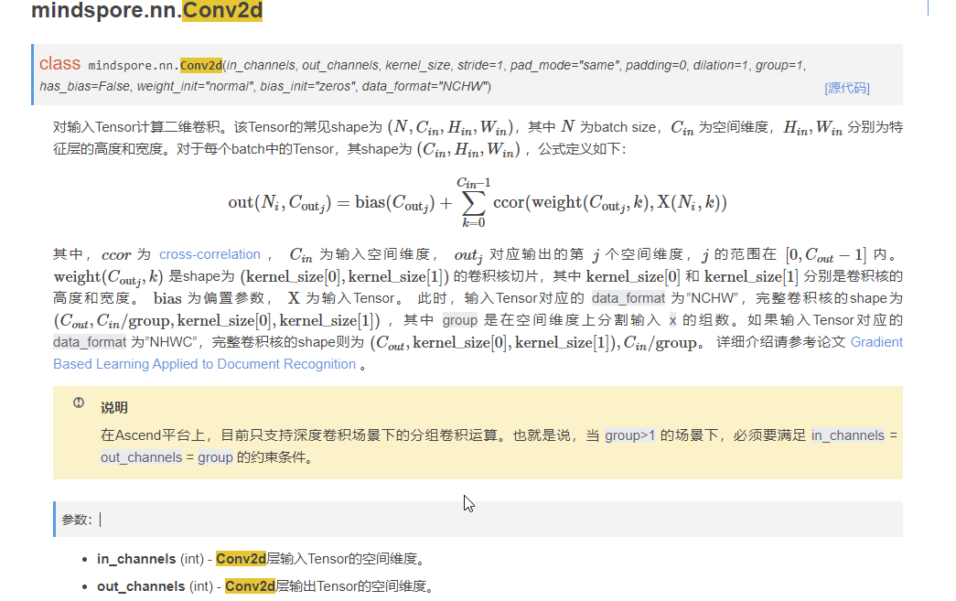输入Tensor的shape为 (N,Cin,Hin,Win)
self.conv1 = nn.Conv2d(num_channel, 6, 5, pad_mode='valid')
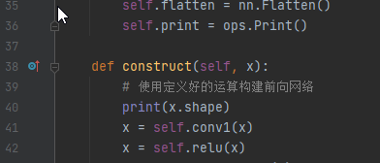
在conv1前面加打印，打印输入的shape(32, 3, 32, 32)，输入的C_in是3，num_channel=1，这个就是不一致的地方了。
4. 解决方案
修改网络的num_channel。
def __init__(self, num_class=10, num_channel=3):
修改之后就能正常跑下去了。

使用自定义数据集运行模型，报错TypeError: The predict type and infer type is not match, predict type is Tuple
1. 系统环境
硬件环境(Ascend/GPU/CPU): GPU
软件环境: MindSpore 版本: 2.0.0
执行模式（静态图/动态图）： 不限
Python 版本: 3.7.5
操作系统平台: linux
2. 报错信息
2.1 问题描述
使用自定义数据集运行mindformers的gpt2大模型，报错。
2.2 报错信息
[WARNING] ME(287:139835160470080,MainProcess):2023-05-31-14:04:41.269.777 [mindspore/train/model.py:1096] For MFLossMonitor callback, {'epoch_end', 'step_begin', 'step_end', 'epoch_begin'} methods may not be supported in later version, Use methods prefixed with 'on_train' or 'on_eval' instead when using customized callbacks.
[WARNING] ME(287:139835160470080,MainProcess):2023-05-31-14:04:41.270.411 [mindspore/train/model.py:1096] For Local2ObsMonitor callback, {'step_end'} methods may not be supported in later version, Use methods prefixed with 'on_train' or 'on_eval' instead when using customized callbacks.
[WARNING] DEVICE(287,7f2adeffd700,python):2023-05-31-14:04:42.063.418 [mindspore/ccsrc/runtime/pynative/async/async_queue.cc:67] WorkerLoop] Run task failed, error msg:The predict type and infer type is not match, predict type is Tuple, infer type is Tensor[Int32], the name of operator is [GetNext]. Please modify or add predict type of operator in predict_out_type_map.h.
----------------------------------------------------
- C++ Call Stack: (For framework developers)
----------------------------------------------------
mindspore/ccsrc/pipeline/pynative/forward/forward.cc:154 UpdateStubNodeAbs
---------------------------------------------------------------------------
TypeError Traceback (most recent call last)
/tmp/ipykernel_287/3074327597.py in <module>
13 optimizers=opt)
14 # 方式1: 开启训练，并使用训练好的权重进行推理
---> 15 trainer.train()
/opt/conda/lib/python3.7/site-packages/mindformers/trainer/trainer.py in train(self, resume_or_finetune_from_checkpoint, initial_epoch, do_eval, do_finetune, **kwargs)
406 wrapper=self.wrapper,
407 callbacks=self.callbacks,
--> 408 is_full_config=True, **kwargs)
409
410 def evaluate(self, eval_checkpoint: Optional[Union[str, bool]] = False, **kwargs):
/opt/conda/lib/python3.7/site-packages/mindformers/trainer/causal_language_modeling/causal_language_modeling.py in train(self, config, network, dataset, wrapper, optimizer, callbacks, **kwargs)
93 wrapper=wrapper,
94 optimizer=optimizer,
---> 95 **kwargs)
96
97 def evaluate(self, *args, **kwargs):
/opt/conda/lib/python3.7/site-packages/mindformers/trainer/base_trainer.py in training_process(self, config, network, dataset, optimizer, wrapper, callbacks, **kwargs)
519 dataset_sink_mode=config.runner_config.sink_mode,
520 sink_size=config.runner_config.per_epoch_size,
--> 521 initial_epoch=config.runner_config.initial_epoch)
522 logger.info(".........Training Over!.............")
523
/opt/conda/lib/python3.7/site-packages/mindspore/train/model.py in train(self, epoch, train_dataset, callbacks, dataset_sink_mode, sink_size, initial_epoch)
1059 dataset_sink_mode=dataset_sink_mode,
1060 sink_size=sink_size,
-> 1061 initial_epoch=initial_epoch)
1062
1063 # When it's distributed training and using MindRT,
/opt/conda/lib/python3.7/site-packages/mindspore/train/model.py in wrapper(self, *args, **kwargs)
98 raise e
99 else:
--> 100 func(self, *args, **kwargs)
101 return wrapper
102
/opt/conda/lib/python3.7/site-packages/mindspore/train/model.py in _train(self, epoch, train_dataset, callbacks, dataset_sink_mode, sink_size, initial_epoch, valid_dataset, valid_frequency, valid_dataset_sink_mode)
615 else:
616 self._train_dataset_sink_process(epoch, train_dataset, list_callback,
--> 617 cb_params, sink_size, initial_epoch, valid_infos)
618
619 @staticmethod
/opt/conda/lib/python3.7/site-packages/mindspore/train/model.py in _train_dataset_sink_process(self, epoch, train_dataset, list_callback, cb_params, sink_size, initial_epoch, valid_infos)
693 list_callback.on_train_step_begin(run_context)
694 train_network = self._check_network_mode(train_network, True)
--> 695 outputs = train_network(*inputs)
696 cb_params.net_outputs = outputs
697
/opt/conda/lib/python3.7/site-packages/mindspore/nn/cell.py in __call__(self, *args, **kwargs)
659 except Exception as err:
660 _pynative_executor.clear_res()
--> 661 raise err
662
663 if isinstance(output, Parameter):
/opt/conda/lib/python3.7/site-packages/mindspore/nn/cell.py in __call__(self, *args, **kwargs)
655 try:
656 _pynative_executor.new_graph(self, *args, **kwargs)
--> 657 output = self._run_construct(args, kwargs)
658 _pynative_executor.end_graph(self, output, *args, **kwargs)
659 except Exception as err:
/opt/conda/lib/python3.7/site-packages/mindspore/nn/cell.py in _run_construct(self, cast_inputs, kwargs)
443 output = self._shard_fn(*cast_inputs, **kwargs)
444 else:
--> 445 output = self.construct(*cast_inputs, **kwargs)
446 if self._enable_forward_hook:
447 output = self._run_forward_hook(cast_inputs, output)
/opt/conda/lib/python3.7/site-packages/mindspore/train/dataset_helper.py in construct(self)
98
99 def construct(self):
--> 100 outputs = self.get_next()
101 return self.network(*outputs)
102
/opt/conda/lib/python3.7/site-packages/mindspore/ops/primitive.py in __call__(self, *args)
315 if should_elim:
316 return output
--> 317 return _run_op(self, self.name, args)
318
319 def __getstate__(self):
/opt/conda/lib/python3.7/site-packages/mindspore/ops/primitive.py in _run_op(obj, op_name, args)
890 if _RUN_OP_ASYNC:
891 stub = _pynative_executor.run_op_async(obj, args)
--> 892 return _convert_stub(stub)
893 return _run_op_sync(obj, op_name, args)
894
/opt/conda/lib/python3.7/site-packages/mindspore/common/_stub_tensor.py in _convert_stub(stub)
191 return tuple(_convert_stub(e) for e in stub)
192 if isinstance(stub, SequenceNode):
--> 193 elements = stub.get_elements()
194 return tuple(_convert_stub(e) for e in elements)
195 if isinstance(stub, NoneTypeNode):
TypeError: The predict type and infer type is not match, predict type is Tuple, infer type is Tensor[Int32], the name of operator is [GetNext]. Please modify or add predict type of operator in predict_out_type_map.h.
----------------------------------------------------
- C++ Call Stack: (For framework developers)
----------------------------------------------------
mindspore/ccsrc/pipeline/pynative/forward/forward.cc:154 UpdateStubNodeAbs
2.3 脚本信息
from mindformers import GPT2Tokenizer
from mindspore.dataset import GeneratorDataset
import mindspore as ms
ms.set_context(device_target="GPU")
tokenizer = GPT2Tokenizer.from_pretrained('gpt2')
class TextSet:
def __init__(self, tokenizer):
with open('data.txt', 'r') as f:
self.content = f.read().replace('\n', '').split('。')
self.tokenizer = tokenizer
def __getitem__(self, idx):
input_ids = self.tokenizer(
self.content[idx],
padding='max_length',
max_length=1025,
return_tensors='ms')
return input_ids['input_ids'].astype(ms.int32)
def __len__(self):
return len(self.content)
txtset = TextSet(tokenizer)
dataset = GeneratorDataset(source=txtset, column_names=['input_ids'])
from mindarmour.privacy.diff_privacy import DPOptimizerClassFactory
from mindformers import AutoModel
model = AutoModel.from_pretrained("gpt2")
GaussianSGD = DPOptimizerClassFactory(micro_batches=2)
GaussianSGD.set_mechanisms('Gaussian', norm_bound=1.0, initial_noise_multiplier=1.5)
opt = GaussianSGD.create('Momentum')(params=model.trainable_params(),learning_rate=0.001,momentum=0.911)
from mindformers.trainer import Trainer
# 初始化预训练任务
trainer = Trainer(task='text_generation',model=model,train_dataset=dataset.batch(4),optimizers=opt)
# 方式1: 开启训练，并使用训练好的权重进行推理
trainer.train()
3. 根因分析
根据日志提示，分析报错代码：问题和GetNext算子的输出类型相关GetNext算子预期输出为Tuple类型，实际输出为Tensor。
TypeError: The predict type and infer type is not match, predict type is Tuple, infer type is Tensor[Int32], the name of operator is [GetNext]. Please modify or add predict type of operator in predict_out_type_map.h.
查看并执行dataset相关脚本：dataset输出为Tuple类型，该结果和上述预期相符，说明框架代码中存在将Tuple(Tensor)解包为Tensor的逻辑。
class TextSet:
def __init__(self, tokenizer):
with open('data.txt', 'r') as f:
self.content = f.read().replace('\n', '').split('。')
self.tokenizer = tokenizer
def __getitem__(self, idx):
input_ids = self.tokenizer(
self.content[idx],
padding='max_length',
max_length=1025,
return_tensors='ms')
return input_ids['input_ids'].astype(ms.int32)
def __len__(self):
return len(self.content)
txtset = TextSet(tokenizer)
dataset = GeneratorDataset(source=txtset, column_names=['input_ids'])
for item in dataset:
print(item)
break
执行结果如下
[Tensor(shape=[1025], dtype=Int32, value= [50256, 447, 251 ... 50256, 50256, 50256])]
分析代码：UpdateOutputAbstract函数在outputs个数为1时，将Tuple(Tensor)解包为Tensor，问题根因明确。
void UpdateOutputAbstract(const VectorRef &outputs, const session::BackendOpRunInfoPtr &op_run_info) {
auto output_size = outputs.size();
if (output_size == 1) {
auto output_tensor = utils::cast<tensor::TensorPtr>(outputs[0]);
MS_EXCEPTION_IF_NULL(output_tensor);
op_run_info->base_op_run_info.abstract = output_tensor->ToAbstract();
return;
}
4. 解决方案
修改UpdateOutputAbstract逻辑，当算子为GetNext的输出类型Tuple，不做解包处理。
```C++
void UpdateOutputAbstract(const VectorRef &outputs, const session::BackendOpRunInfoPtr &op_run_info) {
auto output_size = outputs.size();
if (output_size == 1 && op_run_info->base_op_run_info.op_name != kGetNextOpName) {
auto output_tensor = utils::cast<tensor::TensorPtr>(outputs[0]);
MS_EXCEPTION_IF_NULL(output_tensor);
op_run_info->base_op_run_info.abstract = output_tensor->ToAbstract();
return;
}
``

MindSpore Dump功能使用经验
1. 系统环境
硬件环境(Ascend/GPU/CPU): Ascend/GPU/CPU
软件环境: MindSpore 版本: 2.2.10
执行模式（静态图/动态图）： 不限
Python 版本: 3.8
操作系统平台: linux
2. 报错信息
2.1 问题描述
在使用MindSpore开发算法时，发现算法的执行结果和预期不一致，原始脚本逻辑如下：
init() # 初始化集合通信
...
prob = net1(...) # net1执行结果正常
...
score = net2(...) # net2结果和预期不一致
由于算法需要使用模型并行功能，不太适合使用PyNative方式定位这个问题。这种情况下，可以采用异步Dump，将net2的计算过程dump到文件中，用于进一步分析。 备注：MindSpore提供了Dump功能，用来将模型训练中的图以及算子的输入输出数据保存到磁盘文件。
考虑到dump数据会降低执行速度，导致问题复现较慢；而且dump过多的数据，导致后期筛选困难。因此只想要dump net2的计算结果。按照官方文档，只需要导出环境变量MINDSPORE_DUMP_CONFIG，即可导出计算中间数据：
init() # 初始化集合通信
...
prob = net1(...) # net1执行结果正常
...
os.environ["MINDSPORE_DUMP_CONFIG"]="/path/dump.json"
score = net2(...) # net2结果和预期不一致
重新执行完毕后，发现在指定目录下并未生成数据文件。
3. 根因分析
阅读MindSpore源码，发现框架只会在GeDeviceContext::InitGe()中读取MINDSPORE_DUMP_CONFIG环境变量的信息，而每个MindSpore进程只会执行一次GeDeviceContext初始化。
通过export GLOG_v=1打开info级别日志，发现MindSpore是在初始化集合通信时执行GeDeviceContext初始化。
[INFO] DISTRIBUTED(153924,ffff94c6da70,python3):2023-07-22-11:00:35.823.355 [mindspore/ccsrc/distributed/collective/collective_manager.cc:157] Initialize] Start initializing collective communication for backend: Ascend
...
[INFO] DEVICE(153924,ffff94c6da70,python3):2023-07-22-11:00:43.723.045 [mindspore/ccsrc/plugin/device/ascend/hal/hardware/ge_device_context.cc:124] InitGe] Init ge successful, ge reference = 1.
也就是说，在init()之后再导出MINDSPORE_DUMP_CONFIG并不会真正生效。
4. 解决方案
基于当前MindSpore实现，并不能精确dump某个net的计算过程数据。最终还需要在执行脚本前，先export MINDSPORE_DUMP_CONFIG="/path/dump.json"来实现全量dump。

MindSpore 图算融合 GPU调试
1. 系统环境
硬件环境(Ascend/GPU/CPU): Ascend/GPU
软件环境: MindSpore 版本: 2.2.10
执行模式（静态图/动态图）： 不限
Python 版本: 3.8
操作系统平台: linux
2. 图算融合
2.1 图算融合描述
图算融合简单地说就是将几个算子合并成一个复合粒度算子，以提升性能。
基本算子的组合理论上可以表达任何现有计算图，但是复合算子有更好的通用组合表达能力，
为了兼顾这两样，mindspore提供了图算融合能力，打破算子边界。
图算融合可以通过自动分析和优化现有网络计算图逻辑，并结合目标硬件能力，
对计算图进行计算化简和替代、算子拆分和融合、算子特例化编译等优化，以提升设备计算资源利用率，实现对网络性能的整体优化。
图算融合是通过ms.set_context(enable_graph_kernel=True)开启的，也可以通过（graph_kernel_flags：图算融合的优化选项）来控制，
当与enable_graph_kernel冲突时，它的优先级更高，但是graph_kernel_flags更适用于有经验的用户。
2.2 图算融合的开启方式
1. ms.set_context(enable_graph_kernel=True)
2. ms.set_context(graph_kernel_flags="--opt_level=2 --dump_as_text")
opt_level：设置优化级别。默认值：2。当opt_level的值大于0时，启动图算融合。可选值包括：
0：关闭图算融合。
1：启动算子的基本融合。
2：包括级别1的所有优化，并打开更多的优化，如CSE优化算法、算术简化等。
3：包括级别2的所有优化，并打开更多的优化，如SitchingFusion、ParallelFusion等。在某些场景下，该级别的优化激进且不稳定。使用此级别时要小心。
3. 图算融合支持的后端和模式
Ascend/GPU
GRAPH_MODE/PYNATIVE_MODE
4. 运行脚本及结果分析
使能图算融合
import numpy as np
import mindspore as ms
from mindspore.nn import Cell
import mindspore.ops as ops
ms.set_context(mode=ms.GRAPH_MODE, device_target="GPU")
# save graph ir to view fusion detail.
ms.set_context(save_graphs=2)
# enable graph kernel optimization.
ms.set_context(enable_graph_kernel=True)
class MyNet(Cell):
def construct(self, x):
a = ops.mul(x, 2.0)
res = ops.add(a, 1.0)
return res
x = np.ones((4, 4)).astype(np.float32) * 0.5
net = MyNet()
result = net(ms.Tensor(x))
print("result: {}".format(result))
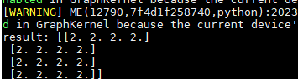
执行完成后，Mul+Add融合成一个算子，所以akg_kernel_meta里面生成了这个算子的json及其他文件。
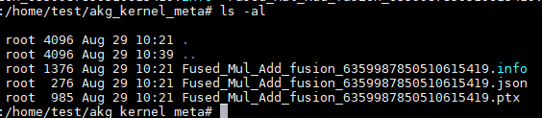
ir图里面也可以看出算子融合了。
关闭算子融合
import numpy as np
import mindspore as ms
from mindspore.nn import Cell
import mindspore.ops as ops
ms.set_context(mode=ms.GRAPH_MODE, device_target="GPU")
# save graph ir to view fusion detail.
ms.set_context(save_graphs=2)
# enable graph kernel optimization.
ms.set_context(enable_graph_kernel=False)
class MyNet(Cell):
def construct(self, x):
a = ops.mul(x, 2.0)
res = ops.add(a, 1.0)
return res
x = np.ones((4, 4)).astype(np.float32) * 0.5
net = MyNet()
result = net(ms.Tensor(x))
print("result: {}".format(result))
执行完成后，Mul+Add未融合成一个算子，所以akg_kernel_meta不存在。开启图算融合，不仅可以让基本算子进行融合，也可以让自定义算子进行融合，自定义算子与基本算子进行融合。

MindSpore 静态图网络编译使用HyperMap优化编译性能
1. 系统环境
硬件环境(Ascend/GPU/CPU): Ascend/GPU/CPU
软件环境: MindSpore 版本: 2.2.10
执行模式（静态图/动态图）： 静态图
Python 版本: 3.8
操作系统平台: linux
2. 问题描述
网络执行过程的时间主要由编译耗时与运行耗时两个组成，在推理的时候，编译耗时远大于运行耗时, 且优化编译性能对于提升网络在实际应用时的部署效果有着极为重要的意义。
3. 根因分析
1. 使用HyperMap优化编译性能
2. 使用Select算子优化编译性能
3. 使用编译缓存优化编译性能
4. 使用vmap优化编译性能
4. 解决方案
使用HyperMap等价语义替换for， 也是优化编译性能的一种方式，下面介绍HyperMap的用法
HyperMap API介绍：
对输入序列做集合运算。
对序列的每个元素或嵌套序列进行运算。与 mindspore.ops.Map 不同，HyperMap 能够用于嵌套结构。
参数：
ops (Union[MultitypeFuncGraph, None]) - ops 是指定运算操作。如果 ops 为 None ，则运算应该作为 HyperMap 实例的第一个入参。默认值为 None 。
reverse (bool) - 在某些场景下，需要逆向以提高计算的并行性能，一般情况下，用户可以忽略。reverse 用于决定是否逆向执行运算，仅在图模式下支持。默认值为 False 。
输入：
args (Tuple[sequence]) -
如果 ops 不是 None ，则所有入参都应该是具有相同长度的序列，并且序列的每一行都是运算的输入。
如果 ops 是 None ，则第一个入参是运算，其余都是输入。
输出：
序列或嵌套序列，执行函数如 operation(args[0][i], args[1][i]) 之后输出的序列
MultitypeFuncGraph的API介绍：
MultitypeFuncGraph是一个用于生成重载函数的类，使用不同类型作为输入。使用 name 去初始化一个MultitypeFuncGraph对象，然后用带有输入类型的 register 注册器进行装饰注册类型。这样使该函数可以使用不同的类型作为输入调用，一般与 HyperMap 、 Map 结合使用。
参数：
name (str) - 操作名。
read_value (bool, 可选) - 如果注册函数不需要对输入的值进行更改，即所有输入都为按值传递，则将 read_value 设置为 True 。默认值： False 。
在使用for循环批量处理列表元素时，可以通过HyperMap等价语义替换来优化网络编译性能。
import time
from mindspore.ops import MultitypeFuncGraph, HyperMap
from mindspore import ops, Tensor
import mindspore as ms
add = MultitypeFuncGraph('add')
@add.register("Tensor", "Tensor")
def add_Tensor(x, y):
return ops.add(x, y)
add_map = HyperMap(add)
list1 = [Tensor(i) for i in range(200)]
list2 = [Tensor(i) for i in range(200)]
@ms.jit
def hyper_map_net():
output = add_map(list1, list2)
return output
start_time = time.time()
output = hyper_map_net()
end_time = time.time()
print("hyper map cost time:", end_time - start_time)
@ms.jit
def for_loop_net():
out = []
for i in range(200):
out.append(i+i)
return out
start_time = time.time()
for_loop_net()
end_time = time.time()
print("for loop cost time:", end_time - start_time)

MindSpore 静态图网络编译使用Select算子优化编译性能
1. 系统环境
硬件环境(Ascend/GPU/CPU): Ascend/GPU/CPU
软件环境: MindSpore 版本: 2.2.10
执行模式（静态图/动态图）： 不限
Python 版本: 3.8
操作系统平台: linux
2. 静态图网络编译性能优化的前因
静态图的特点是将计算图的构建和实际计算分开， 也就是编译和运行分开。在构建阶段，根据完整的计算流程对原始的计算图进行优化和调整，编译得到更省内存和计算量更少的计算图。由于编译之后图的结构不再改变，所以称之为 “静态图”。
3. 静态图网络编译性能优化的方法
1. 使用HyperMap优化编译性能
2. 使用Select算子优化编译性能
3. 使用编译缓存优化编译性能
4. 使用vmap优化编译性能
4. Select算子优化编译性能
在mindspore中，if若是进入控制流，那么每个if都会产生额外的子图，在静态图模式下，子图数量越多，编译耗时越久
而if在网络编写的时候，又是一个常用的语句。在mindspore中，可以用Select等价替换if语句来优化编译性能。虽然Select的编译耗时比if控制流少，但是Select会同时执行true分支和false分支，所以Select的运行耗时比if控制流多。当分支中算子数量较少， 建议使用Select算子。 若是较多，则推荐使用if控制流。
示例代码如下：
import time
from mindspore import ops
import mindspore as ms
@ms.jit
def if_net(x, y):
out = 0
for _ in range(100):
if x < y:
x = x - y
else:
x = x + y
out = out + x
return out
start_time = time.time()
out = if_net(ms.Tensor([0]), ms.Tensor([1]))
end_time = time.time()
print("if net cost time:", end_time - start_time)
@ms.jit
def select_net(x, y):
out = x
for _ in range(100):
cond = x < y
x = ops.select(cond, x - y, x + y)
out = out + x
return out
start_time = time.time()
out = select_net(ms.Tensor([0]), ms.Tensor([1]))
end_time = time.time()
print("select net cost time:", end_time - start_time)
上面的示例中， 算子较少，执行完成时间相比较而言，使用Select的运行耗时比较少，所以使用select能优化性能。

MindSpore 静态图网络编译使用编译缓存或者vmap优化性能
1. 系统环境
硬件环境(Ascend/GPU/CPU): Ascend/GPU/CPU
软件环境: MindSpore 版本: 2.2.10
执行模式（静态图/动态图）： 不限
Python 版本: 3.8
操作系统平台: linux
2. 静态图网络编译性能优化
静态图模式又被称为Graph模式，在Graph模式下，基于图优化、计算图整图下沉等技术，编译器可以针对图进行全局的优化，获得较好的性能，因此比较适合网络固定且需要高性能的场景。
3. 静态图网络编译性能优化的方法
1. 使用HyperMap优化编译性能
2. 使用Select算子优化编译性能
3. 使用编译缓存优化编译性能
4. 使用vmap优化编译性能
4. 使用编译缓存优化编译性能
编译缓存的本质是存储了网络模型的编译中间过程文件，当网络模型不变时，中间过程文件可以复用。复用方法就是在代码中用enable_compile_cache进行控制。
enable_compile_cache支持三个后端：Ascend GPU CPU
使用方法是：
from mindspore import context
context.set_context(enable_compile_cache=True, compile_cache_path="./cache.ms")
enable_compile_cache (bool) - 表示是否加载或者保存前端编译的图。
当 enable_compile_cache 被设置为True时，在第一次执行的过程中，一个硬件无关的编译缓存会被生成并且导出为一个MINDIR文件。
当该网络被再次执行时，如果 enable_compile_cache 仍然为True并且网络脚本没有被更改，那么这个编译缓存会被加载
。注意目前只支持有限的Python脚本更改的自动检测，这意味着可能有正确性风险。默认值： False 。这是一个实验特性，可能会被更改或者删除。

MindSpore模型权重功能无法保存更新后的权重
1. 系统环境
硬件环境(Ascend/GPU/CPU): Ascend/GPU/CPU
软件环境: MindSpore 版本: 2.2.10
执行模式（静态图/动态图）： 不限
Python 版本: 3.8
操作系统平台: linux
2. 报错信息
2.1 问题描述
使用CANN7.0+MindSpore2.1.1，训练loss收敛后保存模型，发现保存的不是训练之后的模型权重，而是初始权重，如下所示:
2.2 初始化权重信息：
Tensor (shape=［6144, 6144], dtype=Float32 , value=
[[ 1.00874314e-02 6. 56688539e-03 -1. 91919804e-02 … 5.64888678e-03 -2. 20796163e-03 4.29333374e-03]
[-1.58290453e-02 -7. 58421593e-05 -4. 00598830e-04 -1.14668552e-02 - 1.13498308e-02 2.55679921e-03]
[ 5.50412433e-03 1. 71776358e-02 -2.33 142842e-02 1.49840652e-03 1.28344800e-02 8.48229043e-03]
[ 5.53949829e-03 -1. 25942379e-02 6.60581887e-03 -8.29280645e-04 -1.08878603e-02 -4.47568891e-04]
[ 1.70315057e-03 3. 48439417e-03 7.81778805e-03 C -7.27706531e-04 7.55816605e-03 -2.24832026e-03]
[ 8.41980707e-03 6. 66081626e-03 -4. 32111416e-03 -1.40487147e-03 - 4.82343137e-03 -4. 50384151e-03]])
训练过程中打印的权重信息：
Tensor(shape=[6144, 6144], dtype=Float32, value=
[[ 1.01261148e-02 6. 58480451e-03 -1. 90741140e-02 5.70917921e-03 -2. 18650815e-03 4.28082701e-03]
[-1.5771551le-02 -4. 06106119e-05 -3.- 39789083e-04 -1.13997944e-02 1.13531193e-02 2.33310624e-03]
[ 5.52728493e-03 1.71936452e-02 -2. 32268739e-02 1.55355304e-03 - 1.29088536e-02 8.45980365e-03]
[ 5.42893354e-03 -1. 26162879e-02 6.61681918e-03 -8.39053362e-04 -1.09538278e-02 -4.17841686e-04] 1.68025843e-03 3.56728001e-03 7.80858565e-03 .. -8.41747446e-04 7.55744614e-03 -2.15848 139e-03]
[ 8.49595107e-03 6.70013577e-03 -4.35717218e-03 -1.36322062e-03 4.75577544e-03 -4. 33780858e-03]])
模型保存的权重信息：
-callbacks begin-
Param: backbone.blocks.0. attention.densel.weight with shape (6144, 6144)
[[ 1.0087431e-02 6.5668854e-03 -1.9 191980e-02 - 5.6488868e-03
-2.2079616e-03 4.2933337e-03]
[-1.5829045e-02 -7 .5842159e-05 -4.0059883e-04 ... -1.1466855e-02
1.1349831e-02 2.5567992e-03]
[ 5.5041243e-03 1. 7177636e-02 -2.3314284e-02 1.4984065e-03
1.2834480e-02 8.4822904e-03]
[ 5.5394983e-03 -1.2594238e-02 6.6058189e-03 ..... -8 .2928065e-04
-1.0887860e-02 -4. 4756889e-04]
[ 1.7031506e-03 3. 4843942e-03 7.8177880e-03 ... -7.. 2770653e-04
7.5581660e-03 -2.. 2483203e-03]
[ 8.4198071e-03 6. 6608163e-03 -4.3211142e-03 .-1.4048715e-03
4.8234314e-03 -4.5038415e-03]]
-callbacks end
3. 根因分析
根据上述信息发现最终保存的模型权重还是和初始化权重一样，表示并没有保存到训练之后的权重。
4. 解决方案
升级版本到MindSpore 2.2之后，模型保存可以正常工作。

模型微调报错RuntimeError: Preprocess failed before run graph 1.
1. 系统环境
硬件环境(Ascend/GPU/CPU): Ascend
软件环境: MindSpore 版本: 2.2.0
执行模式（静态图/动态图）： 不限
Python 版本: 3.9
操作系统平台: linux
2. 报错信息
2.1 问题描述
将qwen-7b全参微调时报错RuntimeError: Preprocess failed before run graph 1.
2.2 报错信息
Traceback (most recent call last):
File "/home/ma-user/work/mindformers-dev/research/qwen/run_qwen.py", line 165, in <module>
main(task=args.task,
File "/home/ma-user/work/mindformers-dev/research/qwen/run_qwen.py", line 118, in main
trainer.finetune(finetune_checkpoint=ckpt, auto_trans_ckpt=auto_trans_ckpt)
File "/home/ma-user/anaconda3/envs/MindSpore/lib/python3.9/site-packages/mindspore/_checkparam.py", line 1313, in wrapper
return func(*args, **kwargs)
File "/home/ma-user/anaconda3/envs/MindSpore/lib/python3.9/site-packages/mindformers/trainer/trainer.py", line 498, in finetune
self.trainer.train(
File "/home/ma-user/anaconda3/envs/MindSpore/lib/python3.9/site-packages/mindformers/trainer/causal_language_modeling/causal_language_modeling.py", line 97, in train
self.training_process(
File "/home/ma-user/anaconda3/envs/MindSpore/lib/python3.9/site-packages/mindformers/trainer/base_trainer.py", line 696, in training_process
transform_and_load_checkpoint(config, model, network, dataset)
File "/home/ma-user/anaconda3/envs/MindSpore/lib/python3.9/site-packages/mindformers/trainer/utils.py", line 311, in transform_and_load_checkpoint
build_model(config, model, dataset, do_eval=do_eval, do_predict=do_predict)
File "/home/ma-user/anaconda3/envs/MindSpore/lib/python3.9/site-packages/mindformers/trainer/utils.py", line 436, in build_model
model.build(train_dataset=dataset, epoch=config.runner_config.epochs,
File "/home/ma-user/anaconda3/envs/MindSpore/lib/python3.9/site-packages/mindspore/train/model.py", line 1274, in build
self._init(train_dataset, valid_dataset, sink_size, epoch)
File "/home/ma-user/anaconda3/envs/MindSpore/lib/python3.9/site-packages/mindspore/train/model.py", line 529, in _init
train_network.compile(*inputs)
File "/home/ma-user/anaconda3/envs/MindSpore/lib/python3.9/site-packages/mindspore/nn/cell.py", line 997, in compile
_cell_graph_executor.compile(self, phase=self.phase,
File "/home/ma-user/anaconda3/envs/MindSpore/lib/python3.9/site-packages/mindspore/common/api.py", line 1547, in compile
result = self._graph_executor.compile(obj, args, kwargs, phase, self._use_vm_mode())
RuntimeError: Preprocess failed before run graph 1.
----------------------------------------------------
- Framework Error Message:
----------------------------------------------------
Out of Memory!!! Request memory size: 35051914240B, Memory Statistic:
Device HBM memory size: 32768M
MindSpore Used memory size: 30678M
MindSpore memory base address: 0x124180000000
Total Static Memory size: 12040M
Total Dynamic memory size: 0M
Dynamic memory size of this graph: 0M
Please try to reduce 'batch_size' or check whether exists extra large shape. For more details, please refer to 'Out of Memory' at https://www.mindspore.cn .
----------------------------------------------------
- C++ Call Stack: (For framework developers)
----------------------------------------------------
mindspore/ccsrc/plugin/device/ascend/hal/hardware/ascend_kernel_executor.cc:286 PreprocessBeforeRunGraph
mindspore/ccsrc/plugin/device/ascend/hal/device/ascend_memory_adapter.cc:185 MallocDynamicDevMem
[WARNING] MD(123569,ffffa9748010,python):2024-01-04-14:24:06.999.824 [mindspore/ccsrc/minddata/dataset/engine/datasetops/data_queue_op.cc:163] ~DataQueueOp]
preprocess_batch: 100;
batch_queue: 1, 1, 1, 1, 1, 1, 1, 1, 1, 1;
push_start_time -> push_end_time
2024-01-04-14:18:18.185.953 -> 2024-01-04-14:18:18.186.203
2024-01-04-14:18:18.205.302 -> 2024-01-04-14:18:18.220.553
2024-01-04-14:18:18.220.798 -> 2024-01-04-14:18:18.221.154
2024-01-04-14:18:18.221.300 -> 2024-01-04-14:18:18.221.999
2024-01-04-14:18:18.222.250 -> 2024-01-04-14:18:18.222.646
2024-01-04-14:18:18.223.158 -> 2024-01-04-14:18:18.223.419
2024-01-04-14:18:18.223.665 -> 2024-01-04-14:18:18.223.945
2024-01-04-14:18:18.224.214 -> 2024-01-04-14:18:18.224.818
2024-01-04-14:18:18.225.096 -> 2024-01-04-14:18:18.225.442
2024-01-04-14:18:18.225.901 -> 2024-01-04-14:18:18.226.317
For more details, please refer to the FAQ at https://www.mindspore.cn/docs/en/master/faq/data_processing.html.
2.3 脚本信息
seed: 0
output_dir: './output'
load_checkpoint: '/home/ma-user/work/infer/qwen_7b_base.ckpt'
src_strategy_path_or_dir: ''
auto_trans_ckpt: True # If true, auto transform load_checkpoint to load in distributed model
only_save_strategy: False
resume_training: False
use_parallel: True
run_mode: 'finetune'
# trainer config
trainer:
type: CausalLanguageModelingTrainer
model_name: 'qwen_7b'
# dataset
train_dataset: &train_dataset
data_loader:
type: MindDataset
dataset_dir: "/home/ma-user/work/infer/alpaca.mindrecord"
shuffle: True
input_columns: ["input_ids", "labels", "attention_mask"]
num_parallel_workers: 8
python_multiprocessing: False
drop_remainder: True
batch_size: 1
repeat: 1
numa_enable: False
prefetch_size: 1
train_dataset_task:
type: CausalLanguageModelDataset
dataset_config: *train_dataset
# runner config
runner_config:
epochs: 5
batch_size: 1
sink_mode: True
sink_size: 2
runner_wrapper:
type: MFTrainOneStepCell
scale_sense:
type: DynamicLossScaleUpdateCell
loss_scale_value: 65536
scale_factor: 2
scale_window: 1000
use_clip_grad: True
# optimizer
optimizer:
type: FP32StateAdamWeightDecay
beta1: 0.9
beta2: 0.95
eps: 1.e-6
weight_decay: 0.1
# lr sechdule
lr_schedule:
type: CosineWithWarmUpLR
learning_rate: 1.e-5
warmup_ratio: 0.01
total_steps: -1 # -1 means it will load the total steps of the dataset
# callbacks
callbacks:
- type: MFLossMonitor
- type: CheckpointMointor
prefix: "qwen"
save_checkpoint_steps: 10000
keep_checkpoint_max: 3
integrated_save: False
async_save: False
- type: ObsMonitor
# default parallel of device num = 8 910
parallel_config:
data_parallel: 8
model_parallel: 1
pipeline_stage: 1
micro_batch_num: 1
vocab_emb_dp: False
gradient_aggregation_group: 4
# when model parallel is greater than 1, we can set micro_batch_interleave_num=2, that may accelerate the train process.
micro_batch_interleave_num: 1
model:
model_config:
type: QwenConfig
batch_size: 1
seq_length: 1024
hidden_size: 4096
num_hidden_layers: 32
num_attention_heads: 32
vocab_size: 151936
intermediate_size: 11008
rms_norm_eps: 1.0e-6
emb_dropout_prob: 0.0
eos_token_id: 151643
pad_token_id: 151643
compute_dtype: "float16"
layernorm_compute_type: "float32"
softmax_compute_type: "float16"
rotary_dtype: "float16"
param_init_type: "float16"
use_past: True
use_flash_attention: False
use_past_shard: False
offset: 0
checkpoint_name_or_path: "/home/ma-user/work/infer/qwen_7b_base.ckpt"
repetition_penalty: 1
max_decode_length: 512
top_k: 0
top_p: 0.8
do_sample: False
# configuration items copied from Qwen
rotary_pct: 1.0
rotary_emb_base: 10000
kv_channels: 128
arch:
type: QwenForCausalLM
processor:
return_tensors: ms
tokenizer:
model_max_length: 8192
vocab_file: "/path/qwen.tiktoken"
pad_token: "<|endoftext|>"
type: QwenTokenizer
type: QwenProcessor
# mindspore context init config
context:
mode: 0 #0--Graph Mode; 1--Pynative Mode
device_target: "Ascend"
enable_graph_kernel: False
graph_kernel_flags: "--disable_expand_ops=Softmax,Dropout --enable_parallel_fusion=true --reduce_fuse_depth=8 --enable_auto_tensor_inplace=true"
ascend_config:
precision_mode: "must_keep_origin_dtype"
max_call_depth: 10000
max_device_memory: "58GB"
save_graphs: False
save_graphs_path: "./graph"
device_id: 0
# parallel context config
parallel:
parallel_mode: 1 # 0-data parallel, 1-semi-auto parallel, 2-auto parallel, 3-hybrid parallel
gradients_mean: False
enable_alltoall: False
full_batch: True
search_mode: "sharding_propagation"
enable_parallel_optimizer: True
strategy_ckpt_config:
save_file: "./ckpt_strategy.ckpt"
only_trainable_params: False
parallel_optimizer_config:
gradient_accumulation_shard: False
parallel_optimizer_threshold: 64
infer:
prefill_model_path: "/path/qwen_7b_prefill.mindir"
increment_model_path: "path/qwen_7b_inc.mindir"
infer_seq_length: 1024
3. 根因分析
单从报错上看是卡内存不足
Out of Memory!!! Request memory size: 35051914240B, Memory Statistic: Device HBM memory size: 32768M MindSpore Used memory size: 30678M
但是看yaml配置文件
batch_size: 1
seq_length: 1024
这个配置设置并不高，按理说910的32g是可以支持的。
然后再配置文件里面有看到另外一个参数
max_device_memory: "58GB"
这个明显不对了，这个应该是给设备内存64G用的。910只有32G，所以设置超限制了。
4. 解决方案
修改max_device_memory，910最大支持32G，去除默认占用的，可以设置为"29G"。

Mindspore训练plog中算子GatherV2_xxx_high_precision_xx报错
1. 系统环境
硬件环境(Ascend/GPU/CPU): Ascend/GPU/CPU
软件环境: MindSpore 版本: 2.4.0
执行模式（静态图/动态图）： 不限
Python 版本: 3.8
操作系统平台: linux
2. 报错信息
2.1 问题描述
GatherV2算子报错在plog中，一般都是数据集的词表和模型词表大小不一样，导致的越界
2.2 报错信息
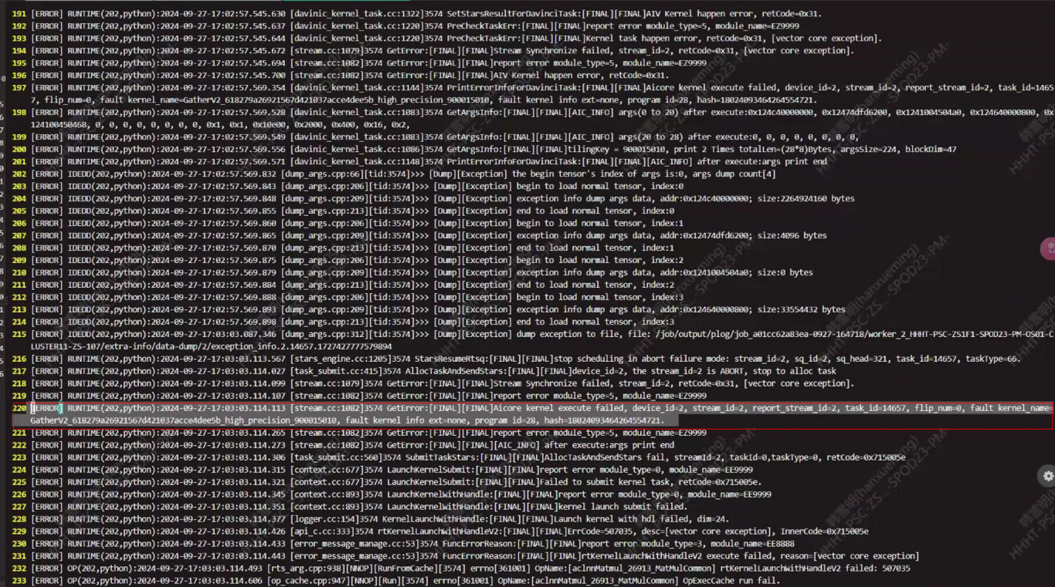3. 根因分析
查看yaml中vocab_size和数据集使用的词表大小是否匹配。
4. 解决方案
查看词表大小的方法：
如果使用 sentencepiece 库：
import sentencepiece as sp
sp_model = sp.SentencePieceProcessor()
sp_model.load("tokenizer.model")
vocab_size = sp_model.get_piece_size()
print(f"词表大小 (vocab_size): {vocab_size}")
如果使用 transformers 库中的相关类（如果适用的话）：
from transformers import LlamaTokenizer
tokenizer = LlamaTokenizer.from_pretrained("tokenizer.model")
vocab_size = tokenizer.vocab_size
print(f"词表大小 (vocab_size): {vocab_size}")
对于使用MIndFormer
from mindformers import LlamaTokenizer
tokenizer = LlamaTokenizer.from_pretrained("tokenizer.model")
vocab_size = tokenizer.vocab_size
print(f"词表大小 (vocab_size): {vocab_size}")
不同的库和方法可能会有一些细微的差异，具体使用哪种方法取决于你项目中已安装和使用的库以及具体的需求。如果在读取过程中遇到权限问题，确保你有足够的权限访问该文件

使用Profiler()函数，报错RuntimeError: The output path of profiler only supports alphabets(a-zA-Z)
1. 系统环境
硬件环境(Ascend/GPU/CPU): Ascend/GPU/CPU
软件环境: MindSpore 版本: 2.2.12
执行模式（静态图/动态图）： 不限
Python 版本: 3.9
操作系统平台: linux
2. 报错信息
2.1 问题描述
在用mindspore_cpu_py39 2.2.12版本下，项目文件路径为E:\MindsporePrj\PreTrain_ms，使用如下脚本信息出现报错。
2.2 报错信息
RuntimeError: The output path of profiler only supports alphabets(a-zA-Z), digit(0-9) or {'-', '_', '.', '/', '@'}, but got the absolute path= E:\MindsporePrj\PreTrain_ms\data
2.3 脚本信息
from mindspore.profiler import Profiler
profiler = Profiler()
3. 根因分析
根据报错提示：分析器的输出路径仅支持字母表（a-zA-Z）、数字（0-9）或{'-'、'_'、'.'、'/'、'@'}，上述给出的路径中有不符合该要求的字符。
4. 解决方案
可以将现在的项目的绝对路径修改下，改成路径中的所有字符都在母表（a-zA-Z）、数字（0-9）或{'-'、'_'、'.'、'/'、'@'}中。

使用dataset.create_dict_iterator()后，计算前向网络报错：untimeError: Illegal AnfNode for evaluating, node: @Batch
1. 系统环境
硬件环境(Ascend/GPU/CPU): CPU
软件环境: MindSpore 版本: 1.10
执行模式（静态图/动态图）： 不限
Python 版本: 3.8
操作系统平台: linux
2. 报错信息
2.1 问题描述
将model(x)放在dataset.create_dict_iterator()遍历的外面，程序正确运行，代码如下：
2.2 报错信息
RuntimeError: Illegal AnfNode for evaluating.node: @BatchNorm.20:фdout(type:Parameter), fg: BatchNorm.20 conf: Node: 0x18b20bbdb00/@BatchNorm.20:фdout-uid(2115), Context: 0x18b20b4fc70/{FuncGraph: BatchNorm.20 Args: [0]: AbstractTensor(shape: (1, 32, 40, 99), element: AbstractScalar(Type: Float32, Value: AnyValue, Shape: NoShape), value_ptr: 0x18b1728ef90, value: AnyValue), [1]: AbstractTensor(shape: (32), element: AbstractScalar(Type: Float32, Value: AnyValue, Shape: NoShape), value_ptr: 0x18b1728ef90, value: AnyValue), [2]: AbstractTensor(shape: (32), element: AbstractScalar(Type: Float32, Value: AnyValue, Shape: NoShape), value_ptr: 0x18b1728ef90, value: AnyValue), [3]: AbstractTensor(shape: (32), element: AbstractScalar(Type: Float32, Value: AnyValue, Shape: NoShape), value_ptr: 0x18b1728ef90, value: AnyValue), [4]: AbstractTensor(shape: (32), element: AbstractScalar(Type: Float32, Value: AnyValue, Shape: NoShape), value_ptr: 0x18b1728ef90, value: AnyValue), [5]: AbstractTuple{element[0]: AbstractTensor(shape: (1, 32, 40, 99), element: AbstractScalar(Type: Float32, Value: AnyValue, Shape: NoShape), value_ptr: 0x18b1728ef90, value: AnyValue), element[1]: AbstractTensor(shape: (32), element: AbstractScalar(Type: Float32, Value: AnyValue, Shape: NoShape), value_ptr: 0x18b1728ef90, value: AnyValue), element[2]: AbstractTensor(shape: (32), element: AbstractScalar(Type: Float32, Value: AnyValue, Shape: NoShape), value_ptr: 0x18b1728ef90, value: AnyValue), element[3]: AbstractTensor(shape: (32), element: AbstractScalar(Type: Float32, Value: AnyValue, Shape: NoShape), value_ptr: 0x18b1728ef90, value: AnyValue), element[4]: AbstractTensor(shape: (32), element: AbstractScalar(Type: Float32, Value: AnyValue, Shape: NoShape), value_ptr: 0x18b1728ef90, value: AnyValue)}, [6]: AbstractTuple{element[0]: AbstractTensor(shape: (1, 32, 40, 99), element: AbstractScalar(Type: Float32, Value: AnyValue, Shape: NoShape), value_ptr: 0x18b1728ef90, value: AnyValue), element[1]: AbstractTensor(shape: (32), element: AbstractScalar(Type: Float32, Value: AnyValue, Shape: NoShape), value_ptr: 0x18b1728ef90, value: AnyValue), element[2]: AbstractTensor(shape: (32), element: AbstractScalar(Type: Float32, Value: AnyValue, Shape: NoShape), value_ptr: 0x18b1728ef90, value: AnyValue), element[3]: AbstractTensor(shape: (32), element: AbstractScalar(Type: Float32, Value: AnyValue, Shape: NoShape), value_ptr: 0x18b1728ef90, value: AnyValue), element[4]: AbstractTensor(shape: (32), element: AbstractScalar(Type: Float32, Value: AnyValue, Shape: NoShape), value_ptr: 0x18b1728ef90, value: AnyValue)}, Parent: { Args: }}, FuncGraph: 0x18b20bb0cb0/BatchNorm.20
2.3 脚本信息
def test(dataset,model,mask_ratio=0.75):
batch_loss = 0
model.set_train(False)
i = 0
x = mindspore.Tensor(np.randon.rand(1, 40, 300).astype(np. float32), dtype=nindspore.float32)
loss, pred, mask = model(x, mask_ratio)
for data in dataset.create_dict_iterator():
# input = data['data']
# x = mindspore.Tensor(np.random.rand(1, 40, 300).astype(np.fLoat32), dtype=mindspore.float32)
# loss, pred, mask = model(x, mask_ratio)
batch_loss += loss
i += 1
return batch_loss/(i+1)
但是只要将model(x)放入dataset.create_dict_iterator()的遍历后，就会报错，即使x并不是dataset中的数据。
def test(dataset,model,mask_ratio=0.75):
batch_loss = 0
model.set_train(False)
i = 0
x = mindspore.Tensor(np.randon.rand(1, 40, 300).astype(np. float32), dtype=nindspore.float32)
# loss, pred, mask = model(x, mask_ratio)
for data in dataset.create_dict_iterator():
# input = data['data']
x = mindspore.Tensor(np.random.rand(1, 40, 300).astype(np.fLoat32), dtype=mindspore.float32)
loss, pred, mask = model(x, mask_ratio)
batch_loss += loss
i += 1
return batch_loss/(i+1)
3. 根因分析
根据报错信息提示，这应该是数据的类型不符合计算。
4. 解决方案
构造数据集类的时候定义了mindspore的tensor，换成np数组就可以了。

使用MindSpore静态图速度慢的问题
1. 系统环境
硬件环境(Ascend/GPU/CPU): Ascend
软件环境: MindSpore 版本: 2.3.1
执行模式（静态图/动态图）： 静态图
Python 版本: 3.9
操作系统平台: linux
2. 报错信息
2.1 问题描述
使用如下代码运行速度太慢,使用torch+gpu版本运行只需要不到1秒的时间,改为用mindspore+npu需要十多秒。
2.2 脚本信息
# 测试脚本如下
from mindspore import nn
import math,time
import mindspore.ops.functional as mF
import mindspore as ms
from mindspore import jit
import torch
import numpy as np
from mindspore.profiler import Profiler
def merge(container, item):
if container is None: return item
else: return ms.ops.cat((container, item), axis=0)
def backProcess(class_tokens, patch_tokens):
anomaly_maps_r, N = None, patch_tokens.shape[0]
# anomaly_maps_r, N = None, len(patch_tokens)
B, L, C = patch_tokens[0].shape[1:] # 1, 324, 1024
l2, L = int(math.sqrt(L - 1)), L - 1 # L取消一维cls token
k_min, k_max = 0.,0.3
if k_max < 1: k_max = int((N - 1) * k_max)
if k_min < 1: k_min = int((N - 1) * k_min)
gamma = ms.ops.ones((C, l2, l2), ms.float16)
beta = ms.ops.zeros((C, l2, l2), ms.float16)
# nn.LayerNorm()
layer_norm = ms.ops.LayerNorm(begin_norm_axis=1, begin_params_axis=1)
for patchsize in [3,5]:
Z_layers = None
for patch_token in patch_tokens: # 遍历layer(4)
features_layers = []
for feature in patch_token:
feature = feature[:, 1:, :] # remove the cls token
feature = feature.reshape(B, l2, l2, C)
feature = feature.transpose((0, 3, 1, 2)) # B, C, l2, l2
feature, _, _ = layer_norm(feature, gamma, beta)
padding = int((patchsize - 1) / 2)
unfolded_feature = ms.ops.unfold(feature, patchsize, 1, padding, 1)
unfolded_feature = unfolded_feature.reshape(B, C, patchsize, patchsize, -1) # B,C,ps,ps,L
feature = unfolded_feature.permute(0, 4, 1, 2, 3) # B,L,C,ps,ps,
feature = feature.reshape(-1, 1, C * patchsize * patchsize) # B*L,1,C*ps*ps
feature = ms.ops.adaptive_avg_pool1d(feature, C).squeeze(1) # B*L,C\
features_layers.append(feature)
features_layers = ms.ops.stack(features_layers, axis=1) # B*L,4,C
features = features_layers.reshape(B, L, -1, C) # (B, L, 4, C)
features /= features.norm(dim=-1, keepdim=True)
Z_layers = merge(Z_layers, features)
anomaly_maps_l = None
# print('121:',Z_layers.shape)
for i in range(Z_layers.shape[2]):
Z = Z_layers[:, :, i] # (N, L, C)
anomaly_maps_msm = None
for i in range(N):
Z_ref = ms.ops.cat((Z[:i], Z[i + 1:]), axis=0) # 参考Z
x1 = Z[i:i + 1].to(dtype=ms.float16) # 1,L,C
x2 = Z_ref.reshape(-1, C).unsqueeze(0).to(dtype=ms.float16) # 1,(N-1)*L,C
rscdist = ms.ops.cdist(x1, x2)
# print('234:', rscdist.shape, (L, N - 1, L))
patch2image = rscdist.reshape(L, N - 1, L)
patch2image = mF.reduce_min(patch2image, -1)
# interval average
vals, _ = ms.ops.topk(patch2image.float(), k_max, largest=False, sorted=True)
vals, _ = ms.ops.topk(vals.float(), k_max - k_min, largest=True, sorted=True)
anomaly_scores = ms.ops.mean(vals, axis=1).unsqueeze(0)
anomaly_maps_msm = merge(anomaly_maps_msm, anomaly_scores)
anomaly_maps_l = merge(anomaly_maps_l, anomaly_maps_msm.unsqueeze(0))
anomaly_maps_l = ms.ops.mean(anomaly_maps_l, axis=0).unsqueeze(0)
anomaly_maps_r = merge(anomaly_maps_r, anomaly_maps_l)
anomaly_maps = ms.ops.mean(anomaly_maps_r, axis=0)
ac_score, _ = ms.ops.max(anomaly_maps, axis=-1)
scores_cls = backFun(ac_score, class_tokens, k_list=[1, 2, 3])
return scores_cls
def backFun(scores_old, cls_tokens=None, k_list=[0]):
if cls_tokens is None or 0 in k_list: return scores_old
# cls_tokens = ms.ops.stack(cls_tokens, 0).float()
cls_tokens = cls_tokens.float()
# print('cls_tokens:',cls_tokens)
scores = (scores_old - scores_old.min()) / (scores_old.max() - scores_old.min())
W = cls_tokens @ cls_tokens.T # similarity_matrix
S_list = []
for k in k_list:
_, topk_matrix = ms.ops.topk(W.float(), W.shape[0] - k, largest=False, sorted=True)
W_mask = W.copy()
for i in range(W.shape[0]): W_mask[i, topk_matrix[i]] = 0
n = W.shape[-1]
D_ = ms.ops.zeros_like(W).float()
for i in range(n): D_[i, i] = 1 / (W_mask[i, :].sum())
P = D_ @ W_mask
S = scores.copy().unsqueeze(-1)
S = P @ S
S_list.append(S)
scores_new = ms.ops.cat(S_list, -1).mean(-1)
return scores_new
if __name__ == '__main__':
t1 = time.time()
ms.context.set_context(mode=ms.context.GRAPH_MODE, device_target="Ascend", device_id=0)
patch_tokens_list = []
class_token_list = []
for _ in range(10):
patch_tokens_list = [ms.Tensor.from_numpy(np.random.randn(4, 1, 325, 1024).astype(np.float16)) for x in range(10)]
class_token_list = [ms.Tensor.from_numpy(np.random.randn(768, ).astype(np.float16)) for x in range(10)]
class_tokens = ms.ops.stack(class_token_list)
patch_tokens = ms.ops.stack(patch_tokens_list)
scores_cls = backProcess(class_tokens,patch_tokens)
t2 = time.time()
print(scores_cls)
print('timeconsume:',t2-t1)
3. 根因分析
这是因为设置成了静态图，静态图在一开始会有图编译相关操作的时间，在昇腾上可能还有一些初始化操作，这也会造成第一次执行时间的加长。
4. 解决方案
如果是使用动态图，一般可以排除前面一两次的时间再观察执行时间，如果是静态图的话，要确保每次输入模型的shape是一致的，不然会触发重编译，每次都编译，速度就变慢了。

MindSpore报错refer to Ascend Error Message
1. 系统环境
硬件环境(Ascend/GPU/CPU): Ascend/GPU/CPU
软件环境: MindSpore 版本: 2.2.10
执行模式（静态图/动态图）： 不限
Python 版本: 3.8
操作系统平台: linux
2. 报错信息
RuntimeError: Run task for graph:kernel_graph_1 error! The details refer to 'Ascend Error Message'
3. 根因分析
该报错是mindspore拦截CANN的报错抛出的通用性报错。通常来说可能是环境配置有误，参数有误，但不排除底层架构实现/算子级别的实现导致的。
4. 解决方案
先尝试使用配套兼容版本。如果更换版本后不能解决或者特殊原因不能更换版本，需要提取底层CANN包日志。操作如下，更多详见CANN手册。
#设置日志级别为1 Info级别
export ASCEND_GLOBAL_LOG_LEVEL=1
#开启日志打屏
export ASCEND_SLOG_PRINT_TO_STDOUT=1
在配置完成后，重新启动训练，复现问题。并获取日志中的ERROR信息，提取报错码和报错信息进行进一步定位和解决。
在下图案例中，我们提取到报错码为module_name=E39999, 和报错信息msg：open so failed.
获取报错码后，可在CANN手册里查询对应原因以及解决方案。

Ascend上构建MindSpore报has no member named 'update output desc dpse' ;did you mean 'update_output_desc_dq'?
1. 系统环境
硬件环境(Ascend/GPU/CPU): Ascend
软件环境: MindSpore 版本: 2.1.1
执行模式（静态图/动态图）： 不限
Python 版本: 3.8
操作系统平台: linux
2. 报错信息
2.1 问题描述
Ascend上构建MindSpore报头文件缺失,报错如下：
2.2 报错信息
In file included from /home/dev/mindspore/mindspore/ccsrc/transform/graph_ir/op_declare/experiment_ops_declare.h:21:0,
from /home/dev/mindspo re/mindspore/ccsrc/transform/graph_ ir/op_declare/experiment_ops_declare.cc:17:/home/dev/mindspo re/mindspore/ccsrc/transform/graph_ir/op_declare/experiment_ops_decla re.cc: In lambda function:
/home/dev/mindspore/mindspore/ccsrc/transform/graph_ir/op_declare/op_declare_macro.h:191:18: error: 'using element_type = class ge: : op: : FlashAttentionScore (aka class ge::op::F lashAttentionScore}' hasno member named 'set_attr_input_layout'; did you mean 'set_attr_scale_value'? (void)p->set_attr_##name(ConvertAny(value, _VA ARGS)):
/home/dev/mindspore/mindspore/ccsrc/transform/graph_ir/op_declare/experiment_ ops_declare.cc:33:20: note: in expansion of macro 'ATTR_DESC' {"input_layout", ATTR_DESC( input_layout, AnyTraits<std: :string>())},
/home/dev/mindspore/mindspore/ccs rc/transform/graph_ir/op_declare/experiment_ops_declare.cc: In lambda function: /home/dev/mindspore/mindspore/ccsrc/trans form/graph ir/op_declare/op_declare macro.h:196:32: error: 'using element_type = class ge: :op: :FlashAttentionScore {aka class ge::op::F lashAttentionScore}' has no member named 'get_attr_input_layout'; did you mean 'get_attr_scale_value'? auto real_value = p->get_att r_##name();
/home/dev/mindspore/mindspore/cc src/transform/graph_ ir/op declare/experiment ops declare .cc:33:20: note: in expansion of maCrO 'ATTR DESC' {"input_layout", ATTR_DESC( input_layout, AnyTraits<std: :string>())}, chenqxia
/home/dev/mindspore/mindspore/ccs rc/transform/graph_ir/op_declare/experiment_ops_declare.cc: In lambda function: /home/dev/mindspo re/mindspore/ccsrc/transform/graph_ir/op_declare/op_declare_macro.h:191:18: error: 'using element_type = class ge::op::FlashAttentionScoreGrad {aka class ge::0
p: : FlashAttentionScoreGrad}' hasno member named 'set_attr_input_layout'; did you mean 'set_att r_scale_value'? (void)p->set_attr_##name(ConvertAny(value,—VA_ARGS ):
/home/dev/mindspore/mindspore/cc src/transform/graph_ir/op_declare/experiment_ops_declare .cc:52:20: note: in expansion of TmacrO 'ATTR_DESC'
{"input_layout", ATTR_DESC( input_layout, AnyTraits<std: :string>())},
/home/dev/mindspore/mindspore/ccs rc/transform/graph_ir/op_declare/experiment_ops_declare.cc: In lambda function: /home/dev/mindspore/mindspore/ccsrc/transform/graph_ir/op_declare/op_declare_macro.h:196:32: error: 'using element_type = class ge: : op: : FlashAttentionScoreGrad {aka class ge::0 p:: FlashAttentionScoreGrad}' has no member named 'get_att r_input_layout'; did you mean 'get_attr_scale_value'? auto real_value = p->get att r_##name():
/home/dev/mindspore/mindspore/ccs rc/transform/graph_ir/op_declare/experiment_ops_declare.cc :52:20: note: in expansion of macro *ATTR_DESC'
{"input_layout", ATTR_DESC( input_layout, AnyTraits<std: :string())}, /home/dev/mindspore/mindspore/ccs rc/transform/graph_ir/op_declare/experiment_ops_declare.cc: In lambda function: /home/dev/mindspo re/mindspore/ccsrc/transform/graph ir/op_declare/op_declare_macro.h:223:18: error: 'using element_type = class ge::op::FlashAttentionScoreGrad {aka class ge::0
p::FlashAttentionScoreG rad}' has no member named 'update output desc dpse' i did you mean 'update_output_desc_dq'?
(void)p->update_output_desc_##name(desc); -henpxao
3. 根因分析
MindSpore和CANN包版本不匹配。
4. 解决方案
需要将对应CANN包的latest/opp/built-in/op_proto/inc/experiment_ops.h文件复制并覆盖mindspore目录下的graphengine/910/third_party/fwkacllib/inc/ops/experiment_ops.h，不需要清缓存，直接重新执行构建命令即可。

用ADGEN数据集评估时报错not support in PyNative RunOp!
1. 系统环境
硬件环境(Ascend/GPU/CPU): Ascend
软件环境: MindSpore 版本: 2.2.10
执行模式（静态图/动态图）： 不限
Python 版本: 3.8
操作系统平台: linux
2. 报错信息
2.1 问题描述
在Ascend上用ADGEN数据集评估时报错not support in PyNative RunOp!
2.2 报错信息
[WARNING] GE_ADPT (2042778, ffffaf6cfc20,python) :2023-10-12-17:27:01.018.444 [mindspore/ccsrc/transfo rm/graph_ir/utils.cc:276] CheckAndGetGraphRunner ] Can not find init_subgraph. kernel_graph_1 sub graph, don't need data init subgraph in INFER mode.
Traceback (most recent call last):
File "wizardcoder/run_wi zardcoder.py", line 150, in <module>
device_id=args.device_id)
File "wizardcoder/run_wiza rdcoder.py", line 99, in main
task.evaluate(eval_chec kpoint=config.model . model_config.checkpoint_name_or path)
File "/home/wizardcoder/ 1_wizardcoder-mindformers-916/mindformers/trainer/t rainer.py", line 589, in evaluate
is full config=True, **kwargs
File "/home/wizardcoder/1_wizardcoder-mindformers- 916/mindformers/trainer/causal_lan guage_ modeling/causal_language_modeling.py", line 156, in evaluat
**kwargs)
File * /home/wizardcoder/1 wizardcoder-mindformers -916/mindformers/trainer/base_trainer.py", line 713, in evaluatel_process
dataset sink mode=con fig.runner_config.sink mode)
File "/ root/miniconda3/envs/iib/python3.77site- packages/mindspore/train/model.py", line 1470 in eval
eval result = self. -eval dataset sink process (valid dataset, list callback, cb params)
File "/root/miniconda3/envs/lib/python3.7/site-packages/mindspore/train/model. py", line 1329, in _eval_dataset_sink_process
self._update _metrics(outputs)
File "/root/miniconda3/envs/lib/python3.7/site-packages/mindspore/train/model.py", line 394, in _update metrics
metric.update(*outputs)
File "/home/wizardcoder/1 wizardcoder-mindformers -916/mindformers/core/metric/metric .py", line 545, in update
logits = self.reshape( logits[:: :-1, ::], (batch_size * (seq_length - 1), -1))
File "/root/miniconda3/envs/lib/python3.7/site-packages/mindspore/ops/primitive .py", line 314, in__call__
return _run_op(self, self.name, args)
File "/root/miniconda3/envs/iib/python3.7/site-packages/mindspore/ops/primitive .py", line 907, in _run_op
stub = _pynative_executor . run_op_async (obj, op_name, args)
File „/root/miniconda3/envs/python3. 7/site-packages/mindspore/common/api .py", line 1275, in run_op_async
return self. executor. run_op_async(*args)
RuntimeError: GE backend is not support in PyNative RunOp!
-------------------------------------------------------------
- C++ Call Stack: (For framework developers)
-------------------------------------------------------------
mindspore/ccsrc/runtime/pynat ive/op compiler.cc:203 Chec kBackendPolicy
3. 根因分析
PerplexityMetric有图外算子导致。
4. 解决方案
将PerplexityMetric替换为ADGENMetric。

使用mint.arctan2在图模式下报错RuntimeError: Compile graph kernel_graph0 failed.
1. 系统环境
硬件环境(Ascend/GPU/CPU): Ascend
软件环境: MindSpore 版本: 2.4.0
执行模式： 不限
Python 版本: 3.9
操作系统平台: linux
2. 报错信息
2.1 问题描述
使用mint.arctan2接口在mindspore.GRAPH_MODE静态图模式时运行出错。
2.2 报错信息
RuntimeError: Compile graph kernel_graph0 failed.
2.3 脚本信息
import mindspore as ms
from mindspore import mint, Tensor, value_and_grad
import numpy as np
ms.set_context(mode=ms.GRAPH_MODE)
input_data = np.array([0, 1])
other_data = np.array([1, 1])
ms_input = Tensor(input_data, ms.float32)
ms_other = Tensor(other_data, ms.float32)
def forward_ms(x, y):
return mint.arctan2(x, y)
# Gradients for MindSpore
grad_fn = value_and_grad(forward_ms)
output_ms, gradient_ms = grad_fn(ms_input, ms_other)
# 打印输出和梯度
print("MindSpore output:", output_ms)
print("MindSpore gradient:", gradient_ms)
3. 根因分析
上述代码中其实走的仍然是动态图的模式，设置了ms.set_context(mode=ms.GRAPH_MODE)后，是让nn.Cell对象或者其子类的construct方法中的代码走静态图，如果不在construct中，依旧是动态图模式。
4. 解决方案
那么可以用mindspore.jit把代码包起来，让不在consruct的代码也按照静态图模式执行，比如在forward_ms加上mindspore.jit标注；
上面的错误是在未执行unset RANK_TABLE_FILE把RANK_TABLE_FILE环境变量去掉的情况下造成的，那么需要先执行了unset RANK_TABLE_FILE之后运行。

模型训练时报错RuntimeError: aclnnFlashAttentionScoreGetWorkspaceSize call failed, please check!
1. 系统环境
硬件环境(Ascend/GPU/CPU): Ascend
软件环境: MindSpore 版本: 2.4.1
执行模式： 不限
Python 版本: 3.9
操作系统平台: Ubuntu=22.04
2. 报错信息
2.1 问题描述
使用同样的环境和数据，一直正常训练，但是会偶尔出现一次刚开始训练就报错。
2.2 报错信息
RuntimeError: aclnnFlashAttentionScoreGetWorkspaceSize call failed, please check!
---------------------------------------------------- - Ascend Error Message: ---------------------------------------------------- EZ1001: 2024-12-04-17:18:01.039.553 Pad InferShape failed.[THREAD:57246] TraceBack (most recent call last): op[PadV3], paddings_contiguous is nullptr![FUNC:PadV3Infershape][FILE:pad_v3.cc][LINE:46][THREAD:57246] infer shape fail, [-1][THREAD:57246] Infer Shape failed.[THREAD:57246] Pad InferShape failed.[THREAD:57246] (Please search "CANN Common Error Analysis" at https://www.mindspore.cn for error code description) ---------------------------------------------------- - C++ Call Stack: (For framework developers) ---------------------------------------------------- mindspore/ccsrc/plugin/device/ascend/kernel/opapi/aclnn/flash_attention_score_aclnn_kernel.h:51 operator()
3. 根因分析
根据下面报错信息分析，应该是环境中有缓存之类的影响，所以导致拉起训练时报错。
RuntimeError: aclnnFlashAttentionScoreGetWorkspaceSize call failed, please check!
4. 解决方案
之前训练可以正常进行，这说明脚本是没有问题的，那么剩下的问题就应该是环境起了变化造成了报错。
大概是以下原因，首先是之前正常训练之后，保存了训练号后的模型权重文件，这些文件占用了内存，造成了本次拉起训练时出现了报错，那么这种情况可以清除掉之前保存的权重文件；还有可能是环境中还存在其他正在运行的脚本，可以使用ps
aux命令进行查看，如果存在别的进程，可以先kill掉再尝试拉起本次训练。

运行MindCV案例报错Malloc for kernel input failed, Memory isn't enough, node:Default/ReduceMean-op0
1. 系统环境
硬件环境(Ascend/GPU/CPU): Ascend910
软件环境: MindSpore 版本: 2.4.0
执行模式： 不限
Python 版本: 3.8
操作系统平台: linux
2. 报错信息
2.1 问题描述
使用昇腾hub仓库镜像
swr.cn-south-1.myhuaweicloud.com/ascendhub/ascend-mindspore:24.0.RC1-A2-ubuntu20.04
2.2 脚本信息
run.py代码内容
import os
from mindcv.data import create_dataset, create_transforms, create_loader
cifar10_dir = '/home/HwHiAiUser/datasets-cifar10-bin/cifar-10-batches-bin/' # 你的数据存放路径
num_classes = 10 # 类别数
num_workers = 8 # 数据读取及加载的工作线程数
# 创建数据集
dataset_train = create_dataset(
name='cifar10', root=cifar10_dir, split='train', shuffle=True, num_parallel_workers=num_workers
)
# 创建所需的数据增强操作的列表
trans = create_transforms(dataset_name='cifar10', image_resize=224)
# 执行数据增强操作，生成所需数据集。
loader_train = create_loader(dataset=dataset_train,
batch_size=64,
is_training=True,
num_classes=num_classes,
transform=trans,
num_parallel_workers=num_workers)
num_batches = loader_train.get_dataset_size()
from mindcv.models import create_model
# 实例化 DenseNet-121 模型并加载预训练权重。
network = create_model(model_name='densenet121', num_classes=num_classes, pretrained=True)
from mindcv.loss import create_loss
loss = create_loss(name='CE')
from mindcv.scheduler import create_scheduler
# 设置学习率策略
lr_scheduler = create_scheduler(steps_per_epoch=num_batches,
scheduler='constant',
lr=0.0001)
from mindcv.optim import create_optimizer
# 设置优化器
opt = create_optimizer(network.trainable_params(), opt='adam', lr=lr_scheduler)
from mindspore import Model
# 封装可训练或推理的实例
model = Model(network, loss_fn=loss, optimizer=opt, metrics={'accuracy'})
from mindspore import LossMonitor, TimeMonitor, CheckpointConfig, ModelCheckpoint
# 设置在训练过程中保存网络参数的回调函数
ckpt_save_dir = './ckpt'
ckpt_config = CheckpointConfig(save_checkpoint_steps=num_batches)
ckpt_cb = ModelCheckpoint(prefix='densenet121-cifar10',
directory=ckpt_save_dir,
config=ckpt_config)
model.train(5, loader_train, callbacks=[LossMonitor(num_batches//5), TimeMonitor(num_batches//5), ckpt_cb], dataset_sink_mode=False)
# 加载验证数据集
dataset_val = create_dataset(name='cifar10', root=cifar10_dir, split='test', shuffle=True, num_parallel_workers=num_workers, download=download)
# 执行数据增强操作，生成所需数据集。
loader_val = create_loader(dataset=dataset_val,
batch_size=64,
is_training=False,
num_classes=num_classes,
transform=trans,
num_parallel_workers=num_workers)
# 验证微调后的DenseNet121的精度
acc = model.eval(loader_val, dataset_sink_mode=False)
print(acc)
2.3 报错信息
root@aa7694f83d88:/home/HwHiAiUser# python run.py
[WARNING] GE_ADPT(236,ffff84256010,python):2025-02-19-01:05:14.181.688 [mindspore/ccsrc/utils/dlopen_macro.h:82] DlsymAscend] Dynamically load symbol acltdtGetSliceInfoFromItem failed, ret/lib64/libacl_tdt_channel.so: undefined symbol: acltdtGetSliceInfoFromItem
/usr/local/python3.9.2/lib/python3.9/site-packages/numpy/core/getlimits.py:549: UserWarning: The value of the smallest subnormal for <class 'numpy.float64'> type is zero.
setattr(self, word, getattr(machar, word).flat[0])
/usr/local/python3.9.2/lib/python3.9/site-packages/numpy/core/getlimits.py:89: UserWarning: The value of the smallest subnormal for <class 'numpy.float64'> type is zero.
return self._float_to_str(self.smallest_subnormal)
/usr/local/python3.9.2/lib/python3.9/site-packages/numpy/core/getlimits.py:549: UserWarning: The value of the smallest subnormal for <class 'numpy.float32'> type is zero.
setattr(self, word, getattr(machar, word).flat[0])
/usr/local/python3.9.2/lib/python3.9/site-packages/numpy/core/getlimits.py:89: UserWarning: The value of the smallest subnormal for <class 'numpy.float32'> type is zero.
return self._float_to_str(self.smallest_subnormal)
32293888B [00:01, 20216098.00B/s]
[WARNING] ME(236:281472898785296,MainProcess):2025-02-19-01:06:05.518.737 [mindspore/train/serialization.py:1456] For 'load_param_into_net', 2 parameters in the 'net' are not loaded, because they are not in the 'parameter_dict', please check whether the network structure is consistent when training and loading checkpoint.
[WARNING] ME(236:281472898785296,MainProcess):2025-02-19-01:06:05.522.433 [mindspore/train/serialization.py:1460] ['classifier.weight', 'classifier.bias'] are not loaded.
/usr/local/Ascend/ascend-toolkit/latest/opp/built-in/op_impl/ai_core/tbe/impl/util/util_conv2d_dynamic.py:130: UserWarning: conv2d fmap ori_range changed from [[32, 2147483647], [128, 128], [16, 63], [16, 63]] to [[32, 2147483647], [128, 128], [16, 63], (16, 63)].
warnings.warn(to_print)
/usr/local/Ascend/ascend-toolkit/latest/opp/built-in/op_impl/ai_core/tbe/impl/util/util_conv2d_dynamic.py:130: UserWarning: conv2d fmap ori_range changed from [[32, 2147483647], [256, 256], [16, 63], [16, 63]] to [[32, 2147483647], [256, 256], [16, 63], (16, 63)].
warnings.warn(to_print)
/usr/local/Ascend/ascend-toolkit/latest/opp/built-in/op_impl/ai_core/tbe/impl/util/util_conv2d_dynamic.py:130: UserWarning: conv2d fmap ori_range changed from [[32, 2147483647], [512, 512], [4, 15], [4, 15]] to [[32, 2147483647], [512, 512], [4, 15], (4, 15)].
warnings.warn(to_print)
[ERROR] KERNEL(236,fffc917fa1e0,python):2025-02-19-01:06:32.168.621 [mindspore/ccsrc/plugin/device/ascend/kernel/acl/acl_kernel_mod.cc:261] Launch] Kernel launch failed, msg: Malloc Mem From Mem Pool failed, size:25690144
----------------------------------------------------
- C++ Call Stack: (For framework developers)
----------------------------------------------------
mindspore/ccsrc/transform/acl_ir/acl_allocator.cc:32 AllocFunc
[ERROR] DEVICE(236,fffc917fa1e0,python):2025-02-19-01:06:32.168.737 [mindspore/ccsrc/plugin/device/ascend/hal/hardware/ge_kernel_executor.cc:948] LaunchKernel] Launch kernel failed, kernel full name: Default/AvgPool-op0
[ERROR] DEVICE(236,fffc917fa1e0,python):2025-02-19-01:06:32.217.974 [mindspore/ccsrc/runtime/pynative/op_runner.cc:324] MallocForKernelOutput] Allocate output memory failed, node:Default/BNTrainingUpdate-op0
Traceback (most recent call last):
File "/home/HwHiAiUser/run.py", line 60, in <module>
model.train(5, loader_train, callbacks=[LossMonitor(num_batches//5), TimeMonitor(num_batches//5), ckpt_cb], dataset_sink_mode=False)
File "/usr/local/python3.9.2/lib/python3.9/site-packages/mindspore/train/model.py", line 1082, in train
self._train(epoch,
File "/usr/local/python3.9.2/lib/python3.9/site-packages/mindspore/train/model.py", line 115, in wrapper
func(self, *args, **kwargs)
File "/usr/local/python3.9.2/lib/python3.9/site-packages/mindspore/train/model.py", line 630, in _train
self._train_process(epoch, train_dataset, list_callback, cb_params, initial_epoch, valid_infos)
File "/usr/local/python3.9.2/lib/python3.9/site-packages/mindspore/train/model.py", line 932, in _train_process
outputs = self._train_network(*next_element)
File "/usr/local/python3.9.2/lib/python3.9/site-packages/mindspore/nn/cell.py", line 693, in __call__
raise err
File "/usr/local/python3.9.2/lib/python3.9/site-packages/mindspore/nn/cell.py", line 689, in __call__
output = self._run_construct(args, kwargs)
File "/usr/local/python3.9.2/lib/python3.9/site-packages/mindspore/nn/cell.py", line 477, in _run_construct
output = self.construct(*cast_inputs, **kwargs)
File "/usr/local/python3.9.2/lib/python3.9/site-packages/mindspore/nn/wrap/cell_wrapper.py", line 418, in construct
return self._no_sens_impl(*inputs)
File "/usr/local/python3.9.2/lib/python3.9/site-packages/mindspore/nn/wrap/cell_wrapper.py", line 433, in _no_sens_impl
loss = self.network(*inputs)
File "/usr/local/python3.9.2/lib/python3.9/site-packages/mindspore/nn/cell.py", line 693, in __call__
raise err
File "/usr/local/python3.9.2/lib/python3.9/site-packages/mindspore/nn/cell.py", line 690, in __call__
_pynative_executor.end_graph(self, output, *args, **kwargs)
File "/usr/local/python3.9.2/lib/python3.9/site-packages/mindspore/common/api.py", line 1264, in end_graph
self._executor.end_graph(obj, output, *args, *(kwargs.values()))
RuntimeError: Malloc for kernel input failed, Memory isn't enough, node:Default/ReduceMean-op0
----------------------------------------------------
- C++ Call Stack: (For framework developers)
----------------------------------------------------
mindspore/ccsrc/runtime/pynative/op_runner.cc:587 LaunchKernels
root@aa7694f83d88:/home/HwHiAiUser#
3. 根因分析
根据报错信息的提示，这是因为使用的硬件算力不足造成的。
RuntimeError: Malloc for kernel input failed, Memory isn't enough, node:Default/ReduceMean-op0
Kernel launch failed, msg: Malloc Mem From Mem Pool failed, size:25690144
4. 解决方案
对于解决算力不足的问题，有两个解决方向。
第一是可以使用算力内存更大的硬件，这可以在保证最终的模型精度。
第二是修改脚本中的超参数，比如将batch_size设置的更小，这样也能减小每个batch计算时所需的算力，那么也可以在不修改硬件的情况下继续训练模型。还可以使用更小一些的精度计算，这样也能节省硬件算力，但是这种方式都可能对模型的精度造成降低。

使用mindspore.ops.Bernoulli在昇腾设备上训练报错RuntimeError: Sync stream failed:Ascend_0
1. 系统环境
硬件环境(Ascend/GPU/CPU): Ascend910
软件环境: MindSpore 版本: 2.3.1
执行模式： 不限
Python 版本: 3.9.2
操作系统平台: linux
2. 报错信息
2.1 问题描述
使用CPU正常训练：
context.set_context(device_target="CPU", mode=context.PYNATIVE_MODE, pynative_synchronize =True)
ms.dataset.config.set_debug_mode(True)
如果使用
context.set_context(device_target="Ascend", save_graphs=False, mode=context.GRAPH_MODE)
则会报错。
2.2 报错信息
[WARNING] GE_ADPT(700158,ffffb4b28be0,python3):2024-12-23-16:52:11.085.773 [mindspore/ccsrc/transform/graph_ir/utils.cc:84] FindAdapter] Can't find OpAdapter for Bernoulli
[ERROR] DEVICE(700158,fffbfbfff1e0,python3):2024-12-23-16:52:43.004.511 [mindspore/ccsrc/plugin/device/ascend/hal/device/ascend_stream_manager.cc:257] SyncStream] Call runtime aclrtSynchronizeStreamWithTimeout error.
[ERROR] DEVICE(700158,fffbfbfff1e0,python3):2024-12-23-16:52:43.004.584 [mindspore/ccsrc/plugin/device/ascend/hal/device/ascend_stream_manager.cc:270] SyncAllStreams] SyncStream for stream id 0 failed.
0%| | 0/36 [01:37<?, ?it/s]
Traceback (most recent call last):
File "/data/lai/aagnet_ms_v1/seg_trainer.py", line 186, in <module>
loss = train_net(node_attr, edge_attr, node_grid, edge_grid, label, *batch_homo.get_batched_graph()).asnumpy()
File "/root/miniconda3/envs/mindspore_gl/lib/python3.9/site-packages/mindspore/nn/cell.py", line 703, in __call__
out = self.compile_and_run(*args, **kwargs)
File "/root/miniconda3/envs/mindspore_gl/lib/python3.9/site-packages/mindspore/nn/cell.py", line 1074, in compile_and_run
return _cell_graph_executor(self, *new_args, phase=self.phase)
File "/root/miniconda3/envs/mindspore_gl/lib/python3.9/site-packages/mindspore/common/api.py", line 1860, in __call__
return self.run(obj, *args, phase=phase)
File "/root/miniconda3/envs/mindspore_gl/lib/python3.9/site-packages/mindspore/common/api.py", line 1911, in run
return self._exec_pip(obj, *args, phase=phase_real)
File "/root/miniconda3/envs/mindspore_gl/lib/python3.9/site-packages/mindspore/common/api.py", line 185, in wrapper
results = fn(*arg, **kwargs)
File "/root/miniconda3/envs/mindspore_gl/lib/python3.9/site-packages/mindspore/common/api.py", line 1891, in _exec_pip
return self._graph_executor(args, phase)
RuntimeError: Sync stream failed:Ascend_0
----------------------------------------------------
- Ascend Error Message:
----------------------------------------------------
E29999: Inner Error!
E29999: 2024-12-23-16:52:22.334.581 The error from device(chipId:0, dieId:0), serial number is 1. there is a dsa error, dsa channel is 2, error intr status=0x4.[FUNC:ProcessStarsDsaErrorInfo][FILE:device_error_proc.cc][LINE:1491][THREAD:700513]
TraceBack (most recent call last):
Task execute failed,device_id=0,stream_id=2,task_id=270,flip_num=0,task_type=50(STARS_COMMON).[FUNC:GetError][FILE:stream.cc][LINE:1082][THREAD:702423]
rtStreamSynchronizeWithTimeout execute failed, reason=[task exception][FUNC:FuncErrorReason][FILE:error_message_manage.cc][LINE:53][THREAD:702423]
synchronize stream failed, runtime result = 507001[FUNC:ReportCallError][FILE:log_inner.cpp][LINE:161][THREAD:702423]
(Please search "CANN Common Error Analysis" at https://www.mindspore.cn for error code description)
----------------------------------------------------
- C++ Call Stack: (For framework developers)
----------------------------------------------------
mindspore/ccsrc/runtime/graph_scheduler/graph_scheduler.cc:865 Run
Traceback (most recent call last):
File "/data/lai/aagnet_ms_v1/seg_trainer.py", line 186, in <module>
loss = train_net(node_attr, edge_attr, node_grid, edge_grid, label, *batch_homo.get_batched_graph()).asnumpy()
File "/root/miniconda3/envs/mindspore_gl/lib/python3.9/site-packages/mindspore/nn/cell.py", line 703, in __call__
out = self.compile_and_run(*args, **kwargs)
File "/root/miniconda3/envs/mindspore_gl/lib/python3.9/site-packages/mindspore/nn/cell.py", line 1074, in compile_and_run
return _cell_graph_executor(self, *new_args, phase=self.phase)
File "/root/miniconda3/envs/mindspore_gl/lib/python3.9/site-packages/mindspore/common/api.py", line 1860, in __call__
return self.run(obj, *args, phase=phase)
File "/root/miniconda3/envs/mindspore_gl/lib/python3.9/site-packages/mindspore/common/api.py", line 1911, in run
return self._exec_pip(obj, *args, phase=phase_real)
File "/root/miniconda3/envs/mindspore_gl/lib/python3.9/site-packages/mindspore/common/api.py", line 185, in wrapper
results = fn(*arg, **kwargs)
File "/root/miniconda3/envs/mindspore_gl/lib/python3.9/site-packages/mindspore/common/api.py", line 1891, in _exec_pip
return self._graph_executor(args, phase)
RuntimeError: Sync stream failed:Ascend_0
----------------------------------------------------
- Ascend Error Message:
----------------------------------------------------
E29999: Inner Error!
E29999: 2024-12-23-16:52:22.334.581 The error from device(chipId:0, dieId:0), serial number is 1. there is a dsa error, dsa channel is 2, error intr status=0x4.[FUNC:ProcessStarsDsaErrorInfo][FILE:device_error_proc.cc][LINE:1491][THREAD:700513]
TraceBack (most recent call last):
Task execute failed,device_id=0,stream_id=2,task_id=270,flip_num=0,task_type=50(STARS_COMMON).[FUNC:GetError][FILE:stream.cc][LINE:1082][THREAD:702423]
rtStreamSynchronizeWithTimeout execute failed, reason=[task exception][FUNC:FuncErrorReason][FILE:error_message_manage.cc][LINE:53][THREAD:702423]
synchronize stream failed, runtime result = 507001[FUNC:ReportCallError][FILE:log_inner.cpp][LINE:161][THREAD:702423]
(Please search "CANN Common Error Analysis" at https://www.mindspore.cn for error code description)
----------------------------------------------------
- C++ Call Stack: (For framework developers)
----------------------------------------------------
mindspore/ccsrc/runtime/graph_scheduler/graph_scheduler.cc:865 Run
wandb:
wandb: You can sync this run to the cloud by running:
wandb: wandb sync /data/lai/aagnet_ms_v1/wandb/offline-run-20241223_165002-5lu2e9y2
wandb: Find logs at: wandb/offline-run-20241223_165002-5lu2e9y2/logs
[ERROR] DEVICE(700158,ffffb4b28be0,python3):2024-12-23-16:53:43.316.438 [mindspore/ccsrc/plugin/device/ascend/hal/device/ascend_stream_manager.cc:257] SyncStream] Call runtime aclrtSynchronizeStreamWithTimeout error.
[ERROR] DEVICE(700158,ffffb4b28be0,python3):2024-12-23-16:53:43.316.502 [mindspore/ccsrc/plugin/device/ascend/hal/device/ascend_kernel_runtime.cc:578] SyncStream] Sync default stream failed.
[ERROR] DEVICE(700158,ffffb4b28be0,python3):2024-12-23-16:53:43.316.533 [mindspore/ccsrc/runtime/device/kernel_runtime_manager.cc:134] WaitTaskFinishOnDevice] SyncStream failed
[ERROR] DEVICE(700158,ffffb4b28be0,python3):2024-12-23-16:53:43.316.668 [mindspore/ccsrc/plugin/device/ascend/hal/device/ascend_stream_manager.cc:257] SyncStream] Call runtime aclrtSynchronizeStreamWithTimeout error.
[ERROR] DEVICE(700158,ffffb4b28be0,python3):2024-12-23-16:53:43.316.697 [mindspore/ccsrc/plugin/device/ascend/hal/device/ascend_stream_manager.cc:270] SyncAllStreams] SyncStream for stream id 0 failed.
[ERROR] ME(700158,ffffb4b28be0,python3):2024-12-23-16:53:43.316.720 [mindspore/ccsrc/runtime/hardware/device_context_manager.cc:490] WaitTaskFinishOnDevice] SyncStream failed
3. 根因分析
查找MindSpore官网中ops.Bernoulli接口API的文档解释。
支持平台：GPU、CPU。因此在Ascend硬件平台上会有报错。
context.set_context(device_target="CPU", mode=context.PYNATIVE_MODE, pynative_synchronize =True)
context.set_context(device_target="GPU", mode=context.PYNATIVE_MODE, pynative_synchronize =True)
4. 解决方案
根据官网API的指导。可以在GPU、CPU硬件环境中导入使用ops.Bernoulli接口。

使用mint.arctan2在图模式下报错RuntimeError: Compile graph kernel_graph0 failed.
1. 系统环境
硬件环境(Ascend/GPU/CPU): Ascend/GPU/CPU
软件环境: MindSpore 版本: 2.4.0
执行模式： 不限
Python 版本: 3.9
操作系统平台: linux
2. 报错信息
2.1 问题描述
使用mint.arctan2接口在mindspore.GRAPH_MODE静态图模式时运行出错。
2.2 脚本信息
在终端分别使用或者不使用unset RANK_TABLE_FILE,再使用下面的脚本。
import mindspore as ms
from mindspore import mint, Tensor, value_and_grad
import numpy as np
ms.set_context(mode=ms.GRAPH_MODE)
input_data = np.array([0, 1])
other_data = np.array([1, 1])
ms_input = Tensor(input_data, ms.float32)
ms_other = Tensor(other_data, ms.float32)
def forward_ms(x, y):
return mint.arctan2(x, y)
# Gradients for MindSpore
grad_fn = value_and_grad(forward_ms)
output_ms, gradient_ms = grad_fn(ms_input, ms_other)
# 打印输出和梯度
print("MindSpore output:", output_ms)
print("MindSpore gradient:", gradient_ms)
2.3 报错信息
RuntimeError: Compile graph kernel_graph0 failed.
3. 根因分析
如果unset RANK_TABLE_FILE，该代码是可以正常执行的。
如果设置了RANK_TABLE_FILE。打印的日志里面多了个jit level 设定为O2
[WARNING] CORE(2631152,400007f165c0,python):2025-04-01-11:04:57.470.107 [mindspore/core/utils/ms_context.cc:530] GetJitLevel] Set jit level to O2 for rank table startup method.
查看mint接口的说明
https://www.mindspore.cn/docs/zh-CN/master/api_python/mindspore.mint.html
mint接口当前是实验性接口，在图编译模式为O0和PyNative模式下性能比ops更优。当前暂不支持O2（图下沉模式）及CPU、GPU后端，后续会逐步完善。
因此当环境设置了RANK_TABLE_FILE，查看如下代码的527行。
https://gitee.com/mindspore/mindspore/blob/v2.4.0/mindspore/core/utils/ms_context.cc
// If use rank table startup method, set jit level to O2.
if (!common::UseDynamicCluster() && !common::GetEnv("RANK_TABLE_FILE").empty() && jit_level != kAttrJitLevelO2) {
if (first_call) {
MS_LOG(WARNING) << "Set jit level to O2 for rank table startup method.";
}
jit_level = kAttrJitLevelO2;
}
first_call = false;
4. 解决方案
unset RANK_TABLE_FILE后执行该脚本。
或是在代码中删掉该环境变量。

MindCV训练报错ValueError: For 'context.set_context', the keyword argument jit_config is notrecognized!
1. 系统环境
硬件环境(Ascend/GPU/CPU): Ascend910
软件环境: MindSpore 版本: 2.2.10、MindCV=0.3.0
执行模式： 不限
Python 版本: 3.9.2
操作系统平台: linux
2. 报错信息
2.1 问题描述
在昇腾910上运行如下指令，出现报错。
python train.py --model=resnet50 --dataset=cifar10 --dataset_download
2.2 报错信息
Traceback (most recent call last):
File "/home/ma-user/work/arxiv/train.py", line 321, in <module>
main()
File "/home/ma-user/work/arxiv/train. py",line 33, in main
ms.set_context(jit_config={"jit_level": "02"})
File "/home/ma-user/anaconda3/envs/MindSpore/lib/python3.9/site-packages/mindspore/_checkparam.py", line 1313, in wrapper
return func(*args, **kwargs)
File "/home/ma-user/anaconda3/envs/Mindspore/lib/python3.9/site-packages/mindspore/context.py", line 1499, in set_context
raise ValueError(f"For 'context.set_context', thekeyword argument {key} is not recognized!For detailed
ValueError: For 'context.set_context', the keyword argument jit_config is notrecognized! For detailed usage of'set_context'. please refer to the Mindspore official website.
3. 根因分析
ValueError: For 'context.set_context', the keyword argument jit_config is notrecognized! For detailed usage of'set_context'. please refer to the Mindspore official website.
这个报错信息很明了，set_context接口并没有jit_config这个参数。
查看2.2.10的api
https://www.mindspore.cn/docs/zh-CN/r2.2/api_python/mindspore/mindspore.set_context.html
的确找不到jit_config
查看2.3的api
https://www.mindspore.cn/docs/zh-CN/r2.3.0/api_python/mindspore/mindspore.set_context.html
可以找到jit_config
4. 解决方案
因为mindcv mindspore都是有版本依赖的
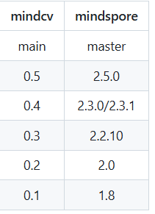
所以最简单的办法就是去掉如下代码
ms.set_context(jit_config={"jit_level": "02"})
此外，也可以升级mindcv mindspore版 cann版本。

GRAPH_MODE下运行ms_tensor = mint.ones_like(input_tensor, dtype=dtype)报错The pointer[device_address] is null.
1. 系统环境
硬件环境(Ascend/GPU/CPU): Ascend910
软件环境: MindSpore 版本: 2.4.0
执行模式： Graph
Python 版本: 3.9.10
操作系统平台: linux
2. 报错信息
2.1 问题描述
运行下述代码报错：
2.2 脚本信息
import mindspore.numpy as mnp
import numpy as np
import mindspore as ms
from mindspore import mint, Tensor, ops, value_and_grad
from mindspore import context
# 设置为 GRAPH 模式
context.set_context(mode=context.GRAPH_MODE, device_target="Ascend")
# 设置为 PYNATIVE 模式
# context.set_context(mode=context.PYNATIVE_MODE)
"""
mindspore.mint.ones_like(input, *, dtype=None)
创建一个数值全为1的Tensor，shape和 input 相同，dtype由 dtype 决定。
如果 dtype = None，输出Tensor的数据类型会和 input 一致。
参数：input (Tensor) - 任意维度的Tensor。
关键字参数：dtype (mindspore.dtype, 可选) - 用来描述所创建的Tensor的 dtype。如果为 None ，那么将会使用 input 的dtype。默认值： None 。
返回：Tensor，具有与 input 相同的shape并填充了1。
异常：TypeError - input 不是Tensor。
"""
# 创建一个包含所有 Mindspore dtype 的列表
dtype_list = [
ms.int8, ms.byte,
ms.int16, ms.short,
ms.int32, ms.intc,
ms.int64, ms.intp,
ms.uint8, ms.ubyte,
# ms.uint16, ms.ushort,
# ms.uint32, ms.uintc,
# ms.uint64, ms.uintp,
ms.float16, ms.half,
ms.float32, ms.single,
ms.float64, ms.double,
# ms.bfloat16,
# ms.complex64,
# ms.complex128
]
def test_support_dtype(dtype_list):
input_tensor = ms.tensor([[1, 2, 3], [4, 5, 6]], dtype=ms.float32)
for dtype in dtype_list:
try:
ms_tensor = mint.ones_like(input_tensor, dtype=dtype)
print(f"Success: MindSpore mint.ones_like() support {dtype}")
except Exception as e:
print(f"Error with dtype {dtype}: {e}")
if __name__ == "__main__":
# 输入不同dtype，测试框架的支持度
test_support_dtype(dtype_list)
2.3 报错信息
Error with dtype Float16: The pointer[device_address] is null.
- Framevork Unexpected ExceptionRaised
This exception is caused by franework's unexpected error. Please create an issue at https://gitee. con/nindspore/mindspore/issues to get help.
- C++ Call Stack: (For frameworkdevelopers)
mindspore/ccsrc/runtine/device/device_address_utils. cc: 1038CreatekernelTensor
Error with dtype Float32: The pointer[device_address] is null.
- Framevork Unexpected Exception Raised:
This exception is caused by franework's unexpected error. Please create an issue at https: //gitee. con/mindspore/mindspore/issues to get help.
- C++ Call Stack: (For franework developers)
mindspore/ccsrc/runtine/device/device_address_utils. cc: 1038 CreatekernelTensor复制
3. 根因分析
测试代码虽然设置了图模式，但是并没有定义网络，所以相关算子还是运行在pynative模式下。
https://www.mindspore.cn/docs/zh-CN/r2.5.0/model_train/program_form/static_graph.html
使用Graph模式需要设置ms.set_context(mode=ms.GRAPH_MODE)，使用Cell类并且在construct函数中编写执行代码，此时construct函数的代码将会被编译成静态计算图。Cell定义详见Cell API文档。
但是即使代码写成如此，也不应该报错。应该是内部实现有问题，导致静态切换动态的时候出问题了。
4. 解决方案
动静切换的问题需要修改mindspore代码。
原测试代码如果要测试mint.ones_like在图模式下，就需要定义在网络中，这样的话就是图模式下运行该算子。
import numpy as np
import mindspore as ms
from mindspore import mint, Tensor, ops, value_and_grad
from mindspore import context
# 设置为 GRAPH 模式
context.set_context(mode=context.GRAPH_MODE, device_target="Ascend")
# 设置为 PYNATIVE 模式
# context.set_context(mode=context.PYNATIVE_MODE)
"""
mindspore.mint.ones_like(input, *, dtype=None)
创建一个数值全为1的Tensor，shape和 input 相同，dtype由 dtype 决定。
如果 dtype = None，输出Tensor的数据类型会和 input 一致。
参数：input (Tensor) - 任意维度的Tensor。
关键字参数：dtype (mindspore.dtype, 可选) - 用来描述所创建的Tensor的 dtype。如果为 None ，那么将会使用 input 的dtype。默认值： None 。
返回：Tensor，具有与 input 相同的shape并填充了1。
异常：TypeError - input 不是Tensor。
"""
# 创建一个包含所有 Mindspore dtype 的列表
dtype_list = [
ms.int8, ms.byte,
ms.int16, ms.short,
ms.int32, ms.intc,
ms.int64, ms.intp,
ms.uint8, ms.ubyte,
# ms.uint16, ms.ushort,
# ms.uint32, ms.uintc,
# ms.uint64, ms.uintp,
ms.float16, ms.half,
ms.float32, ms.single,
ms.float64, ms.double,
# ms.bfloat16,
# ms.complex64,
# ms.complex128
]
class Network(ms.nn.Cell):
def __init__(self, dtype):
super().__init__()
self.dtype = dtype
def construct(self, x):
x = mint.ones_like(x, dtype=self.dtype)
return x
def test_support_dtype(dtype_list):
input_tensor = ms.tensor([[1, 2, 3], [4, 5, 6]], dtype=ms.float32)
for dtype in dtype_list:
try:
n = Network(dtype)
n(input_tensor)
print(f"Success: MindSpore mint.ones_like() support {dtype}")
except Exception as e:
print(f"Error with dtype {dtype}: {e}")
if __name__ == "__main__":
# 输入不同dtype，测试框架的支持度
test_support_dtype(dtype_list)

使用mint.index_select 在图模式下求梯度报错AssertionError
1. 系统环境
硬件环境(Ascend/GPU/CPU): Ascend/GPU/CPU
软件环境: MindSpore 版本: 2.4
执行模式： Graph
Python 版本: 3.9
操作系统平台: linux
2. 报错信息
2.1 问题描述
使用mint.index_select在图模式如果没有unset RANK_TABLE_FILE,就会报错RuntimeError
2.2 报错信息
不开启unet：
=============================================================== FAILURES ===============================================================
__________________________________________________ test_index_select_forward_back[0] ___________________________________________________
mode = 0
@pytest.mark.parametrize('mode', [ms.GRAPH_MODE, ms.PYNATIVE_MODE])
def test_index_select_forward_back(mode):
"""测试前向和反向传播，对比梯度"""
ms.set_context(mode=mode)
def forward_ms(x):
return mint.index_select(x, 0, ms_index).sum()
def forward_torch(x):
return torch.index_select(x, 0, torch_index).sum()
try:
input_data = [[1, 6, 2, 4], [7, 3, 8, 2], [2, 9, 11, 5]]
index = [0, 2]
ms_tensor, torch_tensor, ms_index, torch_index = create_tensors(input_data, ms.float32, torch.float32, index=index, requires_grad=True)
grad_fn_ms = value_and_grad(forward_ms)
output_ms, gradient_ms = grad_fn_ms(ms_tensor)
output_torch = forward_torch(torch_tensor)
output_torch.backward()
compare_results(output_ms, output_torch.detach())
compare_results(gradient_ms, torch_tensor.grad)
except Exception as e:
> raise e
test_index_select.py:167:
_ _ _ _ _ _ _ _ _ _ _ _ _ _ _ _ _ _ _ _ _ _ _ _ _ _ _ _ _ _ _ _ _ _ _ _ _ _ _ _ _ _ _ _ _ _ _ _ _ _ _ _ _ _ _ _ _ _ _ _ _ _ _ _ _ _ _ _
test_index_select.py:160: in test_index_select_forward_back
output_ms, gradient_ms = grad_fn_ms(ms_tensor)
../anaconda3/envs/MindSpore/lib/python3.9/site-packages/mindspore/common/api.py:960: in staging_specialize
out = _MindsporeFunctionExecutor(func, hash_obj, dyn_args, process_obj, jit_config)(*args, **kwargs)
../anaconda3/envs/MindSpore/lib/python3.9/site-packages/mindspore/common/api.py:188: in wrapper
results = fn(*arg, **kwargs)
../anaconda3/envs/MindSpore/lib/python3.9/site-packages/mindspore/common/api.py:582: in __call__
raise err
../anaconda3/envs/MindSpore/lib/python3.9/site-packages/mindspore/common/api.py:579: in __call__
phase = self.compile(self.fn.__name__, *args_list, **kwargs)
_ _ _ _ _ _ _ _ _ _ _ _ _ _ _ _ _ _ _ _ _ _ _ _ _ _ _ _ _ _ _ _ _ _ _ _ _ _ _ _ _ _ _ _ _ _ _ _ _ _ _ _ _ _ _ _ _ _ _ _ _ _ _ _ _ _ _ _
self = <mindspore.common.api._MindsporeFunctionExecutor object at 0xffff8a646b80>, method_name = 'after_grad'
args = (Tensor(shape=[3, 4], dtype=Float32, value=
[[ 1.00000000e+00, 6.00000000e+00, 2.00000000e+00, 4.00000000e+00],
[ ...00000e+00, 8.00000000e+00, 2.00000000e+00],
[ 2.00000000e+00, 9.00000000e+00, 1.10000000e+01, 5.00000000e+00]]),)
kwargs = {}
compile_args = (Tensor(shape=[3, 4], dtype=Float32, value=
[[ 1.00000000e+00, 6.00000000e+00, 2.00000000e+00, 4.00000000e+00],
[ ...00000e+00, 8.00000000e+00, 2.00000000e+00],
[ 2.00000000e+00, 9.00000000e+00, 1.10000000e+01, 5.00000000e+00]]),)
key_id = '1876501395697841734756182555320576'
generate_name = 'mindspore.ops.composite.base.after_grad./home/ma-user/anaconda3/envs/MindSpore/lib/python3.9/site-packages/mindspore/ops/composite/base.py.599.1734756182555320576'
echo_function_name = 'function "after_grad" at the file "/home/ma-user/anaconda3/envs/MindSpore/lib/python3.9/site-packages/mindspore/ops/composite/base.py", line 599'
full_function_name = 'mindspore.ops.composite.base.after_grad./home/ma-user/anaconda3/envs/MindSpore/lib/python3.9/site-packages/mindspore/ops/composite/base.py.599'
create_time = '1734756182555320576', key = 0, parameter_ids = ''
phase = 'mindspore.ops.composite.base.after_grad./home/ma-user/anaconda3/envs/MindSpore/lib/python3.9/site-packages/mindspore/ops/composite/base.py.599.1734756182555320576.0'
jit_config_dict = {'debug_level': 'RELEASE', 'exc_mode': 'auto', 'infer_boost': 'off', 'jit_level': '', ...}
def compile(self, method_name, *args, **kwargs):
"""Returns pipeline for the given args."""
# Check whether hook function registered on Cell object.
if self.obj and hasattr(self.obj, "_hook_fn_registered"):
if self.obj._hook_fn_registered():
logger.warning(f"For 'Cell', it's not support hook function when using 'jit' decorator. "
f"If you want to use hook function, please use context.set_context to set "
f"pynative mode and remove 'jit' decorator.")
# Chose dynamic shape tensors or actual input tensors as compile args.
compile_args = self._generate_compile_args(args)
key_id = self._get_key_id()
compile_args = get_auto_dynamic_shape_args_with_check_input_signature(compile_args, key_id,
self.input_signature)
# Restore the mutable attr for every arg.
compile_args = _restore_mutable_attr(args, compile_args)
self._compile_args = compile_args
generate_name, echo_function_name = self._get_generate_name()
# The full Function name
full_function_name = generate_name
create_time = ''
# Add key with obj
if self.obj is not None:
if self.obj.__module__ != self.fn.__module__:
logger.info(
f'The module of `self.obj`: `{self.obj.__module__}` is not same with the module of `self.fn`: '
f'`{self.fn.__module__}`')
self.obj.__parse_method__ = method_name
if isinstance(self.obj, ms.nn.Cell):
generate_name = generate_name + '.' + str(self.obj.create_time)
create_time = str(self.obj.create_time)
else:
generate_name = generate_name + '.' + str(self._create_time)
create_time = str(self._create_time)
generate_name = generate_name + '.' + str(id(self.obj))
full_function_name = generate_name
else:
# Different instance of same class may use same memory(means same obj_id) at diff times.
# To avoid unexpected phase matched, add create_time to generate_name.
generate_name = generate_name + '.' + str(self._create_time)
create_time = str(self._create_time)
self.enable_tuple_broaden = False
if hasattr(self.obj, "enable_tuple_broaden"):
self.enable_tuple_broaden = self.obj.enable_tuple_broaden
self._graph_executor.set_enable_tuple_broaden(self.enable_tuple_broaden)
key = self._graph_executor.generate_arguments_key(self.fn, compile_args, kwargs, self.enable_tuple_broaden)
parameter_ids = _get_parameter_ids(args, kwargs)
if parameter_ids != "":
key = str(key) + '.' + parameter_ids
phase = generate_name + '.' + str(key)
update_auto_dynamic_shape_phase_with_check_input_signature(compile_args, key_id, phase, self.input_signature)
if phase in ms_compile_cache:
# Release resource should be released when CompileInner won't be executed, such as cur_convert_input_
# generated in generate_arguments_key.
self._graph_executor.clear_compile_arguments_resource()
return phase
_check_recompile(self.obj, compile_args, kwargs, full_function_name, create_time, echo_function_name)
# If enable compile cache, get the dependency files list and set to graph executor.
self._set_compile_cache_dep_files()
if self.jit_config_dict:
self._graph_executor.set_jit_config(self.jit_config_dict)
else:
jit_config_dict = JitConfig().jit_config_dict
self._graph_executor.set_jit_config(jit_config_dict)
if self.obj is None:
# Set an attribute to fn as an identifier.
if isinstance(self.fn, types.MethodType):
setattr(self.fn.__func__, "__jit_function__", True)
else:
setattr(self.fn, "__jit_function__", True)
> is_compile = self._graph_executor.compile(self.fn, compile_args, kwargs, phase, True)
E RuntimeError: Compile graph kernel_graph0 failed.
E
E ----------------------------------------------------
E - C++ Call Stack: (For framework developers)
E ----------------------------------------------------
E mindspore/ccsrc/plugin/device/ascend/hal/hardware/ge_graph_executor.cc:636 CompileGraph
../anaconda3/envs/MindSpore/lib/python3.9/site-packages/mindspore/common/api.py:674: RuntimeError复制
开启：
test_index_select.py:165: in test_index_select_forward_back
compare_results(gradient_ms, torch_tensor.grad)_ _ _ _ _ _ _ _ _ _ _ _ _ _ _ _ _ _ _ _ _ _ _ _ _ _ _ _ _ _ _ _ _ _ _ _ _ _ _ _ _ _ _ _ _ _ _ _ _ _ _ _ _ _ _ _ _ _ _ _ _ _ _ _ _ _ _ _
ms_result = Tensor(shape=[3, 4], dtype=Float32, value=
[[-9.15310234e-02, 1.28829825e+00, -1.13139284e+00, -2.20877814e+00],
[-7...1860191e-01, 6.35216951e-01, 2.55284572e+00],
[-9.15310234e-02, 1.28829825e+00, -1.13139284e+00, -2.20877814e+00]])
torch_result = tensor([[1., 1., 1., 1.],
[0., 0., 0., 0.],
[1., 1., 1., 1.]]), atol = 0.001
def compare_results(ms_result, torch_result, atol=1e-3):
> assert np.allclose(ms_result.asnumpy(), torch_result.numpy(), atol=atol)
E assert False
E + where False = <function allclose at 0xffff078191f0>(array([[-0.09153102, 1.2882982 , -1.1313928 , -2.2087781 ],\n [-0.75677174, -0.4818602 , 0.63521695, 2.5528457 ],\n [-0.09153102, 1.2882982 , -1.1313928 , -2.2087781 ]],\n dtype=float32), array([[1., 1., 1., 1.],\n [0., 0., 0., 0.],\n [1., 1., 1., 1.]], dtype=float32), atol=0.001)
E + where <function allclose at 0xffff078191f0> = np.allclose
E + and array([[-0.09153102, 1.2882982 , -1.1313928 , -2.2087781 ],\n [-0.75677174, -0.4818602 , 0.63521695, 2.5528457 ],\n [-0.09153102, 1.2882982 , -1.1313928 , -2.2087781 ]],\n dtype=float32) = <bound method Tensor.asnumpy of Tensor(shape=[3, 4], dtype=Float32, value=\n[[-9.15310234e-02, 1.28829825e+00, -1.1313...860191e-01, 6.35216951e-01, 2.55284572e+00],\n [-9.15310234e-02, 1.28829825e+00, -1.13139284e+00, -2.20877814e+00]])>()
E + where <bound method Tensor.asnumpy of Tensor(shape=[3, 4], dtype=Float32, value=\n[[-9.15310234e-02, 1.28829825e+00, -1.1313...860191e-01, 6.35216951e-01, 2.55284572e+00],\n [-9.15310234e-02, 1.28829825e+00, -1.13139284e+00, -2.20877814e+00]])> = Tensor(shape=[3, 4], dtype=Float32, value=\n[[-9.15310234e-02, 1.28829825e+00, -1.13139284e+00, -2.20877814e+00],\n [-7...1860191e-01, 6.35216951e-01, 2.55284572e+00],\n [-9.15310234e-02, 1.28829825e+00, -1.13139284e+00, -2.20877814e+00]]).asnumpy
E + and array([[1., 1., 1., 1.],\n [0., 0., 0., 0.],\n [1., 1., 1., 1.]], dtype=float32) = <built-in method numpy of Tensor object at 0xffffa45d3040>()
E + where <built-in method numpy of Tensor object at 0xffffa45d3040> = tensor([[1., 1., 1., 1.],\n [0., 0., 0., 0.],\n [1., 1., 1., 1.]]).numpy
test_index_select.py:28: AssertionError
2.3 脚本信息
在终端分别使用或者不使用unset RANK_TABLE_FILE,再使用下面的脚本。
import pytest
import numpy as np
import mindspore as ms
from mindspore import Tensor, value_and_grad, mint
import torch
def create_tensors(input_data, ms_dtype, torch_dtype, index=None, requires_grad=False):
ms_tensor = Tensor(input_data, ms_dtype)
torch_tensor = torch.tensor(input_data, dtype=torch_dtype, requires_grad=requires_grad)
if index is not None:
ms_index = Tensor(index, ms.int32)
torch_index = torch.tensor(index, dtype=torch.long)
else:
ms_index = None
torch_index = None
return ms_tensor, torch_tensor, ms_index, torch_index
def perform_index_select(ms_tensor, torch_tensor, dim, ms_index, torch_index):
ms_result = mint.index_select(ms_tensor, dim, ms_index)
torch_result = torch.index_select(torch_tensor, dim, torch_index)
return ms_result, torch_result
def compare_results(ms_result, torch_result, atol=1e-3):
assert np.allclose(ms_result.asnumpy(), torch_result.numpy(), atol=atol)
@pytest.mark.parametrize('mode', [ms.GRAPH_MODE, ms.PYNATIVE_MODE])
def test_index_select_forward_back(mode):
"""测试前向和反向传播，对比梯度"""
ms.set_context(mode=mode)
def forward_ms(x):
return mint.index_select(x, 0, ms_index).sum()
def forward_torch(x):
return torch.index_select(x, 0, torch_index).sum()
try:
input_data = [[1, 6, 2, 4], [7, 3, 8, 2], [2, 9, 11, 5]]
index = [0, 2]
ms_tensor, torch_tensor, ms_index, torch_index = create_tensors(input_data, ms.float32, torch.float32, index=index, requires_grad=True)
grad_fn_ms = value_and_grad(forward_ms)
output_ms, gradient_ms = grad_fn_ms(ms_tensor)
output_torch = forward_torch(torch_tensor)
output_torch.backward()
compare_results(output_ms, output_torch.detach())
compare_results(gradient_ms, torch_tensor.grad)
except Exception as e:
raise e
3. 根因分析
根因：mint接口在图模式下暂不支持图下沉模式。
查看mint接口的相关说明，里面有提及到mint接口的限制。
https://www.mindspore.cn/docs/zh-CN/r2.4.0/api_python/mindspore.mint.html
mindspore.mint提供了大量的functional、nn、优化器接口，API用法及功能等与业界主流用法一致，方便用户参考使用。 mint接口当前是实验性接口，在图编译模式为O0和PyNative模式下性能比ops更优。当前暂不支持图下沉模式及CPU、GPU后端，后续会逐步完善。
然后再参看set_context的接口说明，里面有图模式的相关设置的说明。Altas训练产品为O2，其余产品均为O0
https://www.mindspore.cn/docs/zh-CN/r2.4.0/api_python/mindspore/mindspore.set_context.html
jit_config (dict) - 设置全局编译选项的配置，只在使用Cell或者jit装饰器定义的网络中生效，默认不设置。 context设置全局jit config，而JitConfig设置局部网络的jit config，二者同时存在时，全局jit config不会覆盖局部网络的jit config。
jit_level (str): 用来控制编译优化级别。默认值为空，框架根据产品类别自动选择优化级别，Altas训练产品为O2，其余产品均为O0。动态Shape场景须为O0/O1，不支持O2。其值范围如下：
O0: 除必要影响功能的优化外，其他优化均关闭，使用逐算子执行的执行方式。
O1: 使能常用优化和自动算子融合优化，使用逐算子执行的执行方式。
O2: 开启极致性能优化，使用下沉的执行方式。
4. 解决方案
因为mint接口不支持图下沉模式，所以代码手动设置 jit_level为O0
ms.set_context(jit_level="O0")，修改后代码如下
import pytest
import numpy as np
import mindspore as ms
from mindspore import Tensor, value_and_grad, mint
import torch
def create_tensors(input_data, ms_dtype, torch_dtype, index=None, requires_grad=False):
ms_tensor = Tensor(input_data, ms_dtype)
torch_tensor = torch.tensor(input_data, dtype=torch_dtype, requires_grad=requires_grad)
if index is not None:
ms_index = Tensor(index, ms.int32)
torch_index = torch.tensor(index, dtype=torch.long)
else:
ms_index = None
torch_index = None
return ms_tensor, torch_tensor, ms_index, torch_index
def perform_index_select(ms_tensor, torch_tensor, dim, ms_index, torch_index):
ms_result = mint.index_select(ms_tensor, dim, ms_index)
torch_result = torch.index_select(torch_tensor, dim, torch_index)
return ms_result, torch_result
def compare_results(ms_result, torch_result, atol=1e-3):
assert np.allclose(ms_result.asnumpy(), torch_result.numpy(), atol=atol)
@pytest.mark.parametrize('mode', [ms.GRAPH_MODE, ms.PYNATIVE_MODE])
def test_index_select_forward_back(mode):
"""测试前向和反向传播，对比梯度"""
ms.set_context(mode=mode)
ms.set_context(jit_level="O0")
def forward_ms(x):
return mint.index_select(x, 0, ms_index).sum()
def forward_torch(x):
return torch.index_select(x, 0, torch_index).sum()
try:
input_data = [[1, 6, 2, 4], [7, 3, 8, 2], [2, 9, 11, 5]]
index = [0, 2]
ms_tensor, torch_tensor, ms_index, torch_index = create_tensors(input_data, ms.float32, torch.float32, index=index, requires_grad=True)
grad_fn_ms = value_and_grad(forward_ms)
output_ms, gradient_ms = grad_fn_ms(ms_tensor)
output_torch = forward_torch(torch_tensor)
output_torch.backward()
compare_results(output_ms, output_torch.detach())
compare_results(gradient_ms, torch_tensor.grad)
except Exception as e:
raise e

使用mindspore.mint.where()报错The supported input and output data types for the current operator are: node is Default/Bitwis
1. 系统环境
硬件环境(Ascend/GPU/CPU): Ascend
软件环境: MindSpore 版本: 2.4.1
执行模式： 不限
Python 版本: 3.9
操作系统平台: Ubuntu=22.04
2. 报错信息
2.1 问题描述
torch.where()参数condition和mindspore.mint.where()参数condition在需要多个逻辑表达式情况下的写法不一样。对于需要两个逻辑表达式的情况，如：
(neg >= -delta) & (neg <= delta)
需要使用ops.logical_and接口来实现。
比如参数condition为：
condition = ops.logical_and((neg >= -delta), (neg <= delta))
如果参数condition使用如下代码会报错：
condition = (neg >= -delta) & (neg <= delta)
2.2 脚本信息
def test_where_value_and_grad():
def ternarize_torch(tensor):
delta = get_delta_torch(tensor)
alpha = get_alpha_torch(tensor, delta)
pos = torch.where(tensor > delta, 1, tensor)
neg = torch.where(pos<-delta, -1, pos)
ternary = torch.where((neg >= -delta) & (neg <= delta), 0, neg)
return ternary * alpha
def get_alpha_torch(tensor, delta):
ndim = len(tensor.shape)
view_dims = (-1,) + (ndim - 1)*(1,)
i_delta = (torch.abs(tensor) > delta)
i_delta_count = i_delta.view(i_delta.shape[0], -1).sum(1)
tensor_thresh = torch.where((i_delta), tensor, 0)
alpha = (1 / i_delta_count)*(torch.abs(tensor_thresh.view(tensor.shape[0], -1)).sum(1))
alpha = alpha.view(view_dims)
return alpha
def get_delta_torch(tensor):
ndim = len(tensor.shape)
view_dims = (-1,) + (ndim - 1) * (1,)
n = tensor[0].nelement()
norm = tensor.norm(1, ndim - 1).view(tensor.shape[0], -1)
norm_sum = norm.sum(1)
delta = (0.75 / n) * norm_sum
return delta.view(view_dims)
def ternarize_ms(tensor):
delta = get_delta_ms(tensor)
alpha = get_alpha_ms(tensor, delta)
pos = mint.where(tensor > delta, 1, tensor)
neg = mint.where(pos<-delta, -1, pos)
condition = ops.logical_and((neg >= -delta), (neg <= delta))
#condition = (neg >= -delta) & (neg <= delta)
ternary = mint.where(condition, 0, neg)
return ternary * alpha
def get_alpha_ms(tensor, delta):
ndim = len(tensor.shape)
view_dims = (-1,) + (ndim - 1)*(1,)
i_delta = (ops.abs(tensor) > delta)
i_delta_count = i_delta.view(i_delta.shape[0], -1).sum(1)
tensor_thresh = mint.where((i_delta), tensor, 0)
alpha = (1 / i_delta_count)*(ops.abs(tensor_thresh.view(tensor.shape[0], -1)).sum(1))
alpha = alpha.view(view_dims)
return alpha
def get_delta_ms(tensor):
ndim = len(tensor.shape)
view_dims = (-1,) + (ndim - 1) * (1,)
n = tensor[0].nelement()
norm = tensor.norm(1, ndim - 1).view(tensor.shape[0], -1)
norm_sum = norm.sum(1)
delta = (0.75 / n) * norm_sum
return delta.view(view_dims)
x_np = np.random.randn(3, 3).astype(np.float32)
x_torch = torch.from_numpy(x_np)
x_torch.requires_grad = True
x_ms = Parameter(Tensor.from_numpy(x_np))
y_torch = ternarize_torch(x_torch)
y_ms = ternarize_ms(x_ms)
print(f"<value torch> {y_torch}\n"
f"<value_ms> {y_ms}")
if np.allclose(y_torch.detach().numpy(), y_ms.asnumpy(), atol=1e-3):
print("[value] WITHIN TOLERANCE (from test_stack_value_and_grad): "
"value discrepancy between torch.stack "
"mindspore.mint.stack is less than 1e-3.")
else:
print("[value] BEYOND TOLERANCE (from test_stack_value_and_grad): "
"value discrepancy is beyond tolerance.")
print('='*50)
y_sum = y_torch.sum()
y_sum.backward()
grad_ms = ms.grad(ternarize_ms, grad_position=0)(x_ms)
print(f"<grad torch> {x_torch.grad}\n"
f"<grad> {grad_ms}")
if np.allclose(x_torch.grad.numpy(), grad_ms.asnumpy(), atol=1e-3):
print("[grad] WITHIN TOLERANCE (from test_stack_value_and_grad): "
"grad discrepancy between torch.stack "
"mindspore.mint.stack is less than 1e-3.")
else:
print("[grad] BEYOND TOLERANCE (from test_stack_value_and_grad): "
"grad discrepancy is beyond tolerance.")
print('='*50)
2.3 报错信息
---------------------------------------------------------------------------
TypeError Traceback (most recent call last)
Cell In[4], line 1
----> 1 test_where_value_and_grad()
Cell In[2], line 70, in test_where_value_and_grad()
67 y_torch = ternarize_torch(x_torch)
68 y_ms = ternarize_ms(x_ms)
---> 70 print(f"<value torch> {y_torch}\n"
71 f"<value_ms> {y_ms}")
72 if np.allclose(y_torch.detach().numpy(), y_ms.asnumpy(), atol=1e-3):
73 print("[value] WITHIN TOLERANCE (from test_stack_value_and_grad): "
74 "value discrepancy between torch.stack "
75 "mindspore.mint.stack is less than 1e-3.")
File ~/anaconda3/envs/MindSpore/lib/python3.9/site-packages/mindspore/common/_stub_tensor.py:48, in _stub_method.<locals>.fun(*arg, **kwargs)
46 def fun(*arg, **kwargs):
47 stub = arg[0]
---> 48 arg = (stub.stub_sync(),) + arg[1:]
49 return method(*arg, **kwargs)
File ~/anaconda3/envs/MindSpore/lib/python3.9/site-packages/mindspore/common/_stub_tensor.py:159, in StubTensor.stub_sync(self)
157 """sync real tensor."""
158 if self.stub:
--> 159 val = self.stub.get_value()
160 self.tensor = Tensor(val, internal=True)
161 if hasattr(self, "member_cache"):
TypeError: The supported input and output data types for the current operator are: node is Default/BitwiseAnd-op1
InputDesc [0] support {int16,int32,int64,int8,uint16,uint32,uint64,uint8,}
InputDesc [1] support {int16,int32,int64,int8,uint16,uint32,uint64,uint8,}
OutputDesc [0] support {int16,int32,int64,int8,uint16,uint32,uint64,uint8,}
But current operator's input and output data types is:
InputDesc [0] is Bool
InputDesc [1] is Bool
OutputDesc [0] is Bool
----------------------------------------------------
- C++ Call Stack: (For framework developers)
----------------------------------------------------
mindspore/ccsrc/plugin/device/ascend/hal/device/kernel_select_ascend.cc:586 HandleKernelSelectFailure
[WARNING] DEVICE(3671,ffff657fa1e0,python):2024-12-25-16:48:33.998.529 [mindspore/ccsrc/transform/acl_ir/op_api_convert.h:114] GetOpApiFunc] Dlsym aclSetAclOpExecutorRepeatable failed!
[WARNING] KERNEL(3671,ffff657fa1e0,python):2024-12-25-16:48:33.998.585 [mindspore/ccsrc/transform/acl_ir/op_api_cache.h:54] SetExecutorRepeatable] The aclSetAclOpExecutorRepeatable is unavailable, which results in aclnn cache miss.
[WARNING] DEVICE(3671,ffff62ff91e0,python):2024-12-25-16:48:34.028.472 [mindspore/ccsrc/transform/acl_ir/op_api_convert.h:114] GetOpApiFunc] Dlsym aclDestroyAclOpExecutor failed!
3. 根因分析
当condition = (neg >= -delta) & (neg <= delta)的时候，因为有操作符&，框架会把这个操作符自动转换成 ops.bitwise_and 算子。
而该算子当前并不支持bool类型，因此会报
TypeError: The supported input and output data types for the current operator are: node is Default/BitwiseAnd-op1
4. 解决方案
用ops.logical_and 算子替换操作符&，该算子可以支持bool类型
ops.logical_and((neg >= -delta), (neg <= delta))

使用mindspore.mint.gather函数计算出的结果错误
1. 系统环境
硬件环境(Ascend/GPU/CPU): Ascend910
软件环境: MindSpore 版本: 2.4.0
执行模式： 不限
Python 版本: 3.7
操作系统平台: linux
2. 报错信息
2.1 问题描述
运行下述代码计算错误，程序正常运行，但给出错误结果。
2.2 脚本信息
import mindspore
from mindspore import mint, Tensor, ops, value_and_grad, context
import numpy as np
input_tensor = Tensor(np.array([[-0.1, 0.3, 3.6], [0.4, 0.5, -3.2]]), dtype = mindspore.float32)
index = Tensor(np.array([[0, 0], [1, 4]]), dtype = mindspore.int32)
output = mint.gather(input_tensor, 1, index)
print(output)
输出计算结果
[[-0.1 -0.1]
[ 0.5 0.5]]
3. 根因分析
https://www.mindspore.cn/docs/zh-CN/r2.5.0/api_python/mint/mindspore.mint.gather.html?highlight=gather
gather操作返回输入Tensor在指定 index 索引对应的元素组成的切片。
input_tensor shape是（2,3）
index [[0, 0], [1, 4]]
其中4 取值不在范围 [0, input.shape[dim]) 内
api也有相关说明
警告
在Ascend后端，以下场景将导致不可预测的行为：
正向执行流程中，当 index 的取值不在范围 [-input.shape[dim], input.shape[dim]) 内；
反向执行流程中，当 index 的取值不在范围 [0, input.shape[dim]) 内。
4. 解决方案
修改index的值在有效范围内,例如修改成如下
import mindspore
from mindspore import mint, Tensor, ops, value_and_grad, context
import numpy as np
input_tensor = Tensor(np.array([[-0.1, 0.3, 3.6], [0.4, 0.5, -3.2]]), dtype = mindspore.float32)
index = Tensor(np.array([[0, 0], [1, 2]]), dtype = mindspore.int32)
output = mint.gather(input_tensor, 1, index)
print(output)

使用Modelarts训练yolov5出现报错TypeError: modelarts_pre_process() missing 1 required positional argument:’args’
1. 系统环境
硬件环境(Ascend/GPU/CPU): Ascend910
软件环境: MindSpore 版本: 2.1.0
执行模式： 不限
Python 版本: 3.7
操作系统平台: linux
2. 报错信息
2.1 问题描述
在Modelarts里面的训练作业里面训练yolov5，出现报错。使用的代码：https://gitee.com/mindspore/models/blob/master/official/cv/YOLOv5
2.2 报错信息
在default_config.yaml文件里面enable_modelarts参数是False的时候出现如下报错：
FileNotFoundError:[Error 2] No such file or directory:’/cache/data/annotations/instances_train2017.json’
但是在enable_modelarts为False的时候，在notbook环境下，是可以正常跑通训练的。把enable_modelarts改为True的时候，在训练界面，就可以找到路径了，但是会报下面的错误。
TypeError: modelarts_pre_process() missing 1 required positional argument:’args’
并且把enable_modelarts改为True的时候，在notbook环境下，也会报和上述相同的错误。
3. 根因分析
1.default_config.yaml文件里面enable_modelarts参数是False 报
FileNotFoundError:[Error 2] No such file or directory:’/cache/data/annotations/instances_train2017.json’
这个报错是因为代码走到了训练流程里面，因为环境里面没数据集导致。这个只要在对应位置放置数据集就行。
2.enable_modelarts改为True 报
TypeError: modelarts_pre_process() missing 1 required positional argument:’args’
其实这里还没走到训练流程，这个是前置流程。
train.py 128行代码定义了moxing_wrapper这个装饰器
@moxing_wrapper(pre_process=modelarts_pre_process, post_process=modelarts_post_process, pre_args=[config])
def run_train():
这个装饰器定义在 official/cv/YOLOv5/model_utils/moxing_adapter.py
def moxing_wrapper(pre_process=None, post_process=None, **kwargs):
"""
Moxing wrapper to download dataset and upload outputs.
"""
def wrapper(run_func):
@functools.wraps(run_func)
def wrapped_func(*args, **kwargs):
# Download data from data_url
if config.enable_modelarts:
if config.data_url:
sync_data(config.data_url, config.data_path)
print("Dataset downloaded: ", os.listdir(config.data_path))
if config.checkpoint_url:
sync_data(config.checkpoint_url, config.load_path)
print("Preload downloaded: ", os.listdir(config.load_path))
if config.train_url:
sync_data(config.train_url, config.output_path)
print("Workspace downloaded: ", os.listdir(config.output_path))
mindspore.set_context(save_graphs_path=os.path.join(config.output_path, str(get_rank_id())))
config.device_num = get_device_num()
config.device_id = get_device_id()
if not os.path.exists(config.output_path):
os.makedirs(config.output_path)
if pre_process:
if "pre_args" in kwargs.keys():
pre_process(*kwargs["pre_args"])
else:
pre_process()
# Run the main function
run_func(*args, **kwargs)
# Upload data to train_url
if config.enable_modelarts:
if post_process:
if "post_args" in kwargs.keys():
post_process(*kwargs["post_args"])
else:
post_process()
if config.train_url:
print("Start to copy output directory")
sync_data(config.output_path, config.train_url)
return wrapped_func
return wrapper
出问题的是modelarts_pre_process 这个函数，该函数有一个参数，但是调用的时候并没有参数传递过去。
也就是下面的代码走到了else分支。
if "pre_args" in kwargs.keys():
pre_process(*kwargs["pre_args"])
else:
pre_process()
为什么传递给装饰器的kwargs一开始是有值的，但是变成了空呢？
问题出在了official/cv/YOLOv5/model_utils/moxing_adapter.py
第136行
def moxing_wrapper(pre_process=None, post_process=None, **kwargs):
第142行
def wrapped_func(*args, **kwargs):
以及162行
if "pre_args" in kwargs.keys():
def moxing_wrapper(pre_process=None, post_process=None, **kwargs):
"""
Moxing wrapper to download dataset and upload outputs.
"""
def wrapper(run_func):
@functools.wraps(run_func)
def wrapped_func(*args, **kwargs):
...
if pre_process:
if "pre_args" in kwargs.keys():
pre_process(*kwargs["pre_args"])
else:
pre_process()
外层的moxing_wrapper和内层的wrapped_func都使用了kwargs这个参数名。
而if "pre_args" in kwargs.keys():这个判断明显的判断外层的装饰器输入的参数，而不是内层的被装饰的函数。
4. 解决方案
修改文件 official/cv/YOLOv5/model_utils/moxing_adapter.py
修改重名的 kwargs ，另外一个可以用其他的名称代替。这里内部函数修改为wrap_kwargs。
def moxing_wrapper(pre_process=None, post_process=None, **kwargs):
"""
Moxing wrapper to download dataset and upload outputs.
"""
def wrapper(run_func):
@functools.wraps(run_func)
def wrapped_func(*args, **wrap_kwargs):
# Download data from data_url
if config.enable_modelarts:
if config.data_url:
sync_data(config.data_url, config.data_path)
print("Dataset downloaded: ", os.listdir(config.data_path))
if config.checkpoint_url:
sync_data(config.checkpoint_url, config.load_path)
print("Preload downloaded: ", os.listdir(config.load_path))
if config.train_url:
sync_data(config.train_url, config.output_path)
print("Workspace downloaded: ", os.listdir(config.output_path))
mindspore.set_context(save_graphs_path=os.path.join(config.output_path, str(get_rank_id())))
config.device_num = get_device_num()
config.device_id = get_device_id()
if not os.path.exists(config.output_path):
os.makedirs(config.output_path)
if pre_process:
if "pre_args" in kwargs.keys():
pre_process(*kwargs["pre_args"])
else:
pre_process()
# Run the main function
run_func(*args, **wrap_kwargs)
# Upload data to train_url
if config.enable_modelarts:
if post_process:
if "post_args" in kwargs.keys():
post_process(*kwargs["post_args"])
else:
post_process()
if config.train_url:
print("Start to copy output directory")
sync_data(config.output_path, config.train_url)
return wrapped_func
return wrapper

使用mint.masked_select在图模式下报错Parse Lambda Function Fail. Node type must be Lambda, but got Call.
1. 系统环境
硬件环境(Ascend/GPU/CPU): Ascend
软件环境: MindSpore 版本: 2.4.0
执行模式： Graph
Python 版本: 3.9.10
操作系统平台: linux
2. 报错信息
2.1 问题描述
使用mint.masked_select在图模式下报错Parse Lambda Function Fail. Node type must be Lambda, but got Call.
2.2 报错信息
================================================================================== FAILURES ==================================================================================
_____________________________________________________________________ test_masked_select_forward_back[0] _____________________________________________________________________
mode = 0
@pytest.mark.parametrize('mode', [ms.GRAPH_MODE, ms.PYNATIVE_MODE])
def test_masked_select_forward_back(mode):
"""测试前向和反向传播，对比梯度"""
ms.set_context(mode=mode)
def forward_ms(x, mask):
return mint.masked_select(x, mask).sum()
def forward_torch(x, mask):
return torch.masked_select(x, mask).sum()
try:
input_data = [[1.0, 6.0, 2.0, 4.0], [7.0, 3.0, 8.0, 2.0], [2.0, 9.0, 11.0, 5.0]]
mask = [
[True, False, True, False],
[False, True, False, True],
[True, False, True, False]
]
ms_tensor, torch_tensor, ms_mask, torch_mask = create_tensors(input_data, ms.float32, torch.float32, mask=mask, requires_grad=True)
grad_fn_ms = value_and_grad(lambda x: forward_ms(x, ms_mask))
output_ms, gradient_ms = grad_fn_ms(ms_tensor)
output_torch = forward_torch(torch_tensor, torch_mask)
output_torch.backward()
compare_results(output_ms, output_torch.detach())
compare_results(gradient_ms, torch_tensor.grad)
except Exception as e:
> raise e
test_masked_select.py:228:
_ _ _ _ _ _ _ _ _ _ _ _ _ _ _ _ _ _ _ _ _ _ _ _ _ _ _ _ _ _ _ _ _ _ _ _ _ _ _ _ _ _ _ _ _ _ _ _ _ _ _ _ _ _ _ _ _ _ _ _ _ _ _ _ _ _ _ _ _ _ _ _ _ _ _ _ _ _ _ _ _ _ _ _ _ _ _
test_masked_select.py:220: in test_masked_select_forward_back
output_ms, gradient_ms = grad_fn_ms(ms_tensor)
../anaconda3/envs/MindSpore/lib/python3.9/site-packages/mindspore/common/api.py:960: in staging_specialize
out = _MindsporeFunctionExecutor(func, hash_obj, dyn_args, process_obj, jit_config)(*args, **kwargs)
../anaconda3/envs/MindSpore/lib/python3.9/site-packages/mindspore/common/api.py:188: in wrapper
results = fn(*arg, **kwargs)
../anaconda3/envs/MindSpore/lib/python3.9/site-packages/mindspore/common/api.py:582: in __call__
raise err
../anaconda3/envs/MindSpore/lib/python3.9/site-packages/mindspore/common/api.py:579: in __call__
phase = self.compile(self.fn.__name__, *args_list, **kwargs)
_ _ _ _ _ _ _ _ _ _ _ _ _ _ _ _ _ _ _ _ _ _ _ _ _ _ _ _ _ _ _ _ _ _ _ _ _ _ _ _ _ _ _ _ _ _ _ _ _ _ _ _ _ _ _ _ _ _ _ _ _ _ _ _ _ _ _ _ _ _ _ _ _ _ _ _ _ _ _ _ _ _ _ _ _ _ _
self = <mindspore.common.api._MindsporeFunctionExecutor object at 0xffff74011f10>, method_name = 'after_grad'
args = (Tensor(shape=[3, 4], dtype=Float32, value=
[[ 1.00000000e+00, 6.00000000e+00, 2.00000000e+00, 4.00000000e+00],
[ ...00000e+00, 8.00000000e+00, 2.00000000e+00],
[ 2.00000000e+00, 9.00000000e+00, 1.10000000e+01, 5.00000000e+00]]),)
kwargs = {}
compile_args = (Tensor(shape=[3, 4], dtype=Float32, value=
[[ 1.00000000e+00, 6.00000000e+00, 2.00000000e+00, 4.00000000e+00],
[ ...00000e+00, 8.00000000e+00, 2.00000000e+00],
[ 2.00000000e+00, 9.00000000e+00, 1.10000000e+01, 5.00000000e+00]]),)
key_id = '1876509713526961735371593348192768'
generate_name = 'mindspore.ops.composite.base.after_grad./home/ma-user/anaconda3/envs/MindSpore/lib/python3.9/site-packages/mindspore/ops/composite/base.py.599.1735371593348192768'
echo_function_name = 'function "after_grad" at the file "/home/ma-user/anaconda3/envs/MindSpore/lib/python3.9/site-packages/mindspore/ops/composite/base.py", line 599'
full_function_name = 'mindspore.ops.composite.base.after_grad./home/ma-user/anaconda3/envs/MindSpore/lib/python3.9/site-packages/mindspore/ops/composite/base.py.599'
create_time = '1735371593348192768', key = 0, parameter_ids = ''
phase = 'mindspore.ops.composite.base.after_grad./home/ma-user/anaconda3/envs/MindSpore/lib/python3.9/site-packages/mindspore/ops/composite/base.py.599.1735371593348192768.0'
jit_config_dict = {'debug_level': 'RELEASE', 'exc_mode': 'auto', 'infer_boost': 'off', 'jit_level': '', ...}
def compile(self, method_name, *args, **kwargs):
"""Returns pipeline for the given args."""
# Check whether hook function registered on Cell object.
if self.obj and hasattr(self.obj, "_hook_fn_registered"):
if self.obj._hook_fn_registered():
logger.warning(f"For 'Cell', it's not support hook function when using 'jit' decorator. "
f"If you want to use hook function, please use context.set_context to set "
f"pynative mode and remove 'jit' decorator.")
# Chose dynamic shape tensors or actual input tensors as compile args.
compile_args = self._generate_compile_args(args)
key_id = self._get_key_id()
compile_args = get_auto_dynamic_shape_args_with_check_input_signature(compile_args, key_id,
self.input_signature)
# Restore the mutable attr for every arg.
compile_args = _restore_mutable_attr(args, compile_args)
self._compile_args = compile_args
generate_name, echo_function_name = self._get_generate_name()
# The full Function name
full_function_name = generate_name
create_time = ''
# Add key with obj
if self.obj is not None:
if self.obj.__module__ != self.fn.__module__:
logger.info(
f'The module of `self.obj`: `{self.obj.__module__}` is not same with the module of `self.fn`: '
f'`{self.fn.__module__}`')
self.obj.__parse_method__ = method_name
if isinstance(self.obj, ms.nn.Cell):
generate_name = generate_name + '.' + str(self.obj.create_time)
create_time = str(self.obj.create_time)
else:
generate_name = generate_name + '.' + str(self._create_time)
create_time = str(self._create_time)
generate_name = generate_name + '.' + str(id(self.obj))
full_function_name = generate_name
else:
# Different instance of same class may use same memory(means same obj_id) at diff times.
# To avoid unexpected phase matched, add create_time to generate_name.
generate_name = generate_name + '.' + str(self._create_time)
create_time = str(self._create_time)
self.enable_tuple_broaden = False
if hasattr(self.obj, "enable_tuple_broaden"):
self.enable_tuple_broaden = self.obj.enable_tuple_broaden
self._graph_executor.set_enable_tuple_broaden(self.enable_tuple_broaden)
key = self._graph_executor.generate_arguments_key(self.fn, compile_args, kwargs, self.enable_tuple_broaden)
parameter_ids = _get_parameter_ids(args, kwargs)
if parameter_ids != "":
key = str(key) + '.' + parameter_ids
phase = generate_name + '.' + str(key)
update_auto_dynamic_shape_phase_with_check_input_signature(compile_args, key_id, phase, self.input_signature)
if phase in ms_compile_cache:
# Release resource should be released when CompileInner won't be executed, such as cur_convert_input_
# generated in generate_arguments_key.
self._graph_executor.clear_compile_arguments_resource()
return phase
_check_recompile(self.obj, compile_args, kwargs, full_function_name, create_time, echo_function_name)
# If enable compile cache, get the dependency files list and set to graph executor.
self._set_compile_cache_dep_files()
if self.jit_config_dict:
self._graph_executor.set_jit_config(self.jit_config_dict)
else:
jit_config_dict = JitConfig().jit_config_dict
self._graph_executor.set_jit_config(jit_config_dict)
if self.obj is None:
# Set an attribute to fn as an identifier.
if isinstance(self.fn, types.MethodType):
setattr(self.fn.__func__, "__jit_function__", True)
else:
setattr(self.fn, "__jit_function__", True)
> is_compile = self._graph_executor.compile(self.fn, compile_args, kwargs, phase, True)
E TypeError: Parse Lambda Function Fail. Node type must be Lambda, but got Call. Please check lambda expression to make sure it is defined on a separate line.
E For example, the code 'func = nn.ReLU() if y < 1 else lambda x: x + 1' rewritten as
E 'if y < 1:
E func = nn.ReLU()
E else:
E func = lambda x: x + 1
E 'will solve the problem.
E
E ----------------------------------------------------
E - Framework Unexpected Exception Raised:
E ----------------------------------------------------
E This exception is caused by framework's unexpected error. Please create an issue at https://gitee.com/mindspore/mindspore/issues to get help.
E
E ----------------------------------------------------
E - C++ Call Stack: (For framework developers)
E ----------------------------------------------------
E mindspore/ccsrc/pipeline/jit/ps/parse/parse.cc:570 ParseFuncGraph
E
E ----------------------------------------------------
E - The Traceback of Net Construct Code:
E ----------------------------------------------------
E # 0 In file /home/ma-user/anaconda3/envs/MindSpore/lib/python3.9/site-packages/mindspore/ops/composite/base.py:601, 33~35
E return grad_(fn, weights, grad_position)(*args)
E ^~
E (See file '/home/ma-user/work/rank_0/om/analyze_fail.ir' for more details. Get instructions about `analyze_fail.ir` at https://www.mindspore.cn/search?inputValue=analyze_fail.ir)
../anaconda3/envs/MindSpore/lib/python3.9/site-packages/mindspore/common/api.py:674: TypeError
2.3 脚本信息
import pytest
import numpy as np
import mindspore as ms
from mindspore import Tensor, value_and_grad, mint
import torch
def create_tensors(input_data, ms_dtype, torch_dtype, mask=None, requires_grad=False):
ms_tensor = Tensor(input_data, ms_dtype)
torch_tensor = torch.tensor(input_data, dtype=torch_dtype, requires_grad=requires_grad)
if mask is not None:
mask = np.array(mask, dtype=bool)
ms_mask = Tensor(mask, ms.bool_)
torch_mask = torch.tensor(mask, dtype=torch.bool)
else:
ms_mask = None
torch_mask = None
return ms_tensor, torch_tensor, ms_mask, torch_mask
def perform_masked_select(ms_tensor, torch_tensor, ms_mask, torch_mask):
ms_result = mint.masked_select(ms_tensor, ms_mask)
torch_result = torch.masked_select(torch_tensor, torch_mask)
return ms_result, torch_result
def compare_results(ms_result, torch_result, atol=1e-3):
assert np.allclose(ms_result.asnumpy(), torch_result.numpy(), atol=atol)
@pytest.mark.parametrize('mode', [ms.GRAPH_MODE, ms.PYNATIVE_MODE])
def test_masked_select_forward_back(mode):
"""测试前向和反向传播，对比梯度"""
ms.set_context(mode=mode)
def forward_ms(x, mask):
return mint.masked_select(x, mask).sum()
def forward_torch(x, mask):
return torch.masked_select(x, mask).sum()
try:
input_data = [[1.0, 6.0, 2.0, 4.0], [7.0, 3.0, 8.0, 2.0], [2.0, 9.0, 11.0, 5.0]]
mask = [
[True, False, True, False],
[False, True, False, True],
[True, False, True, False]
]
ms_tensor, torch_tensor, ms_mask, torch_mask = create_tensors(input_data, ms.float32, torch.float32, mask=mask, requires_grad=True)
grad_fn_ms = value_and_grad(lambda x: forward_ms(x, ms_mask))
output_ms, gradient_ms = grad_fn_ms(ms_tensor)
output_torch = forward_torch(torch_tensor, torch_mask)
output_torch.backward()
compare_results(output_ms, output_torch.detach())
compare_results(gradient_ms, torch_tensor.grad)
except Exception as e:
raise e
3. 根因分析
mindspore.value_and_grad(fn, grad_position=0, weights=None, has_aux=False, return_ids=False)
- fn (Union[Cell, Function]) - 待求导的函数或网络。
grad_fn_ms = value_and_grad(lambda x: forward_ms(x, ms_mask))
匿名函数一般用于临时函数，用在这里并不合适。
lambda x: forward_ms(x, ms_mask)
相当于定义了一个新函数，参数x 。可以直接把forward_ms 作为fn函数，只是输入要带上ms_mask。
4. 解决方案
grad_fn_ms = value_and_grad(lambda x: forward_ms(x, ms_mask))
output_ms, gradient_ms = grad_fn_ms(ms_tensor)
修改为
grad_fn_ms = value_and_grad(forward_ms(x, ms_mask))
output_ms, gradient_ms = grad_fn_ms(ms_tensor, ms_mask)
因为给的代码还有其他依赖。用如下代码可以直接验证。
import mindspore as ms
import numpy as np
from mindspore import ops, mint, value_and_grad, Tensor
import torch
ms.set_context(mode=ms.GRAPH_MODE)
def forward_ms(x, mask):
return mint.masked_select(x, mask).sum()
def forward_torch(x, mask):
return torch.masked_select(x, mask).sum()
try:
input_data = [[1.0, 6.0, 2.0, 4.0], [7.0, 3.0, 8.0, 2.0], [2.0, 9.0, 11.0, 5.0]]
mask = [
[True, False, True, False],
[False, True, False, True],
[True, False, True, False]
]
ms_tensor = Tensor(input_data,dtype=ms.float32)
ms_mask= Tensor(mask,dtype=ms.bool_)
grad_fn_ms = value_and_grad(forward_ms)
output_ms, gradient_ms = grad_fn_ms(ms_tensor,ms_mask)
print(output_ms)
print(gradient_ms)
torch_tensor=torch.from_numpy(np.array(input_data,dtype=np.float32))
torch_tensor.requires_grad=True
torch_mask=torch.from_numpy(np.array(mask,dtype=np.bool_))
output_torch = forward_torch(torch_tensor, torch_mask)
output_torch.backward()
print(output_torch.detach())
print(torch_tensor.grad)
except Exception as e:
raise e
结果输出
21.0
[[1. 0. 1. 0.]
[0. 1. 0. 1.]
[1. 0. 1. 0.]]
tensor(21.)
tensor([[1., 0., 1., 0.],
[0., 1., 0., 1.],
[1., 0., 1., 0.]])

导入TextClassifier接口报错ModuleNotFoundError: No module named ‘mindnlp.models’
1 系统环境
硬件环境(Ascend/GPU/CPU): Ascend/GPU/CPU MindSpor
版本: mindformer =2.1.0
执行模式（PyNative/ Graph）: 不限
Python版本: Python=3.10
操作系统平台: Ubuntu18.04
2 报错信息
2.1 脚本信息
使用如下语法导入TextClassifier报错：
from mindmlp.models import TextClassifier
2.2 报错信息
[mindspore@cloud-0bf420d6-eff4-4075-bf73-1895048a5a38-658f89747c-nwh81 work]$ python k.py
Traceback (most recent call last):
File “/home/mindspore/work/k.py”, line 3, in
from mindnlp.models import TextClassifier
ModuleNotFoundError: No module named ‘mindnlp.models’
[mindspore@cloud-0bf420d6-eff4-4075-bf73-1895048a5a38-658f89747c-nwh81 work]$ pip list | grep mindnlp
mindnlp 0.4.1
3 根因分析
0.1.1 版本还存在 mindnlp.models
https://github.com/mindspore-lab/mindnlp/tree/v0.1.1/mindnlp/models
0.2.0 版本就去掉了
https://github.com/mindspore-lab/mindnlp/blob/v0.2.0/mindnlp/models.py
logger.warning(‘mindnlp.models will be deprecated, please use mindspore.transformers instead.’)
4 解决方案
使用新版本的内置模型来做文本分类,例如Bert
from mindnlp.transformers import BertForSequenceClassification, BertModel
# set bert config and define parameters for training
model = BertForSequenceClassification.from_pretrained('bert-base-chinese', num_labels=2)

模型调用Pad接口填充报错For ‘Pad’, output buffer memset failed.
1 系统环境
硬件环境(Ascend/GPU/CPU): Ascend/GPU/CPU
MindSpore版本: mindformer =2.1.0
执行模式（PyNative/ Graph）: 不限
Python版本: Python=3.10
操作系统平台: Ubuntu18.04
2 报错信息
2.1 脚本信息
import mindspore
from mindspore import Tensor, nn, ops
import numpy as np
class TestNet(nn.Cell):
def __init__(self):
super(Net, self).__init__()
self.pad = nn.Pad(paddings=((0, 0), (0, 999999)))
def construct(self, x):
return self.pad(x)
x = Tensor(np.random.randn(9999, 9999))
pad = TestNet()
output = pad(x)
2.2 报错信息
该报错在开启Padding的Conv2d，DepthwiseConv2d，MaxPooling，AveragePooling等多个算子执行时均会出现。
For ‘Pad’, output buffer memset failed.
3 根因分析
参数设置过大,显存不足,无法执行.
4 解决方案
降低参数值
import mindspore
from mindspore import Tensor, nn, ops
import numpy as np
class TestNet(nn.Cell):
def __init__(self):
super(Net, self).__init__()
self.pad = nn.Pad(paddings=((0, 0), (0, 99)))
def construct(self, x):
return self.pad(x)
x = Tensor(np.random.randn(99, 99))
pad = TestNet()
output = pad(x)

模型初始化和加载时间过长解决
1.系统环境
硬件环境(Ascend/GPU/CPU): GPU
MindSpore版本: MindSpore=2.4、MindFormer=1.1.0
执行模式（PyNative/ Graph）: 不限
Python版本: Python=3.8
操作系统平台: linux
2.报错信息
初始化模型和加载的代码如下：
其中model=GLAForCausalLM这一句代码要执行几百秒，时间很长。
脚本信息：
import mindspore as ms
from mindnlp.transformers importAutoTokenizer, AutoConfig
from gla_mindspore.model.modeling_glaimport GLAForCausalLM
from gla_mindspore.model.configuration_glaimport GLAConfig
import json
import mindspore.numpy as mnp
from time import time
ms. set_device("Ascend")
def load_gla_config(config_path):
with open(config_path, "r") as f:
config_data = json. load(f)
return GLAConfig(**config_data)
# config = AutoConfig.from_pretrained('/home/HWHiAiUser/HUST-VL/GLA/flash-linear-attention/my_model/gla-1.3B-100B')
config = load_gla_config("/home/HwHiAiUser/HUST-VL/GLA/flash-linear-attention/my_model/gla-1. 3B-100B/config. json")
model = GLAForCausalLM(config)
3.根因分析
如果开静态图是mindspore.set_context(mode=0)这样。mindnlp模型静态图不是这样用的，需要对推理的代码打mindspore.jit标签；在上下文里面设置静态图，只能让mindspore.nn.Cell的子类construct方法中的计算逻辑走整个静态图，construct外部的代码无效，而mindnlp的模型实现没有使用nn.Cell类和其construct方法，construct外部的代码需要用mindspore.jit标签包起来才能走静态图；否则的话，没法把整个模型编译成静态图，框架可能会把每一次的api或者算子的调用都判断为一个独立的小图，这样会有大量的出图入图的额外开销，所以mindspore.set_context(mode=0)后，可能比默认的动态图模式慢了几十倍。
4.解决方案
mindnlp的静态图用法可以参考以下链接：
mindnlp的静态图
还有要注意，就算确实用起了静态图模式，也要确保模型的输入和输出shape是固定的，不然很有可能触发重编译，如果计算图重编译的话，每次推理加上编译的时间，速度也是会很慢的；
至于model=GLAForCausalLM速度很慢，如果你的模型是bin文件，通常会比较快一些，但如果是safetensor格式的话，通常比较慢；safetensor格式也分情况，要看存储介质，如果是在物理机的高性能ssd上加载，相对比较快一些。

静态式下报错TypeError: pynative模式不支持重新计算
1.系统环境
硬件环境(Ascend/GPU/CPU): GPU
MindSpore版本: mindspore=2.5.0
执行模式（PyNative/ Graph）: PyNative
Python版本: Python=3.10
操作系统平台: Ubuntu22.04
2.问题描述
在MindSpore静态图模式下使用nn.Cell.recompute方法报错
脚本信息
import mindspore
from mindspore import context
context.set_context(mode=context.GRAPH_MODE)
3.报错信息
/site-packages/mindspore/nn/cell.py in recompute(self, mode, output_recompute)
1306 “”"
1307 if context.get_context(“mode”) == context.PYNATIVE_MODE:
-> 1308 raise TypeError(“Recompute is not supported in pynative mode currently.”)
1309 Validator.check_bool(mode)
1310 Validator.check_bool(output_recompute)
TypeError: Recompute is not supported in pynative mode currently.
4.根因分析
这个是使用了nn.Cell.recompute方法来设置重计算，这个方法确实目前只支持静态图模式。
5.解决方案
将脚本的运行模式切换成静态图。
import mindspore
from mindspore import context
context.set_context(mode=context.GRAPH_MODE)
如果动态图模式下使用的话，可以尝试用mindspore.recompute，mindspore.recompute文档:
https://www.mindspore.cn/docs/zh-CN/r2.6.0rc1/api_python/mindspore/mindspore.recompute.html?highlight=recompute#mindspore.recompute

分布式并行报错案例
4.1 报错ERROR：the value of strategy must be the power of 2, but get xx
4.2 并行模式配置报错：Parallel mode dose not support semi_parallel
4.3 Ascend多卡训练报错davinci_model : load task fail, return ret xxx
4.4 docker下运行分布式代码报nccl错误：connect returned Connection timed out，成功解决
4.5 MindSpore报错Please try to reduce 'batch_size' or check whether exists extra large shape.
4.6 MindSpore报错：wq.weight in the argument 'net' should have the same shape as wq.weight in the argument 'parameter_dict'.
4.7 多机训练报错：import torch_npu._C ImportError: libascend_hal.so: cannot open shared object file: No such file or directory
4.8 MindSpore微调qwen1.5 报错AllocDeviceMemByEagerFree failed, alloc size
4.9 使用MindSpore的get_auto_parallel_context("device_num")识别设备信息错误
4.10 docker执行报错：RuntimeError: Maybe you are trying to call 'mindspore.communication.init()' without using 'mpirun'
4.11 Ascend环境运行mindspore脚本报：网络脚本的设备被占用，只支持每张卡运行一个网络脚本

报错ERROR：the value of strategy must be the power of 2, but get xx
1. 系统环境
Hardware Environment(Ascend/GPU/CPU): Ascend
Software Environment:
MindSpore version (source or binary): 1.6.1
Python version (e.g., Python 3.7.5): 3.7.6
OS platform and distribution (e.g., Linux Ubuntu 16.04):
GCC/Compiler version (if compiled from source):
2. 脚本
在分布式运行环境中，需要bash启动脚本和python文件，分别如下：
将下述的bash脚本另存为 run.sh
#!/bin/bash
set -e
EXEC_PATH=$(pwd)
export HCCL_CONNECT_TIMEOUT=120 # 避免复现需要很长时间，设置超时为120s
export RANK_SIZE=8
export RANK_TABLE_FILE=${EXEC_PATH}/rank_table_8pcs.json
for((i=0;i<8;i++))
do
rm -rf device$i
mkdir device$i
cp ./train.py ./device$i
cd ./device$i
export DEVICE_ID=$i
export RANK_ID=$i
echo "start training for device $i"
env > env$i.log
python ./train.py > train.log$i 2>&1 &
cd ../
done
echo "The program launch succeed, the log is under device0/train.log0."
将下述的脚本命名为run.py
"""Operator Parallel Example"""
import numpy as np
from mindspore import context, Parameter
from mindspore.nn import Cell, Momentum
from mindspore.ops import operations as P
from mindspore.train import Model
from mindspore.nn.loss import SoftmaxCrossEntropyWithLogits
import mindspore.dataset as ds
import mindspore.communication.management as D
from mindspore.train.callback import LossMonitor
from mindspore.train.callback import ModelCheckpoint
from mindspore.common.initializer import initializer
step_per_epoch = 4
def get_dataset(*inputs):
def generate():
for _ in range(step_per_epoch):
yield inputs
return generate
class Net(Cell):
"""define net"""
def __init__(self):
super().__init__()
self.matmul = P.MatMul().shard(((6, 4), (4, 6)))
self.weight = Parameter(initializer("normal", [32, 60]), "w1")
self.relu = P.ReLU().shard(((6, 4),))
def construct(self, x):
out = self.matmul(x, self.weight)
out = self.relu(out)
return out
if __name__ == "__main__":
context.set_context(mode=context.GRAPH_MODE, device_target="Ascend", save_graphs=True)
D.init()
rank = D.get_rank()
context.set_auto_parallel_context(parallel_mode="semi_auto_parallel", device_num=8, full_batch=True)
np.random.seed(1)
input_data = np.random.rand(60, 32).astype(np.float32)
label_data = np.random.rand(60, 16).astype(np.float32)
fake_dataset = get_dataset(input_data, label_data)
net = Net()
callback = [LossMonitor(), ModelCheckpoint(directory="{}".format(rank))]
dataset = ds.GeneratorDataset(fake_dataset, ["input", "label"])
loss = SoftmaxCrossEntropyWithLogits()
learning_rate = 0.001
momentum = 0.1
epoch_size = 1
opt = Momentum(net.trainable_params(), learning_rate, momentum)
model = Model(net, loss_fn=loss, optimizer=opt)
model.train(epoch_size, dataset, callbacks=callback, dataset_sink_mode=False)
3. rank_table_8p.json参考如下
{
"version": "1.0",
"server_count": "1",
"server_list": [
{
"server_id": "10.90.41.205",
"device": [
{
"device_id": "0",
"device_ip": "192.98.92.107",
"rank_id": "0"
},
{
"device_id": "1",
"device_ip": "192.98.93.107",
"rank_id": "1"
},
{
"device_id": "2",
"device_ip": "192.98.94.107",
"rank_id": "2"
},
{
"device_id": "3",
"device_ip": "192.98.95.107",
"rank_id": "3"
},
{
"device_id": "4",
"device_ip": "192.98.92.108",
"rank_id": "4"
},
{
"device_id": "5",
"device_ip": "192.98.93.108",
"rank_id": "5"
},
{
"device_id": "6",
"device_ip": "192.98.94.108",
"rank_id": "6"
},
{
"device_id": "7",
"device_ip": "192.98.95.108",
"rank_id": "7"
}
],
"host_nic_ip": "reserve"
}
],
"status": "completed"
}
假设本地拥有8个Ascend 910设备，那么可以设置启动命令如下:
bash run.sh 8
4. 报错信息
如此配置的运行结果会收到“并行度非2的幂次方”的报错，信息如下：
[ERROR] PARALLEL (70022, 7fd69fa7700,python):2022-04-06-15:31:52:343.111 [mindspore/ccsrc/fronted/parallel/ops_info/operator_info.cc:125] CheckStrategyValue] MatMulInfo00: The strategy is ((6, 4), (4,6)), the value of stategy must be the power of 2, but get 6.
5. 报错分析和解决
该报错原因就是当前并行不支持非2的幂次方的并行切分，6*4显然不是2的幂次方。因此我们只需要根据实际情况选择16，32或其它符合要求的并行度即可。我们把算子的shard切分度改为符合要求的即可。

并行模式配置报错：Parallel mode dose not support semi_parallel
1. 系统环境
Hardware Environment(Ascend/GPU/CPU): Ascend
Software Environment:
MindSpore version (source or binary): 1.6.0
Python version (e.g., Python 3.7.5): 3.7.5
OS platform and distribution (e.g., Linux Ubuntu 16.04):
GCC/Compiler version (if compiled from source): 7.3.0
2. 运行脚本
在分布式运行环境中，需要bash启动脚本、python训练脚本以及rank_table的配置文件，将三个文件保存在同一目录下，三文件分别如下：
bash启动脚本
将以下shell脚本保存为run.sh
#!/bin/bash
RANK_SIZE=$1
EXEC_PATH=$(pwd)
export RANK_SIZE=${RANK_SIZE}
export HCCL_CONNECT_TIMEOUT=120 # 避免复现需要很长时间，设置超时为120s
export RANK_TABLE_FILE=${EXEC_PATH}/rank_table_8pcs.json # rank_table file的存放位置
for((i=0;i&lt;${RANK_SIZE};i++))
do
rm -rf device$i
mkdir device$i
cp ./train.py ./device$i
cd ./device$i
export DEVICE_ID=$i
export RANK_ID=$i
echo &quot;start training for device $i&quot;
env &gt; env$i.log
python ./train.py &gt; train.log$i 2&gt;&amp;1 &amp;
cd ../
done
echo &quot;The program launch succeed, the log is under device*/train.log*.;
3. 训练脚本
将以下python脚本保存为train.py
Parallel Example
import numpy as np
from mindspore import context, Parameter
from mindspore.nn import Cell, Momentum
from mindspore.ops import operations as P
from mindspore.train import Model
from mindspore.nn.loss import SoftmaxCrossEntropyWithLogits
import mindspore.dataset as ds
import mindspore.communication.management as D
from mindspore.train.callback import LossMonitor
from mindspore.train.callback import ModelCheckpoint
from mindspore.common.initializer import initializer
step_per_epoch = 4
def get_dataset(*inputs):
def generate():
for _ in range(step_per_epoch):
yield inputs
return generate
class Net(Cell):
&quot;&quot;&quot;define net&quot;&quot;&quot;
def __init__(self):
super().__init__()
self.matmul = P.MatMul().shard(((2, 4), (4, 1)))
self.weight = Parameter(initializer(&quot;normal&quot;, [32, 16]), &quot;w1&quot;)
self.relu = P.ReLU().shard(((8, 1),))
def construct(self, x):
out = self.matmul(x, self.weight)
out = self.relu(out)
return out
if __name__ == &quot;__main__&quot;:
context.set_context(mode=context.GRAPH_MODE, device_target=&quot;Ascend&quot;, save_graphs=True)
D.init()
rank = D.get_rank()
context.set_auto_parallel_context(parallel_mode=&quot;semi_parallel&quot;, device_num=8, full_batch=True)
np.random.seed(1)
input_data = np.random.rand(16, 32).astype(np.float32)
label_data = np.random.rand(16, 16).astype(np.float32)
fake_dataset = get_dataset(input_data, label_data)
net = Net()
callback = [LossMonitor(), ModelCheckpoint(directory=&quot;{}&quot;.format(rank))]
dataset = ds.GeneratorDataset(fake_dataset, [&quot;input&quot;, &quot;label&quot;])
loss = SoftmaxCrossEntropyWithLogits()
learning_rate = 0.001
momentum = 0.1
epoch_size = 1
opt = Momentum(net.trainable_params(), learning_rate, momentum)
model = Model(net, loss_fn=loss, optimizer=opt)
model.train(epoch_size, dataset, callbacks=callback, dataset_sink_mode=False)
rank_table文件
将下面json文件保存为rank_table_8pcs.json
{
&quot;version&quot;: &quot;1.0&quot;,
&quot;server_count&quot;: &quot;1&quot;,
&quot;server_list&quot;: [
{
&quot;server_id&quot;: &quot;10.90.41.205&quot;,
&quot;device&quot;: [
{
&quot;device_id&quot;: &quot;0&quot;,
&quot;device_ip&quot;: &quot;192.98.92.107&quot;,
&quot;rank_id&quot;: &quot;0&quot;
},
{
&quot;device_id&quot;: &quot;1&quot;,
&quot;device_ip&quot;: &quot;192.98.93.107&quot;,
&quot;rank_id&quot;: &quot;1&quot;
},
{
&quot;device_id&quot;: &quot;2&quot;,
&quot;device_ip&quot;: &quot;192.98.94.107&quot;,
&quot;rank_id&quot;: &quot;2&quot;
},
{
&quot;device_id&quot;: &quot;3&quot;,
&quot;device_ip&quot;: &quot;192.98.95.107&quot;,
&quot;rank_id&quot;: &quot;3&quot;
},
{
&quot;device_id&quot;: &quot;4&quot;,
&quot;device_ip&quot;: &quot;192.98.92.108&quot;,
&quot;rank_id&quot;: &quot;4&quot;
},
{
&quot;device_id&quot;: &quot;5&quot;,
&quot;device_ip&quot;: &quot;192.98.93.108&quot;,
&quot;rank_id&quot;: &quot;5&quot;
},
{
&quot;device_id&quot;: &quot;6&quot;,
&quot;device_ip&quot;: &quot;192.98.94.108&quot;,
&quot;rank_id&quot;: &quot;6&quot;
},
{
&quot;device_id&quot;: &quot;7&quot;,
&quot;device_ip&quot;: &quot;192.98.95.108&quot;,
&quot;rank_id&quot;: &quot;7&quot;
}
],
&quot;host_nic_ip&quot;: &quot;reserve&quot;
}
],
&quot;status&quot;: &quot;completed&quot;
}
4. 报错分析
启动脚本
如果本地机器有8个Ascend 910设备，那么可以设置启动命令如下：
bash run.sh 8
错误信息分析
如下图所示，明显的报错信息说明当前的并行模式中不支持semi_parallel这种模式。
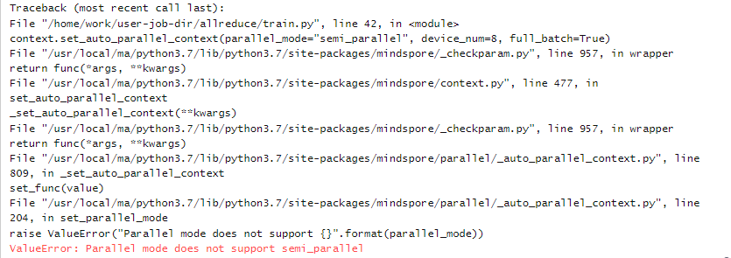
5. 报错解决
修改错误
在MindSpore主页中找到set_auto_parallel_context接口，观察到参数parallel_mode 的可选项有如下几种，正确配置即可。
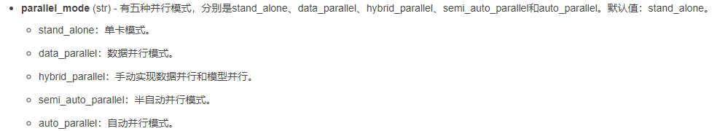
6. 成功运行
在合理配置并行模式之后（如配置成semi_auto_parallel），成功运行输出loss值，如下图所示：
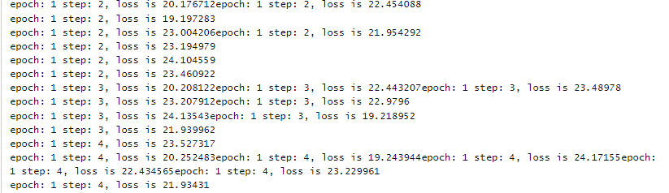

Ascend多卡训练报错davinci_model : load task fail, return ret xxx
在Ascend上进行多机/多卡训练时，经常会遇到这种报错：
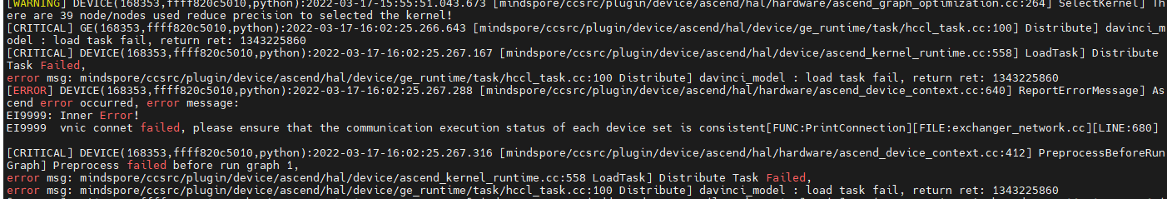
报这种错误的原因是该卡在最大等待时长内，没有收到其他卡的同步消息。
而没有收到其他卡的同步消息，有很多种可能：
其他卡挂了；
其他卡还在执行编译，且编译时间略长，超出了该卡的最大等待时长；
对于第一种情况，需要检查是否存在某张卡有问题无法正常使用的情况，可能是硬件问题，也可能是软件问题，可以通过查看每张卡的plog得知进一步的信息：
$ cd /root/ascend/log/plog
$ vi plog-xxx.log
而对于第二种情况，我们可以设置延长每张卡的最大等待时长：
$ export HCCL_CONNECT_TIMEOUT=600
这里设置成了600秒(默认为300秒)，可以根据自己需要设置不同的时长。

docker下运行分布式代码报nccl错误：connect returned Connection timed out，成功解决
1. 系统环境
硬件环境(Ascend/GPU/CPU): Ascend/GPU/CPU
软件环境: MindSpore 版本: 1.7.0
执行模式（静态图/动态图）： 不限
Python 版本: 3.7.6
操作系统平台: linux
2. 报错信息
2.1 问题描述
docker下运行分布式代码报nccl错误：connect returned Connection timed out。
2.2 报错信息
Failed to init nccl communicator for group
init nccl communicator for group nccl_world_group
3. 根因分析
可能是建立容器的时候没有设置允许共享内存： --ipc=host。
4. 解决方案
重新建立容器，在建立时加入设置： --ipc=host
形式如： sudo docker run -it --ipc=host

MindSpore报错Please try to reduce 'batch_size' or check whether exists extra large shape.
1. 系统环境
硬件环境(Ascend/GPU/CPU): Ascend/GPU/CPU
软件环境: MindSpore 版本: 2.0.0
执行模式（静态图/动态图）： 不限
Python 版本: 3.9
操作系统平台: linux
2. 报错信息
2.1 问题描述
进行分布式配置后，运行脚本出现如下报错。
2.2 报错信息
RuntimeError: Preprocess failed before run graph 1.
----------------------------------------------------
- Framework Error Message:
----------------------------------------------------
Out of Memory!!! Request memory size: 13518844928B, Memory Statistic:
Device HBM memory size: 32768M
MindSpore Used memory size: 30720M
MindSpore memory base address: 0x124180000000
Total Static Memory size: 19792M
Total Dynamic memory size: 0M
Dynamic memory size of this graph: 0M
Please try to reduce 'batch_size' or check whether exists extra large shape. For more details, please refer to 'Out of Memory' at https://www.mindspore.cn .
----------------------------------------------------
- C++ Call Stack: (For framework developers)
----------------------------------------------------
mindspore/ccsrc/plugin/device/ascend/hal/hardware/ascend_kernel_executor.cc:244 PreprocessBeforeRunGraph
mindspore/ccsrc/plugin/device/ascend/hal/device/ascend_memory_adapter.cc:169 MallocDynamicDevMem
3. 根因分析
没有执行代码，根据报错信息提示的是OOM，申请内存大于实际内存。
4. 解决方案
减小申请的内存，可在分布式设置之前添加下面代码
from mindspore import context
context.set_context(max_device_memory="25GB")

MindSpore报错：wq.weight in the argument 'net' should have the same shape as wq.weight in the argument 'parameter_dict'.
1. 系统环境
硬件环境(Ascend/GPU/CPU): Ascend
软件环境: MindSpore 版本: 2.3.0
执行模式（静态图/动态图）： 静态图
Python 版本: 3.9
操作系统平台: linux
2. 报错信息
2.1 问题描述
执行分布式训练任务，加载ckpt出现如下报错。
2.2 报错信息
For 'load_param_into_net', wq.weight in the argument 'net' should have the same shape as wq.weight in the argument 'parameter_dict'. But got its shape (512, 8192) in the argument 'net' and shape (8192, 8192) in the argument 'parameter_dict'. May you need to check whether the checkpoint you loaded is correct or the batch size and so on in the 'net' and 'parameter_dict' are same.
3. 根因分析
a. 错误出现的位置为，加载checkpoint时失败
b. 报错信息为：网络中wq.weight参数的shape为(512, 8192)，但是checkpoint文件中q.weight参数的shape为(8192, 8192)，shape不一致加载失败了。
c. 排查是网络的shape还是checkpoint文件的shape不符合预期，经过排查发现，网络中的shape是切分后的，是符合预期的。
d. 发现checkpoint中保存的参数shape是全量的，并不是切分好的。
e. 进一步排查发现，save_checkpoint方法默认会把所有parameter合并保存成全量的，导致和网络中shape不一致。
4. 解决方案
在调用save_checkpoint的时候，把integrated_save参数手动设置为false，使所有节点保存切分后的参数。
重新加载保存后的checkpoint文件，问题解决。

多机训练报错：import torch_npu._C ImportError: libascend_hal.so: cannot open shared object file: No such file or directory
1. 系统环境
硬件环境(Ascend/GPU/CPU): Ascend
软件环境: MindSpore 版本: 2.3.0
执行模式（静态图/动态图）： 不限
Python 版本: 3.7.6
操作系统平台: linux
2. 报错信息
2.1 问题描述
行多机训练报错，单机执行相同命令可正常启动训练。
2.2 报错信息
Traceback (most recent call last):
File "/work/share/lcy/audio/CosyVoice/examples/libritts/cosyvoice/cosyvoice/bin/train.py", line 15, in <module>
import torch_npu
File "/usr/local/lib/python3.10/dist-packages/torch_npu/__init__.py", line 17, in <module>
import torch_npu.npu
File "/usr/local/lib/python3.10/dist-packages/torch_npu/npu/__init__.py", line 122, in <module>
from torch_npu.utils import should_print_warning
File "/usr/local/lib/python3.10/dist-packages/torch_npu/utils/__init__.py", line 2, in <module>
from ._module import _apply_module_patch
File "/usr/local/lib/python3.10/dist-packages/torch_npu/utils/_module.py", line 26, in <module>
from torch_npu.npu.amp.autocast_mode import autocast
File "/usr/local/lib/python3.10/dist-packages/torch_npu/npu/amp/__init__.py", line 7, in <module>
from .sharded_grad_scaler import ShardedGradScaler
File "/usr/local/lib/python3.10/dist-packages/torch_npu/npu/amp/sharded_grad_scaler.py", line 9, in <module>
from torch_npu.npu.utils import npu_check_overflow
File "/usr/local/lib/python3.10/dist-packages/torch_npu/npu/utils.py", line 12, in <module>
import torch_npu._C
ImportError: libascend_hal.so: cannot open shared object file: No such file or directory
2.3 脚本信息
import torch_npu._C
ImportError: libascend_hal.so: cannot open shared object file: No such file or directory
3. 根因分析
多机执行命令如下：
sudo docker exec {$docker_id} /bin/bash -c 'source /usr/local/Ascend/ascend-toolkit/set_env.sh; pkill -9 python; pkill -9 torchrun; cd /xxx1; bash train_multinode.sh llm /xxx2/hostfile 60009;'
拉起训练任务失败，单机执行命令如下：
# 先执行docker exec -it {$docker_id} bash手动进入容器
bash train_multinode.sh llm /xxx2/hostfile 60009
拉起训练任务成功。
1）登录到物理机上，手动进入容器，执行训练命令，能拉起训练任务
2）登录到物理机上，不进入容器，在容器外通过docker exec执行命令，报错，但在命令中加上环境变量之后也不报错了
3）不登录物理机，通过HJ平台拉起任务，报错，加上环境变量还是报错
从报错日志看，找不到libascend_hal.so文件，通过find / -name 'libascend_hal.so'命令找到该文件在/usr/local/Ascend/driver/lib64/driver目录下，需要将该路径加到$LD_LIBRARY_PATH系统环境变量下。
export LD_LIBRARY_PATH=/usr/local/Ascend/driver/lib64/driver:$LD_LIBRARY_PATH
将环境变量加入到训练脚本中后，HJ平台可正常拉起多机训练任务。
手动执行不报错，因为该环境变量在容器镜像中已加入到了/root/.bashrc中，手动登录容器会自动加载。但在容器外执行或者通过HJ平台调用时，不会加载。
在HJ平台加上环境变量还是报错：因为HJ平台加环境变量时，source的setenv.sh实际未执行成功（因为容器内没挂载对应的脚本）。
总结：碰到libascend_hal.so库文件找不到的问题时，检查环境变量 env | grep LD_LIBRARY_PATH ，查看LD_LIBRARY_PATH环境变量中是否包含/usr/local/Ascend/driver/lib64/driver路径，无论通过哪种方式加载，最终确保LD_LIBRARY_PATH环境变量中包含/usr/local/Ascend/driver/lib64/driver路径即可。
4. 解决方案
LD_LIBRARY_PATH环境变量未包含/usr/local/Ascend/driver/lib64/driver路径，将/usr/local/Ascend/driver/lib64/driver路径添加到LD_LIBRARY_PATH环境变量中。

MindSpore微调qwen1.5 报错AllocDeviceMemByEagerFree failed, alloc size
1. 系统环境
硬件环境(Ascend/GPU/CPU): Ascend
软件环境: MindSpore 版本: 2.3.0
执行模式（静态图/动态图）： 不限
Python 版本: 3.8
操作系统平台: linux
2. 报错信息
2.1 问题描述
使用ms2.3.0，mindformer-r.1.2.0，微调qwen1_5_7b,配置文件如下：
2.2 报错信息
"trainer': {'model_name' :'qwen2_7b','type': 'CausalLanguageModelingTrainer'},
"use parallel': False}
2024-10-09 14:09:44,272 - mindfo mers[mindfommers/trainer/base trainer.py:787] - INFO - .Model Compiling, Please Wait a Moment
[WARNING] ME(1739195:281472916631776, MainProcess):2024-10-09- 14:09:44.273.000 [mindspo re/train/model.py:1328] For MFLossMonitor callback, f'step_begin', 'step.end', 'epoch_end', 'epoch_begin'} methods may not be supported in later version, Use methods prefixed with 'on_train' or 'on_eval' instead when using customized callbacks-
[WARNING] ME(1739195:281472916631776,MainProcess) :2024-10-09-14:09:44.273.000 [mindspore/train/model .py:1328] For Local20bsMonitor callback, {'epoch_end', 'steend'} methods may not be supported in later version, Use methods prefixed with "on train' or 'on eval' instead when using customized callbacks.(ERRORJ DEVICE (1739195,ffff8535b0e0.python) :2024-10-09- 14:12:37.081.576 [mindspore/ccsrc/plugin/device/ascend/hal/device/ascend_vmm_adapter.cc:206] AllocDeviceMem] Reserve memory address failed.
[ERROR] PRE_ACT (1739195, ffff8535b0e0,python) :2024-10-09-14: 12:37.081.722 [mindspore/ccs rc/backend/common/mem_reuse/mem_dynamic_allocator.cc:414] AddMemBlockAnd
MemBufByEagerFree] AllocDeviceMemByEagerFree failed, alloc size : 0. [ERRORI RUNTIME FRAMEWORK(1739195, ffff8535b0e0,python) :2024-10-09- 14:12:37.081.857 [mindspore/ccsrc/runtime/graph_scheduler/actor/data_prepare_actor.cc:129] SyncTensorData] #umsg#Memory not enough:#umsg#Device( id:0) memory isn't enough and alloc failed, kernel name: Default/data-895, alloc size: 2B.
IERRORI DEVICE(1739195, ffff8535b0e0.python) :2024-10-09-14:12:37.082 -022 [mindspore/ccsrc/plugin/device/ascend/hal/device/ascend_vmm_adapter.cc:206] AllocDeviceMem] Reserve memory address failed.
TERROR] PRE ACT( 1739195, ffff8535b0e0, python) :2024-10-09-14:12:37.082.057 [mindspore/ccsrc/backend/common/mem_ reuse/mem dynamic_allocato r.cc:414] AddMemBlockAndMemBufByEagerFree] AllocDeviceMemByEagerFree failed, alloc size : 0.
(ERROR]'RUNTIME FRAMEWORK(1739195, ffff8535b0e0,python) :2024-10-09-14: 12:37.082.100 [mindspore/ccsrc/runtime/graph scheduler/actor/data prepare actor.cc:129] SyncTensorData] #umsg#Memory not enough:#umsg#Deviće(id:0) memory isn't enough and alloc failed, kernel name: Default/data-1360, alloc size: 16B.
(ERRORI DEVICE(1739195, ffff8535b0e0python) :2024-10-09-14:12:37.082.239 [mindspore/ccsrc/plugin/device/ascend/hal/device/ascend_wmm_adapter .cc:206] AllocDeviceMem] Reserve memory address failed.
[ERROR] PRE_ ACT (1739195, ffff8535b0e0,python) :2024-10-09-14: 12:37.082.273 [mindspore/ccs rc/backend/common/mem_reuse/mem_dynamic_allocator.cc:414] AddMemBlockAndMemBufByEagerFree] AllocDeviceMemByEagerFree failed, alloc size : 0.
(ERROR] RUNT IME_FRAMEWORK(1739195, ffff8535b0e0,python) :2024-10-09-14: 12:37.082.313 [mindspore/ccsrc/runtime/graph_scheduler/actor/data_prepare_actor.cc:129] SyncTensorData] #umsg#Memory not enough:#umsg#Device(id:0) memory isn't enough and alloc failed, kernel name: Default/data-1658, alloc size: 2B.
(ERROR] DEVICE(1739195, ffff8535b0e0,python) :2024-10-09-14: 12:37.082.424 [mindspore/ccsrc/plugin/device/ascend/hal/device/ascend_vmm_adapter.cc:206] AllocDeviceMem] Reserve memory address failed.
[ERROR] PRE_ACT(1739195, ffff8535b0e0,python) :2024-10-09-14: 12:37.082.457 [mindspore/ccsrc/backend/common/mem_reuse/mem_dynamic_allocator.cc:414] AddMemBlockAndMemBufByEagerFree] AllocDeviceMemByEagerFree failed, alloc size : 0.
[ERROR] RUNT IME_FRAMEWORK(1739195, ffff8535b0e0,python) :2024-10-09-14: 12:37.082.519 [mindspore/ccsrc/runtime/graph_scheduler/actor/data_prepare_actor.cc:129] SyncTensorData] #umsg#Memory not enough:#umsg#Device( id:0) memory isn't enough and alloc failed, kernel name: Default/data-862, alloc size: 2B.
[ERROR] DEVICE (1739195, ffff8535b0e0,python) :2024-10-09-14: 12:37.082.648 Imindspore/ccsrc/plugin/device/ascend/hal/device/ascend_vmm_adapter.cc:206] AllocDeviceMem] Reserve memory address failed.
[ERROR] PRE ACT(1739195, ffff8535b0e0, python): :2024-10-09-14:12:37.082.679 [mindspore/ccsrc/backend/common/mem_reuse/mem_dynamic_allocato r.cc:414] AddMemBlockAndMemBufByEagerFree] AllocDeviceMemByEagerFree failed, alloc size : 0.
(ERROR] RUNTIME FRAMEWORK(1739195, ffff8535b0e0,python) :2024-10-09-14: 12:37.082.719 [mindspore/ccsrc/runtime/graph scheduler/actor/data prepare actor.cc:129] SyncTensorData] #umsg#Memory not enough:#umsg#Device( id:0) memory isn't enough and alloc failed, kernel name: Default/data-1339,- alloc size: 16B.
[ERROR] DEVICE (1739195,ffff8535b0e0,python) :2024-10-09-14:12:37.082.832 [mindspo re/ccsrc/plugin/device/ascend/hal/device/ascend_vmm_adapter .cc:206] AllocDeviceMem] Reserve memory address failed.
[ERROR] PRE. ACT(1739195, ffff8535b0e0,python) :2024-10-09-14: 12:37.082.863 [mindspore/ccs rc/backend/common/mem_reuse/mem_dynamic_allocator.cc:414] AddMemBlockAndMemBufByEagerFree] AllocDeviceMemByEagerFree failed, alloc size
2.3 配置信息
seed: 42
output_dir: './output'
load_checkpoint: ''
auto_trans_ckpt: False # If true, auto transform load_checkpoint to load in distributed model
only_save_strategy: False
resume_training: False
run_mode: 'finetune'
# trainer config
trainer:
type: CausalLanguageModelingTrainer
model_name: 'qwen2_7b'
# if True, do evaluate during the training process. if false, do nothing.
# note that the task trainer should support _evaluate_in_training function.
do_eval: False
eval_step_interval: -1 # num of step intervals between each eval, -1 means no step end eval.
eval_epoch_interval: 50 # num of epoch intervals between each eval, 1 means eval on every epoch end.
# runner config
runner_config:
epochs: 5
batch_size: 1
sink_mode: True
sink_size: 1
# wrapper cell config
runner_wrapper:
type: MFTrainOneStepCell
scale_sense:
type: DynamicLossScaleUpdateCell
loss_scale_value: 4096
scale_factor: 2
scale_window: 1000
use_clip_grad: True
# optimizer
optimizer:
type: FP32StateAdamWeightDecay
beta1: 0.9
beta2: 0.95
eps: 1.e-8
learning_rate: 1.e-6
weight_decay: 0.01
# lr schedule
lr_schedule:
type: CosineWithWarmUpLR
learning_rate: 1.e-6
warmup_ratio: 0.01
total_steps: -1 # -1 means it will load the total steps of the dataset
# dataset
train_dataset: &train_dataset
data_loader:
type: MindDataset
dataset_dir: ""
shuffle: True
input_columns: ["input_ids", "target_ids", "attention_mask"]
num_parallel_workers: 8
python_multiprocessing: False
drop_remainder: True
batch_size: 1
repeat: 1
numa_enable: False
prefetch_size: 1
train_dataset_task:
type: CausalLanguageModelDataset
dataset_config: *train_dataset
# eval dataset
eval_dataset: &eval_dataset
data_loader:
type: MindDataset
dataset_dir: ""
shuffle: False
input_columns: ["input_ids", "target_ids", "attention_mask"]
num_parallel_workers: 8
python_multiprocessing: False
drop_remainder: False
repeat: 1
numa_enable: False
prefetch_size: 1
eval_dataset_task:
type: CausalLanguageModelDataset
dataset_config: *eval_dataset
use_parallel: True
# parallel context config
parallel:
parallel_mode: 1 # 0-data parallel, 1-semi-auto parallel, 2-auto parallel, 3-hybrid parallel
gradients_mean: False
enable_alltoall: False
full_batch: True
search_mode: "sharding_propagation"
enable_parallel_optimizer: True
strategy_ckpt_save_file: "./ckpt_strategy.ckpt"
parallel_optimizer_config:
gradient_accumulation_shard: False
parallel_optimizer_threshold: 64
# default parallel of device num = 8 910
parallel_config:
data_parallel: 1
model_parallel: 8
pipeline_stage: 1
use_seq_parallel: True
micro_batch_num: 1
vocab_emb_dp: True
gradient_aggregation_group: 8
# when model parallel is greater than 1, we can set micro_batch_interleave_num=2, that may accelerate the train process.
micro_batch_interleave_num: 1
# recompute config
recompute_config:
recompute: True
select_recompute: False
parallel_optimizer_comm_recompute: False
mp_comm_recompute: False
recompute_slice_activation: False
# callbacks
callbacks:
- type: MFLossMonitor
- type: CheckpointMonitor
prefix: "qwen2"
save_checkpoint_steps: 5000
keep_checkpoint_max: 1
integrated_save: False
async_save: False
- type: ObsMonitor
# mindspore context init config
context:
mode: 0 #0--Graph Mode; 1--Pynative Mode
device_target: "Ascend"
enable_graph_kernel: False
max_call_depth: 10000
max_device_memory: "55GB"
save_graphs: False
save_graphs_path: "./graph"
device_id: 0
jit_config:
jit_level: "O0"
ascend_config:
precision_mode: "must_keep_origin_dtype"
# model config
model:
model_config:
type: LlamaConfig
batch_size: 1 # add for increase predict
seq_length: 256
hidden_size: 4096
num_layers: 32
num_heads: 32
vocab_size: 151936
intermediate_size: 11008
qkv_has_bias: True
rms_norm_eps: 1.0e-6
theta: 1000000.0
max_position_embedding: 32768
emb_dropout_prob: 0.0
eos_token_id: 151643
pad_token_id: 151643
compute_dtype: "bfloat16"
layernorm_compute_type: "float32"
softmax_compute_type: "float16"
rotary_dtype: "float16"
param_init_type: "float32"
use_past: False
extend_method: "None" # support "None", "PI", "NTK"
use_flash_attention: True
fine_grain_interleave: 1
qkv_concat: False
block_size: 32
num_blocks: 128
offset: 0
checkpoint_name_or_path: ""
repetition_penalty: 1
max_decode_length: 512
top_k: 0
top_p: 0.8
do_sample: False
compute_in_2d: True
# configuration items copied from Qwen
pet_config:
pet_type: lora
# configuration of lora
lora_rank: 64
lora_alpha: 16
lora_dropout: 0.05
target_modules: '.*wq|.*wk|.*wv|.*wo|.*w1|.*w2|.*w3'
freeze_exclude: ["*wte*", "*lm_head*"]
rotary_pct: 1.0
rotary_emb_base: 1000000
kv_channels: 128
arch:
type: LlamaForCausalLM
processor:
return_tensors: ms
tokenizer:
model_max_length: 4096
vocab_file: "/path/vocab.json"
merges_file: "/path/merges.txt"
unk_token: "<|endoftext|>"
eos_token: "<|endoftext|>"
pad_token: "<|endoftext|>"
type: Qwen2Tokenizer
type: Qwen2Processor
processor:
return_tensors: ms
tokenizer:
model_max_length: 4096
vocab_file: "/path/vocab.json"
merges_file: "/path/merges.txt"
unk_token: "<|endoftext|>"
eos_token: "<|endoftext|>"
pad_token: "<|endoftext|>"
type: Qwen2Tokenizer
type: Qwen2Processor
# metric
metric:
type: PerplexityMetric
eval_callbacks:
- type: ObsMonitor
auto_tune: False
filepath_prefix: './autotune'
autotune_per_step: 10
profile: False
profile_start_step: 1
profile_stop_step: 10
init_start_profile: False
profile_communication: False
profile_memory: True
layer_scale: False
layer_decay: 0.65
lr_scale_factor: 256
# aicc
remote_save_url: "Please input obs url on AICC platform."
3. 根因分析
错误提示是显存不足了。
4. 解决方案
配置文件里配置的是8个64G的昇腾卡使用模型并行训练的，如果卡数不够肯定显存不够的。可以多加卡试试。

使用MindSpore的get_auto_parallel_context("device_num")识别设备信息错误
1. 系统环境
硬件环境(Ascend/GPU/CPU): Ascend
软件环境: MindSpore=2.4.1、mindformer=1.3.0
执行模式： 不限
Python 版本: 3.9
操作系统平台: linux
2. 报错信息
2.1 问题描述
参考msrun启动教程：不设置device_target会自动指定为MindSpore包对应的后端硬件设备，但是通过以下命令发现识别到的NPU卡数量为1，导致MSRUN跑并行任务时只有一个NPU节点有日志。
2.2 脚本信息
import mindspore as ms
ms.set_context(mode=ms.GRAPH_MODE, device_target="Ascend")
device_num = ms.context.get_auto_parallel_context("device_num")
print("MindSpore识别到的NPU卡数量为:", device_num)
2.3 报错信息
(MindSpore) [root ringmo] $npu-smi info
+------------------------------------------------------------------------------------------------------------------------------+
| npu-smi 23.0.rc2.0 Version: 24.1.rc2.1 |
+------------------------+------------------------+---------------------------------------------------------------------------+
| NPU Name | Health | Power(W) Temp(C) Hugepages-Usage(page) |
| Chip | Bus-Id | AICore(%) Memory-Usage(MB) HBM-Usage(MB) |
+==============+==============+============================================+
| 3 910 | OK | 97.9 45 0 / 0 |
| 0 | 0000:02:00.0 | 0 0 / 0 3673 / 65536 |
+==============+==============+============================================+
| 5 910 | OK | 94.5 45 0 / 0 |
| 0 | 0000:41:00.0 | 0 0 / 0 3340 / 65536 |
+==============+==============+============================================+
+------------------------+------------------------+---------------------------------------------------------------------------+
| NPU Chip | Process id | Process name | Process memory(MB) |
+==============+==============+============================================+
| No running process found in NPU 3 |
+==============+==============+============================================+
| No running process found in NPU 5 |
+==============+==============+============================================+
(MindSpore) [root ringmo] $python
Python 3.9.18 | packaged by conda-forge | (main, Aug 30 2023, 04: 25: 25)
[GCC 12.3.0] on Linux
Type "help", "copyright", "credits" or "license" for more information.
>>> inport nindspore as ms
>>>
>>> ms.set_ context(mode=ns.GRAPH_MODE, device_target="Ascend")
>>> device_num = ms.context.get_auto_parallel_context("device_num")
>>> print("MindSpore识别到的NPU卡数量为:", device_num)
MindSpore识别到的NPU卡数量为: 1
3. 根因分析
这个获取卡数的方式好像不对，get_auto_parallel_context("device_num")只是获取上下文的一个属性值。
4. 解决方案
首先需要使用set_auto_parallel_context给它赋值，否则就是固定的默认值；
通过api获取实际的卡数可以使用get_group_size方法，如果想让get_auto_parallel_context("device_num")返回正确的卡数，那需要把get_group_size的结果传入其中，可参考如下脚本：
import mindspore as ms
from mindspore.communication import init, get_group_size
ms.set_context(mode=ms.GRAPH_MODE, device_target="Ascend")
init()
group_size = get_group_size()
print("group_size_is: ", group_size)
ms.set_auto_parallel_context(device_num=group_sizze)
device_num = ms.context.get_auto_parallel_context("device_num")
print("NPU卡数为： ", device_num)

docker执行报错：RuntimeError: Maybe you are trying to call 'mindspore.communication.init()' without using 'mpirun'
1.问题现象
docker内执行脚本报错：
RuntimeError: Maybe you are trying to call 'mindspore.communication.init()' without using 'mpirun', which will make MindSpore load several environment variables and check their validation. Please use 'mpirun' to launch this process to fix this issue, or refer to this link if you want to run distributed training without using 'mpirun': https://www.mindspore.cn/tutorials/experts/zh-CN/master/parallel/train_gpu.html
·容器外执行npu-smi info可以看到卡未被占用。
容器内执行npu-smi info 报错。
DrvMngGetConsoleLogLevel failed. (g_conLogLevel=3)
dcmi model initialized failed, because the device is used. ret is -8020
2.问题根因
卡已经被其他docker占用，导致当前docker加载不上卡，导致报错，采用如下方式启动的docker是独占卡的，单张卡只能被单个docker加载，导致其他docker内看不到卡。
--device=/dev/davinci0 \
--device=/dev/davinci1 \
--device=/dev/davinci2 \
--device=/dev/davinci3 \
--device=/dev/davinci4 \
--device=/dev/davinci5 \
--device=/dev/davinci6 \
--device=/dev/davinci7 \
--device=/dev/davinci manager \
--device=/dev/devmm svm \
--device=/dev/hisi hdc \
3.解决方案
使用这种方式加载的卡可以支持多docker共用，docker内都可以看到卡的状态。
docker run -itd --net=host --cap-add=SYS_PTRACE -e ASCEND_VISIBLE_DEVICES=0-7

Ascend环境运行mindspore脚本报：网络脚本的设备被占用，只支持每张卡运行一个网络脚本
1.现象描述
在Ascend环境安装MindSpore，运行网络脚本时，报如下错误：
RuntimeError: mindspore/ccsrc/plugin/device/ascend/hal/device/ascend_memory_adapter.cc:47 Initialize] Malloc device memory failed, free memory size is less than half of total memory size.Device 0 Device HBM total size:34359738368 Device HBM free size:1929908224 may be other processes occupying this card, check as: ps -ef|grep python
2.原因分析
出现此类错误是因为运行网络脚本的设备被占用，当前MindSpore框架在Ascend环境只支持每张卡运行一个网络脚本。
3.解决办法
方法一：切换空闲设备
- 使用npu-smi info查询设备的使用情况，在当前问题场景主要查看HBM-Usage的使用情况，如下图2、3、6卡是空闲设备，npu-smi的详细使用方法
- 切换使用未被占用的device， export DEVICE_ID={device_id} //device_id取值0~7
- 重新执行训练脚本
方法二：杀死占用设备的网络脚本（不建议）
- 查询是否存在其他程序占用设备 ps -ef | grep python
- 若判断程序为无用进程可选择杀死进程 kill {pid}
- 重新执行网络脚本

模型精度调优案例
5.1 Mindspore网络精度自动比对功能中protobuf问题分析
5.2 使用mindpsore.nn.conv3d在GPU上精度不足
5.3 使用model仓库的YOLOV5训练没有混合精度配置
5.4 将torch架构的模型迁移到mindspore架构中时精度不一致

Mindspore网络精度自动比对功能中protobuf问题分析
1. 系统环境
硬件环境(Ascend/GPU/CPU): GPU
软件环境: MindSpore 版本: 2.0.0
执行模式（静态图/动态图）： 静态图
Python 版本: 3.8
操作系统平台: linux
2. 报错信息
2.1 问题描述
在mindspore的网络精度自动比对功能中，图模式下调用mindinsightx.compare.proto.me.mindinsight_anf_ir_pb2依赖包中的ModelProto方法报错TypeError: Descriptors cannot not be created directly。
同时，在使用onnx包下的onnx.ModelProto()存储模型信息时也会出现报错onnx 1.14.1 requires protobuf>=3.20.2。
2.2 报错信息
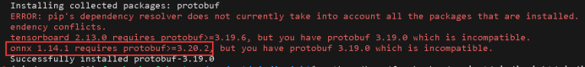
2.3 脚本信息
def _get_model_proto(self):
return me_ir_pb2.ModelProto()
def load(self, path):
"""
Loads graph file.
Args:
path (str): Graph file path to be loaded.
"""
self.real_path = os.path.realpath(path)
self._proto = self._get_model_proto()
try:
with open(self.real_path, 'rb') as f:
self._proto.ParseFromString(f.read())
except message.DecodeError:
try:
with open(self.real_path, 'r') as f:
text_format.Merge(f.read(), self._proto)
except Exception:
raise ValueError(f'Cannot load MindSpore graph file {self.real_path}.')
id_node_map = dict()
graph_def = self._proto.graph
for node_def in graph_def.node:
node = self._parse_proto_node(node_def)
if not node.node_id or not node.name:
continue
self.add_node(node)
id_node_map[node.node_id] = node
for param_def in graph_def.parameters:
node = self._parse_proto_parameter(param_def)
if not node.node_id or not node.name:
continue
self.add_node(node)
id_node_map[node.node_id] = node
for node_def in graph_def.node:
node = self.get_node_by_name(node_def.full_name)
if node is None:
continue
for input_def in node_def.input:
input_node = id_node_map.get(input_def.name, None)
if input_node is None:
continue
self.add_edge(input_node, node)
def load_pbtxt(self, path):
self.real_path = os.path.realpath(path)
self._proto = onnx.ModelProto()
try:
with open(self.real_path, 'r') as f:
text_format.Parse(f.read(), self._proto)
except Exception:
raise ValueError(f'Cannot load MindSpore graph file {self.real_path}.')
node_map = dict()
graph_def = self._proto.graph
id = 0
for node_def in graph_def.node:
id += 1
node = MeNode(name=node_def.name,
node_id=id,
node_type=node_def.op_type,
scope='Default')
if not node.node_id or not node_def.name:
continue
forward_pattern = r':(\d+)'
backward_pattern = r':-(\d+)'
forward_shapes = []
backward_shapes = []
for output in node_def.output:
forward_match = re.search(forward_pattern, output)
if forward_match:
forward_shapes.append(int(forward_match.group(1)))
backward_match = re.search(backward_pattern, output)
if backward_match:
backward_shapes.append(int(backward_match.group(1)))
node.shape = forward_shapes + backward_shapes
self.add_node(node)
node_map[node.name] = node
for node_def in graph_def.node:
node = self.get_node_by_name(node_def.name)
if node is None:
continue
for input_def in node_def.input:
input_node_name = input_def.split(':')[0]
input_node = node_map.get(input_node_name)
if input_node is None:
continue
self.add_edge(input_node, node)
3. 根因分析
Protobuf的版本不匹配，在mindinsight中，需要protobuf版本满足<=3.20.1，而在onnx中，需要protobuf版本满足>=3.20.2。
4. 解决方案
pip uninstall protobuf
pip install protobuf==3.20.1
通过安装中间版本protobuf==3.20.1，顺利同时解决所有问题，最终成功运行比较文件~
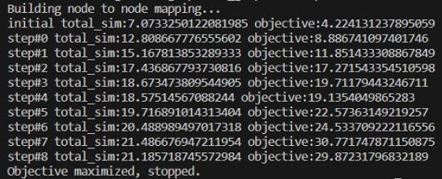

使用mindpsore.nn.conv3d在GPU上精度不足
1. 系统环境
硬件环境(Ascend/GPU/CPU): GPU
软件环境: MindSpore 版本: 2.1
执行模式（静态图/动态图）： 不限
Python 版本: 3.7
操作系统平台: linux
2. 报错信息
2.1 问题描述
mindpsore.nn.conv3d在GPU上精度不足问题，测试conv3d，在group不等于的场景下，用例概率性失败，失败原因为torch上的output和mindspore的output有部分维度结果不一致。
2.2 脚本信息
import mindspore
from mindspore import ops
from mindspore import Tensor, nn
from mindspore.common.api import jit
from mindspore import context
import numpy as np
import torch
input = np.random.uniform(size=(16,3,10,32,32))
ms_input = Tensor(input, mindspore.float32)
conv3d = nn.Conv3d(in_channels=3, out_channels=32, kernel_size=(4, 3, 3), has_bias=True, pad_mode='valid')
ms_out = conv3d(ms_input)
torch_input = torch.Tensor(input)
m = torch.nn.Conv3d(3, 32,kernel_size=(4, 3, 3))
torch_out = m(torch_input)
# 失败
y = np.subtract(ms_out.asnumpy(), torch_out.detach().numpy())
w = np.where(np.abs(y) > 0.00004, 1, 0)
z = np.count_nonzero(w)
3. 根因分析
由于input为随机数，因此使用np.random.seed()确定随机种子，通过固定随机数的方式确定必现的复现条件。确定复现场景后，将mindspore与torch输出相减，记录指定精度下差异位的个数。
y = np.subtract(ms_out.numpy(), torch_out.numpy())
w = np.where(np.abs(y) > 0.00004, 1, 0)
z = np.count_nonzero(w)
在此案例中，精度4*1e-5时有15个结果不一致，在默认绝对精度为1e-5的场景下，mindspore与torch不相等的结果有2500+，因此用例不通过。
4. 解决方案
GPU平台上对于较大tensor输入的计算精度可能下降，不满足默认绝对精度值，需要针对单个用例进行调整。此处用例有1e-3的相对精度误差，但是在随机数结果较小的情况下，相对精度误差的影响没有绝对精度误差大，因此并不会缓解mindspore和torch的返回值差异。

使用model仓库的YOLOV5训练没有混合精度配置
1. 系统环境
硬件环境(Ascend/GPU/CPU): Ascend/GPU/CPU
软件环境: MindSpore 版本: 2.4
执行模式： 不限
Python 版本: 3.9
操作系统平台: linux
2. 报错信息
使用models仓库的YOLOv5模型进行训练，但是无法进行混合精度的配置：
https://gitee.com/mindspore/models/blob/master/official/cv/YOLOv5/train.py。
3. 根因分析
在models仓库的YOLOv5模型：https://gitee.com/mindspore/models/blob/master/official/cv/YOLOv5/train.py这个没有设置混合精度的代码
4. 解决方案
方法一：加一下数据格式代码，调用network.to(mindspore.float16)，把这个network对象中的算子都强行走fp16了。
network = YOLOV5(is_training=True, version=dict_version[config.yolov5_version])
这种方法也会把loss的network也强行按照fp16进行计算，可能会有loss精度问题。
方法二：使用mindyolo套件中的yolov5模型，里面直接可以通过参数配置混合精度模式（O0/O1/O2/O3），loss的精度模式也可以单独配置，仓库地址：https://github.com/mindspore-lab/mindyolo

将torch架构的模型迁移到mindspore架构中时精度不一致
1 系统环境
硬件环境(Ascend/GPU/CPU): Ascend
MindSpore版本: 2.2.14
执行模式（PyNative/ Graph）: PyNative
Python版本: Python=3.10
操作系统平台: Ubuntu18.04
2 报错信息
2.1 脚本信息
torch的代码：
class GELUConvBlock(nn.Module):
def __init__(
self, in_ch, out_ch, group_size):
super().__init__()
self.conv = nn.Conv2d(in_ch, out_ch, 3, 1, 1)
self.group_norm = nn.GroupNorm(group_size, out_ch)
self.gelu = nn.GELU()
def forward(self, x):
x = self.conv(x)
print(x)
x = self.group_norm(x)
x = self.gelu(x)
return x
固定了nn.conv2d的权重。
import numpy as np
# 固定随机种子
np.random.seed(42)
# 卷积参数
in_ch = 64
out_ch = 32
kernel_size = 3
# 统一权重 shape: (out_channels, in_channels, kernel_h, kernel_w)
weight_np = np.random.randn(out_ch, in_ch, kernel_size, kernel_size).astype(np.float32)
print(weight_np)
得到权重如下：
[[[1 4.9671414e-01 -1.3826430e-01 6.4768857e-01]]
[ 1.5230298e+00 -2.3415338e-01 -2.3413695e-01]
[ 1.5792128e+00 7.6743472e-01 -4.6947438e-01]]
[[ 5.4256004e-01 -4.6341768e-01 -4.6572974e-01]]
[ 2.4196227e-01 -1.9132802e+00 -1.7249179e+00]
[-5.6228751e-01 -1.0128311e+00 3.1424734e-01]]
[[-9.0802407e-01 -1.4123037e+00 1.4656488e+00]]
[-2.2577630e-01 6.7528203e-02 -1.4247482e+00]]
[-5.4438275e-01 1.1092259e-01 -1.1509936e+00]]
之后固定了输入得到经过卷积后的输出，代码和输出如下：
固定随机种子以保证可复现性
torch.manual_seed(42)
# 定义输入参数
batch_size = 1
in_ch = 64
out_ch = 32
group_size = 2 # GroupNorm的分组数（必须能整除out_ch）
height, width = 16, 16
# 生成固定随机输入（形状为 [batch_size, in_ch, height, width]）
input_tensor = torch.randn(batch_size, in_ch, height, width)
print(input_tensor.dtype)
# 初始化模块
block = GELUConvBlock(in_ch, out_ch, group_size)
with torch.no_grad():
block.conv.weight.copy_(torch.tensor(weight_np))
# 前向传播
output = block(input_tensor)
# 打印输出信息
# print(output)
torch.float32
tensor([[[[ 12.8685, -13.9928, 10.2607, …, -12.4960, -14.2980, -5.3835],
[ -6.0367, -3.7743, 0.2609, …, -16.6816, 18.7610, -1.6896],
[ 20.4237, -29.2998, -13.6293, …, -45.5814, 22.7568, -24.5661],
…,
[-41.9423, -33.8824, -6.4840, …, -35.2593, -19.5696, -28.8629],
[-15.1163, -18.7457, 9.1265, …, -7.0993, 20.0634, -1.6840],
[ 20.7623, 21.6005, -9.9522, …, 8.3804, 8.0551, 19.4785]],
[[ 17.2460, 10.6954, 33.3876, …, -15.3125, -2.3259, 12.5942],
[-17.9752, 2.5080, 19.0125, …, 16.0485, -15.1048, 4.2263],
[ 33.6510, 43.4881, 3.3938, …, -19.5759, 6.9983, -38.9134],
…,
[ 7.1470, 22.2052, -16.5933, …, 6.5175, 19.8026, 28.3119],
[-16.4020, 12.0544, -53.4701, …, -15.9740, 4.4595, -32.3315],
[ 6.7833, 7.0182, -10.2338, …, -19.6627, 20.2132, 13.7222]],
[[ -3.7571, -7.8292, -4.9203, …, -3.0067, 27.1352, -14.4893],
[-16.7018, -74.0261, -24.2703, …, -6.4855, 5.9101, -1.9450],
[ -9.6489, -2.2309, 15.9349, …, 3.4376, 37.7087, 0.7485],
…,
[ 17.7427, -17.9123, -1.9595, …, 21.7801, 43.1779, -4.2342],
[ 19.6051, 3.6274, 3.0769, …, 47.5359, 23.2772, -10.5134],
[-10.2644, 0.4692, 24.5563, …, 39.0300, 10.2725, -18.6780]],
…]])
之后转到mindspore上，PYNATIVE_MODE模式下用NPU调试代码
依旧固定初始化参数和输入
class GELUConvBlock(nn.Cell):
def __init__(self, in_ch, out_ch, group_size):
super().__init__()
self.conv = nn.Conv2d(in_ch,
out_ch,
3,
stride=1,
has_bias=False,
padding=1,
pad_mode='pad',
dtype=ms.float32)
self.conv.weight.set_data(Tensor(weight_np, dtype=ms.float32)) # 强制初始化参数
self.group_norm = nn.GroupNorm(group_size, out_ch)
self.gelu = nn.GELU(approximate=False)
def construct(self, x):
x = self.conv(x)
print(x)
x = self.group_norm(x)
x = self.gelu(x)
return x
在经过卷积层处理
import torch
torch.manual_seed(42)
ms.set_seed(42)
# 定义输入参数
batch_size = 1
in_ch = 64
out_ch = 32
group_size = 2 # GroupNorm的分组数（必须能整除out_ch）
height, width = 16, 16
# 生成固定随机输入（形状为 [batch_size, in_ch, height, width]）
input_tensor = torch.randn(batch_size, in_ch, height, width).detach().cpu().numpy()
input_tensor = Tensor(input_tensor, dtype = ms.float32)
# 初始化模块
block = GELUConvBlock(in_ch, out_ch, group_size)
# 前向传播
output = block(input_tensor)
# # 打印输出信息
# print(output)
[[[[ 12.88811 -13.965936 10.268403 … -12.48695 -14.285012 -5.3615685 ]
[ -6.010967 -3.7509742 0.27916503 … -16.662071 18.78757 -1.6597592 ]
[ 20.440784 -29.288181 -13.600904 … -45.567055 22.780708 -24.546972 ]
…
[-41.915035 -33.864902 -6.4803376 … -35.24102 -19.55607 -28.843998 ]
[-15.095564 -18.728704 9.1526985 … -7.071264 20.083946 1.6947057 ]
[ 20.78365 21.612846 -9.93457 … 8.392191 8.073755 19.496553 ]]
[[ 17.292835 10.740439 33.433903 … -15.270564 -2.2864969 12.634817 ]
[-17.921299 2.5554345 19.058323 … 16.08888 -15.051955 4.2758093 ]
[ 33.696594 43.529957 3.4286156 … -19.52608 7.0427046 -38.873337 ]
…]]]
误差在10的-2次方，模型后面还会用到大量的卷积，叠加之后误差会更大。该如何对齐和torch.nn.Conv2d的精度呢？
3 根因分析
torch.nn.Conv2d 有个bias的参数默认值为True
mindspore的 has_bias设置为False
因为有这个参数的存在导致计算结果不一致
4 解决方案
torch的代码：将nn.Conv2d的bias的参数设置为False
class GELUConvBlock(nn.Module):
def __init__(
self, in_ch, out_ch, group_size):
super().__init__()
self.conv = nn.Conv2d(in_ch, out_ch, 3, 1, 1,bias=False)
self.group_norm = nn.GroupNorm(group_size, out_ch)
self.gelu = nn.GELU()
def forward(self, x):
x = self.conv(x)
print(x)
x = self.group_norm(x)
x = self.gelu(x)
return x

模型性能调优案例
6.1 mindspore-Dump功能调试
6.2 PyNative 调试体验
6.3 mindspore之中间文件保存
6.4 随机数生成函数导致模型速度越来越慢

mindspore-Dump功能调试
1. 系统环境
硬件环境(Ascend/GPU/CPU): Ascend
软件环境: MindSpore 版本: 2.3
执行模式（静态图/动态图）： 不限
Python 版本: 3.7.6
操作系统平台: linux
2. Dump功能简介
对于静态图模式（GRAPH），Dump功能可以将模型训练中的图、算子的输入输出数据保存到文件。
对于动态图模式（PYNATIVE），Dump功能仅支持Ascend后端的溢出检测能力，要看其他的可以直接调用print。
Dump可以协助定位，可以比对标杆相同位置算子的输出输出数据，来定位模型的精度问题。
3. 同步Dump
Ascend开启同步Dump，dump的时候自动关闭内存复用，有时候没dump出现误差（报错），dump的时候误差符合要求或报错消失，就要考虑是内存复用的影响。
同步Dump目前支持Ascend、GPU和CPU上的图模式，暂不支持PyNative模式（pynative直接print就可以）
开启同步Dump操作步骤
创建json文件
设置环境变量 MINDSPORE_DUMP_CONFIG，变量值为json绝对路径
启动训练脚本，生成的数据文件保存在json文件中指定的位置
以下是json文件
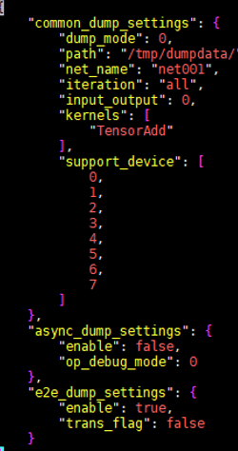
dump_mode:0，表示Dump出该网络中的所有算子数据
2iteration:”all”表示Dump所有迭代的数据
input_output:0表示Dump出算子的输入和算子的输出设置成1，表示Dump出算子的输入；设置成2，表示Dump出算子的输出
enable:设置成true，表示开启同步Dump
设置环境变量
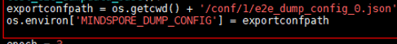
脚本执行完成后，dump数据会在/tmp/dumpdata下面产生, 后缀是npy, 可以直接用numpy.load读取
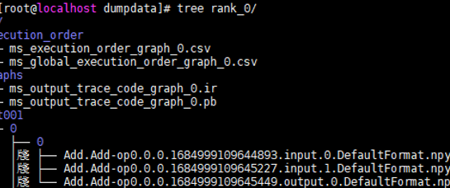
4. 异步Dump
大型网络（如Bert Large）使用同步Dump时会导致内存溢出，MindSpore通过异步Dump提供了大型网络的调试能力
异步Dump操作步骤
创建json文件
设置环境变量 MINDSPORE_DUMP_CONFIG，变量值为json绝对路径
启动训练脚本，生成的数据文件保存在json文件中指定的位置
若是设置file_format为bin，需要使用run包提供的msaccucmp.py解析dump出来的文件
json
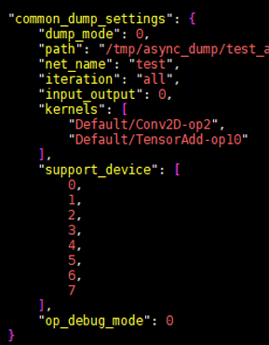
其他配置都和同步的基本一致，file_format若是不设置则取默认值为bin, 保存的文件为bin格式，所以当前保存的dump文件的格式为bin
解析文件：
python /usr/local/Ascend/latest/toolkit/tools/operator_cmp/compare/msaccucmp.py convert -d /tmp/async_dump/test_async_dump/rank_0/test/0/0/ -out /home/dumpdata/ -f NCHW
原始文件：
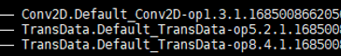
解析后的文件

PyNative 调试体验
1. 系统环境
硬件环境(Ascend/GPU/CPU): Ascend
软件环境: MindSpore 版本: 2.1
执行模式（静态图/动态图）： 不限
Python 版本: 3.7.5
操作系统平台: linux
2. PyNative简介
pynative是通过ms.set_context(mode=ms.PYNATIVE_MODE)设置的。
图模式分为动态图和静态图两种，静态图使用JIT编译优化执行，使用静态语法，在语法上有较多限制， 相对于静态图来说动态图更加灵活，它通过解释执行，具有动态语法亲和性。
动态图逐语句执行Python指令，因此每条Python指令执行完，都能够得到执行结果。
3. 断点调试
加入pdb.set_trace()脚本，就会停住，等待输入pdb指令
import numpy as np
import mindspore as ms
import mindspore.ops as ops
import mindspore.nn as nn
import pdb
ms.set_context(device_target="Ascend", mode=ms.PYNATIVE_MODE)
class PrintDemo(nn.Cell):
def __init__(self):
super(PrintDemo, self).__init__()
self.add1 = ops.Add()
self.add2 = ops.Add()
def construct(self, x, y):
out = self.add1(x, y)
pdb.set_trace()
out = self.add2(out, x)
return x
x = ms.Tensor(np.ones([2, 1]).astype(np.int32))
y = ms.Tensor(np.ones([2, 2]).astype(np.int32))
net = PrintDemo()
output = net(x, y)
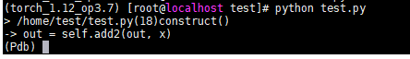
打印变量y的取值 p y
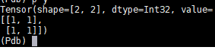
查看程序调用栈 bt
(Pdb) bt
/home/test/test.py(24)<module>()
-> output = net(x, y)
/root/miniconda3/envs/torch_1.12_op3.7/lib/python3.7/site-packages/mindspore/nn/cell.py(660)__call__()
-> output = self._run_construct(args, kwargs)
/root/miniconda3/envs/torch_1.12_op3.7/lib/python3.7/site-packages/mindspore/nn/cell.py(444)_run_construct()
-> output = self.construct(*cast_inputs, **kwargs)
> /home/test/test.py(18)construct()
-> out = self.add2(out, x)
(Pdb)
查看脚本上下文 l 1, 30 查看1-30行
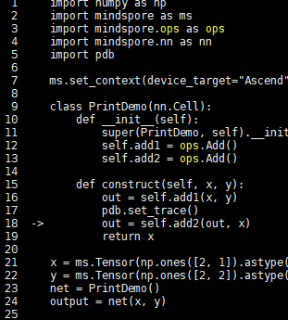
执行代码，直到下一个断点 c
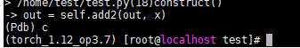
断点调试是网络调试必不可少的调试方法。

mindspore之中间文件保存
1. 系统环境
硬件环境(Ascend/GPU/CPU): Ascend
软件环境: MindSpore 版本: 1.7.0
执行模式（静态图/动态图）： 不限
Python 版本: 3.7.6
操作系统平台: linux
2. 保存中间文件
保存中间文件是通过set_context(save_graphs=3)来控制保存图的，其中save_graphs的值不一样，效果也是不同的:
save_graphs (bool 或 int) - 表示是否保存中间编译图。默认值： 0 。可用的选项为：
False或0：不保存中间编译图。
1：运行时会输出图编译过程中生成的一些中间文件。
True或2：生成更多后端流程相关的ir文件。
3：生成可视化计算图和更多详细的前端ir图。
当 save_graphs 属性设为 1 、 2 、 3 或者 True 时， save_graphs_path 属性用于设置中间编译图的存储路径。默认情况下，计算图保存在当前目录下。
可以输入save_graphs_path 控制保存的ir图的地址
import numpy as np
import mindspore as ms
import mindspore.ops as ops
import mindspore.nn as nn
import pdb
ms.set_context(device_target="Ascend", mode=ms.GRAPH_MODE, save_graphs=3)
class PrintDemo(nn.Cell):
def __init__(self):
super(PrintDemo, self).__init__()
self.add1 = ops.Add()
self.add2 = ops.Add()
def construct(self, x, y):
out = self.add1(x, y)
out = self.add2(out, x)
return x
x = ms.Tensor(np.ones([2, 1]).astype(np.int32))
y = ms.Tensor(np.ones([2, 2]).astype(np.int32))
net = PrintDemo()
output = net(x, y)
生成的文件
total 1288
drwx------. 3 root root 20480 Jul 31 21:53 .
drwxr-xr-x. 30 root root 4096 Jul 27 10:08 ..
-r--------. 1 root root 2805 Jul 31 21:53 00_parse_0000.ir
-r--------. 1 root root 5977 Jul 31 21:53 00_parse_0001.dot
-r--------. 1 root root 1402 Jul 31 21:53 01_symbol_resolve_0008.ir
-r--------. 1 root root 4153 Jul 31 21:53 01_symbol_resolve_0009.dot
-r--------. 1 root root 1402 Jul 31 21:53 02_combine_like_graphs_0010.ir
-r--------. 1 root root 4153 Jul 31 21:53 02_combine_like_graphs_0011.dot
-r--------. 1 root root 1402 Jul 31 21:53 03_meta_unpack_prepare_0014.ir
-r--------. 1 root root 4153 Jul 31 21:53 03_meta_unpack_prepare_0015.dot
-r--------. 1 root root 1782 Jul 31 21:53 04_abstract_specialize_0016.ir
-r--------. 1 root root 4291 Jul 31 21:53 04_abstract_specialize_0017.dot
-r--------. 1 root root 1782 Jul 31 21:53 05_pack_expand_0018.ir
-r--------. 1 root root 4291 Jul 31 21:53 05_pack_expand_0019.dot
-r--------. 1 root root 481 Jul 31 21:53 06_auto_monad_0020.ir
-r--------. 1 root root 1076 Jul 31 21:53 06_auto_monad_0021.dot
-r--------. 1 root root 481 Jul 31 21:53 07_inline_0022.ir
-r--------. 1 root root 1076 Jul 31 21:53 07_inline_0023.dot
-r--------. 1 root root 563 Jul 31 21:53 08_pre_auto_parallel_0024.ir
-r--------. 1 root root 1076 Jul 31 21:53 08_pre_auto_parallel_0025.dot
-r--------. 1 root root 563 Jul 31 21:53 09_pipeline_split_0026.ir
-r--------. 1 root root 1076 Jul 31 21:53 09_pipeline_split_0027.dot
-r--------. 1 root root 682 Jul 31 21:53 10_optimize_0278.ir
-r--------. 1 root root 1078 Jul 31 21:53 10_optimize_0279.dot
-r--------. 1 root root 682 Jul 31 21:53 11_auto_monad_reorder_0280.ir
-r--------. 1 root root 1078 Jul 31 21:53 11_auto_monad_reorder_0281.dot
-r--------. 1 root root 682 Jul 31 21:53 12_get_jit_bprop_graph_0282.ir
-r--------. 1 root root 1078 Jul 31 21:53 12_get_jit_bprop_graph_0283.dot
-r--------. 1 root root 682 Jul 31 21:53 13_eliminate_special_op_node_0290.ir
-r--------. 1 root root 1078 Jul 31 21:53 13_eliminate_special_op_node_0291.dot
-r--------. 1 root root 682 Jul 31 21:53 14_validate_0292.ir
-r--------. 1 root root 1078 Jul 31 21:53 14_validate_0293.dot
-r--------. 1 root root 682 Jul 31 21:53 15_distribtued_split_0294.ir
-r--------. 1 root root 1078 Jul 31 21:53 15_distribtued_split_0295.dot
-r--------. 1 root root 682 Jul 31 21:53 16_task_emit_0296.ir
-r--------. 1 root root 1078 Jul 31 21:53 16_task_emit_0297.dot
-r--------. 1 root root 682 Jul 31 21:53 17_execute_0298.ir
-r--------. 1 root root 1078 Jul 31 21:53 17_execute_0299.dot
-r--------. 1 root root 730 Jul 31 21:53 ModelDigraph_0300.dot
-r--------. 1 root root 110 Jul 31 21:53 ms_output_optimize.pb
-r--------. 1 root root 518 Jul 31 21:53 opt_a_r1_a_2_addn_check_dump_0056.ir
-r--------. 1 root root 1076 Jul 31 21:53 opt_a_r1_a_2_addn_check_dump_0057.dot
-r--------. 1 root root 518 Jul 31 21:53 opt_a_r1_a_2_arithmetic_simplify_0066.ir
-r--------. 1 root root 1076 Jul 31 21:53 opt_a_r1_a_2_arithmetic_simplify_0067.dot
-r--------. 1 root root 518 Jul 31 21:53 opt_a_r1_a_2_compare_switch_simplify_0054.ir
-r--------. 1 root root 1076 Jul 31 21:53 opt_a_r1_a_2_compare_switch_simplify_0055.dot
-r--------. 1 root root 518 Jul 31 21:53 opt_a_r1_a_2_depend_value_elim_0078.ir
-r--------. 1 root root 1076 Jul 31 21:53 opt_a_r1_a_2_depend_value_elim_0079.dot
-r--------. 1 root root 518 Jul 31 21:53 opt_a_r1_a_2_environ_get_eliminate_0076.ir
-r--------. 1 root root 1076 Jul 31 21:53 opt_a_r1_a_2_environ_get_eliminate_0077.dot
-r--------. 1 root root 518 Jul 31 21:53 opt_a_r1_a_2_float_environ_get_switch_0060.ir
-r--------. 1 root root 1076 Jul 31 21:53 opt_a_r1_a_2_float_environ_get_switch_0061.dot
-r--------. 1 root root 518 Jul 31 21:53 opt_a_r1_a_2_float_tuple_getitem_switch_0058.ir
-r--------. 1 root root 1076 Jul 31 21:53 opt_a_r1_a_2_float_tuple_getitem_switch_0059.dot
-r--------. 1 root root 518 Jul 31 21:53 opt_a_r1_a_2_incorporate_call_0072.ir
-r--------. 1 root root 1076 Jul 31 21:53 opt_a_r1_a_2_incorporate_call_0073.dot
-r--------. 1 root root 518 Jul 31 21:53 opt_a_r1_a_2_incorporate_call_switch_0074.ir
-r--------. 1 root root 1076 Jul 31 21:53 opt_a_r1_a_2_incorporate_call_switch_0075.dot
-r--------. 1 root root 518 Jul 31 21:53 opt_a_r1_a_2_inline_0062.ir
-r--------. 1 root root 1076 Jul 31 21:53 opt_a_r1_a_2_inline_0063.dot
-r--------. 1 root root 518 Jul 31 21:53 opt_a_r1_a_2_merge_addn_0052.ir
-r--------. 1 root root 1076 Jul 31 21:53 opt_a_r1_a_2_merge_addn_0053.dot
-r--------. 1 root root 518 Jul 31 21:53 opt_a_r1_a_2_reduce_all_const_elim_0080.ir
-r--------. 1 root root 1076 Jul 31 21:53 opt_a_r1_a_2_reduce_all_const_elim_0081.dot
-r--------. 1 root root 518 Jul 31 21:53 opt_a_r1_a_2_specialize_transform_0050.ir
-r--------. 1 root root 1076 Jul 31 21:53 opt_a_r1_a_2_specialize_transform_0051.dot
-r--------. 1 root root 518 Jul 31 21:53 opt_a_r1_a_2_switch_simplify_0048.ir
-r--------. 1 root root 1076 Jul 31 21:53 opt_a_r1_a_2_switch_simplify_0049.dot
-r--------. 1 root root 518 Jul 31 21:53 opt_a_r1_a_2_tuple_list_get_item_eliminator_0070.ir
-r--------. 1 root root 1076 Jul 31 21:53 opt_a_r1_a_2_tuple_list_get_item_eliminator_0071.dot
-r--------. 1 root root 518 Jul 31 21:53 opt_a_r1_a_2_tuple_list_set_item_eliminator_0068.ir
-r--------. 1 root root 1076 Jul 31 21:53 opt_a_r1_a_2_tuple_list_set_item_eliminator_0069.dot
-r--------. 1 root root 518 Jul 31 21:53 opt_a_r1_a_2_updatestate_useless_node_eliminater_0064.ir
-r--------. 1 root root 1076 Jul 31 21:53 opt_a_r1_a_2_updatestate_useless_node_eliminater_0065.dot
-r--------. 1 root root 602 Jul 31 21:53 opt_a_r1_a_3_check_bprop_eliminate_0124.ir
-r--------. 1 root root 1078 Jul 31 21:53 opt_a_r1_a_3_check_bprop_eliminate_0125.dot
-r--------. 1 root root 602 Jul 31 21:53 opt_a_r1_a_3_micro_step_allgather_replace_0134.ir
-r--------. 1 root root 1078 Jul 31 21:53 opt_a_r1_a_3_micro_step_allgather_replace_0135.dot
-r--------. 1 root root 602 Jul 31 21:53 opt_a_r1_a_3_mini_step_allgather_replace_0132.ir
-r--------. 1 root root 1078 Jul 31 21:53 opt_a_r1_a_3_mini_step_allgather_replace_0133.dot
-r--------. 1 root root 602 Jul 31 21:53 opt_a_r1_a_3_replace_applicator_0128.ir
-r--------. 1 root root 1078 Jul 31 21:53 opt_a_r1_a_3_replace_applicator_0129.dot
-r--------. 1 root root 602 Jul 31 21:53 opt_a_r1_a_3_row_tensor_add_zeros_like_0130.ir
-r--------. 1 root root 1078 Jul 31 21:53 opt_a_r1_a_3_row_tensor_add_zeros_like_0131.dot
-r--------. 1 root root 602 Jul 31 21:53 opt_a_r1_a_3_same_eliminate_0122.ir
-r--------. 1 root root 1078 Jul 31 21:53 opt_a_r1_a_3_same_eliminate_0123.dot
-r--------. 1 root root 602 Jul 31 21:53 opt_a_r1_a_3_split_environ_get_set_with_tuple_value_0136.ir
-r--------. 1 root root 1078 Jul 31 21:53 opt_a_r1_a_3_split_environ_get_set_with_tuple_value_0137.dot
-r--------. 1 root root 602 Jul 31 21:53 opt_a_r1_a_3_switch_layer_defer_inline_0126.ir
-r--------. 1 root root 1078 Jul 31 21:53 opt_a_r1_a_3_switch_layer_defer_inline_0127.dot
-r--------. 1 root root 596 Jul 31 21:53 opt_a_r1_cell_reuse_handle_not_recompute_node_pass_remove_not_recompute_node_0102.ir
-r--------. 1 root root 1076 Jul 31 21:53 opt_a_r1_cell_reuse_handle_not_recompute_node_pass_remove_not_recompute_node_0103.dot
-r--------. 1 root root 602 Jul 31 21:53 opt_b_r1_b_1_environ_add_const_eliminate__0190.ir
-r--------. 1 root root 1078 Jul 31 21:53 opt_b_r1_b_1_environ_add_const_eliminate__0191.dot
-r--------. 1 root root 602 Jul 31 21:53 opt_b_r1_b_1_environ_get_add_eliminate_0184.ir
-r--------. 1 root root 1078 Jul 31 21:53 opt_b_r1_b_1_environ_get_add_eliminate_0185.dot
-r--------. 1 root root 602 Jul 31 21:53 opt_b_r1_b_1_environ_get_depend_swap_0188.ir
-r--------. 1 root root 1078 Jul 31 21:53 opt_b_r1_b_1_environ_get_depend_swap_0189.dot
-r--------. 1 root root 602 Jul 31 21:53 opt_b_r1_b_1_environ_get_eliminate_0182.ir
-r--------. 1 root root 1078 Jul 31 21:53 opt_b_r1_b_1_environ_get_eliminate_0183.dot
-r--------. 1 root root 602 Jul 31 21:53 opt_b_r1_b_1_environ_get_set_eliminate_0186.ir
-r--------. 1 root root 1078 Jul 31 21:53 opt_b_r1_b_1_environ_get_set_eliminate_0187.dot
-r--------. 1 root root 602 Jul 31 21:53 opt_b_r1_b_1_float_tuple_getitem_switch_0166.ir
-r--------. 1 root root 1078 Jul 31 21:53 opt_b_r1_b_1_float_tuple_getitem_switch_0167.dot
-r--------. 1 root root 602 Jul 31 21:53 opt_b_r1_b_1_inline_0170.ir
-r--------. 1 root root 1078 Jul 31 21:53 opt_b_r1_b_1_inline_0171.dot
-r--------. 1 root root 602 Jul 31 21:53 opt_b_r1_b_1_load_eliminater_0176.ir
-r--------. 1 root root 1078 Jul 31 21:53 opt_b_r1_b_1_load_eliminater_0177.dot
-r--------. 1 root root 602 Jul 31 21:53 opt_b_r1_b_1_make_slice_get_slice_eliminator_0164.ir
-r--------. 1 root root 1078 Jul 31 21:53 opt_b_r1_b_1_make_slice_get_slice_eliminator_0165.dot
-r--------. 1 root root 602 Jul 31 21:53 opt_b_r1_b_1_parallel_virtual_node_0194.ir
-r--------. 1 root root 1078 Jul 31 21:53 opt_b_r1_b_1_parallel_virtual_node_0195.dot
-r--------. 1 root root 602 Jul 31 21:53 opt_b_r1_b_1_reset_defer_inline_0168.ir
-r--------. 1 root root 1078 Jul 31 21:53 opt_b_r1_b_1_reset_defer_inline_0169.dot
-r--------. 1 root root 602 Jul 31 21:53 opt_b_r1_b_1_special_op_eliminate_0180.ir
-r--------. 1 root root 1078 Jul 31 21:53 opt_b_r1_b_1_special_op_eliminate_0181.dot
-r--------. 1 root root 602 Jul 31 21:53 opt_b_r1_b_1_stopgrad_eliminater_0178.ir
-r--------. 1 root root 1078 Jul 31 21:53 opt_b_r1_b_1_stopgrad_eliminater_0179.dot
-r--------. 1 root root 602 Jul 31 21:53 opt_b_r1_b_1_tuple_list_convert_item_index_to_positive_0162.ir
-r--------. 1 root root 1078 Jul 31 21:53 opt_b_r1_b_1_tuple_list_convert_item_index_to_positive_0163.dot
-r--------. 1 root root 602 Jul 31 21:53 opt_b_r1_b_1_tuple_list_get_item_const_eliminator_0154.ir
-r--------. 1 root root 1078 Jul 31 21:53 opt_b_r1_b_1_tuple_list_get_item_const_eliminator_0155.dot
-r--------. 1 root root 602 Jul 31 21:53 opt_b_r1_b_1_tuple_list_get_item_depend_reorder_0160.ir
-r--------. 1 root root 1078 Jul 31 21:53 opt_b_r1_b_1_tuple_list_get_item_depend_reorder_0161.dot
-r--------. 1 root root 602 Jul 31 21:53 opt_b_r1_b_1_tuple_list_get_item_eliminator_0152.ir
-r--------. 1 root root 1078 Jul 31 21:53 opt_b_r1_b_1_tuple_list_get_item_eliminator_0153.dot
-r--------. 1 root root 602 Jul 31 21:53 opt_b_r1_b_1_tuple_list_get_set_item_eliminator_0158.ir
-r--------. 1 root root 1078 Jul 31 21:53 opt_b_r1_b_1_tuple_list_get_set_item_eliminator_0159.dot
-r--------. 1 root root 602 Jul 31 21:53 opt_b_r1_b_1_tuple_list_set_item_eliminator_0156.ir
-r--------. 1 root root 1078 Jul 31 21:53 opt_b_r1_b_1_tuple_list_set_item_eliminator_0157.dot
-r--------. 1 root root 602 Jul 31 21:53 opt_b_r1_b_1_updatestate_pure_node_eliminater_0174.ir
-r--------. 1 root root 1078 Jul 31 21:53 opt_b_r1_b_1_updatestate_pure_node_eliminater_0175.dot
-r--------. 1 root root 602 Jul 31 21:53 opt_b_r1_b_1_updatestate_useless_node_eliminater_0172.ir
-r--------. 1 root root 1078 Jul 31 21:53 opt_b_r1_b_1_updatestate_useless_node_eliminater_0173.dot
-r--------. 1 root root 602 Jul 31 21:53 opt_b_r1_b_1_value_based_eliminate_0192.ir
-r--------. 1 root root 1078 Jul 31 21:53 opt_b_r1_b_1_value_based_eliminate_0193.dot
-r--------. 1 root root 602 Jul 31 21:53 opt_b_r1_b_1_zero_like_fill_zero_0150.ir
-r--------. 1 root root 1078 Jul 31 21:53 opt_b_r1_b_1_zero_like_fill_zero_0151.dot
-r--------. 1 root root 518 Jul 31 21:53 opt_pass_0_py_interpret_to_execute_0028.ir
-r--------. 1 root root 1076 Jul 31 21:53 opt_pass_0_py_interpret_to_execute_0029.dot
-r--------. 1 root root 602 Jul 31 21:53 opt_pass_10_remove_dup_value_0230.ir
-r--------. 1 root root 1078 Jul 31 21:53 opt_pass_10_remove_dup_value_0231.dot
-r--------. 1 root root 602 Jul 31 21:53 opt_pass_11_tuple_transform_0236.ir
-r--------. 1 root root 1078 Jul 31 21:53 opt_pass_11_tuple_transform_0237.dot
-r--------. 1 root root 602 Jul 31 21:53 opt_pass_12_add_cache_embedding_0238.ir
-r--------. 1 root root 1078 Jul 31 21:53 opt_pass_12_add_cache_embedding_0239.dot
-r--------. 1 root root 637 Jul 31 21:53 opt_pass_13_add_recomputation_0240.ir
-r--------. 1 root root 1078 Jul 31 21:53 opt_pass_13_add_recomputation_0241.dot
-r--------. 1 root root 637 Jul 31 21:53 opt_pass_14_cse_after_recomputation_0244.ir
-r--------. 1 root root 1078 Jul 31 21:53 opt_pass_14_cse_after_recomputation_0245.dot
-r--------. 1 root root 637 Jul 31 21:53 opt_pass_15_environ_conv_0246.ir
-r--------. 1 root root 1078 Jul 31 21:53 opt_pass_15_environ_conv_0247.dot
-r--------. 1 root root 637 Jul 31 21:53 opt_pass_16_label_micro_interleaved_index_0248.ir
-r--------. 1 root root 1078 Jul 31 21:53 opt_pass_16_label_micro_interleaved_index_0249.dot
-r--------. 1 root root 637 Jul 31 21:53 opt_pass_17_slice_recompute_activation_0250.ir
-r--------. 1 root root 1078 Jul 31 21:53 opt_pass_17_slice_recompute_activation_0251.dot
-r--------. 1 root root 637 Jul 31 21:53 opt_pass_18_micro_interleaved_order_control_0252.ir
-r--------. 1 root root 1078 Jul 31 21:53 opt_pass_18_micro_interleaved_order_control_0253.dot
-r--------. 1 root root 637 Jul 31 21:53 opt_pass_19_comp_comm_scheduling_0254.ir
-r--------. 1 root root 1078 Jul 31 21:53 opt_pass_19_comp_comm_scheduling_0255.dot
-r--------. 1 root root 518 Jul 31 21:53 opt_pass_1_rewriter_before_opt_a_0030.ir
-r--------. 1 root root 1076 Jul 31 21:53 opt_pass_1_rewriter_before_opt_a_0031.dot
-r--------. 1 root root 637 Jul 31 21:53 opt_pass_20_reorder_send_recv_between_fp_bp_0256.ir
-r--------. 1 root root 1078 Jul 31 21:53 opt_pass_20_reorder_send_recv_between_fp_bp_0257.dot
-r--------. 1 root root 637 Jul 31 21:53 opt_pass_21_comm_op_add_attrs_0258.ir
-r--------. 1 root root 1078 Jul 31 21:53 opt_pass_21_comm_op_add_attrs_0259.dot
-r--------. 1 root root 637 Jul 31 21:53 opt_pass_22_process_send_recv_for_ge_0260.ir
-r--------. 1 root root 1078 Jul 31 21:53 opt_pass_22_process_send_recv_for_ge_0261.dot
-r--------. 1 root root 637 Jul 31 21:53 opt_pass_23_add_comm_op_reuse_tag_0262.ir
-r--------. 1 root root 1078 Jul 31 21:53 opt_pass_23_add_comm_op_reuse_tag_0263.dot
-r--------. 1 root root 637 Jul 31 21:53 opt_pass_24_overlap_opt_shard_in_pipeline_0264.ir
-r--------. 1 root root 1078 Jul 31 21:53 opt_pass_24_overlap_opt_shard_in_pipeline_0265.dot
-r--------. 1 root root 637 Jul 31 21:53 opt_pass_25_grouped_pairwise_exchange_alltoall_0266.ir
-r--------. 1 root root 1078 Jul 31 21:53 opt_pass_25_grouped_pairwise_exchange_alltoall_0267.dot
-r--------. 1 root root 637 Jul 31 21:53 opt_pass_26_overlap_recompute_and_grad_model_parallel_0268.ir
-r--------. 1 root root 1078 Jul 31 21:53 opt_pass_26_overlap_recompute_and_grad_model_parallel_0269.dot
-r--------. 1 root root 637 Jul 31 21:53 opt_pass_27_split_matmul_comm_elemetwise_0270.ir
-r--------. 1 root root 1078 Jul 31 21:53 opt_pass_27_split_matmul_comm_elemetwise_0271.dot
-r--------. 1 root root 637 Jul 31 21:53 opt_pass_28_split_layernorm_comm_0272.ir
-r--------. 1 root root 1078 Jul 31 21:53 opt_pass_28_split_layernorm_comm_0273.dot
-r--------. 1 root root 637 Jul 31 21:53 opt_pass_29_overlap_grad_matmul_and_grad_allreduce_0274.ir
-r--------. 1 root root 1078 Jul 31 21:53 opt_pass_29_overlap_grad_matmul_and_grad_allreduce_0275.dot
-r--------. 1 root root 602 Jul 31 21:53 opt_pass_2_opt_a_0140.ir
-r--------. 1 root root 1078 Jul 31 21:53 opt_pass_2_opt_a_0141.dot
-r--------. 1 root root 637 Jul 31 21:53 opt_pass_30_handle_group_info_0276.ir
-r--------. 1 root root 1078 Jul 31 21:53 opt_pass_30_handle_group_info_0277.dot
-r--------. 1 root root 602 Jul 31 21:53 opt_pass_3_slice_cell_reuse_recomputed_activation_0142.ir
-r--------. 1 root root 1078 Jul 31 21:53 opt_pass_3_slice_cell_reuse_recomputed_activation_0143.dot
-r--------. 1 root root 602 Jul 31 21:53 opt_pass_4_rewriter_after_opt_a_0144.ir
-r--------. 1 root root 1078 Jul 31 21:53 opt_pass_4_rewriter_after_opt_a_0145.dot
-r--------. 1 root root 602 Jul 31 21:53 opt_pass_5_convert_pyexecute_list_input_0146.ir
-r--------. 1 root root 1078 Jul 31 21:53 opt_pass_5_convert_pyexecute_list_input_0147.dot
-r--------. 1 root root 602 Jul 31 21:53 opt_pass_6_order_py_execute_after_rewriter_0148.ir
-r--------. 1 root root 1078 Jul 31 21:53 opt_pass_6_order_py_execute_after_rewriter_0149.dot
-r--------. 1 root root 602 Jul 31 21:53 opt_pass_7_opt_b_0210.ir
-r--------. 1 root root 1078 Jul 31 21:53 opt_pass_7_opt_b_0211.dot
-r--------. 1 root root 602 Jul 31 21:53 opt_pass_8_cconv_0212.ir
-r--------. 1 root root 1078 Jul 31 21:53 opt_pass_8_cconv_0213.dot
-r--------. 1 root root 602 Jul 31 21:53 opt_pass_9_opt_after_cconv_0228.ir
-r--------. 1 root root 1078 Jul 31 21:53 opt_pass_9_opt_after_cconv_0229.dot
-r--------. 1 root root 1827 Jul 31 21:53 opt_resolve_r1_resolve_getattr_setattr_resolve_0002.ir
-r--------. 1 root root 4153 Jul 31 21:53 opt_resolve_r1_resolve_getattr_setattr_resolve_0003.dot
-r--------. 1 root root 1827 Jul 31 21:53 opt_resolve_r1_resolve_getattr_setattr_resolve_0004.ir
-r--------. 1 root root 4153 Jul 31 21:53 opt_resolve_r1_resolve_getattr_setattr_resolve_0005.dot
-r--------. 1 root root 1180 Jul 31 21:53 opt_substep_meta_unpack_prepare_r1_0_meta_unpack_prepare_0012.ir
-r--------. 1 root root 4153 Jul 31 21:53 opt_substep_meta_unpack_prepare_r1_0_meta_unpack_prepare_0013.dot
-r--------. 1 root root 602 Jul 31 21:53 opt_substep_opt_after_cconv_r1_0_c_1_0214.ir
-r--------. 1 root root 1078 Jul 31 21:53 opt_substep_opt_after_cconv_r1_0_c_1_0215.dot
-r--------. 1 root root 602 Jul 31 21:53 opt_substep_opt_after_cconv_r1_1_parameter_eliminate_0216.ir
-r--------. 1 root root 1078 Jul 31 21:53 opt_substep_opt_after_cconv_r1_1_parameter_eliminate_0217.dot
-r--------. 1 root root 602 Jul 31 21:53 opt_substep_opt_after_cconv_r1_2_updatestate_depend_eliminate_0218.ir
-r--------. 1 root root 1078 Jul 31 21:53 opt_substep_opt_after_cconv_r1_2_updatestate_depend_eliminate_0219.dot
-r--------. 1 root root 602 Jul 31 21:53 opt_substep_opt_after_cconv_r1_3_updatestate_assign_eliminate_0220.ir
-r--------. 1 root root 1078 Jul 31 21:53 opt_substep_opt_after_cconv_r1_3_updatestate_assign_eliminate_0221.dot
-r--------. 1 root root 602 Jul 31 21:53 opt_substep_opt_after_cconv_r1_4_updatestate_loads_eliminate_0222.ir
-r--------. 1 root root 1078 Jul 31 21:53 opt_substep_opt_after_cconv_r1_4_updatestate_loads_eliminate_0223.dot
-r--------. 1 root root 602 Jul 31 21:53 opt_substep_opt_after_cconv_r1_5_cse_0224.ir
-r--------. 1 root root 1078 Jul 31 21:53 opt_substep_opt_after_cconv_r1_5_cse_0225.dot
-r--------. 1 root root 602 Jul 31 21:53 opt_substep_opt_after_cconv_r1_6_renormalize_0226.ir
-r--------. 1 root root 1078 Jul 31 21:53 opt_substep_opt_after_cconv_r1_6_renormalize_0227.dot
-r--------. 1 root root 637 Jul 31 21:53 opt_substep_opt_after_recompute_r1_0_cse_0242.ir
-r--------. 1 root root 1078 Jul 31 21:53 opt_substep_opt_after_recompute_r1_0_cse_0243.dot
-r--------. 1 root root 518 Jul 31 21:53 opt_substep_opt_a_r1_0_expand_dump_flag_0032.ir
-r--------. 1 root root 1076 Jul 31 21:53 opt_substep_opt_a_r1_0_expand_dump_flag_0033.dot
-r--------. 1 root root 518 Jul 31 21:53 opt_substep_opt_a_r1_10_pynative_shard_0086.ir
-r--------. 1 root root 1076 Jul 31 21:53 opt_substep_opt_a_r1_10_pynative_shard_0087.dot
-r--------. 1 root root 518 Jul 31 21:53 opt_substep_opt_a_r1_11_auto_parallel_0088.ir
-r--------. 1 root root 1076 Jul 31 21:53 opt_substep_opt_a_r1_11_auto_parallel_0089.dot
-r--------. 1 root root 596 Jul 31 21:53 opt_substep_opt_a_r1_12_parallel_0090.ir
-r--------. 1 root root 1076 Jul 31 21:53 opt_substep_opt_a_r1_12_parallel_0091.dot
-r--------. 1 root root 596 Jul 31 21:53 opt_substep_opt_a_r1_13_allreduce_fusion_0092.ir
-r--------. 1 root root 1076 Jul 31 21:53 opt_substep_opt_a_r1_13_allreduce_fusion_0093.dot
-r--------. 1 root root 596 Jul 31 21:53 opt_substep_opt_a_r1_14_virtual_dataset_0094.ir
-r--------. 1 root root 1076 Jul 31 21:53 opt_substep_opt_a_r1_14_virtual_dataset_0095.dot
-r--------. 1 root root 596 Jul 31 21:53 opt_substep_opt_a_r1_15_get_grad_eliminate__0096.ir
-r--------. 1 root root 1076 Jul 31 21:53 opt_substep_opt_a_r1_15_get_grad_eliminate__0097.dot
-r--------. 1 root root 596 Jul 31 21:53 opt_substep_opt_a_r1_16_virtual_output_0098.ir
-r--------. 1 root root 1076 Jul 31 21:53 opt_substep_opt_a_r1_16_virtual_output_0099.dot
-r--------. 1 root root 596 Jul 31 21:53 opt_substep_opt_a_r1_17_cell_reuse_recompute_pass_0100.ir
-r--------. 1 root root 1076 Jul 31 21:53 opt_substep_opt_a_r1_17_cell_reuse_recompute_pass_0101.dot
-r--------. 1 root root 596 Jul 31 21:53 opt_substep_opt_a_r1_18_cell_reuse_handle_not_recompute_node_pass_0104.ir
-r--------. 1 root root 1076 Jul 31 21:53 opt_substep_opt_a_r1_18_cell_reuse_handle_not_recompute_node_pass_0105.dot
-r--------. 1 root root 596 Jul 31 21:53 opt_substep_opt_a_r1_19_meta_fg_expand_0106.ir
-r--------. 1 root root 1076 Jul 31 21:53 opt_substep_opt_a_r1_19_meta_fg_expand_0107.dot
-r--------. 1 root root 518 Jul 31 21:53 opt_substep_opt_a_r1_1_switch_simplify_0034.ir
-r--------. 1 root root 1076 Jul 31 21:53 opt_substep_opt_a_r1_1_switch_simplify_0035.dot
-r--------. 1 root root 596 Jul 31 21:53 opt_substep_opt_a_r1_20_after_resolve_0108.ir
-r--------. 1 root root 1076 Jul 31 21:53 opt_substep_opt_a_r1_20_after_resolve_0109.dot
-r--------. 1 root root 596 Jul 31 21:53 opt_substep_opt_a_r1_21_a_after_grad_0110.ir
-r--------. 1 root root 1076 Jul 31 21:53 opt_substep_opt_a_r1_21_a_after_grad_0111.dot
-r--------. 1 root root 602 Jul 31 21:53 opt_substep_opt_a_r1_22_renormalize_0112.ir
-r--------. 1 root root 1078 Jul 31 21:53 opt_substep_opt_a_r1_22_renormalize_0113.dot
-r--------. 1 root root 602 Jul 31 21:53 opt_substep_opt_a_r1_23_real_op_eliminate_0114.ir
-r--------. 1 root root 1078 Jul 31 21:53 opt_substep_opt_a_r1_23_real_op_eliminate_0115.dot
-r--------. 1 root root 602 Jul 31 21:53 opt_substep_opt_a_r1_24_auto_monad_grad_0116.ir
-r--------. 1 root root 1078 Jul 31 21:53 opt_substep_opt_a_r1_24_auto_monad_grad_0117.dot
-r--------. 1 root root 602 Jul 31 21:53 opt_substep_opt_a_r1_25_auto_monad_eliminator_0118.ir
-r--------. 1 root root 1078 Jul 31 21:53 opt_substep_opt_a_r1_25_auto_monad_eliminator_0119.dot
-r--------. 1 root root 602 Jul 31 21:53 opt_substep_opt_a_r1_26_cse_0120.ir
-r--------. 1 root root 1078 Jul 31 21:53 opt_substep_opt_a_r1_26_cse_0121.dot
-r--------. 1 root root 602 Jul 31 21:53 opt_substep_opt_a_r1_27_a_3_0138.ir
-r--------. 1 root root 1078 Jul 31 21:53 opt_substep_opt_a_r1_27_a_3_0139.dot
-r--------. 1 root root 518 Jul 31 21:53 opt_substep_opt_a_r1_2_a_1_0036.ir
-r--------. 1 root root 1076 Jul 31 21:53 opt_substep_opt_a_r1_2_a_1_0037.dot
-r--------. 1 root root 518 Jul 31 21:53 opt_substep_opt_a_r1_3_recompute_prepare_0038.ir
-r--------. 1 root root 1076 Jul 31 21:53 opt_substep_opt_a_r1_3_recompute_prepare_0039.dot
-r--------. 1 root root 518 Jul 31 21:53 opt_substep_opt_a_r1_4_updatestate_depend_eliminate_0040.ir
-r--------. 1 root root 1076 Jul 31 21:53 opt_substep_opt_a_r1_4_updatestate_depend_eliminate_0041.dot
-r--------. 1 root root 518 Jul 31 21:53 opt_substep_opt_a_r1_5_updatestate_assign_eliminate_0042.ir
-r--------. 1 root root 1076 Jul 31 21:53 opt_substep_opt_a_r1_5_updatestate_assign_eliminate_0043.dot
-r--------. 1 root root 518 Jul 31 21:53 opt_substep_opt_a_r1_6_updatestate_loads_eliminate_0044.ir
-r--------. 1 root root 1076 Jul 31 21:53 opt_substep_opt_a_r1_6_updatestate_loads_eliminate_0045.dot
-r--------. 1 root root 518 Jul 31 21:53 opt_substep_opt_a_r1_7_parameter_eliminate_0046.ir
-r--------. 1 root root 1076 Jul 31 21:53 opt_substep_opt_a_r1_7_parameter_eliminate_0047.dot
-r--------. 1 root root 518 Jul 31 21:53 opt_substep_opt_a_r1_8_a_2_0082.ir
-r--------. 1 root root 1076 Jul 31 21:53 opt_substep_opt_a_r1_8_a_2_0083.dot
-r--------. 1 root root 518 Jul 31 21:53 opt_substep_opt_a_r1_9_accelerated_algorithm_0084.ir
-r--------. 1 root root 1076 Jul 31 21:53 opt_substep_opt_a_r1_9_accelerated_algorithm_0085.dot
-r--------. 1 root root 602 Jul 31 21:53 opt_substep_opt_b_r1_0_b_1_0196.ir
-r--------. 1 root root 1078 Jul 31 21:53 opt_substep_opt_b_r1_0_b_1_0197.dot
-r--------. 1 root root 602 Jul 31 21:53 opt_substep_opt_b_r1_1_b_2_0198.ir
-r--------. 1 root root 1078 Jul 31 21:53 opt_substep_opt_b_r1_1_b_2_0199.dot
-r--------. 1 root root 602 Jul 31 21:53 opt_substep_opt_b_r1_2_updatestate_depend_eliminate_0200.ir
-r--------. 1 root root 1078 Jul 31 21:53 opt_substep_opt_b_r1_2_updatestate_depend_eliminate_0201.dot
-r--------. 1 root root 602 Jul 31 21:53 opt_substep_opt_b_r1_3_updatestate_assign_eliminate_0202.ir
-r--------. 1 root root 1078 Jul 31 21:53 opt_substep_opt_b_r1_3_updatestate_assign_eliminate_0203.dot
-r--------. 1 root root 602 Jul 31 21:53 opt_substep_opt_b_r1_4_updatestate_loads_eliminate_0204.ir
-r--------. 1 root root 1078 Jul 31 21:53 opt_substep_opt_b_r1_4_updatestate_loads_eliminate_0205.dot
-r--------. 1 root root 602 Jul 31 21:53 opt_substep_opt_b_r1_5_renormalize_0206.ir
-r--------. 1 root root 1078 Jul 31 21:53 opt_substep_opt_b_r1_5_renormalize_0207.dot
-r--------. 1 root root 602 Jul 31 21:53 opt_substep_opt_b_r1_6_cse_0208.ir
-r--------. 1 root root 1078 Jul 31 21:53 opt_substep_opt_b_r1_6_cse_0209.dot
-r--------. 1 root root 1827 Jul 31 21:53 opt_substep_opt_resolve_r1_0_resolve_0006.ir
-r--------. 1 root root 4153 Jul 31 21:53 opt_substep_opt_resolve_r1_0_resolve_0007.dot
-r--------. 1 root root 602 Jul 31 21:53 opt_substep_opt_trans_graph_r1_0_d_1_0232.ir
-r--------. 1 root root 1078 Jul 31 21:53 opt_substep_opt_trans_graph_r1_0_d_1_0233.dot
-r--------. 1 root root 602 Jul 31 21:53 opt_substep_opt_trans_graph_r1_1_renormalize_0234.ir
-r--------. 1 root root 1078 Jul 31 21:53 opt_substep_opt_trans_graph_r1_1_renormalize_0235.dot
-r--------. 1 root root 637 Jul 31 21:53 opt_substep_special_op_eliminate_r1_0_ad_related_special_op_eliminate_0284.ir
-r--------. 1 root root 1078 Jul 31 21:53 opt_substep_special_op_eliminate_r1_0_ad_related_special_op_eliminate_0285.dot
-r--------. 1 root root 637 Jul 31 21:53 opt_substep_special_op_eliminate_r1_1_mutable_op_eliminate_0286.ir
-r--------. 1 root root 1078 Jul 31 21:53 opt_substep_special_op_eliminate_r1_1_mutable_op_eliminate_0287.dot
-r--------. 1 root root 637 Jul 31 21:53 opt_substep_special_op_eliminate_r1_2_convert_tensor_op_eliminate_0288.ir
-r--------. 1 root root 1078 Jul 31 21:53 opt_substep_special_op_eliminate_r1_2_convert_tensor_op_eliminate_0289.dot
drwx------. 4 root root 53 Jul 31 20:22 rank_0
-rw-------. 1 root root 73 Jul 31 20:30 test2.py
-r--------. 1 root root 90 Jul 31 20:22 test.data
-rw-------. 1 root root 581 Jul 31 21:52 test.py
3. 根因分析
parse阶段负责解析入口函数，该阶段会初步生成MindIR，如果查看IR文件，我们能观察到该阶段仅仅解析了顶层Cell的图信息；
symbol_resolve阶段负责进一步解析入口函数，主要是递归解析入口函数直接或间接引用到的其他函数和对象。如果使用了尚不支持的语法，一般会在此阶段出错；
abstract_specialize阶段，会根据输入信息推导出IR中所有节点的数据类型和形状信息。当需要查看IR中具体算子的形状或数据类型，可查看该IR文件；
optimize阶段负责硬件无关的优化，自动微分与自动并行功能也是在该阶段展开。该阶段又可细分为若干个子阶段，在IR文件列表中，其中以opt_pass_[序号]为前缀的文件分别是这些子阶段结束后保存的IR文件，非框架开发人员无需过多关注；
validate阶段负责校验编译出来的计算图，如果到此阶段IR中还有仅临时使用的内部算子，则会报错退出；
task_emit阶段负责将计算图传给后端进一步处理；
execute阶段负责启动执行图流程，该阶段的IR图是前端编译阶段的最终图。
%0([CNode]20) = Add(%para1_x, %para2_y)，图里面会出现类似这样的关键字。
若是编译失败，会出现analyze_fail.ir这样的ir图，可以根据这个图找到具体报错的语句

随机数生成函数导致模型速度越来越慢
1. 系统环境
硬件环境(Ascend/GPU/CPU): Ascend/GPU/CPU
软件环境: MindSpore 版本: 1.7.0
执行模式（静态图/动态图）： 不限
Python 版本: 3.9.13
操作系统平台: linux
2. 报错信息
2.1 问题描述
随机数生成函数导致模型速度越来越慢。
2.2 脚本信息
import os
import time
import random
import numpy as np
import mindspore as ms
from mindspore import nn, Tensor, ops
seed = 1
ms.set_seed(seed)
np.random.seed(seed) # Numpy module.
random.seed(seed) # Python random module.
class net(nn.Cell):
def __init__(self, in_dims=4, out_dims=1):
super().__init__()
self.fc1 = nn.Dense(in_dims, 4, has_bias=False)
self.relu = nn.ReLU()
self.fc2 = nn.Dense(4, out_dims, has_bias=False)
def construct(self, x):
x = self.fc1(x)
x = self.relu(x)
x = self.fc2(x)
rand_tensor = ms.numpy.rand(x.shape)
return x
class NetWithLoss(nn.Cell):
def __init__(self, net: nn.Cell):
super(NetWithLoss, self).__init__()
self.net = net
def construct(self, state):
out = self.net(state)
return out.mean()
net = net()
optimizer = nn.Adam(net.get_parameters(), 0.001) # 使用0学习率，便于观察梯度
net_with_loss = NetWithLoss(net)
net_train_one_step = nn.TrainOneStepCell(net_with_loss, optimizer)
data = ms.Tensor(
np.random.normal(loc=0.0, scale=1.0, size=(1,4)),
dtype=ms.float32)
for i in range(1, 1000):
t1 = time.time()
out = net_train_one_step(data)
t2 = time.time()
print('%d-iter, time:'%(i), t2-t1)
3. 根因分析
在PyNative模式下，存在算子缓存机制——每次执行一个算子，如果算子attr和input维度相同，则复用之前的缓存；否则创建新的缓存。
当前脚本中，每次执行rand_tensor = ms.numpy.rand(x.shape)，UniformReal算子的随机数种子会发生变化，因此会生成新的缓存
随着调用次数增加，缓存数量增加，缓存查询操作变慢，导致执行速度变慢。
def rand(*shape, dtype=mstype.float32):
...
seed = get_seed()
if seed is not None:
seed1, seed2 = _get_seed(seed, "UniformReal")
uniformreal = P.UniformReal(seed=seed1, seed2=seed2)
else:
uniformreal = P.UniformReal()
return uniformreal(size).astype(dtype)
4. 解决方案
方案1：使用图模式执行脚本
import os
import time
import random
import numpy as np
import mindspore as ms
from mindspore import nn, Tensor, ops, context
# 使用图模式执行
context.set_context(mode=context.GRAPH_MODE)
seed = 1
ms.set_seed(seed)
np.random.seed(seed) # Numpy module.
random.seed(seed) # Python random module.
class net(nn.Cell):
def __init__(self, in_dims=4, out_dims=1):
super().__init__()
self.fc1 = nn.Dense(in_dims, 4, has_bias=False)
self.relu = nn.ReLU()
self.fc2 = nn.Dense(4, out_dims, has_bias=False)
def construct(self, x):
x = self.fc1(x)
x = self.relu(x)
x = self.fc2(x)
rand_tensor = ms.numpy.rand(x.shape)
return x
class NetWithLoss(nn.Cell):
def __init__(self, net: nn.Cell):
super(NetWithLoss, self).__init__()
self.net = net
def construct(self, state):
out = self.net(state)
return out.mean()
net = net()
optimizer = nn.Adam(net.get_parameters(), 0.001) # 使用0学习率，便于观察梯度
net_with_loss = NetWithLoss(net)
net_train_one_step = nn.TrainOneStepCell(net_with_loss, optimizer)
data = ms.Tensor(
np.random.normal(loc=0.0, scale=1.0, size=(1,4)),
dtype=ms.float32)
for i in range(1, 1000):
t1 = time.time()
out = net_train_one_step(data)
t2 = time.time()
print('%d-iter, time:'%(i), t2-t1)
方案2：不再随机数种子，避免生成缓存
import os
import time
import random
import numpy as np
import mindspore as ms
from mindspore import nn, Tensor, ops
seed = 1
# 不再设置随机数种子，避免每次执行时，UniformReal算子随机数种子发生变化
# ms.set_seed(seed)
np.random.seed(seed) # Numpy module.
random.seed(seed) # Python random module.
class net(nn.Cell):
def __init__(self, in_dims=4, out_dims=1):
super().__init__()
self.fc1 = nn.Dense(in_dims, 4, has_bias=False)
self.relu = nn.ReLU()
self.fc2 = nn.Dense(4, out_dims, has_bias=False)
def construct(self, x):
x = self.fc1(x)
x = self.relu(x)
x = self.fc2(x)
rand_tensor = ms.numpy.rand(x.shape)
return x
class NetWithLoss(nn.Cell):
def __init__(self, net: nn.Cell):
super(NetWithLoss, self).__init__()
self.net = net
def construct(self, state):
out = self.net(state)
return out.mean()
net = net()
optimizer = nn.Adam(net.get_parameters(), 0.001) # 使用0学习率，便于观察梯度
net_with_loss = NetWithLoss(net)
net_train_one_step = nn.TrainOneStepCell(net_with_loss, optimizer)
data = ms.Tensor(
np.random.normal(loc=0.0, scale=1.0, size=(1,4)),
dtype=ms.float32)
for i in range(1, 1000):
t1 = time.time()
out = net_train_one_step(data)
t2 = time.time()
print('%d-iter, time:'%(i), t2-t1)

模型推理报错案例
7.1 训练过程中推理精度不变问题定位思路
7.2 MindSpore网络推理时使用Matmul矩阵乘法算子计算速度较慢
7.3 mindspore推理报错NameError:The name 'LTM' is not defined, or not supported in graph mode.
7.4 MindSpore推理报错：Load op info form json config failed, version: Ascend310
7.5 使用converter_lite转换包含Dropout算子的模型至MindSpore模型失败
7.6 使用mindsporelite推理，出现data size not equal 错误，tensor size 0
7.7 mindyolo在ckpt模型转为ONNX模型时报错
7.8 MindSpore Lite推理报错RuntimeError: data size not equal! Numpy size: 6144000, Tensor size: 0
7.9 使用MindSpore Lite端侧模型转换工具将YOLOv8.onnx转为.ms报错Convert failed. Ret: Common error code.
7.10 模型推理报错ValueError: For BatchMatMul, inputs shape cannot be broadcast on CPU/GPU.
7.11 MindSpore Lite调用macBert模型报错
7.12 MindSpore Lite模型加载报错RuntimeError: build from file failed! Error is Common error code.
7.13 使用.om格式模型结合gradio框架进行推理出现模型执行错误
7.14 qwen1.5-0.5b推理报错Launch kernel failed, kernel full name: Default/ScatterNdUpdate-op0
7.15 mindformers推理qwen2.5-72b报显存不足及解决
7.16 使用MindSpore将.ckpt转.air再转.om出现AttributeError: 'AclLiteModel' object has no attribute '_is_destroye

训练过程中推理精度不变问题定位思路
1. 系统环境
硬件环境(Ascend/GPU/CPU): Ascend
软件环境: MindSpore 版本: 1.8.0
执行模式（静态图/动态图）： 不限
Python 版本: 3.7.5
操作系统平台: linux
2. 报错信息
网络边训练边推理，每进行一个epoch进行一次推理，推理的精度总是不变。
3. 根因分析
1. 每个epoch都保存了ckpt，load ckpt查看参数，每个参数都变了，说明参数是正常更新的；
2. 怀疑是不是eval有问题，使用pth转的ckpt做推理，精度差不多，说明前向和推理有问题可能性不大；
3. 怀疑是不是函数式的写法还未支持完善，改为model.train形式实验，发现loss变化趋势差不多，排除；
4. 打印eval的时候前向结果，这是个三分类网络，发现前向结果均为2，怀疑很大可能是训练不好导致的；
5. 要到torch脚本，先排查loss函数，优化器和学习率，是对应的；对比参数初始化方法，代码上思路相同；打印参数初始化方法中的param name，发现原意为筛调预训练模型bert的param不初始化，但实际代码中虽然做了筛选，但后面直接使用了self.parameter获取了所有的param，应改为cell.parameter" 。
4. 解决方案
最后发现出现问题的代码是：
for cell in self.cells():
if type(cell) != BertModel:
for param in self.get_parameter:
xxxxx
self.get_parameter获取了整个网络的parameter，而不是cell的parameter。

MindSpore网络推理时使用Matmul矩阵乘法算子计算速度较慢
1. 系统环境
硬件环境(Ascend/GPU/CPU): Ascend/GPU/CPU
软件环境: MindSpore 版本: 1.7.0
执行模式（静态图/动态图）： 不限
Python 版本: 3.7.6
操作系统平台: linux
2. 报错信息
2.1 问题描述
在使用 Mindspore 训练网络时，发现网络推理的时间过长。
2.2 报错信息
profiler 后发现大部分的时间都花在了 全连接层的 Matmul 矩阵乘法上，应该如何优化？
3. 根因分析
根据报错信息可知，训练速度慢的主要原因是Matmul 矩阵乘法上。对于计算量比较密集的算子，使用float32精度计算会比float16精度计算耗时更多。为了提升速度，节省时间，可以在执行前先转化成float16精度类型，计算结束后再转换回float32精度类型，这样可以加快计算速度。
- 自定义代码测试，数值相乘，看运行时间差距
import numpy as np
import mindspore.nn as nn
from mindspore.ops import operations as ops
import mindspore as ms
import time
ms.set_context(mode=ms.GRAPH_MODE, device_target="GPU")
class Net(nn.Cell):
def __init__(self):
super(Net, self).__init__()
self.matmul = ops.MatMul(transpose_b=True)
def construct(self, x, y):
return self.matmul(x, y)
x = ms.Tensor(np.arange(10240*10240).reshape(10240, 10240).astype(np.float32))
y = ms.Tensor(np.arange(10240*10240).reshape(10240, 10240).astype(np.float32))
net = Net()
# print(net(x, y))
# 计时
a = time.time()
output = net(x, y)
time32 = time.time() - a
# print(output)
print(output.shape)
print (time32)
net2 = Net()
# 类型转换
x2 = ms.Tensor(x, dtype=ms.float16)
# 计时
b = time.time()
output = net(x, y)
time16 = time.time() - b
# print(output)
print(output.shape)
print (time16)
(10240, 60)
2.1297342777252197
(10240, 60)
0.626335620880127
- 输出结果：可以看出float16要比float32快数倍
4. 解决方案
- 执行前先转化成float16精度类型，计算结束后再转换回float32精度类型，这样可以加快计算速度。
- 根据报错信息可知作者使用全连接层时遇到的问题，因此我们通过全连接层运算，发现数据类型转换后速度提升约50倍。
import numpy as np
import mindspore.nn as nn
from mindspore.ops import operations as ops
import mindspore as ms
import time
ms.set_context(mode=ms.GRAPH_MODE, device_target="GPU")
x = ms.Tensor(np.arange(10240*10240).reshape(10240, 10240).astype(np.float32))
net = nn.Dense(10240, 60)
# 计时
a = time.time()
output = net(x)
time32 = time.time() - a
# print(output)
print(output.shape)
print (time32)
net2 = nn.Dense(10240, 60)
# 类型转换
x2 = ms.Tensor(x, dtype=ms.float16)
# 计时
b = time.time()
output = net(x)
time16 = time.time() - b
# print(output)
print(output.shape)
print (time16)
(10240, 60)
2.1592183113098145
(10240, 60)
0.04055523872375488
- 提速将近2.15/0.04 = 50 倍

mindspore推理报错NameError:The name 'LTM' is not defined, or not supported in graph mode.
1. 系统环境
硬件环境(Ascend/GPU/CPU): Ascend/GPU/CPU
软件环境: MindSpore 版本: 1.7.0
执行模式（静态图/动态图）： 不限
Python 版本: 3.9
操作系统平台: linux
2. 报错信息
2.1 问题描述
运行一下代码，mindspore推理报错。
2.2 报错信息
[CRITICAL] PARSER(3727058,7f213f7cd740,python):2023-04-27-17:58:18.788.462 [mindspore/ccsrc/pipeline/jit/parse/function_block.cc:257] HandleBuiltinNamespaceInfo] The name 'LTM' is not defined, or not supported in graph mode.
Traceback (most recent call last):
File "testtest.py", line 21, in <module>
outs = nets(inps)
File "/home/ma-user/anaconda3/envs/tmp/lib/python3.7/site-packages/mindspore/nn/cell.py", line 586, in __call__
out = self.compile_and_run(*args)
File "/home/ma-user/anaconda3/envs/tmp/lib/python3.7/site-packages/mindspore/nn/cell.py", line 964, in compile_and_run
self.compile(*inputs)
File "/home/ma-user/anaconda3/envs/tmp/lib/python3.7/site-packages/mindspore/nn/cell.py", line 937, in compile
_cell_graph_executor.compile(self, *inputs, phase=self.phase, auto_parallel_mode=self._auto_parallel_mode)
File "/home/ma-user/anaconda3/envs/tmp/lib/python3.7/site-packages/mindspore/common/api.py", line 1006, in compile
result = self._graph_executor.compile(obj, args_list, phase, self._use_vm_mode())
NameError: mindspore/ccsrc/pipeline/jit/parse/function_block.cc:257 HandleBuiltinNamespaceInfo] The name 'LTM' is not defined, or not supported in graph mode.
# In file testtest.py(13)
LTM_ = [LTM[:, :i].sum(2) for i in range(k + 1)]
2.3 脚本信息
import numpy as np
import mindspore as ms
import mindspore.nn as nn
import mindspore.context as context
class model(nn.Cell):
def __init__(self,):
super().__init__()
def construct(self, LTM):
k = LTM.shape[2]
LTM_ = [LTM[:, :i].sum(2) for i in range(k + 1)]
return LTM_
if __name__ == '__main__':
context.set_context(mode=context.GRAPH_MODE, device_target='GPU', save_graphs=False)
inps = ms.Tensor(np.random.random((3, 8, 256, 256)))
nets = model()
outs = nets(inps)
import pdb; pdb.set_trace()
print(outs.shape)
3. 根因分析
根据报错提示，分析可能是这一行不支持graph模式
LTM_ = [LTM[:, :i].sum(2) for i in range(k + 1)]
4. 解决方案
将LTM_ = [LTM[:, :i].sum(2) for i in range(k + 1)]换成多行的写法，发现i=0的时候reducesum的asix范围超限，因为range是从0。开始的，所以将LTM[:, :i]修改为LTM[:, :i+1]，具体代码如下：
import numpy as np
import mindspore as ms
import mindspore.nn as nn
import mindspore.context as context
class model(nn.Cell):
def __init__(self,):
super().__init__()
def construct(self, LTM):
k = LTM.shape[2]
LTM_ = []
for i in range(k + 1):
LTM_.append(LTM[:, :i+1].sum(2))
#LTM_ = [LTM[:, :i+1].sum(2) for i in range(k + 1)]
return LTM_
if __name__ == '__main__':
context.set_context(mode=context.GRAPH_MODE, device_target='GPU', save_graphs=False)
inps = ms.Tensor(np.random.random((3, 8, 256, 256)))
nets = model()
outs = nets(inps)
import pdb; pdb.set_trace()
print(outs[0].shape)
输入shape为(3, 1, 256)

MindSpore推理报错：Load op info form json config failed, version: Ascend310
1. 系统环境
硬件环境(Ascend/GPU/CPU): Ascend/GPU/CPU
软件环境: MindSpore 版本: 2.1.0
执行模式（静态图/动态图）： 不限
Python 版本: 3.9
操作系统平台: linux
2. 报错信息
2.1 问题描述
docker镜像来源官方镜像库：swr.cn-south-1.myhuaweicloud.com/ascendhub/ascend-mindspore:23.0.RC2-ubuntu18.04。
2.2 报错信息
[ERROR] KERNEL(242,fffebb19f1f0,python):2024-06-05-09:57:26.246.982 [mindspore/ccsrc/kernel/oplib/op_info_utils.cc:172] LoadOpInfoJson] Get op info json suffix path failed, soc_version: Ascend310P3
[ERROR] KERNEL(242,fffebb19f1f0,python):2024-06-05-09:57:26.247.074 [mindspore/ccsrc/kernel/oplib/op_info_utils.cc:111] GenerateOpInfos] Load op info json failed, version: Ascend310P3
Traceback (most recent call last):
File "test.py", line 8, in
print(ops.add(x, y))
File "/usr/local/python3.7.5/lib/python3.7/site-packages/mindspore/common/_stub_tensor.py", line 49, in fun
return method(*arg, **kwargs)
File "/usr/local/python3.7.5/lib/python3.7/site-packages/mindspore/common/tensor.py", line 486, in __str__
return str(self.asnumpy())
File "/usr/local/python3.7.5/lib/python3.7/site-packages/mindspore/common/tensor.py", line 924, in asnumpy
return Tensor_.asnumpy(self)
RuntimeError: Load op info form json config failed, version: Ascend310P3
----------------------------------------------------
- C++ Call Stack: (For framework developers)
----------------------------------------------------
mindspore/ccsrc/plugin/device/ascend/hal/device/ascend_kernel_runtime.cc:431 Init
[ERROR] PIPELINE(242,ffff08132ee0,python):2024-06-05-09:57:26.248.372 [mindspore/ccsrc/pipeline/jit/pipeline.cc:2230] ClearResAtexit] Check exception before process exit: Load op info form json config failed, version: Ascend310P3
----------------------------------------------------
- C++ Call Stack: (For framework developers)
----------------------------------------------------
mindspore/ccsrc/plugin/device/ascend/hal/device/ascend_kernel_runtime.cc:431 Init
2.3 脚本信息
import numpy as np
import mindspore as ms
import mindspore.ops as ops
ms.set_context(device_target="Ascend")
x = ms.Tensor(np.ones([1,3,3,4]).astype(np.float32))
y = ms.Tensor(np.ones([1,3,3,4]).astype(np.float32))
print(ops.add(x, y))
3. 根因分析
Ascend310是推理专用卡，不能用于训练，所以调用mindspore相关算子会报错。
4. 解决方案
安装mindspore_lite，可以通过python调用predict接口进行推理。
import mindspore_lite as mslite
import numpy as np
model = mslite.Model()
context = mslite.Context()
context.target = ["ascend"]
model.build_from_file("mobilenetv2.mindir", mslite.ModelType.MINDIR,context)
inputs = model.get_inputs()
in_data = np.fromfile("input.bin", dtype=np.float32)
inputs[0].set_data_from_numpy(in_data)
outputs = model.predict(inputs)
for output in outputs:
data = output.get_data_to_numpy()
print("outputs' shape: ", data.shape)

使用converter_lite转换包含Dropout算子的模型至MindSpore模型失败
1. 系统环境
硬件环境(Ascend/GPU/CPU): Ascend/GPU/CPU
软件环境: MindSpore 版本: 2.2.13
执行模式（静态图/动态图）： 不限
Python 版本: 3.9
操作系统平台: linux
2. 报错信息
2.1 问题描述
使用Mindspore构建只包含单个Dropout算子的模型，格式分别为ONNX和MINDIR，无法正确使用converter_lite工具转换为.ms格式。执行下面命令，有以下报错（trainModel参数是否存在都会导致同样的报错）：
./converter_lite --fmk=MINDIR --trainModel=true --modelFile=demo10.mindir --outputFile=demo10
2.2 报错信息
[ERROR] LITE(32309,ffff9357b010,converter_lite):2024-08-13-15:04:46.393.679 [mindspore/lite/tools/common/graph_util.cc:133] GetShapeVectorAndIdxFromCNode] Abstract is not abstract tensor. Default/Dropout-op6
[ERROR] LITE(32309,ffff9357b010,converter_lite):2024-08-13-15:04:46.393.727 [mindspore/lite/tools/common/graph_util.cc:236] TraceOutput] Get node shape failed.
[ERROR] LITE(32309,ffff9357b010,converter_lite):2024-08-13-15:04:46.393.745 [mindspore/lite/tools/common/graph_util.cc:661] GetFuncGraphOutputsInfo] Trace output failed.
[ERROR] CORE(32309,ffff9357b010,converter_lite):2024-08-13-15:04:46.393.784 [mindspore/core/utils/log_adapter.cc:433] operator^] Runtime error for null exception handler.
[ERROR] LITE(32309,ffff9357b010,converter_lite):2024-08-13-15:04:46.394.005 [mindspore/lite/tools/converter/converter.cc:1324] RunConverter] Exception occurred: Failure info [Get outputs info of funcgraph failed].
----------------------------------------------------
- Framework Unexpected Exception Raised:
----------------------------------------------------
This exception is caused by framework's unexpected error. Please create an issue at https://gitee.com/mindspore/mindspore/issues to get help.
----------------------------------------------------
- C++ Call Stack: (For framework developers)
----------------------------------------------------
mindspore/lite/tools/common/func_graph_utils.cc:83 GetFuncGraphOutputNames
[ERROR] LITE(32309,ffff9357b010,converter_lite):2024-08-13-15:04:46.394.038 [mindspore/lite/tools/converter/converter.cc:1328] RunConverter] Convert model failed
[ERROR] LITE(32309,ffff9357b010,converter_lite):2024-08-13-15:04:46.394.061 [mindspore/lite/tools/converter/cxx_api/converter.cc:374] Convert] Convert model failed, ret=Common error code.
ERROR [mindspore/lite/tools/converter/converter_lite/main.cc:104] main] Convert failed. Ret: Common error code.
Convert failed. Ret: Common error code.
2.3 脚本信息
import numpy as np
import mindspore
from mindspore import Parameter, ops, Tensor, nn
class Dropout(nn.Cell):
def __init__(self):
super(Dropout, self).__init__()
self.Dropout = ops.Dropout(keep_prob=0.8)
def construct(self, x):
return self.Dropout(x)
dropout = Dropout()
dummy_input = Tensor(np.random.rand(2000, 1600), mindspore.float32)
mindspore.export(dropout, dummy_input, file_name="demo10", file_format="MINDIR")
3. 根因分析
看报错信息是convert工具在处理output的时候遇到了不支持的类型，应该是mask的输出比较特殊导致convert处理失败。
GetShapeVectorAndIdxFromCNode] Abstract is not abstract tensor
4. 解决方案
1.算子使用ops.dropout, 因为该算子只有一个输出
import numpy as np
import mindspore
from mindspore import Parameter, ops, Tensor, nn
class Dropout(nn.Cell):
def __init__(self):
super(Dropout, self).__init__()
def construct(self, x):
return ops.dropout(x, p=0.2)
dropout = Dropout()
dummy_input = Tensor(np.random.rand(2000, 1600), mindspore.float32)
mindspore.export(dropout, dummy_input, file_name="demo10", file_format="MINDIR")
2.不将Dropout的输出mask作为网络输出
import numpy as np
import mindspore
from mindspore import Parameter, ops, Tensor, nn
mindspore.set_context(device_target="CPU")
class Dropout(nn.Cell):
def __init__(self):
super(Dropout, self).__init__()
self.Dropout = ops.Dropout(keep_prob=0.8)
def construct(self, x):
x, _ = self.Dropout(x)
return x
dropout = Dropout()
dummy_input = Tensor(np.random.rand(2000, 1600), mindspore.float32)
mindspore.export(dropout, dummy_input, file_name="demo11", file_format="MINDIR")

使用mindsporelite推理，出现data size not equal 错误，tensor size 0
1. 系统环境
硬件环境(Ascend/GPU/CPU): Ascend
软件环境: MindSpore 版本: 2.3.1
执行模式（静态图/动态图）： 不限
Python 版本: 3.9
操作系统平台: linux
2. 报错信息
2.1 问题描述
使用mindsporelite推理报错RuntimeError: data size not equal! Numpy size: 9216, Tensor size: 0。
2.2 报错信息
Traceback (most recent call last):
File "/mnt/onnx/infer.py", line 18, in <module>
inputs[0].set_data_from_numpy(a_data)
File "/mnt/lib/python3.9/site-packages/mindspore_lite/tensor.py", line 603, in set_data_from_numpy
raise RuntimeError(
RuntimeError: data size not equal! Numpy size: 9216, Tensor size: 0
2.3 脚本信息
生成一个动态shape的onnx
import torch
from torch import Tensor
import math
import numpy as np
class Model(torch.nn.Module):
def __init__(self):
super().__init__()
def forward(self, a, b):
result = torch.bmm(a, b)
return result
a = Tensor(np.ones([3, 16, 48], dtype=np.float32))
b = Tensor(np.ones([3, 48, 16], dtype=np.float32))
model = Model()
result = model(a,b)
print(result)
torch.onnx.export(model, (a,b), 'bmm_dynamic.onnx',input_names = ['a','b'], # the model's input names
output_names = ['output'], # the model's output names
dynamic_axes={'a' : {1:'m',2:'n'}, # variable lenght axes
'b' : {1:'n',2:'m'},
'output' : {1:'m',2:'m'}})
确认生成后的onnx文件
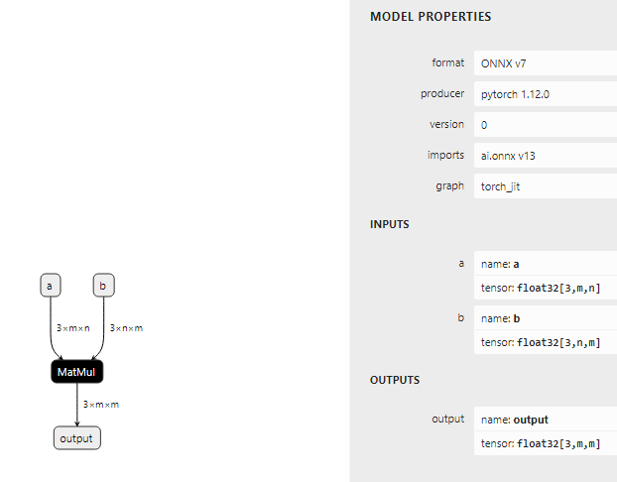
将onnx文件通过mindspore lite云测转换工具转换成mslite
converter_lite --fmk=ONNX --saveType=MINDIR --optimize=none --modelFile=bmm_dynamic.onnx --outputFile=bmm_dynamic
通过mindspore lite云测python接口进行推理
import numpy as np
import mindspore_lite as mslite
# init context, and set target is cpu
context = mslite.Context()
context.target = ["cpu"]
context.cpu.thread_num = 1
context.cpu.thread_affinity_mode=2
MODEL_PATH = "./bmm_dynamic.mindir"
model = mslite.Model()
model.build_from_file(MODEL_PATH, mslite.ModelType.MINDIR, context)
# set model input
inputs = model.get_inputs()
a_data = np.ones([3, 16, 48], dtype=np.float32)
inputs[0].set_data_from_numpy(a_data)
b_data = np.ones([3, 48, 16], dtype=np.float32)
inputs[1].set_data_from_numpy(b_data)
# execute inference
outputs = model.predict(inputs)
data = outputs[0].get_data_to_numpy()
print(data)
3. 解决方案
当输入是动态shape时（模型输入的shape的维度包含-1），必须通过 resize 把-1换成固定维度。
在inputs = model.get_inputs() 后面加上打印
print(inputs[0].shape)
print(inputs[1].shape)
得到的结果是
[3, -1, -1]
[3, -1, -1]
需要增加model.resize(inputs, [[3, 16, 48],[3, 48, 16]])，修改后代码如下：
import numpy as np
import mindspore_lite as mslite
# init context, and set target is cpu
context = mslite.Context()
context.target = ["cpu"]
context.cpu.thread_num = 1
context.cpu.thread_affinity_mode=2
MODEL_PATH = "./bmm_dynamic.mindir"
model = mslite.Model()
model.build_from_file(MODEL_PATH, mslite.ModelType.MINDIR, context)
# set model input
inputs = model.get_inputs()
print(inputs[0].shape)
print(inputs[1].shape)
model.resize(inputs, [[3, 16, 48],[3, 48, 16]])
a_data = np.ones([3, 16, 48], dtype=np.float32)
inputs[0].set_data_from_numpy(a_data)
b_data = np.ones([3, 48, 16], dtype=np.float32)
inputs[1].set_data_from_numpy(b_data)
# execute inference
outputs = model.predict(inputs)
data = outputs[0].get_data_to_numpy()
print(data)

mindyolo在ckpt模型转为ONNX模型时报错
1. 系统环境
硬件环境(Ascend/GPU/CPU): CPU
软件环境: MindSpore 版本: 2.3.1
执行模式（静态图/动态图）： 不限
Python 版本: 3.9
操作系统平台: linux
2. 报错信息
2.1 问题描述
python ./deploy/export.py --config ./configs/yolov8/yolov8n.yaml --weight yolov8-n_500e_mAP372-cc07f5bd.ckpt --per_batch_size 1 --file_format ONNX --device_target CPU，yolo v8n 转换报错。
2.2 报错信息
2024-09-27 15:47:31,563 [WARNING] Parse Model, args: nearest, keep str type
2024-09-27 15:47:32,299 [WARNING] Parse Model, args: nearest, keep str type
2024-09-27 15:47:37,168 [INFO] number of network params, total: 3.167795M, trainable: 3.157184M
[WARNING] ME(200291:139697284708160,MainProcess):2024-09-27-15:47:37.530.337 [mindspore/train/serialization.py:1658] For 'load_param_into_net', remove parameter prefix name: ema., continue to load.
2024-09-27 15:47:37,541 [INFO] Load checkpoint from [yolov8-n_500e_mAP372-cc07f5bd.ckpt] success.
Traceback (most recent call last):
File "/home/py/mindyolo/./deploy/export.py", line 84, in <module>
export_weight(args)
File "/home/py/mindyolo/./deploy/export.py", line 76, in export_weight
export(network, input_arr, file_name=file_name, file_format=args.file_format)
File "/root/miniconda3/envs/py3.9/lib/python3.9/site-packages/mindspore/train/serialization.py", line 1895, in export
_export(net, file_name, file_format, *inputs, **kwargs)
File "/root/miniconda3/envs/py3.9/lib/python3.9/site-packages/mindspore/train/serialization.py", line 1951, in _export
_save_onnx(net, file_name, *inputs, **kwargs)
File "/root/miniconda3/envs/py3.9/lib/python3.9/site-packages/mindspore/train/serialization.py", line 2008, in _save_onnx
onnx_stream = _executor._get_func_graph_proto(net, graph_id)
File "/root/miniconda3/envs/py3.9/lib/python3.9/site-packages/mindspore/common/api.py", line 1958, in _get_func_graph_proto
return self._graph_executor.get_func_graph_proto(exec_id, ir_type, incremental)
RuntimeError: i: 5 out of range: 5, cnode: @2118_2117_1_mindyolo_models_yolov8_YOLOv8_construct_37:CNode_38{[0]: ValueNode<Primitive> PrimFunc_StridedSlice, [1]: CNode_39, [2]: ValueNode<ValueTuple> (0, 0, 0), [3]: ValueNode<ValueTuple> (0, 64, 0), [4]: ValueNode<ValueTuple> (1, 1, 1)}
----------------------------------------------------
- Framework Unexpected Exception Raised:
----------------------------------------------------
This exception is caused by framework's unexpected error. Please create an issue at https://gitee.com/mindspore/mindspore/issues to get help.
----------------------------------------------------
- C++ Call Stack: (For framework developers)
----------------------------------------------------
mindspore/core/ir/anf.cc:422 input
3. 解决方案
新版本cpu支持有问题 2.3.1 硬件平台 支持上只写了Ascend，需要用mindspore 2.2.14版本。
安装mindspore 2.2.14版本后执行会报
RuntimeError: Can not find key SiLU in convert map. Exporting SiLU operator is not yet supported.
修改方法也简单，修改mindyolo/models/layers/conv.py
self.act = nn.SiLU() if act is True else (act if isinstance(act, nn.Cell) else Identity)
替换成
self.act = Swish()
导入增加
from .activation import Swish
记得有两处self.act需要改动。修改后继续导出
python ./deploy/export.py --config ./configs/yolov8/yolov8n.yaml --weight yolov8-n_500e_mAP372-cc07f5bd.ckpt --per_batch_size 1 --file_format ONNX --device_target CPU
2024-09-27 15:22:37,156 [WARNING] Parse Model, args: nearest, keep str type
2024-09-27 15:22:37,976 [WARNING] Parse Model, args: nearest, keep str type
2024-09-27 15:22:43,617 [INFO] number of network params, total: 3.167795M, trainable: 3.157184M
[WARNING] ME(189459:139720360478528,MainProcess):2024-09-27-15:22:43.968.741 [mindspore/train/serialization.py:1469] For 'load_param_into_net', remove parameter prefix name: ema., continue to load.
2024-09-27 15:22:43,978 [INFO] Load checkpoint from [yolov8-n_500e_mAP372-cc07f5bd.ckpt] success.
Traceback (most recent call last):
File "/home/py/mindyolo/./deploy/export.py", line 84, in <module>
export_weight(args)
File "/home/py/mindyolo/./deploy/export.py", line 76, in export_weight
export(network, input_arr, file_name=file_name, file_format=args.file_format)
File "/root/miniconda3/envs/py3.9/lib/python3.9/site-packages/mindspore/train/serialization.py", line 1664, in export
_export(net, file_name, file_format, *inputs, **kwargs)
File "/root/miniconda3/envs/py3.9/lib/python3.9/site-packages/mindspore/train/serialization.py", line 1718, in _export
_save_onnx(net, file_name, *inputs, **kwargs)
File "/root/miniconda3/envs/py3.9/lib/python3.9/site-packages/mindspore/train/serialization.py", line 1775, in _save_onnx
onnx_stream = _executor._get_func_graph_proto(net, graph_id)
File "/root/miniconda3/envs/py3.9/lib/python3.9/site-packages/mindspore/common/api.py", line 1667, in _get_func_graph_proto
return self._graph_executor.get_func_graph_proto(exec_id, ir_type, incremental)
RuntimeError: Can not find key FillV2 in convert map. Exporting FillV2 operator is not yet supported.
----------------------------------------------------
- C++ Call Stack: (For framework developers)
----------------------------------------------------
mindspore/ccsrc/transform/express_ir/onnx_exporter.cc:4115 ExportPrimitive
上面报错就是算子支持了。看来yolov8n不支持导出onnx。
经测试yolo5n可以正常导出。导出命令和结果如下。
python3 ./deploy/export.py --config ./configs/yolov5/yolov5n.yaml --weight yolov5n_300e_mAP273-9b16bd7b.ckpt --per_batch_size 1 --file_format ONNX --device_target CPU
2024-09-27 16:12:46,281 [WARNING] Parse Model, args: nearest, keep str type
2024-09-27 16:12:47,242 [WARNING] Parse Model, args: nearest, keep str type
2024-09-27 16:12:50,199 [INFO] number of network params, total: 1.8817M, trainable: 1.872157M
[WARNING] ME(210591:139772762715968,MainProcess):2024-09-27-16:12:50.520.379 [mindspore/train/serialization.py:1469] For 'load_param_into_net', remove parameter prefix name: ema., continue to load.
[WARNING] ME(210591:139772762715968,MainProcess):2024-09-27-16:12:50.529.926 [mindspore/train/serialization.py:1378] For 'load_param_into_net', 1 parameters in the 'net' are not loaded, because they are not in the 'parameter_dict', please check whether the network structure is consistent when training and loading checkpoint.
[WARNING] ME(210591:139772762715968,MainProcess):2024-09-27-16:12:50.530.095 [mindspore/train/serialization.py:1383] model.model.24.stride is not loaded.
2024-09-27 16:12:50,530 [INFO] Load checkpoint from [yolov5n_300e_mAP273-9b16bd7b.ckpt] success.
2024-09-27 16:12:53,600 [INFO] Export completed.

MindSpore Lite推理报错RuntimeError: data size not equal! Numpy size: 6144000, Tensor size: 0
1. 系统环境
硬件环境(Ascend/GPU/CPU): Ascend/GPU/CPU
软件环境: MindSpore 版本: 2.3.1
执行模式（静态图/动态图）： 不限
Python 版本: 3.7.6
操作系统平台: linux
2. 报错信息
2.1 问题描述
使用如下脚本进行推理出现报错。
2.2 报错信息
name: kv_cache,
dtype: DataType.FLOAT32,
shape: [48, -1, 1024, -1],
format: Format.NCHW,
element_num: 0,
data_size: 0.
device: None:-1.
2.3 脚本信息
inputs = self.ms_model.get_inputs()
inputs[1].set_data_from_numpy(xa.astype(np.float32))
inputs[2].set_data_from_numpy(kv_cache.astype(np.float32))
inputs[3].set_data_from_numpy(np.array([offset],dtype=np.int32))
inputs[0].set_data_from_numpy(x.astype(np.int32))
3. 根因分析
调用get_inputs然后进行set_data_from_numpy是lite云测推理的方法。
查看如下文档：
https://www.mindspore.cn/lite/api/zh-CN/r2.3.1/mindspore_lite/mindspore_lite.Model.html?highlight=get_inputs#mindspore_lite.Model.get_inputs
其中kv_cache的shape是[48, -1, 1024, -1]
是动态shape，因此需要调用。
inputs = model.get_inputs()
model.resize(inputs, [四个输入的shape])
4. 解决方案
在get_inputs后调用resize接口。
inputs = self.ms_model.get_inputs()
self.ms_model.resize(inputs, [四个输入的shape])
inputs[1].set_data_from_numpy(xa.astype(np.float32))
inputs[2].set_data_from_numpy(kv_cache.astype(np.float32))
inputs[3].set_data_from_numpy(np.array([offset],dtype=np.int32))
inputs[0].set_data_from_numpy(x.astype(np.int32))

使用MindSpore Lite端侧模型转换工具将YOLOv8.onnx转为.ms报错Convert failed. Ret: Common error code.
1. 系统环境
硬件环境(Ascend/GPU/CPU): Ascend
软件环境: MindSpore 版本: 2.2.10
执行模式（静态图/动态图）： 不限
Python 版本: 3.8
操作系统平台: linux
2. 报错信息
2.1 问题描述
YOLOv8训练的模型.onnx，使用MindSpore Lite端侧离线模型转换工具转为.ms报错失败。
2.2 报错信息
WARNING: Logging before InitGoogleLogging() is written to STDERR
I0905 15:58:04.880090 95696 :0] [DEBUG] CORE(95768,1,?):2024-9-5 15:58:4 [build\mindspore\merge\mindspore\core\ops_merge_4.cc:7703] Register] Reg simple infer for op MeanExt
I0905 15:58:04.880090 95696 :0] [DEBUG] CORE(95768,1,?):2024-9-5 15:58:4 [build\mindspore\merge\mindspore\core\ops_merge_4.cc:7703] Register] Reg simple infer for op Mul
I0905 15:58:04.880090 95696 :0] [DEBUG] CORE(95768,1,?):2024-9-5 15:58:4 [build\mindspore\merge\mindspore\core\ops_merge_4.cc:7703] Register] Reg simple infer for op Neg
I0905 15:58:04.880090 95696 :0] [DEBUG] CORE(95768,1,?):2024-9-5 15:58:4 [build\mindspore\merge\mindspore\core\ops_merge_4.cc:7703] Register] Reg simple infer for op NonZero
I0905 15:58:04.881093 95696 :0] [DEBUG] CORE(95768,1,?):2024-9-5 15:58:4 [build\mindspore\merge\mindspore\core\ops_merge_4.cc:7703] Register] Reg simple infer for op NonZeroExt
I0905 15:58:04.881093 95696 :0] [DEBUG] CORE(95768,1,?):2024-9-5 15:58:4 [build\mindspore\merge\mindspore\core\ops_merge_4.cc:7703] Register] Reg simple infer for op OneHotExt
I0905 15:58:04.881093 95696 :0] [DEBUG] CORE(95768,1,?):2024-9-5 15:58:4 [build\mindspore\merge\mindspore\core\ops_merge_4.cc:7703] Register] Reg simple infer for op Ones
I0905 15:58:04.881093 95696 :0] [DEBUG] CORE(95768,1,?):2024-9-5 15:58:4 [build\mindspore\merge\mindspore\core\ops_merge_4.cc:7703] Register] Reg simple infer for op OnesLikeExt
I0905 15:58:04.881093 95696 :0] [DEBUG] CORE(95768,1,?):2024-9-5 15:58:4 [build\mindspore\merge\mindspore\core\ops_merge_4.cc:7703] Register] Reg simple infer for op ProdExt
I0905 15:58:04.881093 95696 :0] [DEBUG] CORE(95768,1,?):2024-9-5 15:58:4 [build\mindspore\merge\mindspore\core\ops_merge_4.cc:7703] Register] Reg simple infer for op ReduceAll
I0905 15:58:04.881093 95696 :0] [DEBUG] CORE(95768,1,?):2024-9-5 15:58:4 [build\mindspore\merge\mindspore\core\ops_merge_4.cc:7703] Register] Reg simple infer for op ReLU
I0905 15:58:04.881093 95696 :0] [DEBUG] CORE(95768,1,?):2024-9-5 15:58:4 [build\mindspore\merge\mindspore\core\ops_merge_4.cc:7703] Register] Reg simple infer for op RepeatInterleaveGrad
I0905 15:58:04.881093 95696 :0] [DEBUG] CORE(95768,1,?):2024-9-5 15:58:4 [build\mindspore\merge\mindspore\core\ops_merge_4.cc:7703] Register] Reg simple infer for op RepeatInterleaveInt
I0905 15:58:04.881093 95696 :0] [DEBUG] CORE(95768,1,?):2024-9-5 15:58:4 [build\mindspore\merge\mindspore\core\ops_merge_4.cc:7703] Register] Reg simple infer for op RepeatInterleaveTensor
I0905 15:58:04.881093 95696 :0] [DEBUG] CORE(95768,1,?):2024-9-5 15:58:4 [build\mindspore\merge\mindspore\core\ops_merge_4.cc:7703] Register] Reg simple infer for op ReverseV2
I0905 15:58:04.881093 95696 :0] [DEBUG] CORE(95768,1,?):2024-9-5 15:58:4 [build\mindspore\merge\mindspore\core\ops_merge_4.cc:7703] Register] Reg simple infer for op Rsqrt
I0905 15:58:04.881093 95696 :0] [DEBUG] CORE(95768,1,?):2024-9-5 15:58:4 [build\mindspore\merge\mindspore\core\ops_merge_4.cc:7703] Register] Reg simple infer for op Sin
I0905 15:58:04.881093 95696 :0] [DEBUG] CORE(95768,1,?):2024-9-5 15:58:4 [build\mindspore\merge\mindspore\core\ops_merge_4.cc:7703] Register] Reg simple infer for op Softmax
I0905 15:58:04.881093 95696 :0] [DEBUG] CORE(95768,1,?):2024-9-5 15:58:4 [build\mindspore\merge\mindspore\core\ops_merge_4.cc:7703] Register] Reg simple infer for op SoftplusExt
I0905 15:58:04.881093 95696 :0] [DEBUG] CORE(95768,1,?):2024-9-5 15:58:4 [build\mindspore\merge\mindspore\core\ops_merge_4.cc:7703] Register] Reg simple infer for op SortExt
I0905 15:58:04.881093 95696 :0] [DEBUG] CORE(95768,1,?):2024-9-5 15:58:4 [build\mindspore\merge\mindspore\core\ops_merge_4.cc:7703] Register] Reg simple infer for op Sqrt
I0905 15:58:04.882090 95696 :0] [DEBUG] CORE(95768,1,?):2024-9-5 15:58:4 [build\mindspore\merge\mindspore\core\ops_merge_4.cc:7703] Register] Reg simple infer for op StackExt
I0905 15:58:04.882090 95696 :0] [DEBUG] CORE(95768,1,?):2024-9-5 15:58:4 [build\mindspore\merge\mindspore\core\ops_merge_4.cc:7703] Register] Reg simple infer for op SumExt
I0905 15:58:04.882090 95696 :0] [DEBUG] CORE(95768,1,?):2024-9-5 15:58:4 [build\mindspore\merge\mindspore\core\ops_merge_4.cc:7703] Register] Reg simple infer for op Tanh
I0905 15:58:04.882090 95696 :0] [DEBUG] CORE(95768,1,?):2024-9-5 15:58:4 [build\mindspore\merge\mindspore\core\ops_merge_4.cc:7703] Register] Reg simple infer for op TanhGrad
I0905 15:58:04.882090 95696 :0] [DEBUG] CORE(95768,1,?):2024-9-5 15:58:4 [build\mindspore\merge\mindspore\core\ops_merge_4.cc:7703] Register] Reg simple infer for op TopkExt
I0905 15:58:04.882090 95696 :0] [DEBUG] CORE(95768,1,?):2024-9-5 15:58:4 [build\mindspore\merge\mindspore\core\ops_merge_4.cc:7703] Register] Reg simple infer for op UniformExt
I0905 15:58:04.882090 95696 :0] [DEBUG] CORE(95768,1,?):2024-9-5 15:58:4 [build\mindspore\merge\mindspore\core\ops_merge_4.cc:7703] Register] Reg simple infer for op Unique2
I0905 15:58:04.882090 95696 :0] [DEBUG] CORE(95768,1,?):2024-9-5 15:58:4 [build\mindspore\merge\mindspore\core\ops_merge_4.cc:7703] Register] Reg simple infer for op UniqueDim
I0905 15:58:04.882090 95696 :0] [DEBUG] CORE(95768,1,?):2024-9-5 15:58:4 [build\mindspore\merge\mindspore\core\ops_merge_4.cc:7703] Register] Reg simple infer for op Zeros
I0905 15:58:04.882090 95696 :0] [DEBUG] CORE(95768,1,?):2024-9-5 15:58:4 [build\mindspore\merge\mindspore\core\ops_merge_4.cc:7703] Register] Reg simple infer for op ZerosLikeExt
I0905 15:58:04.882090 95696 :0] [DEBUG] CORE(95768,1,?):2024-9-5 15:58:4 [build\mindspore\merge\mindspore\core\ops_merge_4.cc:7703] Register] Reg simple infer for op ArgMaxWithValue
I0905 15:58:04.882090 95696 :0] [DEBUG] CORE(95768,1,?):2024-9-5 15:58:4 [build\mindspore\merge\mindspore\core\ops_merge_4.cc:7703] Register] Reg simple infer for op Atan2Ext
I0905 15:58:04.882090 95696 :0] [DEBUG] CORE(95768,1,?):2024-9-5 15:58:4 [build\mindspore\merge\mindspore\core\ops_merge_4.cc:7703] Register] Reg simple infer for op BatchMatMul
I0905 15:58:04.882090 95696 :0] [DEBUG] CORE(95768,1,?):2024-9-5 15:58:4 [build\mindspore\merge\mindspore\core\ops_merge_4.cc:7703] Register] Reg simple infer for op BatchNormExt
I0905 15:58:04.883090 95696 :0] [DEBUG] CORE(95768,1,?):2024-9-5 15:58:4 [build\mindspore\merge\mindspore\core\ops_merge_4.cc:7703] Register] Reg simple infer for op BinaryCrossEntropy
I0905 15:58:04.883090 95696 :0] [DEBUG] CORE(95768,1,?):2024-9-5 15:58:4 [build\mindspore\merge\mindspore\core\ops_merge_4.cc:7703] Register] Reg simple infer for op BinaryCrossEntropyGrad
I0905 15:58:04.883090 95696 :0] [DEBUG] CORE(95768,1,?):2024-9-5 15:58:4 [build\mindspore\merge\mindspore\core\ops_merge_4.cc:7703] Register] Reg simple infer for op BCEWithLogitsLoss
I0905 15:58:04.883090 95696 :0] [DEBUG] CORE(95768,1,?):2024-9-5 15:58:4 [build\mindspore\merge\mindspore\core\ops_merge_4.cc:7703] Register] Reg simple infer for op BinaryCrossEntropyWithLogitsBackward
I0905 15:58:04.883090 95696 :0] [DEBUG] CORE(95768,1,?):2024-9-5 15:58:4 [build\mindspore\merge\mindspore\core\ops_merge_4.cc:7703] Register] Reg simple infer for op BatchMatMulExt
I0905 15:58:04.883090 95696 :0] [DEBUG] CORE(95768,1,?):2024-9-5 15:58:4 [build\mindspore\merge\mindspore\core\ops_merge_4.cc:7703] Register] Reg simple infer for op Cast
I0905 15:58:04.883090 95696 :0] [DEBUG] CORE(95768,1,?):2024-9-5 15:58:4 [build\mindspore\merge\mindspore\core\ops_merge_4.cc:7703] Register] Reg simple infer for op Ceil
I0905 15:58:04.883090 95696 :0] [DEBUG] CORE(95768,1,?):2024-9-5 15:58:4 [build\mindspore\merge\mindspore\core\ops_merge_4.cc:7703] Register] Reg simple infer for op ClampScalar
I0905 15:58:04.883090 95696 :0] [DEBUG] CORE(95768,1,?):2024-9-5 15:58:4 [build\mindspore\merge\mindspore\core\ops_merge_4.cc:7703] Register] Reg simple infer for op ClampTensor
I0905 15:58:04.883090 95696 :0] [DEBUG] CORE(95768,1,?):2024-9-5 15:58:4 [build\mindspore\merge\mindspore\core\ops_merge_4.cc:7703] Register] Reg simple infer for op Cos
I0905 15:58:04.883090 95696 :0] [DEBUG] CORE(95768,1,?):2024-9-5 15:58:4 [build\mindspore\merge\mindspore\core\ops_merge_4.cc:7703] Register] Reg simple infer for op Dense
I0905 15:58:04.883090 95696 :0] [DEBUG] CORE(95768,1,?):2024-9-5 15:58:4 [build\mindspore\merge\mindspore\core\ops_merge_4.cc:7703] Register] Reg simple infer for op Div
I0905 15:58:04.883090 95696 :0] [DEBUG] CORE(95768,1,?):2024-9-5 15:58:4 [build\mindspore\merge\mindspore\core\ops_merge_4.cc:7703] Register] Reg simple infer for op DivMod
I0905 15:58:04.883090 95696 :0] [DEBUG] CORE(95768,1,?):2024-9-5 15:58:4 [build\mindspore\merge\mindspore\core\ops_merge_4.cc:7703] Register] Reg simple infer for op EluExt
I0905 15:58:04.883090 95696 :0] [DEBUG] CORE(95768,1,?):2024-9-5 15:58:4 [build\mindspore\merge\mindspore\core\ops_merge_4.cc:7703] Register] Reg simple infer for op EluGradExt
I0905 15:58:04.883090 95696 :0] [DEBUG] CORE(95768,1,?):2024-9-5 15:58:4 [build\mindspore\merge\mindspore\core\ops_merge_4.cc:7703] Register] Reg simple infer for op Erf
I0905 15:58:04.883090 95696 :0] [DEBUG] CORE(95768,1,?):2024-9-5 15:58:4 [build\mindspore\merge\mindspore\core\ops_merge_4.cc:7703] Register] Reg simple infer for op Erfinv
I0905 15:58:04.884090 95696 :0] [DEBUG] CORE(95768,1,?):2024-9-5 15:58:4 [build\mindspore\merge\mindspore\core\ops_merge_4.cc:7703] Register] Reg simple infer for op Eye
I0905 15:58:04.884090 95696 :0] [DEBUG] CORE(95768,1,?):2024-9-5 15:58:4 [build\mindspore\merge\mindspore\core\ops_merge_4.cc:7703] Register] Reg simple infer for op FlattenExt
I0905 15:58:04.884090 95696 :0] [DEBUG] CORE(95768,1,?):2024-9-5 15:58:4 [build\mindspore\merge\mindspore\core\ops_merge_4.cc:7703] Register] Reg simple infer for op Floor
I0905 15:58:04.884090 95696 :0] [DEBUG] CORE(95768,1,?):2024-9-5 15:58:4 [build\mindspore\merge\mindspore\core\ops_merge_4.cc:7703] Register] Reg simple infer for op GeLU
I0905 15:58:04.884090 95696 :0] [DEBUG] CORE(95768,1,?):2024-9-5 15:58:4 [build\mindspore\merge\mindspore\core\ops_merge_4.cc:7703] Register] Reg simple infer for op Generator
I0905 15:58:04.884090 95696 :0] [DEBUG] CORE(95768,1,?):2024-9-5 15:58:4 [build\mindspore\merge\mindspore\core\ops_merge_4.cc:7703] Register] Reg simple infer for op Greater
I0905 15:58:04.884090 95696 :0] [DEBUG] CORE(95768,1,?):2024-9-5 15:58:4 [build\mindspore\merge\mindspore\core\ops_merge_4.cc:7703] Register] Reg simple infer for op GreaterEqual
I0905 15:58:04.884090 95696 :0] [DEBUG] CORE(95768,1,?):2024-9-5 15:58:4 [build\mindspore\merge\mindspore\core\ops_merge_4.cc:7703] Register] Reg simple infer for op GroupNorm
I0905 15:58:04.884090 95696 :0] [DEBUG] CORE(95768,1,?):2024-9-5 15:58:4 [build\mindspore\merge\mindspore\core\ops_merge_4.cc:7703] Register] Reg simple infer for op Im2ColExt
I0905 15:58:04.884090 95696 :0] [DEBUG] CORE(95768,1,?):2024-9-5 15:58:4 [build\mindspore\merge\mindspore\core\ops_merge_4.cc:7703] Register] Reg simple infer for op Col2ImGrad
I0905 15:58:04.884090 95696 :0] [DEBUG] CORE(95768,1,?):2024-9-5 15:58:4 [build\mindspore\merge\mindspore\core\ops_merge_4.cc:7703] Register] Reg simple infer for op Col2ImExt
I0905 15:58:04.884090 95696 :0] [DEBUG] CORE(95768,1,?):2024-9-5 15:58:4 [build\mindspore\merge\mindspore\core\ops_merge_4.cc:7703] Register] Reg simple infer for op IsFinite
I0905 15:58:04.884090 95696 :0] [DEBUG] CORE(95768,1,?):2024-9-5 15:58:4 [build\mindspore\merge\mindspore\core\ops_merge_4.cc:7703] Register] Reg simple infer for op LayerNormExt
I0905 15:58:04.884090 95696 :0] [DEBUG] CORE(95768,1,?):2024-9-5 15:58:4 [build\mindspore\merge\mindspore\core\ops_merge_4.cc:7703] Register] Reg simple infer for op LeakyReLUExt
I0905 15:58:04.884090 95696 :0] [DEBUG] CORE(95768,1,?):2024-9-5 15:58:4 [build\mindspore\merge\mindspore\core\ops_merge_4.cc:7703] Register] Reg simple infer for op LeakyReLUGradExt
I0905 15:58:04.884090 95696 :0] [DEBUG] CORE(95768,1,?):2024-9-5 15:58:4 [build\mindspore\merge\mindspore\core\ops_merge_4.cc:7703] Register] Reg simple infer for op Less
I0905 15:58:04.884090 95696 :0] [DEBUG] CORE(95768,1,?):2024-9-5 15:58:4 [build\mindspore\merge\mindspore\core\ops_merge_4.cc:7703] Register] Reg simple infer for op LessEqual
I0905 15:58:04.884090 95696 :0] [DEBUG] CORE(95768,1,?):2024-9-5 15:58:4 [build\mindspore\merge\mindspore\core\ops_merge_4.cc:7703] Register] Reg simple infer for op Log
I0905 15:58:04.885092 95696 :0] [DEBUG] CORE(95768,1,?):2024-9-5 15:58:4 [build\mindspore\merge\mindspore\core\ops_merge_4.cc:7703] Register] Reg simple infer for op LogicalAnd
I0905 15:58:04.885092 95696 :0] [DEBUG] CORE(95768,1,?):2024-9-5 15:58:4 [build\mindspore\merge\mindspore\core\ops_merge_4.cc:7703] Register] Reg simple infer for op LogicalNot
I0905 15:58:04.885092 95696 :0] [DEBUG] CORE(95768,1,?):2024-9-5 15:58:4 [build\mindspore\merge\mindspore\core\ops_merge_4.cc:7703] Register] Reg simple infer for op LogicalOr
I0905 15:58:04.885092 95696 :0] [DEBUG] CORE(95768,1,?):2024-9-5 15:58:4 [build\mindspore\merge\mindspore\core\ops_merge_4.cc:7703] Register] Reg simple infer for op MatMul
I0905 15:58:04.885092 95696 :0] [DEBUG] CORE(95768,1,?):2024-9-5 15:58:4 [build\mindspore\merge\mindspore\core\ops_merge_4.cc:7703] Register] Reg simple infer for op MatMulExt
I0905 15:58:04.885092 95696 :0] [DEBUG] CORE(95768,1,?):2024-9-5 15:58:4 [build\mindspore\merge\mindspore\core\ops_merge_4.cc:7703] Register] Reg simple infer for op MatrixInverseExt
I0905 15:58:04.885092 95696 :0] [DEBUG] CORE(95768,1,?):2024-9-5 15:58:4 [build\mindspore\merge\mindspore\core\ops_merge_4.cc:7703] Register] Reg simple infer for op Max
I0905 15:58:04.885092 95696 :0] [DEBUG] CORE(95768,1,?):2024-9-5 15:58:4 [build\mindspore\merge\mindspore\core\ops_merge_4.cc:7703] Register] Reg simple infer for op Min
I0905 15:58:04.885092 95696 :0] [DEBUG] CORE(95768,1,?):2024-9-5 15:58:4 [build\mindspore\merge\mindspore\core\ops_merge_4.cc:7703] Register] Reg simple infer for op Addmm
I0905 15:58:04.885092 95696 :0] [DEBUG] CORE(95768,1,?):2024-9-5 15:58:4 [build\mindspore\merge\mindspore\core\ops_merge_4.cc:7703] Register] Reg simple infer for op Arange
[WARNING] LITE(95768,1,?):2024-9-5 15:58:4 [build\mindspore\tools\converter\parser\onnx\onnx_op_parser.cc:5856] CheckOnnxModel] Cannot find input: of node: /model.10/Resize
[WARNING] LITE(95768,1,?):2024-9-5 15:58:4 [build\mindspore\tools\converter\parser\onnx\onnx_op_parser.cc:5856] CheckOnnxModel] Cannot find input: of node: /model.13/Resize
[WARNING] LITE(95768,1,?):2024-9-5 15:58:5 [mindspore\lite\src\litert\infer_manager.cc:153] CheckInfershapeResult] Unexpected input format 0
[WARNING] LITE(95768,1,?):2024-9-5 15:58:5 [mindspore\lite\tools\optimizer\graph\node_infershape.cc:294] InferShapeByNNACL] InferShapeByNNACL for op: /model.22/dfl/conv/Conv failed.
[WARNING] LITE(95768,1,?):2024-9-5 15:58:5 [mindspore\lite\tools\optimizer\graph\infershape_pass.cc:314] InferProcess] node infer shape failed, node is /model.22/dfl/conv/Conv
[WARNING] LITE(95768,1,?):2024-9-5 15:58:5 [mindspore\lite\tools\optimizer\graph\infershape_pass.cc:189] Run] infer shape failed.
[WARNING] LITE(95768,1,?):2024-9-5 15:58:5 [mindspore/lite/tools/optimizer/const_fold/constant_folding_fusion.h:48] Run] Do constant fold failed.
[WARNING] LITE(95768,1,?):2024-9-5 15:58:5 [mindspore\lite\src\litert\infer_manager.cc:153] CheckInfershapeResult] Unexpected input format 0
[WARNING] LITE(95768,1,?):2024-9-5 15:58:5 [mindspore\lite\tools\optimizer\graph\node_infershape.cc:294] InferShapeByNNACL] InferShapeByNNACL for op: /model.22/dfl/conv/Conv failed.
[WARNING] LITE(95768,1,?):2024-9-5 15:58:5 [mindspore\lite\tools\optimizer\graph\infershape_pass.cc:314] InferProcess] node infer shape failed, node is /model.22/dfl/conv/Conv
[WARNING] LITE(95768,1,?):2024-9-5 15:58:5 [mindspore\lite\tools\optimizer\graph\infershape_pass.cc:189] Run] infer shape failed.
[WARNING] LITE(95768,1,?):2024-9-5 15:58:5 [mindspore/lite/tools/optimizer/const_fold/constant_folding_fusion.h:48] Run] Do constant fold failed.
[WARNING] LITE(95768,1,?):2024-9-5 15:58:5 [mindspore\lite\src\litert\infer_manager.cc:153] CheckInfershapeResult] Unexpected input format 0
[WARNING] LITE(95768,1,?):2024-9-5 15:58:5 [mindspore\lite\tools\optimizer\graph\node_infershape.cc:294] InferShapeByNNACL] InferShapeByNNACL for op: /model.22/dfl/conv/Conv failed.
[WARNING] LITE(95768,1,?):2024-9-5 15:58:5 [mindspore\lite\tools\optimizer\graph\infershape_pass.cc:314] InferProcess] node infer shape failed, node is /model.22/dfl/conv/Conv
[WARNING] LITE(95768,1,?):2024-9-5 15:58:5 [mindspore\lite\tools\optimizer\graph\infershape_pass.cc:189] Run] infer shape failed.
[WARNING] LITE(95768,1,?):2024-9-5 15:58:5 [mindspore/lite/tools/optimizer/const_fold/constant_folding_fusion.h:48] Run] Do constant fold failed.
[WARNING] LITE(95768,1,?):2024-9-5 15:58:5 [mindspore\lite\src\litert\infer_manager.cc:153] CheckInfershapeResult] Unexpected input format 0
[WARNING] LITE(95768,1,?):2024-9-5 15:58:5 [mindspore\lite\tools\optimizer\graph\node_infershape.cc:294] InferShapeByNNACL] InferShapeByNNACL for op: /model.22/dfl/conv/Conv failed.
[WARNING] LITE(95768,1,?):2024-9-5 15:58:5 [mindspore\lite\tools\optimizer\graph\infershape_pass.cc:314] InferProcess] node infer shape failed, node is /model.22/dfl/conv/Conv
[WARNING] LITE(95768,1,?):2024-9-5 15:58:5 [mindspore\lite\tools\optimizer\graph\infershape_pass.cc:189] Run] infer shape failed.
[WARNING] LITE(95768,1,?):2024-9-5 15:58:5 [mindspore/lite/tools/optimizer/const_fold/constant_folding_fusion.h:48] Run] Do constant fold failed.
[WARNING] LITE(95768,1,?):2024-9-5 15:58:5 [mindspore\lite\src\litert\infer_manager.cc:153] CheckInfershapeResult] Unexpected input format 0
[WARNING] LITE(95768,1,?):2024-9-5 15:58:5 [mindspore\lite\tools\optimizer\graph\node_infershape.cc:294] InferShapeByNNACL] InferShapeByNNACL for op: /model.22/dfl/conv/Conv failed.
[WARNING] LITE(95768,1,?):2024-9-5 15:58:5 [mindspore\lite\tools\optimizer\graph\infershape_pass.cc:314] InferProcess] node infer shape failed, node is /model.22/dfl/conv/Conv
[WARNING] LITE(95768,1,?):2024-9-5 15:58:5 [mindspore\lite\tools\optimizer\graph\infershape_pass.cc:189] Run] infer shape failed.
[WARNING] LITE(95768,1,?):2024-9-5 15:58:5 [mindspore/lite/tools/optimizer/const_fold/constant_folding_fusion.h:48] Run] Do constant fold failed.
[WARNING] LITE(95768,1,?):2024-9-5 15:58:5 [mindspore\lite\src\litert\infer_manager.cc:153] CheckInfershapeResult] Unexpected input format 0
[WARNING] LITE(95768,1,?):2024-9-5 15:58:5 [mindspore\lite\tools\optimizer\graph\node_infershape.cc:294] InferShapeByNNACL] InferShapeByNNACL for op: /model.22/dfl/conv/Conv failed.
[WARNING] LITE(95768,1,?):2024-9-5 15:58:5 [mindspore\lite\tools\optimizer\graph\infershape_pass.cc:314] InferProcess] node infer shape failed, node is /model.22/dfl/conv/Conv
[WARNING] LITE(95768,1,?):2024-9-5 15:58:5 [mindspore\lite\tools\optimizer\graph\infershape_pass.cc:189] Run] infer shape failed.
[WARNING] LITE(95768,1,?):2024-9-5 15:58:5 [mindspore/lite/tools/optimizer/const_fold/constant_folding_fusion.h:48] Run] Do constant fold failed.
[WARNING] LITE(95768,1,?):2024-9-5 15:58:5 [mindspore\lite\src\litert\infer_manager.cc:153] CheckInfershapeResult] Unexpected input format 0
[WARNING] LITE(95768,1,?):2024-9-5 15:58:5 [mindspore\lite\tools\optimizer\graph\node_infershape.cc:294] InferShapeByNNACL] InferShapeByNNACL for op: /model.22/dfl/conv/Conv failed.
[WARNING] LITE(95768,1,?):2024-9-5 15:58:5 [mindspore\lite\tools\optimizer\graph\infershape_pass.cc:314] InferProcess] node infer shape failed, node is /model.22/dfl/conv/Conv
[WARNING] LITE(95768,1,?):2024-9-5 15:58:5 [mindspore\lite\tools\optimizer\graph\infershape_pass.cc:189] Run] infer shape failed.
[WARNING] LITE(95768,1,?):2024-9-5 15:58:5 [mindspore/lite/tools/optimizer/const_fold/constant_folding_fusion.h:48] Run] Do constant fold failed.
[WARNING] LITE(95768,1,?):2024-9-5 15:58:5 [mindspore\lite\src\litert\infer_manager.cc:153] CheckInfershapeResult] Unexpected input format 0
[WARNING] LITE(95768,1,?):2024-9-5 15:58:5 [mindspore\lite\tools\optimizer\graph\node_infershape.cc:294] InferShapeByNNACL] InferShapeByNNACL for op: /model.22/dfl/conv/Conv failed.
[WARNING] LITE(95768,1,?):2024-9-5 15:58:5 [mindspore\lite\tools\optimizer\graph\infershape_pass.cc:314] InferProcess] node infer shape failed, node is /model.22/dfl/conv/Conv
[WARNING] LITE(95768,1,?):2024-9-5 15:58:5 [mindspore\lite\tools\optimizer\graph\infershape_pass.cc:189] Run] infer shape failed.
[WARNING] LITE(95768,1,?):2024-9-5 15:58:5 [mindspore/lite/tools/optimizer/const_fold/constant_folding_fusion.h:48] Run] Do constant fold failed.
[WARNING] LITE(95768,1,?):2024-9-5 15:58:5 [mindspore\lite\src\litert\infer_manager.cc:153] CheckInfershapeResult] Unexpected input format 0
[WARNING] LITE(95768,1,?):2024-9-5 15:58:5 [mindspore\lite\tools\optimizer\graph\node_infershape.cc:294] InferShapeByNNACL] InferShapeByNNACL for op: /model.22/dfl/conv/Conv failed.
[WARNING] LITE(95768,1,?):2024-9-5 15:58:5 [mindspore\lite\tools\optimizer\graph\infershape_pass.cc:314] InferProcess] node infer shape failed, node is /model.22/dfl/conv/Conv
[WARNING] LITE(95768,1,?):2024-9-5 15:58:5 [mindspore\lite\tools\optimizer\graph\infershape_pass.cc:189] Run] infer shape failed.
[WARNING] LITE(95768,1,?):2024-9-5 15:58:5 [mindspore/lite/tools/optimizer/const_fold/constant_folding_fusion.h:48] Run] Do constant fold failed.
[WARNING] LITE(95768,1,?):2024-9-5 15:58:5 [mindspore\lite\src\litert\infer_manager.cc:153] CheckInfershapeResult] Unexpected input format 0
[WARNING] LITE(95768,1,?):2024-9-5 15:58:5 [mindspore\lite\tools\optimizer\graph\node_infershape.cc:294] InferShapeByNNACL] InferShapeByNNACL for op: /model.22/dfl/conv/Conv failed.
[WARNING] LITE(95768,1,?):2024-9-5 15:58:5 [mindspore\lite\tools\optimizer\graph\infershape_pass.cc:314] InferProcess] node infer shape failed, node is /model.22/dfl/conv/Conv
[WARNING] LITE(95768,1,?):2024-9-5 15:58:5 [mindspore\lite\tools\optimizer\graph\infershape_pass.cc:189] Run] infer shape failed.
[WARNING] LITE(95768,1,?):2024-9-5 15:58:5 [mindspore/lite/tools/optimizer/const_fold/constant_folding_fusion.h:48] Run] Do constant fold failed.
[WARNING] LITE(95768,1,?):2024-9-5 15:58:5 [mindspore\lite\src\litert\infer_manager.cc:153] CheckInfershapeResult] Unexpected input format 0
[WARNING] LITE(95768,1,?):2024-9-5 15:58:5 [mindspore\lite\tools\optimizer\graph\node_infershape.cc:294] InferShapeByNNACL] InferShapeByNNACL for op: /model.22/dfl/conv/Conv failed.
[WARNING] LITE(95768,1,?):2024-9-5 15:58:5 [mindspore\lite\tools\optimizer\graph\infershape_pass.cc:314] InferProcess] node infer shape failed, node is /model.22/dfl/conv/Conv
[WARNING] LITE(95768,1,?):2024-9-5 15:58:5 [mindspore\lite\tools\optimizer\graph\infershape_pass.cc:189] Run] infer shape failed.
[WARNING] LITE(95768,1,?):2024-9-5 15:58:5 [mindspore/lite/tools/optimizer/const_fold/constant_folding_fusion.h:48] Run] Do constant fold failed.
[WARNING] LITE(95768,1,?):2024-9-5 15:58:5 [mindspore\lite\src\litert\infer_manager.cc:153] CheckInfershapeResult] Unexpected input format 0
[WARNING] LITE(95768,1,?):2024-9-5 15:58:5 [mindspore\lite\tools\optimizer\graph\node_infershape.cc:294] InferShapeByNNACL] InferShapeByNNACL for op: /model.22/dfl/conv/Conv failed.
[WARNING] LITE(95768,1,?):2024-9-5 15:58:5 [mindspore\lite\tools\optimizer\graph\infershape_pass.cc:314] InferProcess] node infer shape failed, node is /model.22/dfl/conv/Conv
[WARNING] LITE(95768,1,?):2024-9-5 15:58:5 [mindspore\lite\tools\optimizer\graph\infershape_pass.cc:189] Run] infer shape failed.
[WARNING] LITE(95768,1,?):2024-9-5 15:58:5 [mindspore/lite/tools/optimizer/const_fold/constant_folding_fusion.h:48] Run] Do constant fold failed.
[WARNING] LITE(95768,1,?):2024-9-5 15:58:5 [mindspore\lite\src\litert\infer_manager.cc:153] CheckInfershapeResult] Unexpected input format 0
[WARNING] LITE(95768,1,?):2024-9-5 15:58:5 [mindspore\lite\tools\optimizer\graph\node_infershape.cc:294] InferShapeByNNACL] InferShapeByNNACL for op: /model.22/dfl/conv/Conv failed.
[WARNING] LITE(95768,1,?):2024-9-5 15:58:5 [mindspore\lite\tools\optimizer\graph\infershape_pass.cc:314] InferProcess] node infer shape failed, node is /model.22/dfl/conv/Conv
[WARNING] LITE(95768,1,?):2024-9-5 15:58:5 [mindspore\lite\tools\optimizer\graph\infershape_pass.cc:189] Run] infer shape failed.
[WARNING] LITE(95768,1,?):2024-9-5 15:58:5 [mindspore/lite/tools/optimizer/const_fold/constant_folding_fusion.h:48] Run] Do constant fold failed.
[WARNING] LITE(95768,1,?):2024-9-5 15:58:5 [mindspore\lite\src\litert\infer_manager.cc:153] CheckInfershapeResult] Unexpected input format 0
[WARNING] LITE(95768,1,?):2024-9-5 15:58:5 [mindspore\lite\tools\optimizer\graph\node_infershape.cc:294] InferShapeByNNACL] InferShapeByNNACL for op: /model.22/dfl/conv/Conv failed.
[WARNING] LITE(95768,1,?):2024-9-5 15:58:5 [mindspore\lite\tools\optimizer\graph\infershape_pass.cc:314] InferProcess] node infer shape failed, node is /model.22/dfl/conv/Conv
[WARNING] LITE(95768,1,?):2024-9-5 15:58:5 [mindspore\lite\tools\optimizer\graph\infershape_pass.cc:189] Run] infer shape failed.
[WARNING] LITE(95768,1,?):2024-9-5 15:58:5 [mindspore\lite\src\litert\infer_manager.cc:153] CheckInfershapeResult] Unexpected input format 0
[WARNING] LITE(95768,1,?):2024-9-5 15:58:5 [mindspore\lite\tools\optimizer\graph\node_infershape.cc:294] InferShapeByNNACL] InferShapeByNNACL for op: /model.22/dfl/conv/Conv failed.
[WARNING] LITE(95768,1,?):2024-9-5 15:58:5 [mindspore\lite\tools\optimizer\graph\infershape_pass.cc:314] InferProcess] node infer shape failed, node is /model.22/dfl/conv/Conv
[WARNING] LITE(95768,1,?):2024-9-5 15:58:5 [mindspore\lite\tools\optimizer\graph\infershape_pass.cc:189] Run] infer shape failed.
[WARNING] LITE(95768,1,?):2024-9-5 15:58:5 [mindspore\lite\src\litert\infer_manager.cc:153] CheckInfershapeResult] Unexpected input format 0
[WARNING] LITE(95768,1,?):2024-9-5 15:58:5 [mindspore\lite\tools\converter\legacy_optimizer\graph\infershape_pass.cc:629] InferSubgraph] InferShape failed, name: /model.22/dfl/conv/Conv, type: Conv2DFusion
[ERROR] LITE(95768,1,?):2024-9-5 15:58:5 [mindspore\lite\tools\converter\legacy_optimizer\graph\infershape_pass.cc:646] Run] InferSubgraph index: 0 failed, ret: -500
[ERROR] LITE(95768,1,?):2024-9-5 15:58:5 [mindspore\lite\tools\converter\optimizer.cc:78] Run] Run GraphPass failed
[ERROR] LITE(95768,1,?):2024-9-5 15:58:5 [mindspore\lite\tools\converter\graphdef_transform.cc:71] QuantTransform] Run quant_node_optimizer graphPasses Failed
[ERROR] LITE(95768,1,?):2024-9-5 15:58:5 [mindspore\lite\tools\converter\converter_metagraph.cc:102] Build] Transform meta graph failed -500
[ERROR] LITE(95768,1,?):2024-9-5 15:58:5 [mindspore\lite\tools\converter\converter.cc:1243] SaveGraph] Convert to meta graph failed
[ERROR] LITE(95768,1,?):2024-9-5 15:58:5 [mindspore\lite\tools\converter\converter.cc:1196] HandleGraphCommon] Save graph failed: -1 Common error code.
[ERROR] LITE(95768,1,?):2024-9-5 15:58:5 [mindspore\lite\tools\converter\converter.cc:1136] Convert] Handle graph failed: -1 Common error code.
[ERROR] LITE(95768,1,?):2024-9-5 15:58:5 [mindspore\lite\tools\converter\converter.cc:1328] RunConverter] Convert model failed
[ERROR] LITE(95768,1,?):2024-9-5 15:58:5 [mindspore\lite\tools\converter\cxx_api\converter.cc:374] Convert] Convert model failed, ret=Common error code.
ERROR [mindspore\lite\tools\converter\converter_lite\main.cc:104] main] Convert failed. Ret: Common error code.
Convert failed. Ret: Common error code.
2.3 执行命令
.\converter\converter_lite --fmk=ONNX --modelFile=best.onnx --outputFile=base
3. 根因分析
端侧算子支持有限。
4. 解决方案
saveType 修改为 MINDIR，执行如下命令。
.\converter\converter_lite --fmk=ONNX --modelFile=best.onnx --outputFile=base --saveType=MINDIR

模型推理报错ValueError: For BatchMatMul, inputs shape cannot be broadcast on CPU/GPU.
1. 系统环境
硬件环境(Ascend/GPU/CPU): Ascend/GPU/CPU
软件环境: MindSpore 版本: 2.2.0
执行模式（静态图/动态图）： 静态图
Python 版本: 3.7
操作系统平台: linux
2. 报错信息
2.1 问题描述
当
2.2 报错信息
2023-12-14 18:03:45,101 - mindformers[mindformers/auto_class.py:704] - INFO - Config in the yaml file /home/ma-user/work/model_save/llama2/llama2_7b.yaml are used for tokenizer building.
2023-12-14 18:03:45,141 - mindformers[mindformers/auto_class.py:711] - INFO - Load the tokenizer name LlamaTokenizer from the /home/ma-user/work/model_save/llama2
2023-12-14 18:03:45,142 - mindformers[mindformers/models/base_tokenizer.py:1979] - INFO - config in the yaml file /home/ma-user/work/model_save/llama2/llama2_7b.yaml are used for tokenizer building.
2023-12-14 18:03:45,332 - mindformers[mindformers/models/base_tokenizer.py:1988] - WARNING - Can't find the tokenizer_config.json in the file_dict. The content of file_dict is : {}
2023-12-14 18:03:45,333 - mindformers[mindformers/models/base_tokenizer.py:1995] - INFO - build tokenizer class name is: LlamaTokenizer using args {'unk_token': '<unk>', 'bos_token': '<s>', 'eos_token': '</s>', 'pad_token': '<unk>', 'vocab_file': '/home/ma-user/work/model_save/llama2/tokenizer.model'}.
2023-12-14 18:03:45,353 - mindformers[mindformers/auto_class.py:790] - INFO - LlamaTokenizer Tokenizer built successfully!
2023-12-14 18:03:45,392 - mindformers[mindformers/auto_class.py:368] - INFO - model config: /home/ma-user/work/model_save/llama2/llama2_7b.yaml and checkpoint_name_or_path: /home/ma-user/work/model_save/llama2/llama2_7b.ckpt are used for model building.
2023-12-14 18:03:45,393 - mindformers[mindformers/version_control.py:33] - INFO - The Cell Reuse compilation acceleration feature is not supported when the environment variable ENABLE_CELL_REUSE is 0 or MindSpore version is earlier than 2.1.0 or stand_alone mode or pipeline_stages <= 1
2023-12-14 18:03:45,393 - mindformers[mindformers/version_control.py:37] - INFO -
The current ENABLE_CELL_REUSE=0, please set the environment variable as follows:
export ENABLE_CELL_REUSE=1 to enable the Cell Reuse compilation acceleration feature.
2023-12-14 18:03:45,393 - mindformers[mindformers/version_control.py:43] - INFO - The Cell Reuse compilation acceleration feature does not support single-card mode.This feature is disabled by default. ENABLE_CELL_REUSE=1 does not take effect.
2023-12-14 18:03:45,393 - mindformers[mindformers/version_control.py:46] - INFO - The Cell Reuse compilation acceleration feature only works in pipeline parallel mode(pipeline_stage>1).Current pipeline stage=1, the feature is disabled by default.
2023-12-14 18:05:42,907 - mindformers[mindformers/models/base_model.py:115] - INFO - weights in /home/ma-user/work/model_save/llama2/llama2_7b.ckpt are loaded
2023-12-14 18:05:42,911 - mindformers[mindformers/auto_class.py:453] - INFO - model built successfully!
2023-12-14 18:05:44,344 - mindformers[mindformers/auto_class.py:125] - INFO - the content in /home/ma-user/work/model_save/llama2/llama2_7b.yaml is used for config building.
2023-12-14 18:05:44,345 - mindformers[mindformers/version_control.py:33] - INFO - The Cell Reuse compilation acceleration feature is not supported when the environment variable ENABLE_CELL_REUSE is 0 or MindSpore version is earlier than 2.1.0 or stand_alone mode or pipeline_stages <= 1
2023-12-14 18:05:44,345 - mindformers[mindformers/version_control.py:37] - INFO -
The current ENABLE_CELL_REUSE=0, please set the environment variable as follows:
export ENABLE_CELL_REUSE=1 to enable the Cell Reuse compilation acceleration feature.
2023-12-14 18:05:44,345 - mindformers[mindformers/version_control.py:43] - INFO - The Cell Reuse compilation acceleration feature does not support single-card mode.This feature is disabled by default. ENABLE_CELL_REUSE=1 does not take effect.
2023-12-14 18:05:44,345 - mindformers[mindformers/version_control.py:46] - INFO - The Cell Reuse compilation acceleration feature only works in pipeline parallel mode(pipeline_stage>1).Current pipeline stage=1, the feature is disabled by default.
2023-12-14 18:06:54,088 - mindformers[mindformers/tools/download_tools.py:71] - ERROR - Connect error, please download https://ascend-repo-modelzoo.obs.cn-east-2.myhuaweicloud.com/MindFormers/llama2/llama2_7b.ckpt to ./checkpoint_download/llama2/llama2_7b.ckpt.
2023-12-14 18:06:54,089 - mindformers[mindformers/models/base_model.py:106] - INFO - checkpoint download failed, and pretrained weights are unloaded.
2023-12-14 18:06:54,089 - mindformers[mindformers/auto_class.py:292] - INFO - model built successfully!
2023-12-14 18:06:54,138 - mindformers[mindformers/generation/text_generator.py:1097] - INFO - Generation Config is: {'max_length': 512, 'max_new_tokens': 30, 'num_beams': 1, 'do_sample': False, 'use_past': True, 'temperature': 1.0, 'top_k': 0, 'top_p': 1.0, 'repetition_penalty': 1, 'encoder_repetition_penalty': 1.0, 'renormalize_logits': False, 'pad_token_id': 0, 'bos_token_id': 1, 'eos_token_id': 2, '_from_model_config': True}
2023-12-14 18:06:54,138 - mindformers[mindformers/generation/text_generator.py:176] - INFO - The generation mode will be **GREEDY_SEARCH**.
[WARNING] UTILS(2539493,ffff98fd9b70,python):2023-12-14-18:07:03.679.634 [mindspore/ccsrc/utils/comm_manager.cc:80] GetInstance] CommManager instance for CPU not found, return default instance.
Traceback (most recent call last):
File "/home/ma-user/work/mindformers/for_test.py", line 20, in <module>
outputs = model.generate(inputs, max_new_tokens=30, do_sample=False)
File "/home/ma-user/work/mindformers/mindformers/generation/text_generator.py", line 1114, in generate
output_ids = self._greedy_search(
File "/home/ma-user/work/mindformers/mindformers/generation/text_generator.py", line 394, in _greedy_search
res = self._incremental_infer(
File "/home/ma-user/work/mindformers/mindformers/generation/text_generator.py", line 225, in _incremental_infer
res = self(
File "/home/ma-user/.conda/envs/mindformer/lib/python3.9/site-packages/mindspore/nn/cell.py", line 680, in __call__
out = self.compile_and_run(*args, **kwargs)
File "/home/ma-user/.conda/envs/mindformer/lib/python3.9/site-packages/mindspore/nn/cell.py", line 1020, in compile_and_run
self.compile(*args, **kwargs)
File "/home/ma-user/.conda/envs/mindformer/lib/python3.9/site-packages/mindspore/nn/cell.py", line 997, in compile
_cell_graph_executor.compile(self, phase=self.phase,
File "/home/ma-user/.conda/envs/mindformer/lib/python3.9/site-packages/mindspore/common/api.py", line 1547, in compile
result = self._graph_executor.compile(obj, args, kwargs, phase, self._use_vm_mode())
ValueError: For BatchMatMul, inputs shape cannot be broadcast on CPU/GPU, with x shape [const vector]{1, 32, 4096, 128}, y shape [const vector]{128, 128}
----------------------------------------------------
- C++ Call Stack: (For framework developers)
----------------------------------------------------
mindspore/core/ops/batch_matmul.cc:119 CheckBatchMatmulInputWhetherCanBeBroadcast
----------------------------------------------------
- The Traceback of Net Construct Code:
----------------------------------------------------
# 0 In file /home/ma-user/work/mindformers/mindformers/models/llama/llama.py:379
if self.use_past:
# 1 In file /home/ma-user/work/mindformers/mindformers/models/llama/llama.py:380
if not isinstance(init_reset, Tensor):
# 2 In file /home/ma-user/work/mindformers/mindformers/models/llama/llama.py:384
if self.training:
# 3 In file /home/ma-user/work/mindformers/mindformers/models/llama/llama.py:387
tokens = input_ids
^
# 4 In file /home/ma-user/work/mindformers/mindformers/models/llama/llama.py:402
if not self.training:
# 5 In file /home/ma-user/work/mindformers/mindformers/models/llama/llama.py:407
if (not self.use_past or self.is_first_iteration) and input_position is not None:
^
# 6 In file /home/ma-user/work/mindformers/mindformers/models/llama/llama.py:389
output = self.model(tokens, input_position, init_reset, batch_valid_length)
^
# 7 In file /home/ma-user/work/mindformers/mindformers/models/llama/llama.py:229
if self.is_first_iteration:
# 8 In file /home/ma-user/work/mindformers/mindformers/models/llama/llama.py:230
freqs_cis = (self.tile(self.reshape(self.freqs_cos, (1, 1, seq_len, -1)), (bs, 1, 1, 1)),
^
# 9 In file /home/ma-user/work/mindformers/mindformers/models/llama/llama.py:245
if not self.use_flash_attention:
# 10 In file /home/ma-user/work/mindformers/mindformers/models/llama/llama.py:246
mask = self.expand_dims(mask, 1)
# 11 In file /home/ma-user/work/mindformers/mindformers/models/llama/llama.py:389
output = self.model(tokens, input_position, init_reset, batch_valid_length)
^
# 12 In file /home/ma-user/work/mindformers/mindformers/models/llama/llama.py:252
for i in range(self.num_layers):
# 13 In file /home/ma-user/work/mindformers/mindformers/models/llama/llama.py:253
h, _ = self.layers[i](h, freqs_cis, mask,
# 14 In file /home/ma-user/work/mindformers/mindformers/models/llama/llama_transformer.py:532
if self.compute_in_2d and x.ndim != 2:
# 15 In file /home/ma-user/work/mindformers/mindformers/models/llama/llama_transformer.py:539
if self.use_past and self.is_first_iteration:
# 16 In file /home/ma-user/work/mindformers/mindformers/models/llama/llama_transformer.py:541
self.assign_past(self.key_past, self.mul_past(self.key_past, self.cast(init_reset, self.dtype)))
^
# 17 In file /home/ma-user/work/mindformers/mindformers/models/llama/llama_transformer.py:558
if self.use_past:
# 18 In file /home/ma-user/work/mindformers/mindformers/models/llama/llama_transformer.py:549
h, layer_present = self.attention(input_x, freqs_cis, mask,
# 19 In file /home/ma-user/work/mindformers/mindformers/models/llama/llama_transformer.py:253
query, key = self.apply_rotary_emb(query, key, freqs_cis) # dp, mp, 1, 1
^
# 20 In file /home/ma-user/work/mindformers/mindformers/models/llama/llama_layer.py:151
self.mul(self.rotate_half(xq, swap_mask), freqs_sin))
^
# 21 In file /home/ma-user/work/mindformers/mindformers/models/llama/llama_layer.py:140
x = self.bmm_swap(x, swap_mask)
^
(See file '/home/ma-user/work/mindformers/rank_0/om/analyze_fail.ir' for more details. Get instructions about `analyze_fail.ir` at https://www.mindspore.cn/search?inputValue=analyze_fail.ir)
2.3 脚本信息
import mindspore
from mindformers import AutoConfig, AutoModel, AutoTokenizer
# 指定图模式，指定使用训练卡id
mindspore.set_context(mode=0, device_id=0)
tokenizer = AutoTokenizer.from_pretrained('/home/ma-user/work/model_save/llama2')
# model的实例化有以下两种方式，选择其中一种进行实例化即可
# 1. 直接根据默认配置实例化
model = AutoModel.from_pretrained('/home/ma-user/work/model_save/llama2')
# 2. 自定义修改配置后实例化
config = AutoConfig.from_pretrained('/home/ma-user/work/model_save/llama2/llama2_7b.yaml')
config.use_past = True # 此处修改默认配置，开启增量推理能够加速推理性能
# config.xxx = xxx # 根据需求自定义修改其余模型配置
model = AutoModel.from_config(config) # 从自定义配置项中实例化模型
inputs = tokenizer("I love Beijing, because")["input_ids"]
# 首次调用model.generate()进行推理将包含图编译时间，推理性能显示不准确，多次重复调用以获取准确的推理性能
outputs = model.generate(inputs, max_new_tokens=30, do_sample=False)
response = tokenizer.decode(outputs)
print(response)
['<s>I love Beijing, because it’s a city that is constantly changing. I have been living here for 10 years and I have seen the city change so much.I']
3. 根因分析
对于BatchMatMul，输入形状不能在CPU/GPU上广播。
4. 解决方案
MindFormers不支持CPU/GPU的硬件。需要更换运行环境，在Ascend910或310上计算硬件上可以推理成功。

MindSpore Lite调用macBert模型报错
1. 系统环境
硬件环境(Ascend/GPU/CPU): Ascend/GPU/CPU
软件环境: MindSpore 版本: 2.2.10
执行模式（静态图/动态图）： 不限
Python 版本: 3.8
操作系统平台: linux
2. 报错信息
2.1 问题描述
使用机型：华为META60
场景：导出MacBert模型，用鸿蒙的MindSpore Lite 调用模型执行推理，代码如下：
2.2 报错信息
E signal_chain_handler call 2 rd sigchain action for signal: 11 sca_sigaction=5b31a4d874 noreturn=0 FREEZE_signo_11 thread_list_lock_status:-1 tl_lock_count=0 tl_lock_waiters=0 tl_lock_tid_fail=-1 tl_lock_count_tid=-1
E [mindspore/lite/src/litert/kernel/cpu/fp16/cast_fp16.cc:102] DoCast# Unsupported output data type 30
E [mindspore/lite/src/litert/kernel/cpu/fp16/cast_fp16.cc:102] DoCast# Unsupported output data type 30
E [mindspore/lite/src/litert/lite_kernel.cc:133] Execute# run kernel failed, name: /bert/Cast_1
E [mindspore/lite/src/executor/sub_graph_kernel.cc:473] Execute# run kernel failed, name: /bert/Cast_1
E [mindspore/lite/src/litert/lite_mindrt.cc:48] RunOpData# run kernel failed, name: CpuFP16SubGraph3_7
E signal_chain_handler call usr sigaction for signal: 11 sig_action.sa_sigaction=00000000B5217330
E [mindspore/lite/src/litert/mindrt_executor.cc:334] Run# MindrtRun failed
E [mindspore/lite/src/litert/lite_session.cc:887] RunGraph# RunGraph failed : -1
E [mindspore/lite/src/litert/cxx_api/model/model_impl.cc:525] Predict# Run graph failed.
E signal_chain_handler call 2 rd sigchain action for signal: 11 sca_sigaction=5b31a4d874 noreturn=0 FREEZE_signo_11 thread_list_lock_status:-1 tl_lock_count=0 tl_lock_waiters=0 tl_lock_tid_fail=-1 tl_lock_count_tid=-1
2.3 脚本信息
auto inputs = OH_AI_ModelGetInputs(model);
int n1 = 1;
int n2 = 8;
OH_AI_ShapeInfo *shape_infos = new OH_AI_ShapeInfo[3];
shape_infos[0].shape_num = 2;
shape_infos[0].shape[0] = n1;
shape_infos[0].shape[1] = n2;
shape_infos[1].shape_num = 2;
shape_infos[1].shape[0] = n1;
shape_infos[1].shape[1] = n2;
shape_infos[2].shape_num = 2;
shape_infos[2].shape[0] = n1;
shape_infos[2].shape[1] = n2;
auto modelResizeInputs = OH_AI_ModelResize(model, inputs, shape_infos, 3);
auto ret = FillInputTensor(inputs, input_data);
auto predict_ret = OH_AI_ModelPredict(model, inputs, &outputs, nullptr, nullptr);
if (predict_ret != OH_AI_STATUS_SUCCESS) {
OH_AI_ModelDestroy(&model);
LOGE("MS_LITE_ERR: MSLite Predict error.\n");
return OH_AI_STATUS_LITE_ERROR;
}
3. 根因分析
从报错来提示分析是cast算子不支持从fp16直接转bool类型。
4. 解决方案
看代码只支持转int64，int32，loat32, float16。修改网络先转换成float32 然后再转bool类型https://gitee.com/mindspore/mindspore/blob/master/mindspore/lite/src/litert/kernel/cpu/fp16/cast_fp16.cc
switch (output_data_type) {
case kNumberTypeInt64:
Float16ToInt64(reinterpret_cast<float16_t *>(input_data) + offset,
reinterpret_cast<int64_t *>(output_data) + offset, data_num);
break;
case kNumberTypeInt32:
Float16ToInt32(reinterpret_cast<float16_t *>(input_data) + offset,
reinterpret_cast<int32_t *>(output_data) + offset, data_num);
break;
case kNumberTypeFloat32:
Float16ToFloat32(reinterpret_cast<float16_t *>(input_data) + offset,
reinterpret_cast<float *>(output_data) + offset, data_num);
break;
case kNumberTypeFloat16:
memcpy(reinterpret_cast<float16_t *>(output_data) + offset, reinterpret_cast<float16_t *>(input_data) + offset,
data_num * sizeof(float16_t));
break;
default:
MS_LOG(ERROR) << "Unsupported output data type " << output_data_type;
return RET_ERROR;
}

MindSpore Lite模型加载报错RuntimeError: build from file failed! Error is Common error code.
1. 系统环境
硬件环境(Ascend/GPU/CPU): Ascend
软件环境: MindSpore 版本: 2.1
执行模式（静态图/动态图）： 不限
Python 版本: 3.8
操作系统平台: linux
2. 报错信息
2.1 问题描述
使用MindSpore Lite增量推理，在加载模型时报错。
2.2 报错信息
[TRACE] GE(334540, python) :2023-10-13-18:54:37.246.214 [status:STOP] [ge_api.cc :316]334540 GEInitializeImpl :GEInitialize finished
[ERROR] ME (334540, ffff887bdbe0, python) :2023-10-13-18:55:54.973.902 [mindspore/lite/src/extendrt/c xx_api/model/model.cc:101] Build] Catch exception: The pointer[mngl is null.
- Framework Unexpected Exception Raised:
This exception is caused by framework's unexpected error. Please create an issue at https://gitee.com/mindspore/mindspo re/issues to get help.
- C++ Call Stack: (For framework developers)
mindspore/core/ir/func_g raph.cc:352 free_variables_total
Traceback (most recent call last):
File "lite chat.py", line 206, in modules
chat(tokenizer file, prefill mindir_path, decode mindi r_path, lite_config, device_id)
File "lite chat.py", line 75, in load model
model0.build from file(model pathO, mslite.ModelType. MINDIR, context, config file)
File "/home/miniconda3/lib/python3.7/site-packages/mindspore_lite/model.py, line 95, in warpper
return func(*args, **kwargs)
File "/home/miniconda3/lib/python3. 7/site-packages/mindspore_lite/model .py", line 235, in build_from_file
raise RuntimeError(- f"build from file - failed! Error is - (ret.Tostring()}")
RuntimeError: build from file failed! Error is Common error code.
[TRACEI GE(334540,python):2023-10-13-18:55:55.355.775 [status:INIT] [ge api .cc:3621334540 GEFinalize: GEFinalize start
[TRACEI GE(334540,python):2023-10-13-18:55:55.355.910 [status :RUNNING] Tge_api.cc:3731334540 GEFinalize:Finalizing environment
[TRACE] GE(334540,python):2023-10-13- 18:55:58.021.147 [status:SToP] [ge_api .cc:4011334540 GEFinalize:GEFinalize finished
3. 根因分析
通过设置日志等级
export ASCEND_SLOG_PRINT_TO_STDOUT=1
export ASCEND_GLOBAL_LOG_LEVEL=1
确定报错的原因，发现是内存不足。
DewMemAllacHgePageManaged:[LOAD][LOAD][drv ap1] halWemAlloc failed: sLze=1572400(Byte), type=2, modJleId=45, drvFlag=3242591731706905600, drwRetCode=6!
4. 解决方案
经过实验发现，对于mindspore2.2之前的版本，通过将环境变量MS_GE_TRAIN去除，或者将MS_GE_TRAIN设置为0，可以成功加载。

使用.om格式模型结合gradio框架进行推理出现模型执行错误
1. 系统环境
硬件环境(Ascend/GPU/CPU): Ascend
软件环境: MindSpore 版本: 2.4.1
执行模式： 不限
Python 版本: 3.9
操作系统平台: Ubuntu 22.04
2. 报错信息
2.1 问题描述
在香橙派上结合使用.om格式模型搭配gradio框架进行模型推理时出现。
Execute model failed for acl.mdl.execute error 107004
2.2 脚本信息
资源初始化的几行代码：
acl_resource = AclLiteResource()
acl_resource.init()
path = os.getcwd()
model_path = os.path.join(path, "nested_unet.om")
model = AclLiteModel(model_path)
写在处理函数外会导致该错误，若填到gradio的处理函数中去，即脚本如下
import os
import time
import cv2
import numpy as np
import matplotlib.pyplot as plt
import gradio as gr
import acl
import acllite_utils as utils
from acllite_model import AclLiteModel
from acllite_resource import resource_list
from src.deep_learning.utils import get_time
class AclLiteResource:
"""
AclLiteResource
"""
def __init__(self, device_id=0):
self.device_id = device_id
self.context = None
self.stream = None
self.run_mode = None
def init(self):
"""
init resource
"""
print("init resource stage:")
ret = acl.init()
ret = acl.rt.set_device(self.device_id)
utils.check_ret("acl.rt.set_device", ret)
self.context, ret = acl.rt.create_context(self.device_id)
utils.check_ret("acl.rt.create_context", ret)
self.stream, ret = acl.rt.create_stream()
utils.check_ret("acl.rt.create_stream", ret)
self.run_mode, ret = acl.rt.get_run_mode()
utils.check_ret("acl.rt.get_run_mode", ret)
print("Init resource success")
def __del__(self):
print("acl resource release all resource")
resource_list.destroy()
if self.stream:
print("acl resource release stream")
acl.rt.destroy_stream(self.stream)
if self.context:
print("acl resource release context")
acl.rt.destroy_context(self.context)
print("Reset acl device ", self.device_id)
acl.rt.reset_device(self.device_id)
print("Release acl resource success")
def infer_ultrasound_image(image):
# 图像读取由gradio框架自动进行，为RGB格式
start = time.time()
"""挪进来的代码"""
acl_resource = AclLiteResource()
acl_resource.init()
path = os.getcwd()
model_path = os.path.join(path, "nested_unet.om")
model = AclLiteModel(model_path)
copied_image = np.copy(image)
image = cv2.resize(np.array(image), dsize=(256, 256))
if len(image.shape) == 3:
input_array = np.expand_dims(image.astype(np.float32).transpose((2, 0, 1)), axis=0) / 127.5 - 1
else:
input_array = np.expand_dims(np.tile(image.astype(np.float32), reps=(3, 1, 1), axis=0)) / 127.5 - 1
result = model.execute([input_array, ])
output_as_numpy = np.argmax(result[0], axis=1).astype(np.uint8) * 255
output_as_numpy = output_as_numpy.reshape(256, 256)
kernel = np.ones((5, 5), np.uint8)
opened_output = cv2.morphologyEx(output_as_numpy, cv2.MORPH_OPEN, kernel)
processed_output = cv2.morphologyEx(opened_output, cv2.MORPH_CLOSE, kernel)
resized_output = cv2.resize(processed_output, dsize=(572, 572))
contours, hierarchy = cv2.findContours(resized_output, cv2.RETR_TREE, cv2.CHAIN_APPROX_NONE)
res = cv2.drawContours(cv2.resize(copied_image, dsize=(572, 572)), contours, -1, (100, 255, 0), 1)
end = time.time()
print(get_time(start=start, end=end))
return res
input_data = gr.Image(label='请输入甲状腺超声图像')
output_data = gr.Image(label="结节位置如下图所示")
iface = gr.Interface(fn=infer_ultrasound_image,
inputs=input_data,
outputs=output_data,
title = "基于UNet++的甲状腺超声结节区域检测器",
description = "选择甲状腺超声图像，通过图像分割和轮廓检测确定结节区域。")
iface.launch()
运行的结果是正常的，能够在gradio构建的网页中返回预期图片，但是每次调用处理函数都要初始化一次model会导致性能的大幅降低，比直接用checkpoints推理还要慢不少。
3. 根因分析
应该是gradio每次访问时调用的那个函数是不同的子线程，默认pyacl中子线程应该是用了不同的且也是未初始化的上下文导致推理出错。
4. 解决方案
需要手动设置下子线程中也是用上面初始化中的主线程里所使用的上下文，参考代码：
context, _ = acl.rt.get_context()
if context != acl_resource.context:
print("do set context...")
acl.rt.context(acl_resource.context)

qwen1.5-0.5b推理报错Launch kernel failed, kernel full name: Default/ScatterNdUpdate-op0
1. 系统环境
硬件环境(Ascend/GPU/CPU): Ascend310
软件环境: MindSpore= 2.4.1、Mindnlp=0.4.0
执行模式： PyNative
Python 版本: 3.9.2
操作系统平台: linux
2. 报错信息
2.1 问题描述
执行下方链接中的qwen1.5-0.5b.py，会出现如下报错。
https://github.com/mindspore-courses/orange-pi-mindspore/tree/master/Online/14-qwen1.5-0.5b
2.2 报错信息
Prefix dict has been built successfully.
Qwen2ForCausalLM has generative capabilities, as prepare_inputs_for_generation is explicitly overwritten. However, it doesn't directly inherit from GenerationMixin.PreTrainedModel will NOT inherit from GenerationMixin, and this model will lose the ability to call generate and other related functions.
- If you are the owner of the model architecture code, please modify your model class such that it inherits from GenerationMixin (after PreTrainedModel, otherwise you'll get an exception).
- If you are not the owner of the model architecture class, please contact the model code owner to update it.
Sliding Window Attention is enabled but not implemented for eager; unexpected results may be encountered.
[WARNING] DEVICE(4480,e7fff25f2020,python):2024-12-30-14:44:43.528.024 [mindspore/ccsrc/plugin/device/ascend/hal/device/ascend_memory_adapter.cc:116] Initialize] Free memory size is less than half of total memory size.Device 0 Device HBM total size:16367894528 Device HBM free size:7189217280 may be other processes occupying this card, check as: ps -ef|grep python
The attention mask is not set and cannot be inferred from input because pad token is same as eos token. As a consequence, you may observe unexpected behavior. Please pass your input's attention_mask to obtain reliable results.
Traceback (most recent call last):
File "/home/HwHiAiUser/miniconda3/envs/myconda/lib/python3.9/site-packages/gradio/queueing.py", line 536, in process_events
response = await route_utils.call_process_api(
File "/home/HwHiAiUser/miniconda3/envs/myconda/lib/python3.9/site-packages/gradio/route_utils.py", line 322, in call_process_api
output = await app.get_blocks().process_api(
File "/home/HwHiAiUser/miniconda3/envs/myconda/lib/python3.9/site-packages/gradio/blocks.py", line 1935, in process_api
result = await self.call_function(
File "/home/HwHiAiUser/miniconda3/envs/myconda/lib/python3.9/site-packages/gradio/blocks.py", line 1532, in call_function
prediction = await utils.async_iteration(iterator)
File "/home/HwHiAiUser/miniconda3/envs/myconda/lib/python3.9/site-packages/gradio/utils.py", line 671, in async_iteration
return await iterator.anext()
File "/home/HwHiAiUser/miniconda3/envs/myconda/lib/python3.9/site-packages/gradio/utils.py", line 776, in asyncgen_wrapper
response = await iterator.anext()
File "/home/HwHiAiUser/miniconda3/envs/myconda/lib/python3.9/site-packages/gradio/chat_interface.py", line 653, in _stream_fn
first_response = await async_iteration(generator)
File "/home/HwHiAiUser/miniconda3/envs/myconda/lib/python3.9/site-packages/gradio/utils.py", line 671, in async_iteration
return await iterator.anext()
File "/home/HwHiAiUser/miniconda3/envs/myconda/lib/python3.9/site-packages/gradio/utils.py", line 664, in anext
return await anyio.to_thread.run_sync(
File "/home/HwHiAiUser/miniconda3/envs/myconda/lib/python3.9/site-packages/anyio/to_thread.py", line 56, in run_sync
return await get_async_backend().run_sync_in_worker_thread(
File "/home/HwHiAiUser/miniconda3/envs/myconda/lib/python3.9/site-packages/anyio/_backends/_asyncio.py", line 2441, in run_sync_in_worker_thread
return await future
File "/home/HwHiAiUser/miniconda3/envs/myconda/lib/python3.9/site-packages/anyio/_backends/_asyncio.py", line 943, in run
result = context.run(func, *args)
File "/home/HwHiAiUser/miniconda3/envs/myconda/lib/python3.9/site-packages/gradio/utils.py", line 647, in run_sync_iterator_async
return next(iterator)
File "/home/HwHiAiUser/Desktop/qwen/qwen1.5-0.5b.py", line 48, in predict
for new_token in streamer:
File "/home/HwHiAiUser/miniconda3/envs/myconda/lib/python3.9/site-packages/mindnlp/transformers/generation/streamers.py", line 282, in next
value = self.text_queue.get(timeout=self.timeout)
File "/home/HwHiAiUser/miniconda3/envs/myconda/lib/python3.9/queue.py", line 179, in get
raise Empty
_queue.Empty
Traceback (most recent call last):
File "/home/HwHiAiUser/miniconda3/envs/myconda/lib/python3.9/site-packages/gradio/queueing.py", line 536, in process_events
response = await route_utils.call_process_api(
File "/home/HwHiAiUser/miniconda3/envs/myconda/lib/python3.9/site-packages/gradio/route_utils.py", line 322, in call_process_api
output = await app.get_blocks().process_api(
File "/home/HwHiAiUser/miniconda3/envs/myconda/lib/python3.9/site-packages/gradio/blocks.py", line 1935, in process_api
result = await self.call_function(
File "/home/HwHiAiUser/miniconda3/envs/myconda/lib/python3.9/site-packages/gradio/blocks.py", line 1532, in call_function
prediction = await utils.async_iteration(iterator)
File "/home/HwHiAiUser/miniconda3/envs/myconda/lib/python3.9/site-packages/gradio/utils.py", line 671, in async_iteration
return await iterator.anext()
File "/home/HwHiAiUser/miniconda3/envs/myconda/lib/python3.9/site-packages/gradio/utils.py", line 776, in asyncgen_wrapper
response = await iterator.anext()
File "/home/HwHiAiUser/miniconda3/envs/myconda/lib/python3.9/site-packages/gradio/chat_interface.py", line 653, in _stream_fn
first_response = await async_iteration(generator)
File "/home/HwHiAiUser/miniconda3/envs/myconda/lib/python3.9/site-packages/gradio/utils.py", line 671, in async_iteration
return await iterator.anext()
File "/home/HwHiAiUser/miniconda3/envs/myconda/lib/python3.9/site-packages/gradio/utils.py", line 664, in anext
return await anyio.to_thread.run_sync(
File "/home/HwHiAiUser/miniconda3/envs/myconda/lib/python3.9/site-packages/anyio/to_thread.py", line 56, in run_sync
return await get_async_backend().run_sync_in_worker_thread(
File "/home/HwHiAiUser/miniconda3/envs/myconda/lib/python3.9/site-packages/anyio/_backends/_asyncio.py", line 2441, in run_sync_in_worker_thread
return await future
File "/home/HwHiAiUser/miniconda3/envs/myconda/lib/python3.9/site-packages/anyio/_backends/asyncio.py", line 943, in run
result = context.run(func, *args)
File "/home/HwHiAiUser/miniconda3/envs/myconda/lib/python3.9/site-packages/gradio/utils.py", line 647, in run_sync_iterator_async
return next(iterator)
File "/home/HwHiAiUser/Desktop/qwen/qwen1.5-0.5b.py", line 29, in predict
input_ids = tokenizer.apply_chat_template(
File "/home/HwHiAiUser/miniconda3/envs/myconda/lib/python3.9/site-packages/mindnlp/transformers/tokenization_utils_base.py", line 1768, in apply_chat_template
rendered_chat = compiled_template.render(
File "/home/HwHiAiUser/miniconda3/envs/myconda/lib/python3.9/site-packages/jinja2/environment.py", line 1304, in render
self.environment.handle_exception()
File "/home/HwHiAiUser/miniconda3/envs/myconda/lib/python3.9/site-packages/jinja2/environment.py", line 939, in handle_exception
raise rewrite_traceback_stack(source=source)
File "
3. 根因分析
因为这个单开了个thread，这个timeout时间设置的比较短（timeout=120），还没生成就timeout。
4. 解决方案
在qwen1.5-0.5b.py中设置的timeout=120，还没生成就timeout，可以设置为300。
streamer = TextIteratorStreamer(tokenizer, timeout=300, skip_prompt=True, skip_special_tokens=True)

mindformers推理qwen2.5-72b报显存不足及解决
1. 系统环境
硬件环境(Ascend/GPU/CPU): Ascend
软件环境: MindSpore 版本: 2.2.10
执行模式： 不限
Python 版本: 3.8
操作系统平台: linux
2. 报错信息
2.1 问题描述
命令：
bash ../../scripts/msrun_launcher.sh "run_qwen2.py
--config predict_qwen2_72b_instruct.yaml
--load_checkpoint /home/tzl/qwen2.5_72b/ckpt/qwen2.5_72b.ckpt
--vocab_file /home/tzl/qwen2.5_72b/vocab.json
--merges_file /home/tzl/qwen2.5_72b/merges.txt
--run_mode predict
--use_parallel True
--auto_trans_ckpt True
--predict_data 帮助我制定一份去上海的旅游攻略" 8
推理报显存不足错误。
2.2 报错信息
[WARNING] DEVICE( 34291, ffff89caec20,python ):2024-12-16-10:12:52.891.209 [m indspore/ccsrc/plugin/dev ice/ascend/hal/device/ascend memory_adapter.cc:145] Initialize] Reserved memory size for othercomponents(2113929216) is less thanrecommend size(4068186112), It may leadto Out Of Memory in HCCLor other components, Please double check context key 'variable_memory_max_size'/'max_device_memory'
[MS_ALLOC_CONF]Runtime config: enable_vmm: False
[WARNING] DEVICE( 34291, ffff89caec20,python):2024-12-16-10:12:56.763.772[mindspore/ccsrc/plugin/device/ascend/hal/hardware/ascend_collective_comm/multi_ascend_collective_comm_lib.cc:76] Initialize]Loading LCCL because env MS_ENABLE_LCCLis set to on. Pay attentionthat LCCL only supports communicationgroup within single node inKernelByKernel for now.
2.3 日志信息
/usr/local/lib/python3.10/dist-packages/numpy/core/getlimits.py:549: UserWarning: The value of the smallest subnormal for <class 'numpy.float64'> type is zero.
setattr(self, word, getattr(machar, word).flat[0])
/usr/local/lib/python3.10/dist-packages/numpy/core/getlimits.py:89: UserWarning: The value of the smallest subnormal for <class 'numpy.float64'> type is zero.
return self.float_to_str(self.smallest_subnormal)
/usr/local/lib/python3.10/dist-packages/numpy/core/getlimits.py:549: UserWarning: The value of the smallest subnormal for <class 'numpy.float32'> type is zero.
setattr(self, word, getattr(machar, word).flat[0])
/usr/local/lib/python3.10/dist-packages/numpy/core/getlimits.py:89: UserWarning: The value of the smallest subnormal for <class 'numpy.float32'> type is zero.
return self.float_to_str(self.smallest_subnormal)
Namespace(task='text_generation', config='predict_qwen2_72b_instruct.yaml', run_mode='predict', load_checkpoint='/home/tzl/qwen2.5_72b/ckpt/qwen2.5_72b.ckpt', auto_trans_ckpt=True, vocab_file='/home/tzl/qwen2.5_72b/vocab.json', merges_file='/home/tzl/qwen2.5_72b/merges.txt', predict_data='帮助我制定一份去上海的旅游攻略', seq_length=None, predict_length=8192, use_parallel=True, device_id=-1, use_past=None, do_sample=None, top_k=None, top_p=None, train_dataset='', remote_save_url=None, batch_size=1)
2024-12-16 10:12:37,702 - mindformers[mindformers/core/context/build_context.py:188] - INFO - Predict context config, jit_level: O0, infer_boost: on
[WARNING] DISTRIBUTED(34291,ffff89caec20,python):2024-12-16-10:12:37.705.272 [mindspore/ccsrc/distributed/rpc/tcp/tcp_comm.cc:481] Connect] Connection 210 source: 127.0.0.1:33806, destination: 127.0.0.1:8118
[WARNING] DISTRIBUTED(34291,fffd4ffff120,python):2024-12-16-10:12:37.705.297 [mindspore/ccsrc/distributed/rpc/tcp/tcp_comm.cc:78] ConnectedEventHandler] Connection from 127.0.0.1:33806 to 127.0.0.1:8118 is successfully created. System errno: Success
[WARNING] DISTRIBUTED(34291,ffff89caec20,python):2024-12-16-10:12:37.705.311 [mindspore/ccsrc/distributed/rpc/tcp/tcp_comm.cc:490] Connect] Waiting for the state of the connection to 127.0.0.1:8118 to be connected...Retry number:1
[WARNING] DISTRIBUTED(34291,ffff89caec20,python):2024-12-16-10:12:38.705.539 [mindspore/ccsrc/distributed/rpc/tcp/tcp_comm.cc:481] Connect] Connection 211 source: 127.0.0.1:33862, destination: 127.0.0.1:8118
[WARNING] DISTRIBUTED(34291,ffff89caec20,python):2024-12-16-10:12:38.705.564 [mindspore/ccsrc/distributed/rpc/tcp/tcp_comm.cc:490] Connect] Waiting for the state of the connection to 127.0.0.1:8118 to be connected...Retry number:2
[WARNING] DISTRIBUTED(34291,fffd5507f120,python):2024-12-16-10:12:38.705.582 [mindspore/ccsrc/distributed/rpc/tcp/tcp_comm.cc:78] ConnectedEventHandler] Connection from 127.0.0.1:33862 to 127.0.0.1:8118 is successfully created. System errno: Success
[WARNING] DISTRIBUTED(34291,ffff89caec20,python):2024-12-16-10:12:39.705.997 [mindspore/ccsrc/distributed/cluster/cluster_context.cc:194] BuildCluster] Topology build timed out., retry(1/2400).
[WARNING] DISTRIBUTED(34291,ffff89caec20,python):2024-12-16-10:12:42.706.110 [mindspore/ccsrc/distributed/cluster/cluster_context.cc:194] BuildCluster] Topology build timed out., retry(2/2400).
[WARNING] DISTRIBUTED(34291,ffff89caec20,python):2024-12-16-10:12:45.706.231 [mindspore/ccsrc/distributed/cluster/cluster_context.cc:196] BuildCluster] Cluster is successfully initialized.
[WARNING] DISTRIBUTED(34291,ffff89caec20,python):2024-12-16-10:12:45.706.399 [mindspore/ccsrc/distributed/cluster/cluster_context.cc:260] PostProcess] This node 0 rank id: 0
[WARNING] DEVICE(34291,ffff89caec20,python):2024-12-16-10:12:52.891.209 [mindspore/ccsrc/plugin/device/ascend/hal/device/ascend_memory_adapter.cc:145] Initialize] Reserved memory size for other components(2113929216) is less than recommend size(4068186112), It may lead to Out Of Memory in HCCL or other components, Please double check context key 'variable_memory_max_size'/'max_device_memory'
[MS_ALLOC_CONF]Runtime config: enable_vmm:False
[WARNING] DEVICE(34291,ffff89caec20,python):2024-12-16-10:12:56.763.772 [mindspore/ccsrc/plugin/device/ascend/hal/hardware/ascend_collective_comm/multi_ascend_collective_comm_lib.cc:76] Initialize] Loading LCCL because env MS_ENABLE_LCCL is set to on. Pay attention that LCCL only supports communication group within single node in KernelByKernel for now.
[WARNING] DISTRIBUTED(34291,ffff89caec20,python):2024-12-16-10:12:56.774.255 [mindspore/ccsrc/distributed/collective/collective_manager.cc:309] CreateCommunicationGroup] Start to create communication group: hccl_world_group [const vector]{0, 1, 2, 3, 4, 5, 6, 7}
[WARNING] DISTRIBUTED(34291,ffff89caec20,python):2024-12-16-10:12:56.788.319 [mindspore/ccsrc/distributed/collective/collective_manager.cc:374] CreateCommunicationGroup] Begin initialize communication group on the device side: hccl_world_group
[WARNING] DISTRIBUTED(34291,ffff89caec20,python):2024-12-16-10:13:05.961.917 [mindspore/ccsrc/distributed/collective/collective_manager.cc:384] CreateCommunicationGroup] End initialize communication group on the device side: hccl_world_group
2024-12-16 10:13:05,965 - mindformers[mindformers/tools/utils.py:182] - INFO - set strategy path to './output/strategy/ckpt_strategy_rank_0.ckpt'
2024-12-16 10:13:05,990 - mindformers[mindformers/trainer/trainer.py:985] - INFO - Load configs in /home/tzl/mindformers/configs/gpt2/run_gpt2.yaml to build trainer.
2024-12-16 10:13:05,990 - mindformers[mindformers/trainer/trainer.py:1068] - INFO - ..........Init Config..........
2024-12-16 10:13:05,990 - mindformers[mindformers/core/parallel_config.py:52] - INFO - initial parallel_config from dict: {'data_parallel': 1, 'model_parallel': 8, 'pipeline_stage': 1, 'micro_batch_num': 1, 'vocab_emb_dp': False, 'gradient_aggregation_group': 4}
2024-12-16 10:13:05,992 - mindformers[mindformers/tools/utils.py:167] - INFO - set output path to '/home/tzl/mindformers/research/qwen2/output'
2024-12-16 10:13:06,008 - mindformers[mindformers/trainer/base_trainer.py:92] - INFO - host_name: huawei, host_ip: 172.104.223.8
2024-12-16 10:13:06,009 - mindformers[mindformers/trainer/base_trainer.py:98] - INFO - Now Running Task is: text_generation, Model is: qwen2_72b
2024-12-16 10:13:06,009 - mindformers[mindformers/trainer/base_trainer.py:124] - WARNING - Input model name is not in the supported list or unspecified.
2024-12-16 10:13:06,009 - mindformers[mindformers/trainer/base_trainer.py:125] - WARNING - See the list of supported task and model name: ['baichuan2_13b', 'baichuan2_7b', 'baichuan_7b', 'bloom_176b', 'bloom_560m', 'bloom_65b', 'bloom_7.1b', 'codegeex2_6b', 'codellama_34b', 'common', 'deepseek1_5_7b', 'deepseek_33b', 'glm2_6b', 'glm2_6b_lora', 'glm3_6b', 'glm4_9b', 'glm_6b', 'glm_6b_chat', 'glm_6b_lora', 'glm_6b_lora_chat', 'gpt2', 'gpt2_13b', 'gpt2_52b', 'gpt2_lora', 'gpt2_xl', 'gpt2_xl_lora', 'internlm_7b', 'internlm_7b_lora', 'llama2_13b', 'llama2_70b', 'llama2_7b', 'llama_13b', 'llama_65b', 'llama_7b', 'llama_7b_lora', 'llama_7b_slora', 'pangualpha_13b', 'pangualpha_2_6b', 'qwen_7b', 'qwen_7b_lora', 'skywork_13b', 'yi_34b', 'yi_6b', 'ziya_13b']
2024-12-16 10:13:06,010 - mindformers[mindformers/trainer/base_trainer.py:126] - WARNING - The default model config: /home/tzl/mindformers/configs/gpt2/run_gpt2.yaml will now be used for the text_generation task
2024-12-16 10:13:06,010 - mindformers[mindformers/trainer/trainer.py:1139] - INFO - ..........Init Model..........
2024-12-16 10:13:06,010 - mindformers[mindformers/trainer/trainer.py:318] - INFO - ==========Trainer Init Success!==========
2024-12-16 10:13:06,011 - mindformers[mindformers/tools/utils.py:570] - INFO - Remake ./output/strategy...
2024-12-16 10:13:06,012 - mindformers[mindformers/tools/utils.py:587] - INFO - Folder ./output/strategy is remaked.
2024-12-16 10:13:06,012 - mindformers[mindformers/tools/utils.py:570] - INFO - Remake ./output/transformed_checkpoint...
2024-12-16 10:13:06,012 - mindformers[mindformers/tools/utils.py:587] - INFO - Folder ./output/transformed_checkpoint is remaked.
2024-12-16 10:13:06,012 - mindformers[mindformers/trainer/trainer.py:1139] - INFO - ..........Init Model..........
2024-12-16 10:13:06,013 - mindformers[mindformers/trainer/base_trainer.py:190] - INFO - The current parallel mode is semi_auto_parallel, full batch is True,so global batch size will be changed: global_batch_size = batch_size * data_parallel * micro_batch_interleave_num * gradient_accumulation_steps = 1 = 1 * 1 * 1 * 1
2024-12-16 10:13:06,013 - mindformers[mindformers/trainer/base_trainer.py:416] - INFO - .........Build Network From Config..........
2024-12-16 10:13:06,015 - mindformers[mindformers/version_control.py:103] - INFO - The Lazy Inline compilation acceleration feature only works in pipeline parallel mode (pipeline_stage > 1). Current pipeline stage=1, the feature is disabled by default. You can also enable lazy inline without pipeline parallel, by setting environment variable export ENABLE_LAZY_INLINE_NO_PIPELINE=1.
2024-12-16 10:13:06,024 - mindformers[mindformers/models/llama/llama.py:95] - INFO - Open prefill flatten and disable custom flash attention op:False
2024-12-16 10:13:06,024 - mindformers[mindformers/models/llama/llama.py:102] - INFO - MoE config is None, use normal FFN
2024-12-16 10:13:06,547 - mindformers[mindformers/models/utils.py:123] - INFO - num_layers per stage: [[80]]
2024-12-16 10:13:06,547 - mindformers[mindformers/models/utils.py:124] - INFO - Accumulated num_layers per stage: [[80]]
2024-12-16 10:13:06,547 - mindformers[mindformers/models/utils.py:125] - INFO - Pipeline id list: [0, 0, 0, 0, 0, 0, 0, 0, 0, 0, 0, 0, 0, 0, 0, 0, 0, 0, 0, 0, 0, 0, 0, 0, 0, 0, 0, 0, 0, 0, 0, 0, 0, 0, 0, 0, 0, 0, 0, 0, 0, 0, 0, 0, 0, 0, 0, 0, 0, 0, 0, 0, 0, 0, 0, 0, 0, 0, 0, 0, 0, 0, 0, 0, 0, 0, 0, 0, 0, 0, 0, 0, 0, 0, 0, 0, 0, 0, 0, 0]
2024-12-16 10:13:06,547 - mindformers[mindformers/models/utils.py:126] - INFO - Interleave id list: [0, 0, 0, 0, 0, 0, 0, 0, 0, 0, 0, 0, 0, 0, 0, 0, 0, 0, 0, 0, 0, 0, 0, 0, 0, 0, 0, 0, 0, 0, 0, 0, 0, 0, 0, 0, 0, 0, 0, 0, 0, 0, 0, 0, 0, 0, 0, 0, 0, 0, 0, 0, 0, 0, 0, 0, 0, 0, 0, 0, 0, 0, 0, 0, 0, 0, 0, 0, 0, 0, 0, 0, 0, 0, 0, 0, 0, 0, 0, 0]
2024-12-16 10:13:06,548 - mindformers[mindformers/models/utils.py:136] - INFO - Formative layer_recompute: [[0]]
2024-12-16 10:13:06,548 - mindformers[mindformers/models/utils.py:137] - INFO - Formative select_recompute: {'feed_forward\.mul': [[0]], 'feed_forward\.w1\.activation\.silu': [[0]]}
2024-12-16 10:13:06,548 - mindformers[mindformers/models/utils.py:138] - INFO - Formative select_comm_recompute: {'.*\.norm': [[0]]}
2024-12-16 10:13:06,576 - mindformers[mindformers/version_control.py:63] - INFO - Predict enable lazy inline.
[WARNING] ME(34291:281472993520672,MainProcess):2024-12-16-10:13:06.576.000 [mindspore/common/parameter.py:837] This interface may be deleted in the future.
2024-12-16 10:13:06,601 - mindformers[mindformers/version_control.py:63] - INFO - Predict enable lazy inline.
2024-12-16 10:13:06,628 - mindformers[mindformers/version_control.py:63] - INFO - Predict enable lazy inline.
2024-12-16 10:13:06,655 - mindformers[mindformers/version_control.py:63] - INFO - Predict enable lazy inline.
2024-12-16 10:13:06,679 - mindformers[mindformers/version_control.py:63] - INFO - Predict enable lazy inline.
2024-12-16 10:13:06,709 - mindformers[mindformers/version_control.py:63] - INFO - Predict enable lazy inline.
2024-12-16 10:13:06,735 - mindformers[mindformers/version_control.py:63] - INFO - Predict enable lazy inline.
2024-12-16 10:13:06,759 - mindformers[mindformers/version_control.py:63] - INFO - Predict enable lazy inline.
2024-12-16 10:13:06,783 - mindformers[mindformers/version_control.py:63] - INFO - Predict enable lazy inline.
2024-12-16 10:13:06,805 - mindformers[mindformers/version_control.py:63] - INFO - Predict enable lazy inline.
2024-12-16 10:13:08,949 - mindformers[mindformers/models/modeling_utils.py:1502] - INFO - model built, but weights is unloaded, since the config has no checkpoint_name_or_path attribute or checkpoint_name_or_path is None.
2024-12-16 10:13:08,949 - mindformers[mindformers/models/llama/llama.py:407] - INFO - Predict run mode:True
2024-12-16 10:13:08,990 - mindformers[mindformers/trainer/base_trainer.py:579] - INFO - Network Parameters: 72706 M.
2024-12-16 10:13:09,319 - mindformers[mindformers/trainer/utils.py:367] - INFO - .........Building model.........
[WARNING] PARALLEL(34291,ffff89caec20,python):2024-12-16-10:13:09.407.797 [mindspore/ccsrc/frontend/parallel/step_parallel_utils.cc:2156] ExtendInputArgsAbstractShape] The input 1 is not a tensor.
[WARNING] PARALLEL(34291,ffff89caec20,python):2024-12-16-10:13:09.407.879 [mindspore/ccsrc/frontend/parallel/step_parallel_utils.cc:2156] ExtendInputArgsAbstractShape] The input 2 is not a tensor.
[WARNING] PARALLEL(34291,ffff89caec20,python):2024-12-16-10:13:09.407.894 [mindspore/ccsrc/frontend/parallel/step_parallel_utils.cc:2156] ExtendInputArgsAbstractShape] The input 3 is not a tensor.
[WARNING] PARALLEL(34291,ffff89caec20,python):2024-12-16-10:13:09.407.911 [mindspore/ccsrc/frontend/parallel/step_parallel_utils.cc:2156] ExtendInputArgsAbstractShape] The input 4 is not a tensor.
[WARNING] PARALLEL(34291,ffff89caec20,python):2024-12-16-10:13:09.407.925 [mindspore/ccsrc/frontend/parallel/step_parallel_utils.cc:2156] ExtendInputArgsAbstractShape] The input 5 is not a tensor.
[WARNING] PARALLEL(34291,ffff89caec20,python):2024-12-16-10:13:09.407.936 [mindspore/ccsrc/frontend/parallel/step_parallel_utils.cc:2156] ExtendInputArgsAbstractShape] The input 6 is not a tensor.
[WARNING] PARALLEL(34291,ffff89caec20,python):2024-12-16-10:13:09.407.949 [mindspore/ccsrc/frontend/parallel/step_parallel_utils.cc:2156] ExtendInputArgsAbstractShape] The input 7 is not a tensor.
[WARNING] PARALLEL(34291,ffff89caec20,python):2024-12-16-10:13:09.407.962 [mindspore/ccsrc/frontend/parallel/step_parallel_utils.cc:2156] ExtendInputArgsAbstractShape] The input 8 is not a tensor.
[WARNING] PARALLEL(34291,ffff89caec20,python):2024-12-16-10:13:09.407.976 [mindspore/ccsrc/frontend/parallel/step_parallel_utils.cc:2156] ExtendInputArgsAbstractShape] The input 9 is not a tensor.
[WARNING] PARALLEL(34291,ffff89caec20,python):2024-12-16-10:13:09.407.987 [mindspore/ccsrc/frontend/parallel/step_parallel_utils.cc:2156] ExtendInputArgsAbstractShape] The input 10 is not a tensor.
[WARNING] PARALLEL(34291,ffff89caec20,python):2024-12-16-10:13:09.408.006 [mindspore/ccsrc/frontend/parallel/step_parallel_utils.cc:2156] ExtendInputArgsAbstractShape] The input 12 is not a tensor.
[WARNING] PARALLEL(34291,ffff89caec20,python):2024-12-16-10:13:37.410.646 [mindspore/ccsrc/frontend/parallel/pass/dataset_reader_optimizer.cc:305] BroadcastDataset] For now on, only dataset sink mode support dataset reader optimizer.
[WARNING] PARALLEL(34291,ffff89caec20,python):2024-12-16-10:13:46.538.237 [mindspore/ccsrc/frontend/parallel/pass/overlap_recompute_allgather_and_flashattention_grad.cc:194] OverlapRecomputeAllGatherAndFlashAttentionGrad] Currently, duplicated allgather overlap with flashattention grad only support in lazy_line mode.
2024-12-16 10:14:55,193 - mindformers[mindformers/trainer/utils.py:380] - INFO - /home/tzl/mindformers/research/qwen2/output is_share_disk: False
2024-12-16 10:14:55,194 - mindformers[mindformers/tools/ckpt_transform/transform_checkpoint.py:163] - INFO - rank_id: 0
2024-12-16 10:14:55,195 - mindformers[mindformers/tools/ckpt_transform/transform_checkpoint.py:164] - INFO - world_size: 8
2024-12-16 10:14:55,195 - mindformers[mindformers/tools/ckpt_transform/transform_checkpoint.py:165] - INFO - transform_process_num: 1
2024-12-16 10:14:55,195 - mindformers[mindformers/tools/ckpt_transform/transform_checkpoint.py:166] - INFO - transform_rank_id_list: [0]
2024-12-16 10:14:55,195 - mindformers[mindformers/tools/ckpt_transform/transform_checkpoint.py:225] - INFO - The strategy files under ./output/strategy will be used as the dst_strategy.
2024-12-16 10:14:55,196 - mindformers[mindformers/tools/ckpt_transform/transform_checkpoint.py:485] - INFO - .........Collecting strategy.........
2024-12-16 10:14:55,196 - mindformers[mindformers/tools/ckpt_transform/transform_checkpoint.py:490] - INFO - pipeline_stage = 1, strategy using ./output/strategy/ckpt_strategy_rank_0.ckpt
2024-12-16 10:14:55,197 - mindformers[mindformers/tools/ckpt_transform/utils.py:41] - INFO - Soft link of checkpoint file from /home/tzl/qwen2.5_72b/ckpt/qwen2.5_72b.ckpt to /tmp/tmpottchla/qwen2/rank_0/qwen2.5_72b.ckpt created.
2024-12-16 10:14:55,197 - mindformers[mindformers/tools/utils.py:570] - INFO - Remake ./output/transformed_checkpoint/qwen2...
2024-12-16 10:14:55,198 - mindformers[mindformers/tools/utils.py:587] - INFO - Folder ./output/transformed_checkpoint/qwen2 is remaked.
2024-12-16 10:14:55,198 - mindformers[mindformers/tools/utils.py:690] - INFO - Wait Remake ./output/transformed_checkpoint/qwen2 by main rank.
2024-12-16 10:14:57,111 - mindformers[mindformers/tools/ckpt_transform/transform_checkpoint.py:275] - INFO - The transformed checkpoint will be saved under ./output/transformed_checkpoint/qwen2.
2024-12-16 10:14:57,112 - mindformers[mindformers/tools/ckpt_transform/transform_checkpoint.py:349] - INFO - .........Transforming ckpt.........
2024-12-16 10:14:57,112 - mindformers[mindformers/tools/ckpt_transform/transform_checkpoint.py:350] - INFO - src_checkpoint: /tmp/tmpottchla/qwen2
2024-12-16 10:14:57,112 - mindformers[mindformers/tools/ckpt_transform/transform_checkpoint.py:351] - INFO - src_strategy: None
2024-12-16 10:14:57,113 - mindformers[mindformers/tools/ckpt_transform/transform_checkpoint.py:352] - INFO - dst_checkpoint: ./output/transformed_checkpoint/qwen2
2024-12-16 10:14:57,113 - mindformers[mindformers/tools/ckpt_transform/transform_checkpoint.py:353] - INFO - dst_strategy: ./output/strategy/ckpt_strategy_rank_0.ckpt
3. 根因分析
这是正常运行时出现的 WARNING，不是报错，也不会影响正常的推理功能，仅作为提示。
4. 解决方案
如果在微调大模型时遇到显存不足，那么报错应该是 "C++ Stack Error" 等这类的错误提示。上面看到的 False 是运行时配置的环境变量 enable_vmm，将其设置为 False 之后可以加速大模型训练和推理用的环境变量。
如果对大模型的训练和推理速度要求不高，可以修改为True。

使用MindSpore将.ckpt转.air再转.om出现AttributeError: 'AclLiteModel' object has no attribute '_is_destroye
1. 系统环境
硬件环境(Ascend/GPU/CPU): Ascend
软件环境: MindSpore 版本: 2.4.1
执行模式： Graph
Python 版本: 3.9
操作系统平台: linux
2. 报错信息
2.1 问题描述
1.主要异常
问题出现在 AclLiteModel 类的 _init_resource 方法中。具体来看，调用acl.mdl.load_from_file 函数失败，并返回了错误代码 145001。
2.析构异常
在 AclLiteModel.del方法中，销毁对象时试图访问 _is_destroyed属性，但该属性不存在。
2.2 报错信息
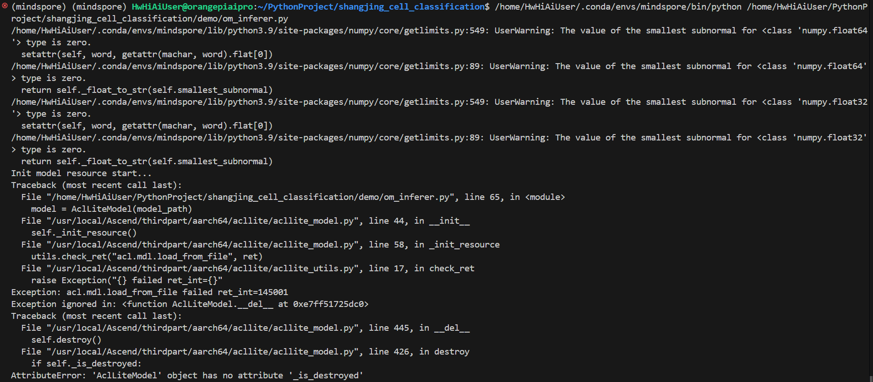2.3 报错脚本
转.air格式所用脚本代码
# export_model.py
import mindspore
import numpy as np
from mindspore import Tensor
from src.deep_learning.networks import NestedUNet
net = NestedUNet(n_channels=3, n_classes=2, is_train=False)
params = mindspore.load_checkpoint('nested_unet_checkpoints/nested_unet_checkpoints.ckpt')
mindspore.load_param_into_net(net, params)
input_tensor = Tensor(np.ones([1, 3, 256, 256]).astype(np.float32))
mindspore.export(net, input_tensor, file_name='nested_unet', file_format='AIR')
转om格式所用命令
atc --framework=1 --model=./nested_unet.air --input_format=NCHW --output=nested_unet --log=error --soc_version=Ascend310B4
报错脚本
import os
import cv2
import numpy as np
import matplotlib.pyplot as plt
import mindspore.dataset as ds
import acl
import acllite_utils as utils
from acllite_model import AclLiteModel
from acllite_resource import resource_list
class AclLiteResource:
"""
AclLiteResource
"""
def __init__(self, device_id=0):
self.device_id = device_id
self.context = None
self.stream = None
self.run_mode = None
def init(self):
"""
init resource
"""
print("init resource stage:")
ret = acl.init()
ret = acl.rt.set_device(self.device_id)
utils.check_ret("acl.rt.set_device", ret)
self.context, ret = acl.rt.create_context(self.device_id)
utils.check_ret("acl.rt.create_context", ret)
self.stream, ret = acl.rt.create_stream()
utils.check_ret("acl.rt.create_stream", ret)
self.run_mode, ret = acl.rt.get_run_mode()
utils.check_ret("acl.rt.get_run_mode", ret)
print("Init resource success")
def __del__(self):
print("acl resource release all resource")
resource_list.destroy()
if self.stream:
print("acl resource release stream")
acl.rt.destroy_stream(self.stream)
if self.context:
print("acl resource release context")
acl.rt.destroy_context(self.context)
print("Reset acl device ", self.device_id)
acl.rt.reset_device(self.device_id)
print("Release acl resource success")
image = cv2.imread('ultrasound_images_to_show/1.jpg')
image = cv2.resize(image, (256, 256))
image = np.expand_dims(image.astype(np.float32).transpose((2, 0, 1)) / 127.5 - 1, axis=0)
acl_resource = AclLiteResource()
acl_resource.init()
path = os.getcwd()
model_path = os.path.join(path, "nested_unet.om")
model = AclLiteModel(model_path)
result = model.execute([image, ]) # result是一个只装了一个numpy数组的列表
output_image = np.argmax(result[0][0], axis=0)
print(output_image.shape)
fig = plt.figure()
plt.imshow(output_image,cmap='gray')
fig.savefig('fig.jpg')
3. 根因分析
使用昇腾硬件及om格式模型进行推理时会直接调用acl相关接口进行显存资源的分配，推理完毕后会调用__del__方法将资源释放，若没有实现实例化AclLiteResource并使用init方法初始化资源管理对象，则会产生上述错误。
4. 解决方案
在代码：
model = AclLiteModel(model_path)
result = model.execute([image, ]) # result是一个只装了一个numpy数组的列表
的前面补充这两句：
acl_resource = AclLiteResource()
acl_resource.init()
如此操作以后，报错消失，正常运行的控制台输出如下：
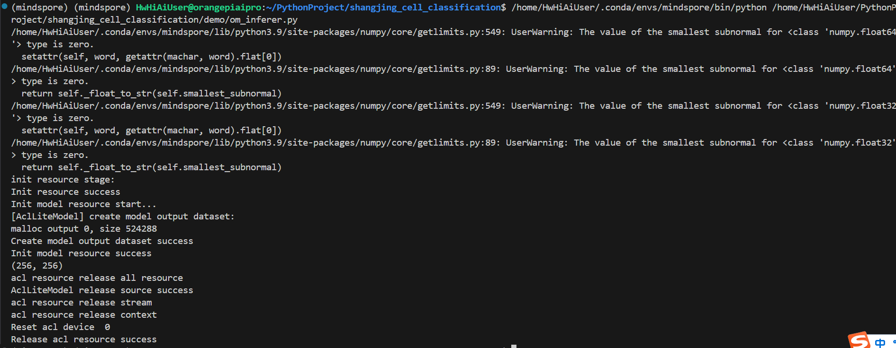推理结果如下：
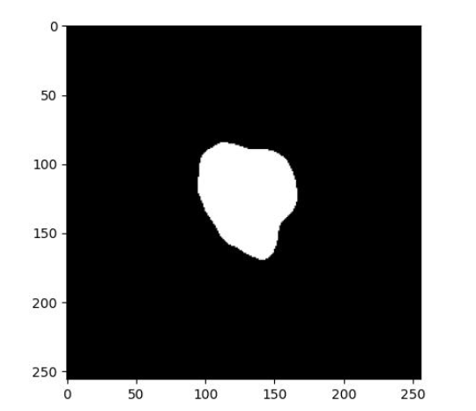
这正是理想的结果，说明这样操作是正确的。
5. 注意事项
因此报错相关的issue是本人之前在mindspore的gitee仓提的，故不论是脚本名还是路径名都与样图高度相似。我自己提出的问题我自己发现并解决了，也算一种圆满吧。代码存放的位置是我的gitee仓库，因为本仓库还有其他用途，暂时不能完全开源，因此附件仅包含复现本报错的必要代码。
5.1 注意事项一
使用香橙派的toolkit相关工具将.air模型转.om模型时必须把以下内容加到.bashrc中不然会报错:
# lib libraries that the run package depends on
export LD_LIBRARY_PATH=${LOCAL_ASCEND}/ascend-toolkit/latest/lib64:${LOCAL_ASCEND}/driver/lib64:${LOCAL_ASCEND}/ascend-toolkit/latest/opp/op_impl/built-in/ai_core/tbe/op_tiling:${LD_LIBRARY_PATH}
# Environment variables that must be configured
export TBE_IMPL_PATH=${LOCAL_ASCEND}/ascend-toolkit/latest/opp/op_impl/built-in/ai_core/tbe # TBE operator implementation tool path
export ASCEND_OPP_PATH=${LOCAL_ASCEND}/ascend-toolkit/latest/opp # OPP path
export PATH=${LOCAL_ASCEND}/ascend-toolkit/latest/compiler/ccec_compiler/bin/:${PATH} # TBE operator compilation tool path
export PYTHONPATH=${TBE_IMPL_PATH}:${PYTHONPATH}
以上环境变量并没有内置在香橙派的镜像中，因此需要自己装格式的朋友请将上述内容加到.bashrc中。
5.2 注意事项二
从.air转为香橙派可用的模型的转换命令为
atc --framework=1 --model=./nested_unet.air --input_format=NCHW --output=nested_unet --log=error --soc_version=Ascend310B4 # 把“nested_unet”换成待转文件名
注意一定要写Ascend310B4，写Ascend310可能会出问题
找不到传附件功能，使用超链接下载时生成的下载链接不稳定，代码请命令行下载：
pip install openi后使用如下命令即可下载代码压缩包：
openi dataset download enter/nodule_segmentation shangjing_cell_classification阉割版.zip --cluster NPU --save_path .
压缩包内包含了复现使用的代码和图像数据。

模型迁移报错案例
8.1 报错ValueError: For 'Mul', x.shape and y.shape are supposed to broadcast, where broadcast means that x.
8.2 报错RuntimeError: The 'sub' operation does not support the type [kMetaTypeNone, Tensor[Float32]].
8.3 迁移pytorch代码时如何将torch.device映射 usability/api
8.4 迁移网络tacotron2时遇到backbone中的FPN架构没有nn.ModuleDict
8.5 迁移网络tacotron2时遇到mindspore没有对应torch的tensor.clone接口
8.6 迁移网络tacotron2时遇到mindspore中缺少MultiScaleRoiAlign算子
8.7 迁移网络tacotron2时遇到torch.max、torch.min可以传入2个tensor，但是ops.max不可以
8.8 迁移网络tacotron2时遇到mindsporeAPI binary_cross_entropy_with_logits描述有问题
8.9 迁移网络tacotron2时遇到grad_fn反向求导报错
8.10 迁移网络tacotron2时遇到RuntimeError: The pointer[top_cell_] is null.
8.11 迁移网络tacotron2时遇到Loss损失过高问题
8.12 迁移网络tacotron2时mindspore的权重初始化与torch的不一致
8.13 迁移网络tacotron2时遇到mindspore中没有Tensor.detach()方法及解决
8.14 迁移tacotron2网络到MindSpore时遇到torch.Tensor.new_full()接口缺失
8.15 迁移tacotron2网络到MindSpore时遇到torch.tensor.copy_函数缺失
8.16 迁移tacotron2网络到MindSpore时ops.flip(image, -1)水平翻转图片出现报错
8.17 MindSpore实现多输出模型的loss用LossBase类实现
8.18 迁移网络时转化为静态图的时候报错
8.19 MindSpore实现Swin Transformer时遇到tensor和numpy均不能采用.format经行格式化输出
8.20 MindSpore实现Swin Transformer时遇到ms.common.initializer.Constant(0.0)(m.bias)不起初始化改变数值的作用
8.21 使用MindSpore替换torch.distributions的Categorical函数
8.22 MindSpore报错AttributeError: 'Parameter' object has no attribute 'uniform_'
8.23 MindSpore报错AttributeError: The 'Controller' object has no attribute 'to'.
8.24 如何使用MindSpore实现Torch的logsumexp函数
8.25 使用MindSpore Cell的construct报错AttributeError: For 'Cell', the method 'construct' is not defined.
8.26 使用MindSpore替换PyTorch的torch.nn.init
8.27 使用MindSpore报错AttributeError: 'Parameter' object has no attribute 'uniform_'
8.28 使用MindSpore实现pytorch中的前反向传播
8.29 MindSpore如何实现pytoch中的detach()方法
8.30 MindSpore报错TypeError: init() missing 2 required positional arguments: 'vocab_size' and 'embedding_size'
8.31 使用Mindspore的embedding报错
8.32 使用MindSpore报错TypeError:Invalid dtype
8.33 MindSpore2.3设置了int64后，算子里不会默认更改了
8.34 运行wizardcoder迁移代码报错broken pipe

报错ValueError: For 'Mul', x.shape and y.shape are supposed to broadcast, where broadcast means that x.
1. 报错描述
1.1 系统环境
Environment(Ascend/GPU/CPU): GPU-GTX3090(24G)
Software Environment: MindSpore version (source or binary): 1.7.0
Python version (e.g., Python 3.7.5): 3.8.13
OS platform and distribution (e.g., Linux Ubuntu 16.04): Ubuntu 16.04
CUDA version : 11.0
1.2 基本信息
1.2.1脚本
此代码是ConvLSTM从PyTorch迁移到MindSpore的一部分，下面为报错部分
split = ops.Split(1, 2)
output = split(x)
1.2.2报错
部分个人信息做遮挡处理
Traceback (most recent call last):
File "main.py", line 195, in <module>
train()
File "main.py", line 142, in train
loss = train_network(data, label)
File "/home/xxxlab/anaconda2/envs/mindspore/lib/python3.8/site-packages/mindspore/nn/cell.py", line 612, in __call__
raise err
File "/home/xxxlab/anaconda2/envs/mindspore/lib/python3.8/site-packages/mindspore/nn/cell.py", line 609, in __call__
output = self._run_construct(cast_inputs, kwargs)
File "/home/xxxlab/anaconda2/envs/mindspore/lib/python3.8/site-packages/mindspore/nn/cell.py", line 429, in _run_const
ruct
output = self.construct(*cast_inputs, **kwargs)
File "/home/xxxlab/anaconda2/envs/mindspore/lib/python3.8/site-packages/mindspore/nn/wrap/cell_wrapper.py", line 373,
in construct
loss = self.network(*inputs)
File "/home/xxxlab/anaconda2/envs/mindspore/lib/python3.8/site-packages/mindspore/nn/cell.py", line 612, in __call__
raise err
File "/home/xxxlab/anaconda2/envs/mindspore/lib/python3.8/site-packages/mindspore/nn/cell.py", line 609, in __call__
output = self._run_construct(cast_inputs, kwargs)
File "/home/xxxlab/anaconda2/envs/mindspore/lib/python3.8/site-packages/mindspore/nn/cell.py", line 429, in _run_const
ruct
output = self.construct(*cast_inputs, **kwargs)
File "/home/xxxlab/anaconda2/envs/mindspore/lib/python3.8/site-packages/mindspore/nn/wrap/cell_wrapper.py", line 111,
in construct
out = self._backbone(data)
File "/home/xxxlab/anaconda2/envs/mindspore/lib/python3.8/site-packages/mindspore/nn/cell.py", line 612, in __call__
raise err
File "/home/xxxlab/anaconda2/envs/mindspore/lib/python3.8/site-packages/mindspore/nn/cell.py", line 609, in __call__
output = self._run_construct(cast_inputs, kwargs)
File "/home/xxxlab/anaconda2/envs/mindspore/lib/python3.8/site-packages/mindspore/nn/cell.py", line 429, in _run_const
ruct
output = self.construct(*cast_inputs, **kwargs)
File "/home/xxxlab/zrj/mindspore/ConvLSTM-PyTorch/conv/model.py", line 31, in construct
state = self.encoder(input)
File "/home/xxxlab/anaconda2/envs/mindspore/lib/python3.8/site-packages/mindspore/nn/cell.py", line 612, in __call__
raise err
File "/home/xxxlab/anaconda2/envs/mindspore/lib/python3.8/site-packages/mindspore/nn/cell.py", line 609, in __call__
output = self._run_construct(cast_inputs, kwargs)
File "/home/xxxlab/anaconda2/envs/mindspore/lib/python3.8/site-packages/mindspore/nn/cell.py", line 429, in _run_const
ruct
output = self.construct(*cast_inputs, **kwargs)
File "/home/xxxlab/zrj/mindspore/ConvLSTM-PyTorch/conv/encoder.py", line 42, in construct
inputs, state_stage = self.forward_by_stage(
File "/home/xxxlab/zrj/mindspore/ConvLSTM-PyTorch/conv/encoder.py", line 35, in forward_by_stage
outputs_stage, state_stage = rnn(inputs, None)
File "/home/xxxlab/anaconda2/envs/mindspore/lib/python3.8/site-packages/mindspore/nn/cell.py", line 612, in __call__
raise err
File "/home/xxxlab/anaconda2/envs/mindspore/lib/python3.8/site-packages/mindspore/nn/cell.py", line 609, in __call__
output = self._run_construct(cast_inputs, kwargs)
File "/home/xxxlab/anaconda2/envs/mindspore/lib/python3.8/site-packages/mindspore/nn/cell.py", line 429, in _run_const
ruct
output = self.construct(*cast_inputs, **kwargs)
File "/home/xxxlab/zrj/mindspore/ConvLSTM-PyTorch/conv/ConvRNN.py", line 61, in construct
combined_2 = P.Concat(1)((x, r * htprev)) # h' = tanh(W*(x+r*H_t-1))
File "/home/xxxlab/anaconda2/envs/mindspore/lib/python3.8/site-packages/mindspore/common/tensor.py", line 278, in __mu
l__
return tensor_operator_registry.get('__mul__')(self, other)
File "/home/xxxlab/anaconda2/envs/mindspore/lib/python3.8/site-packages/mindspore/ops/composite/multitype_ops/_compile
_utils.py", lin
e 101, in _tensor_mul
return F.mul(self, other)
File "/home/xxxlab/anaconda2/envs/mindspore/lib/python3.8/site-packages/mindspore/ops/primitive.py", line 294, in __ca
ll__
return _run_op(self, self.name, args)
File "/home/xxxlab/anaconda2/envs/mindspore/lib/python3.8/site-packages/mindspore/common/api.py", line 90, in wrapper
results = fn(*arg, **kwargs)
File "/home/xxxlab/anaconda2/envs/mindspore/lib/python3.8/site-packages/mindspore/ops/primitive.py", line 754, in _run
_op
output = real_run_op(obj, op_name, args)
File "/home/xxxlab/anaconda2/envs/mindspore/lib/python3.8/site-packages/mindspore/ops/primitive.py", line 575, in __in
fer__
out[track] = fn(*(x[track] for x in args))
File "/home/xxxlab/anaconda2/envs/mindspore/lib/python3.8/site-packages/mindspore/ops/operations/math_ops.py", line 78
, in infer_shap
e
return get_broadcast_shape(x_shape, y_shape, self.name)
File "/home/xxxlab/anaconda2/envs/mindspore/lib/python3.8/site-packages/mindspore/ops/_utils/utils.py", line 70, in ge
t_broadcast_sha
pe
raise ValueError(f"For '{prim_name}', {arg_name1}.shape and {arg_name2}.shape are supposed "
ValueError: For 'Mul', x.shape and y.shape are supposed to broadcast, where broadcast means that x.shape[i] = 1 or -1 or
y.shape[i] = 1
or -1 or x.shape[i] = y.shape[i], but now x.shape and y.shape can not broadcast, got i: -3, x.shape: [16, 2, 64, 64], y
.shape: [16, 64
, 64, 64].
2. 原因分析以及解决办法
当时真的无比疑惑，为什么split出来的维度不是自己想要的呢？还以为输入的维度就错了，从输入开始debug，结果发现前面都没问题，是split出问题了。
一开始我是通过pytorch-mindspore的对照表进行算子映射的。其中torch.split与mindspore.ops.Split相映射，且备注没有额外信息，我自然就以为他们的参数是一样的。但其实不然，翻阅pytorch和mindspore文档就可以知道torch.split中除了tensor和dim的参数是
split_size_or_sections (int) or (list(int)) – size of a single chunk or list of sizes for each chunk
而mindspore中除了tensor和dim的参数是
output_num (int) - 指定分割数量。其值为正整数。默认值：1。
相对而言，mindspore的参数更好操作和理解，而pytorch还需要自己额外计算，所以在迁移时不能单纯把参数复制过来，还要看是否能相对应上。
3. 总结
迁移时要勤翻pytorch和mindspore api的文档，除了利用mindconvert进行自动映射外，还需要注意一下不支持算子的映射。

报错RuntimeError: The 'sub' operation does not support the type [kMetaTypeNone, Tensor[Float32]].
1. 报错描述
1.1 系统环境
Environment(Ascend/GPU/CPU): GPU-GTX3090(24G) Software Environment: – MindSpore version (source or binary): 1.7.0 – Python version (e.g., Python 3.7.5): 3.8.13 – OS platform and distribution (e.g., Linux Ubuntu 16.04): Ubuntu 16.04 – CUDA version : 11.0
1.2 基本信息
1.2.1脚本
此代码是ConvLSTM从PyTorch迁移到MindSpore的一部分，下面为报错部分
loss = train_network(data, label)
1.2.2报错
部分个人信息做遮挡处理
[WARNING] ME(124028:139969934345984,MainProcess):2022-07-23-20:21:12.940.089 [mindspore/run_check/_check_version.py:140]
MindSpore version 1.7.0 and cuda version 11.0.221 does not match, please refer to the installation guide for version ma
tching information: https://www.mindspore.cn/install
[CRITICAL] ANALYZER(124028,7f4d4a374700,python):2022-07-23-20:21:21.559.937 [mindspore/ccsrc/frontend/operator/composite
/multitype_funcgraph.cc:160] GenerateFromTypes] The 'sub' operation does not support the type [kMetaTypeNone, Tensor[Flo
at32]].
The supported types of overload function `sub` is: [Tensor, List], [Tensor, Tuple], [List, Tensor], [Tuple, Tensor], [Te
nsor, Number], [Number, Tensor], [Tensor, Tensor], [Number, Number].
Traceback (most recent call last):
File "main.py", line 194, in <module>
train()
File "main.py", line 142, in train
loss = train_network(data, label)
File "/home/xxxlab/anaconda2/envs/mindspore/lib/python3.8/site-packages/mindspore/nn/cell.py", line 586, in __call__
out = self.compile_and_run(*args)
File "/home/xxxlab/anaconda2/envs/mindspore/lib/python3.8/site-packages/mindspore/nn/cell.py", line 964, in compile_an
d_run
self.compile(*inputs)
File "/home/xxxlab/anaconda2/envs/mindspore/lib/python3.8/site-packages/mindspore/nn/cell.py", line 937, in compile
_cell_graph_executor.compile(self, *inputs, phase=self.phase, auto_parallel_mode=self._auto_parallel_mode)
File "/home/xxxlab/anaconda2/envs/mindspore/lib/python3.8/site-packages/mindspore/common/api.py", line 1006, in compil
e
result = self._graph_executor.compile(obj, args_list, phase, self._use_vm_mode())
RuntimeError: mindspore/ccsrc/frontend/operator/composite/multitype_funcgraph.cc:160 GenerateFromTypes] The 'sub' operat
ion does not support the type [kMetaTypeNone, Tensor[Float32]].
The supported types of overload function `sub` is: [Tensor, List], [Tensor, Tuple], [List, Tensor], [Tuple, Tensor], [Te
nsor, Number], [Number, Tensor], [Tensor, Tensor], [Number, Number].
The function call stack (See file '/home/xxxlab/zrj/mindspore/ConvLSTM-PyTorch/conv/rank_0/om/analyze_fail.dat' for more
details):
# 0 In file /home/xxxlab/anaconda2/envs/mindspore/lib/python3.8/site-packages/mindspore/nn/wrap/cell_wrapper.py(373)
loss = self.network(*inputs)
^
# 1 In file /home/xxxlab/anaconda2/envs/mindspore/lib/python3.8/site-packages/mindspore/nn/wrap/cell_wrapper.py(112)
return self._loss_fn(out, label)
^
# 2 In file /home/xxxlab/anaconda2/envs/mindspore/lib/python3.8/site-packages/mindspore/nn/loss/loss.py(313)
x = F.square(logits - labels)
2. 原因分析以及解决办法
原因直至Mindspore的loss，一开始我也很纳闷，mindspore的源代码我也不能修改，kMetaTypeNone又是什么类型呢？后来参考这篇文章知道了Mindspore分动静态图模式，默认好像是静态图模式，也就是所有的模型参数都要事先确定下来，不然不能构建静态图
关于静态和动态图的区别，可以参考mindspore官方文档。具体而言，从我的角度就是静态图就是一开始建议完整个模型的计算图，这样子这“张”计算图就可以被重复利用了，不用每次都重新计算，提高计算速度，但这样显而易见的缺点就是可扩展性差。
但是我的模型需要我根据输入进行调整，在对这个报错修改后很多其他地方如MUL操作，也接连出现kMetaTypeNone的错误，这样治标不治本，况且只要模型不改，问题就不可能被解决。
在看了mindspore官方文档后发现mindspore原来是支持动态图的呀！嗨，因为原框架Pytorch就是动态图的，因此只需要将mindspore调整成动态图就行了，具体操作是添加下方代码：
context.set_context(mode=context.PYNATIVE_MODE)
3. 总结
多看mindspore官方文档，深入了解框架原理及之间的区别，多利用社区。

迁移pytorch代码时如何将torch.device映射 usability/api
1 系统环境
硬件环境(Ascend/GPU/CPU): Ascend/GPU/CPU
MindSpore版本: mindspore=1.8.1
执行模式（动态图/静态图）: GRAPH_MODE
Python版本: Python=3.7.5
操作系统平台: Linux
2 报错信息
2.1 问题描述
迁移pytorch代码
import torch
device = torch.device(‘cuda’ if torch.cuda.is_available() else ‘cpu’)
print(type(device))
2.2 报错信息
尝试用ms.set_context(device_target="GPU\CPU\Ascend")，但是运行结果输出为None.
2.3 脚本代码
import torch
import os
import sys
# 有的地方改的不正去，比如这个ms.set_countext
# https://blog.csdn.net/qq_43215538/article/details/126161578
# 有问题，torch里出来的torch type的cpu
# device = torch.device(‘cuda’ if torch.cuda.is_available() else ‘cpu’)
device = ms.set_context(device_target=’CPU’)
print(type(device))
3 根因分析
根因：接口使用错误，可用mindspore.get_context完成。
接口说明：https://www.mindspore.cn/docs/en/r1.7/api_python/mindspore.context.html
原因：set_context应该是没有返回值，用get_context来获取
4 解决方案
import torch
import os
import sys
from mindspore import context
context.set_context(device_target="CPU")
device = context.get_context("device_target")
print(device)
print(type(device))

迁移网络tacotron2时遇到backbone中的FPN架构没有nn.ModuleDict
1. 系统环境
硬件环境(Ascend/GPU/CPU): GPU
软件环境: MindSpore 版本: 2.0
执行模式（静态图/动态图）： 不限
Python 版本: 3.7
操作系统平台: linux
2. 报错信息
迁移网络任务-tacotron2时遇到backbone中的FPN架构没有nn.ModuleDict。
3. 解决方案
这里没有使用resnet50+FPN作为backbone，用的是mobilenetv2的特征提取层作为backbone。
Torch无法实现的源码如下:
class IntermediateLayerGetter(nn.ModuleDict):
"""
Module wrapper that returns intermediate layers from a model
It has a strong assumption that the modules have been registered
into the model in the same order as they are used.
This means that one should **not** reuse the same nn.Module
twice in the forward if you want this to work.
Additionally, it is only able to query submodules that are directly
assigned to the model. So if `model` is passed, `model.feature1` can
be returned, but not `model.feature1.layer2`.
Arguments:
model (nn.Module): model on which we will extract the features
return_layers (Dict[name, new_name]): a dict containing the names
of the modules for which the activations will be returned as
the key of the dict, and the value of the dict is the name
of the returned activation (which the user can specify).
"""
__annotations__ = {
"return_layers": Dict[str, str],
}
def __init__(self, model, return_layers):
if not set(return_layers).issubset([name for name, _ in model.named_children()]):
raise ValueError("return_layers are not present in model")
orig_return_layers = return_layers
return_layers = {str(k): str(v) for k, v in return_layers.items()}
layers = OrderedDict()
# 遍历模型子模块按顺序存入有序字典
# 只保存layer4及其之前的结构，舍去之后不用的结构
for name, module in model.named_children():
layers[name] = module
if name in return_layers:
del return_layers[name]
if not return_layers:
break
super().__init__(layers)
self.return_layers = orig_return_layers
def forward(self, x):
out = OrderedDict()
# 依次遍历模型的所有子模块，并进行正向传播，
# 收集layer1, layer2, layer3, layer4的输出
for name, module in self.items():
x = module(x)
if name in self.return_layers:
out_name = self.return_layers[name]
out[out_name] = x
return out

迁移网络tacotron2时遇到mindspore没有对应torch的tensor.clone接口
1. 系统环境
硬件环境(Ascend/GPU/CPU): GPU
软件环境: MindSpore 版本: 2.0
执行模式（静态图/动态图）： 不限
Python 版本: 3.7
操作系统平台: linux
2. 报错信息
迁移网络任务-tacotron2时遇到mindspore没有对应torch的tensor.clone接口。
3. 解决方案
将如下代码段：
all_matches = matches.clone()
修改为：
ll_matches = Tensor(np.copy(matches.asnumpy()))

迁移网络tacotron2时遇到mindspore中缺少MultiScaleRoiAlign算子
1. 系统环境
硬件环境(Ascend/GPU/CPU): GPU
软件环境: MindSpore 版本: 2.0
执行模式（静态图/动态图）： 不限
Python 版本: 3.7
操作系统平台: linux
2. 报错信息
迁移网络任务-tacotron2时遇到mindspore中缺少MultiScaleRoiAlign算子。
3. 解决方案
根据Pytorch源码手动实现了MultiScaleRoiAlign算子。
Torch源码示例：
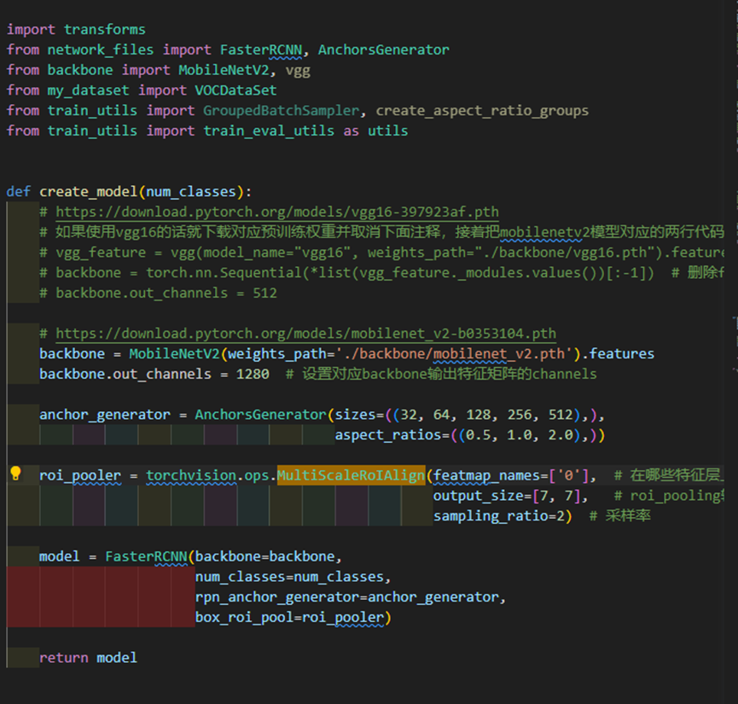实现替换示例：
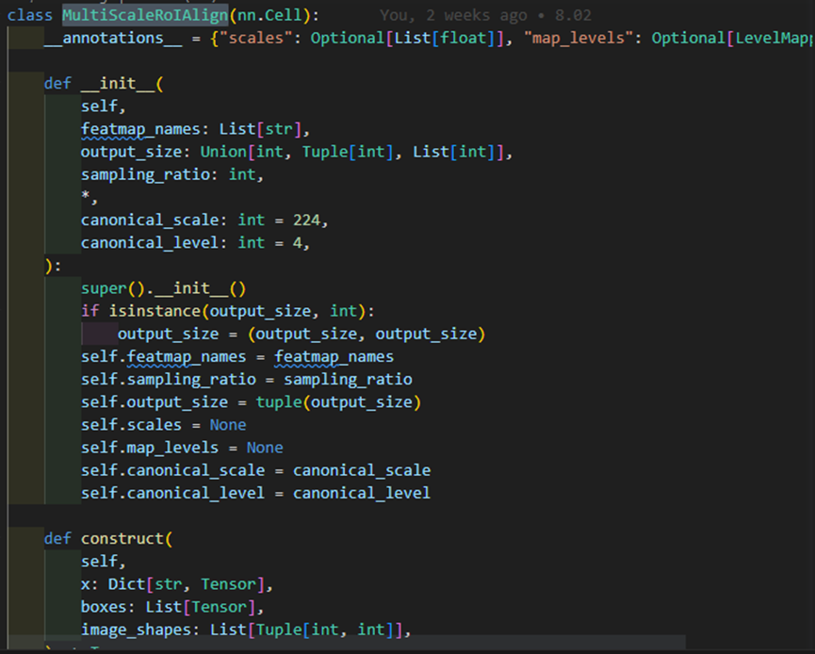

迁移网络tacotron2时遇到torch.max、torch.min可以传入2个tensor，但是ops.max不可以
1. 系统环境
硬件环境(Ascend/GPU/CPU): GPU
软件环境: MindSpore 版本: 2.0
执行模式（静态图/动态图）： 不限
Python 版本: 3.7.6
操作系统平台: linux
2. 报错信息
2.1 问题描述
迁移网络任务-tacotron2时遇到torch.max、torch.min可以传入2个tensor，但是ops.max不可以
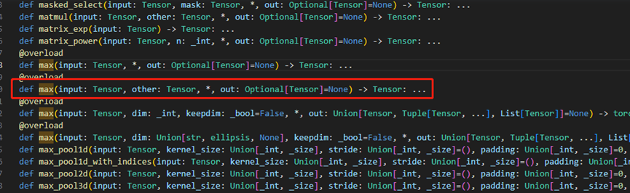3. 解决方案
Mindspore有对应求iou的接口。
Torch源码：
def box_iou(boxes1, boxes2):
area1 = box_area(boxes1)
area2 = box_area(boxes2)
lt = torch.max(boxes1[:, None, :2], boxes2[:, :2])
rb = torch.min(boxes1[:, None, 2:], boxes2[:, 2
wh = (rb - lt).clamp(min=0)
inter = wh[:, :, 0] * wh[:, :, 1]
iou = inter / (area1[:, None] + area2 - inter)
return iou
改为
def box_iou(boxes1, boxes2):
iou = ops.t(ops.iou(boxes1, boxes2, mode='iou'))
return iou

迁移网络tacotron2时遇到mindsporeAPI binary_cross_entropy_with_logits描述有问题
1. 系统环境
硬件环境(Ascend/GPU/CPU): GPU
软件环境: MindSpore 版本: 2.0
执行模式（静态图/动态图）： 不限
Python 版本: 3.7.6
操作系统平台: linux
2. 报错信息
2.1 问题描述
迁移网络任务-tacotron2时遇到mindsporeAPI binary_cross_entropy_with_logits描述有问题。
2.2 报错信息
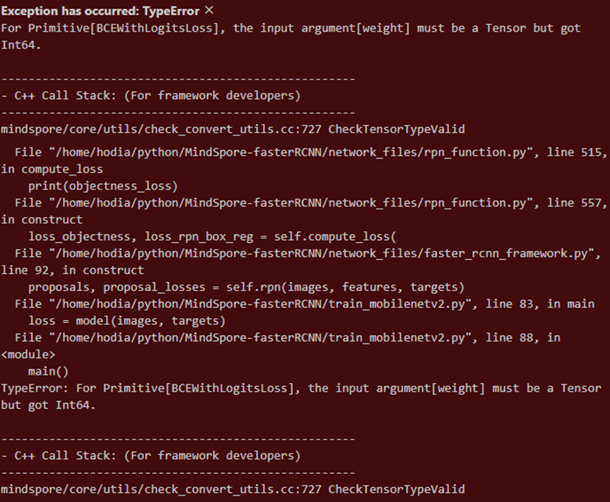2.3 脚本信息
objectness_loss = ops.binary_cross_entropy_with_logits(
logits=objectness[sampled_inds],
label=labels[sampled_inds],
weight=1,
pos_weight=1
)
3. 解决方案
需要传Tensor格式信息，改成。
weight = Tensor(np.ones((1,len(objectness[sampled_inds])))[0],dtype=ms.float32)
pos_weight = Tensor(np.ones((1,len(objectness[sampled_inds])))[0],dtype=ms.float32)
objectness_loss = ops.binary_cross_entropy_with_logits(
logits=objectness[sampled_inds],
label=labels[sampled_inds],
weight=weight,
pos_weight=pos_weight
)

迁移网络tacotron2时遇到grad_fn反向求导报错
1. 系统环境
硬件环境(Ascend/GPU/CPU): GPU
软件环境: MindSpore 版本: 2.0
执行模式（静态图/动态图）： 不限
Python 版本: 3.7.6
操作系统平台: linux
2. 报错信息
2.1 问题描述
迁移网络任务-tacotron2时遇到grad_fn反向求导报错。
2.2 报错信息
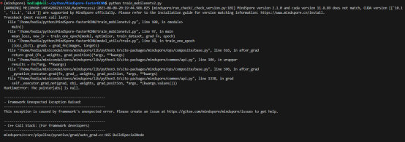
3. 根因分析
mindspore不支持字典类型的正向输出进行反向求导。
4. 解决方案
将字典类型的返回变为list，将输出换成了所有loss相加，并且最后返回所有loss的信息。
def forward_fn(images,targets):
loss_sum,loss_list = model(images,targets)
return loss_sum,loss_list
grad_fn = ms,value_and_grad(forward_fn,grad_position=None,weight=params,has_aux=True)

迁移网络tacotron2时遇到RuntimeError: The pointer[top_cell_] is null.
1. 系统环境
硬件环境(Ascend/GPU/CPU): GPU
软件环境: MindSpore 版本: 2.0
执行模式（静态图/动态图）： 不限
Python 版本: 3.7.6
操作系统平台: linux
2. 报错信息
2.1 问题描述
迁移网络任务-tacotron2时遇到RuntimeError: The pointer[top_cell_] is null.
2.2 报错信息
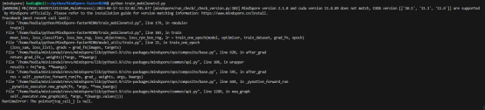
2.3 脚本信息
boxes = Tensor(boxes,dtype=ms.float32)
lables = Tensor(lables,dtype=ms.int64)
iscrowd = Tensor(iscrowd,dtype=ms.int64)
image_id = Tensor([idx])
area = (boxes[:,3] - boxes[:,1])*(boxes[:,2] - boxes[:,0])
3. 根因分析
MindSpore框架对于单算子的执行只支持单线程操作，但是在自定义数据集__getitem__函数中使用了Tensor的运算操作，即会调到框架的算子执行，由于数据集的处理使用了多线程操作，因此导致整体的执行顺序错乱，出现空指针的错误。因此到看到空指针错误且错误在generator.cc中时，就是在数据集中错误使用了Tensor的运算操作。
4. 解决方案
将Tensor改为numpy操作。
boxes = np.array(boxes,dtype=ms.float32)
lables = np.array(lables,dtype=ms.int64)
iscrowd = np.array(iscrowd,dtype=ms.int64)
image_id = np.array([idx])
area = (boxes[:,3] - boxes[:,1])*(boxes[:,2] - boxes[:,0])

迁移网络tacotron2时遇到Loss损失过高问题
1. 系统环境
硬件环境(Ascend/GPU/CPU): GPU
软件环境: MindSpore 版本: 2.0
执行模式（静态图/动态图）： 不限
Python 版本: 3.7.6
操作系统平台: linux
2. 报错信息
2.1 问题描述
迁移网络任务-tacotron2时遇到Loss损失过高问题。
2.2 报错信息
非极大值抑制算法使用错误。
3. 根因分析
通过Print调试可知，直接返回output_idx返回所有索引。
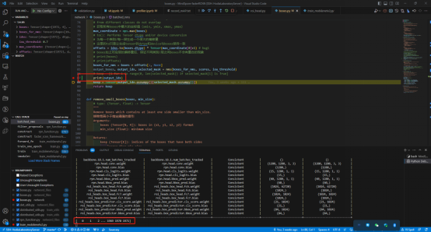
函数是直接返回output_idx，并没有selected_mark为True的选择出来，所以这里会将所有生成的矩形框全部选中，导致损失度一直下降不了。
4. 解决方案
按照API，应该这样调整。
boxes_for_nms = boxes + offsets[:,None]
output_boxes,output_idx,selected_mask = nms(boxes_for_nms,iou_threshould)
keep = Tensor(output_idx.asnumpy()[selected_mask.asnumpy()])
return keep

迁移网络tacotron2时mindspore的权重初始化与torch的不一致
1. 系统环境
硬件环境(Ascend/GPU/CPU): GPU
软件环境: MindSpore 版本: 2.0
执行模式（静态图/动态图）： 不限
Python 版本: 3.7.6
操作系统平台: linux
2. 报错信息
2.1 问题描述
迁移网络任务-tacotron2时mindspore的权重初始化与torch的不一致。
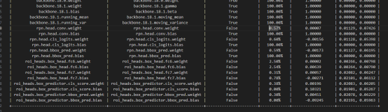
2.2 脚本信息
ts.migrator.compare_pth_and_ckpt(
weight_map_path="/home/hodia/python/Pytorch-fasterRCNN/pt_net_info/torch_net_map.json",
pt_file_path="/home/hodia/python/Pytorch-fasterRCNN/pt_net_info/torch_troubleshooter_create.pth",
ms_file_path="/home/hodia/python/MindSpore-fasterRCNN/ms_net_info/mindspore_troubleshooter_create.ckpt",
compare_value=True)
3. 解决方案
将pytorch的权重转化为mindspore，进行训练。
ts.migrator.convert_weight_and_load(weight_map_path="/home/hodia/python/Pytorch-fasterRCNN/pt_net_info/torch_net_map.json", pt_file_path="/home/hodia/python/Pytorch-fasterRCNN/pt_net_info/torch_troubleshooter_create.pth", net=model)
主要表现在初始化中，Torch的初始化。
for layer in self.children():
if isinstance(layer,nn.Conv2d):
torch.nn.init.normal_(layer.weight,std=0.01)
torch.nn.init.constant_(layer.bias,0)
MindSpore的初始化
for _, layer in self.cells_and_names():
if isinstance(layer,nn.Conv2d):
layer.weight.set_data(ms.common.initializer.initializer(ms.common.initializer.Normal(sigma=0.01,mean=0.0),layer.weight.shape,layer.weight.dtype))
layer.bias.set_data(ms.common.initializer.initializer("zeros",layer.bias.shape,layer.bias.dtype))

迁移网络tacotron2时遇到mindspore中没有Tensor.detach()方法及解决
1. 系统环境
硬件环境(Ascend/GPU/CPU): Ascend
软件环境: MindSpore 版本: 2.0
执行模式（静态图/动态图）： 不限
Python 版本: 3.7.6
操作系统平台: linux
2. 报错信息
迁移网络任务-tacotron2时遇到mindspore中没有Tensor.detach()方法。
3. 解决方案
Mindspore在正向传播的时候不需要记录信息，所以这里使用Parameter(requires_grad=False)替换。
通过查看csdn(https://blog.csdn.net/julac/article/details/129655016)可知：Torch每一步的正向都会记录反向信息，通过detach()这个接口将会让这个Tensor不求梯度。Mindspore中不会记录反向，可以在定义Tensor时候声明这个接口。
Mindspore中默认反向过程，对所有Tenor进行求导。
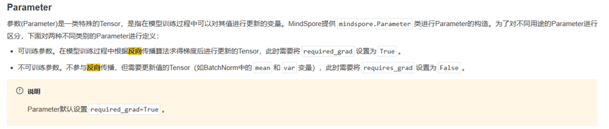如果说当前Tensor不需要求偏导，那么设置requires_grad=False就可以了。
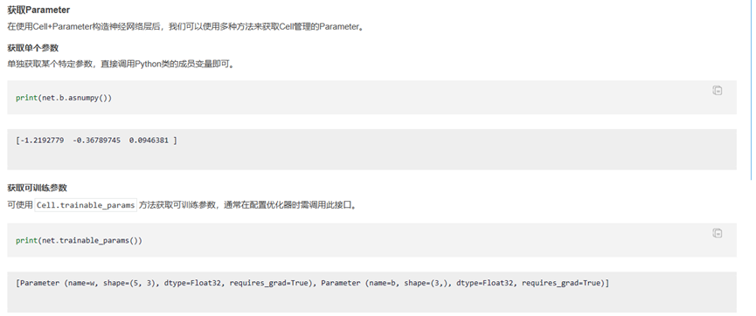

迁移tacotron2网络到MindSpore时遇到torch.Tensor.new_full()接口缺失
1. 系统环境
硬件环境(Ascend/GPU/CPU): Ascend
软件环境: MindSpore 版本: 2.0
执行模式（静态图/动态图）： 不限
Python 版本: 3.7.6
操作系统平台: linux
2. 报错信息
迁移tacotron2网络到MindSpore时遇到torch.Tensor.new_full()接口缺失。
3. 解决方案
pad_img[: img.shape[0], : img.shape[1], : img.shape[2]].copy_(img)
copy_接口是torch.Tensor中深拷贝接口，经查阅，没有发现Mindspore中有对应接口，所有，这里使用numpy的深拷贝。
改为
pad_img[:img.shape[0],:img.shape[1],:img.shape[2]]=img[:img.shape[0],:img.shape[1],:img.shape[2]]

迁移tacotron2网络到MindSpore时遇到torch.tensor.copy_函数缺失
1. 系统环境
硬件环境(Ascend/GPU/CPU): Ascend
软件环境: MindSpore 版本: 2.0
执行模式（静态图/动态图）： 不限
Python 版本: 3.7.6
操作系统平台: linux
2. 报错信息
迁移tacotron2网络到MindSpore时遇到torch.tensor.copy_函数缺失。
3. 解决方案
pad_img[: img.shape[0], : img.shape[1], : img.shape[2]].copy_(img)
copy_接口是torch.Tensor中深拷贝接口，经查阅，没有发现Mindspore中有对应接口，所有，这里使用numpy的深拷贝。
改为
pad_img[:img.shape[0],:img.shape[1],:img.shape[2]]=img[:img.shape[0],:img.shape[1],:img.shape[2]]

迁移tacotron2网络到MindSpore时ops.flip(image, -1)水平翻转图片出现报错
1. 系统环境
硬件环境(Ascend/GPU/CPU): Ascend
软件环境: MindSpore 版本: 2.0
执行模式（静态图/动态图）： 不限
Python 版本: 3.7
操作系统平台: linux
2. 报错信息
迁移tacotron2网络到MindSpore时ops.flip(image, -1)水平翻转图片出现问题。
TypeError: For 'ReverseV2', type of 'axis' should be one of '['list', 'tuple']', but got type 'int'.
3. 解决方案
只支持传元组或者列表，解决方案：改为np.flip(image, -1)可以解决问题。

MindSpore实现多输出模型的loss用LossBase类实现
1. 系统环境
硬件环境(Ascend/GPU/CPU): Ascend/GPU/CPU
软件环境: MindSpore 版本: 2.0.0
执行模式（静态图/动态图）： 不限
Python 版本: 3.7.6
操作系统平台: linux
2. 报错信息
2.1 问题描述
模型训练需要用到模型中间层特征来计算loss（特征间的距离），因此实现模型的时候会额外输出中间的特征。
2.2 脚本信息
class DCTLN(nn.Cell):
def __init__(self, input_shape, num_classes, BatchNormal):
super().__init__()
self.feature_extractor = FeatureExtractor(input_shape, 20, 5, 1, 'same', 2, BatchNormal)
self.hd_classifier = HealthConditionClassifier(100, num_classes)
self.domain_classifier = DomainClassifier(100)
self.grl = GradReverse()
self.apply(self._init_weights)
def construct(self, x):
features = self.feature_extractor(x)
health_condition = self.hd_classifier(features)
domain = self.domain_classifier(self.grl(features))
return features, health_condition, domain
使用pytorch写模型和训练脚本的时候，需要计算出loss然后backward就行。在mindspore的反向传播有些不同，目前写成了forward_fn，然后用value_rand_grad函数来获得梯度并反向传播。
def forward_fn(X_source, y_source, X_target, y_target, penalty_param):
X = ops.concat([X_source, X_target], axis=0)
# predict and calculate the loss
features, logits, domain = model(X)
classification_loss = loss_fn(logits.narrow(0, 0, source_size), y_source)
domain_label = ops.concat([ops.zeros(source_size), ops.ones(target_size)], axis=0)
domain_loss = ops.binary_cross_entropy(domain, domain_label.reshape(-1, 1))
mmd_value = mmd(features.narrow(0, 0, source_size), features.narrow(0, source_size, target_size))
# 更新惩罚系数
model.set_lambda(penalty_param)
loss = classification_loss #+ domain_loss + penalty_param * mmd_value
return loss, logits
grad_fn = mindspore.value_and_grad(forward_fn, None, optimizer.parameters, has_aux=True)
(loss, logits), grads = grad_fn(X_source, y_source, X_target, y_target, penalty_param)
# backpropagation
optimizer(grads)
这种方式就不能用下面方式进行训练
Model(net, loss, opt, metrics={'acc', 'loss'})
如何把多输出模型的loss也用LossBase类实现，然后使用上面这种方式来训练？
3. 根因分析
多输出的模型是能够用Model的方式来训练的，需要自己实现loss_fn和metric。
4. 解决方案
import mindspore as ms
from mindspore import nn
from mindspore.dataset import vision, transforms
from mindspore.dataset import MnistDataset
from mindspore import Accuracy
# download data
from download import download
url = "https://mindspore-website.obs.cn-north-4.myhuaweicloud.com/" \
"notebook/datasets/MNIST_Data.zip"
path = download(url, "./data", kind="zip", replace=False)
# prepare data
train_dataset = MnistDataset('./data/MNIST_Data/train/', 'train', shuffle=True)
test_dataset = MnistDataset('./data/MNIST_Data/test/', 'test')
def datapipe(dataset, batch_size):
image_transforms = [
vision.Rescale(1.0 / 255.0, 0),
vision.Normalize(mean=(0.1307,), std=(0.3081,)),
vision.HWC2CHW()
]
label_transform = transforms.TypeCast(ms.int32)
dataset = dataset.map(image_transforms, 'image')
dataset = dataset.map(label_transform, 'label')
dataset = dataset.batch(batch_size)
return dataset
train_dataset = datapipe(train_dataset, batch_size=64)
test_dataset = datapipe(test_dataset, batch_size=64)
# define model
class Net(nn.Cell):
def __init__(self):
super().__init__()
self.faltten = nn.Flatten()
self.dense_relu_sequential = nn.SequentialCell(
nn.Dense(28*28, 512),
nn.ReLU(),
nn.Dense(512, 512),
nn.ReLU(),
nn.Dense(512, 10)
)
self.conv_relu_sequential = nn.SequentialCell(
nn.Conv2d(1, 10, 4),
nn.ReLU(),
nn.Conv2d(10, 10, 3),
nn.ReLU(),
nn.Flatten(),
nn.Dense(7840, 100),
nn.ReLU(),
nn.Dense(100, 10)
)
def construct(self, x):
logits_conv = self.conv_relu_sequential(x)
x = self.faltten(x)
logits = self.dense_relu_sequential(x)
return logits, logits_conv
model = Net()
# define loss_fn and metric
from mindspore.train import Metric
class double_loss(nn.LossBase):
def __init__(self, reduction='mean'):
super().__init__(reduction)
self.loss_fn = nn.CrossEntropyLoss()
def construct(self, logits, labels):
loss = self.loss_fn(logits[0], labels) + self.loss_fn(logits[1], labels)
return loss
class double_acc(Metric):
def __init__(self):
super().__init__()
self.acc1 = Accuracy()
self.acc2 = Accuracy()
def clear(self):
self.acc1.clear()
self.acc2.clear()
def update(self, logits, labels):
self.acc1.update(logits[0], labels)
self.acc2.update(logits[1], labels)
def eval(self):
return (self.acc1.eval(), self.acc2.eval())
# training with Model API
loss_fn = double_loss()
optimizer = nn.SGD(model.trainable_params(), 1e-2)
from mindspore.train import Model, LossMonitor
loss_monitor = LossMonitor(100)
trainer = Model(model, loss_fn, optimizer, metrics={'acc':double_acc()})
trainer.fit(3, train_dataset, test_dataset, callbacks=[loss_monitor])

迁移网络时转化为静态图的时候报错
1. 系统环境
硬件环境(Ascend/GPU/CPU): GPU
软件环境: MindSpore 版本: 2.0
执行模式（静态图/动态图）： 不限
Python 版本: 3.7.6
操作系统平台: linux
2. 报错信息
迁移网络时转化为静态图的时候报错。
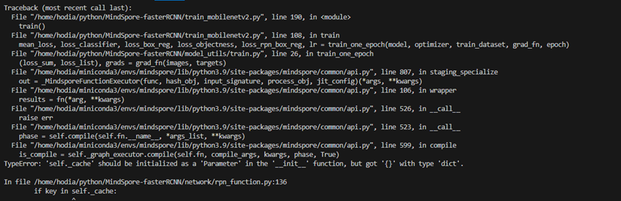3. 根因分析
此问题原因在于当前mindspore在静态图语法的限制，对于cell类的成员属性self._cache，是一个dict，当前暂时不支持在construct里面对其进行修改操作。
源代码：
def cached_grid_anchors(self, grid_sizes, strides):
# type: (List[List[int]], List[List[Tensor]]) -> List[Tensor]
"""将计算得到的所有anchors信息进行缓存"""
key = str(grid_sizes) + str(strides)
# self._cache是字典类型
if key in self._cache:
return self._cache[key]
anchors = self.grid_anchors(grid_sizes, strides)
self._cache[key] = anchors
return anchors
4. 解决方案
只有在函数cached_grid_anchors使用了该成员属性，修改为self._cache作为临时变量：
def cached_grid_anchors(self, grid_sizes, strides):
# type: (List[List[int]], List[List[Tensor]]) -> List[Tensor]
"""将计算得到的所有anchors信息进行缓存"""
key = str(grid_sizes) + str(strides)
# self._cache是字典类型
cache_dict = {}
if key in cache_dict:
return cache_dict[key]
anchors = self.grid_anchors(grid_sizes, strides)
cache_dict[key] = anchors
return anchors

MindSpore实现Swin Transformer时遇到tensor和numpy均不能采用.format经行格式化输出
1. 系统环境
硬件环境(Ascend/GPU/CPU): GPU
软件环境: MindSpore 版本: 2.0
执行模式（静态图/动态图）： 不限
Python 版本: 3.7.6
操作系统平台: linux
2. 报错信息
2.1 问题描述
tensor和numpy均不能采用.format经行格式化输出。
2.2 脚本信息
for image,label in data_loader:
step += 1
images,lagels = image,label
sample_num += image.shape[0]
pred = model(images)
pred_classes = pred.max(axis=1,return_indices=True)[1]
accu_num += ops.equal(pred_classes,labels.astype(ms.int32)).sum()
loss = train_one_step(iamge,label,astype(ms.int32))
accu_loss += loss
data_loader.desc = "[valid epoch {}] loss: {:.3f}".format(epoch,accu_loss.asnumpy().item()/(step+1),accu_num.asnumpy().item()/sample_num)
if not ops.isfinite(loss):
print("WARNING:non-finite loss,ending training",loss)
sys.exit(1)
return accu_loss.asnumpy()/(step+1),accu_num.asnumpy()/sample_num
3. 解决方案
putorch也需要转换，可以这样
accu_num.item()
mindspore需要
accu_num.asnumpy().item()

MindSpore实现Swin Transformer时遇到ms.common.initializer.Constant(0.0)(m.bias)不起初始化改变数值的作用
1. 系统环境
硬件环境(Ascend/GPU/CPU): GPU
软件环境: MindSpore 版本: 2.0
执行模式（静态图/动态图）： 不限
Python 版本: 3.7
操作系统平台: linux
2. 报错信息
2.1 问题描述
ms.common.initializer.Constant(0.0)(m.bias)不起初始化改变数值的作用。
2.2 脚本信息
def init_normal(m):
if type(m) == nn.Dense:
m.weight.set_data(initializer(Normal(sigma=0.01,mean=0,m.weight.shape,m.weight.dtype)))
print(m.bias.value())
ms.common.initialzer.Constant(0.0)(m.bias)
print(m.bias.value())
print('ok')
net.apply(init_normal)
net[0].weight.data[0],net[0].bias.data[0]
3. 解决方案
首先调用内置的初始化器，将所有权重参数初始化为标准差为0.01的高斯随机变量，且将偏置参数设置为0。
form mindspore.common.initializer import initializer,Normal,Constant
def init_normal(m):
if type(m) == nn.Dense:
m.weight.set_data(initializer(Normal(sigma=0.01,mean=0,m.weight.shape,m.weight.dtype)))
m.bias.set_data(initializer(Constant(0.0),m.bias.shape,m.bias.dtype))
net.apply(init_normal)
net[0].weight.data[0],net[0].bias.data[0]

使用MindSpore替换torch.distributions的Categorical函数
1. 系统环境
硬件环境(Ascend/GPU/CPU): Ascend/GPU/CPU
软件环境: MindSpore 版本: 2.0.0
执行模式（静态图/动态图）： 不限
Python 版本: 3.7.6
操作系统平台: linux
2. 报错信息
2.1 问题描述
将pytorch转换成mindspore代码的时候，调用了pytorch.distributions的Categorical方法，这三行代码该怎么使用mindspore的方法进行呢。
2.3 脚本信息
import torch.nn.functional as F
from torch.distributions import Categorical
def sample_cycle_component(self, logits, output_type, random_ratio=0):
action_index_local = Categorical(logits=logits).sample()
prob_matrix = F.softmax(logits, dim=1)
log_prob_matrix = F.log_softmax(logits, dim=1)
3. 根因分析
torch.distributions.Categorical => mindspore.nn.probability.distribution.Categorical
torch.nn.functional.softmax => mindspore.ops.softmax
torch.nn.functional.log_softmax => mindspore.ops.log_softmax
4. 解决方案
from mindspore import ops
from mindspore.nn.probability.distribution import Categorical
def sample_cycle_component(logits, output_type, random_ratio=0):
action_index_local = Categorical(probs=input).sample()
prob_matrix = ops.softmax(logits, axis=1)
log_prob_matrix = ops.log_softmax(logits, axis=1)

MindSpore报错AttributeError: 'Parameter' object has no attribute 'uniform_'
1. 系统环境
硬件环境(Ascend/GPU/CPU): Ascend/GPU/CPU
软件环境: MindSpore 版本: 2.0.0
执行模式（静态图/动态图）： 不限
Python 版本: 3.7.6
操作系统平台: linux
2. 报错信息
2.1 问题描述
将pytorch转换成mindspore代码的过程中报错AttributeError: 'Parameter' object has no attribute 'uniform_'，按照官方文档，将其中的self.parameters()改成了mindspore中nn.Cell模块里面的get_parameters()方法，返回的也是迭代器。
2.2 脚本信息
def init_parameters(self):
init_range = 0.1
for param in self.parameters():
param.data.uniform_(-init_range, init_range)
3. 根因分析
Parameter是Tensor的子类。 mindspore中的操作会创建一个新的Tensor, 不会修改Tensor原本的值。要想改变 具体看文档 例如:
import mindspore as ms
from mindspore import mint, nn, ops
a = mint.ones((2, 2))
b = a.mean()
print(a)
print(b)
要想改变Parameter的内容必须用赋值。
4. 解决方案
方案一：
import mindspore as ms
from mindspore import mint, nn, ops
# a = mint.ones((2, 2))
# b = a.mean()
# print(a)
# print(b)
class Net(nn.Cell):
def __init__(self):
super().__init__()
self.dense = nn.Dense(2, 3)
def init_parameters(self):
init_range = ms.Tensor(0.1)
param: ms.Parameter
for param in self.get_parameters():
param = ops.uniform(param.shape, -init_range, init_range)
net = Net()
net.init_parameters()
print(net.dense.weight.asnumpy())
方案二：
在mindspore=2.4版本中已提供如对标torch.uniform_接口，接口为：mindspore.ops.uniform，请参考使用。

MindSpore报错AttributeError: The 'Controller' object has no attribute 'to'.
1. 系统环境
硬件环境(Ascend/GPU/CPU): Ascend/GPU/CPU
软件环境: MindSpore 版本: 2.0.0
执行模式（静态图/动态图）： 不限
Python 版本: 3.7.6
操作系统平台: linux
2. 报错信息
2.1 问题描述
将pytorch转换成mindspore代码的过程中报错AttributeError: The 'Controller' object has no attribute 'to'.。
2.2 脚本信息
self.controller = Controller(self.args).to(device)
其中Controller定义为：
class Controller(nn.Module):
3. 根因分析
根据文档https://www.mindspore.cn/docs/zh-CN/r2.0/migration_guide/typical_api_comparision.html?highlight=device
pytorch与mindspore device的不同。
PyTorch 在构建模型时，通常会利用 torch.device 指定模型和数据绑定的设备，是在 CPU 还是 GPU 上，如果支持多 GPU，还可以指定具体的 GPU 序号。绑定相应的设备后，需要将模型和数据部署到对应设备，代码如下：
import os
import torch
from torch import nn
# bind to the GPU 0 if GPU is available, otherwise bind to CPU
device = torch.device("cuda:0" if torch.cuda.is_available() else "cpu") # 单 GPU 或者 CPU
# deploy model to specified hardware
model.to(device)
# deploy data to specified hardware
data.to(device)
# distribute training on multiple GPUs
if torch.cuda.device_count() > 1:
model = nn.DataParallel(model, device_ids=[0,1,2])
model.to(device)
# set available device
os.environ['CUDA_VISIBLE_DEVICE']='1'
model.cuda()
而在 MindSpore 中，我们通过 context 中 的 device_target 参数 指定模型绑定的设备，device_id 指定设备的序号。与 PyTorch 不同的是，一旦设备设置成功，输入数据和模型会默认拷贝到指定的设备中执行，不需要也无法再改变数据和模型所运行的设备类型。代码如下：
import mindspore as ms
ms.set_context(device_target='Ascend', device_id=0)
# define net
Model = ..
# define dataset
dataset = ..
# training, automatically deploy to Ascend according to device_target
Model.train(1, dataset)
此外，网络运行后返回的 Tensor 默认均拷贝到 CPU 设备，可以直接对该 Tensor 进行访问和修改，包括转成 numpy 格式，无需像 PyTorch 一样需要先执行 tensor.cpu 再转换成 numpy 格式。
pytorch与mindspore Module的不同
使用 PyTorch 构建网络结构时，我们会用到nn.Module 类，通常将网络中的元素定义在__init__ 函数中并对其初始化，将网络的图结构表达定义在forward 函数中，通过调用这些类的对象完成整个模型的构建和训练。nn.Module 不仅为我们提供了构建图接口，它还为我们提供了一些常用的 API ，来帮助我们执行更复杂逻辑。
MindSpore 中的 nn.Cell 类发挥着和 PyTorch 中 nn.Module 相同的作用，都是用来构建图结构的模块，MindSpore 也同样提供了丰富的 API 供开发者使用，虽然名字不能一一对应，但 nn.Module 中常用的功能都可以在nn.Cell 中找到映射。
4. 解决方案
首先 torch.nn.Module => mindspore.nn.Cell。
import mindspore as ms
from mindspore import ops, nn
ms.set_context(device_target='GPU', device_id = 0)
class Controller(nn.Cell):
def __init__(self):
super().__init__()
self.dense = nn.Dense(2, 3)
def construct(self, x):
return self.dense(x)
net = Controller()
print(net(ops.ones((1,2))))
[[0.00981624 0.00829783 0.00173066]]

如何使用MindSpore实现Torch的logsumexp函数
1. 系统环境
硬件环境(Ascend/GPU/CPU): Ascend/GPU/CPU
软件环境: MindSpore 版本: 2.0.0
执行模式（静态图/动态图）： 不限
Python 版本: 3.7.6
操作系统平台: linux
2. 报错信息
2.1 问题描述
如何使用MindSpore实现Torch的logsumexp函数。
2.2 脚本信息
Torch实现方式如下：
self.logits = logits - logits.logsumexp(dim=-1, keepdim=True)
3. 根因分析
torch.logsumexp => mindspore.nn.logsumexp
4. 解决方案
import mindspore as ms
from mindspore import ops, nn
import torch
logits_torch = torch.randn((1, 2))
logits_ms = ms.Tensor(logits_torch.numpy())
logits_torch = logits_torch - logits_torch.logsumexp(dim=-1, keepdim=True)
logits_ms = logits_ms - logits_ms.logsumexp(axis=-1, keepdims=True)
print(logits_torch)
print(logits_ms)
tensor([[-1.7354, -0.1940]])
[[-1.7353749 -0.19399017]]

使用MindSpore Cell的construct报错AttributeError: For 'Cell', the method 'construct' is not defined.
1. 系统环境
硬件环境(Ascend/GPU/CPU): Ascend/GPU/CPU
软件环境: MindSpore 版本: 2.0.0
执行模式（静态图/动态图）： 不限
Python 版本: 3.7
操作系统平台: linux
2. 报错信息
2.1 问题描述
在pytorch迁移MindSpore过程中，错误信息如下。
2.2 报错信息
File "main_attention.py", line 88, in <module>
autofe.fit_attention(args)
File "/root/FETCH-main/autofe.py", line 251, in fit_attention
actions, log_probs, m1_output, m2_output, m3_output, action_softmax = self.ppo.choose_action_c(
File "/root/FETCH-main/feature_engineer/attention_searching/ppo.py", line 48, in choose_action_c
action_softmax, m1_output, m2_output, m3_output = self.actor_c(input_c, step)
File "/root/miniconda3/lib/python3.8/site-packages/mindspore/nn/cell.py", line 659, in __call__
raise AttributeError("For 'Cell', the method 'construct' is not defined.")
AttributeError: For 'Cell', the method 'construct' is not defined.
2.3 脚本信息
actions, log_probs, m1_output, m2_output, m3_output, action_softmax = self.ppo.choose_action_c(workers_c[i].states[-1], step, epoch, c_ops, sample_rule)
actions, log_probs, m1_output, m2_output, m3_output, action_softmax = ppo.choose_action_c(state_c, step, epoch, c_ops, sample_rule)
脚本定义如下：
self.actor_c = Actor(args, data_nums, operations_c, d_model, d_k, d_v, d_ff, n_heads, dropout=dropout, enc_load_pth=args.enc_c_pth)
class Actor(nn.Cell):
def __init__(self, args, data_nums, operations, d_model, d_k, d_v, d_ff, n_heads, dropout=None, enc_load_pth=None):
super(Actor, self).__init__()
self.args = args
self.reduction_dimension = ReductionDimension(data_nums, d_model)
self.encoder = EncoderLayer(d_model, d_k, d_v, d_ff, n_heads, dropout)
logging.info(f"Randomly initial encoder")
if os.path.exists(enc_load_pth):
self.encoder.load_state_dict(mindspore.load(enc_load_pth))
logging.info(f"Successfully load encoder, enc_load_pth:{enc_load_pth}")
self.select_operation = SelectOperations(d_model, operations)
self.c_nums = len(args.c_columns)
self.layernorm = nn.LayerNorm(normalized_shape=(data_nums,))
def forward(self, input, step):
input_norm = self.layernorm(input)
data_reduction_dimension = self.reduction_dimension(input_norm)
data_reduction_dimension = mindspore.ops.where(mindspore.ops.isnan(data_reduction_dimension),
mindspore.ops.full_like(data_reduction_dimension, 0), data_reduction_dimension)
encoder_output = self.encoder(data_reduction_dimension)
encoder_output = mindspore.ops.where(mindspore.ops.isnan(encoder_output), mindspore.ops.full_like(encoder_output, 0), encoder_output)
output = self.select_operation(encoder_output)
output = mindspore.ops.where(mindspore.ops.isnan(output), mindspore.ops.full_like(output, 0), output)
operation_softmax = mindspore.ops.softmax(output, dim=-1)
return operation_softmax, data_reduction_dimension.squeeze(), \
encoder_output.squeeze(), output
3. 根因分析
根据文档：https://www.mindspore.cn/docs/zh-CN/r2.0/migration_guide/typical_api_comparision.html?highlight=device#nn.Module
使用 PyTorch 构建网络结构时，我们会用到nn.Module 类，通常将网络中的元素定义在__init__ 函数中并对其初始化，将网络的图结构表达定义在forward 函数中，通过调用这些类的对象完成整个模型的构建和训练。nn.Module 不仅为我们提供了构建图接口，它还为我们提供了一些常用的 API ，来帮助我们执行更复杂逻辑。
MindSpore 中的 nn.Cell 类发挥着和 PyTorch 中 nn.Module 相同的作用，都是用来构建图结构的模块，MindSpore 也同样提供了丰富的 API 供开发者使用，虽然名字不能一一对应，但 nn.Module 中常用的功能都可以在nn.Cell 中找到映射。
4. 解决方案
import mindspore as ms
from mindspore import ops, nn
class Actor(nn.Cell):
def __init__(self, args, data_nums, operations, d_model, d_k, d_v, d_ff, n_heads, dropout=None, enc_load_pth=None):
super(Actor, self).__init__()
pass # 原代码
def construct(self, input, step):
pass # 原代码

使用MindSpore替换PyTorch的torch.nn.init
1. 系统环境
硬件环境(Ascend/GPU/CPU): Ascend/GPU/CPU
软件环境: MindSpore 版本: 2.0.0
执行模式（静态图/动态图）： 不限
Python 版本: 3.7.6
操作系统平台: linux
2. 报错信息
做pytorch迁移到MindSpore的过程中需要更改调用torch.nn.init相关的部分，MindSpore该如何替换。
3. 根因分析
torch.nn.init => mindspore.common.initializer 当然除了 torch.nn.init.eye_ 对应的是mindspore.ops.eye
4. 解决方案
import torch
import torch.nn.init as torch_init
import mindspore as ms
from mindspore.common import initializer as ms_init
from mindspore import ops
uniform
w = torch.empty(3, 5)
torch_init.uniform_(w)
print(w)
tensor([[0.6273, 0.6722, 0.4320, 0.0803, 0.4569],
[0.8467, 0.2664, 0.9759, 0.4138, 0.4804],
[0.6302, 0.9383, 0.8273, 0.3065, 0.8729]])
w = ms_init.initializer(ms_init.Uniform(), (3, 5))
print(w)
w = ms_init.initializer("uniform", (3, 5))
print(w)
[[ 0.02076868 -0.00353139 -0.02801976 0.01483764 0.06549707]
[ 0.05656932 0.0125913 -0.04658895 0.01214548 -0.06701916]
[-0.01464871 -0.02846382 0.05644834 -0.05948469 -0.00985342]]
[[ 0.00580789 -0.05222291 0.04916679 -0.0379335 -0.00949833]
[-0.04182563 -0.04885998 0.03340004 -0.05639874 0.0465859 ]
[-0.01674308 -0.03311962 0.06953544 0.01696784 0.03579749]]
constant
w = torch.empty(3, 5)
torch_init.constant_(w, 0.3)
print(w)
tensor([[0.3000, 0.3000, 0.3000, 0.3000, 0.3000],
[0.3000, 0.3000, 0.3000, 0.3000, 0.3000],
[0.3000, 0.3000, 0.3000, 0.3000, 0.3000]])
w = ms_init.initializer(ms_init.Constant(0.3), (3, 5))
print(w)
[[0.3 0.3 0.3 0.3 0.3]
[0.3 0.3 0.3 0.3 0.3]
[0.3 0.3 0.3 0.3 0.3]]
ones
w = torch.empty(3, 5)
torch_init.ones_(w)
print(w)
tensor([[1., 1., 1., 1., 1.],
[1., 1., 1., 1., 1.],
[1., 1., 1., 1., 1.]])
w = ms_init.initializer(ms_init.One(), (3, 5))
print(w)
w = ms_init.initializer("one", (3, 5))
print(w)
[[1. 1. 1. 1. 1.]
[1. 1. 1. 1. 1.]
[1. 1. 1. 1. 1.]]
[[1. 1. 1. 1. 1.]
[1. 1. 1. 1. 1.]
[1. 1. 1. 1. 1.]]
Zero
w = torch.empty(3, 5)
torch_init.zeros_(w)
print(w)
tensor([[0., 0., 0., 0., 0.],
[0., 0., 0., 0., 0.],
[0., 0., 0., 0., 0.]])
w = ms_init.initializer(ms_init.Zero(), (3, 5))
print(w)
w = ms_init.initializer("zero", (3, 5))
print(w)
[[0. 0. 0. 0. 0.]
[0. 0. 0. 0. 0.]
[0. 0. 0. 0. 0.]]
[[0. 0. 0. 0. 0.]
[0. 0. 0. 0. 0.]
[0. 0. 0. 0. 0.]]
eye
w = torch.empty(3, 5)
torch_init.eye_(w)
tensor([[1., 0., 0., 0., 0.],
[0., 1., 0., 0., 0.],
[0., 0., 1., 0., 0.]])
w = ops.eye(3, 5)
print(w)
[[1. 0. 0. 0. 0.]
[0. 1. 0. 0. 0.]
[0. 0. 1. 0. 0.]]
dirac
w = torch.empty(2, 2, 3, 3)
torch_init.dirac_(w, 2)
print(w)
tensor([[[[0., 0., 0.],
[0., 1., 0.],
[0., 0., 0.]],
[[0., 0., 0.],
[0., 0., 0.],
[0., 0., 0.]]],
[[[0., 0., 0.],
[0., 1., 0.],
[0., 0., 0.]],
[[0., 0., 0.],
[0., 0., 0.],
[0., 0., 0.]]]])
w = ms_init.initializer(ms_init.Dirac(2), (2,2,3,3))
print(w)
[[[[0. 0. 0.]
[0. 1. 0.]
[0. 0. 0.]]
[[0. 0. 0.]
[0. 0. 0.]
[0. 0. 0.]]]
[[[0. 0. 0.]
[0. 1. 0.]
[0. 0. 0.]]
[[0. 0. 0.]
[0. 0. 0.]
[0. 0. 0.]]]]
xavier_uniform
w = torch.empty(3, 5)
torch_init.xavier_uniform_(w, gain=1)
print(w)
tensor([[-0.4621, 0.0128, 0.6648, 0.8388, -0.7054],
[ 0.1299, 0.7065, 0.3830, 0.0871, 0.1640],
[ 0.8043, 0.7462, -0.0764, 0.5021, 0.7438]])
w = ms_init.initializer(ms_init.XavierUniform(1), (3,5))
print(w)
w = ms_init.initializer("xavier_uniform", (3, 5))
print(w)
[[-0.1365639 -0.6591273 -0.02490093 0.53927845 -0.40755984]
[-0.30184573 0.5353374 0.05441066 0.39372778 0.13548988]
[-0.33337212 -0.7249835 -0.45743167 0.27087837 0.3974703 ]]
[[ 0.66771585 0.8372303 -0.30232698 -0.23809277 -0.24208683]
[ 0.47933128 0.6843046 0.7311251 -0.47484264 0.78137606]
[-0.715034 -0.28117204 0.28003275 -0.523037 -0.7518653 ]]
xavier_normal
w = torch.empty(3, 5)
torch_init.xavier_normal_(w)
tensor([[ 0.3390, -0.1305, -0.7165, 0.7791, -0.7877],
[-0.7793, -0.6927, 0.0883, 0.1080, -1.6134],
[ 0.2015, -1.2122, 1.5879, 0.1446, -0.3547]])
w = ms_init.initializer(ms_init.XavierNormal(1), (3,5))
print(w)
w = ms_init.initializer("xavier_normal", (3, 5))
print(w)
[[ 0.93760556 0.3392253 0.40076658 -0.19003701 0.14194943]
[ 0.10027266 -0.45792234 0.5151587 0.5029552 0.13373359]
[-0.19225736 0.21525055 -0.1321451 0.30269623 0.5750851 ]]
[[ 0.59728 -0.78122866 0.1958348 0.9556407 -0.35464117]
[ 0.5489269 0.07231056 0.45982736 -0.03406669 0.6918162 ]
[ 0.1374928 -1.3428471 0.21672817 0.2914441 0.5336329 ]]
kaiming_uniform
w = torch.empty(3, 5)
torch_init.kaiming_uniform_(w, mode='fan_in', nonlinearity='relu')
tensor([[ 0.2769, -0.8207, -0.6044, -0.0624, 0.5949],
[ 0.8521, -0.9850, 0.5606, -0.8289, -0.2912],
[ 0.4932, -0.7423, -0.5104, -0.3367, -0.1449]])
w = ms_init.initializer(ms_init.HeUniform(mode='fan_in', nonlinearity='relu'), (3,5))
print(w)
[[-0.5309736 0.8559388 -0.92003417 0.58600163 0.7770014 ]
[-0.7070332 0.6938597 0.20635565 0.9363468 -0.04296735]
[-0.42041913 0.2702668 -0.63106734 -0.73498166 0.26201499]]
kaiming_normal
w = torch.empty(3, 5)
torch_init.kaiming_normal_(w, mode='fan_in', nonlinearity='relu')
tensor([[-0.1372, 0.7091, -1.0794, -0.2982, -0.5171],
[ 0.2817, 0.6475, -0.3793, -0.0194, 0.1257],
[-0.2764, -1.0841, 0.5978, 0.1805, 0.0318]])
w = ms_init.initializer(ms_init.HeNormal(mode='fan_in', nonlinearity='relu'), (3,5))
print(w)
[[ 0.04525672 0.54234827 0.29712144 -0.6286129 0.7247357 ]
[-0.72248465 -0.5347963 0.06399149 0.39091495 -0.04421718]
[-0.22517438 0.12626456 -0.03354136 -0.4759619 -0.5327487 ]]
trunc_normal
w = torch.empty(3, 5)
torch_init.trunc_normal_(w)
tensor([[ 0.0626, 0.5258, 0.7458, -0.1970, 1.2821],
[ 0.2344, 0.5350, 0.4402, 0.2152, 1.0044],
[ 0.3880, -0.1332, 0.6127, 0.9253, 1.5593]])
w = ms_init.initializer(ms_init.TruncatedNormal(1), (3,5))
print(w)
w = ms_init.initializer("truncatedNormal", (3, 5))
print(w)
[[ 0.1207792 -0.21480061 0.09069321 -0.09830502 -0.61501193]
[-0.08540737 0.684896 -0.6055059 0.07456751 -1.7249392 ]
[-0.18215409 0.37354046 0.83819115 -0.25331137 -1.451913 ]]
[[-0.01586118 -0.00392491 0.00117821 -0.01158508 -0.00948633]
[-0.00097138 -0.01572727 -0.00207051 0.00047637 -0.00899001]
[ 0.0042324 0.00122826 -0.00749713 0.01155263 0.00115168]]
orthogonal
w = torch.empty(3, 5)
torch_init.orthogonal_(w)
tensor([[ 0.4940, 0.6654, -0.2924, 0.2797, -0.3866],
[-0.3244, 0.7065, 0.0692, -0.4769, 0.4043],
[-0.6315, -0.0317, -0.6525, -0.0621, -0.4130]])
w = ms_init.initializer(ms_init.Orthogonal(1), (3,5))
print(w)
w = ms_init.initializer("orthogonal", (3, 5))
print(w)
[[ 0.2581128 0.7996161 0.47184658 -0.21337771 0.16069418]
[ 0.09046545 0.12070206 0.23474057 0.43679783 -0.85519093]
[ 0.2695082 0.1381112 -0.53185076 -0.6602976 -0.43523848]]
[[ 0.5105753 0.54908097 0.17701794 -0.10290311 -0.6292047 ]
[-0.71567476 -0.0970166 0.3541471 -0.29048243 -0.5182636 ]
[ 0.3556234 -0.59223086 -0.25964984 -0.64582545 -0.1956683 ]]

使用MindSpore报错AttributeError: 'Parameter' object has no attribute 'uniform_'
1. 系统环境
硬件环境(Ascend/GPU/CPU): Ascend/GPU/CPU
软件环境: MindSpore 版本: 2.0.0
执行模式（静态图/动态图）： 不限
Python 版本: 3.7.6
操作系统平台: linux
2. 报错信息
2.1 问题描述
将pytorch转换成mindspore代码的过程中报错AttributeError: 'Parameter' object has no attribute 'uniform_'，按照官方文档，将其中的self.parameters()改成了mindspore中nn.Cell模块里面的get_parameters()方法，返回的也是迭代器。
2.2 脚本信息
def init_parameters(self):
init_range = 0.1
for param in self.parameters():
param.data.uniform_(-init_range, init_range)
3. 根因分析
param.data.uniform_(-init_range, init_range) 这个是torch的写法
torch 的Tensor支持uniform_的api，具体参考https://pytorch.org/docs/stable/generated/torch.Tensor.uniform_.html#torch.Tensor.uniform_
mindspore的Parameter是Tensor的子类，是不支持uniform_的
然后用uniform_在mindspore的API文档中查找，https://www.mindspore.cn/docs/zh-CN/r2.2/search.html?q=uniform_&check_keywords=yes&area=default
可以找到如下资料。
torch.nn.init
torch.nn.init 需要一个Tensor作为输入，将输入的Tensor原地修改为目标结果。
import torch
x = torch.empty(2, 2)
torch.nn.init.uniform_(x)
运行以上代码之后，x将不在是非初始化状态，其元素将服从均匀分布。
mindspore.common.initializer
mindspore.common.initializer 用于在并行模式中延迟Tensor的数据的初始化。只有在调用了 init_data() 之后，才会使用指定的 init 来初始化Tensor的数据。每个Tensor只能使用一次 init_data() 。
import mindspore
from mindspore.common.initializer import initializer, Uniform
x = initializer(Uniform(), [1, 2, 3], mindspore.float32)
在运行以上代码之后，x 其实尚未完成初始化。如果此时 x 被用来计算，将会作为0来处理。然而，在打印时，会自动调用 init_data() 。
4. 解决方案
三种解决方法
1.在创建网络的初始化阶段创建一个Parameter对象，用initializer进行Uniform初始化，然后给对应的参数进行初始化操作
2.调用Parameter对象的set_data(data, slice_shape=False)方法，具体参考https://www.mindspore.cn/docs/zh-CN/r2.2/api_python/mindspore/mindspore.Parameter.html?highlight=parameter#mindspore.Parameter
3.利用算子mindspore.ops.assign(variable, value) 进行Parameter对象的赋值
这里不建议直接给Parameter对象等于一个Tensor对象进行赋值操作，某些场景下会不起效。
方案1：
class Net(nn.Cell):
def __init__(self):
super().__init__()
weight = Parameter(initializer(Uniform(0.1), [3, 3, 1, 1], ms.float32))
self.conv2d = nn.Conv2d(3, 3, 1, has_bias=False, weight_init=weight)
def construct(self, x):
z = self.conv2d(x)
return z
方案2：
def init_parameters(self):
init_range = ms.Tensor(0.1)
for param in self.get_parameters():
param.set_data(ops.uniform(param.shape, -init_range, init_range))
方案3：
def init_parameters(self):
init_range = ms.Tensor(0.1)
for param in self.get_parameters():
ops.assign(param, ops.uniform(param.shape, -init_range, init_range))

使用MindSpore实现pytorch中的前反向传播
1. 系统环境
硬件环境(Ascend/GPU/CPU): Ascend/GPU/CPU
软件环境: MindSpore 版本: 2.2.0
执行模式（静态图/动态图）： 不限
Python 版本: 3.7.6
操作系统平台: linux
2. 报错信息
2.1 问题描述
如何使用MindSpore实现pytorch中的前向传播和反向传播方式。
2.2 脚本信息
output = rnn(b_x) # rnn output
loss = loss_func(output, b_y) # cross entropy loss
optimizer.zero_grad() # clear gradients for this training step
loss.backward() # backpropagation, compute gradients
optimizer.step() # apply gradients
3. 根因分析
mindspore下：
在模型训练中，一个完整的训练过程（step）需要实现以下三步：
正向计算：模型预测结果（logits），并与正确标签（label）求预测损失（loss）。
反向传播：利用自动微分机制，自动求模型参数（parameters）对于loss的梯度（gradients）。
参数优化：将梯度更新到参数上。
MindSpore使用函数式自动微分机制，因此针对上述步骤需要实现：
定义正向计算函数。
使用value_and_grad通过函数变换获得梯度计算函数。
定义训练函数，使用set_train设置为训练模式，执行正向计算、反向传播和参数优化。
4. 解决方案
以下用一个简单的网络来对比torch和mindspore 前向传播和反向传播的差别。
import torch
import torch.nn as nn
import torch.optim as optim
# 定义一个简单的模型
class Model(nn.Module):
def __init__(self):
super(Model, self).__init__()
self.weight = nn.Parameter(torch.randn(1))
self.bias = nn.Parameter(torch.randn(2))
def forward(self, x):
y = self.weight*x +self.bias
return y
# 实例化模型
model = Model()
# 随机的输入和目标
inputs = torch.tensor([1.,2.], dtype=torch.float32, requires_grad=True)
targets = torch.tensor([101., 202.])
# 定义损失函数
loss_fn = nn.MSELoss()
# 定义优化器，这里以SGD为例
optimizer = optim.SGD(model.parameters(), lr=0.01)
for i in range(1000):
print(f"-----------------------loop:{i}---------------------")
# 前向传播
outputs = model(inputs)
loss = loss_fn(outputs, targets)
print("loss:", loss)
if loss.detach().numpy() <0.001:
break
# 反向传播
loss.backward()
print("inputs.grad:", inputs.grad)
print("inputs before optimizer.step:", model.parameters())
for i in model.parameters():
print(i)
# 梯度更新
optimizer.step()
print("inputs after optimizer.step:", model.parameters())
for i in model.parameters():
print(i)
optimizer.zero_grad()
运行结果：
-----------------------loop:0---------------------
loss: tensor(25024.0586, grad_fn=<MseLossBackward0>)
inputs.grad: tensor([-107.0528, -217.2061])
inputs before optimizer.step: <generator object Module.parameters at 0x0000029FE4BF6900>
Parameter containing:
tensor([1.0824], requires_grad=True)
Parameter containing:
tensor([ 1.0168, -0.8306], requires_grad=True)
inputs after optimizer.step: <generator object Module.parameters at 0x0000029FE4BF6900>
Parameter containing:
tensor([6.0848], requires_grad=True)
Parameter containing:
tensor([2.0058, 1.1760], requires_grad=True)
-----------------------loop:1---------------------
loss: tensor(22111.3359, grad_fn=<MseLossBackward0>)
inputs.grad: tensor([ -672.3835, -1365.1215])
inputs before optimizer.step: <generator object Module.parameters at 0x0000029FE4BF6900>
Parameter containing:
tensor([6.0848], requires_grad=True)
Parameter containing:
tensor([2.0058, 1.1760], requires_grad=True)
inputs after optimizer.step: <generator object Module.parameters at 0x0000029FE4BF6900>
Parameter containing:
tensor([10.7869], requires_grad=True)
Parameter containing:
tensor([2.9349, 3.0626], requires_grad=True)
。。。。。。
-----------------------loop:333---------------------
loss: tensor(0.0010, grad_fn=<MseLossBackward0>)
inputs.grad: tensor([ -61202.0000, -142309.9844])
inputs before optimizer.step: <generator object Module.parameters at 0x0000029FE4BF6900>
Parameter containing:
tensor([84.4544], requires_grad=True)
Parameter containing:
tensor([16.5859, 33.0709], requires_grad=True)
inputs after optimizer.step: <generator object Module.parameters at 0x0000029FE4BF6900>
Parameter containing:
tensor([84.4544], requires_grad=True)
Parameter containing:
tensor([16.5855, 33.0712], requires_grad=True)
-----------------------loop:334---------------------
loss: tensor(0.0010, grad_fn=<MseLossBackward0>)
具体差别查看可以看代码，都有相关注释。
网络定义：在网络定义中，一般会定义出需要的前向网络，损失函数和优化器。在Net()中定义前向网络，PyTorch的网络继承nn.Module；类似地，MindSpore的网络继承nn.Cell。在MindSpore中，损失函数和优化器除了使用MindSpore中提供的外，用户还可以使用自定义的优化器。可参考模型模块自定义。可以使用functional/nn等接口拼接需要的前向网络、损失函数和优化器，详细接口用法可参照接口对比。
正向计算：运行实例化后的网络，可以得到logit，将logit和target作为输入计算loss。需要注意的是，如果正向计算的函数有多个输出，在反向计算时需要注意多个输出对于计算结果的影响。
反向计算：得到loss后，我们可以进行反向计算。在PyTorch中可使用loss.backward()计算梯度，在MindSpore中，先用mindspore.grad()定义出反向传播方程net_backward，再将输入传入net_backward中，即可计算梯度。如果正向计算的函数有多个输出，在反向计算时，可将has_aux设置为True，即可保证只有第一个输出参与求导，其它输出值将直接返回。对于反向计算中接口用法区别详见自动微分对比。
梯度更新：将计算后的梯度更新到网络的Parameters中。在PyTorch中使用optim.step()；在MindSpore中，将Parameter的梯度传入定义好的optim中，即可完成梯度更新。

MindSpore如何实现pytoch中的detach()方法
1. 系统环境
硬件环境(Ascend/GPU/CPU): CPU
软件环境: MindSpore 版本: 2.0.0
执行模式（静态图/动态图）： 不限
Python 版本: 3.7.6
操作系统平台: linux
2. 报错信息
2.1 问题描述
将原pytoch代码网络的forward中对某参数使用了detach方法，MindSpore该如何实现detach()方法。
2.2 脚本信息
Prototypes = self.Prototypes.detach()
3. 根因分析
torch 中detach的用途。
Returns a new Tensor, detached from the current graph.
The result will never require gradient.
.. note::
Returned Tensor uses the same data tensor as the original one.
In-place modifications on either of them will be seen, and may trigger
errors in correctness checks.
返回一个新的tensor，并且这个tensor是从当前的计算图中分离出来的。但是返回的tensor和原来的tensor是共享内存空间的。
4. 解决方案
mindspore 没有detach这个概念。
如果非要在mindspore中找到类似的代替，只能对参数先进行克隆，然后将requires_grad设置为False。或者是直接将参数本身requires_grad设置为False。
但是克隆的话Mindspore和Torch还是有差别。克隆的参数和原来的参数不共享内存空间。原有的参数修改后，克隆的参数不会一起修改。
import torch
from mindspore import Tensor,Parameter
a = torch.tensor([1.0, 2.0, 3.0], requires_grad = True)
a = a.detach() # 会将requires_grad 属性设置为False
a=a*2
print(a.requires_grad)
print(a)
b = Parameter(Tensor([1.0,2.0,3.0]))
c = b.clone()
b=b*2
c.requires_grad = False
print(b.value())
print(c.value())
print(c.requires_grad)

MindSpore报错TypeError: init() missing 2 required positional arguments: 'vocab_size' and 'embedding_size'
1. 系统环境
硬件环境(Ascend/GPU/CPU): GPU/CPU
软件环境: MindSpore 版本: 2.2.0
执行模式（静态图/动态图）： 不限
Python 版本: 3.9
操作系统平台: linux
2. 报错信息
2.1 问题描述
将pytorch框架的代码转换为mindspore报错。
2.2 报错信息
TypeError: __init__() missing 2 required positional arguments: 'vocab_size' and 'embedding_size'
2.3 脚本信息
PyTorch
input_data = self.embedding(input_data)
MindSpore
net = nn.Embedding()
input_data = net(input_data)
3. 根因分析
首先看torch的API：https://pytorch.org/docs/stable/generated/torch.nn.Embedding.html#torch.nn.Embedding
# an Embedding module containing 10 tensors of size 3
embedding = nn.Embedding(10, 3)
# a batch of 2 samples of 4 indices each
input = torch.LongTensor([[1, 2, 4, 5], [4, 3, 2, 9]])
embedding(input)
上面torch代码的self.embedding 应该也是定义了num_embeddings, embedding_dim
再看mindspore API：https://www.mindspore.cn/docs/zh-CN/r2.2/api_python/nn/mindspore.nn.Embedding.html?highlight=embedding#mindspore.nn.Embedding
import mindspore
from mindspore import Tensor, nn
import numpy as np
net = nn.Embedding(20000, 768, True)
x = Tensor(np.ones([8, 128]), mindspore.int32)
# Maps the input word IDs to word embedding.
output = net(x)
result = output.shape
print(result)
classmindspore.nn.Embedding(vocab_size, embedding_size, use_one_hot=False, embedding_table='normal', dtype=mstype.float32, padding_idx=None)
vocab_size (int) - 词典的大小。
embedding_size (int) - 每个嵌入向量的大小。
这两个参数的必选的，分别对应torch的num_embeddings, embedding_dim
4. 解决方案
定义net = nn.Embedding() 的时候提供vocab_size, embedding_size这两个参数即可。
net = nn.Embedding(20000,100)
input_data = net(input_data)

使用Mindspore的embedding报错
1. 系统环境
硬件环境(Ascend/GPU/CPU): GPU/CPU
软件环境: MindSpore 版本: 2.2.0
执行模式（静态图/动态图）： 不限
Python 版本: 3.8
操作系统平台: linux
2. 报错信息
2.1 报错信息
Traceback (most recent cal1 last):
File "main. py", line 206, in Kmodule) main0
File "main. py", line 200, in main
ppo_ori. feature_search ()
File "/root/Catch-master/ppo_ori. py", line 96, in feature_search
sample history = self. controller. sample 0
File "/root/Catch master/control ler_alpha. py", line 446, in sample
res h_c_t_list, ops_logits, otp_logits = self. construct(
File "/root/Catch master/control ler_alpha. py", line 218, in construct
input_data = self. embedding (input_data)
File "/root/miniconda3/1ib/python3. 8/si te packages/mindspore/nn/cel1. py", line 705, in _cal1
raise err
File "/root/miniconda3/1ib/python3. 8/si te packages/mindspore/nn/cel1. py", line 701, in_call
output = self. _run_construct (args, kwargs)
File "/root/miniconda3/1ib/python3. 8/site-packages/mindspore/nn/ce11. py", line 482, in _run_construct
output = self. construct (*cast_inputs, **kwargs)
File "/root/miniconda3/1ib/python3.8/si te packages/mindspore/nn/layer/embedding. py", line 137, in constru
out_shape = self. get_shp(ids) + (self. embedding_size,) File "/root/miniconda3/1ib/python3. 8/si te packages/mindspore/ops/operat ions/array_ops. py", line 701, in.
return x. shape
File "/root/miniconda3/1ib/python3.8/si te packages/mindspore/common/_stub_tensor. py", line 85, in shape
self. stub_shape = self. stub. get_shape()
TypeError: Invalid dtype
2.2 脚本信息
将pytorch的代码转换为mindspore，其中在embedding层遇到如下代码：
import mindspore
from mindspore import Tensor, nn
import numpy as np
net = nn.Embedding(110, 8)
x = Tensor(np.array([[107] *50]), mindspore. int64)
print(x)
# Maps the input wordIDs to word embedding.
output = net(x)
result = output.shape
print(net)
print(result)
其中input_data为int64类型，torch的embedding能够处理，使用mindspore将代码修改为：
net = nn.Embedding(vocab_size=self.hidden_size, embedding_size=self.embedding_size,dtype=ms.int64)
input_data = net(input_data)
3. 根因分析
查看API文档
classmindspore.nn.Embedding(vocab_size, embedding_size, use_one_hot=False, embedding_table='normal', dtype=mstype.float32, padding_idx=None)
vocab_size (int) - 词典的大小。
embedding_size (int) - 每个嵌入向量的大小。
use_one_hot (bool) - 指定是否使用one-hot形式。默认值： False 。
embedding_table (Union[Tensor, str, Initializer, numbers.Number]) - embedding_table的初始化方法。当指定为字符串，字符串取值请参见类 mindspore.common.initializer 。默认值： "normal" 。
dtype (mindspore.dtype) - x的数据类型。默认值： mstype.float32 。
输入：
x (Tensor) - Tensor的shape为 (batch_size,x_length) ，其元素为整型值，并且元素数目必须小于等于vocab_size，否则相应的嵌入向量将为零。该数据类型可以是int32或int64。
输出：
Tensor的shape (batch_size,x_length,embedding_size) 。
可以看出dtype 的默认类型是mstype.float32，输入x元素为整型值 int32或int64.
这个地方就有个矛盾。输入既然是整型，默认值怎么还能是float32
输出的类型是float32。
4. 解决方案
修改dtype为int64。
import mindspore
from mindspore import Tensor, nn
import numpy as np
net = nn.Embedding(110, 8, dtype=mindspore.int64)
x = Tensor(np.array([[107] *50]), mindspore.int64)
print(x)
# Maps the input wordIDs to word embedding.
output = net(x)
result = output.shape
print(net)
print(result)

使用MindSpore报错TypeError:Invalid dtype
1. 系统环境
硬件环境(Ascend/GPU/CPU): Ascend/GPU/CPU
软件环境: MindSpore 版本: 2.2.0
执行模式（静态图/动态图）： 不限
Python 版本: 3.7.6
操作系统平台: linux
2. 报错信息
2.1 问题描述
在将Torch的代码转换为MindSpore时，遇到如下代码：
input_data = self.embedding(input_data)
其中input_data为int64类型，Torch的embedding能够处理。
使用MindSpore替换时出现报错，代码如下。
net = nn.Embedding(vocab_size=self.hidden_size, embedding_size=self.embedding_size,dtype=ms.int64)
input_data = net(input_data)
使用AutoDL进行debug的时候，发现定义出来的net的dtype仍为float32，导致了类型错误。
2.2 报错信息
(embedding) : Embedding<vocab_size=110, embedding_size=8, use_one_hot=False, embedding table=Parameter (name=embedding. embedding table, shape=(110, 8), dtype=Float32, requires_grad=True), dtype=Float32, padding_idx=None>
3. 根因分析
使用MindSpore版本2.2.0中会默认更改格式。
4. 解决方案
使用2.3版本下的mindspore测试，设置了int64后，算子里不会默认更改。
import mindspore as ms
from mindspore import Tensor, nn, context
import numpy as np
context.set_context(device_target='CPU')
net = nn.Embedding(110, 8, dtype=ms.int64)
x = Tensor(np.array([[107]*50]),ms.int64)
print(x)
output = net(x)
print(net)
print(output.shape)

MindSpore2.3设置了int64后，算子里不会默认更改了
1. 系统环境
硬件环境(Ascend/GPU/CPU): CPU
软件环境: MindSpore 版本: 2.2.10
执行模式（静态图/动态图）： 不限
Python 版本: 3.7.6
操作系统平台: linux
2. 报错信息
2.1 问题描述
将一个原先使用torch网络的模型迁移到mindspore环境下训练，出现了内存过度增长的问题。迁移到mindspore下训练时，内存占用会以每秒约20M的速度迅速上升，直到主机内存溢出。
2.2 脚本信息
MindSpore脚本
for _ in range(self.K_epochs):
for index in CustomSampler(self.batch_size, self.mini_batch_size):
grad_fn1 = mindspore.value_and_grad(forward_fn1, None, self.optimizer_actor.parameters)
actor_loss, grads1 = grad_fn1(s[index], a[index], a_logprob[index], adv[index])
if self.use_grad_clip: # Trick 7: Gradient clip
grads1 = ops.clip_by_norm(grads1, 0.5)
self.optimizer_actor(grads1)
# Update critic
grad_fn2 = mindspore.value_and_grad(forward_fn2, None, self.optimizer_critic.parameters)
critic_loss, grads2 = grad_fn2(s[index], a[index], v_target[index])
self.critic_loss.append(critic_loss.item())
if self.use_grad_clip: # Trick 7: Gradient clip
grads2 = ops.clip_by_norm(grads2, 0.5)
self.optimizer_critic(grads2)
Torch脚本：
for _ in range(self.K_epochs):
for index in BatchSampler(SubsetRandomSampler(range(self.batch_size)), self.mini_batch_size, False):
dist_now = self.actor.get_dist(s[index])
dist_entropy = dist_now.entropy().sum(1, keepdim=True)
a_logprob_now = dist_now.log_prob(a[index])
# a/b=exp(log(a)-log(b)) In multi-dimensional continuous action space，we need to sum up the log_prob
ratios = torch.exp(a_logprob_now.sum(1, keepdim=True) - a_logprob[index].sum(1, keepdim=True)) # shape(mini_batch_size X 1)
surr1 = ratios * adv[index] # Only calculate the gradient of 'a_logprob_now' in ratios
surr2 = torch.clamp(ratios, 1 - self.epsilon, 1 + self.epsilon) * adv[index]
actor_loss = -torch.min(surr1, surr2) - self.entropy_coef * dist_entropy # Trick 5: policy entropy
# Update actor
self.optimizer_actor.zero_grad()
actor_loss.mean().backward()
if self.use_grad_clip: # Trick 7: Gradient clip
torch.nn.utils.clip_grad_norm_(self.actor.parameters(), 0.5)
self.optimizer_actor.step()
v_s = self.critic(s[index], a[index])
critic_loss = F.mse_loss(v_target[index], v_s)
self.critic_loss.append(critic_loss.item())
# Update critic
self.optimizer_critic.zero_grad()
critic_loss.backward()
if self.use_grad_clip: # Trick 7: Gradient clip
torch.nn.utils.clip_grad_norm_(self.critic.parameters(), 0.5)
self.optimizer_critic.step()
3. 根因分析
上述的mindspore代码中有两个grad_fn计算，应该会占用较多计算资源，可以将两个grad_fn合并计算。使用的mindspore.value_and_grad。
4. 解决方案
上述的mindspore代码中有两个grad_fn使用的mindspore.value_and_grad，并且传入到参数相似，可进行合并。
首先需要先将前向计算的两个结果进行合并，然后再传入同一个grad_fn函数。
for _ in range(self.K_epochs):
for index in CustomSampler(self.batch_size, self.mini_batch_size):
grad_fn = mindspore.value_and_grad(forward_fn1+forward_fn2, None, self.optimizer_actor.parameters)
actor_loss, grads = grad_fn(s[index], a[index], a_logprob[index], adv[index])
if self.use_grad_clip: # Trick 7: Gradient clip
grads = ops.clip_by_norm(grads, 0.5)
self.optimizer_actor(grads)

运行wizardcoder迁移代码报错broken pipe
1. 系统环境
硬件环境(Ascend/GPU/CPU): Ascend
软件环境: MindSpore 版本: 2.2
执行模式（静态图/动态图）： 不限
Python 版本: 3.8
操作系统平台: linux
2. 报错信息
2.1 问题描述
之前能够跑通的wizardcoder训练代码，在引入mindspore.ops.Print()后再次运行无法跑通。
2.2 报错信息
uring handling of the above exception, another exception occurred:
File "/home/liyejun/miniconda3/envs /test0823/lib/python3.7/multiproc essing/connection.py", line 368, in _send
n = write(seif. handle. buf)
rokenPipeError: [Errno 32] Broken pipe
raceback (most recet catl last)
rokenPipeError: [Errno 32] Broken pipe
3. 根因分析
使用日志打印功能来查看。命令如下：
export GLOG_v = 1: mindspore日志输出等级设置，设为2后停止输出
export ASCEND_GLOBAL_LOG_LEVEL=1: CANN相关日志等级
export ASCEND_SLOG_PRINT_TO_STDOUT=1: CANN相关日志控制,0不输出,1打屏
找到出错的位置，查看前后信息，有一行信息是“type of scalar to print is not support”，推测是在调试的过程中使用了mindspore的mindspore.ops.Print()，打印的对象不满足要求，导致报错。
4. 解决方案
在wizardcoder.py文件中添加了上述print功能，将其注释或者删除后可以跑通，具体位置在WizardCoderLMHeadModel类的__init__()和construct()中。
self.tile = P.Tile()
self.concat = P.Concat(axis=-1)
# self.print - = mindspore.ops.Print()
def _add_eos_to_inputs(self, target_ids):...
output_states, table = self.backbone(tokens, attention_mask)
# self.print('------------------------')
# self.print(output_states. shape)
# self.print(table.shape)
logits = self.head(output_states table)
分析官网对于 ops.Print() 的介绍 （ 参 见 ： https://www.mindspore.cn/docs/zh-CN/r2.1/api_python/ops/mindspore.ops.Print.html#mindspore.ops.Print）
官网说明ops.Print()的入参可以是str、Tensor、int等的union组合, 只注释如下行代码，发现能够正确跑通代码且打印出对应的shape值。
# self.print('------------------------')
self.print(output_states. shape)
self.print(table.shape)
logits = self.head(output_states table

